STUDENT NAME: | AFZAL AHMED
STUDENT NUMBER: | 1806872
LECTURER NAME: | Navami Sudarsan
MODULE TITLE: | Professional Career Development
MODULE CODE: | BMSK4005_LON

Table of contents:

Introduction…………………………………………………………………………………………………….. Page 2
What is a personal development plan?................................................................Page 2
Lifeline exercise…………………………………………………….…………………………………………. Page 2-4
Evaluating Myself………………………………………………………………………………………………Page 4-6
Intrinsic and Extrinsic…………………………………………………………………………………………Page 6

Learning Styles:
Honey and Mumford……………...……………………………………………………………………….. Page 7
VAK Learning Styles..……………...……………………………………………………………………….. Page 8
SWOT Analysis………………………………………………………………………………………………….Page 9-10
SMART Objectives for my University Course:.........................…………………………..Page 10-11
My current job role description..………………………………………………………………………Page 11
Personal development plan………………………………………………………………………………Page 12-13
Personal action plan…………………………………………………………………………………………Page 14
Conclusion………………………………………………………………………………………………………..Page 14
References………………………………………………………………………………………………….…….Page 15

Introduction:

The purpose of this report is to create a reflective personal development plan. I will present a self-evaluation review using theories such as SWOT analysis and SMART objectives. I will discuss the trials and tribulations faced to get to where I am today, share my career ambitions and aspirations. I will try to show how I plan to achieve my ambitions and I will present my lifeline experience from the exercises we learnt in class. Furthermore, I will identify the skills and knowledge gained throughout the years and use examples from my life the different learning styles we have been taught and evaluate myself findings from evidence from books and other resources. I will then reflect on my understanding and expectations I had of employment in the real world. Moreover, I will write about areas I can improve and create an action plan on how to improve my personal development.

What is a personal development plan?

A personal development plan is to establish my purpose and identify what skills I need to develop, breaking it down to short, midterm and long-term goals. I will assess my current position and identify learning opportunities, make an action plan and how I will achieve this. I will write about the possible outcomes and evaluate and review. Finally, I will choose the appropriate ways to achieve these goals.

Lifeline exercise:
Low points
Birth 10 20 25 30 35
High points
Came to UK
First Child
Started University
Married
Father passed
Moved School
Pilgrimage
Left Education
Moved house
Second child
Change career
Promotion
New job
China Business Trip
First Family Holiday
Quit Job
This is a short summary of how I got to where I am today. When I look back in life, the most significant thing was my parents bringing me to the UK from Bangladesh at the age of two with my brothers. I ask myself questions such as, what would I have done? How would have developed as a person? And what would my parent have done financially to support us? Growing up I thoroughly enjoyed my childhood and was very popular in school, then at the age of 11 my mother told me we are moving house to a new area and I would need to move school. All I can remember is tears falling from my eyes and I was trying to convince my parents to stay. As a child I had no idea that we would need to move due to the council implementing changes in the area. They wanted to knock down all the houses in my street to widen the road so they can reduce traffic. Once we moved house, I was still travelling 2 hours to go to my old school to study. I was late every day due to the distance; I had to catch 3 buses and wake up 6.30am to start school for 9am. I was only aged 11 and my parent eventually managed to find me a new school.

I had now officially moved school; it was very tough. Living in a cosmopolitan area and then moving to a very dominant “English” area was something new to me. I never really suffered racism or bullying growing up. From the first day in my new school I was looked at differently being the only Asian boy in my class. I had so many friends in my previous school and was very popular, I did not understand why I was getting bullied. Due to this experience, I now have come to realised I was suffering from social anxiety. I struggled to be myself and was too worried about how others think. From then on, my focus was no longer to study and I couldn’t wait to leave school. I left school and started working and had no vision in life. I just took each day as it came.

My direction in life was going nowhere, one day my mother said I should go to pilgrimage with her, I agreed and made plans to travel. This was an amazing experience; I was on a journey of a lifetime with complete strangers. We had to help one another physically and mentally to overcome challenges. This was a healing experience and I had overcome my social anxiety. Moreover, I had learnt new skills such as, communication skills, team working skills, perseverance and built my confidence. Shortly after I returned my father passed away, it felt like I went to pilgrimage to be able to prepare for this. It was a very difficult time.

I then got married, had two beautiful daughters and started a new job. In my job I was a supervisor at Toolstation and I got a promotion as store manager after 6 months. This was the highest achievement so far is my professional career development. I learnt further skills, such as commercial awareness, problem solving skills and leadership skills. I was performing well and decided it was time to ask for a pay rise, the company did not agree and I felt unwanted and overworked. Shortly after I quit my job for a career change and I got a job as an operational a manager in my current role for Oxicura. Oxicura is a company who sell medical supplies in the USA. I travelled to China and learnt more skills which I didn’t need before such as negotiation skills. I placed our biggest order of date and helped the business turn over one million dollars in my first year. I was managing a small team which produced big results, I felt it was my time to ask for a pay rise again. However, this time I did not just go an ask my CEO. I decided to return top education and study to improve my work. My employers noticed the improvement in my work and when I requested a pay rise, they agreed but I must achieve a merit or above and increase the turnover to two million a year.

Evaluating myself:

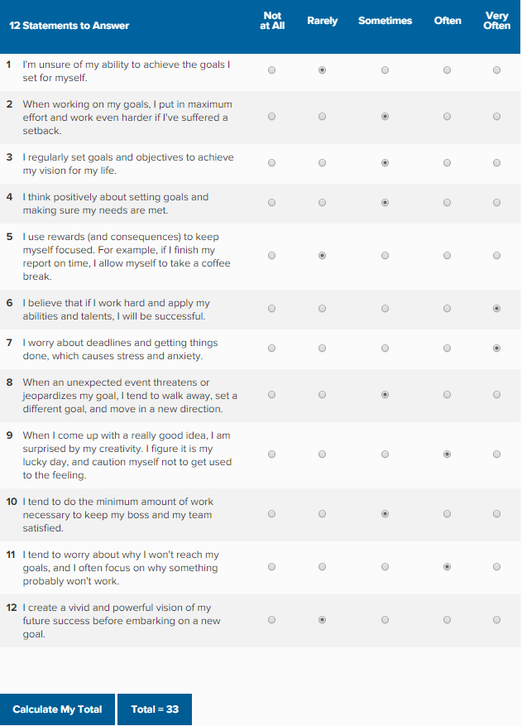

From this self-evaluation exercise I have noticed I am not as self-motivated as I should be. Even though I have made some achievements in my professional career development there is still a lot to improve. Even though I have overcome my social anxiety and I appear to be confident, I realise I need to have more self-confident. There is a research done called Institute for employment studies and one of the skills gaps needed was self-confidence and self-esteem, even though this is not the only skill emphasised, it plays a major role whilst studying, leisure activities, employment and volunteering. Surprisingly for me, self confidence was on the top of the list of employability skills people were lacking (Maund, Schriek and Tinkler 2017).

Furthermore, from this study I can improve on my positive thinking. Sometimes when I have an overload of work it can feel overwhelming, I need to programme my brain to face the challenge instead of fearing that I may not be able to complete it. Positive thinking can also be known as having a positive mindset, an article from Success have explained seven ways to achieve a positive mindset (Alton, 2019).

1. Start the day with positive affirmation.

Having a can-do attitude rather than I can’t do every morning, treating every day positively even if it is a bad day. Building oneself a culture of focusing on what have I done rather than what could I have done.

2. Focus on the good things, however small.

Everyone faces obstacles along the way every day, for example if running late to work due to train delays or disruption, prepare to have literature or an audiobook to make use of the time.

3. Find humour in bad situations.

If for example, if you have had a bad situation at work and the manger has expressed their anger at you. Wind down, speak to a loved one, share some jokes and release the stress with laughter.

4. Turn failures into lessons.

Recently I made a big mistake at work leading to a loss in sales. Subsequently, I explained the scenario to my manger and had a plan in place to learn from it. I implemented a checking system which will reduce the number of mistakes.

5. Transform negative self-talk into positive self-talk.

Speaking positively can have an impact on oneself and others around us. For example, after making the mistake at work, which was creating wrong labels for a product. These products would need re labelling which would cost us more and reduce profits. I explained to my manager positively that I have a system in place to recoup the money. Rather than just say sorry and offer no solutions.

6. Focus on the present.

Focusing on now is extremely important, I don’t hold grudges as they can only remind you of negative situations. Instead, focusing my current situation ca be more powerful and productive.

7. Find positive friends, mentors and co-workers.

I have to surround myself positive thinking people. Sometimes this can mean sacrificing time with people I may have known for years; these people have not allowed me to progress as they have a negative mindset. Having accountability at work can motivate me to be more self-confident. Having stricter deadlines and having a team witth the same goals can help achieve them. I have to look at the task ahead and assign the best person to do that role according to their skill set.

Intrinsic and Extrinsic

To achieve the above there are two types of self-motivation, intrinsic and extrinsic. Intrinsic can be defined as something I love to do, for example exercise because it helps me with stress and I look better. Or trying to save money to afford another holiday. Extrinsic can be something which motivates me due to an external factor. For example, it could be to clean my house as guest will be coming or improving my skills or developing new skill to gain a pay rise at work.

The main difference between the two is that intrinsic is something which only benefits me, so eating healthier to gain better health. Subsequently extrinsic is something I will do to also benefit me however I will need an external factor to feel his. For example, I need to gain good grades, so I will be able to motivate myself to meet the examiners grading by producing high quality work. I would say I am both intrinsic and extrinsic in the way I am motivated depending on the end goals (Cherry, 2019).

Learning Styles: Honey and Mumford

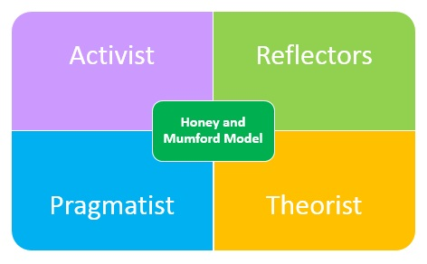

The Honey and Mumford learning style are a mixture of four learning styles, Activists, reflectors, Theorists and Pragmatists. An activist is someone who does not dwell and is fast to making decision, they do not reflect on how well they did and why. They learn by doing and getting their hands dirty. Reflectors are very cautious and careful before doing anything. They are not risk takers and make decisions based on previous experiences. They like to ask others of their opinions and wait for them to contribute before expressing their views. Theorists like to understand the theory behind the actions. They like evidences to be based on facts and used them when challenged. Pragmatists are learners who need to see an outcome before jumping onto a decision. They like to try new ideas and concepts and see the outcome (Morgan, 2017, P96).

According to the Honey and Mumford exercise in class, I am a reflector. I actually agree on this as my wife will call me a push over as I am always listening to others points of views and making decision. I am lacking in the other three learning styles and will need improving on. I like to stand back and observe, sit in the back of class, take in the information and see the bigger picture.

VAK Learning Styles

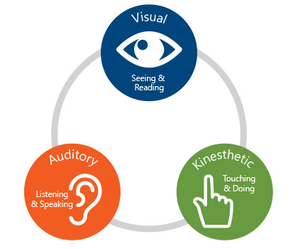

The VAK learning style is split into three preferred styles, Visual (seeing and reading), Auditory (listening and speaking) and Kinaesthetic (touching and doing)

Visual learners learn through seeing, such as a student sitting in front of the class close to a teacher or relying on the route of a sat nav whilst driving. Auditory learners enjoy the oral-aural learning channel. These types of learners enjoy class discussions and are very clear in their discussions to make sure their point is heard. Kinaesthetic learners enjoy exploring, they like to touch, feel and want to do practical hands on experiences (Gholami and S. Bgheri h, 2019).

Once I completed the exercise, I discovered I have a blend of all three styles. During class I visually looked at the board and took notes as well as used auditory method of group discussions and shared ideas and experiences. I would say I used the kinaesthetic type the least even though we were given a structure, I used the notes took off the board visually to write most of my assignment.

SWOT Analysis

SWOT analysis is a tool to find out my strengths and weaknesses as well as finding out any opportunities or threats. It will help me understand myself better and where I am at the moment (Mindtools.com, 2019).

Strengths

- I have good interpersonal skills
- I am a motivated person and like to lead by example
- I have good communication skills and build friendships easily
- I like to help others and put them first
- I am a team player
- I am reliable and trustworthy

Opportunities

- I am an operations manager at work in ecommerce
- Training and development opportunities
- Studying to gain new qualifications
- Starting own ecommerce business
- Future pay rise
- Opportunities to find more freelancing work
Weaknesses

- Excessive workload management
- Delegating tasks to others
- Taking on too much work at once
- Expressing any issues faced
- Being firm with staff
- Social anxiety (has improved over time)

Threats

- I have to continue to learn as laws and regulations are always changing in ecommerce
- Competitors saturating the market so I have to be one step ahead
- Brand building and need a better online presence
- Trends changing leading to less interest in our products
- I have to find new products opportunities
- As a freelancer no job is secure
- Customer leaving to buy off competitors

SMART Objectives for my University Course:

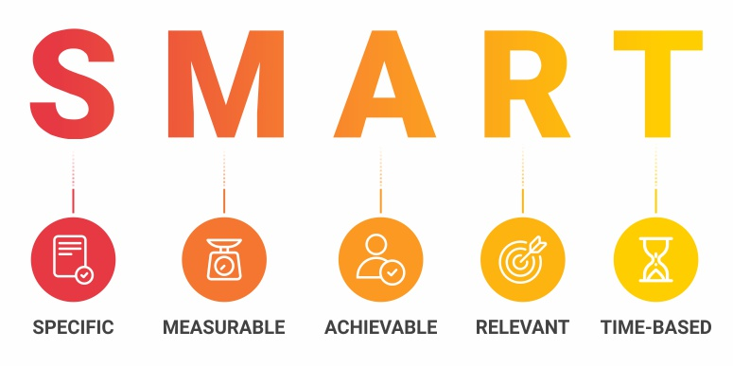

SMART is an acronym which is defined as specific, measurable, achievable, realistic and time based. It is setting goals and breaking down how I will achieve them (Morgan, 2017, P38-39).

Specific: I want to specifically complete all my assignments before the deadline. I will aim to get 500 words done over 8 days. I will read part of a book over 4 days. I will need to make sure I can link the content to the theories I am learning. I must attend class on time to learn the best of my ability. I must ask questions if I do not understand anything.

Measurable: I will aim to complete it by breaking down each part and connecting it to a theory. My introduction will be between two to three hundred words, then I will use theories and exercises done in class to cover the main body. This will approximately be three thousand words; I will then complete the remaining word count with a conclusion. I will show my tutor the work I have completed so far and take the feedback to improve my work.

Achievable: I believe I can achieve this; I have spoken to my lecturers to gain an understanding and meeting deadlines. I have taken time off work to help to complete assignments. The grade I want to achieve is a merit, the tutor cannot grade me now but has explained what is needed to gain a merit. I have to figure out if what I have is correct and of high quality.

Realistic: I have a library across the road from me, I can pop in any time to work on this in the day. I must spend time reading literature and use references. I share looking after my children with my wife who will take time off her work also to support me.

Time based: I will work overtime to get the assignments complete, I am using regular alarm and notification to complete. I also use a tool called Trello to project manage each assignment. (Trello.com, 2019). This enables me to get my paid work for my boss and my university work done in a timely manner. My manager is very understanding and also give me time to complete tasks.

My current role description:

I am a highly experienced professional e-commerce retailer who possesses the required level of management know-how needed to lead, inspire, and motivate staff. Therefore, I help them achieve the best results possible. We gain results through passion, support and using innovating methods. I am excellent at paying attention to detail and put my own systems in place with a zeal and always excited to exceed customer expectations. I am responsible for the online sales of the brand and the online advertising to gain recognition and sales on all social media platforms and sites. I oversee staff members and freelancers ranging from digital marketers, customer service reps, photographers and designers. In addition, working with overseas colleagues in China and the USA to import goods and making sure all rules and regulations are met. I make sure all compliance checks are made to establish us worldwide.

Personal Development Plan
 | Short-Term Time Frame  What do I want to  accomplish in the next  three to six months? | Mid-Term Time Frame  What do I want to  accomplish in the next  six months to two years? | Long-Term Time Frame  What do I want to  accomplish in the next  two to three years?
Part 1 - My Goals  What are my overall goals that I want to accomplish in this time period? | In my current role I would  Like to achieve a turnover of two hundred thousand turnover a month within  The next three to six months. Currently we have been stuck around the one hundred and fifty thousand mark.  I also want to lose around 15kg in weight loss. | In the next six months I  Would like to gain a pay rise. Moreover, I would like to help my team grow by making more money and expand to other countries and see more products.  I also want to train and study to become a personal trainer. | In the next two years I would like my own ecommerce business either in physical goods or health and fitness.  I want to gain an online following so I can help people change their life around I terms of health and fitness.
Part 2 - Skills and Knowledge to be  Learned  What specifically do I need to learn? What project do I need to work on? | To make more money for our business I need to launch more products. Contact more suppliers and negotiate better deals.  I will hire a personal trainer to help me achieve my weight loss goals. I will follow a plan strictly without cheating | I will train my team to a high level so they can do the same job as me. Also find experts overseas to expand. This way we will all be experts in our field and can ask the company for a pay rise  I will ask my personal trainer to recommend me a course to follow so I can become a personal trainer | I will create my own ecommerce store, work on this along with my current role  I will create social media page and gain followers and post great health and fitness content as well as my own journey of losing 15kg.
Adapted from: http://www.hr.ucdavis.edu/sdps/forms/IDP%20Final%2010.14.11.pdf

 | Short-Term Time Frame  What do I want to  accomplish in the next  three to six months? | Mid-Term Time Frame  What do I want to  accomplish in the next  six months to two years? | Long-Term Time Frame  What do I want to  accomplish in the next  two to three years?
Part 3 - Resources  What resources do I need? | I will need good suppliers and shipping companies to produce and deliver products on time.  I will need to fit in exercise and diet around my current job and family.  I will make sacrifices on the way. | I will need full support of my team; I will delegate tasks better so I can focus on growing the business.  I will spend an hour a day working on my online courses. I ask my class mates to help if I get stuck | I will recruit specialists to create an online store and outsource where needed.  For my fitness goals, will join private Facebook groups and masterminds with likeminded people to find mentors who will help guide me.
Part 4 - Time Schedule  What is my time schedule? | September 7th 2019 – March 8th 2020 | March 8th 2020 – January 2021 | Jan 2021
When will I start? | September 7th 2019 | January 2020 | Jan 2021
When do I expect to finish? | December 21st 2019 | December 2020 | December 2021
Part 5 - Completion  When have I completed each step? | □__________  Date: December 21st 2019 | □__________  Date December 2020 | □__________  Date December 2021
Adapted from: http://www.hr.ucdavis.edu/sdps/forms/IDP%20Final%2010.14.11.pdf

Personal action plan:

I have decided to concentrate on one thing (Keller G and Papasan, J 2012) and that is leadership skills. I am lacking the ability to influence and motivate my staff on certain occasions. I will need to communicate clearly, tackle problem solving together, be on top of time management and build trust within employees.

Good leadership is essential in all companies and establishments, one of the roles is to create a place where everyone is willing to help one another rather than blame others (Morgan, 2017, P38-39). All individuals will feel supported and as a result perform better and succeed in their positions. In addition, the team will feel respected and be more open with the leader in future.

I need to have more faith in my staff and not take over the work once they find something difficult, instead I should spend more time and support them and have more faith in them. I will need to make more self-sacrifice so the team can trust me and I can earn their trust.

I have a small team so it is easier for me to know the strengths and weaknesses of them and can apply a swot analysis to help and develop them. I can show them I have found mistakes in myself which has helped me improve. I will also push everyone to do their best by not leading by force but use the leadership skills mentioned above.

I believe I have this skill but I need improving on and will need to develop more skills such as, problem solving, communication and social skills. I have acquired all of these through various life experiences and work life experiences. For me to master leadership skill I will need to perfect my personal development plan and start implementing what I have learnt in my everyday life. I will ask mentors and lecturers in future to give me some time to sit and discuss how far I have gone. I would say the first skill acquired in my life was communication, even though I couldn’t express the right words to my parents about moving house, they understood I was upset. I gained social skills once I went on pilgrimage and developed new friendships and preparing me for the real world. Finally, I would say I gained problem solving skills doing my current job role and also as a husband and parent. I am facing these challenges everyday and as mentioned above, I can get better by implementing what I learnt in University in everyday life.

Conclusion:

In conclusion, this report has described my personal development plan using learning styles and learning exercises. I started off explaining about my lifeline and how I got to where I am today. I did an evaluation of myself using Honey and Mumford learning styles and VAK learning styles. I did a SWOT analysis and a SMART objective of my university assignments. I gave a small introduction of my current role and created a personal development plan. I completed a personal action [plan on leadership as that is my main role and ended with this conclusion. I have included references from text books and online sources with a description of my own experiences. Finally, I gave one area I felt I really needed improving and how I can do this.

References:

- Alton, L. (2019). 7 Ways to Make Positive Thinking a Habit. [online] SUCCESS. Available at: https://www.success.com/7-practical-tips-to-achieve-a-positive-mindset/ [Accessed 3 Sep. 2019].
- Cherry, K. (2019). Extrinsic vs. Intrinsic Motivation: What's the Difference? [online] Very well Mind. Available at: https://www.verywellmind.com/differences-between-extrinsic-and-intrinsic-motivation-2795384 [Accessed 3 Sep. 2019].
- Gholami, S. and S. Bgheri h, M. (2019). Relationship between VAK Learning Styles and Problem Solving Styles regarding Gender and Students' Fields of Study. [ebook] Finland: © 2013 ACADEMY PUBLISHER, p.700. Available at: http://www.academypublication.com/issues/past/jltr/vol04/04/08.pdf [Accessed 3 Sep. 2019].
- Keller, G., & Papasan, J. (2012) The one thing. 2nd ed. London: John Murray (Publishers)
- Maund, A., Shriek, M. and Tinkler, P. (2017). Certificate in higher education. 1st ed. London: Sage Publication Ltd, pp.58-59.
- Morgan, P. (2017). The business guide to study and employability. 1st ed. London: Sage publications Ltd.
- Trello.com. (2019). Trello. [online] Available at: https://trello.com/ [Accessed 4 Sep. 2019].

