

What is the true reflection of the United Kingdom penal system and is it benefiting British Citizens?

Name: Alicia Samuel
Student Number: 0901811
University: UWTSD Swansea
Degree: BSC Proffesional Policing
Due date: 6th May
Word Count: 8091
Acknowledgements
I would like to thank my supervisor Jane Thomas who has supported me not only through the process of my dissertation, but also in the last three years of my degree. She has continued to be a positive figure and motivated me to develop the best academic work possible. A big thank you to my friends and family who have also supported me through the dissertation process, they have been patient and although this work is my own. They have stayed close and been there for me continuously throughout my three-year university degree, for that I am appreciative.

Abstract
The aim of this dissertation is to find the true reflection of the UK prison system. Objectives will be mentioned throughout which will concentrate on exploring the size and capacity within different prisons throughout the UK. Statistics on imprisonment of offenders and the crimes, sentencing and frequency of reoffending will be further addressed in detail followed by research findings on the effectiveness of prisons. It will identify society’s view on the topic of UK prisons and their reasons for what they believe, this was approached through a questionnaire to gain a deeper understanding of society’s views. The questionnaire was distributed on the social media platform Facebook and 80 participants took part.

Declaration


Contents
List of Figures 5
1. Chapter 1 Introduction 6
1.1 Introduction 6
1.2 Background, Context and Rationale 6
1.3 Aims and Objectives 8
1.3.1 Aim: 8
1.3.2 Objectives: 8
1.4 Research Structure 9
2. Chapter 2 Literature Review 10
2.1 Introduction 10
2.2 Objective 1: Explore the size and capacity within UK prisons 10
2.3 Objective 2: How many reoffenders are imprisoned and what for? 11
2.4 Objective 3: Is there evidence to show the system works? 13
2.5 Conclusion 16
3. Chapter 3 Research Methods 17
3.1 Introduction 17
3.2 Research Onion 17
3.2.1 Philosophy 18
3.2.3 Approach 18
3.2.4 Strategies 19
3.2.5 Choice 19
3.2.6 Time Horizon 19
3.3 Techniques for data Collection 20
3.3.1 Data Collection 20
3.3.2 Sampling 20
3.3.3 Survey design 20
3.3.4 Questions and Literature Review matrix 21
3.3.5 Reliability and Validity 23
3.3.6 Limitations 23
3.3.7 Ethical Considerations 23
3.4 Conclusion 23
4. Chapter 4 Analysis findings 24
4.1 Introduction 24
4.2 Data Analysis 24
4.3 Main Body 24
4.4 Responses 25
4.5 Conclusion 33
5. Chapter 5 Conclusion 34
5.1 Recommendations 35
6. References 36

List of Figures

Figure 2.1: Pie chart of most offences committed
Figure 2.3: Percentages of most common reoffending offences (Ministry of Justice, 2022)
Figure 3.1: Research Onion (Saunders et al. 2016)
Figure 4.1: Pie Chart of question 1 results
Figure 4.2: Pie Chart of question 2 results
Figure 4.3: Pie Chart of question 3 results
Figure 4.4: Bar Chart of results for question 4
Figure 4.5: Bar Chart of results for question 5
Figure 4.6: World Cloud Presenting Most Frequent Words and Phrases from question 6
Figure 4.7: Pie Chart of results for question 7
Figure 4.8: Pie Chart of results for question 8
Figure 4.9: Pie Chart of results for question 9

Chapter 1 Introduction

1.1 Introduction

The purpose of this introduction chapter is to offer history and context, as well as the reasoning for this research. The aims and goals, as well as a description and structure of the research project.
Both qualitive and quantitative methods will be used, the use of desktop research with interrogation of physical resources such as books, journals, and reports. The main research techniques that will be used in the dissertation is questionnaires. This allows for the researcher to go into as much or as little detail to their preference as well as remaining anonymous if need be. The dissertation will include many facts and statistics. To ensure these are reliable, the sources will be coming from online websites through google scholar and the library system. By using these research techniques, it allows the researcher to gather a wide range of information.

1.2 Background, Context and Rationale

In the United Kingdom, there are now one hundred and seventeen prisons which incarcerate people who have been sentenced or are on remand awaiting trial for a variety of offences (Beard, 2021). This figure includes all prisons in England and Wales, as well as Her Majesty’s Prison (HMPs) and Her Majesty’s Prison & Probation Service (HMPPS) (Prison Guide, 2021). G4S, Sodex, and Serco are three private firms that operate prisons in the United Kingdom. In 2019-20 the average cost per prisoner in England and Wales was £30,312 Scotland £38,213 and Northern Ireland £43,029 the prison population is now 87,550 which results in an average total of over £3 billion a year spent on prisoners.
In England and Wales prisons are divided into categories, which concentrate on the possibility of an offender escaping and causing harm to the public. As well as the threat they could cause to the prison's authority and stability. Based on these, male dominant prisons are organised into security categories ranging from A-D (Ministry of Justice, 2022).
Category A- These are maximum-security facilities. They imprison male inmates who, if they escaped, would represent the greatest threat to the public, law enforcement, or national security. Category A is separated into three sub-groups: prospective, provisional, and confirmed, and the danger of a prisoner escaping is graded on a scale of standard, high, or extraordinary (Grimwood, 2015).
Category B- These facilities are either local or training facilities. Local prisons house inmates who are taken straight from local courts, whereas training prisons host long-term and high-security inmates.
Category C- Many inmates are housed in category C prisons, which are used for training and resettlement. They allow inmates to build their own abilities so that when they are released, they may find jobs and reintegrate into society.
Category D- These prisons feature low security and allow qualifying inmates to spend the most of their days outside the jail on an employment, learning, or resettlement licence. Only convicts who have been risk-assessed and found to be acceptable and somewhat trusted for open conditions are housed in open prisons (Grimwood, 2015).
According to their dangers and requirements, women and young adults are classified and detained in either closed or open facilities. High-risk females and young adults are given "restricted status," which means they may only be confined in a closed jail. Women and young adults may be detained in high-security prisons in extraordinary circumstances (Ministry of Justice, 2022). However, there are no prisons in Wales which hold women prisoners’ states Belli (2022). The nearest female prisons are in England. Women from North Wales are more likely sent to HMP Styal in Manchester, whilst women from south and west Wales are more likely to be sent to HMP Eastwood Park in Gloucestershire (Clean Break, 2022).
Youth offenders aged between 18-21 are housed in a young offender institution, those aged under 18 who have been detained or sentenced to time in custody by the courts are held in youth custody.
There are four security categories which are used for women prisoners as well as young offenders. Because a woman prisoner is extremely unlikely to fit the standards for category A, the highest security category in everyday use is generally restricted status.
Category A- Prisoners whose escape would pose a serious threat to the public, the police, or the state's security, and for whom the goal must be to make escape impossible.
Restricted Status- Any female, young person, or young adult prisoner who is convicted or on remand is obliged to be confined in designated secure quarters because her escape would pose a substantial risk to the public.
Closed Conditions- Prisoners who do not require the highest levels of security but pose a significant risk in open conditions or for whom open conditions are inappropriate.
Open Conditions- Prisoners who pose a low danger; may be trusted in open circumstances; and are suited for open situations.

1.3 Aims and Objectives

1.3.1 Aim:

What is the true reflection of the United Kingdom penal system and is it benefiting British Citizens?

1.3.2 Objectives:

- Explore and compare the size and capacity within different prison systems throughout UK?

- Research imprisonment of committed criminals, their crimes, sentencing and frequency of reoffending.

- Is there strong evidence to support the effectiveness of the UK penal system?

1.4 Research Structure

This study project will be divided into five chapters to fulfil all three objectives. The first chapter will be an introduction; the second will be a literature review; the third will be the technique and methodology for research; the fourth will be the data analysis; and the fifth will be the conclusion and suggestions.
Chapter one introduces the research project, which provides both background and context. It also entails the rationale for the study, as well as the project's goals and objectives. A literature review, followed by a participant survey, will be used to collect secondary and primary data.
The literature review will be the second chapter, and it will give a more in-depth look at the research project's topic. The literature aids in the knowledge of the issue by highlighting places where comparable investigations have been conducted and the results obtained.
The methods of research and methodology section of Chapter three will determine the most potential primary research approaches and procedures. The data will be analysed when the research is complete.
The primary data acquired using the procedures indicated in Chapter three will be analysed and presented in Chapter four. The data will then be examined and debated.
The research study will conclude in Chapter five, this will include a review of the data discovered and the consequences it entails. In addition, the last chapter will make recommendations for the future, both in terms of study and in terms of society.

Chapter 2 Literature Review

Introduction

This chapter will give a quick summary of the UK prison system and whether it is beneficial to British citizens. It will then go on to cover each of the study objectives separately by reviewing the literature on the subject. The chapter will proceed to explore and compare the size and capacity within different prisons throughout the UK. Statistics on imprisonment of offenders and the crimes, sentencing and frequency of reoffending will be addressed, followed by research findings on the effectiveness of prisons.

Objective 1: Explore the size and capacity within UK prisons

In June 2021, the UK's overall imprisonment population was estimated to be at 87,550 persons which currently is very close to maximum (Ministry of Justice, 2022). England and Wales had a population of 78,756, Scotland had a population of 7,417, and Northern Ireland had a population of 1,377 (Sturge and Tunnicliffe, 2021).
The Home Office reported that 4580 women were incarcerated in England and Wales in September 2005, an increase of 60% from the previous year (Jewkes, 2007). There were 3,857 women in custody as of October 21, 2016. Between 1993 and 2005, the number of women in jail nearly tripled, to 4,470. Even though the number of women in jail has gradually decreased, there are still 1,900 more women in prison now than there were 20 years ago (Criminal Justice Alliance, 2016).
Ministry of Justice, HM Prison Service and Her Majesty’s Prison and Probation Service (2020) state in an open document that the operational capacity figure of all prisons within the UK is 83,823 and the overall population is over 78,000. Looking at the figures from this source it is clear to see that capacity has not been reached. Many of the prison’s population are very close to maximum capacity which may risk overcrowding. However, population figures include prisoners on authorised absence, therefore not all prisoners stay on prison grounds on the term of their sentence.
Eurostat (2021) states that the jail population has increased dramatically over the last 25 years, from 44,246 in 1993 to 82,384 in December 2018. After rapidly increasing for much of this time, it has remained reasonably constant since 2010 and has lately declined, with a drop of 2,312 places in the previous year (Sturge, 2021). The number of prison beds available to house this population is measured in terms of usable operational capacity. Despite a drop in the number of prison beds available, the population was 2,816 people short of capacity in December 2018, an increase of 490 people over the previous year (Allen et al, 2017). Nonetheless, the present population is overcrowded, since it exceeds the 75,005 in-use certified normal accommodation limit, which HM Prison and Probation Service considers to be enough for a good, reasonable standard of living (Sturge, 2021). The estate's overcrowding is not distributed. In December 2018, 72 of 118 prisons had populations that surpassed the requirement for in-use approved housing (House of Commons, 2019). This includes HMP Wandsworth, HMP Pentonville, and HMP Leeds, among others.

Objective 2: How many reoffenders are imprisoned and what for?

According to recent statistics from Ministry of Justice (2010a) approximately half of all criminals released from jail reoffend within a year. In the year after their release from jail or the beginning of a community sentence, one out of every five offenders spent some time in custody. Resource from Oxplore (2022) state that in England and Wales, the most frequent prison sentence duration is 4 years or more for adults and 1-4 years for non-adults. Within nine years, over three-quarters of individuals who were released from jail or started a community order in the first quarter of 2000 were reconvicted of another crime. In the United Kingdom, 75% of ex-offenders reoffend within nine years after their release, and 39% within the first twelve months (UK Research and Innovation, 2022). Within a year, 74% of criminals sentenced to youth imprisonment and 68% of young people serving community sentences reoffend (Ministry of Justice, 2013). For the January to March 2020 offender cohort, the confirmed total of reoffending rates was 24.7%, 24.1% of which were adults and 34.1% were juveniles, these figures are 2% lower than the same period in 2019. (Ministry of Justice, 2022). Even though the number of crimes reported to the British Crime Survey has decreased by 42% since 1995, few academic observers relate much of this decrease to increased jail use (The Howard League, 2007). Reoffending by all ex-convicts costs the economy between £9.5 billion and £13 billion a year, according to the Prison Reform Trust (2013), with £7 billion to £10 billion coming from former short-sentenced prisoner.
Ministry of Justice (2013) states the percentage of offences committed by prisoners. This pie chart was made so that we can clearly indicate that acquisitive crimes such as theft, burglary and robbery were the most common offence with 30%. Vehicle related offences being the second most crime committed with 18% and just slightly under with 17% is violent offences. And lastly drug offences are committed with 5%.
Figure 2.1 Pie chart of most offences committed
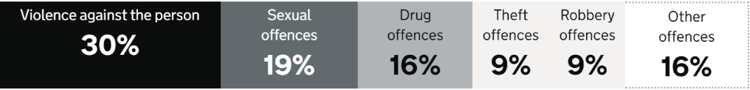

Figure 2.3 Percentages of reoffending offences (Ministry of Justice, 2022)
By type of offence, the percentage of people in prison who have been sentenced. Ministry of justice (2022) propose that the most common re-offending crime to be committed is violence against the person with 30%. Violent crime includes anything from petty attacks like pushing and shoving, harassing, and abuse that do little bodily injury to wounding and killing (Wright, 2017). Sexual Offences are committed 19% of the time, rape, sexual assault, and illicit sexual conduct against adults and minors, as well as sexual grooming and indecent exposure, are all considered sexual offences (Crime Prosecution Service, 2017). Drug offences such as possession, supplying, trafficking, producing, or possessing a recipe of an illegal drug are committed 16% (Crime Prosecution Service, 2021). Theft and robbery both are committed 9% of the time, Robbery is defined as taking from someone with the use of or threat of force (Flatley, 2017). Burglary also known as theft is defined as entering a property without authorization with the intent of stealing, committing a major assault, or causing criminal damage (Theft Act, 1968). There are many other offences which are committed some which are associated with drugs misuse, alcohol misuse, fraud, anti-social behaviour and many more, these offences are committed 16% of the time (Wright, 2014).
The majority of women who go to prison are only there for a short time. However, according to Prison Reform Trust (2019) over 2,200 more women are in jail now than there were 25 years ago. In 2015, three out of every five women sentenced to jail were serving six months or less. Only a third of women in detention in 1993 received a sentence of six months or under (Criminal Justice Alliance, 2016). In comparison to 12% of males, 26% of all women in jail and 28% of women serving terms of less than 12 months had no previous convictions. 85% of women sentenced to jail have committed a nonviolent crime, whereas compared to 46% of males. 69% of remanded women and 59% of women serving an immediate prison term were there for a non-violent offence as of June 30, 2016 (Webster, 2016). In 2015, 42% of women were sentenced to prison for stealing and handling stolen items. Women who are in prison for drug offences has decreased over the last 10 years in 2015 with 420 prisoners, compared to 1163 in 2006. However the number in custody for violent offences has gone up to 913 in 2015 (Criminal Justice Alliance, 2016).

Objective 3: Is there evidence to show the system works?

The purpose of prisons is to ensure that everyone receives justice by prosecuting and punishing the guilty and assisting them to break the cycle of their criminal behaviour while protecting the innocent (Garside, 2008). There is an ongoing argument on whether punishment is the best solution for the penal system or rehabilitation to help prisoners break the imprisonment cycle. According to Self (2011), “Prison does not work for the majority of inmates either as punishment or rehabilitation”.
A document published by the University of Glasgow and the Scottish Centre for Crime & Justice Research (2022) states that the main reason for incarcerating criminals is
-To protect the public
-To punish the offender
-To serve as a deterrent to the offender and others
-To rehabilitate
Garside (2008) and University of Glasgow and the Scottish Centre for Crime & Justice Research (2022) both have a similar agreement on the purpose of the penal system. Raynor and Robinson’s (2005), tells us that the Oxford English Dictionary defines rehabilitation as “the action of restoring something to a previous (proper) condition or status”. The core principle of incarceration-based rehabilitation is that a person who has been imprisoned will never wish to return to prison after being released. It is believed that an inmate's experiences while incarcerated would make such a long-term effect on a former prisoner that he or she will go to any length to avoid serving a second sentence (Zamble and Porporino, 1990). Recidivism has been proven to be reduced through rehabilitation programmes states Ward and Langlands (2009). Restorative justice disappoints to fulfil its promise as a needs-based justice system by failing to effectively address offender rehabilitation. Evidence from the Scottish Government have concluded that rehabilitative cognitive- behavioural programmes which address criminogenic needs have the strongest evidence in reducing reconviction rates (Sapouna et al, 2015). Given that criminals frequently experience several obstacles, such as drug abuse or educational deficiencies, Ministry of Justice (2010b) believe that holistic programs that address various criminogenic needs are more likely to reduce reoffending. This is especially true for young people and women who insult others. Offender willingness to participate in rehabilitative programmes is critical to their effectiveness, and treatments that are tailored to the attitude of offenders are more likely to reduce reoffending. The Good Lives Model, although sharing many components with the Risk-Need-Responsivity model (RNR) method, places a greater emphasis on offenders' strengths and objectives (Heffernan and Ward, 2019). This has been recommended to assist and enhance offenders' incentive to finish treatment, but further study into its practical implications is needed. Although rehabilitation during the sentencing of prisoners is vital, life when they are released can be daunting. Especially when prisoners have served a long sentence, outside life will not sometimes be as they knew it before. Continued support is of the utmost importance after release. This will include working alongside probation services. They emphasise the need of programmes that assist convicts as they make the journey 'through the gate’ (Parliament, 2021). The two most important things are employment and housing. Only 17.3 percent of prisoners are granted housing on the first night after release. When analysing employment targets, only 4% of prisoners were successful in acquiring a job within the first six weeks after release (Charles, 2021). These low figures raise questions about whether prisons are effective in rehabilitating people. According to Beard (2021) organisations such as ‘Prison Reform’ state that instead of adding more jail beds, they suggest, the government should lower the prison population, decrease overcrowding and provide more resources for rehabilitation.
A significant amount of the people in the United Kingdom do not want inmates to be rehabilitated; instead, they want them punished. According to a BBC reporter Will Self (2011) not many individuals who have endured the prison system as a punishment or form of rehabilitation reform into law abiding citizens if anything their criminal activities escalate. A large proportion of the British public feel quite enraged at the amount of taxpayer’s money that is allocated to the upkeep of prisoners and furthermore resent wasted money on failed initiatives. They do however believe that more money should be spent on reliable addiction programmes, aid prisoners with mental health problems as well as teaching illiterate inmates. Some members of the public do not believe that imprisonment is the answer to some convicted criminals, if an individual is proven to not be of a physical threat, then they should be made to undertake unpaid work. Meta- analyses are uncertain of what "works" in correctional therapy since meta-analysis of data on rehabilitation has not yet proved that any one technique of treatment is significantly and dependably successful (Logan and Gaes, 1993). However, rehabilitation programmes and activities such as yoga, learning to play an instrument and music interaction are all cost-effective and have many psychological benefits according to University of Oxford, 2013). They encourage prisoners to engage, help them gain new skills, improvement in a positive attitude, control of their behaviour resulting in them less likely to re-offend (Oxplore, 2022).

Conclusion

Objective 1- Answering the objective of exploring the size and capacity of UK prisons, research has concluded that England and Wales have the greatest prisoners in the overall population of the United Kingdom. Following on from this the size of prisons have reached very close to maximum capacity, with overcrowding being an issue. However, is not severe enough to be classed as unreasonable standards of living conditions.
Objective 2- Recidivism is a failure in the criminal system that is inherited year after year. Criminals are continually recycled through the courts and into prison, resulting in additional victims of crime and further societal expense. The most common offence to be committed is theft, burglary, and robbery however the most reoffending crime is violence against a person.
Objective 3- When it come to “does the penal system work” there is no straight answer. The ongoing argument of whether rehabilitation is the way forward in reducing the number of prisoners or if punishing them will have better results. In the research found, many sources have proven reasons as to how and why rehabilitation can encourage prisoners to better their behaviour to result in improved long-term effects when released. However, the issue with rehabilitation programmes is having to encourage prisoners to participate in programmes and take them seriously. When prisoners are released a very small percentage of those gain employment, a larger number end up reoffending again. Sources from articles have the opinions of the public. Majority of individuals feel as though rehabilitation is a waste of expenses as reoffending numbers are proven to be a lot higher than rehabilitation programmes changing prisoners mind set. Therefore, opinions of the public side with punishment are a more efficient method to reduce prisoners.

Chapter 3 Research Methods

Introduction

The previous chapter evaluated a wide range of research focusing on the penal system, specifically the size and capacity of UK prisons, as well as an understanding of the number of prisoners who reoffend and the most common crimes committed, as well as detailed evidence of whether a prison's purpose is being fulfilled.
The third chapter attempts to examine the decision-making processes that goes into developing techniques of collecting public data about the penal system. The research onion will be utilised to aid the decision-making process to reach this goal. There will be conversations about reliability, validity, and ethnic concerns throughout the process of selecting which approach is the best while developing those methods. The research onion, created by Saunders et al. (2016a), will be utilised to aid the decision-making process.

Research Onion

The research onion is a detailed explanation of the several layers or steps that must be completed to develop a successful technique states Raithatha (2017). The research methodology begins with the definition of the fundamental philosophy, followed by the selection of approaches, methods, and strategies, as well as the establishment of time horizons, all of which led to the study design. The research onion in the diagram below, proposed by Saunders et al. (2016b), is a technique for organising research and developing study design by working through the layers of the onion one layer at a time (Melnikovas, 2018).
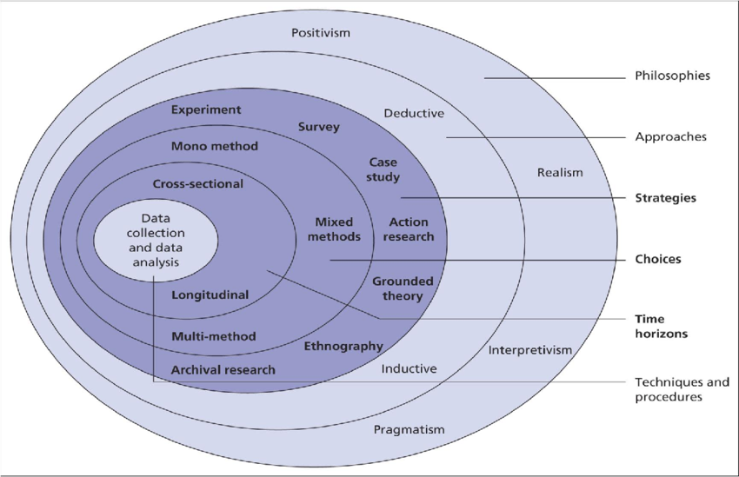

Figure 3.2.1 Research Onion (Saunders et al. 2016)

Philosophy

The first component of the research onion is philosophies, which defines:
Ontology- The researcher’s view of nature of reality or being.
Epistemology- The researcher’s view regarding what constitutes acceptable knowledge.
Axiology- The researcher’s view of the role of values in research.
There are four research philosophies in management research, they are: Positivism, Realism, Interpretivism and Pragmatism (Saunders et al. 2009a),
The Pragmatism method was chosen as the research philosophy because it employs a variety of techniques, concepts, and principles, or a combination of all three, to explain the research's findings and answers. This was the best philosophical approach for this type of research, as opposed to Positivism, which focuses on using science and mathematics to explain theories (Saunders et al. 2009b), and the researcher believed that using science and mathematics alone would make it more difficult to explain the correct solutions and conclusions of the research problem.

Approach

On a higher level, the research philosophy might imply a theory development approach, which generally includes the following:
Deductive- methods start with a hypothesis and try to improve or test it through research.
Inductive -include formulating hypotheses based on research
Qualitative and quantitative research are closely related to research methods. Qualitative research is concerned with data that is written, visual, or audible, whereas quantitative research is concerned with numerical data (Phair and Warren, 2021). The reason for employing a deductive method here is because quantitative research usually starts with theory and progresses through hypothesis testing. A broader theory is applied to a specific setting, event, or observation to check if it fits with the theory.

Strategies

Survey research is a quantitative technique that uses self-report measurements on a small sample of people. It's a versatile methodology that may be used to a wide range of scientific and practical research problems (Vizcarguenaga-Aguirre and López-Robles, 2020). As part of the researchers study it was decided that a survey would be used as it allowed them to collect a large amount of data. Members of the public participated in this survey which gave the researcher a variety of opinions and answers, due to the questionnaire being anonymous participants were not hesitant to reveal somewhat personal opinions which resulted in a well filled out survey.

Choice

In comparison to the Mono Method, which would have restricted the researcher to only using one type of data collection, either qualitative or quantitative that data would not be representative of how every participant feels. The researcher chose to use Mixed Methods because it enabled them to collect the most amount of data, which in turn allowed them to gain more insight into how the public feel and their thoughts about the penal system.

Time Horizon

Time Horizon defines the time frame for the research, there are two components.
Cross-sectional- When data is collected at one point in time
Longitudinal- When data collection entails collecting data on a regular basis over a lengthy period in order to compare the results.
A cross-sectional temporal horizon was chosen for this investigation since it was regarded most appropriate. Given the scope of the study topic, a cross sectional analysis would be more than sufficient. Research conducted over a longer period may produce better findings, but because this study is looking for current thoughts, the only practical benefit of extra time would be that more people would contribute to the survey.

Techniques for data Collection

Data Collection

To gather primary data, the researcher chose to employ a questionnaire. The benefits of employing a questionnaire include the ability for participants to fill out the questionnaire anonymously if they do not want to receive unwelcome attention as a result of sharing sensitive information. Another benefit is that the researcher may be able to gather a large number of people to fill out their questionnaire, allowing them to gain a deeper understanding of the prison system. However, there are certain downsides to using a questionnaire, such as participants' perceptions that some of the questions are demanding of personal information and hence opt not to provide such details. However, the researcher was aware that this may be an issue which is why the multiple-choice option was given. A survey will be used to acquire quantitative data. Quantitative research is based on numbers and provides measurable outcomes. Data tends to represent in charts, graphs, or tables, and quantitatively analysed to test theories.

Sampling

It is unrealistic to collect data from a targeted audience, therefore data from the researcher’s questionnaire was acquired from a sample of the population through the platform of Facebook. A random probability sampling of people was selected to participate in the questionnaire.

Survey design

A questionnaire is a set of standard questions that participants fill out to reflect their thoughts and feelings about the purpose of the questions asked (Gillham, 2000). To minimise misunderstanding, questions should be based on research goals and tested. In the researcher’s questionnaire there were eight closed questions and two open questions. Closed questions are a quick and easy way for participants to answer without thinking too much whereas open questions allow the participants to express and reflect their thoughts (Vinten, 1995). The questionnaire also provided a scale of numbers in which the participants could rate one to ten, also known as Likert scale. One being strongly agree and ten being strongly disagree. By agreeing or disagreeing with a statement on a Likert scale, the process of scoring replies creates a respondent's belief or opinion (Nemoto and Beglar, 2013).

Questions and Literature Review matrix

Questions in Survey | Literature Review
- Do you agree to take this survey and enable the information you provide to be used in my research project?  - Yes  - No | This question was asked for consent to ensure the participant understood and were aware of why the questionnaire was taken.
- What age group do you fall under?  - 18-24  - 25-34  - 35-44  - 45-60  - 60+ | Questions 2-3 are both demographic questions which gives a background context for analysis
- What gender describes you?

- Male
- Female
- Non-binary
- Prefer not to say

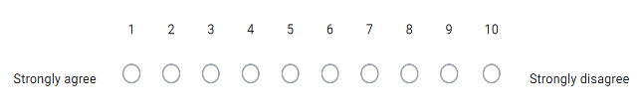  - How strongly do you agree or disagree that the prison system is effective? | This question was a Likert scale closed question, it allowed the researcher to  collect feedback from the general population on how they feel about the prison system ranging in numbers. This will affect the rest of the survey as well as all other questions.
- Do you think the prison system is failing? if so, please tick relevant options as to why below:  - Funding  - Social attitudes  - Educational opportunities  - Individual attitude  - Childhood experiences  - Other | This question was important to ask as it would be very useful in the analysis findings, it allowed participants to have a say in what they believe in.
- What other alternatives could there be instead of prisons? | The first open ended question allowed participants to openly express their thoughts and views.
- As an estimate, how many prisoners do you think there are in the UK currently?  - 40,000- 60,000  - 60,000-80,000  - 80,000-100,000 | This question links to objective 1, comparison to Ministry of Justice (2022) and the publics results can be compared. It was asked because it gave the researcher an inside of how much knowledge a random population of participants had.
- What do you think is the most common reoffending crime?  - Vehicle offences  - Drugs offences  - Violence  - Theft/ burglary/ robbery | This question was asked as it relates to objective 2. The researcher can compare what the public said compared to the Ministry of justice (2013).
- What do you think the best solution to decrease criminals in prison is?  - Rehabilitation  - Punishment  - Other | Objective 3 explores this question in depth from sources such as Self (2011). Therefore, this question was important to ask as both results can be compared.
- Following on with the above question, what is your reasoning? | The second open and final question allows the research to openly reflect on their answers, enabling them to make their final views on the Prison system.

Reliability and Validity

Ensuring that the research is reliable and valid is critical since the study would become irrelevant without them. The term’s reliability and validity are used to assess the quality of research. They describe the accuracy with which a method, approach, or test measure something. Validity is related to precise measures, whereas reliability is concerned with its consistency (Roberts and Priest, 2006).

Limitations

A limitation which will affect this research is COVID-19, the researcher was unable to interview certain individuals such as police and prison officers. Having a targeted group of professional individuals who are well educated on the criminal system would have been a beneficial to compare their thoughts with those of the general public. To address this, the researcher went ahead with the questionnaire which was highly useful for the analysis.

Ethical Considerations

This study is carried out in accordance with the UWTSD's ethical standards, with permission from the research supervisor and co-ordinator received via an ethics approval form. Confidentiality, identification, and data privacy were used to address ethical concerns. All participants were over the age of 18 when they took part in the survey, which was completely voluntary.

Conclusion

The relevant research methodologies for this study were selected in this chapter. The researcher's decision to use a quantitative technique in the form of a survey with a random sample of members of the general public was then justified. The data from the survey will be analysed and evaluated in the next chapter.

Chapter 4 Analysis findings

4.1 Introduction

This chapter will analyse all the data gathered through the researcher's selected data collecting method and will conclude the replies collected from the participants. The researcher was aiming for a total of one hundred responses to make it valid and reliable, however only eighty participants took part in the questionnaire and shared their thoughts and opinions on the UK prison system. In order to carry out a full analysis, the researcher will identify similar themes in the participants' responses and come up with cognitive conclusions which summarise the topic of the prisons system. The three components that will be used in this chapter will be describing and explaining what was stated in the empirical results, then an analysis of those results and lastly synthesising the empirical results to the literature review.

4.2 Data Analysis

The information gathered from the survey will be analysed using Google Docs. This presents percentages and summarises the findings to establish public opinion on the study topic's objectives. Google Docs delivers the most thorough analysis for the questions asked and includes all the responses. The data gathered from each question using Google Docs will be included in the entire study of this chapter. The participants found Google Docs to be quite useful and user-friendly, and it was simple to share via a link in a social media message or email.

4.3 Main Body

With just under 100 respondents, the researcher was still able to gather useful data that will aid them in reaching a more comprehensive conclusion regarding how the public perceives the prison system. The questions included in the survey varied from their perception and knowledge of the criminal system to questions about their opinion on alternatives to prisons and reasoning. This allowed the researcher to collect a variety of perspectives and opinions on many aspects of the prison system, as well as detect any common themes or connections within the responses. Eight multiple choice questions and two open ended questions were included in the survey to achieve a fair mix between allowing participants to express themselves in their own words while also utilising questions that would provide appropriate statistical data to utilise for conclusions. The questionnaire also included a numerical scale, sometimes known as a Likert scale, which participants ranked their opinion on a range of one to ten. One represents a strong agreement, whereas ten represents a severe disagreement. None of the questions in this survey were mandatory, and participants were able to decline or stop the survey at any moment.

4.4 Responses


- Q.1

Figure 4.1 Pie Chart of question 1 results
The first question was to ensure that the participant understood the objective of the questionnaire and how the information they provided would be utilised. The pie chart analysed that all 80 participants allowed their consent which tells the researcher they understand and allow their information to be used in the research project.

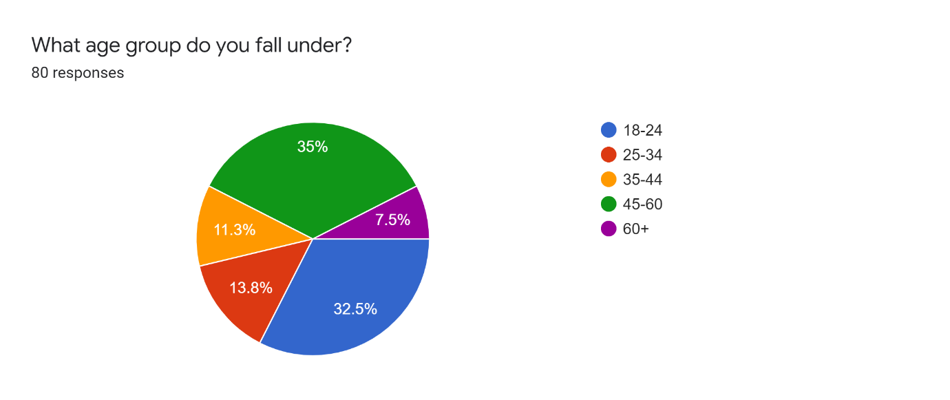
- Q.2
Figure 4.2 Pie chart of question 2 results
The survey's second question was a multiple-choice question that was intended to determine the demographics of the participants by asking how old they were. When it came to determining the age range of the participants, there was a wide variety of ages, making the results credible and fair. The majority, 35%, were between the ages of 45 and 60, and just under with 32.5% were between the ages of 18 and 24. There were similar percentages of participants that were aged between 25-34 and 35-44 which overall totalled a quarter of the pie chart. There was a very small percentage of participants which fell under the 60+ bracket, elder generation may not have access to internet sources which could explain that there was only 7.5%. Having a range of participants aged from 18 to 60+, benefited the research. Collecting answers from participants with different life experiences showed a difference in behaviour and opinion on the topic of the prison system.

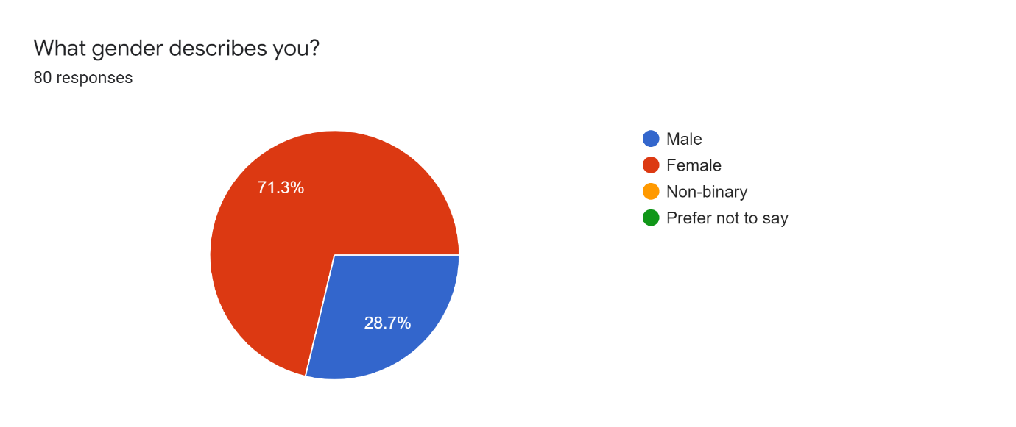
- Q.3
Figure 4.3: Pie Chart of question 3 results
The third question intended to determine the respondent's gender identity, 71.3% of respondents were female and 28.7% were male. Other genders, such as non-binary, were a possibility, but no participants fell into this category. The survey also included an option for "other," although again, no respondents fell into this category. Gender survey questions are delicate in nature, but they may help the researcher evaluate their data in their surveys more precisely. With the majority of participants being female, this could raise a concern in limitations, however this cannot be helped as the questionnaire was voluntary.

- Q.4
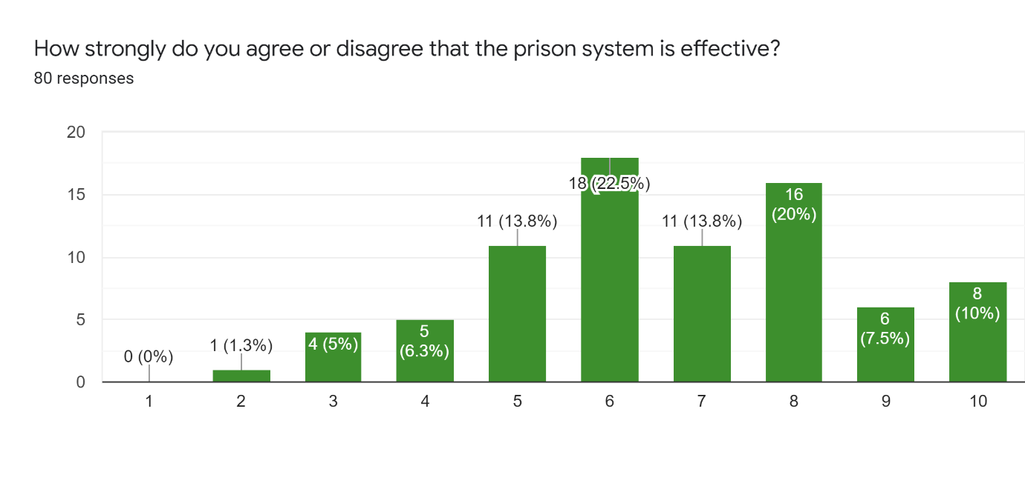
Figure 4.4 bar chart of results for question 4
This question was scaled from 1 to 10, one being strongly agreeing and ten being strongly disagreeing on whether the prison system is effective. As you can see from the bar chart the bars slightly raise between the numbers 5 and 8. A fair few of the 80 respondents replied negatively to this statement with 18 participants selecting the number 6 and 16 participants selecting 8. The results show that individuals are dissatisfied with the system and do not believe it is working. This question was interesting to compare and contrast to objective 3 in the literature review, as Self (2011) also had negative sources stating that “prison does not work for the majority of inmates”.

- Q.5
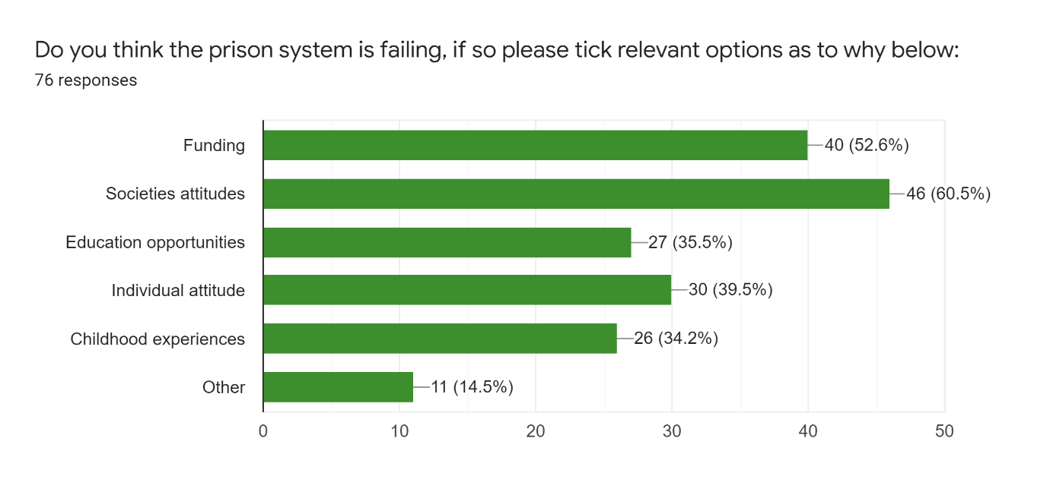

Figure 4.5: Bar chart of results for question 5
The results from question 5 correlate with earlier results in objective 2 which showed the expense of prisoners being sent to prison and reoffending ex-convicts costing the economy billions (Prison Reform Trust, 2013) which is a large reason as to why the prison system is failing. Objective 3 indicated rehabilitation programmes are an expensive considering reoffending rates are higher than rehabilitated prisoners (Charles, 2021) which is another reason as to why the system is unsuccessful. Here in this bar chart, there were a total of 76 responses. 60.5% of participants believe that social attitudes are the cause of failure in the penal system. Closely with just over 50% participants agreed with results found in the literature review stating that funding is lacking resulting the failing of prisons systems. Education opportunities, Individual attitudes and childhood experiences are all within the 30-40% showing that the participants have a strong say and belief that the failure is caused by the childhood experience the prisoners have. When the experience of a child’s upbring is traumatic it can tend to cause the individual to be a criminal, which can link with the lack of educational opportunities and the negative attitude (Boppre and Boyer, 2019). Eleven percent of respondents selected “other”.

- Q.6
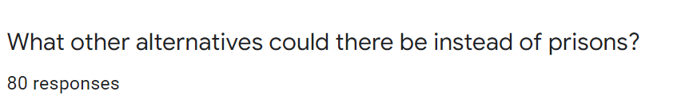

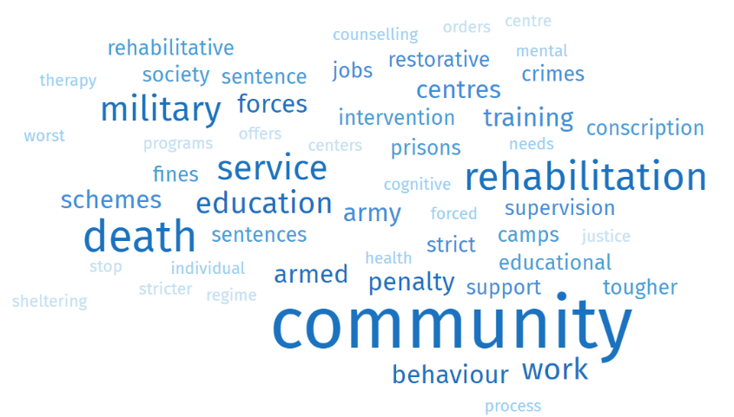

Figure 4.6: World Cloud Presenting Most Frequent Words and Phrases from question 6

Question 6 allowed those who selected “other” in question 5 to expand on what alternatives there could be instead of prisons. This question allowed the researcher to have an insight of the public’s thoughts and the ideas they had on this topic. Many answers had the words rehabilitation, death penalty and community service.
Rehabilitation- Some of the participants had a positive outlook to rehabilitation, they stated in their answers that rehabilitation schemes should be designed in categories of different crimes and to concentrate more so on controlling individuals’ behaviour. Compared to the results found in the literature review Logan and Gaes (1993) believes that “any one technique of treatment is significantly and dependably successful”. These two results have different views of how rehabilitation can be an alternative to prisons.
Death Penalty- Many of the participants were all for introducing the return of the death penalty. However, only for serious crime such as “Paedophilia and murder”.
Community- Majority of answers included the word “community” all relating to criminals having to work for society in local communities. This alternative was an option that participants felt that less serious crimes such as “Assault and drink driving”.

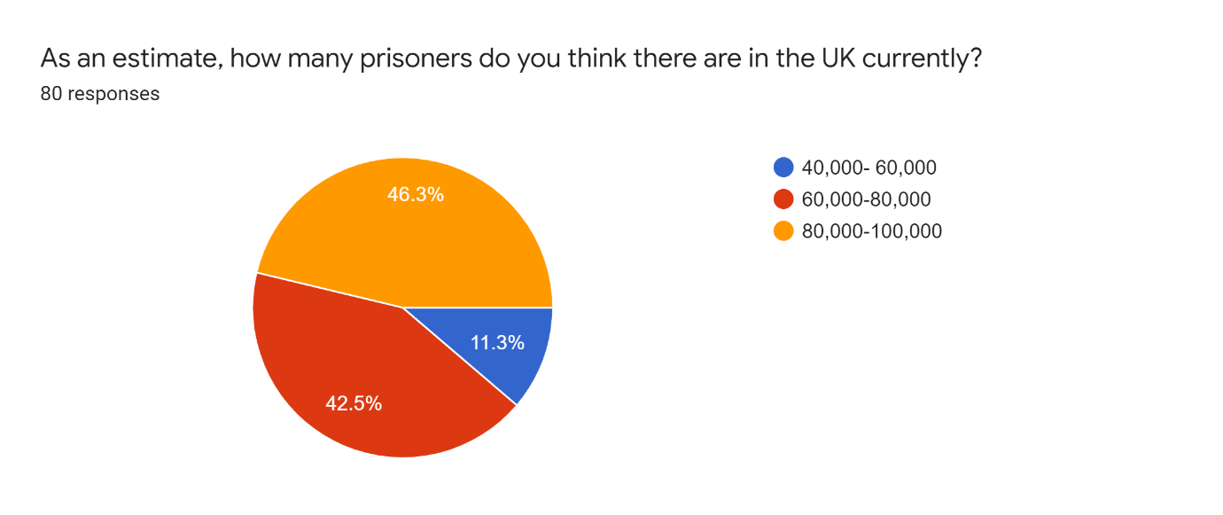
- Q.7
Figure 4.7: Pie chart of results for question 7
Question 7 correlates with earlier results from objective 1 in the literature review, which states an updated statistic of how many prisoners in total there currently are in the UK (Ministry of Justice, 2022). The Pie charts shows that all 80 participants responded to this question. Close to half of participants also relate with the results given earlier on in the research with 46.3% of participants selecting 80,000-100,000 as the estimated number of prisoners in the UK and 42.5% selected 60,000-80,000.

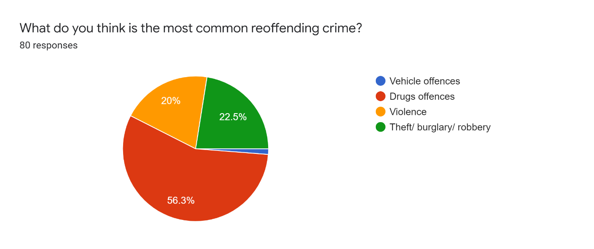
- Q.8

Figure 4.8: Pie Chart of results from question 8

Question 8 concentrates on the research from objective 2, continuing with the theme of re-offending. From the results, we can see that over half of participants with 56.3% selected that in their opinion drug offences were the most common re-offending crime. It would make sense as to why majority of respondents selected drugs as for may it can be an addiction problem. However, figures from Ministry of justice (2022) state that violence is the most common offence.

- Q.9
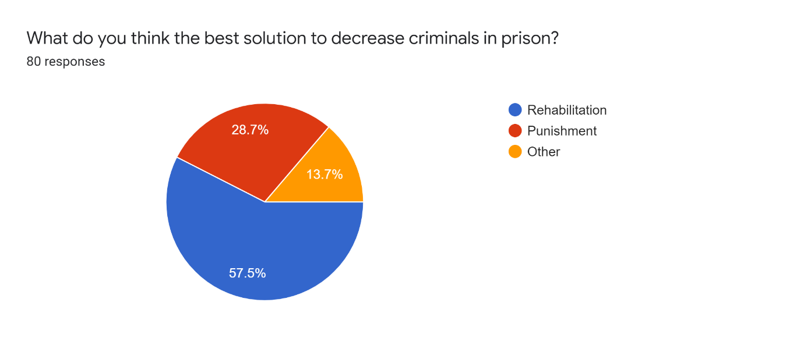

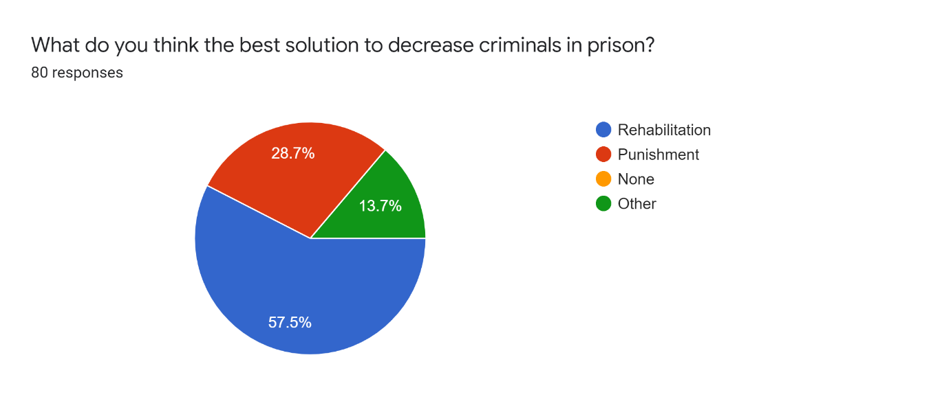

Figure 4.9: Pie Chart of results for question 9
Question 9 presented the participants with a controversial question of whether they believe rehabilitation or punishment can decrease the number of prisoners in the UK. From the results it is apparent that the strong majority do believe that rehabilitation is the solution to decrease criminals, with over half 57.5% of participants selecting rehabilitation. In contrast, the study in objective 3 had sources from University of Oxford (2013) which also believed that rehabilitation programmes have many benefits to prisoners. However, other sources such as Self (2011) are against rehabilitation and side more with punishment. This tells us that there are mixed views on this debate. The option of “none” was also available and 13.7% of respondents fell under this section. Which indicates that these participants do not agree with either punishment or rehabilitation as a solution to decreasing the number of criminals in the UK.

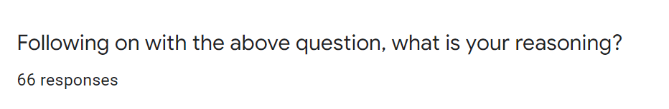
- Q.10

Punishment | Rehabilitation | None
- Individuals don’t feel fear  - Murderers should have their lives taken from them  - Prison is too easy, punishing needs to be harsher  - White room torture helps reset the mindset  - Severe consequences must be put in place  - Criminals should be scared of prison  - Prison is too safe  - Prison shouldn’t be a place to avoid | - With improvements it can impact their behaviour and attitudes  - Helps prepare for society and better life choices  - Opens a different way of life  - Will benefit those with drug addictions and mental health problems if rehab concentrates more on these issues  - Most criminals need help as never had support  - Can change the psychology of criminals  - Will look at the root of offending  - Offers opportunities in life | - Education schemes to gain qualifications should be available  - Prevent rather then cure  - Prison is the right solution  - The cycle of reoffending will never be broken  - Prisons make criminals worse off- mixing with other criminals which influence them  - The cycle is too strong

The final question asks participants to elaborate on their reasoning to question 9 as to why they selected rehabilitation, punishment or neither as their answer. Above are some examples of the participants reasoning as to why they fell under each category. As you can see, those who fell under punishment, common answers which related to punishment is that prison is currently “too easy” and therefore the punishment needs to be tougher. Those who agreed with rehabilitation is the greatest solution for decreasing criminals believe that reform can encourage the behaviour and attitudes of individuals which can open positive opportunities for when they are released. However, many answers mention that improvements and better developed rehabilitation schemes need to be made. Finally, those who did not believe that either rehabilitation or punishment is a means of reducing criminals state that the reoffending cycle will “never be broken”.

4.5 Conclusion

This chapter achieved all three objectives:
“Explore the size and capacity within UK prisons”
“How many reoffenders are imprisoned and what for?”
“Is there evidence to show the system works?”

An analysis of the questionnaire was compared to previous findings in the literature review. The following chapter will summarise all chapters and will provide recommendations, which the Police could use to have a better understanding as to why the prison system is failing and possibly provide ways to develop services to stop prisoners from re-offending.

Chapter 5 Conclusion

There is much to conclude from this dissertation, views differ greatly in relation to some of the objectives. However, the general overview of the prisons system is failure.
Objective 1: “Explore the size and capacity within UK prisons”
Following research into the size and capacity of UK prisons. It is clear that many prisons are extremely close to their maximum capacity, however are within reason of living standard regulations. Coincidentally the majority of the public’s estimations on prison population were correct to latest statistics.

Objective 2: “How many reoffenders are imprisoned and why?”
Reoffending is a major concern within the criminal justice system as present measures and stratergies do not seem to be working. Too many criminals resort back to life of crime following release. Statistics from reliable sources gathered and shown in the literature review state that robbery and burglarly are the most common offences re commited. The survey’s results showed that the publics opinion on recurring crimes are drug related. This tells the researcher that these views agree that reoffending is major issue that needs solving. However, views differ when it comes to “why” criminals are re commiting as they have different opinions of most common offences.

Objective 3: “Is there evidence to show the system works? “
Evidentially in both research methods, the literature review and questionnaire mutually have a negative opinion of the prison system. Although, the literature review analysed the benefits of rehabilitation and the majority of views within the questionnaire agreed that rehabilitation is the best solution to better an individuals life. The literature review also give negative reasons of how rehabilitation in prisons is clearly not working as the reoffending rates have decreased over the last few years. The opinions of both also stated that the rehabilitation is not as effective as it could be. Therefore telling the researcher that the prison system is failing and more deveplopment into rehabilitation needs to be put in place to help solve reoffending rates.

5.1 Recommendations

The following suggestions have been made following the completion of this dissertation:
- Future study should involve a wider sample size with equal numbers of men and women of each gender and age group for the findings to be generalised.

- It is also recommended that research of the reoffending cycle to be researched closely, this will allow a good insight as to why prions systems are not working.

- Finally, the researcher also suggests for the funding for extra support for majority of prisoners who is in need for basic statements such as (ID, bank account, home) so that they are more likely to be employed, resulting in less reoffending rates.

References

Allen, G., Audickas, L. and Watson, C. (2017) Prisons Statistics, England and Wales. Available at: https://researchbriefings.files.parliament.uk/documents/CBP-8161/CBP-8161.pdf [Accessed 16th March 2022].
Beard, J. (2021) ‘The prison estate’, House of Commons Library, 8th October. Available at: https://researchbriefings.files.parliament.uk/documents/SN05646/SN05646.pdf [Accessed 16th March 2022].
Belli, E. (2022) ‘Prison: Locking up women does not work, charity warns’, BBC NEWS, 3rd April. Available at: https://www.bbc.co.uk/news/uk-wales-60959611#:~:text=There%20are%20no%20female%20prisons%20in%20Wales%20so,risk%20of%20losing%20their%20home%2C%20said%20Mr%20Borja. [Accessed 5th April 2022].
Boppre, B., Boyer, C. (2019). ‘The Traps Started During My Childhood: The Role of Substance Abuse in Women's Responses to Adverse Childhood Experiences (ACEs)’, Journal of Aggression, Maltreament and Trauma, 1 (22). http://dx.doi.org/10.1080/10926771.2019.1651808
Charles, A. (2021) ‘Is prison an effective form of punishment’, The University of Law, 11th April. Available at: https://www.law.ac.uk/resources/blog/is-prison-effective/ [Accessed 14th April 2022].
Clean Break (2022) There are no women’s prisons in Wales. What does this mean for Welsh women? Available at: https://www.cleanbreak.org.uk/news/blog-womens-prisons-wales/ [Accessed 5th April 2022].
Crime Prosecution Service (2017) Sexual Offence. Available at: https://www.cps.gov.uk/crime-info/sexual-offences [Accessed 7th April 2022].
Crime Prosecution Service (2021) Drug Offences. Available at: https://www.cps.gov.uk/legal-guidance/drug-offences [Accessed 8th April 2022].
Criminal Justice Alliance (2016) WOMEN IN PRISON IN ENGLAND & WALES. Available at: https://www.criminaljusticealliance.org/wp-content/uploads/Women-in-Prison-in-EW-Factsheet.pdf [Accessed 5th April 2022].
Eurostat (2021) Prison population. Available at: https://ec.europa.eu/eurostat/databrowser/view/crim_pris_pop/default/line?lang=en [Accessed 16th March 2022].
Flatley, J. (2017) ‘Overview of robbery and theft from the person: England and Wales’, Office for National Statistics, 20th July. Available at: https://www.ons.gov.uk/peoplepopulationandcommunity/crimeandjustice/articles/overviewofrobberyandtheftfromtheperson/2017-07-20 [Accessed 8th April 2022].
Garside, R. (2008) ‘The purpose of the criminal justice system’, Centre for Crime and Justice Studies, 17th March. Available at: https://www.crimeandjustice.org.uk/resources/purpose-criminal-justice-system [Accessed 12th April 2022].
Gillham, B. (2000). Developing a Questionnaire. 2nd Edition. London: Real world Research.
Grimwood, G, G. (2015) Categorisation of prisoners in the UK. Available at: https://researchbriefings.files.parliament.uk/documents/CBP-7437/CBP-7437.pdf [Accessed 15th March 2022].
Heffernan, R. and Ward, T. (2019) The Good Lives Model and the Rehabilitation of Individuals Convicted of Sexual Offending. New Zealand: School of Psychology
House of Commons (2019) Prison population 2022: planning for the future. Available at: https://publications.parliament.uk/pa/cm201719/cmselect/cmjust/483/483.pdf [Accessed 16th March 2022].
Jewkes, Y. (2007) Women in Prison. USA and Canada: Willian Publishing.
Logan, C, H and Gaes, G.G (1993) ‘META-ANALYSIS AND THE REHABILITATION OF PUNISHMENT’, JUSTICE QUARTERLY, 10 (2), pp. 1-13.
Melnikovas, A. (2018) ‘Towards an Explicit Research Methodology: Adapting Research Onion Model for Futures Studies’, Journal of Futures Studies, 23 (2), pp.29-44. DOI:10.6531/JFS.201812_23(2).0003
Ministry of Justice (2010a) Breaking the Cycle: Effective Punishment, Rehabilitation and Sentencing of Offenders. Available at: https://assets.publishing.service.gov.uk/government/uploads/system/uploads/attachment_data/file/185936/breaking-the-cycle.pdf [Accessed 8th April 2022].
Ministry of Justice (2010b) Breaking the Cycle: Effective Punishment, Rehabilitation and Sentencing of Offenders. Available at: https://assets.publishing.service.gov.uk/government/uploads/system/uploads/attachment_data/file/185936/breaking-the-cycle.pdf [Accessed 8th April 2022].
Ministry of Justice (2013) The factors associated with proven re-offending following release from prison: findings from Waves 1 to 3 of SPCR. Available at: https://assets.publishing.service.gov.uk/government/uploads/system/uploads/attachment_data/file/491119/re-offending-release-waves-1-3-spcr-findings.pdf [Accessed 4th April 2022].
Ministry of Justice (2022) National statistics Offender management statistics quarterly: July to September 2021. Available at: https://www.gov.uk/government/statistics/offender-management-statistics-quarterly-july-to-september-2021/offender-management-statistics-quarterly-july-to-september-2021 [Accessed 16th March 2022].
Ministry of Justice (2022) Prison Data. Available at: https://data.justice.gov.uk/prisons [Accessed 7th April 2022].
Ministry of Justice (2022) Proven reoffending statistics: January to March 2020. Available at: https://www.gov.uk/government/statistics/proven-reoffending-statistics-january-to-march-2020/proven-reoffending-statistics-january-to-march-2020 [accessed 22nd March 2022].
Ministry of Justice (2022) Working in the Prison and Probation service. Available at: https://prisonjobs.blog.gov.uk/your-a-d-guide-on-prison-categories/ [Accessed 10th March 2022].
Ministry of Justice and Prison Reform Trust (2008) Prisoners Information Book. London: Prison reform Trust
Ministry of Justice, HM Prison Service and Her Majesty’s Prison and Probation Service (2020) Prison population figures: 2020. Available at: https://www.gov.uk/government/statistics/prison-population-figures-2020 [Accessed 18th March 2022].
Nemoto, T. and Beglar, D, (2013) Developing Likert- Scale Questionnaires. Available at: jalt2013_001.pdf (jalt-publications.org) [Accessed 27th April 2022].
Oxplore (2022) Does prison work? Available at: https://oxplore.org/question-detail/does-prison-work#1746 [Accessed 21st April 2022].
Parliament (2021) Through the Gate and the new Resettlement model. Available at: https://publications.parliament.uk/pa/cm5801/cmselect/cmjust/285/28507.htm#:~:text=Through%20the%20Gate%20%28TTG%29%20resettlement%20services%20were%20introduced,support%20entry%20to%20education%2C%20training%20and%20employment.%E2%80%9D%20128 [Accessed 14th April 222].
Phair, D. and Warren, K. (2021) ‘Saunders’ Research Onion: Explained’, Grad Coach, January. Available at: https://gradcoach.com/saunders-research-onion/ [Accessed 25th April 2022].
Prison Guide (2021) Prisons UK – List of all UK Prisons. Available at: https://prisonguide.co.uk/prisons-uk/ [Accessed 16th March 2022].
Prison Reform Trust (2013) New prison app reveals major challenges to rehabilitating our penal system. Available at: http://www.prisonreformtrust.org.uk/PressPolicy/News/vw/1/ItemID/191?CMP=EMCSOCEML657 [Accessed 21st April 2022].
Prison Reform Trust (2019) Why focus on reducing women’s imprisonment? England and Wales Fact Sheet. Available at: http://www.prisonreformtrust.org.uk/Portals/0/Why%20Women%20England%20and%20Wales.pdf [Accessed 7th April 2022].
Raithatha, Y. (2017). Understanding the economic impact terrorism has on the destination decision making: Northern Irish tourists. Doctoral dissertation. Dublin Business School
Raynor, P, Robinson, G. (2005) Rehabilitation, Crime and Justice. Basingsoke: Palgrave Macmillian
Roberts, P. and Priest, H. (2006) ‘Reliability and validity in research’, Royal College of Nursing Publishing, 20 (44), pp. 44. DOI: https://go.gale.com/ps/i.do?id=GALE%7CA149022548&sid=googleScholar&v=2.1&it=r&linkaccess=abs&issn=00296570&p=HRCA&sw=w&userGroupName=anon%7Ef2e821ef
Sapouna, M., Bisset, C., Conlong, A.M., Matthews, B. (2015) What Works to Reduce Reoffending: A Summary of the Evidence. London: The Scottish Government
Saunders, M., Lewis, P. and Thornhill, A. (2009a) Research methods for business students. England: Pearson Education Limited.
Saunders, M., Lewis, P. and Thornhill, A. (2009b) Research methods for business students. England: Pearson Education Limited.
Saunders, M., Lewis, P., & Thornhill, A. (2016a). Research Methods for Business Students. 7th Edition. Nueva York: Pearson Education Limited.
Saunders, M., Lewis, P., & Thornhill, A. (2016b). Research Methods for Business Students. 7th Edition. Nueva York: Pearson Education Limited.
Self, W. (2011) ‘A Point of View: Prisons don't work’, BBC NEWS, 7th October. Available at: A Point of View: Prisons don't work - BBC News [Accessed 12th April 2022].
Sturge, G. (2021) ‘UK Prison Population Statistics’, House of Commons Library, 29th October. Available at: https://researchbriefings.files.parliament.uk/documents/SN04334/SN04334.pdf#:~:text=To%20put%20the%20prison%20population%20in%20context%2C%20it,and%2096%20per%20100%2C000%20in%20Northern%20Ireland%20%282018%2F19%29.5 [Accessed 16th March 2022].
Sturge, G. and Tunnicliffe, R. (2021) ‘UK Prison Population Statistics’, UK Parliament, 29th October. Available at: https://commonslibrary.parliament.uk/research-briefings/sn04334/#:~:text=1%2079%2C453%20in%20England%20and%20Wales%2C%202%207%2C004,Ireland%20%28these%20at%20the%20end%20of%20June%202019%29. [Accessed 18th March 2022].
The Howard League (2007) The Principles and Limits of the Penal System. Available at: https://howardleague.org/wp-content/uploads/2016/04/The-Principles-and-Limits-of-the-Penal-System.pdf [Accessed 21st April].
Theft Act 1968, c.60. Available at: Theft Act 1968 (legislation.gov.uk) [Accessed 13th April 2022].
UK Research and Innovation (2022) Breaking the Cycle? Prison Visitation and Recidivism in the UK. Available at: https://gtr.ukri.org/projects?ref=ES%2FK002023%2F1#:~:text=Reoffending%20or%20recidivism%20is%20key%20to%20the%20operation,release%2C%20and%2039.3%25%20within%20the%20first%20twelve%20months. [Accessed 22nd March 2022].
University of Glasgow and the Scottish Centre for Crime & Justice Research (2022) What is Prison for? Available at: http://www.sccjr.ac.uk/wp-content/uploads/2015/10/SCCJR-What-is-prison-for-.pdf [Accessed 21st April 2022].
University of Oxford (2013) Prisoners doing yoga may see psychological benefits. Available at: https://www.psy.ox.ac.uk/news/prisoners-doing-yoga-may-see-psychological-benefits [Accessed 21st April 2022].
Vinten, G. (1995), ‘Open versus closed questions – an open issue’, Management Decision, 33 (4), pp. 27-31. DOI: https://doi.org/10.1108/00251749510084653
Vizcarguenaga-Aguirre, I., and López-Robles, J.R. (2020) Mono, mixed or multiple strategy approach: a descriptive study of the latest published articles in the International Journal of Project Management. 3rd International Conference on Research and Education in Project Management: REPM 2020
Ward, T. and Langlands, R. (2009) ‘Repairing the rupture: Restorative justice and the rehabilitation of offenders’, Aggression and Violent Behaviour, 14, pp. 205-214.
Webster, R. (2016) ‘8/10 Women Prisoners Have Committed a Non-Violent Offence’, Russel Webster, 12th March. Available at: https://www.russellwebster.com/810-women-prisoners-have-committed-a-non-violent-offence/ [Accessed 7th April 2022].
Wright, E. (2017) ‘Overview of violent crime and sexual offences’, Office for National Statistics, 9th February. Available at: https://www.ons.gov.uk/peoplepopulationandcommunity/crimeandjustice/compendium/focusonviolentcrimeandsexualoffences/yearendingmarch2016/overviewofviolentcrimeandsexualoffences [Accessed 7th April 2022].
Wright, J. (2014) Transforming Rehabilitation: a summary of evidence on reducing reoffending. Available at: *Transforming Rehabilitation: a summary of evidence on reducing reoffending (second edition) (publishing.service.gov.uk) [Accessed 13th April 2022].
Zamble, E. and Porporino, F. (1990) ‘Coping, imprisonment, and rehabilitation: Some data and their implications’, Criminal Justice and Behaviour, 17(1), pp.53-70.

