University of Wales Trinity Saint David
Wales Institute of Science and Art


Engineering Management
Project Planning
ACHA5012

Scott Holden
2200027
November 20234
Contents
1 Introduction 1
1.1 Aims 1
1.2 Objectives 1
2 Team roles and responsibilities 2
2.1 Identification of skills and personality traits 3
2.2 ‘Belbin’s’ Model 4
3 Group tasks 5
4 Individual tasks 7
5 Significant milestones 8
5.1 Gateway Objectives 8
5.2 Risk management 8
6 Project summary 9
6.1 Individual project plan 9
7 References 10

Table 1 shows the team roles and responsibilities as decided within the group. 2
Table 2 shows the positive and negative personality traits and skills for Belbin's Plant. 3
Figure 1 shows the 9 roles that Belbin's model has described. 5
Table 3 shows the tasks generated by the group with all the associated timings. 7
Figure 2 shows a flow chart of completing SIT or System integration testing. 9
Figure 3 shows the groups agreed upon Gantt chart. 10

Introduction
This report is to detail the group and individual plans for the Level 5 group design project, within this report sections detail the group and individual aims that the group intends to meet. The project that has been set for the group is to design an ‘Active Aero Wing’ for the Universities’ Morgan plus 4. Within the project, each member has chosen an area of engineering that they would like to study further. This includes areas such as Mechatronics, Simulation and Team management.

Aims
- The aim of this report is to give the reader an understanding of the group’s cohesion and the planning doctrine we have utilised. Detailing the individual personality traits within said group.
- This report aims to give an insight into my individual section of planning the group project.

Objectives
- The reader should be able to gather an image of the planning techniques used within our group and as an individual to determine the efficacy of our strategies
- The reader should be able to recognise the personality trait associated with my section of the group project.

Team roles and responsibilities
Table 1 shows the team roles and responsibilities as decided within the group.
Names | Roles | Responsibilities
Nathan Evans | Aerodynamics Development | Aerodynamics Development | • Learn ANSYS software to test the Morgan Plus Four.  Provide data on a baseline run of the Morgan Plus Four.  • Design a rear wing using research and theoretical knowledge.  Producing a CAD model of the Final Design to all departments.  • Test iterations/final design of the rear wing in the wind tunnel to ensure CFD is correct  • Working with Manufacturing/ prototype department to produce the final concept to test in the wind tunnel  • Using the wind tunnel test the wing profile and gather data.  • Deliver accurate data to all departments regarding the performance of the rear wing.
Oliver Wilson | Aerodynamics Development | Aerodynamics Development
Alexander Cook | Project management | Project management | • Managing the project, ensuring all group members are comfortable with their tasks.  • Produce a Gantt chart.  • Ensuring group moral is always at consistent level.  • Risk Management – identify potential risks to the project’s success and provide solutions to mitigate.  • Consider Costs.
Alexander Cook | Manufacturing | Project management | • Manage CAD Files of the rear wing and mounting brackets etc.  • Produce multiple prototypes for the testing in the wind tunnel.  • Produce the final concept assembled.
Mathew Starke | Structural and Materials | Structural and Materials | • Conduct research into materials that can potentially be used to produce the rear wing.  • Produce a mounting solution for the rear wing to the chassis of the Morgan.  • Learn FEA procedures to carry out tests on designs.  • Analyse the rear wing design using FEA. Locate regions of weakness in the design of the rear wing and mounting solutions.  • Research into methods to increase any areas of weakness and then apply to design.
Conor Jenkins | Structural and Materials | Structural and Materials
Alexander White | Control Systems and Mechatronics | Control Systems and Mechatronics | • Communicate with all departments to ensure that the mechatronics can be implemented into the design without any major reconstruction of the concept.  • Research into the provided mechatronics and decide which is most suitable.  • Produce code and circuit allowing for the rear wing to perform outputs.
Scott Holden | Vehicle Dynamics | Vehicle Dynamics | Determine sufficient electrical systems to differentiate data from sensors. Create electrical filters, for correct mechatronic movement from data collected. Research electrical equipment provided to us. Test chosen equipment for compatibility against our chosen design.
Scott Holden | Control Systems and Mechatronics | Vehicle Dynamics
Dylan Brierley | Vehicle Dynamics | Vehicle Simulation | • Learn OptimumLap software.  • Use initial data on the Morgan and OptimumLap to do initial sim runs.  • Learn VIGrade software.  • Using the data produced by CFD, test the Morgan Plus Four performance using VIGrade software.  • Produce data on the performance of the vehicle. Use this data to produce code for the control system.  • Analyse data produced from the tests.

Identification of skills and personality traits
Table 2 shows the positive and negative personality traits and skills for Belbin's Plant.
Positive Traits | Negative Traits
Creativity, Innovative, Free-minded and an ability to problem solve | Disregarding or ignoring details in favour of the bigger picture, Inclination to ignore discussed team protocol and improbable communication.

As can be seen from the table above, the ‘Plant’ has really useful skills but some negative traits that can be detrimental to the team’s success. The plant can be regarded as an essential to a strong team due to their ability to problem solve. (Bednár, et al., 2020) The plants are usually best utilised with the use of a co-ordinator as it allows them to stay on track with the groups project and allow them to communicate their thoughts effectively as communication is unlikely to happen from the plant themselves.

‘Belbin’s’ Model
Dr R Belbin developed this model in order to give students on management courses an insight and a method of assessing their individual contribution in teams, this model consists of going through sections and scoring the comments within the section with all the points giving within said section equalling 10 ‘points’ for example
Section I
WHAT I BELIEVE I CAN CONTRIBUTE TO A TEAM
- I think I can quickly see and take advantage of new opportunities – 1
- I can work well with a very wide range of people – 0
- Producing ideas is one of my natural assets – 3
- My ability rests in being able to draw people out whenever I detect they have something of value to contribute to group objectives – 1
- My capacity to follow through has much to do with my personal effectiveness – 1
- I am ready to face temporary unpopularity if it leads to worthwhile results in the end – 3
- I can usually sense what is realistic and likely to work – 0
- I can offer a reasoned case for alternative courses of action without introducing bias or prejudice – 1
Sandford, M. (2024) Self Perception Inventory. [Engineering Management, ACHA5012] UWTSD October 2024
The section above is an extract from the handout given to us during a lecture so that we could determine our contribution into teams. Once all the sections are completed in the same way as the one above, all the marks can be tallied up and then compared against the matrix at the end. With each individual scoring each comment differently it allows people to get an accurate view of the kind of team player they are.

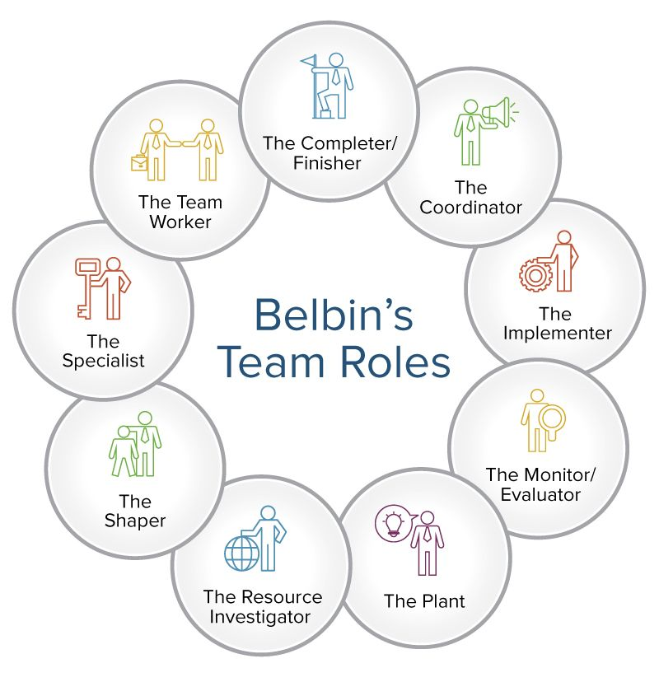
Belbin’s Model uses 9 archetypes (The tutor handout had been adjusted to give us 8) that the inventory will sort an individual into when the inventory has been completed, after completing the inventory, I was given the ‘Plant’ archetype. The plant denotes and inventive individual with the ability to be creative and develop new ideas and give suggestions, Belbin also states that ‘Plants’ are best managed by a co-ordinator as they can keep the individual’s ideas in line with the group’s needs, and that although they can provide imaginative and original ideas, they can also cause disruption. This can be attributed to their original ideas; these can be seen as radical and lacking in practicality. (Belbin, 2024)
Figure 1 shows the 9 roles that Belbin's model has described.

Group tasks
The tasks have been divided into 6 different sections; these are as follows:
Project management: The includes overseeing the entirety of the project and co-ordinating the members of the group and assisting group tasks where it is needed. Ensuring group cohesion is imperative to the team’s success; with the project manager ensuring group morale is consistent and identifying potential risks to the team’s progress. The project manager will also have to consider costs on a larger scale compared to the individual costs calculated by each team member. Producing Gantt charts and mitigating wasted time is again imperative to the general success of the team’s project.
Aerodynamics Development: The Aero development consists of learning different types of software in order to provide a baseline of data for the Morgan Plus 4, designing the rear wing using research, theoretical knowledge and simulation data given. A major task within the Aerodynamics development is producing iterations of the rear wing design and distributing them to all the correct departments, this includes using the wind tunnel to test chosen wing profiles to gather data that can then be relayed back to the team. Once these tasks have been done, the data gathered on the performance of the wing can them be given to manufacturing to produce a final concept/prototype.
Structural and Materials: A major part of this department’s task include researching materials that can potentially be used and implemented into a wing design and producing a mounting solution. Learning FEA (Finite Element Analysis) is crucial as it will allow the department to view areas of weakness within the design concept and more accurately design a suitable solution to the task set for the group. Once the areas of weakness have been identified, practical solutions can then be applied into the structural design of the mounts and the wing concept itself.
Control Systems and Mechatronics: This department will be responsible for conducting research into sufficient electrical systems that will control the actuation points for the rear wing, communication to the other departments is critical as the chosen mechatronics need to be implemented without impeding the chosen structural design concepts. Research into Simulink and Matlab will enable the department to create sufficient code in order to control the design based off an initial singular input from a sensor. Creating a working prototype of the electrical system and actuators using an Arduino board are critical for the performance of this department. Once a sufficient system has been developed, it can then be adjusted to regulate input from multiple sensors and allow the wing to be activated at multiple points with the data gathered from the sensors around the car (A brake pressure sensor would allow the wing to go vertical as an air brake for example).
Vehicle Dynamics: This department is primarily simulation based, using the OptimumLap software to do initial simulation runs with the Morgan Plus 4, once this baseline data has been analysed it can then be used to produce the performance data of the vehicle on the given tracks that have been simulated.

Table 3 shows the tasks generated by the group with all the associated timings.
Group Tasks | Duration  (Hours) | Start Date | Finish Date
Allocating roles and responsibilities to each group member. | 3 | 30/09/2024 | 14/10/2024
Consolidate a communication platform to ensure all information associated with the project is conveyed accurately. | 3 | 30/09/2024 | 4/10/2024
Familiarising the group with the regulations associated with the project. | 4 | 7/10/2024 | 21/10/2024
Begin the initiation phase of the project. Using initial ideas begin producing a plan for different wing concepts and mounting solutions. | 8 | 21/10/2024 | 25/10/2024
All departments begin listing tasks involved with each specific role that need to be completed throughout the project. | 8 | 28/10/24 | 4/11/2024
Software related to each role (i.e. FEA, VI Grade and ANSYS). Begin the initiation process by generating ideas for each role. | 8-15 | 14/10/2024 | 4/11/2024-18/11/2024
Reconvene and discuss work and ideas completed by each department. Ensure that all ideas are considered. Summarise and discuss further the route/idea the group wants to develop towards. | 8 | 18/11/2024 | 22/11/2024
Each department produces work to be organised into a presentation for the interim VIVA. | 20 | 25/11/2024 | 10/12/2024
Evaluate and review all work completed prior to assignment and VIVA submission. | 20 | 10/03/2025 | 28/03/2025
Pre-presentation meetings to ensure all aspects of the project are understood before the final VIVA and all departments have work presented. | 20 | 17/03/2025 | 30/03/2025

Individual tasks
For my contribution to the group project, I have chosen to study further into electronics and mechatronics. This specialism will revolve around determining sufficient electrical systems to read the data given from multiple sensors, a user interface and a working prototype of an actuation systems.
Task | Time Duration | Time (Opt) | Time (Pes) | Start Date | Ideal End Date | Bill Of Materials
Gain an understanding of Matlab and Simulink software that can be used to control the electrical and mechatronic system | 32 | 28 | 29 | 07/10/24 | 04/11/24 | Matlab + Simulink software - £800
 | 28
 | 25
Research into appropriate Mechatronics and confirm the most suitable | 40 | 36 | 37 | 14/10/24 | 18/11/24 | Laptop - £750
 | 36
 | 32
Produce Initial VIVA presentation section | 10 | 7 | 8 | 07/10/24 | 06/12/24 | Microsoft 365 License - £60
Produce Initial VIVA presentation section | 7
Produce Initial VIVA presentation section | 5
Research Electrical filters to minimise unnecessary noise and irrelevant data | 15 | 12 | 13 | 14/10/24 | 28/10/24
 | 12
 | 10
Develop initial code to move actuators based off one data input | 20 | 17 | 18 | 14/10/24 | 04/11/24
 | 17
 | 15
Create initial electrical circuits using the Arduino boards and potentiometers | 25 | 20 | 21 | 21/10/24 | 11/11/24 | Arduino Uno - £30 Solderless Breadboard £250
 | 20
 | 15
Complete Matlab and Simulink onramp sessions | 22 | 15 | 16 | 07/10/24 | 21/11/24
Complete Matlab and Simulink onramp sessions | 15
Complete Matlab and Simulink onramp sessions | 8
Develop Electrical filters | 18 | 13 | 14 | 28/10/24 | 11/11/24
Develop Electrical filters | 13
Develop Electrical filters | 10
Research PWM at variable voltages and develop an understanding of the associated uses | 8 | 6 | 7 | 28/10/24 | 04/11/24
 | 6
 | 5
Develop a solid understanding of how an Arduino can be controlled by Simulink | 25 | 22 | 23 | 04/11/24 | 25/11/24
 | 22
 | 20
Implement Mechatronics and control systems into the prototype and complete systems integration testing | 30 | 28 | 28 | 27/01/25 | 24/02/25 | Linear Actuators - £200 Electrical consumables (Wiring, Hand tools) - £100
 | 28
 | 26
Table 4 shows the personal chosen tasks.

Significant milestones
An example of a significant milestone would be ‘System Integration Testing’ (SIT). This is a process of validating the compatibility of all the systems chosen components. For the electronics and mechatronics, it would integrate the final code and electrical circuits to the prototype wing. This would be classed as a crucial gateway of our project as it can introduce unforeseen issues into the project that will need to be rectified in order to produce a successful product. The earlier that SIT can be implemented ensures that I can mitigate identified risks and ensure end to end functions.
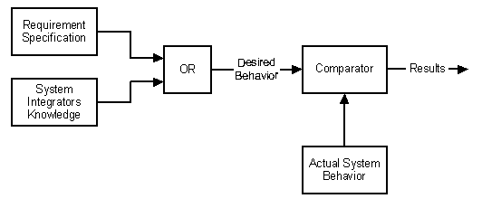
Figure 3 shows a flow chart of completing SIT or System integration testing.

Gateway Objectives
Gateway objectives are objectives that must be met in order to move forward with the project, for example my gateway objective is confirming that the code and electrical systems will be able to move an actuator using sufficient telemetry data from a single input. Once movement from a single sensor has been certified, multiple sensors can then be used allowing the wing to be relocated depending on the aerodynamics needed. This could be pushing the wing vertical to use as an air brake to slow down the vehicle; the data needed for this actuation could be acquired from a brake pedal position sensor. Without getting the system to be effective using a single data input, it would be impossible to get the system to use multiple data inputs. With this gateway objective, a strict criterion of success is going to be used, whether the system is able to move an actuator as data is input from a sensor or not; using an absolute value for this is ideal as it is clear and presentable to the rest of the group.

Risk management
Risk management within the group is crucial due to the nature of the task se, even more so the risks posed by the development of the electrical systems, some risks identified for my section of the group are detailed below.

Control system errors
Errors in the initial prototype stages can be identified and rectified by running multiple iterations of the code to ensure the control system works under varying conditions, this can be achieved by running multiple data sets to ensure the control system and actuators are running effectively. To mitigate the risks posed, essential bug finding within the code is essential, with multiple runs with the code at every stage of development ensures that the code will be sufficient for the group’s designs.

Electrical dangers
Due to the hazards associated with electricity sufficient weatherproofing of the control systems will be required to mitigate risk to the operator and the design itself. As electricity can generate heat, a fire hazard can become a huge risk to the final product and for the consumers post development, because of this, efficient heat sinks and cooling will be required to ensure the electrical control systems and mechatronics used do not pose a risk. Ways of mitigating this risk can include sufficient heat sinks as mentioned above, fire resistant covering used for any electrical cabling and weather proofing for the actuators.

Project summary
Figure 4 shows the groups agreed upon Gantt chart.

References
Bednár, R. et al., 2020. Belbin team roles in a start-up team. EDP Sciences, Volume 83, p. p.1002.
Belbin, 2024. The 9 Team Roles. [Online]
Available at: https://www.leadershipsolutions.co.nz/the-9-team-roles/
[Accessed 6 November 2024].
Sandford, M. (2024) Self Perception Inventory. [Engineering Management, ACHA5012] UWTSD October 2024

