LINA BIRMANTE
STUDENT NUMBER 2010698
MODULE LEADER TUSHARA BALENDRAN

Dissertation Proposal

THE IMPACT OF INTEGRATED MARKETING COMMUNICATION AND DIGITAL MARKETING ON THE FAST FOOD INDUSTRY OF THE UK
Table of Contents
Introduction 4
Research background 4
Rationale of the study 4
Problem of the research 5
Aim and objectives of the research 5
Aim 5
Objective 5
Questions of the research 6
Literature review 6
Concept of digital marketing in the fast-food industry 6
Critical review on the impact of digital marketing on the fast-food industry 6
Importance of market communication in digital marketing in the fast-food industry 7
Challenges faced by the organisations in the implementation of digital marketing communication 7
Recommendations or course of action for improving marketing communication 7
Theoretical framework 8
Digital marketing model implemented in fast food industries 8
Literature gap 9
Overview of research methodology 9
Research philosophy 9
Research design 10
Research approach 10
Data collection method 10
Sample size and sampling technique 10
Data analysis method 10
Timeline 10
Reference list 11

Introduction
An increasing number of restaurants, as well as hotels in the UK, has accelerated the growth of the fast-food industry. On the other hand, globalization is one of the important reasons behind the growth of the fast-food industry in the UK. The research proposal will focus on the background, aims, and objectives of the particular research about the impact of digital marketing on the fast-food industry of the UK.

Research background
As per recent information, the most popular fast-food chains in the UK are KFC, McDonald, Domino’s pizza, Subway, and others (Statista.com, 2021). Among these popular brands, most of them use digital marketing tools to communicate for business and marketing. Therefore, the utilisation of digital marketing has created a significant impact on the growth and profit of companies. Different fast food brands have a different strategies in marketing communication (Namin, 2017). For instance, KFC has adopted a strategy with swipeable marketing experiences for fast food consumers whereas Burgerfuel has started a quiz campaign for consumers to communicate with them (Nguyen et al. 2018). Thus, the research will focus on marketing communication as well as utilisation of digital marketing in the fast-food industry of the UK.
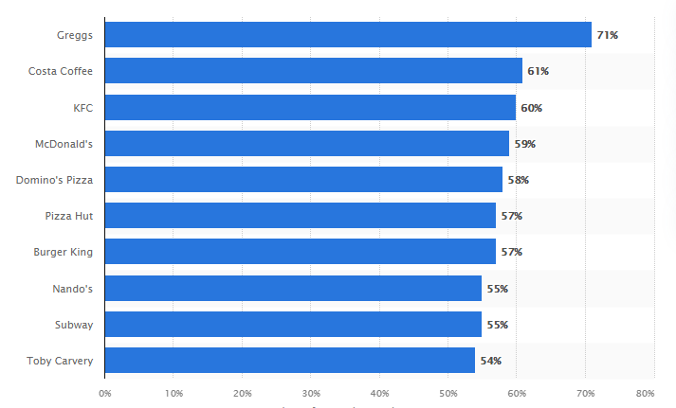
Figure 1: Fast food brands of UK
(Source: Statista.com, 2021)

Rationale of the study
In this era of social media most brands take digital marketing strategies for attracting consumers. The dramatic expansion of digital food marketing has been seen in the UK over a few years. The popularity of fast-food brands in the UK has expressed the utilization of digital marketing communication. According to Bala and Verma (2018), due to digital marketing, several small brands face challenges. Therefore, this research will address the issues and focus on the importance of using digital marketing.
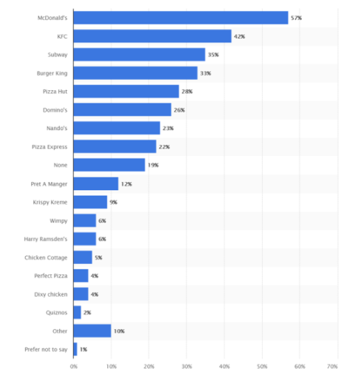
Figure 2: popularity of fast food brands in UK
(Source: Bhagat and Sambargi, 2019)

Problem of the research
Globalisation has created increased trends in using digital marketing. However, due to the trends of digital marketing small fast food business organizations are facing challenges as they are incapable of investing hugely in digital marketing. As opined by Bhagat and Sambargi (2019), without proper implementation of technology and investment businesses can face problems communicating with customers. Therefore, the research will also highlight the problems and issues of digital marketing that need to be encountered by business entities of the UK.

Aim and objectives of the research

Aim
The prime aim of the study is to conduct an in-depth analysis of the fast-food industry of the UK in terms of understanding the impact of marketing communication and digital marketing.

Objective
- To understand the impact of digital marketing on the fast-food industry of the UK
- To evaluate the importance of marketing communication and utilization of digital marketing in terms of accelerating growth of the fast-food industry
- To analyse the marketing communication issues that need to be encountered by the business entities of the fast-food industry of the UK.
- To recommend the course of action for improving marketing communication by utilizing digital technologies in the UK

Questions of the research
RQ1: What are the significant impacts of digital marketing and communication on the fast-food industry of the UK?
RQ 2: What is the importance of marketing communication as well as the utilization of digital marketing to accelerate the growth of the fast-food industry in the UK?
RQ 3: What are the issues that need to be encountered by the business entities of the fast-food industry?
RQ 4: what course of action is needed to improve marketing communication in the UK?

Literature review

Concept of digital marketing in the fast-food industry
Advertisement through digital media such as blogs, social media platforms, websites, or different search engines is referred to as digital marketing. In the current business scenario, going digital enhances the credibility of a brand (Minculete and Olar, 2018). Reaching the targeted audience in the fast-food industry is crucial to understanding the taste and preferences of the customers.
Marketing of fast foods has been currently done through diversified digital channels by sharing the images of foods to attract customers. For an example of Mcdonald's, the image of food has been shown on the Facebook wall of the customers when they pass through an outlet (Statista.com, 2021). It catches the attention of the customers to purchase from the store.

Critical review on the impact of digital marketing on the fast-food industry
Understanding the preferences of the customers has been crucial for organizations in the fast-food industry to deliver accordingly. As per the data of 2019, the number of active social media users has been 3.48 billion across the globe (Pai, 2021). Promotion of the food images through social media reaches a wide range of potential customers.
Repeated contents of a particular dish with eye-catching images trigger people to purchase from the particular brand (Ledikwe et al. 2020). It results in revenue generation positively. The Revolution of marketing through digital media has currently played a significant role in revenue generation through the online selling of fast foods.
In contrast, digital marketing creates issues in the presentation of foods with more attractive images which negatively impacts the customers. The difference between the perceived food and actual food creates dissatisfaction among the customers of different segments.

Importance of market communication in digital marketing in the fast-food industry
The idea of the manufacturer has been communicated through the marketing communication of a brand. Relationships with the customers have been a substantial factor sustained in the market in its current condition (Dearlove et al. 2021). Marketing communication became easier through diverse digital channels and it reaches a wide range of customers in a shorter while.
The creation of transparency of a brand is crucial which has been done effectively by social media. Social presence enhances market communication for fast food brands globally. Reaching the targeted audiences by a campaign requires professional marketing communication which has been done efficiently by digital marketing experts in the process.
Digital marketing has been utilized in different ways like influencer marketing, food blogs, and social media content creation (GC and Kirves, 2019). Influencer marketing refers to promoting the brand through local food influencers having more followers on social media. Swiping the food offers grabs the attention of the customers to complete a purchase.

Challenges faced by the organizations in the implementation of digital marketing communication
The key challenges that have been faced by the fast-food industry in digital marketing strategy are the "selection of content”, “customer-oriented market”, and “omnichannel marketing strategy". Engaging customers through the right content has been the biggest challenge for the fast-food industry (Bhojaraja, 2018). Competition among the brands has been a critical factor that creates a shortage of appropriate content to stay in the competition.
“Customer-oriented market” refers to the creation of approaches according to the expectation of the customers. As per the data, 66% of the customers have been dominated by the experience faced by them in communication with a particular brand (Statista.com, 2021). Carrying forward of the experience creates extra pressure on the other brands to stay in the competition.
“Omni-channel marketing strategy" has been implemented by most of the organisations in the fast-food industry for the execution of digital promotion through their websites or email marketing (Bhojaraja, 2018). Customers searched multiple websites before the completion of a purchase. It has been a challenge for organizations to innovate content as it requires lots of investment.

Recommendations or course of action for improving marketing communication
The recommended strategies that can be implemented in the global fast-food industry to improve marketing communication have been "understanding of the audiences' ', “authentic information sharing”, “creation of brand recognition”, and “perception of insights”.
Understanding the audience helps the fast-food brands to customize authentic information according to their preferences. Sharing authentic information enhances brand image which is a crucial process for the improvement of marketing communication (Widyastuti et al. 2021). It has created the recognition of the brand among the customers. Analysis of the strengths and weaknesses of the company has been recommended for improvement of communication.

Theoretical framework
RACE framework has been the important framework for the successful implementation of digital marketing. RACE stands for “Reach-Act-Convert-Engage” (Poole et al. 2021). Planning of the strategy has been done in the initial stage. Reach refers to the creation of awareness of the brand among the targeted customer base. Act refers to the interaction with the audience through digital channels.
Convert refers to the conversion of potential customers to leads. Generation of revenue has been done in this stage (Poole et al. 2021). The last step is customer engagement. The repeated purchase has been done by the customers after a successful engagement with the brand.
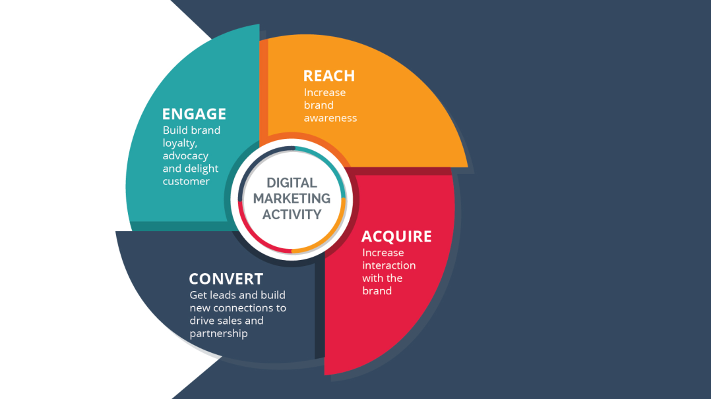
Figure 3: RACE framework
(Source: Poole et al. 2021)

Digital marketing model implemented in fast food industries
The honeycomb model has been currently the effective strategy of social media marketing. The model includes 7 blocks as “sharing”, “presence”, “relationship”, “identity”, “conversation”, “reputation” and “group” (Pietikäinen, 2020). The above-mentioned elements of the honeycomb model have been implemented by the markets in the food industry to overview the digital channel activities of the particular brand.
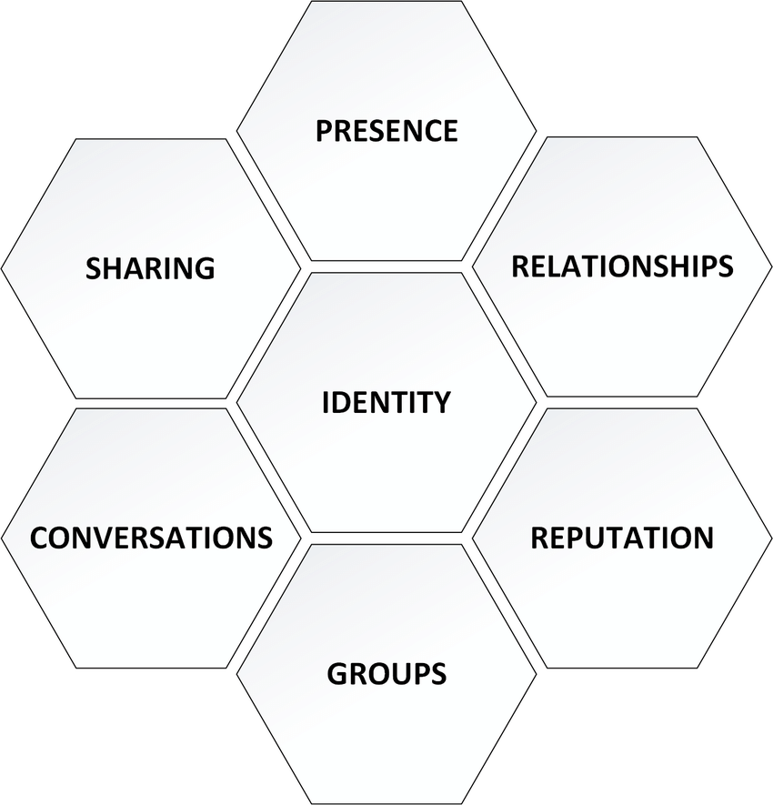

Figure 4: The honeycomb model
(Source: Pietikäinen, 2020)

Analysis of the performance of digital marketing channels has been performed by the digital marketers by implementing the seven blocks of the honeycomb model in the process of digital marketing strategy development (Pietikäinen, 2020). It improves the identity of the brand in the market.

Literature gap
The current research has covered all the prospects of digital marketing for fast food industries in the global market context. However, the different elements of digital marketing have been leftover in the process which is a gap in the literature.

Overview of research methodology

Research philosophy
In order to analyse the impact of digital marketing as well as marketing communication on the fast-food industry of the UK, the research will utilise positivism philosophy. As per the view of Marsonet (2019), a positivist approach in research can provide authentic information that can be gathered from natural phenomena. Hence, taking positivism philosophy the research will understand the importance of using digital marketing.

Research design
This research will use descriptive design in terms of analysing the information about the trends of digital marketing and marketing communication in the UK. As opined by Hunter et al. (2019), descriptive design is effective to describe natural and authentic data. Thus, using descriptive design the research can describe the effectiveness of marketing communication.

Research approach
This research will follow a deductive approach for analysing the impact of digital marketing on the fast-food industry of the UK. Thus, this approach will be effective to generalise research findings to a certain extent.

Data collection method
The Data collection method is important to gather authentic data for research. This research will follow primary qualitative and quantitative as well as secondary qualitative data collection methods. In order to obtain numerical information from a selected sample population including one-to-one authentic responses, this data collection technique will be effective.

Sample size and sampling technique
From this context, this research will collect primary quantitative data from 121 fast-food customers of the UK. In order to provide information, the right sampling size and technique choosing are important (Taherdoost, 2017). On the other hand, the research will collect primary qualitative data from 3 managers of fast-food brands in the UK. However, secondary data will also be collected from 8 peer-reviewed journal articles by using the self-selection non-probability sampling technique.
The research will also follow the random sampling technique for conducting survey and self-selection non-probability technique for collecting primary data through interviews.

Data analysis method
In order to analyse data that will be obtained from several sources, the research will follow different methods. The research will use the statistical data analysis method to analyse primary quantitative data as well as use the content analysis method to analyse data of interviews. On the other hand, the research will follow thematic analysis to understand the author's opinion of 8 peer-reviewed articles.

Timeline
[Refer to Appendix 1]

Reference list
Bala, M. and Verma, D., (2018). A critical review of digital marketing. M. Bala, D. Verma (2018). A Critical Review of Digital Marketing. International Journal of Management, IT & Engineering, 8(10), pp.321-339.
Bhagat, R. and Sambargi, S., (2019). Evaluation of personal innovativeness and perceived expertise on digital marketing adoption by women entrepreneurs of micro and small enterprises. International Journal of Research and Analytical Reviews (IJRAR), 6(1), pp.338-351.
Bhojaraja, D.M., 2018. Challenges and Opportunities in Digital Marketing. Google scholar.
Dearlove, T., Begley, A., Scott, J.A. and Devenish-Coleman, G., 2021. Digital Marketing of Commercial Complementary Foods in Australia: An Analysis of Brand Messaging. International journal of environmental research and public health, 18(15), p.7934.
GC, S. and Kirves, J., 2019. Developing Digital Marketing Strategy for Restaurant X Using Service Design Tools.
Hunter, D., McCallum, J. and Howes, D., (2019). Defining exploratory-descriptive qualitative (EDQ) research and considering its application to healthcare. Journal of Nursing and Health Care, 4(1).
Ledikwe, A., Stiehler-Mulder, B. and Roberts-Lombard, M., 2020. Product involvement, WOM and eWOM in the fast food industry: A young adult perspective in an emerging African economy. Cogent Business & Management, 7(1), p.1817288.
Marsonet, M., (2019). Philosophy and logical positivism. Academicus International Scientific Journal, 10(19), pp.32-36.
Minculete, G. and Olar, P., 2018, June. Approaches to the modern concept of digital marketing. In International conference Knowledge-based organization (Vol. 24, No. 2, pp. 63-69).
Namin, A., (2017). Revisiting customers' perception of service quality in fast food restaurants. Journal of Retailing and Consumer Services, 34, pp.70-81.
Nguyen, Q., Nisar, T.M., Knox, D. and Prabhakar, G.P., 2018. Understanding customer satisfaction in the UK quick service restaurant industry: The influence of the tangible attributes of perceived service quality. British Food Journal.
Pai, A.N., 2021. In pursuit of effective digital marketing actions in the agri-food sector: case FarmX (Bachelor's thesis, University of Twente).
Pietikäinen, M.O., 2020. Social media marketing through influencers with a particular focus on Instagram and Honeycomb model.
Poole, S.M., Grier, S.A., Thomas, K.D., Sobande, F., Ekpo, A.E., Torres, L.T., Addington, L.A., Weekes-Laidlow, M. and Henderson, G.R., 2021. Operationalizing critical race theory in the marketplace. Journal of Public Policy & Marketing, 40(2), pp.126-142.
Statista.com,2021.mcdonald-s-advertising-spending-worldwide.Available on:https://www.statista.com/statistics/286541/mcdonald-s-advertising-spending-worldwide/[Accesssed on:23rd October, 2021]
Statista.com. (2021), Most popular dining brands in the United Kingdom (UK) as of December 2020, Available at: https://www.statista.com/statistics/950444/most-popular-restaurant-brands-in-the-united-kingdom-uk/[Accessed on: 20/10/2021]
Taherdoost, H., (2017). Determining sample size; how to calculate survey sample size. International Journal of Economics and Management Systems, 2.
Widyastuti, N.W., Ali, A., Winangsih, R. and Haila, H., 2021, March. Community Empowerment and Social Media Models as Marketing Communication Innovations for Local Culinary Products in Serang, Indonesia. In 2nd and 3rd International Conference on Food Security Innovation (ICFSI 2018-2019) (pp. 63-69). Atlantis Press.

Appendix: Timeline
Activity | 1st week- 2nd week | 3rd week - 4thweek | 5th week - 6th week | 7th week - 8th week | 9th week - 10th week | 11th week - 12th week | 13th week - 14th week | 15th week - 16th week
Selection of topic
Identification of research objectives and question
Developing research proposal
Providing an overview of the concept and scope of the research
Selecting appropriate literary sources for drafting literature review
Selecting appropriate methodology
Selecting interview and survey participants
Selecting articles and journals
Data collection
Data analysis
Writing findings
Analysing the findings
conclusion
Suggesting recommendations
Final drafting
Final proposal submission through electronic media

