
Academic and Employability skills
[Document subtitle]



Student: Alina Olaru 2123361Lecturer: Laura James

Table of Contents
- Introduction…………………………………………………………..2
- Main findings…………………………………………………………3
2.1 Important employability skills ………………………………………….4
2.1.1 Digital competence……………………………………………………..5
2.1.2 Emotional Inteligence…………………………………………………..6
2.1.3 Resilience…………….…………………………………………………….6
2.2. Reasons for employers look for employability skills during recruitment …6
2.2.1 Importance of these skills for employers……………………………….7
2.2.2 Importance of these skills for employees……………………………….7
2.3 Demonstration of emplpyability skills and increasing atractiveness to prospective employer…………………………………………………………………….8
3.0 Conclusion ……………………………………………………………………..9
Reference list……………………………………………………………………………10

- Introduction
The following report was tasked by the lecturer of Academic and Employability skills module Laura James and initiated by Alina Olaru ( 2123361).Bellow I will reflect, analyse and evaluate the importance of Employability skills for the workplace for every candidate that is looking for a better position and opportunity within the desired job. After I have been familiarised with this module, I realised how important it is to have employability skills.
Employability skills are abilities that make an individual employable. Employability is a term that is used as a measurement by employers on graduates’ marketability (Rahmat, Ahmad, Idris & Zainal, 2011). These skills help enable the candidate to apply them in almost every job from many industries. Employability skills are very important as it helps people to progress In the workplace and to standout on top of the company on the competitive jobs that they have available. This report is going to analyse in detail the importance of employability skills and the way they are going to help the candidate on their workplace.

2.0 Main Findings
Yorke (2006) argued that Employability delivers from complex learning and are a collection of capacities or achievements strongly aligned with academic valuing of good learning. Even from early starts schools are teaching these employability skills to students to practice their problem-solving skills, communication skills and teamwork learning programs. By having these skills introduced to them will help them in the workplace to be better candidates for business proprietary, competitiveness, and fairness. If they work on these skills, they will surely have a successful professional life.
The important employability skills:
- Critical thinking and problem solving
Critical thinking skills is done when an individual sees a situation, argument, or information in a critical manner before making any judgements. It analyses and criticize the issue with both positive and negative importance of situation i9n order to form logical judgements.
- Professionalism and ethical skill
To employ them employers wants the candidates to have strong work ethics and high professionalism as it helps build trust, engagement, and success.
- Teamwork and collaboration
Teamwork helps to improve employability skills. To achieve success in the organisation people must know how to collaborate with their colleagues and to bring teamwork into practice.
- Digital skills
In this modern world is very important to have digital skills as most of the jobs requires it and automatically individuals with good digital skills gets privileged and gets accepted for the role. Technical skills are like writing skills, programming, system development, entrepreneurship, and others (Ang, M.C.H., 2011)
- Leadership
Most of the employers are looking for employees with good leadership skills. This is a very important skills will help the organisation to develop performance.

2.1. Important employability skill
2.1.1 Digital competence

Living in this modern world, were most of the things are online, digital competence is a vital aspect that employers are highly looking for. First, digital skills can help people find jobs as most of the jobs are only advertised on online which is needed to apply via online application or a Cv. Many of the application include a series of online assessments to demonstrate level of people’s digital skills, having these successfully passed they can reach the next stage of the application. Digital competence can be developed by learn how to access, use computers to retrieve, store information, communicate, present and exchange information, create and share your own subjects. Especially when covid came in our life’s the importance of digital skills became a major quality as most of the jobs went online on working from home not only digital competence also gives efficiency in an employee, helps to communicate withing the organisation, with customers and retailers which help grow productivity. Few years ago, digital skills were very appreciated but nowadays they are vital. There are so many ways to help increasing digital competence, and they aren’t time consuming or very expensive, it cand either be learned online, at work, or on face to face training. If employees are looking to progress in work ,a good option is getting online courses as it’s fast and can be done from everyone’s conform and flexibility. Currently UK needs around 750.00 people with digital competence to maximise on jobs that could bring around 12 billion pounds on the Uk economy. People of all ages are taking courses to help them boost their digital skills so that they can make the most out of their computers.

2.1.2 Emotional Intelligence
Emotional Intelligence is the ability to overcome stress, challenges understand others’ emotions and communicate effectively to avoid conflicts. Below are few important points of those individuals that demonstrate high emotional intelligence:
- Self-control
- Conscientiousness
- Trustworthiness
- Social Skills
- Building bonds

Organisations these days are looking for employees who posed these skills and there are many causes behind it. By searching in different sources, it has been proven that by having these skills employees can increase and support cooperative relationship within the company or with other companies. By being more self-aware can impact our live in a positive way at home or in work. Becoming more understanding and calm in every critical situation at workplace will allow you to have a better connection and closure with the ones you work with .

2.1.3 Resilience
Evolve resilience is one of the most important skills that is needed to have as an employee. Resilience is the capacity to successfully adapt to different challenges, life experiences and unexpected work problems. By developing this skill employees become able to identify the possible risks and causes when a problem occurs and can apply different measures to avoid any circumstances. These days different organisations have moments when they have different complications, issues and misunderstandings which they require employee capable to bring effective solutions to sustain the upgrowing business in the operating industry.

2.2. Reasons for employers look for employability skills during recruitment

2.2.1 Importance of these skills to employers
Lifelong learning is the key to employability for actual and future jobs. Enthusiasm and motivation to increase employability skills and to aim more will only fulfil career for employees. Existing skills can always be improved and expanded in favour of getting new skills in exchange.
Employers not only choose employees with employability skills but also appreciate them because that means that they are able to cope with different difficulties and with issues with their team members. It also means by having these skills employees can handle all the requirements and all the linked situations. Employers look for these qualities as they always resulted productive employees who wants to progress within the company and also to develop relations with other organisations in order to progress business. Digitalization nowadays have created chances for growth and success by getting and keeping new consumers. To develop a good workplace environment and to support the behaviours and attitudes of employees within the company employers aim to find candidates with employability skills so they can reach spectacular achievements withing the organization.

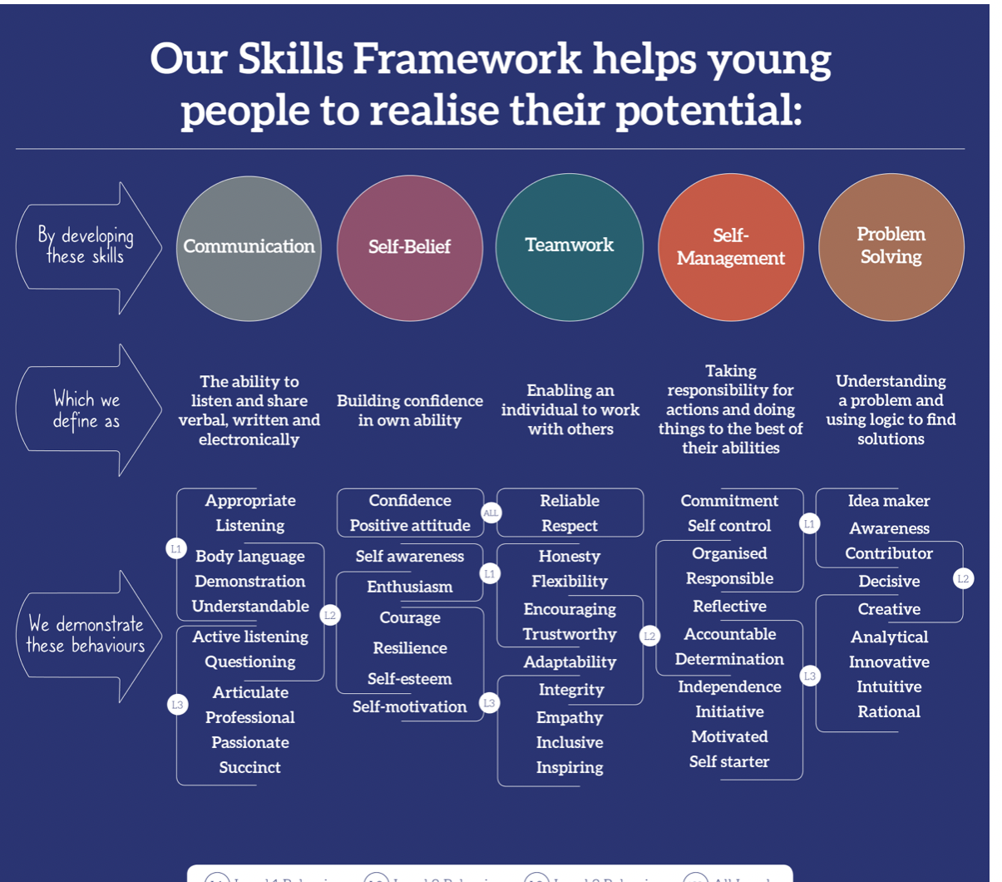

Not only employers are aiming to find employability skills in their candidates, but employees are working hard to get these qualities too. Nowadays the job market is very competitive, and everyone is trying to stand out to be able to reach progression. At-present every type of corporation aims to find people with managerial and leadership skills to be effective. Because of high competition between candidates, there are more chances for employees to have a better pursuit. Without these qualities or capacity, it is impossible to progress to a better position in any field. If employees have digital skills, emotional intelligence, and flexibility they can make their own judgements in any circumstances.
During the interview employers are giving different examples or situations to see if the candidates have any leadership skills, problems solving, organising, planning and time management skills. If the employee does not own these skills, they will not secure the position for the. However, security is important for both parts, mainly employees so they can expand soft skills to prove their capability to their employers.

2.3. Demonstration of employability skills

By demonstrating employability skills in interview helps the employers to identify if an employee can perform and have the capability to progress in the workplace. In any organisation by highlighting all the accomplishments that they have and prove these skills they can erase any doubts that employer might have and start building trust. Therefore, education and experience is not enough for the interviewer to decide if the candidate is suitable or not, employers would want to know more about The candidate and hear different examples on how they faced the problems so they can see why they are different from the others and what are they ready to bring on the table. The candidate should prove their employers why they must be the one chosen, how much they are willing to learn and how their skills fit with the specific requirements. Before attending the interview, candidates should prepare for the main question “Why should I hire you’’. The candidate should point out the skills that will make them different than the rest, highlight their skills, goals, experience. Another important part of the preparation is to do as many mock interviews as possible in front of family and friends to receive feedback. By doing this. It will help them gain trust in themselves, and to get rid of nervousness and all the other confidence issues that they might have.

3.0 Conclusion

It has been concluded that investing time and motivation on developing in Academic and Employability skills candidates are more likely to get suitable jobs in their most wanted fields. Another characteristic that si been found from the research is that Academic and employability skills play an important role on achieving success and progression. It can be said that these skills not only play an important role on professional development but also on personal growth. Communication skills, problem solving, team work etc. are some of the main key points of interpersonal skills that a candidate must have so they can perform and improve in different productivity. Problem solved is a strategy that is used by most of the companies to improve behavioural and hardworking attitudes and to boost a powerful team working within the company. I want to say that by being part of the Academic and Employability course I have improved my interpersonal skills such as critical thinking, resilience, people skills, reading/ righting and many more.

References

