

BMIH6007

International Meetings Management for the Hotel Industry

Presentation

Student Name:Andreea Gama
Student ID:2219781

Table of Contents
Slide 1: Title Page 3
Slide 2: Content Page 3
Slide 3: Introduction 4
Slide 4: Event Objectives 5
Slide 5: Background Research 6
Slide 6: Target Market 7
Slide 7: Operational Factors 8
Slide 8: Financial Feasibility 9
Slide 9: Competition and Differentiation 11
Slide 10: Situational and Cultural Considerations 12
Slide 11: Anticipated Impact 13
Slide 12: Conclusion 14
Slide 13: References 15

Slide 1: Title Page
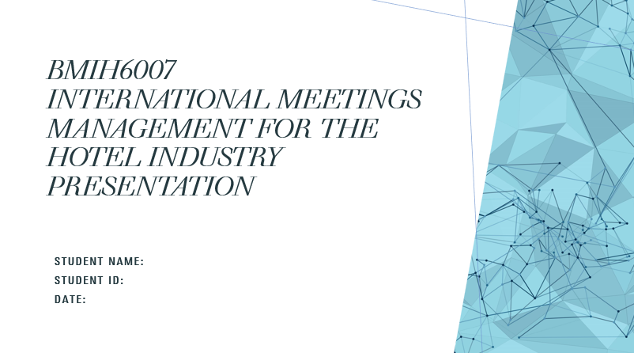

Slide 2: Content Page
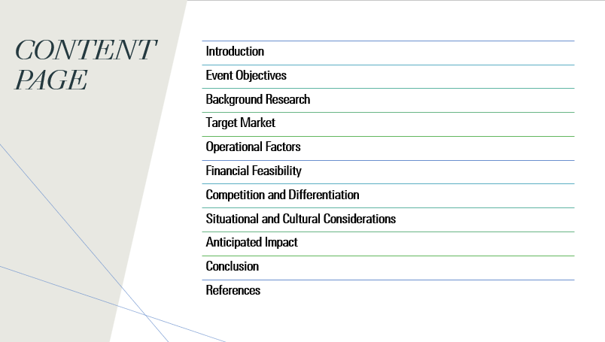

Slide 3: Introduction
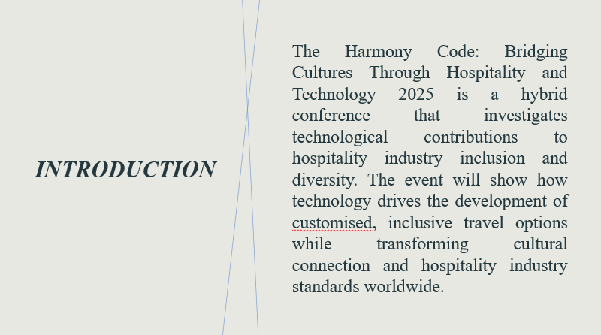
Slide Content
The Harmony Code: Bridging Cultures Through Hospitality and Technology 2025 is a hybrid conference that investigates technological contributions to hospitality industry inclusion and diversity. The event will show how technology drives the development of customised, inclusive travel options while transforming cultural connection and hospitality industry standards worldwide.
Speaker Notes
Welcome to The Harmony Code: This hybrid conference will be called The Harmony Code: Bridging Cultures Through Hospitality and Technology 2025. The hybrid forum unites leaders of hospitality sectors along with innovative technology specialists and cultural domain experts to examine technology applications for better EDI outcomes. The growing need for inclusive, personalised guest experience drives the event where advanced solutions, including AI technology, virtual reality capabilities, and multilingual support systems, are deployed. Global travel's rising cultural diversity and inclusion demands focus from this conference through its specific study of hospitality-technology intersections to deliver operational guidance to industry players. We strive to create an inclusive environment to enrich international travel.

Slide 4: Event Objectives
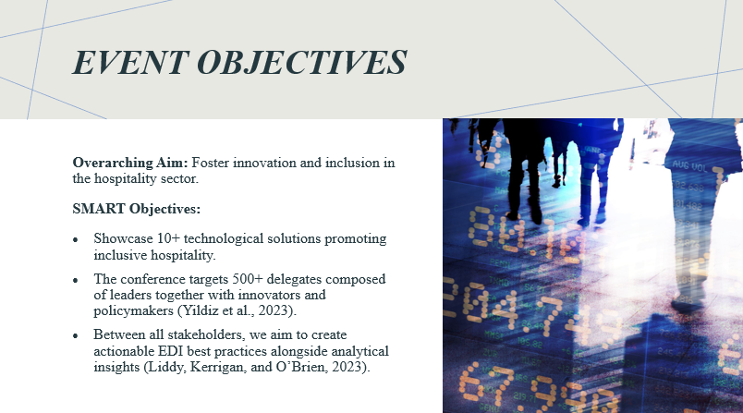
Slide Content
Overarching Aim: Foster innovation and inclusion in the hospitality sector.
SMART Objectives:
- Showcase 10+ technological solutions promoting inclusive hospitality.
- The conference targets 500+ delegates composed of leaders together with innovators and policymakers (Yildiz et al., 2023).
- Between all stakeholders, we aim to create actionable EDI best practices alongside analytical insights (Liddy, Kerrigan, and O’Brien, 2023).
Speaker Notes
The core mission of this event combines technological advancements with innovation to improve the hospitality industry's performance and inclusion. We established clear objectives to reach this target. The main objective is to present more than ten innovative technological solutions that help address EDI problems in hospitality industry operations. Our initiative targets 500+ individuals, consisting of hospitality leaders alongside tech innovators and policymakers, to produce diverse, beneficial collaborations. The event will create applicable insights together with the best practices designed to boost industry-wide efforts in EDI. The event advances its mission to drive transformative changes throughout the hospitality sector through these specific targets.

Slide 5: Background Research
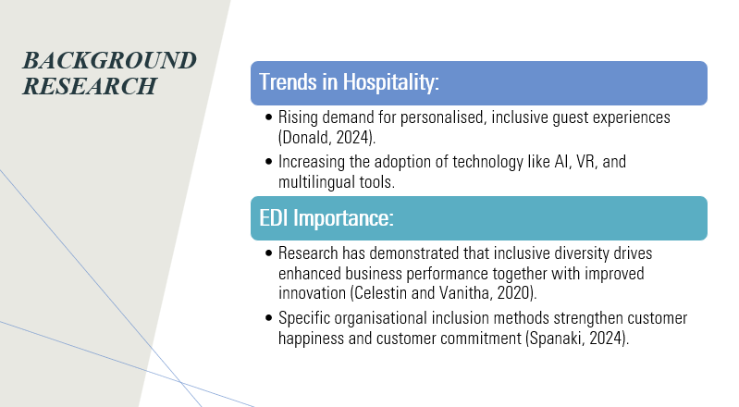
Slide Content
Trends in Hospitality:
- Rising demand for personalised, inclusive guest experiences (Donald, 2024).
- Increasing the adoption of technology like AI, VR, and multilingual tools.
EDI Importance:
- Research has demonstrated that inclusive diversity drives enhanced business performance together with improved innovation (Celestin and Vanitha, 2020).
- Specific organisational inclusion methods strengthen customer happiness and customer commitment (Spanaki, 2024).
Speaker Notes
The hospitality industry stands amid a transformation because guests demand personalised experience and complete inclusivity. Modern hospitality solutions emerge through combined efforts between artificial intelligence (AI) and virtual reality (VR) technologies to deliver personalised immersive experiences. Thorough emphasis on Equality, Diversity, and Inclusion (EDI) activities in business operations proves essential according to research indicating diverse businesses achieve better financial results and demonstrate increased innovation. Tools that enable inclusiveness led to better customer satisfaction, which creates brand trust and brand loyalty. This event harnesses current marketplace trends to establish a forum for investigating how hospitality must integrate technology and equality, diversity, and inclusion functions to transform global guest encounters.

Slide 6: Target Market
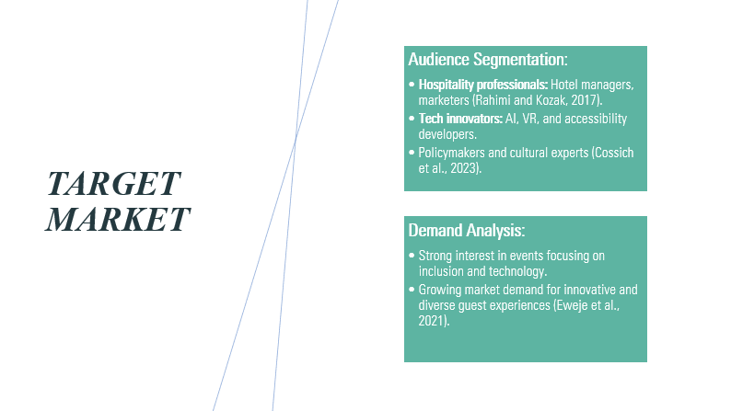
Slide Content
Audience Segmentation:
- Hospitality professionals: Hotel managers, marketers (Rahimi and Kozak, 2017).
- Tech innovators: AI, VR, and accessibility developers.
- Policymakers and cultural experts (Cossich et al., 2023).
Demand Analysis:
- Strong interest in events focusing on inclusion and technology.
- Growing market demand for innovative and diverse guest experiences (Eweje et al., 2021).
Speaker Notes
The Harmony Code specifically targets diverse influential participants to attend its event. The main audience consists of hotel managers alongside marketers who want to find innovative approaches to improve guest satisfaction. Tech innovators specialising in artificial intelligence, together with virtual reality technology and accessibility tools, remain essential for uncovering modern technological achievements. Industry guidelines, together with policy insights and cultural expertise, will drive both inclusive enhancement and standards development. Statistical demand analysis shows a positive market response toward technological and diverse-focused events because the hospitality industry currently values guest-orientated personalised experiences. These focused stakeholders work synergistically to create dialogues that deliver actionable solutions.

Slide 7: Operational Factors
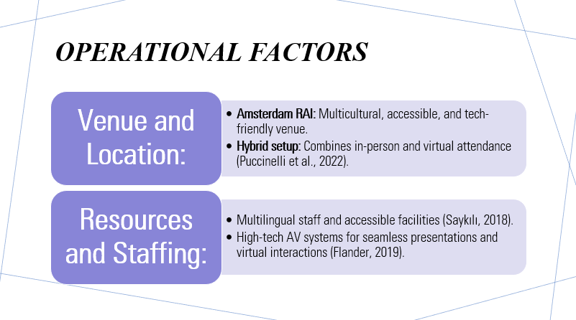
Slide Content
Venue and Location:
- Amsterdam RAI: Multicultural, accessible, and tech-friendly venue.
- Hybrid setup: Combines in-person and virtual attendance (Puccinelli et al., 2022).
Resources and Staffing:
- Multilingual staff and accessible facilities (Saykılı, 2018).
- High-tech AV systems for seamless presentations and virtual interactions (Flander, 2019).
Speaker Notes
Amsterdam RAI serves as the selected host site since its multicultural space and top-tier capabilities make it suitable for The Harmony Code event. The event facility stands as a perfect reflection of its fundamental inclusive message, which prioritises accessibility. The integrated approach delivers simultaneous opportunities for live-in-person participation together with online virtual engagement, therefore enabling wide participation. The availability of staff that speak different languages, together with modern presentation equipment and buildings that serve every type of need, will form the foundation of our resources. These operational considerations underline the event's goal of providing seamless participation across its physical and digital platforms and its dedication to inclusivity and high standards.

Slide 8: Financial Feasibility
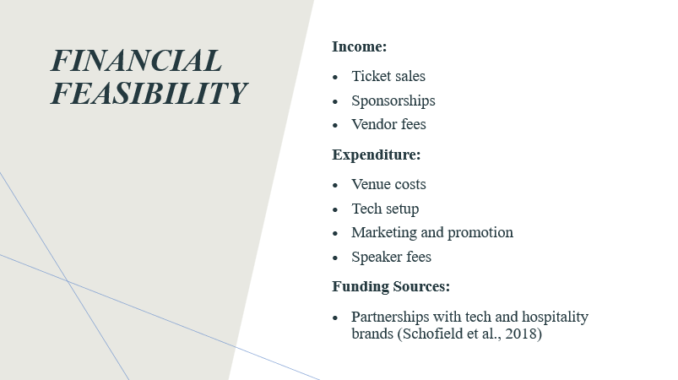
Content Slide
Income:
- Ticket sales
- Sponsorships
- Vendor fees
Expenditure:
- Venue costs
- Tech setup
- Marketing and promotion
- Speaker fees
Funding Sources:
- Partnerships with tech and hospitality brands (Schofield et al., 2018)
Speaker Notes
The financial viability of this event is presented through this slide, which details anticipated income streams against expected costs. Our financial projections show profits will come from ticket sales together with sponsorships alongside vendor payments. The money will be allocated toward hiring an event space while funding technological systems as well as expenses dedicated to marketing and speaking costs. The event’s core funding approach depends on strategic partnerships between technology and hospitality brands while maintaining our fundamental theme of cultural innovation. The event's strategic partnerships will simultaneously reduce financial expenses, boost endorsement from sponsors, and expand the audience reach. The budget organisation format enables financial viability while enabling maximum industry attendance.

Slide 9: Competition and Differentiation
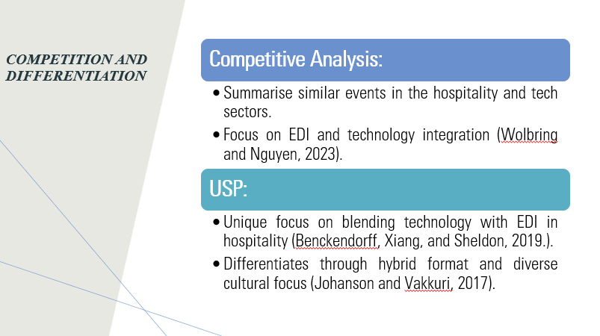
Content Slide
Competitive Analysis:
- Summarise similar events in the hospitality and tech sectors.
- Focus on EDI and technology integration (Wolbring and Nguyen, 2023).
USP:
- Unique focus on blending technology with EDI in hospitality (Benckendorff, Xiang, and Sheldon, 2019.).
- Differentiates through hybrid format and diverse cultural focus (Johanson and Vakkuri, 2017).
Speaker Notes
The conductive platform shows competing events in the hotel and technical industries, emphasising innovation and inclusion experiences. The distinguishing feature of our event is the combination of EDI with technology, which tackles critical concerns about AI cultural biases and the accessibility needs of participants. The conference will adopt a hybrid model that enables contributors anywhere to join and make the event more extensive in reach. The fusion of technology alongside diversity remains unique within the hospitality industry, thus establishing “The Harmony Code” as an industry first, although it slots into a strategic market gap.

Slide 10: Situational and Cultural Considerations
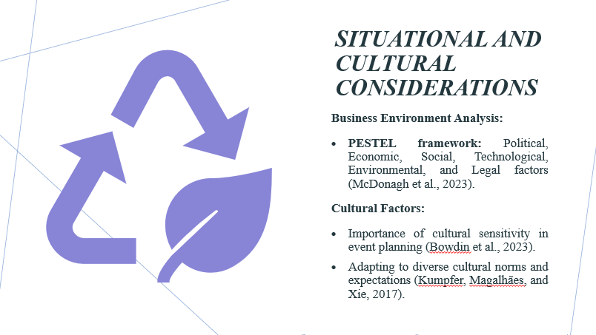
Content Slide
Business Environment Analysis:
- PESTEL framework: Political, Economic, Social, Technological, Environmental, and Legal factors (McDonagh et al., 2023).
Cultural Factors:
- Importance of cultural sensitivity in event planning (Bowdin et al., 2023).
- Adapting to diverse cultural norms and expectations (Kumpfer, Magalhães, and Xie, 2017).
Speaker Notes
The success factors for the event require assessment through PESTEL analysis, which we demonstrate in this slide. Event logistics, together with reach, will be shaped by political stability, economic standing and technological progress. Future social developments together with environmental protection guidelines will influence sustainable practices during our approach. Every stage of planning and execution in diverse events demands attendees recognise participant cultural elements in a display of cultural awareness. The rules that manage both system data privacy and accessibility become fundamental elements for our event development because they dictate our planning approach at all stages.

Slide 11: Anticipated Impact
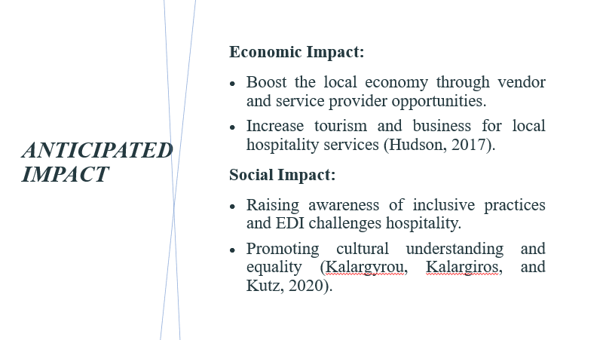
Content Slide
Economic Impact:
- Boost the local economy through vendor and service provider opportunities.
- Increase tourism and business for local hospitality services (Hudson, 2017).
Social Impact:
- Raising awareness of inclusive practices and EDI challenges hospitality.
- Promoting cultural understanding and equality (Kalargyrou, Kalargiros, and Kutz, 2020).
Speaker Notes
Local economic growth is driven by the event through partnerships that link organisations from hospitality services to vendors and providers. Inaugural international participation will create opportunities for tourism growth alongside the expansion of hotel infrastructure. "The Harmony Code" generates societal advantages that teach the hospitality industry about diversity, equity, and inclusion matters. Through investigation, the event develops inclusive practice solutions and resolves technological accessibility barriers alongside bias mitigation because these practices yield increased knowledge about inclusive techniques. When organisations and individuals implement inclusive diversity approaches with increasing speed, society and the hospitality industry gain rapid results.

Slide 12: Conclusion
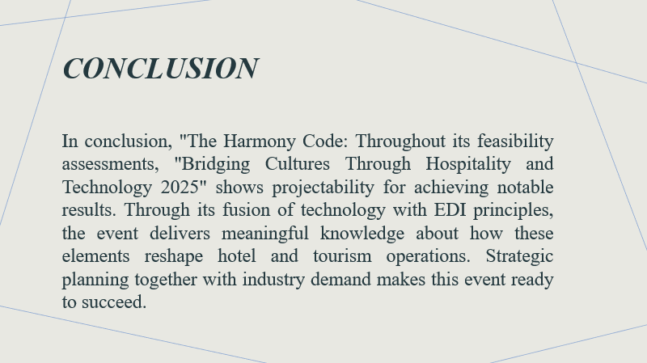
Content Slide
In conclusion, "The Harmony Code: The "Bridging Cultures Through Hospitality and Technology 2025" framework creates projected scenarios that allow researchers to identify significant outcomes from their feasibility evaluations. Through the integration of EDI principles with technology capabilities, the event serves as a platform for delivering vital knowledge about hotel and tourism operational modifications. Project planning based on market understanding ensures every component needed for success becomes part of this initiative.
Speaker Notes
The approach of "The Harmony Code" brings distinctive value to the project because it adds service delivery with technological advancement alongside diverse and inclusive elements. The integration of EDI principles with virtual and physical meetings enables this event to deliver beneficial results by detecting industry issues and then supplying appropriate answers. The successful launch of this event credits its finite strategic planning elements that perform market assessment and financial viability reviews. Market demands, hospitality industry changes, and social diversity requirements, together with technological progress, facilitate sustainable hospitality transformations via this event.

Slide 13: References


