

April 26, 2026
Archie Coveney (2502379)
Dr Kerry Tudor
University of Wales Trinity Saint David
Word Count (Excluding Abstract, Headings Tables, Figures, References, Appendices): 3273
Testing and Sustainability Analysis of Composite Materials for Motorsport and Automotive Applications
BEng Motorsport Engineering (ACHA6012)

Abstract
This report investigates the tensile mechanical properties of six composite material systems, alongside a reference aluminium material, in the context of motorsport and automotive sustainability objectives. Tensile testing was conducted in accordance with ISO 527-4 using a universal tensile testing machine with an Epsilon clip-on extensometer. The materials tested include woven and non-woven carbon fibre composites with epoxy and bio-based resin systems, woven and non-woven flax fibre bio-composites, and woven Kevlar epoxy composites.
The highest tensile performance was observed in carbon-woven epoxy, with a mean UTS of 423 MPa and a Young’s modulus of 63 GPa, approximately 3.7 times that of the aluminium reference material. Bio-based resin carbon composites exhibited performance comparable to epoxy equivalents under controlled conditions, supporting their feasibility for semi-structural applications. Woven flax bio-composites achieved a mean UTS of 102 MPa, broadly comparable to aluminium, albeit with substantially lower stiffness, making them well suited to non-structural applications.
Sustainability analysis highlighted the high impact of carbon fibre production, which accounts for over 50% of the total CFRP lifecycle impact, whilst natural fibre composites offer an 80% reduction in production energy compared to synthetic alternatives. End-of-life recycling infrastructure for CFRP remains a critical gap. A hybrid material strategy, in which CFRP is used for structural applications and natural fibre composites for lower-load applications, combined with investment in recycling infrastructure, is recommended as the most viable pathway to sustainable adoption of composites across the automotive and motorsport sectors.
Table of Contents
Abstract 1
Table Of Figures 3
Table Of Tables 3
List Of Abbreviations 3
1.0 Introduction 4
2.0 Literature Review 5
2.1 Composite Material Types and Structures 5
2.2 Manufacturing Processes 6
2.3 Applications in Motorsport and Automotive Industries 7
3.0 Sustainability Analysis 8
3.1 Lifecycle Assessment of Composite Materials 8
3.2 End-of-Life Considerations: Recyclability and Disposal 9
3.3 Carbon Footprint Reduction Potential 10
4.0 Experimental Testing 11
4.1 Materials and Specimens 11
4.2 Testing Standards and Procedures 13
4.3 Results 14
4.4 Validation Against Published Data 17
4.5 Discussion of Results 18
5.0 Recommendations Based on Test Results 20
6.0 Conclusions 21
Bibliography 22
Appendix A: Raw Test Data 24
Appendix B: Equipment Specifications / Calibration Data 26
Appendix C: Manufacturer Datasheets 27

Table Of Figures
Figure 4.0a: Universal tensile testing machine with Epsilon clip-on extensometer mounted on a composite specimen, Engineering Science Laboratories, UWTSD (Coveney, 2026) 11
Figure 4.0b: All tested specimens following tensile fracture, showing from top to bottom: aluminium alloy, carbon non-woven bio, carbon woven bio, carbon woven epoxy, flax non-woven bio, flax woven bio and Kevlar woven epoxy (Coveney, 2026) 12
Figure 4.1a: Stress-strain curves for carbon fibre composites and aluminium reference material (Coveney, 2026) 15
Figure 4.1b: Stress-strain curves for flax, Kevlar and aluminium reference material (Coveney, 2026) 15
Figure 4.2: Mean ultimate tensile strength comparison across all tested materials (Coveney, 2026) 16
Figure 4.3: Mean Young's modulus comparison across all tested materials (Coveney, 2026) 16

Table Of Tables
Table 4.1 – Tensile Test Results 14
Table 4.2 – Comparison of Experimental Results Against Published Values 17
Table A.1 — Tensile Test Results for All Specimens 24
Table A.2 — Extract of Raw Test Machine Data (Aluminium T1, first 10 data rows) 25
Table B.1 – Tensile Testing Equipment Specifications 26
Table B.2 – Extensometer Specifications 26
Table C.1 — Published Mechanical Property Ranges for Tested Material Types 27

List Of Abbreviations
Abbreviation | Definition
CFRP | Carbon Fibre Reinforced Polymer
FRP | Fibre Reinforced Polymer
NFRC | Natural Fibre Reinforced Composite
UTS | Ultimate Tensile Strength
LCA | Lifecycle Assessment
RTM | Resin Transfer Moulding
ELV | End-of-Life Vehicle
FIA | Fédération Internationale de l'Automobile
ISO | International Organisation for Standardisation
MPa | Megapascal
GPa | Gigapascal
PAN | Polyacrylonitrile
VARI | Vacuum Assisted Resin Infusion

1.0 Introduction
Composite materials are vital in high-performance automotive and motorsport engineering, offering superior strength-to-weight ratios over metals. McLaren introduced the first carbon fibre composite monocoque in Formula One in 1980 (Savage, 2010), prompting widespread adoption across motorsport and the mainstream automotive sector, driven by emissions regulations and performance goals.
However, the sustainability of composites poses challenges: carbon fibre production is energy-intensive, and recycling is difficult, highlighting a conflict between performance and circular economy principles. Bio-based resins and natural fibres show promise for greener composites but require further performance evaluation.
This report examines the tensile properties of six composite systems and aluminium, tested in accordance with ISO 527-4. Materials include woven and non-woven carbon fibre with epoxy and bio-resins, flax fibre bio-composites, and Kevlar epoxy. Results, validated against literature, inform industry applications and future research directions.

2.0 Literature Review

2.1 Composite Material Types and Structures
Composite materials combine two or more constituents to achieve superior properties. In automotive and motorsport engineering, fibre-reinforced polymer (FRP) composites are key, featuring fibres that bear mechanical loads and a matrix that binds them, transfers stress, and shields against environmental factors.
Carbon fibre-reinforced polymers (CFRPs) are the highest-performance category of composite materials used in these industries. The mechanical response of CFRP is primarily governed by the architecture of the fibre. Çetin et al. (2025) demonstrated that fibre architecture significantly influences the impact resistance and stiffness of CFRP composites, with unidirectional and biaxial configurations exhibiting different energy absorption characteristics compared with plain-woven architectures due to the presence or absence of fibre crimp. Ekoi et al. (2021) further establish that woven and non-woven CFRP configurations exhibit significantly different mechanical responses, with non-woven composites reaching 714 MPa in tensile strength compared to 351 MPa for woven ones, consistent with Section 4 results.
The choice of matrix system significantly affects composite performance. Traditionally, petrochemical epoxy resins have dominated structural applications due to their known properties, but bio-based epoxy systems from sustainable feedstocks are now a viable alternative. Boursier Niutta et al. (2023) conducted a direct comparison of epoxy and bio-epoxy carbon fibre twill composites under quasi-static loading, showing no significant difference in tensile strength. The authors suggested that the interfacial bonding with bio-based resin could match or exceed that of conventional epoxy, though microscopic confirmation is needed. Since only static tests were performed, the fatigue and impact performance of bio-epoxy under dynamic, cyclic loading typical in motorsport remains less established, limiting confidence in replacing structural components.
Kevlar, or aramid fibre, is a key composite reinforcement in automotive and motorsport fields. Known for high tensile strength and impact resistance, Kevlar-49 composites can reach tensile strengths of 167–172 MPa and a tensile modulus around 9.3 GPa in thermoplastic matrices, with performance depending on matrix type and laminate design (Yeung & K.P. Rao, 2011). Thermoset epoxy matrices are generally expected to yield higher interfacial strength and, therefore, greater tensile performance than their thermoplastic equivalents.
Natural fibre composites, especially those reinforced with flax fibres, represent an emerging sustainable alternative to synthetic fibre systems. Ahmad et al. (2015) identified that natural fibre composites excel in mechanical performance per weight, biodegradability, and cost compared to glass and carbon fibres, though they face limitations like moisture sensitivity and fibre variability.

2.2 Manufacturing Processes
Abdurohman et al. (2018) found that vacuum infusion produced superior tensile strength (346 MPa) and modulus (10,673 MPa) compared to hand layup (261 MPa, 8,661 MPa) in glass fibre composites, with electron microscopy confirming fewer voids due to controlled vacuum pressure – a void-reduction principle transferable across FRP systems generally.
The introduction of bio-based resin systems presents additional manufacturing considerations. Kirschnick et al. (2024) identified that resin viscosity, curing behaviour, and material heterogeneity significantly contribute to process variability in bio-based FRP manufacturing, necessitating precise optimisation of temperature and cure time for consistent performance. This complexity currently hinders large-scale industrial adoption, though ongoing development of bio-based formulations is gradually overcoming these challenges.

2.3 Applications in Motorsport and Automotive Industries
The adoption of composite materials has been a transformative development across the history of competitive racing. Savage (2010) notes that the first composite chassis was built by Cooper Cars in the early 1960s with a glass fibre-reinforced polymer skin over an aluminium honeycomb core. In 1980, McLaren introduced the first carbon fibre monocoque, dramatically improving performance and safety due to CFRP’s damage-tolerance and energy-absorbing properties, which enhanced Formula One safety. This innovation led to CFRP becoming the standard structural material in top-tier motorsport.
In the broader automotive sector, the primary driver of the utilisation of composites was mass reduction and the associated benefits for fuel economy and vehicle emissions performance. Joost (2012) established that a 10% reduction in vehicle weight can improve fuel economy by 6–8% while maintaining performance, with CO2 emissions models suggesting reductions of up to 8% for similar weight savings. This underscores automakers' ongoing interest in lightweight composites to meet stricter emissions standards. Furthermore, Joost (2012) notes that mass reduction is crucial for electric vehicles, as it extends range and boosts energy efficiency, a trend that is increasingly important as the industry shifts to electrification.
Sustainability objectives and legislative pressure are driving an increase in the application of natural fibre composites in automotive interior and semi-structural components. Wazeer et al. (2023) reviewed the role of composites in electric vehicle design, emphasising the importance of mass reduction and material sustainability. Using natural fibre-reinforced composites for body panels and interior trim offers a near-term way to lower the environmental impact of vehicle manufacturing, especially as non-structural components, due to their lower mechanical performance compared to carbon (Holberry & Houston, 2006).

3.0 Sustainability Analysis

3.1 Lifecycle Assessment of Composite Materials
Lifecycle assessment (LCA) provides the methodological framework for evaluating the sustainability of composite materials, quantifying environmental impacts across raw material extraction, in-service use, and end-of-life disposal.
The in-service phase typically represents the greatest opportunity for environmental benefits through the adoption of composites. Composite substitution for conventional metallic components reduces vehicle mass, in turn directly reducing fuel consumption and associated CO2 emissions over a vehicle’s operational life. As established by Joost (2012), a 10% vehicle mass reduction yields a 6–8% fuel economy improvement, indicating that the operational carbon savings from composite use can substantially offset the higher production energy associated with composite manufacture over a sufficient service life.
However, carbon fibre composites carry a significantly higher environmental burden during production than conventional materials. Hermansson et al. (2019) identified that carbon fibre production is responsible for more than 50% of total CFRP climate impact and energy use across all lifecycle studies, and the dominant energy consumer is the carbonisation process, which requires temperatures of 1000–1700°C.
Natural fibre composites present a considerably more favourable production phase profile. Prasad et al. (2024) reported energy consumption of 9.5 MJ/kg for natural fibre composites compared to 54.7 MJ/kg for synthetic fibre composites, representing a reduction of over 80%. Life cycle assessment studies indicate that natural fibre composites can reduce CO2 emissions by approximately 15–20% over aluminium-based structural components. This finding is directly relevant to this study, as aluminium serves as the reference material in the experimental investigation.

3.2 End-of-Life Considerations: Recyclability and Disposal
End-of-life management poses a sustainability challenge for composite materials. Unlike metals, which can be recycled by melting and reforming with low energy, thermoset matrices cannot be remelted because of their cross-linked structure.
Pyrolysis and solvolysis represent the two primary technical routes for CFRP fibre recovery. Keith et al. (2025) compared pyrolysis (thermal decomposition at 450–700°C in inert atmospheres) and solvolysis (using chemical solvents below 200°C), which are methods for recycling fibres; however, neither is widely adopted, creating a gap between circular economy goals and actual recycling rates. Natural fibres and bio-resins are biodegradable and renewable, simplifying end-of-life management. Still, biodegradation in landfills is slow, and infrastructure for composting or chemical recovery remains limited.
The EU End-of-Life Vehicle Directive establishes a 95% recycling target for vehicle mass. The increased adoption of composite materials in automotive design presents a significant challenge to meeting this requirement. Sakai et al. (2014) identified that the increase in lightweight composites has made automotive shredder residue recycling more challenging, as current infrastructure struggles with these materials. Evolving regulations emphasise the need for scalable recycling solutions to promote sustainable composites in vehicles.
In motorsport, the FIA aims to make Formula One carbon neutral by 2030, part of its sustainability plan (FIA, 2020). This includes operational emissions and the embodied carbon in car materials, especially CFRP, which poses a challenge to balance performance with reducing lifecycle impact. Meanwhile, the UK plans to ban new petrol and diesel car sales, emphasising lightweight composites to increase electric vehicle range (Department for Transport, 2021).

3.3 Carbon Footprint Reduction Potential
The environmental case for CFRP adoption extends beyond qualitative lifecycle comparisons and requires quantification. Assuming composite substitution reduces component mass by 30–40% compared to aluminium, and applying the relationship established by Joost (2012), an in-service CO2 reduction of about 15–25 g/km could be achieved. Over 150,000 km, this amounts to roughly 2.25–3.75 tCO2 saved, partially offsetting CFRP’s higher production emissions. However, this estimate is sensitive to vehicle lifetime, component scope, and manufacturing energy sources.
This justification does not directly apply to motorsport, where competition vehicles often retire or are rebuilt before 10,000 km, making carbon costs unrecoverable in-service. This weakens the environmental argument for virgin CFRP in short-lifecycle uses and emphasises the need for recycled fibres and bio-based matrices in motorsport.
Alternative precursors such as lignin (Hermansson et al., 2019) and bio-based resin substitution (Boursier Niutta et al., 2023) offer complementary routes that lower embodied carbon while preserving structural performance, though their industrial-scale feasibility remains a key research gap.

4.0 Experimental Testing

4.1 Materials and Specimens
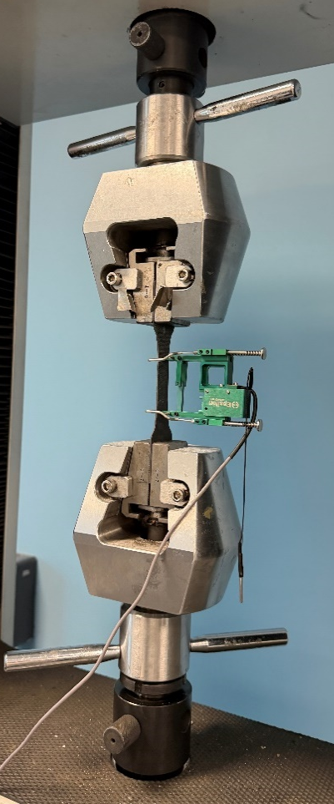
This investigation tested seven materials: one metallic aluminium alloy and six composites—non-woven and woven carbon and flax fibres with bio-resin, woven carbon with epoxy, and woven Kevlar (aramid) fibre. Bio-resin systems offer a more sustainable matrix, making resin comparison a key goal. Full specimen dimensions are in Table 4.1. Testing used a universal tensile machine (Figure 4.0a), with a green Epsilon clip-on extensometer mounted on each specimen at a 50 mm gauge length to measure strain precisely during elastic deformation.
Figure 4.0a: Universal tensile testing machine with Epsilon clip-on extensometer mounted on a composite specimen, Engineering Science Laboratories, UWTSD (Coveney, 2026)
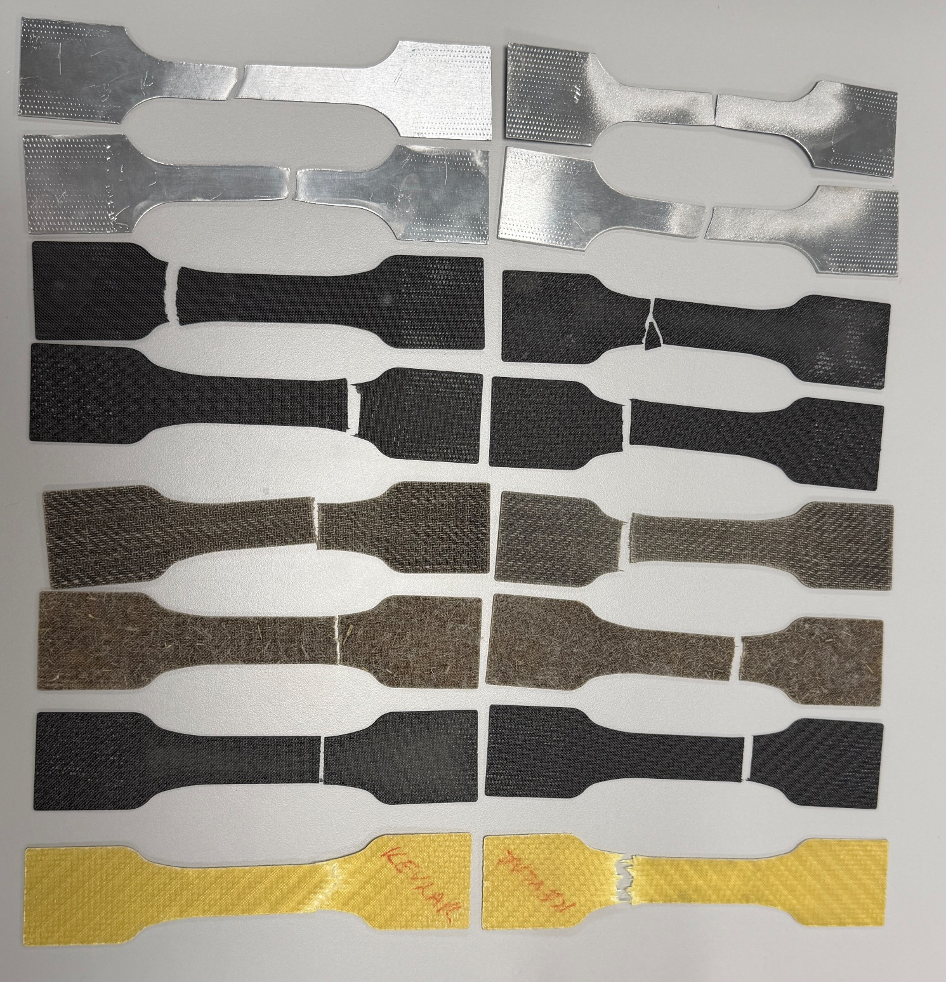
Figure 4.0b displays tested specimens post-fracture, highlighting each material's failure mode: brittle transverse fracture in carbon fibre, diffuse failure in flax, and fibrous progressive fracture in Kevlar.
Figure 4.0b: All tested specimens following tensile fracture, showing from top to bottom: aluminium alloy, carbon non-woven bio, carbon woven bio, carbon woven epoxy, flax non-woven bio, flax woven bio and Kevlar woven epoxy (Coveney, 2026)

4.2 Testing Standards and Procedures
Tensile testing was conducted in accordance with ISO 527-4 for isotropic and orthotropic fibre-reinforced plastic composites. Tests were conducted at ambient temperature under quasi-static conditions. Key data included ultimate tensile strength (UTS, Rm, in MPa), Young’s modulus (E, in GPa), and 0.2% proof stress (Rp0.2, in MPa), with two tests per material.
The extensometer was removed before specimen fracture to prevent damage, leading to less accurate post-peak displacement data; only crosshead movement was recorded as displacement. Initial stress/strain data were discarded to account for extensometer seating. A sharp load reversal, caused by the extensometer knife edge disengaging during removal, appears on curves, especially for woven carbon specimens, and is identifiable by a change from detailed, noisier data with the extensometer to smoother data from the crosshead. Data after this transition indicate general load-displacement behaviour rather than precise material strain.

4.3 Results
The results for all test specimens are presented in Table 4.1 below.
Material | Specimen | Width × Thickness (mm) | Cross-Section (mm²) | UTS — Rm (MPa) | Young's Modulus (GPa) | Rp0.2 (MPa)
Aluminium | T1 | 15 × 1.5 | 22.50 | 115 | 58.6 | 105
Aluminium | T2 | 15 × 1.5 | 22.50 | 118 | 55.6 | 110
Aluminium | T1b | 15 × 1.5 | 22.50 | 114 | 53.1 | 107
Aluminium | T2b | 15 × 1.5 | 22.50 | 113 | 50.6 | 104
Carbon Non-Woven Bio | T1 | 15 × 1.5 | 22.50 | 262 | 5.8 | 245
Carbon Non-Woven Bio | T2 | 20 × 1.5 | 30.00 | 190 | 4.8 | 152
Carbon Woven Bio | T1 | 15 × 1.5 | 22.50 | 274 | 33.8 | 191
Carbon Woven Bio | T2 | 20 × 1.5 | 30.00 | 203 | 26.4 | 150
Carbon Woven Epoxy | T1 | 19.5 × 0.7 | 13.65 | 404 | 70.0 | 344
Carbon Woven Epoxy | T2 | 19.5 × 0.7 | 13.65 | 442 | 56.3 | 325
Flax Non-Woven Bio | T1 | 20 × 1.5 | 30.00 | 36 | 6.7 | 29
Flax Non-Woven Bio | T2 | 19 × 1.0 | 19.00 | 55 | 11.6 | 41
Flax Woven Bio | T1 | 19 × 1.5 | 28.50 | 105 | 2.1 | 74
Flax Woven Bio | T2 | 20 × 1.5 | 30.00 | 100 | 2.1 | 84
Kevlar | T1 | 19.5 × 0.8 | 15.60 | 357 | 12.0 | 214
Kevlar | T2 | 20 × 1.5 | 30.00 | 194 | 4.6 | 148
Table 4.1 – Tensile Test Results

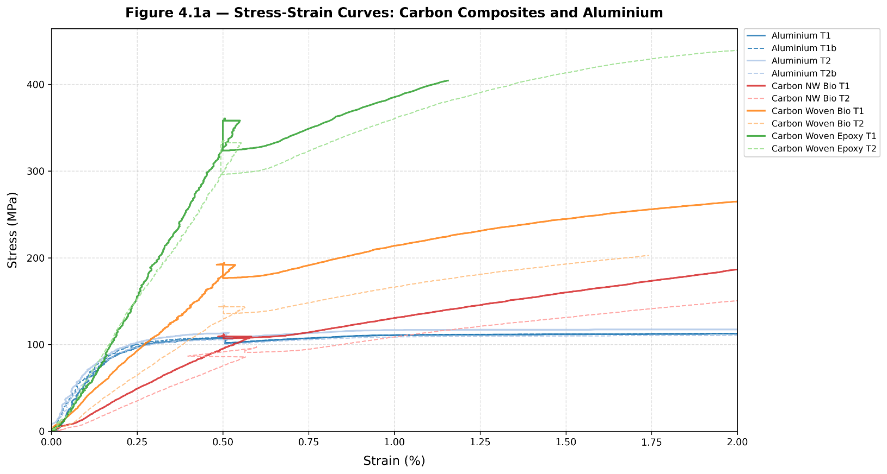
The stress-strain behaviour of all specimens during tensile testing is illustrated in Figures 4.1a and 4.1b, carbon composites and aluminium shown separately from flax, Kevlar and aluminium for clarity. Curves are presented to peak stress only, as post-fracture data were inconsistently captured across specimens.
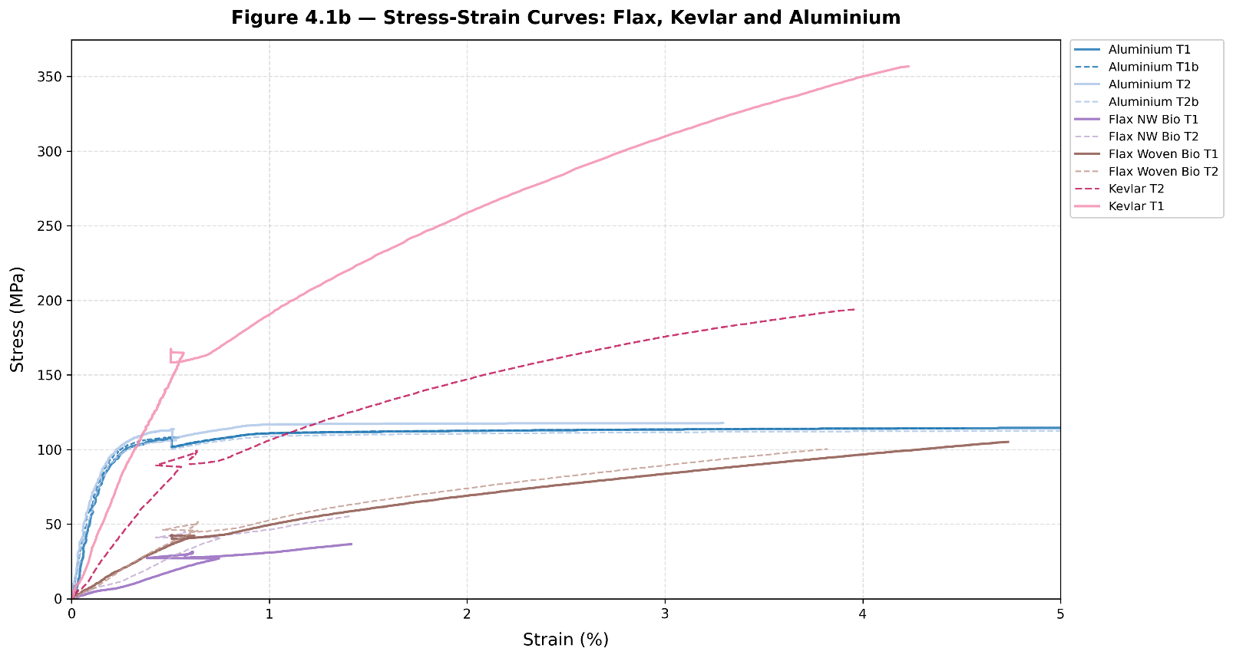
Figure 4.1a: Stress-strain curves for carbon fibre composites and aluminium reference material (Coveney, 2026)
Figure 4.1b: Stress-strain curves for flax, Kevlar and aluminium reference material (Coveney, 2026)
Mean UTS and Young’s modulus values are compared across material groups in Figures 4.2 and 4.3, respectively.
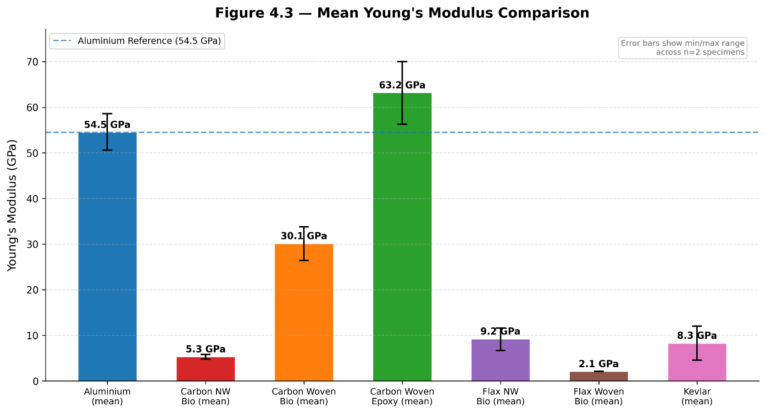
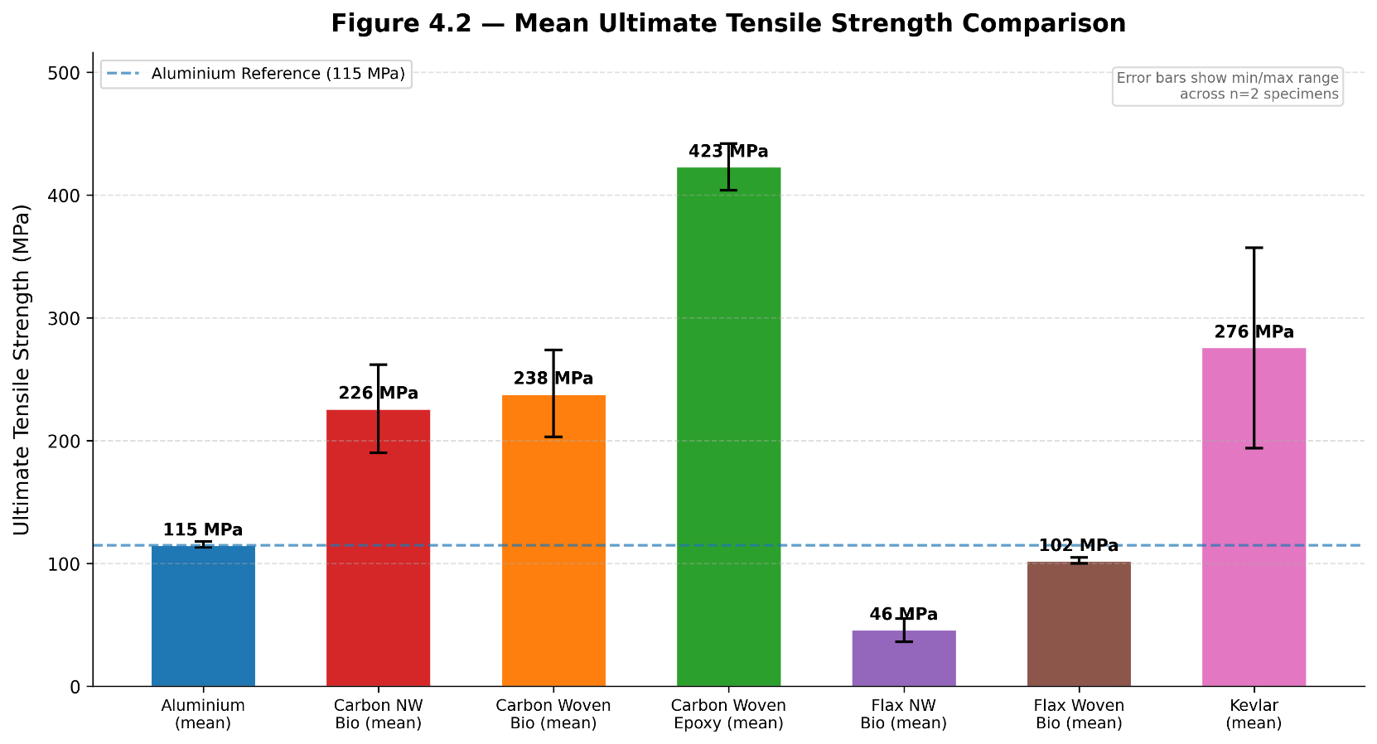
Figure 4.2: Mean ultimate tensile strength comparison across all tested materials (Coveney, 2026)
Figure 4.3: Mean Young's modulus comparison across all tested materials (Coveney, 2026)

4.4 Validation Against Published Data
To assess the reliability of the tensile test results, the measured values were compared with manufacturer data and values reported in the published literature. The comparison is presented in Table 4.2.
Table 4.2 – Comparison of Experimental Results Against Published Values
Material | Experimental UTS (MPa) | Published UTS (MPa) | Experimental Modulus (GPa) | Published Modulus (GPa) | Source
Aluminium alloy | 113–118 | 136 (cold-worked) / 366 (T6) | 50.6–58.6 | 71.23 | (Guo et al., 2022; Nietsch et al., 2025)
Carbon Woven Epoxy | 404–442 | 483–546 | 56–70 | 54.7–54.9 | (Gong et al., 2024)
Carbon Woven Bio | 203–274 | 645–655 | 26–34 | 54.7–54.9 | (Boursier Niutta et al., 2023)
Flax Woven Bio | 100–105 | 100–300 | 2.1 | 10–30 | (Ahmad et al., 2015)
Kevlar Woven | 194–357 | 167–172 | 4.6–12.0 | 9.3 | (Yeung & K.P. Rao, 2011)
The carbon-woven epoxy’s UTS of 404–442 MPa and modulus of 56–70 GPa align with published ranges of 483–546 MPa and 58–62 GPa for similar composites with 47–53% fibre volume (Gong et al., 2024). Lower experimental values stem from reduced fibre content, typical of hand-prepared specimens compared to controlled manufacturing.
The carbon woven bio results, with strengths of 203–274 MPa, are below the 645–655 MPa reported by Boursier Niutta et al. (2023), with differences between T1 and T2 specimen widths discussed in Section 4.5. The experimental modulus of 26–34 GPa is also lower than the published range of 54.7–54.9 GPa, due to a reduced fibre volume fraction and the lower stiffness of the bio-resin matrix compared to conventional epoxy.
The flax-woven bio specimens exhibited UTS values of 100–105 MPa, at the lower end of the 100–300 MPa range associated with fibre type, volume fraction, and manufacturing method (Ahmad et al., 2015). The experimental modulus of 2.1 GPa is lower than the typical 10–30 GPa range, likely due to the bio-resin matrix's reduced stiffness relative to conventional thermosets, and its sensitivity to testing irregularities and manufacturing variability, consistent with the findings of Kirschnick et al. (2024).
The Kevlar specimens produced UTS values of 194–357 MPa; the lower bound is consistent with the 167–172 MPa reported by Yeung & K.P. Rao (2011) for Kevlar 49 thermoplastic composites. The T1 test yielded an upper bound of 357 MPa, reflecting the superior interfacial strength of the epoxy matrix relative to thermoplastic systems, as further discussed in Section 4.5.3.
Aluminium specimens had a mean UTS of 115 MPa, well below the 366 MPa of the EN AW–6082–T6 alloy reported by Nietsch et al. (2025). This confirms the specimens are a low-grade, non-heat-treated alloy; Guo et al. (2022), reported 136 MPa for grain-refined pure aluminium, consistent with these results. The measured modulus of 50.6–58.6 GPa reflects chord modulus reduction during plastic deformation.

4.5 Discussion of Results
This study tested only two specimens per material, whereas ISO 527-4 recommends at least five for reliable statistical analysis. With only two samples, a meaningful standard deviation or coefficient of variation cannot be determined. As a result, findings are indicative rather than conclusive. This limitation is especially relevant for the carbon non-woven bio and Kevlar materials, where inter-specimen UTS varied by over 25%, indicating high sensitivity to specimen geometry or manufacturing differences.

4.5.1 Carbon Fibre Composites
The carbon-woven epoxy specimens exhibited the highest tensile strength among tested materials (Figure 4.1a, Figures 4.2, 4.3), with a mean UTS of 423 MPa and a modulus of approximately 63 GPa, significantly exceeding that of the aluminium reference at 115 MPa. Consistent results across both specimens, along with typical brittle transverse fractures, confirm their strength and reliability. The stress-strain curves (Figure 4.1a) illustrate linear-elastic behaviour to failure without a yield plateau, consistent with CFRP's brittle fracture mode. In contrast, aluminium exhibits a ductile elastic-plastic transition, visible in Figure 4.1a, reflecting its ductile failure mode and contrasting with the linear-elastic behaviour of all tested composites. Carbon woven epoxy achieves a specific strength of approximately 273 kN·m/kg, compared to 43 kN·m/kg for aluminium, a 6.3-fold advantage—underscoring its use in weight-critical motorsport structures.
The carbon-woven bio specimens showed lower strength values of 203–274 MPa, partly due to differences in specimen width (15 mm vs 20 mm). As noted in Section 2.1, Boursier Niutta et al. (2023) noted no statistically significant difference in quasi-static tensile strength between conventional epoxy and bio-epoxy carbon fibre composites, indicating that performance differences are likely due to specimen geometry rather than resin system quality.
Non-woven carbon bio specimens show low modulus (~5 GPa) despite UTS of 190–262 MPa, due to random fibre orientation that causes the response to be matrix-dominated rather than fibre-reinforcement (Ekoi et al., 2021).

4.5.2 Flax Fibre Composites
The woven flax bio-specimens had an average UTS of approximately 102 MPa and a low modulus of 2.1 GPa (Figures 4.1b, 4.2), which is weaker than that of carbon composites but typical for natural fibre composites. Non-woven flax specimens were weaker, with tensile strengths of 36–55 MPa, due to random fibre orientation, and exhibited a more diffuse failure zone than carbon composites (Figure 4.0b). Woven flax shows a more gradual stress increase than non-woven variants due to its aligned fibre architecture, as seen in Figure 4.1b.

4.5.3 Kevlar
The Kevlar specimens showed variable results, with UTS values of 194 MPa and 357 MPa (Figure 4.1b), and moduli of 12.0 GPa and 4.6 GPa. They had different cross-sectional areas—15.6 mm² for T1 and 30 mm² for T2—indicating T2 had more plies. Increasing laminate thickness in multi-ply woven composites does not proportionally increase tensile strength due to interlaminar defects and consolidation voids. The 357 MPa and 12.0 GPa values for T1 align with published data for thin woven Kevlar epoxy laminates, making it more reliable for material characterisation. The fibrous fracture profile, shown in Figure 4.0b, indicates fibre pull-out rather than brittle fracture as seen in carbon epoxy specimens. Kevlar's progressive failure mode and higher strain-to-fracture make it better suited for energy-absorbing crash structures than brittle, low-strain CFRP options.

5.0 Recommendations Based on Test Results
This study evaluates materials for composite motorsport and automotive use based on mechanical performance and sustainability. Carbon woven epoxy has the highest tensile strength, with a mean UTS of 423 MPa and a 63 GPa modulus—about 3.7 times that of aluminium at similar stiffness. Suitable for high-load structural parts like monocoque chassis, roll hoops, and suspension wishbones, it offers high strength and light weight. Testing confirms its reliability, but environmental and recycling concerns restrict its use to essential structural components.
Carbon-woven bio resin composites have mean UTS values of 203–274 MPa, lower than epoxy but significantly higher than aluminium. Boursier Niutta et al. (2023) found no significant difference in quasi-static tensile strength between bio-epoxy and traditional epoxy carbon fibre composites under controlled conditions. The performance gap results from specimen geometry, not material limitations. These bio-composites are suitable for semi-structural automotive and motorsport parts such as body panels, aerodynamic elements, and interior brackets, offering sustainability benefits with minimal mechanical compromises.
Woven flax bio-composites have a mean UTS of 102 MPa, like aluminium, but a low modulus of 2.1 GPa, limiting their use to non-structural parts such as interior trim, door linings, underbody cladding, and aerodynamic fairings in automotive and motorsport applications. They also use 80% less energy during production than synthetic fibre composites, as reported by Prasad et al. (2024), emphasising the importance of lifecycle accounting as the industry moves toward electrification. Kevlar-woven epoxy, with a tensile strength of 357 MPa, undergoes progressive deformation and provides impact resistance, making it suitable for crash structures, side-impact panels, and helmet shells in motorsport.
Scalable end-of-life recycling for CFRP is a crucial gap between current composite use and circular economy goals. Keith et al. (2025) identify solvolysis as a promising recovery route, though industrial-scale application remains limited. Future research should optimise the process, assess economic viability, and evaluate the mechanical performance of recycled carbon fibre—such as multi-axial loading, high-temperature resistance, and fatigue life—to determine if recycled CFRP can replace virgin material in motorsport and automotive parts under real-world conditions.

6.0 Conclusions
This study tested six composite materials, including an aluminium reference, to assess their mechanical performance and sustainability for automotive and motorsport uses. Carbon woven epoxy showed the highest tensile strength, with a mean UTS of 423 MPa and a modulus of 63 GPa—about 3.7 times that of aluminium—confirming its suitability for structural parts. Carbon-woven bio resin composites performed similarly to epoxy under controlled conditions, supporting their use in semi-structural, low-carbon applications. Woven flax bio-composites had a UTS of around 102 MPa, comparable to aluminium, but with much lower stiffness, making them suitable for non-structural parts where sustainability is key. Natural fibre composites reduce energy use in production by 80% compared to synthetics, thereby enhancing their lifecycle benefits. Key sustainability challenges include energy-intensive carbon fibre production, limited recycling infrastructure, and the need to balance performance with circular economy standards. A hybrid approach—using CFRP for high-load parts and natural fibres elsewhere, alongside recycling investments—offers a practical path for sustainable automotive and motorsport composites.

Bibliography
Abdurohman, K., Satrio, T., Muzayadah, N. L., & Teten. (2018). A comparison process between hand lay-up, vacuum infusion and vacuum bagging method toward e-glass EW 185/lycal composites. Journal of Physics: Conference Series, 1130(1). https://doi.org/10.1088/1742-6596/1130/1/012018
Ahmad, F., Choi, H. S., & Park, M. K. (2015). A review: Natural fiber composites selection in view of mechanical, light weight, and economic properties. In Macromolecular Materials and Engineering (Vol. 300, Number 1, pp. 10–24). Wiley-VCH Verlag. https://doi.org/10.1002/mame.201400089
Boursier Niutta, C., Ciardiello, R., Tridello, A., & Paolino, D. S. (2023). Epoxy and Bio-Based Epoxy Carbon Fiber Twill Composites: Comparison of the Quasi-Static Properties. Materials, 16(4). https://doi.org/10.3390/ma16041601
Çetin, A., Uzay, Ç., & Geren, N. (2025). Effect of Fiber Architecture on the Physical and Mechanical Properties of Carbon Fiber-Reinforced Polymer Composites. Arabian Journal for Science and Engineering, 50(22), 18925–18938. https://doi.org/10.1007/s13369-024-09908-4
Department for Transport. (2021). Decarbonising Transport: A Better, Greener Britain. www.gov.uk/dft
Ekoi, E. J., Dickson, A. N., & Dowling, D. P. (2021). Investigating the fatigue and mechanical behaviour of 3D printed woven and nonwoven continuous carbon fibre reinforced polymer (CFRP) composites. Composites Part B: Engineering, 212. https://doi.org/10.1016/j.compositesb.2021.108704
FIA. (2020, December 17). FIA introduces sustainable fuel into Formula 1 and commits to becoming carbon neutral from 2021 and net zero by 2030. Https://Www.Fia.Com/News/Fia-Introduces-Sustainable-Fuel-Formula-1-and-Commits-Becoming-Carbon-Neutral-2021-and-Net-Zero.
Gong, J., Saeed, N., Huang, X., Tian, W., Li, L., & Song, J. (2024). Influences of Fiber Volume Content on the Mechanical Properties of 2D Plain Carbon-Fiber Woven Composite Materials. Polymers, 16(1). https://doi.org/10.3390/polym16010108
Guo, S., Yu, H., Wang, Z., Yu, W., Cheng, W., Huang, L., Liu, C., Yin, F., Zhao, W., & Qin, C. (2022). Microstructural Evolution and Mechanical Properties of Pure Aluminum upon Multi-Pass Caliber Rolling. Materials, 15(3). https://doi.org/10.3390/ma15031206
Hermansson, F., Janssen, M., & Svanström, M. (2019). Prospective study of lignin-based and recycled carbon fibers in composites through meta-analysis of life cycle assessments. Journal of Cleaner Production, 223, 946–956. https://doi.org/10.1016/j.jclepro.2019.03.022
Holberry, J., & Houston, D. (2006). Natural-Fiber-Reinforced Polymer Composites in Automotive Applications. https://doi.org/10.1007/s11837-006-0234-2
Joost, W. J. (2012). Reducing vehicle weight and improving U.S. energy efficiency using integrated computational materials engineering. JOM, 64(9), 1032–1038. https://doi.org/10.1007/s11837-012-0424-z
Keith, M. J., Al-Duri, B., McDonald, T. O., & Leeke, G. A. (2025). Solvent-Based Recycling as a Waste Management Strategy for Fibre-Reinforced Polymers: Current State of the Art. In Polymers (Vol. 17, Number 7). Multidisciplinary Digital Publishing Institute (MDPI). https://doi.org/10.3390/polym17070843
Kirschnick, U., Feuchter, M., Ravindran, B., Salzmann, M., Duretek, I., Fauster, E., & Schledjewski, R. (2024). Manufacturing bio-based fiber-reinforced polymer composites: process performance in RTM and VARI processes. Advanced Manufacturing: Polymer and Composites Science, 10(1). https://doi.org/10.1080/20550340.2024.2379205
Nietsch, J. A., Ott, A. C., Watzl, G., Cerny, A., Grabner, F. J., Grünsteidl, C., & Österreicher, J. A. (2025). Comparative study of elastic properties measurement techniques during plastic deformation of aluminum, magnesium, and titanium alloys: application to springback simulation. Meccanica, 60(1), 55–72. https://doi.org/10.1007/s11012-024-01918-8
Prasad, V., Alliyankal Vijayakumar, A., Jose, T., & George, S. C. (2024). A Comprehensive Review of Sustainability in Natural-Fiber-Reinforced Polymers. In Sustainability (Switzerland) (Vol. 16, Number 3). Multidisciplinary Digital Publishing Institute (MDPI). https://doi.org/10.3390/su16031223
Sakai, S. ichi, Yoshida, H., Hiratsuka, J., Vandecasteele, C., Kohlmeyer, R., Rotter, V. S., Passarini, F., Santini, A., Peeler, M., Li, J., Oh, G. J., Chi, N. K., Bastian, L., Moore, S., Kajiwara, N., Takigami, H., Itai, T., Takahashi, S., Tanabe, S., … Yano, J. (2014). An international comparative study of end-of-life vehicle (ELV) recycling systems. In Journal of Material Cycles and Waste Management (Vol. 16, Number 1, pp. 1–20). https://doi.org/10.1007/s10163-013-0173-2
Savage, G. (2010). Formula 1 Composites Engineering. Engineering Failure Analysis, 17(1), 92–115. https://doi.org/10.1016/j.engfailanal.2009.04.014
Wazeer, A., Das, A., Abeykoon, C., Sinha, A., & Karmakar, A. (2023). Composites for electric vehicles and automotive sector: A review. In Green Energy and Intelligent Transportation (Vol. 2, Number 1). Elsevier B.V. https://doi.org/10.1016/j.geits.2022.100043
Yeung, H., & K.P. Rao. (2011, October 3). Mechanical Properties of Kevlar-49 Fibre Reinforced Thermoplastic Composites. 18th International Conference on Composites Materials, ICCM 2011.

Appendix A: Raw Test Data
Full tensile test results for all sixteen specimens are presented in Table A.1 below.
Material | Specimen | Width × Thickness (mm) | Cross-Section (mm²) | UTS — Rm (MPa) | Young's Modulus (GPa) | Rp0.2 (MPa)
Aluminium | T1 | 15 × 1.5 | 22.50 | 115 | 58.6 | 105
Aluminium | T2 | 15 × 1.5 | 22.50 | 118 | 55.6 | 110
Aluminium | T1b | 15 × 1.5 | 22.50 | 114 | 53.1 | 107
Aluminium | T2b | 15 × 1.5 | 22.50 | 113 | 50.6 | 104
Carbon Non-Woven Bio | T1 | 15 × 1.5 | 22.50 | 262 | 5.8 | 245
Carbon Non-Woven Bio | T2 | 20 × 1.5 | 30.00 | 190 | 4.8 | 152
Carbon Woven Bio | T1 | 15 × 1.5 | 22.50 | 274 | 33.8 | 191
Carbon Woven Bio | T2 | 20 × 1.5 | 30.00 | 203 | 26.4 | 150
Carbon Woven Epoxy | T1 | 19.5 × 0.7 | 13.65 | 404 | 70.0 | 344
Carbon Woven Epoxy | T2 | 19.5 × 0.7 | 13.65 | 442 | 56.3 | 325
Flax Non-Woven Bio | T1 | 20 × 1.5 | 30.00 | 36 | 6.7 | 29
Flax Non-Woven Bio | T2 | 19 × 1.0 | 19.00 | 55 | 11.6 | 41
Flax Woven Bio | T1 | 19 × 1.5 | 28.50 | 105 | 2.1 | 74
Flax Woven Bio | T2 | 20 × 1.5 | 30.00 | 100 | 2.1 | 84
Kevlar | T1 | 19.5 × 0.8 | 15.60 | 357 | 12.0 | 214
Kevlar | T2 | 20 × 1.5 | 30.00 | 194 | 4.6 | 148
Table A.1 — Tensile Test Results for All Specimens

Table A.2 presents an extract of the raw data obtained from the universal testing machine for a representative specimen (Aluminium T1), illustrating the column structure and data acquisition parameters common across all sixteen test files.
All test data was obtained with a sampling rate of 50Hz.
Table A.2 — Extract of Raw Test Machine Data (Aluminium T1, first 10 data rows)
Time (s) | Load (kN) | Elongation (mm) | Displacement (mm) | Stress (MPa) | Strain (%)
0.00 | 0.000 | 0.0000 | 0.000 | 0.000 | 0.000
0.02 | 0.000 | 0.0004 | 0.000 | 0.000 | 0.001
0.04 | 0.000 | 0.0008 | 0.000 | 0.000 | 0.002
0.06 | 0.000 | 0.0014 | 0.000 | 0.000 | 0.003
0.08 | 0.000 | 0.0020 | 0.000 | 0.000 | 0.004
0.10 | 0.000 | 0.0024 | 0.000 | 0.000 | 0.005
0.12 | 0.000 | 0.0026 | 0.000 | 0.000 | 0.005
0.14 | 0.000 | 0.0028 | 0.000 | 0.000 | 0.006
0.16 | 0.000 | 0.0028 | 0.001 | 0.000 | 0.006
0.18 | 0.000 | 0.0030 | 0.001 | 0.000 | 0.006

Appendix B: Equipment Specifications / Calibration Data
Table B.1 – Tensile Testing Equipment Specifications
Equipment | Specification
Testing machine | Universal tensile testing machine
Extensometer | Epsilon clip-on extensometer
Gauge length | 50 mm
Data acquisition rate | 50 Hz
Test standard | ISO 527-4
All tensile tests were conducted under displacement control at a constant crosshead speed in accordance with the requirements of ISO 527-4. The load cell was zeroed prior to each test, and specimen dimensions were measured using vernier callipers before clamping. Specimens were aligned vertically within the grips to minimise bending moments during loading. The extensometer was attached within the reduced gauge section of each specimen and removed manually prior to anticipated specimen fracture to prevent instrument damage.
Extensometer Specification | Detail
Manufacturer | Epsilon Technology Corp
Type | Clip-on axial extensometer
Gauge length | 50 mm
Measurement principle | Resistance strain gauge bridge
Application | Direct specimen surface contact via knife edges
Table B.2 – Extensometer Specifications

Appendix C: Manufacturer Datasheets
Table C.1 — Published Mechanical Property Ranges for Tested Material Types
Material | UTS (MPa) | Modulus (GPa) | Density (g/cm³) | Source
Low-grade aluminium alloy | 95–136 | 57–71 | 2.70 | Guo et al. (2022); Nietsch et al. (2025)
Carbon woven epoxy | 483–546 | 58–62 | 1.55 | Gong et al. (2024)
Carbon woven bio-epoxy | 645–655 | 54.7–54.9 | ~1.50 | Boursier Niutta et al. (2023)
Flax-woven bio-composite | 100–300 | 10–30 | ~1.30 | Ahmad et al. (2015)
Kevlar-49 thermoplastic composite | 167–172 | ~9.3 | ~1.35 | Yeung & K.P. Rao (2011)
Density values are approximate literature values for similar fibre-matrix composites. Published property ranges, based on peer-reviewed reports of comparable systems, serve as validation references in Section 4.4.

