ACBA4017 – Digital Surveying and Highway Design – Assignment:
Planning of a Digital Survey of the Dylan Thomas Centre, a Grade II listed neoclassical building in Swansea.

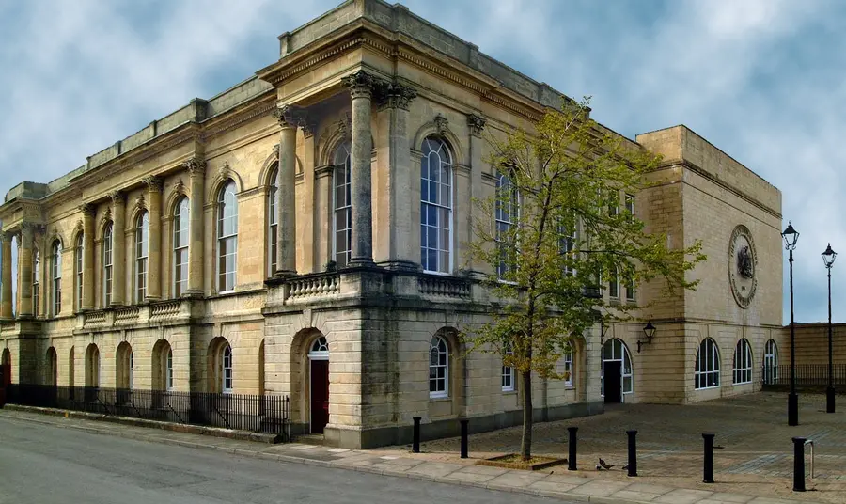

Heritage Fund (2018)

Prepared By: Morgan Owens
For Review By: Hannah Williams & Deborah Hughes
Contents
Introduction 3
Survey Objectives and Scope 3
Selection of Digital Tools and Technologies 4
Laser Scanning (LiDAR / 3D Laser Scanners) 4
Building Information Modelling (BIM) 4
Thermal Imaging Cameras 5
Survey Planning 5
Challenges and Solutions 5
Conclusion and Recommendations 6
References 7

Introduction
Building surveys are an important part of property management whether you’re buying, selling, renovating or maintaining a building. They give a detailed picture of the property’s condition and help identify issues like damp, subsidence or structural damage. This information helps owners and buyers make informed decisions, plan repairs and avoid unexpected costs. This article looks at why surveys matter in the property industry and how technology is changing the way they’re done. It also explains the different types of surveys and what they can do for individuals and organisations involved in property investment and management.

The use of Digital tools, have made building surveys faster, safer, and more accurate. Technologies like 3D laser scanning and LiDAR allow surveyors to create detailed digital models of buildings, making it easier to spot issues and plan repairs. Drones are now more commonly used to inspect roofs and other hard to reach areas, often with thermal cameras attached to detect heat loss or damp, without needing ladders or scaffolding, saving time and being safer. Another key development is Building Information Modelling (BIM), which creates a digital version of the building, including details about its structure and systems. This helps teams work together more effectively and manage the building over time. Surveyors also use mobile apps and cloud based software to collect and share data onsite, which speeds up reporting and reduces errors. Clients can access this information online, making the process more transparent and efficient.

In summary, building surveys are necessary for understanding a property's condition and planning for its future. With the help of digital technology, surveys are becoming more thorough, efficient, and easier to use, which is helping the industry move towards a more modern and reliable approach.

Historic England (2024);
Leica Geosystems (n.d.);
Surphaser (n.d.)

Survey Objectives and Scope
The primary objective of a building survey is to deliver a thorough and systematic evaluation of a structure’s physical condition, the performance, and the compliance with the current building standards and regulations. A building survey begins with an assessment of the structural integrity of the property, identifying any visible or underlying issues such as cracks, subsidence, dampness, or material fatigue that may compromise the building’s safety and/or longevity. This includes both load bearing elements and non-structural components, ensuring a general understanding of the building’s stability.

Terra Measurement (n.d.);
Gil et al. (2024))

In addition to structural analysis, the survey involves detailed documentation of the building’s existing conditions. This includes accurate measurements, spatial configurations, construction materials, and architectural features. Such documentation is vital for producing as-built drawings and for informing future design interventions, whether for renovation, restoration, or adaptive reuse. The survey also evaluates the condition and functionality of building services, including electrical systems, plumbing, heating, ventilation, air conditioning (HVAC), and fire safety installations. Ensuring these systems are operational and compliant with modern standards is crucial for occupant safety and comfort.

Another key objective is to identify defects, deterioration, and areas requiring maintenance. This proactive approach allows for the development of maintenance schedules, cost estimates, and repair strategies, extending the building’s lifespan and reducing long term costs. The survey also plays a critical role in verifying that the building adheres to local building codes, accessibility standards, and environmental regulations, including energy efficiency and sustainability benchmarks. This ensures that the building is not only legally compliant but also aligned with contemporary architectural values and practices.

From a design and planning perspective, the data collected through a building survey provides a fundamental understanding of the site and its constraints, enabling architects and designers to make informed decisions. Furthermore, building surveys are instrumental in property valuation and real estate transactions, offering stakeholders a clear picture of the building’s condition, potential liabilities, and investment value. Overall, building surveys serve as a bridge between theoretical knowledge and real world application, equipping students with the analytical and observational skills necessary for professional practice in architecture and construction.

The scope of this building survey focuses on the Dylan Thomas Centre. Originally constructed in 1829 as the Swansea Guildhall, the building now operates as a museum and arts centre dedicated to the life and legacy of the poet Dylan Thomas. Given its historical significance and adaptive reuse, the survey aims to assess a wide range of architectural and structural elements. Key areas of focus include evaluating the structural integrity of the building’s foundations, walls, and roof, particularly in relation to age related wear and any previous alterations. The externals, including but not limited to façades, roofing, and fenestration, will be examined for signs of weathering, water ingress, and thermal inefficiency. Internally, the survey will document the condition of public exhibition spaces, finishes, and circulation areas, with attention to accessibility and compliance with modern building regulations. The performance and safety of building services, such as electrical, plumbing, HVAC, and fire protection systems will also be reviewed to ensure they are suitable for the use and structure of the building.

Additionally, the survey will also consider the conservation of original architectural features and materials, ensuring that any recommendations for repair or upgrade are sensitive to the building’s heritage status. Environmental performance, including insulation and energy use, will be preliminarily assessed to identify opportunities for sustainable improvements that align with conservation principles.

Selection of Digital Tools and Technologies
Modern building surveys increasingly rely on digital tools and technologies to enhance accuracy, efficiency, and data integration. These tools are especially valuable when surveying complex or historically significant structures, such as the Dylan Thomas Centre, where traditional methods may be limited or invasive. The following section outlines three key technologies—laser scanning, Building Information Modelling (BIM), and thermal imaging cameras—and justifies their use based on the objectives and scope of the survey.

Laser Scanning (LiDAR / 3D Laser Scanners)
Laser scanning, often referred to as LiDAR (Light Detection and Ranging), is a highly accurate method for capturing the geometry of a building in three dimensions. It works by emitting laser beams that measure distances to surfaces, generating a dense point cloud that represents the building’s form and spatial characteristics. This technology is particularly useful for documenting existing conditions, especially in heritage buildings where original drawings may be incomplete or outdated. For the Dylan Thomas Centre, laser scanning enables the precise recording of architectural details without physical contact, preserving delicate features while providing a reliable basis for analysis and future design work. It also facilitates structural assessments by revealing deformations, misalignments, or irregularities that may not be visible through traditional surveying methods.

Building Information Modelling (BIM)
Building Information Modelling (BIM) is a digital process that involves creating a comprehensive 3D model of a building, integrating both its physical and functional characteristics. BIM allows for the centralisation of survey data, including inputs from laser scanning, and supports collaboration among architects, engineers, and conservation specialists. In the context of the Dylan Thomas Centre, BIM is particularly valuable for managing the building’s lifecycle, enabling planners to simulate design interventions, assess spatial relationships, and coordinate restoration efforts. It also enhances decision making by providing a visual where various scenarios can be assessed before implementation. The use of BIM ensures that any proposed changes are well informed and sensitive to the building’s historical significance.

Thermal Imaging Cameras
Thermal imaging cameras are used to detect temperature variations across building surfaces, revealing issues such as heat loss, moisture intrusion, and insulation defects. These cameras operate by capturing infrared radiation, which is then translated into visual data that highlights thermal anomalies. For older buildings like the Dylan Thomas Centre, thermal imaging is an invaluable tool for assessing environmental performance without invasive procedures. It helps identify hidden problems such as dampness behind walls or poorly insulated roof areas, which may not be apparent during a visual inspection. This technology supports the survey’s objective of improving energy efficiency and occupant comfort while maintaining the integrity of the historic structure.

FJDynamics (2025) ;
Martín-Lerones et al. (2021).
Leica Geosystems (n.d.).
Surphaser (n.d.).
Historic England (2024)

Survey Planning
The Dylan Thomas Centre building survey will follow a simple plan, starting with preparation. This will involve reviewing existing drawings, historical records and previous reports to understand the building’s history. Consents will be obtained and safety checks will be done. The main objectives of the survey are to assess the building’s structure, document its condition and evaluate its environmental performance. To do this a mix of traditional and digital tools will be used.

Laser scanning will capture the building’s shape in 3D to create accurate models and identify any structural issues. Thermal imaging will be used to find areas of heat loss or dampness especially around windows and roofs. A visual inspection will identify visible problems like cracks or water damage and manual measurements will be taken where necessary. Photos will be used to record key features and defects and the building’s services (electrics, plumbing and heating) will also be checked.

Leica Geosystems (n.d.).
Terra Measurement (n.d.) ;
Gil et al. (2024)

Once the site visit is finished, the data will be collected, processed and analysed. The 3D scans will be turned into a digital model using BIM software, and thermal images will be reviewed to highlight problem areas. All findings will be brought together in a final report, which will include visuals, a summary of issues, and recommendations for repairs or improvements. Throughout the process, care will be taken to protect the building’s historic features and follow health and safety rules.

Challenges and Solutions
There may be a few problems during the building survey of the Dylan Thomas Centre. Some parts of the building might be hard to reach or in use by the public. To get around this, the survey can be done during quieter times or after it closes, and tools like drones or laser scanners can help reach difficult areas. Then, as the building is old and protected, we need to be careful not to damage anything. Using safe tools like thermal cameras and 3D scanners means we can check things without touching them. Next, as the building is based in Wales, bad weather or poor lighting might make it hard to collect good data. Planning the survey for a dry day and bringing extra lights can help. Fourth, the digital tools we use will collect a lot of data, which can be hard to manage. Using the right software and having trained people on the team will make this easier. Lastly, safety is very important. If we need to work at height or in small spaces, we will make sure to wear the right gear and follow safety rules. With good planning, these challenges can be handled easily.

Historic England (2024);
Martín-Lerones et al. (2021).
FJDynamics (2025)

Conclusion and Recommendations
The survey of the Dylan Thomas Centre will follow a set process. It starts with preparation, reviewing existing documents, setting goals and choosing the right tools. On site the survey will use laser scanning to capture the shape of the building, thermal imaging to detect heat loss and damp, and visual inspections to find any damage. Photos and manual measurements will support the digital data, and the condition of services like plumbing and electrics will be checked. After the visit all the data will be processed and analysed using BIM software to produce a model. The final report will include visuals, findings and recommendations for repairs or improvements. Throughout the survey we will follow safety rules and take care to protect the historic fabric of the building.

References

FJDynamics. (2025). Top 10 3D Laser Scanners for Buildings in 2025. [online] Available at: https://www.fjdynamics.com/blog/industry-insights-65/best-3d-laser-scanner-for-buildings-347 [Accessed 17 Jul. 2025].

Gil, A., Arayici, Y., Kumar, B. and Laing, R. (2024). Machine and Deep Learning Implementations for Heritage Building Information Modelling: A Critical Review. [online] University of Strathclyde. Available at: https://strathprints.strath.ac.uk/88886/7/Gil-etal-JCCH-2024-Machine-and-deep-learning-implementations-for-heritage-building.pdf [Accessed 17 Jul. 2025].

Historic England. (2024). Surveying and Recording Heritage. [online] Available at: https://historicengland.org.uk/advice/technical-advice/recording-heritage/ [Accessed 19 Jul. 2025].

Leica Geosystems. (n.d.). Building Construction with 3D Laser Scanning. [online] Available at: https://leica-geosystems.com/industries/pure-surveying/get-inspired-to-grow-your-business/laser-scanning/building-construction [Accessed 19 Jul. 2025].

Leica Geosystems. (n.d.). Heritage Surveying with Surveybase. [online] Available at: https://leica-geosystems.com/case-studies/reality-capture/heritage%20surveying%20with%20surveybase [Accessed 18 Jul. 2025].

Martín-Lerones, P., Olmedo, D., López-Vidal, A., Gómez-García-Bermejo, J. and Zalama, E. (2021). BIM Supported Surveying and Imaging Combination for Heritage Conservation. Remote Sensing, 13(8), p.1584. [online] Available at: https://www.mdpi.com/2072-4292/13/8/1584 [Accessed 18 Jul. 2025].

Surphaser. (n.d.). How 3D Laser Scanners Work for Buildings. [online] Available at: https://surphaser.com/blog/3d-laser-scanner-for-buildings-how-it-works/ [Accessed 24 Jul. 2025].

Terra Measurement. (n.d.). Digital Twin and Measured Building Surveys. [online] Available at: https://terrameasurement.com/measured-building/ [Accessed 16 Jul. 2025].

Heritage Fund (2018). The Dylan Thomas Exhibition Centre [Photograph]. Available from: https://www.heritagefund.org.uk/projects/dylan-thomas-exhibition [Accessed 24 Jul. 2025]

