Assessment Form

Module: Preparing for Professional Policing
Student Name: D’Andre Wells
Module Tutor (s): Kelly Andrews
Question | 1  Situation | 2  Task | 3.  Action | 4.  Result |  | Total Mark
1 | 5/5 | 2/5 | 15/15 | 5/5 |  | 27/30
2 | 5/5 | 3/5 | 15/15 | 2/5 |  | 25/30
3 | 5/5 | 3/5 | 13/15 | 4/5 |  | 25/30
 |  |  |  |  |  | Total Mark 77 /90
Key
No Reference | Minimum | Satisfactory | Exceptional
0 | 0-4 | 5-10 | 11-15

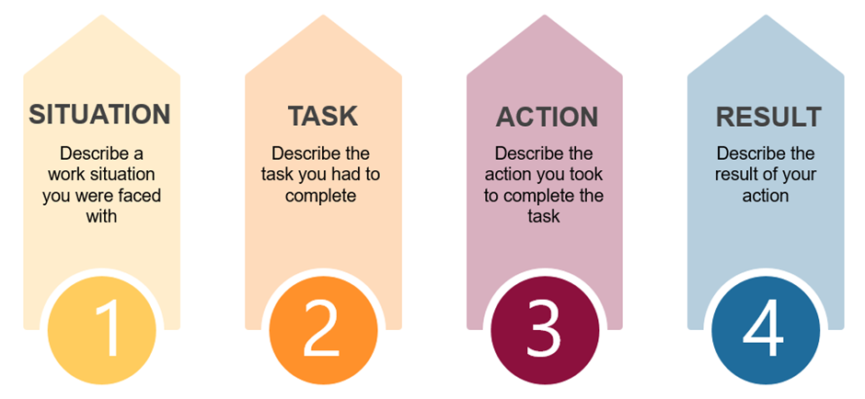

Question | Comments
1 | Q5  Situation: Went to a call – serious incident female injured. 10 people in the flat.  Speaking to the ten people stories were not adding up.  I made the decision to arrest all ten people, I couldn’t just hold them all I had now power.  If I had let them go or they could have been suspects. Within that short space of time, I made the decision to arrest.  If I had not done that they could have Disa guarded key evidence.  Result: All ten were taken to custody for questioning.
2 | Q8.  Example – domestic incident – female very erratic  Task: Needed to let her talk  Actions: Let her talk – picking out key points – I was able to calm her – reassured her – I went back over the key points that she covered in her account – she was a lot calmer- I was able to piece together what had happened bit by bit, rather than jumping around it. Took 3 hours to do this. Also kept her up to date with what happened.  Adjusted voice because of ALN – adjusted way I spoke to her  Result: emailed the police with female. Very positive result she completely changed her view of the police
3 | Q7;  Went to a DV incident with a colleague but my colleague didn’t want to do this.  In the moment we didn’t have time to talk to through. I made the arrest. My colleague didn’t agree. Sat him down after and explained why I had made that decision; he had missed a keep point of information and had a different view.  I may have been wrong – so we both sat down to discuss our views. I was able to make him understand the reason for this, after the conversation we had was finished. His views were as reliant as mine which I took into consideration.  Needed to highlight task in more detail.  Very good detail around actions and situation for each question needs to provide more for task.  Excellent examples given.  .

.

.

