LCBB4005
THE GLOBAL BUSINESS ENVIRONMENT
Assignment 1

Angela Nastasiu
Student ID (1907399)

Contents
Introduction 2
PESTEL analysis of the car manufacturing industry 3
Political 3
Economic 3
Sociocultural 3
Technological 4
Environmental 4
Legal 4
Analysis of the change in the industry 5
Upcoming changes in the car industry 7
Porter’s five forces model 8
Conclusion 10
References 11

Introduction
This assignment is done based on the electronic car sector in the European region. The major forces which are shaping the electronic car manufacturing sector are shown in the PESTEL analysis, also there is another analysis about the change in this industry which is shown from the student’s perspective. Happening and upcoming changes in this sector are shown and also why the market is shifting towards electronic cars that are shown using porter’s five forces.

PESTEL analysis of the car manufacturing industry

Political
Protection Regulations
Driving automotive can be risky, though people think that traveling through airplanes is more dangerous in reality, traveling using a car is more dangerous because it is most likely for people be in an accident when they are in a car or motorbike. For this reason governments around the world has different strict safety guidelines and laws around the car industry. Most of the vehicle plants in the UK are foreign-owned so the same rules regarding car manufacturing are applied in the UK and also other countries of Europe (Parliament.uk, 2020). These strict guidelines make it very difficult for manufactures to produce cars and for a new company to come here and take a place is more difficult.

Economic
Increasing Disposable Earnings
People are now more interested in buying cars as they have money to spend on luxury items. With this growing demand, the car industry is flourishing and more cars are sold. Electronic car sales have increased in Europe (Kim, n.d.) because of the awareness of carbon emission from cars in people. In January electronic vehicle registration has increased by 72 percent in Europe.

Sociocultural
Acceptance of Driving
From a sociocultural perspective, the interest of people in driving is growing day by day. People now own at least one car per family mostly in countries like the UK. There are many schemes, bank loans provided to buy cars. This has played a great role in making people interested in buying cars. Owning a car also symbolizes social status and this is also a reason for the growth of car purchasing. Having a car in the family is also very convenient and people can travel easily with family or alone.

Technological
Self-Driving Vehicles
The leading high-tech change influencing the motorized business is the improvement of the self-driving feature of a car. Companies like Tesla are already providing electronic cars that are rechargeable. These cars do not require any fuel. They are operated by charging. The company has charging poles. Petrol pumps will not be necessary for the future as the owners will charge the cars and if there is an issue with the car the manufacturing company will fix it (T., 2020). More companies are opting for this technology now. In Europe, people are buying more electronic cars now.

Environmental
Carbon Emissions
Apart from governing the security feature of the motorized business, officials also take boundless attention in the ecological penalties of motorized cars. Nearly all vehicles are driven by fossil oils producing a sum of ecological contaminants when scorched. A key worry with motorized vehicles is that of carbon releases (Fiscal instruments favouring electric over conventional cars are greener, 2020). The government of European countries and other nations have taken many steps to reduce this carbon emission as this is not environment friendly.

Legal
Copyright Concerns
Definite structures of a vehicle from its marking to even its figure can be sheltered by copyright, logo, or patent regulations. It is unusual to pick up about permissible confrontations in the motorized interstellar, but these cases are seen (Kurebwa and Mushiri, 2019). In current times, an intensifying concern has been that of Chinese vehicle makers deliberately copying the designs of western car competitors. This kind of copying can only be stopped by imposing laws.

Analysis of the change in the industry
Thoughts that were measured unmanageable are now attainable through engineering. Now, the vehicle manufacturing business is intensively modernized. It is presently obvious that ground-breaking inventions are conceivable, and all that rests in the commercialization of modernizer’s notions. Barely does a day permit for a modernizer to shape a conception car that vehicle businesses future accept in engineering either in segregation or as a profitable approach to improve their trade.
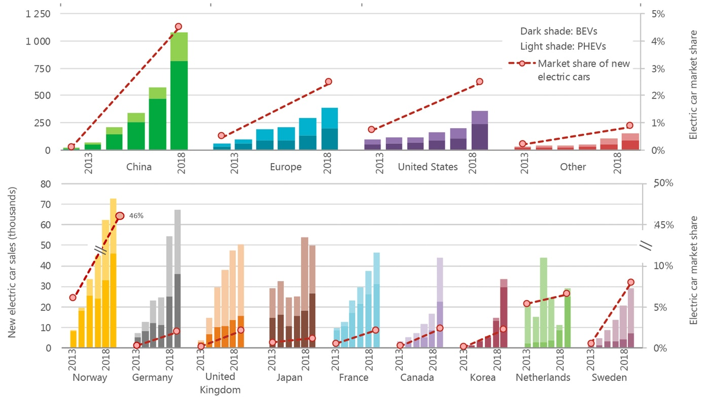
Figure 1: Electronic car market changes in different countries
Source: (Raghu, 2013)
The world is experiencing an essential revolt, and the technical revolution is at the core of everything. The locomotive trade business is no exclusion to this. The result of this revolution is electronic cars. Companies are now headed to the direction of inventing automatic cars, some of them can also run without a driver. From manual engines to automated engines the car industry has shown tremendous success in innovation.
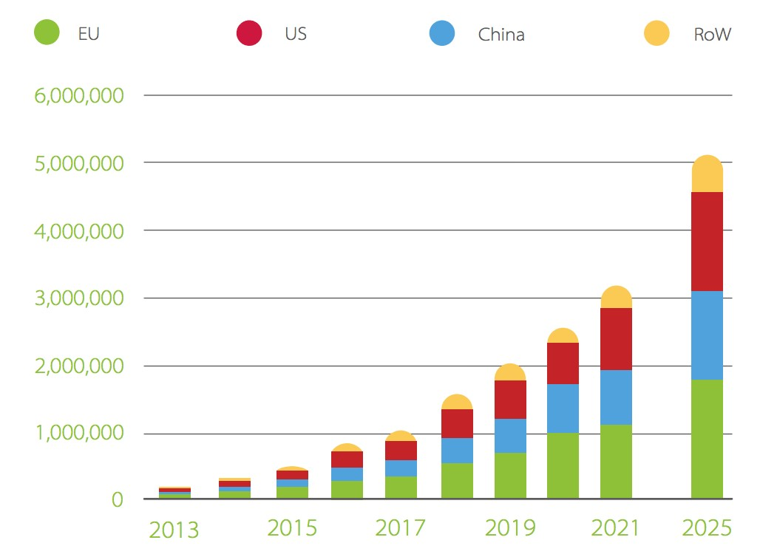
Figure 2: Predictive global electronic car sales
Source: (Raghu, 2013)
It is presently vibrant that car manufactures have clutched a specific set of expertise, and their proficiency in business is increasing with time. The future of flexibility is further about megatrends that are invented by car companies and these are like benchmarks for other companies as well. These trends will shape the future of car manufacturing in Europe as well as other countries.

Upcoming changes in the car industry
The car manufacturers are interested in keeping their customers happy, satisfying their needs. For this the market leaders of this industry are coming up with new ideas, innovations and these notions are driving this industry, giving it a shape (A, 2017). The following are some changes which are happening and will happen in the future:
Electrification: Maximum nations are today applying regulation directed at engineering. These are for carbon discharge free automobiles. Some companies have already made electronic cars which are rechargeable and runs without fuel so this makes that car carbon emission-free.
Shared: Trendsetters have faith in that the future will have skilfully accomplished taskforces that will enormously decrease on agility expenses.
Self-sufficient: There are already self-driven cars. In the future most cars will be self-driven, they would not need any driver and run with the help of software.
Associated: With the changes in vehicles structure other related aspects of the vehicle industry will change as well. People won’t need to have car driving lessons or keep drivers. There will be an infrastructural change. Also, people working in petrol pumps, car workshops, and driving schools will lose jobs.
The trends regarding the car industry are changing. People can see this industry is going towards modernization. Customers are accepting this openly. Many people are now opted towards having their vehicles. Cars are a luxury item and with time the manufacturers are taking this luxury to the next level.

Porter’s five forces model
The threat of New Entrants
There are complete great obstacles to access in the car production business, making the danger of new applicants little. In reality, a very less number of businesses or entrepreneurs are proficient enough to enter the car industry because operating in this industry requires a huge amount of investment for setting up manufacturing plants and distribution function. In this industry having safety, dependability and sturdiness are really important for buyers. New applicants cannot provide these to the customers. New applicants will take make years to build their reputation amongst the established companies and so survival becomes difficult. In Europe especially in the UK has many car manufacturing plants that are foreign-owned (Aboltins, 2014). No local company can try to compete in that market because of the existing companies’ reputation, cost advantages, capital, and government policies, etc.
Competition from substitutes
Now the future is going towards electronic cars and these cars with an internal combustion engine do not require fuel like traditional car engines but still, many customers use traditional cars but there is seen a shift in the market and car companies are concerted now more on innovation. The competition is done majorly on innovation which is environment friendly. In Western Europe, many countries are manufacturing and importing car parts (McNaughton and Green, 2013) and in the UK there are many existing car pants so there is always ongoing competition amongst them.
Bargaining Power of Suppliers
The control of dealers is alleviated by the quantity of present possible dealers in this business, but converting charges are great since forming share designs and descriptions need reasonable early speculation. Conversely, at hand is petite intimidation that these dealers will incorporate onward. Automobile producers need elements like-manual labour, car parts, different resources, and facilities. The charge of these contributions can have an important result ineffectiveness. In the case of the car industry. The automobile sector in Europe is very powerful, the cars assembled here are sold in many other countries. Western Europe countries which produce and import car parts hold the bargaining power.
Bargaining Power of Buyers
Consumer control denotes to the aptitude of separate clients to exchange values that remove income from the vender. Isolated persons, profitmaking businesses, and administrations are the main purchasers of motorized cars. Having few exclusions, purchasers have the control to pace absent from an acquisition that they do not want and make that purchase from other dealer companies. Discrete customers affect value within an agreed authorization, but petite control over producers. In Europe, many dealer companies supply their parts too many famous car manufacturing companies (UK new car market stabilises, 2016), and those companies being such popular the dealer companies do not want to lose their dealership because if they can have a good relationship with those companies in the future they will again purchase from them. In this situation, customers are more powerful.
Rivalry among Competitors
By the growth of foreign participants in the 70’s and ’80s, competition in the motorized business has converted to be much more concentrated as companies contest on equally charges and non-price magnitudes. Thoughtful rivalry instigated to occur in the 90’s with an overflow of innovative cars, designs and perceptions (Stewart and Hood, 2012). The circumstance that the motorized business is an established one expresses that rivalry is aggressive and competition will only upsurge day by day. Industry development is smooth, and many participants with alike market stocks are rebellious for control, and each of the market companies has enormous capital power. In Europe, many companies are making car parts and supplying them to large car companies. There are car assembly plants who buy parts from these plants and the UK has many car manufacturing plants who take parts from these suppliers as well. There is rivalry among suppliers for selling these parts and also rivalry among companies to sell cars.

Conclusion
The electronic car market in Europe and especially in the UK is flourishing. In January the market went through an extraordinary upsurge regarding electronic car sales which shows that people are getting very interested in buying cars of new features. The market is going through a technological change that is shaping the market as well and companies need to concrete on innovation which is environment friendly to survive in this change.

References
A, M., 2017. Autonomous Car: The Future of Secured Transportation. International Journal Of Engineering And Computer Science,
Aboltins, K., 2014. THE CAR AFTERSALES MARKET IN EUROPE AND LATVIAN REGIONS. Regional Formation and Development Studies, 11(3).
European Environment Agency. 2020. Fiscal Instruments Favouring Electric Over Conventional Cars Are Greener. [online] Available at: <https://www.eea.europa.eu/publications/fiscal-instruments-favouring-electric-over> [Accessed 3 May 2020].
Kim, Y., n.d. Japanese Inward Investment in UK Car Manufacturing.
Kurebwa, J. and Mushiri, T., 2019. Passenger car safety and emergency healthcare: a literature review. Procedia Manufacturing, 35, pp.35-49.
McNaughton, R. and Green, M., 2013. Global Competition and Local Networks.
Metal Powder Report, 2016. UK new car market stabilises. 71(1), p.13.
Parliament.uk. 2020. Parliament.Uk. [online] Available at: <https://www.parliament.uk/documents/commons-committees/Exiting-the-European-Union/17-19/Sectoral%20Analyses/4-Sectoral-Analyses-Automotive-Report.pdf> [Accessed 2 May 2020].
Raghu, G., 2013. Car Market and Consumer Behaviour - A Study of Consumer Perception. SSRN Electronic Journal,
Stewart, D. and Hood, N., 2012. East European Competition in the UK Car Market: Some Empirical Evidence. European Journal of Marketing, 15(1), pp.10-19.
T., D., 2020. Self Driving Car. International Journal of Psychosocial Rehabilitation, 24(5), pp.380-388.

