Food and Beverage Operations
Module Code: BMIH4002
Student Name: Daniela Romaniuc
Student ID:2229887

Part 1 Restaurant Concept
Introducing the Restaurant
“Bites on the Go”
Location: Glasgow, RoadSide
Type of Restaurant: Drive-through, Dine in,
Foods offered: Fast Food, continental, local popularities.
Description
Bites on the Go would be targeting most of the individual who wants to have a small break and take a bite. With its efficient service and food quality the restaurant will ensure that its customers can acquire the services in their small part of time. For the first time in the location.
Customised items: Customers will get the opportunity to choose the essential ingredients provided in the menu and choose their own Sandwiches and Burgers according to their requirements.
Target Audience
The target audience of this restaurant will be regular travellers and students that require food on the go. It will provide an immersive experience that will consist of both on-the-go and dining processes.

Positioning Map

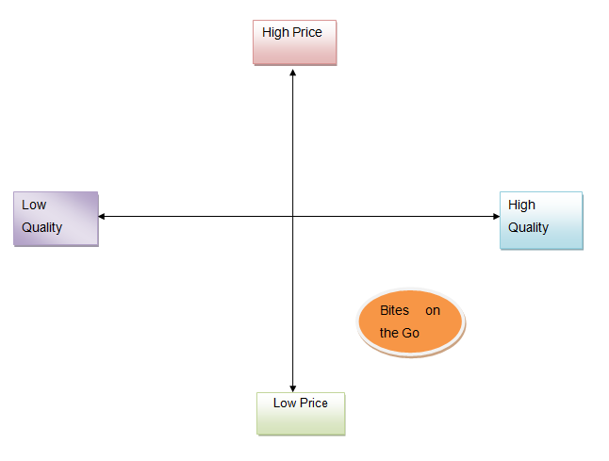
Figure: Position Mapping of the Restaurant according to affordability and quality
Source: Developed by the author

The concept of ‘Bite on The Go’ is developed to provide quality food at affordable rates for a range of its customers. The restaurant will make sure that students get effective compensation provided by the authority.
Justification for considering the menu
The menu considered in the concept of the restaurant is created by supervising the various needs and demands of the millennials as its major target audience. Along with the fundamental items in fast food restaurants it has also been considered the dedicated section of vegan food to provide services to the concerned customers and health enthusiasts. The designed menu at this moment might be considered small but in view of most demands, it provides the essential delicacies that most individuals love to have on the go.

Part 2 Menu Design
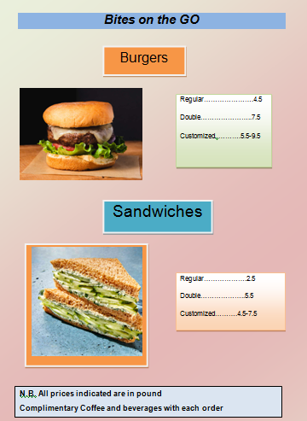

References
Books
Cousins, J. 2020 Food and beverage service. 9th ed. London: Hodder Education Group.**
Davis, B et al. 2018 Food and Beverage Management. 6 edn London: Routledge.**
Johnston, R. 2012 Service operations management : improving service delivery. 4th ed. Harlow, England: Pearson.*
Motarjemi, Y and Lelieveld, H 2014 Food safety management : a practical guide for the food industry Illustrated edition. Amsterdam: Academic Press.*
Journals
Zutshi, A. 2019 ‘How to develop well-informed and assured teams to embed food safety compliance in the UK catering and hospitality industry’, Perspectives in Public Health, 139(6), pp. 294–295.*

