Does Mass Media affect the formation of our identity negatively or Positively?
Student Name: Alana Jones
P Number: 1700817
BA title: Fine Art, Studio, Site and Context
Word Count: 5678
Tutor: Craig Wood
Submitted in partial fulfilment of the requirements for the degree of BA (Hons) University of Wales Trinity St David, Swansea, 10th December 2019

Table of Contents
- Title page……………………………………………………………………………………1
- Table of Contents/ summary of topic………………………………………….2
- Introduction…………………………………………………………………………………3
- Modern Consumer culture and our life choices…………...………….….3-4
- Consumer culture theory…………………………………………………………….5-6
- Society of The Spectacle………………………………………………………………6-7
- Andy Warhol……………………………………………………………………………….7-9
- Capitalist System………………………………………………………………………….9-10
- Effect on adolescent identity……………………………………………………….10-11
- Social media…………………………………………………………………………………11-13
- Deception of companies………………………………………………………………13-14
- Audrey Jones Tinder Diaries…………………………………………………………14-15
- Nastya Nudnik Emjoi Nation…………………………………………………………15-16
- Social media as a platform for awareness……………………………………17
- Gender and consumer culture…………………………………………………….17-20
- Conclusion…………………………………………………………………………………..20-21
- Works Cited………………………………………………………………………………..22-24
Summary of Topic
This independent research document will explore the relationship between mass media and the formation of our identity. It will explore topics such as consumer culture, gender, social status and mainstream culture (everything that is normal in society). I will explore the need that people have to fit in and how it effects our identity.
This Independent research document will explore the relationship between mass media and the formation of our identity. It will include topics such as social media, gender, consumer culture, social status and conventional society (all things that are normal in our society). We live in a time of change, political up rise, the fight for female and gender equality, the rise of technology and booming consumerism. It’s hard to know your own identity in a social culture with so much going on; during this research document I will look at many artists and writers who have explored the ideas of vanity, identity, social media and mainstream culture to try and get some answers. According to Collins dictionary, people, ideas or activities that are part of the mainstream are regarded as the most conventional, typical and normal because they belong to the same system or group as most others of their kind. I will explore the need that people have to fit in and to be ‘normal’ and the struggles that people face if they do not fit into mainstream society.
In the age of social media, people cover up who they truly are, put on a mask and project who they want others to see on apps such as Facebook, Instagram etc rather than being true to themselves. I’ve been looking into ‘The Vanity of Small Differences’ (2012) a series of six tapestries at Victoria Miro and three programmes, all in the Best Possible Taste with Grayson Perry on Channel 4; during the programmes he gathers information and inspiration from people all over Britain. It is a narrative partly inspired by the people Perry met and also Hogarth’s a Rake’s. Grayson Perry is a famous artist and transvestite. During this work he explores issues regarding social class and modern consumer culture. ‘The Vanity of small differences’ Grayson Perry says is a “story of class and mobility, for I think nothing has as strong an influence on our aesthetic taste as the social class in which we grown up.” (Victoria-miro, 2012). Creating this piece, Perry thought about consumerism and focused on “the emotional investment we make in the things we choose to live with, wear, eat, read or drive.” And that “class and taste run deep in our character – we care.” Like what was said previously, we project what we think others want to see, we’re not true to ourselves. (Victoria-miro, 2012). It highlights that the choices we make in everyday life e.g. the clothes we wear, are actually more significant than what we think; when we pick our outfit for the day, we care more about what other people think of it than we do ourselves and it defines out presence. As John Berger says in Ways of Seeing, a woman’s presence “is manifest in her gestures, voice, opinions, expressions, clothes, chosen surroundings, taste- indeed there is nothing she can do which does not contribute to her presence.” (Berger, 1972, p.46); it’s all about an idea or representation of ourselves that we want to project onto society, it’s not necessarily who we truly are, whether we are doing this unconsciously or consciously. The tapestry follows a story of a character Tim Rakewell and is composed of characters, incidents and objects Perry encountered on his journey through Sunderland, Tunbridge Wells and The Cotswolds. (Victoria-miro, 2012). Each Tapestry contains cultural references and product placement; Perry highlights not only the social class Tim Rakewell is journeying through but also the brands associated with it such as cans of Red Bull, iPhones and Cath Kidston bags (artfund.org, 2016). the story follows Tim has he rises through the social classes and gains a fortune from a software company; although, in the end he crashes and dies an untimely death, serving as a reminder that regardless of our social classes, our existence is impermanent. It instils a resounding sense that despite our best efforts to differentiate ourselves from others, we are remarkably similar. (artfund.org, 2016). It is a massive comment on how we present and identify ourselves in a society controlled by consumer culture. For example, often people pay for the name of a brand rather than the actual product itself just because it’s mainstream and conventional and so we just want to fit in.
According to Eric J. Arnould’s and Craig J. Thompson’s journal on consumer culture theory (CCT), consumers are seen as culture producers (Arnould and Thompson, 2005, p.873), the research addresses the ways in which we, the consumers, forge feelings of social solidarity and create self-selected, distinctive and sometimes transient cultural worlds through the pursuit of common consumption interests (Arnould and Thompson, 2005, p.873). They write about how socioeconomic transformations have greatly changed the traditional bases of sociality and has instead encouraged a dominant ethos of radical individualism created around the quest we all have for personal distinctiveness and autonomy in lifestyle choices. In response to these potentially isolating conditions, consumers forge more collective identifications for short periods in time and participate in rituals of solidarity that are grounded in common lifestyle interests and leisure avocations. (Arnould and Thompson, 2005, p.873.). Essentially, we often follow what others do in an attempt to make us feel less alone and more accepted; whether that’s buying the same clothes as others or eating at the same popular chain restaurants as others. Nobody wants to be an outcast. We then project this onto others through images of experiences or material items on social media. In a sense, we are creating a false reality, one in which everyone’s lives are perfect; As Guy Debord says in Society of the Spectacle, “everything that was directly lived has receded into a representation” (Debord, 1967, p.10). We believe that what we see online is real, but in reality, it’s just a representation, for example, a profile someone has made on Facebook isn’t really them, it’s purely a representation of them. Seeing these images of expensive material items that others have on social media can, in effect, cause many to believe that their lives are inadequate to others especially individuals who are less privileged (lower class). Grayson Perry believes, we dislike no one quite so much as our nearest neighbour. It is suggested that this idea is a crucial part of our modern consumer culture: we buy things believing that we are expressing our uniqueness, but in fact we are adhering to a set of norms set out by our social class. (artfund.org, 2016). However, you could say that we willingly complicit in our own seduction by marketplace narratives; we know that our identities are being influenced by brands and advertisements, but we simply don’t care. Most research on consumer’s practices of ideological resistance highlights the creative and often sophisticated ways in which consumers critically reinterpret media and advertising ideals and ideological inducements. (Arnould and Thompson, 2005, p.875.)
According to Guy Debord in The Society of the Spectacle, “In societies dominated by modern conditions of production, life is presented as an immense accumulation of spectacles.” (Deord, 1967, p. 10) The “spectacle” is Debord’s term for everyday manifestation of capitalist driven phenomena; advertisement, television, film and celebrity. Debord defines the spectacle as the “autocratic reign of the market economy.” Though the term “mass media” is often used to describe the spectacles form (hyperallergic.com, 2016). He says that the spectacle is a “social relation between people that is meditated by images.” (Debord, 1967, p.10) This links in with something artist Andy Warhol once said about not wanting to be a model because you can never look like that image of yourself in reality, a lot of the things we see around us are not real, but only a representation of the real thing. It is an inversion of life, an autonomous movement of the non-living. It is part of society and the focal of all vision and consciousness (Debord, 1967, p.10). The spectacle is the result of the dominant mode of production. It is not a decoration added to the real world. It is at the heart of this real society’s unreality. In all of its particular manifestos- news, propaganda, advertising, entertainment- the spectacle represents the dominant model of life (debord, 1967, p.11). The language of the spectacle consists of signs of the dominant system of production, signs which are at the same time the ultimate end products of that system (debord, 1967, p.11). The domination of social life began with an evident degradation of being into having; human fulfilment became about what one possessed rather than what one is. In other words, we care more about what material items and money we have rather than valuing our personal qualities and intelligence. Social life is dominated by the accumulated productions of the economy (debord, 1967, p.13).
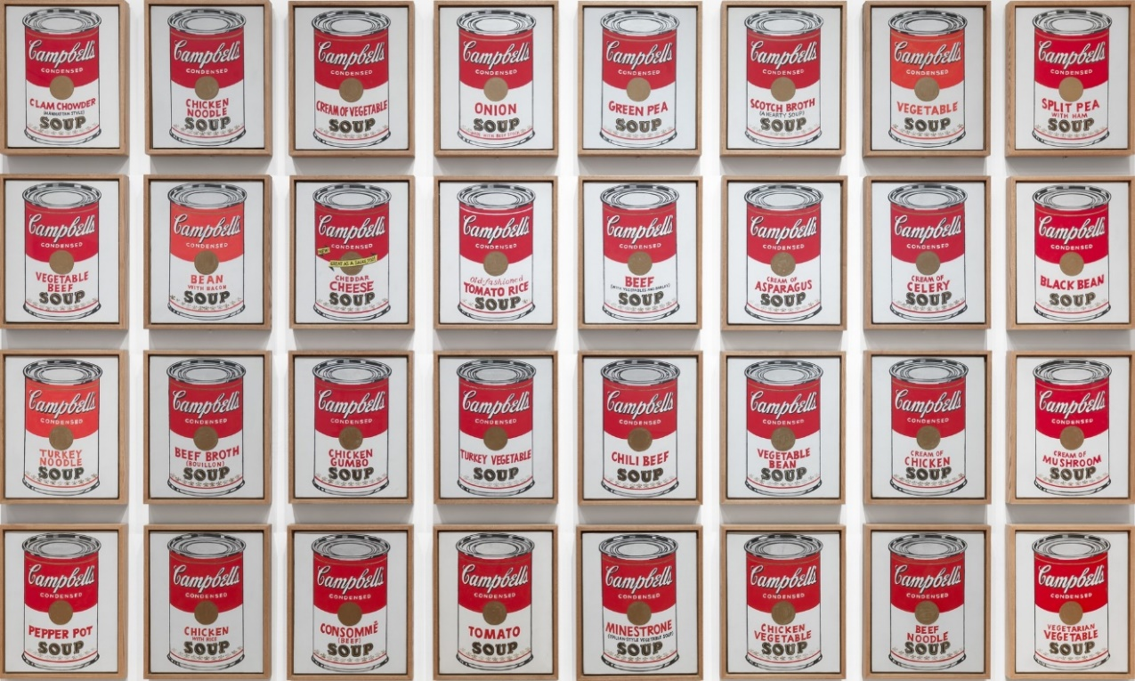
Artist Andy Warhol is renowned for his work drawn from popular culture. Pop artists drew from popular culture in order to achieve recognisable and easily reproduceable works of art, which often include high contrasting bright colours and lines to make them ‘pop’. Warhol realised that people receive the same message over and over through repetition exposure. (Schroeder, 1997, p.477) He claimed that every day he would eat the same things, indulging in big brands such as Coca-Cola and Campbell’s Soup (Schroeder, 1997, p.447). In fact, his first massive success was from a series he made called Campbell’s Soup (Warhol, 1962) in which displays cans of the soup placed unified next to each other as if in a supermarket ready to be bought as seen in the artwork above.

As well as big brands, Warhol also was obsessed with the notion of celebrities, you can see this within his works of Marilyn Monroe and Elvis Presley, Pop art utilized subjects “that anybody walking down Broad-way could recognize in a split second” (Schroeder, 1997, p.447). Pop artists borrowed from the world of advertising, television, grocery stores etc (Schroeder, 1997, p.447). Warhol adopted readymade symbols within his work, some of his most famous subjects were originally designed by others; this has allowed him to become very successful in creating his own brand equity (Schroeder, 1997, p.478) This is because the images he used were already easily identifiable by the public. Warhol demonstrated that consumer’s positive feelings about products often lay far outside the product itself; this links to the Economic and Philosophic Manuscript of 1844 in saying that people get different forms of gratification from a product whether that’s through affirmation of another or directly consuming the product. According to Jonathan E. Schroeder, his success was phenomenal evidence that brand are physiological entities, with associations far outside the context of consumption (1997, p.478). He has also helped us realise that celebrities have brand equity, consumer awareness etc. (Schroeder, 1997, p.480) Warhol has stated in a famous quote, “A Coke is a Coke, and no amount of money can get you a better Coke.” Meaning that popular brands tended to promote equal opportunity for consumers. (Schroeder, 1997, p.478) making everyone in society feel like we can fit in no matter what social class we fall under. However, Warhol, had a desire to gain more and more, almost like Tim Rakewell in The Vanity of Small Differences and like most people in society. He was driven by a desire to be famous, for anything, he says “I wish I could invent something like blue jeans. Something to be remembered by, something mass.” (Warhol, quoted in Consumer Researcher, 1997, p.478) Suggesting that he wants the gratification from others buying into and recognising his ideas in order to boost its own ego and to make him feel important in the world. ‘Warhol represents a charismatic figure totally concerned with strategically marketing the ultimate commodity, oneself’ (Schroeder, 1997, p. 478) Warhol was willing to show us how we consume celebrities, while also providing a thoughtful reminder of the discrepancies between public and private identity (Schroeder, 1997, p.480) He put emphasis on the fact that the things we know best are brought to us via mass markets, media and production (Schroeder, 1997, p.480). Warhol was fascinated in the relationships between images and reality, especially his own, he says, “It must be hard to be a model, because you’d want to look like the photograph of you, and you can’t ever look this way.” (Warhol, quoted in Consumer Researcher, p.480). I feel like this is especially true in this day in age (2019), people will post images of themselves on social media that have been edited and in reality they will never look like that photograph really; I feel like the consequences of other people seeing these edited images are very bad as it can make people feel that the way they are in reality isn’t good enough as they may not realise that the image has even been edited at all.
The problem is, is that we are fuelled by the need for money because we are controlled by a capitalist system in which money is the key to succeeding in life. Once we gain this money through work, we then feel the need to spend it on the products that the capitalist system is advertising to us. According to the Economic and Philosophic Manuscripts of 1844, “Every product is a bait with which to seduce away the other’s very being, his money, every real and possible need is a weakness which will lead the fly to the gluepot.” (Marx, 1932, p.50). Essentially, the need we feel to fit into mainstream society, is a weakness in which advertisers can use against us in order to get us to buy into their products. The ‘machine’ (capitalist system) “accommodates itself to the weakness of the human being in order to make the weak human being into a machine.” (Marx, 1959, p.50). People often say the phrase ‘money doesn’t buy you happiness’, but this is completely untrue. However, money comes at a price: the less you express yourself, the less you eat, the less you love, the less you go to the theatre etc, the more money you have but the greater your alienated life becomes. All of these things that the political economist takes from you, he replaces with money; and all of the things that you can’t do, your money can do; Your money can eat and drink, it can travel, it can go to the theatre (Marx, 1959, p.51). However, people may forget that there would be no production without consumption, and that a things value is determined by its use, and that use is determined by fashion. It wishes to only see ‘useful’ things produced; however, by doing so that production of too many useful things creates too large a useless population (Marx, 1959, p.51). The main drive for us to earn money and then spend it on materialistic objects or experiences is the gratification that we get from it. In what manner the object exists for someone, is the characteristic mode of their gratification. This could be from the direct affirmation of the object, such as eating or drinking; or it could be from the affirmation of another turning into their own gratification- This is most often the case on social media, people get gratification from the ‘likes’ and ‘views’ of others when they post photographs of newly bought material items, which then fuels them to want more and more in order to get more gratification.
In this millennium, it is especially important to realise how growing up in a world saturated with technology, multiculturalism and mass media imagery has affected the formation of children’s and adolescent’s identities. This is explored in the review A Conceptual Framework for Examining Adolescent Identity, Media Influence and Social Development by Blake Te’Neil Lloyd. Theorists believe that individuals will react to mass media imagery, interpreting it as their own, being selective with regard to the type of information processed; viewers will look to messages that attend to pre-existing beliefs and attitudes that serve to support personal values (Lloyd, 2002, p.74). Putting it simply, we are drawn to messages that we already identity with and are familiar with to back up beliefs and ideas that we already have. According to the review, people of similar social class or in similar social settings or demographic characteristics, tend to have similar responses to the same stimuli (Lloyd, p.74. 2002). Mass media is often a primary source of information and has a certain level of validity by reporting information and in turn, it is said that mass communications have the power to shape conceptions and impressions of normal behaviour in given situations. Social theorists argue about how this effects children; some say for example, that violence on television teaches children that it’s an effective method of problem solving, whereas, some say children imitate the violent behaviour that they are exposed to (Lloyd, 2002, p.74) So, how does this effect the way in which young individuals interact in society? Technology is only going to become increasingly more entertaining and specific to the targeted audience members; it is probable that young audience members “will adapt and use this information as a tool for understanding of self and others” (Lloyd, 2002, p.74-p.75), does this mean that people will no longer learn social skills from friends and family members? It is because the mass media devices of the 21st century provides new opportunities to learn appropriate and inappropriate social behaviours without the risk of peer rejection and so viewers can rehearse (cognitively) interactions with peers and selectively apply them as appropriate situations arise (Lloyd, 2002, p.75.) I wonder what effect this lack of rejection will have on young people when it comes to dealing with situations in real life.
On social media we are the most strongly influenced by consumer culture and lifestyle instructions put upon us by society. We even use social media to meet our partners. Most people tend to meet people within their social circles such as in school or at work, however, the number of potential partners in a person’s circle can be very limited; so surely having a vast number of suitors at your finger tips online is a good thing? It can allow people who live certain lifestyles that are perhaps lonelier e.g. someone who travels for work, to meet a partner. It can also allow people who are more introverted and shy a non-pressured way to meet people. Express.co.uk says that online dating is good because you can meet people at your own pace, taking the pressure of if you haven’t dated for a while, you will also find better matches because dating websites match you to people using compatibility, which means less hassle trying to find ‘the one’ (express.co.uk, 2017). Although, what use is this if people are lying on their profiles? Dating online can leave you open to deception. According to The Review of the Ugly Truth and Negative Aspects of Online Dating, deceptive behaviour is more often found on the internet due to the absence of no verbal cues in online communication, meaning that information can easily be manipulated (Ankee and Yazdanifard, 2015). Many online daters manipulate their profile in order to look more attractive because of the standards that have been put on us by consumer culture and mainstream society. They can do this by editing images in order to enhance physical features, they can lie about their social class (income), or they can just outright lie about their whole identity, someone who does this is commonly known as a “catfish”. There is an MTV tv show that explores the issues of this called Catfish, which brings people who have been in online relationships together and more often than not their online partner has been lying about their identity. An experiment carried out has proved that people are more deceptive online. It shows that users are deceptive on photograph and text based self-presentation to form a better impression in an online dating environment (Ankee and Yazdanifard, 2015). Men are willing to manipulate in order to appear more dominant and kinder than the actual self and women have more of a tendency to present a more favourable physical appearance than they actually are (Ankee and Yazdanifard, 2015). So, what does this mean for the adolescents learning their social behaviour from the internet if it’s filled with deception and manipulation? And how do we know what’s true and what’s untrue on an online platform so easy to manipulate?
Carrying on with the subject of deception, a major example of companies and media taking advantage of us is the Cambridge Analytica scandal, a political scandal in which Facebook harvested raw data from up to 87million Facebook profiles in which they sold to Trump in order for him to campaign. The people working for Cambridge Analytica essentially used our identities and personal information in order to manipulate us through advertising to vote for Donald Trump as president. The SCL who does the work for Cambridge Analytica was quotes describing their expertise as “phycological warfare” and “influence operations” (vox.com, 2018), which proves that they had full intentions of exploiting the publics personal information in order for the company to gain. A previous employee who worked for the privacy side of Facebook told the New York Time, “The people whose job is to protect the user always are fighting an uphill battle against the people whose job is to make money for the company.” (vox.com, 2018)This is a scary quote to read as Facebook is one of the largest, if not the largest, platform for people to connect on the entire internet and it’s horrible to think that our personal traits can be so easily exploited by companies and there is nothing we can really do about it because as quoted before, we are “willingly complicit in out own seduction of marketplace narratives.” (Arnould and Thompson, 2005, p.875.) We know the possible risks of putting personal and private information online but we still choose to do it regardless.
On the more positive side, an artist who approaches the topic of social media with humour and wit is California based artist Audrey Jones in her series called Tinder Diaries, it is a series of illustrations in which she displays conversations she has had with her tinder matches; it reflects the sad state of dating in today’s culture. Here as an example of just one of her many conversations. The illustration depicts slightly grotesque looking figures of men making crude comments about sex. She says she “said ‘yes’ to as many potential suitors as I could and made illustrations based on the conversations or the first things they would say to me.” (vice, 2017). Although her depictions of the modern man are shocking and concerning, she says, “I suppose I seek to provide humour in art and comment on the ironies of everyday life” (vice, 2017). The illustrations all at the same time are disgusting, humanizing, heartfelt and demonstrates the cries for love often reduced to simple pleas for physical and emotional nourishment (vice, 2017). The internet has made it very hard to create real connections with people, it’s easy to hide behind a phone and perhaps this results in people being less cautious in what they say because there are no real
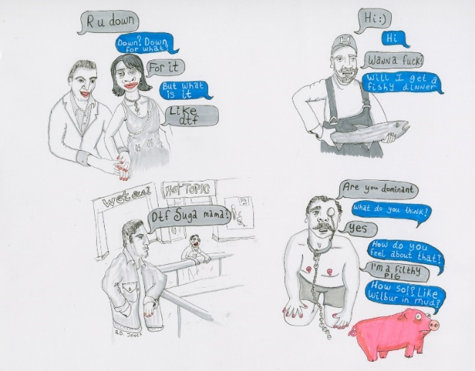
Audrey Jones Tinder Diaries

consequences at times, you could just ‘block’ someone if it goes wrong; also, there’s so much option online that you can easily just move onto the next person; it’s like an online menu of people you can pick from.
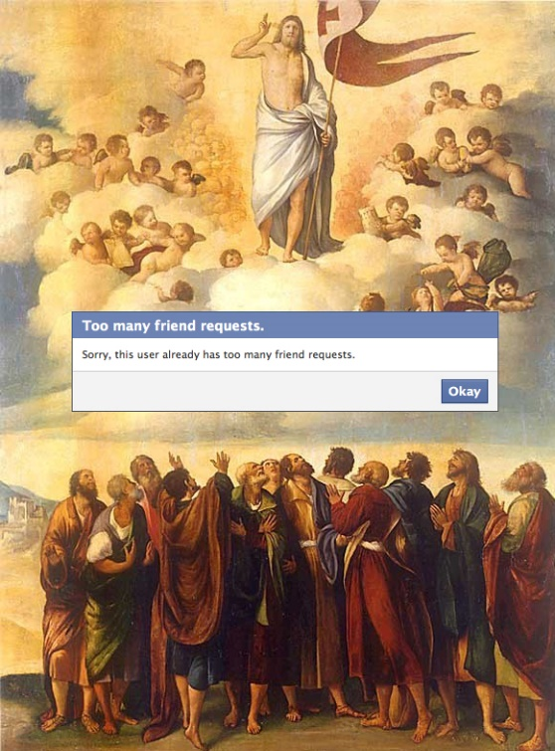
Another artist who approaches the topic of social media in a slightly humorous manner is Ukrainian artist Nastya Nudnik in their series of work called Emoji Nation.

Nastya Nudnik – Emoji nation

The artist incorporates social media notifications, emoji’s and other characteristic imagery from our digital culture and embeds them into well known works of art. During an interview with Dazed Digital, the artist answers the question, “Do you think emoji is becoming a language?”. She says, “I’m sure it has become a language already. It’s much easier to use eloquent yellow face than describe the same emotion with words.” (Gorton, Dazeddigtal, 2014) According to the Oxford dictionary, the definition of an emoji is a small digital image or icon used to express an idea or emotion. The internet has made communication evolve rapidly, Nudnik says, “there’s no time to explain anymore.” Does this mean that in the future this will be one of the only ‘languages’ that people speak? Will words be lost and be replaced by emoji’s? According to linguist Neil Cohn on bbc.com in an article called Will Emoji Become a New Language? Some outlets have claimed that emojis are an emerging language and could compete with English in global usage. To many, especially the younger generation, this could be an exciting development in the way in which we communicate; however, to many it would also be “linguistic Armageddon” (Cohn, bb.com, 2015). Cohn says that an emoji, along with text, can enhance writing, and suggests it’s similar to the way in which we use our hand gestures when we speak; for example, adding a ‘winky’ face to text with an emoji can make a message sound flirtier than it would without one. It is said that online this gestural communication that we have face to face is taken away but Cohn’s Suggests that emoji’s may be able to allow us to use the gestures we would in real life but through the internet. However, to become their own language they would be missing a key component, grammar. If we were to make a ‘sentence’ out of emoji’s we would have to have them in a linear order, which limits how complex expressions can be made. We also don’t have the freedom with emoji’s to draw from our own mental vocabulary, we have to go through online lists to be able to find the emoji suitable for what we want to say (Cohn, bb.com, 2015), so overall, I’m not sure if it would be effective as a language.
Social media makes it extremely easy to share ideas beyond geographical boundaries and can unite people on a huge platform for the achievement of specific goals. It can also provide awareness among society like campaigns, promotions and advertising articles which helps society to be up to date with current information (p.73.) A good thing about social media is that it has allowed people to express their identity freely, linking back to the review about adolescent identity, social media can allow people to express themselves without direct peer rejection. Social media has also brought many issues regarding gender, equality and identity to attention. In Britain there is a growing acceptance of people who may identify as transgender, gay, bisexual etc. There is also a fight to stop the stereotyping of groups of people such as men being stereotyped as strong and masculine and females being stereotyped as the damsel in distress. Social media has contributed to the growing acceptance of these groups as it provides a platform in which individuals can share their stories and inspire other people to act against the discrimination, it also makes the individuals who are discriminated against feel more accepted when they see someone similar to them but confident in who they are online.
A key artist I have looked at who explores issues regarding both gender and identity was British sculpture, photographer and installation artist Helen Chadwick (1953- 1996). Chadwick had a desire to look past “the self’s usual boundary- to look past likeness- past gender, beneath the skin, within the cell” (Chadwick et al., 2004, p.13) Instead she focused on spirit, society and the individual, male and female (Chadwick et al., 2004, p.13). One of the insights offered by Chadwick’s work is that “the self is never discovered as an entity but can only be discerned in the relations between the black and white terms on which so much of our culture is founded.” (Chadwick et al., 2004, p.13). Linking this statement in with The Vanity of Small differences Grayson Perry, they both make a comment on how everything we buy into (consumerism) like what brands we wear, what house we live in, what we eat, all makes us who we are as an individual and places us where we fit in society and what class we’re in. This has a massive impact on our personality and how we live our lives. Chadwick likes to make images of a kind of physical identification of the self; although she thinks “it’s a kind of space that none of us can really know for ourselves and because, for many people, it’s troubled terrain.” (the guardian, 2019). Often, we live like it’s a competition, competing to get the best phone, or best clothes, because we think that makes us better than people who have less than us. This consumerism mindset can take hold of your life; Chadwick explains, “The image of vanity, I despise and it’s about the despicable hold that a kind of vanity in what one does has over you.” (the guardian, 2019). We can’t be truly happy if all we’re concerned about is materialistic things.
It is also important to realise that the different genders, male and female (putting it in simple terms) consume differently because they have completely different perspectives of life. According to Michael G. Luchs in Sex, Personality, and Sustainable Consumer Behaviour: Elucidating the Gender Effect, women are more likely than men to express concerns about consumptions broader impacts and to act upon those concerns. Limited research has also found that consumer behaviour is influenced by personality. Women tend to be more agreeable and open compared to men, which means that they are more likely to be concerned about and act upon social and environmental issues. Women also get different gratification from certain modes of consumption than men e.g. women get pleasure out of shopping whilst men appear to be more disdain about it (Bakshi, p.1). There are many different factors that influence consumer behaviour such as cultural factors, psychological factors, personal factors and social factors (Bakshi, p.2). Males and females want different products and are likely to have different ways in liking or obtaining these. This is why there are many sex-typed products on the market; sex- typed products are defined as a product that takes on either masculine or feminine qualities, put simply Barbies for girls and Action Man for boys (Bakshi p.4)
You could say that some companies take advantage of this however, an example of this is with the “Pink Tax”. “Pink Tax” is a concept made to highlight identical products priced differently based on the targeted gender, women are paying more money than men for the same toiletries (Devany, Vogue.co.uk, 2019) purely because of a difference in colour, for example, you have one blue razor and one pink razor completely the same, the women would get charged more for the more feminine pink colour. MP Christine Jardine says, “Products marketed at women are on average considerably more expensive than those marketed at men.” (Devany, Vogue, co.uk, 2019). It’s unfair that companies use this to con people into spending more money on a product that’s function is no better than the latter.
The social presence of a women is also very different to men. According to John Berger in Ways of Seeing, “A man’s presence is dependant upon the promise of power which he embodies.” (Berger, 1972, p.45); this promised power may be economic, physical, temperamental, sexual, social or moral, a man’s presence suggests what he is capable of doing to you or for you. A woman’s presence, on the other hand, defines what can and cannot be done to her (Berger, 1972, p.46). The social presence of a women has developed from living in such a limited space and being born “into the keeping of men” (Berger, 1972 p.46) According to Berger, this has caused the woman’s personality to be split into two. A woman has been taught to constantly watch and survey herself. Berger puts it simply and says, “Men act and women appear, men look at women, women watch themselves being looked at.” This not only determines most relations between women and men but also the relation of women to themselves (Berger, 1972, p.47). This is why, as mentioned before, a woman’s “presence is manifest in her gestures, voice, opinions, clothes, chosen surroundings, taste” (Berger, 1972, p.46.). This would perhaps explain why women actually enjoy and get pleasure out of shopping whereas men don’t.
As a conclusion, after doing this research, I have realised how great of an impact mass media actually has on how we form our identity and society. Out of this research I have discovered that most of the effects of it are negative and it has completely reshaped the way in which we function as a society. From adolescents learning social behaviour on television to being open to manipulation online, the society we live in today is full of falseness and the need to be better than those around us. It’s all about money and how much we have and the things that money allows us to buy in order to boost our ego and present a false reality onto society through the means of social media as Marx says, “all of the things that you can’t do, your money can do.” (Marx, 1959, p.51). We forget that our time alive is temporary and we chose to live our lives contempt under the capitalist systems and we feed off the gratification of the things that we consume, as shown by Perry in the Vanity of Small differences. After reading the effects that social media is already having on us I dread to see what the future holds for society and that there’s not really anything than we can do to stop it because the “machine” is so powerful. However, regardless of this, there are some positives that comes with it; like the power that social media has to bring people together from across the globe and the platform it provides for people who feel alone to connect with others through common interests without even having to meet face to face. Social media has also brought important topics to the forefront like equality and has allowed people who otherwise feel alone to bond with like-minded individuals online. Although, I do think the negative aspects of it greatly outweigh the good due to the extreme effects it could potentially have on society, especially in children. I believe that if we carry on to learn behaviours from television and the internet that people will stop knowing how to function when it comes to face to face contact and will create extreme social anxiety within individuals. I also think that consumerism is causing us to be so obsessed with our image and what other people think of us that our real identities are getting lost behind a false reality. I think in the future that almost everything will be done online and face to face contact with other human beings will be kept minimal in an extreme scenario. I believe that the capitalist system is using mass media to distract us from their destructive behaviour, like harming the environment and wars; instead of focusing on important issues we’re more bothered that someone has a nicer pair of shoes than us. So, to answer my question “Does Mass Media Effect the Formation of Our Identity Negatively or Positively?” I believe that overall it effects our identity negatively.

Bibliography
Websites
- Art Fund. (2019). Object of the month: The Vanity of Small Differences by Grayson Perry. [online] Available at: https://www.artfund.org/whats-on/more-to-see-and-do/features/object-of-the-month-the-vanity-of-small-differences-by-grayson-perry [Accessed 7 Nov. 2019].
- Cohn, N. (2019). Will emoji become a new language?. [online] Bbc.com. Available at: https://www.bbc.com/future/article/20151012-will-emoji-become-a-new-language [Accessed 20 Nov. 2019].
- Collinsdictionary.com. (2019). Mainstream culture definition and meaning | Collins English Dictionary. [online] Available at: https://www.collinsdictionary.com/dictionary/english/mainstream-culture [Accessed 6 Nov. 2019].
- Devany (2019). How Pink Tax Is Being Challenged In The UK To Financially Help Women In 2019. [online] British Vogue. Available at: https://www.vogue.co.uk/article/pink-tax-women-money-christine-jardine [Accessed 1 Dec. 2019].
- Dazed. (2019). Emoji Nation updates famous artworks for the internet age. [online] Available at: https://www.dazeddigital.com/artsandculture/article/19457/1/emoji-nation-nastya-nudnik-famous-artworks-update [Accessed 10 Dec. 2019].
- Express.co.uk. (2019). Online dating: Top 10 reasons you should give it a try. [online] Available at: https://www.express.co.uk/featured/life-style/life/823308/top-10-benefits-of-online-dating [Accessed 26 Nov. 2019].
- Hyperallergic. (2019). An Illustrated Guide to Guy Debord's 'The Society of the Spectacle'. [online] Available at: https://hyperallergic.com/313435/an-illustrated-guide-to-guy-debords-the-society-of-the-spectacle/ [Accessed 9 Nov. 2019].
- the Guardian. (2019). Interview: Helen Chadwick, shortlisted in 1987. [online] Available at: https://www.theguardian.com/artanddesign/1987/nov/18/20yearsoftheturnerprize.turnerprize [Accessed 10 Dec. 2019].
- Victoria Miro. (2019). Grayson Perry: The Vanity of Small Differences. [online] Available at: https://www.victoria-miro.com/exhibitions/429/ [Accessed 24 Nov. 2019].
- Vice. (2019). The Artist Turning Bad Tinder Matches into Great Drawings | City of the Seekers. [online] Available at: https://www.vice.com/en_au/article/pgw3by/audrey-jones-bad-tinder-matches-great-drawings [Accessed 18 Nov. 2019].
- Vox. (2019). The Facebook and Cambridge Analytica scandal, explained with a simple diagram. [online] Available at: https://www.vox.com/policy-and-politics/2018/3/23/17151916/facebook-cambridge-analytica-trump-diagram [Accessed 24 Nov. 2019].

Books
- Berger, J. (1972). Ways of seeing. London: British Broadcasting Corp. and Penguin Books.
- Chadwick, H., Sladen, M., Horlock, M. and Martischnig, E. (2004). Helen Chadwick. Ostildern-Ruit: Hatje Cantz [for] Barbican Art Gallery.
- Debord, G. (1992). Society of the spectacle and other films. London: Rebel Press.
Journals
- Ankee, A. and Yazdanifard, R. (2015). The Review of the Ugly Truth and Negative Aspects of Online Dating. Global Journal of Management and Business Research: E Marketing, 15(4).
- Arnould, E. and Thompson, C. (2005). Consumer Culture Theory (CCT): Twenty Years of Research. Journal of Consumer Research, 31(4), pp.868-882.
- Bakshi, S. (n.d.). IMPACT OF GENDER ON CONSUMER PURCHASE BEHAVIOUR. 1(9).
- Lloyd, B. (2002). A conceptual framework for examining adolescent identity, media influence, and social development. Review of General Psychology, 6(1), pp.73-91.
- Marx, K. (1959). Economic and Philosophic Manuscripts of 1844. Economica, 26(104), p.379.
- Schroeder, J. (1997). Andy Warhol: Consumer Researcher. Advances in Consumer Research, 24.
Artworks
- Audrey Jones. Tinder Diaries. Available at: https://www.vice.com/en_au/article/pgw3by/audrey-jones-bad-tinder-matches-great-drawings [Accessed: 23 Nov. 2019]
- Andy Warhol. (1962). Campbell’s Soup Cans. Available at: https://www.moma.org/collection/works/79809 [Accessed: 1 Dec. 2019]
- Nastya Nudnik. Emoji Nation. Available at: https://www.dazeddigital.com/artsandculture/article/19457/1/emoji-nation-nastya-nudnik-famous-artworks-update [Accessed: 17 Nov. 2019]

