

Student’s Name: Nidhi Shah

Student’s number: 2224182

Module code and title: LCHS 7007 – Population Health and Digital Health Promotion

Lecturer’s name: Dr Diola Bijlhout

Assignment title: Part A – Blog
Part B – Poster design

POPULATION HEALTH AND DIGITAL HEALTH PROMOTION
Table of Contents
Blog- 1 3
Overview of Asthma and the reason for it to be a health concern 3
Overview of the technology 3
The use of technology in addressing and promoting health problems 3
Evidence of selected digital technology in promoting Health 3
Impact of technology on health promotion 3
Ways to address the shortfall 3
Blog-2 4
Overview of Malnutrition and Reason for it to be a Health Problem 4
Overview of designed digital Technology 4
The use of technology in addressing and promoting health problems 4
Impact of digital technology on Health problem 5
Ways to address shortfalls 5
Reference list 6

Blog- 1

Overview of Asthma and the reason for it to be a health concern
Asthma is a chronic condition that gradually impacts the airways in the lungs. In addition, this health problem makes the airways to become inflamed and narrowed at times (nhlbi.nih.gov. 2023). This health problem can be concerning because it causes issues breathing normally while interrupting daily activities such as work, school, sleep, and many more.

Overview of the technology

https://www.healthdirect.gov.au/kiss-my-asthma-app

Kiss my asthma is a software application that is developed by young people and acquires diverse features to track asthma. In addition to this, the application includes the ability to track asthma symptoms, mood tracker, action plan, and many more which makes it easy to treat asthma in an effective manner (healthdirect.gov.au 2023).

The use of technology in addressing and promoting health problems
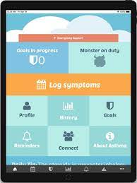

Kiss my asthma is a beneficial digital application which helps people with asthma to track symptoms, attacks as well as severity. Along with this, the application operates with the help of smartphones which provides immediate methods for obtaining asthma information as well as self-management support in an authentic manner (nih.gov 2023).

Evidence of selected digital technology in promoting Health
Kiss my asthma is used by a huge number of young people who believe in the self-management of their health. In addition to this, the application is available on different online stores where one can download and manage their asthma on a daily basis.

shortfall of technology in health promotion
With the help of this digital technology, it becomes easier for asthma patients to track the disease and manage it on a daily basis. Only depending upon the application can affect the mental health of asthma patients which can be taken as a disadvantage.

Ways to address the shortfall

It is essential for people with asthma to focus on their medication as well as daily physical activities rather than depending only on application. In order to manage the shortfalls of the technology, it will be beneficial to identify and evaluate the negative impact as well as the harm that can occur while processing data within the application.

Blog-2

Overview of Malnutrition and Reason for it to be a Health problem

https://www.starhealth.in/blog/malnutrition

Malnutrition can be discussed as one of the major maternal and child health problems as it deals with the excesses in nutrient intake or imbalance of essential nutrients that impact the health of the child (who.int 2023). In addition, it is a concerning health problem as it impacts the mental as well as physical functioning that changes in body cell mass.

Overview of designed digital technology

Happy Baby is an application which will help pregnant women to gather proper information about the food and nutrients they will intake during pregnancy in order to avoid issues like malnutrition. The application will include the birth scale of the baby and recommendations about the ways to take proper nutritional care of the baby from its first day on earth. Along with this, there will also be the implementation of a child growth monitor which will help to provide accurate measurement of the child's height, food consumption, and many more.

The use of technology in addressing and promoting health problems
The respective digital technology will help to manage the health of the mother during pregnancy as there are a variety of things that are required to be analyzed and observed during pregnancy in order to avoid health issues like malnutrition. As different technologies help to measure malnutrition outcomes (Trtovac and Lee, 2018). This application will also provide benefits in managing malnutrition in an effective manner while measuring different factors related to the baby.

Impact of digital technology on Health problem
The technology will help to manage the health of both the mother and baby which will also be beneficial for acquiring different knowledge related to child health. There might be some errors related to the application which can impact data and information such as lack of app syncing, unable to load data and information, and many more.

Ways to address shortfalls
In order to deal with the shortfalls, it will be beneficial to note down the tracking records. Along with this, weekly or monthly checkups will also be suggested in order to avoid inconvenience.

PART – B

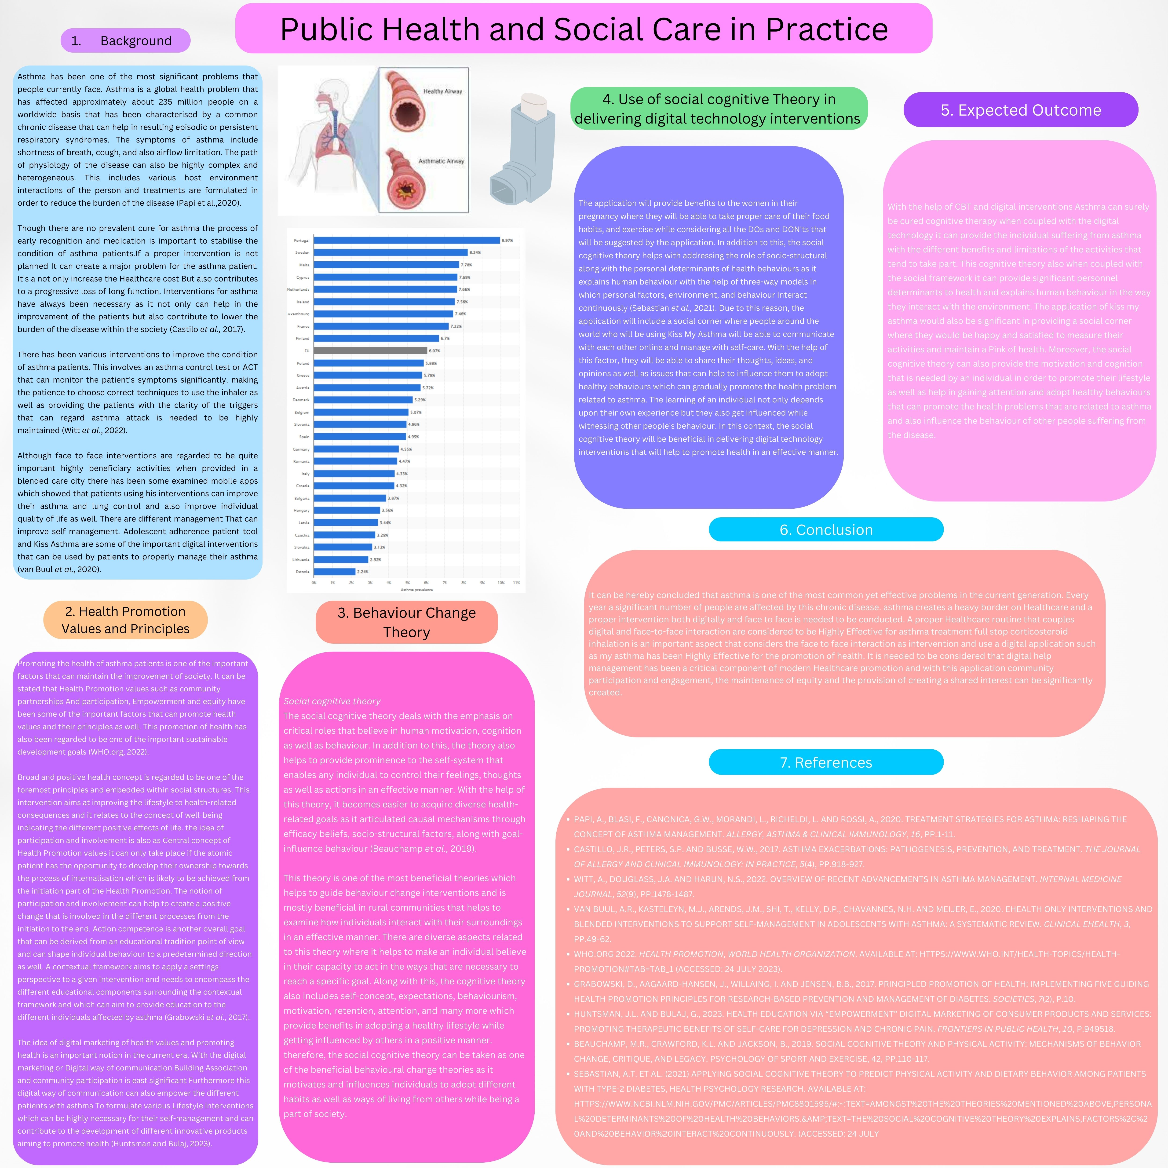

Reference list
healthdirect.gov.au (2023) Kiss My Asthma App, healthdirect. Available at: https://www.healthdirect.gov.au/kiss-my-asthma-app
nhlbi.nih.gov (2023) What is asthma?, National Heart Lung and Blood Institute. Available at: https://www.nhlbi.nih.gov/health/asthma#:~:text=Asthma%20is%20a%20chronic%20(long,airways%20when%20you%20breathe%20out.
nih.gov (2023) ‘kiss myasthma’: Using a participatory design approach to develop a self-management app with young people with asthma, The Journal of asthma : official journal of the Association for the Care of Asthma. Available at: https://pubmed.ncbi.nlm.nih.gov/29064746/
Trtovac, D. and Lee, J. (2018) The use of technology in identifying hospital malnutrition: Scoping review, JMIR medical informatics. Available at: https://www.ncbi.nlm.nih.gov/pmc/articles/PMC5797288/
who.int (2023) Malnutrition, World Health Organization. Available at: https://www.who.int/health-topics/malnutrition#:~:text=Malnutrition%20refers%20to%20deficiencies6%20or,as%20diet%2Drelated%20noncommunicable%20diseases.

Reference List (Part B)

- Papi, A., Blasi, F., Canonica, G.W., Morandi, L., Richeldi, L. and Rossi, A., 2020. Treatment strategies for asthma: reshaping the concept of asthma management. Allergy, Asthma & Clinical Immunology, 16, pp.1-11.

Castillo, J.R., Peters, S.P. and Busse, W.W., 2017. Asthma exacerbations: pathogenesis, prevention, and treatment. The Journal of Allergy and Clinical Immunology: In Practice, 5(4), pp.918-927.
- Witt, A., Douglass, J.A. and Harun, N.S., 2022. Overview of recent advancements in asthma management. Internal Medicine Journal, 52(9), pp.1478-1487.
- van Buul, A.R., Kasteleyn, M.J., Arends, J.M., Shi, T., Kelly, D.P., Chavannes, N.H. and Meijer, E., 2020. eHealth only interventions and blended interventions to support self-management in adolescents with asthma: a systematic review. Clinical eHealth, 3, pp.49-62.
- WHO.org 2022. Health promotion, World Health Organization. Available at: https://www.who.int/health-topics/health-promotion#tab=tab_1 (Accessed: 24 July 2023).
- Grabowski, D., Aagaard-Hansen, J., Willaing, I. and Jensen, B.B., 2017. Principled promotion of health: implementing five guiding health promotion principles for research-based prevention and management of diabetes. Societies, 7(2), p.10.
- Huntsman, J.L. and Bulaj, G., 2023. Health education via “empowerment” digital marketing of consumer products and services: Promoting therapeutic benefits of self-care for depression and chronic pain. Frontiers in Public Health, 10, p.949518.
- Beauchamp, M.R., Crawford, K.L. and Jackson, B., 2019. Social cognitive theory and physical activity: Mechanisms of behavior change, critique, and legacy. Psychology of Sport and Exercise, 42, pp.110-117.
- Sebastian, A.T. et al. (2021) Applying social cognitive theory to predict physical activity and dietary behavior among patients with type-2 diabetes, Health psychology research. Available at: https://www.ncbi.nlm.nih.gov/pmc/articles/PMC8801595/#:~:text=Amongst%20the%20theories%20mentioned%20above,personal%20determinants%20of%20health%20behaviors.&amp;text=The%20social%20cognitive%20theory%20explains,factors%2C%20and%20behavior%20interact%20continuously. (Accessed: 24 July)

