Title: Internship
Assignment Name: Implementation Plan
Student Name: Daniel Ramsey
Course Name and Number: Internship and Volunteerism BMSP6003
Lecturer: Davina Evans
Date: 4th November 2019

Overview
This internship is the product of a collaboration including Coleg Sir Gar, University of Wales, Trinity Saint David and Carmarthenshire County Council. Facilitated by university lecturers Davina Evans and Jessica Shore, a working group, Llwybro Sir Gar was created, in the hope of establishing cross organisation working relationships and the placing of university students in local public sector organisations to undertake internship placements. Consultation with various local organisations began, which led to Paul White, Carmarthen Market general manager, offering a placement to myself, Daniel Ramsey. I immediately knew this required me to be an effective and active listener. One who is capable of taking relevant notes and execute Paul’s wishes. A skill that I would need to improve on as outlined in the skill audit (Appendix D).
To ensure this placement was a good fit for all parties involved, an introductory meeting was held, and discussions ensued whereby Paul outlined his initial vision of exploring the decline in footfall of Carmarthen Market. Over the course of the next few meetings, and to my relief, the brief dramatically changed somewhat. As I am now in my final year of university and my academic workload is phenomenal, Paul gracefully revised the brief and now wishes for me to select a stall holder who’s digital marketing use is sub-standard, and to devise a plan to enhance their digital marketing presence.

Placement Provider
The placement provider, Carmarthenshire County Council (CCC), is a local public sector organisation committed to innovative and current affairs. Although small in comparison to other county councils, Carmarthenshire County Council (CCC) has outlined its vision to build “A Digitally Enabled Carmarthenshire”. One who’s main objective is the empowerment of its residents to embrace the technological shift and supporting local businesses to compete in the ever-changing digital economy. (Appendix A) (Carmarthenshire County Council, 2017). To achieve these aims and objectives, a “Digital Transformation Strategy” has been devised (Appendix B), with four key priority areas identified that will enable CCC to achieve their over- arching vision (Appendix C). Upon reading the strategic goals and aspirations of CCC to empower Carmarthenshire with digital capabilities, I felt that all these countless hours of watching Digital Marketing YouTube videos has led me to this point. Surely the knowledge I have gained to this point will enable me to succeed.

Skills Audit
Before the project commenced, an assessment of my skills was undertaken (Appendix D), more commonly used to by organisations to identify an employees training and development needs (Whiddett & Hollyforde, 2003). In the hope to identify my personal strengths and weaknesses, I found the audit somewhat challenging, struggling to find examples relating to the answers that I had given. This project is not only beneficial to CCC but also a self-reflective journey. This placement requires an individual who is innovative and adaptable, skills that are displayed in my current business where social media algorithm changes happen on a frequent basis, as outlined in the skills audit. Furthermore, the ability to be an engaging and a dynamic communicator is essential, evidently displayed on a daily basis with the value given to my audience in the posts that are shared to my Facebook group.

SMART Goals and Objectives
As previously discussed, this project not only builds cross-organisation collaboration, but a personal, self-reflective journey for me. Attainable goals will need to be set, and upon further investigation, the most prominent and widely used guideline to measure self-reflection or personal goals uses the acronym S.M.A.R.T. Described as being logical, linear, easy to analyse and a left brain tool, the technique in question is not suited for everyone (Lopper, 2007). With that being said, for the purpose of this project, the S.M.A.R.T acronym is apt. To truly reach optimum levels in self-reflection, the goal set has to be Specific, Measurable, Attainable, Relevant and Time Bound. My personal SMART Goal can be located in Appendix E.
To make this project a success, a sequence of events, both personal and business will have to be planned. One event would lead to another, and the notion that Davidson (2000) forms that to definitively define this as a project and not a task, multiple events could overlap in intricate patterns ring true (Davidson, 2000). To effectively track the progress and further aid my time management, it is crucial that a Gantt Chart is prepared (Appendix D). This will outline the steps that are required to complete the project, crucial meetings that are being held with Paul and myself, and to document my progress with the ability to make any relevant changes.
I assess this project to be a very long-winded process. As outlined in the overall business SMART Goal (Appendix F), a stall holder will be selected from the market to increase their digital marketing use. As the stall holder selected will have little or no knowledge of digital marketing, I propose the project will require meticulous planning and execution. Organisation and effective time management is imperative, self-identified in the skills audit as a major weakness of mine, and one that requires much work, as outlined as my overall SMART Goal in Appendix E. Therefore, to ensure the project is delivered in a timely fashion and to Paul’s specified brief, free tools such as Google calendar will need to be utilised, in the hope that my meeting and project requirements schedule are planned effectively.

Relevant Documentation
Before the commencement of the project, documentation had to be completed to safeguard all parties involved. Firstly, A Placement Provider Agreement (Appendix G) was signed between the placement provider, university placement co-ordinator and myself to ensure all parties were in agreement to the particulars involved in the project. Not only does an agreement have to be made between all parties, a Health and Safety Questionnaire (Appendix H) was also completed. Questionnaires such as these not only meet legal requirements of organisations but can also be used to improve work conditions (Kuhn, Warren, & Leong, 2007). Other safeguarding documentation were also needed to be completed such as Placement Provider Contact Information (Appendix I), and a risk assessment (Appendix K). None more important than the next, it was essential that all documentation were meticulously completed to ensure best practice and safeguarded both the organisation and individual undertaking the project.

Resources
To make this project a complete success, all resources available to me will have to be utilised. Although I will have email support of Davina, Jessica and Paul (placement co-ordinators and provider), all work undertaken will be mostly be completed by myself, with having to draw from my experience, YouTube videos and online marketing forums as a source of project educational knowledge. Furthermore, the resources available to me are limited, the funding none existent and all the technology such as computers and software are my own.

Conclusion
This essay conveys my thoughts and feeling in regard to the project being undertaken between myself and CCC. It highlights the skills I possess, both negative and positive, and also draws attention to the SMART Goals I have set to achieve these goals. Although this project fills me with excitement, the feeling of being thrown in at the deep end springs to mind. Will this hinder the success of the project?

Appendices
A. 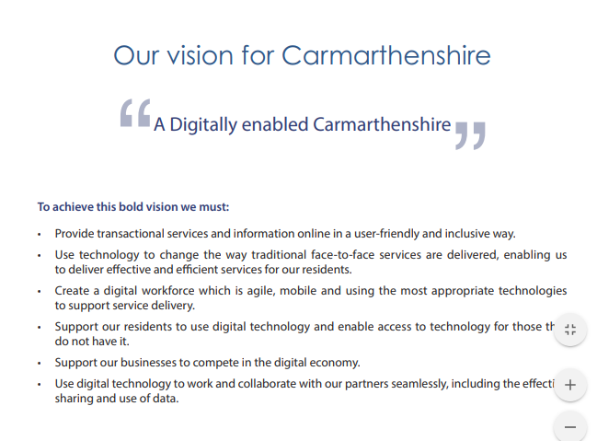
B. 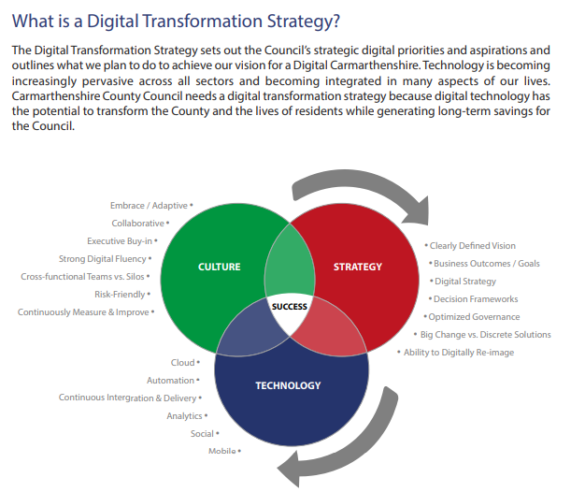

C. 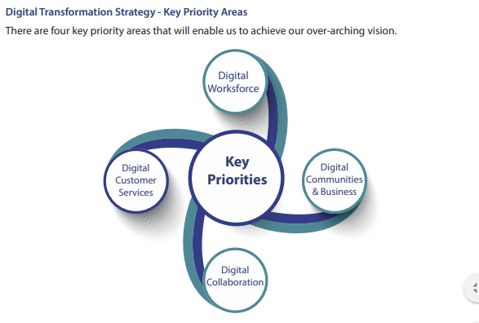

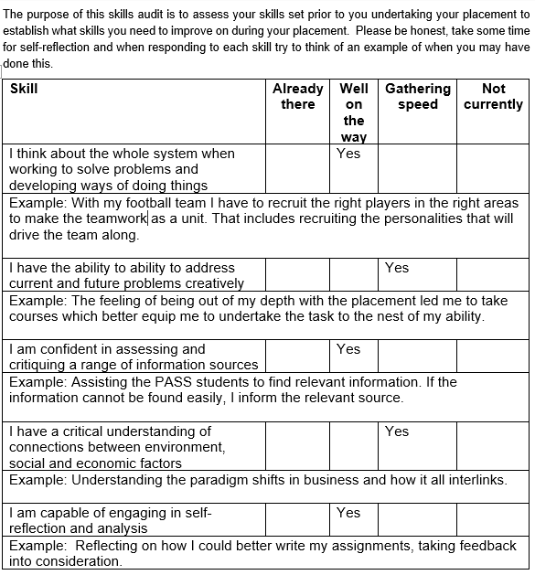
D.

.

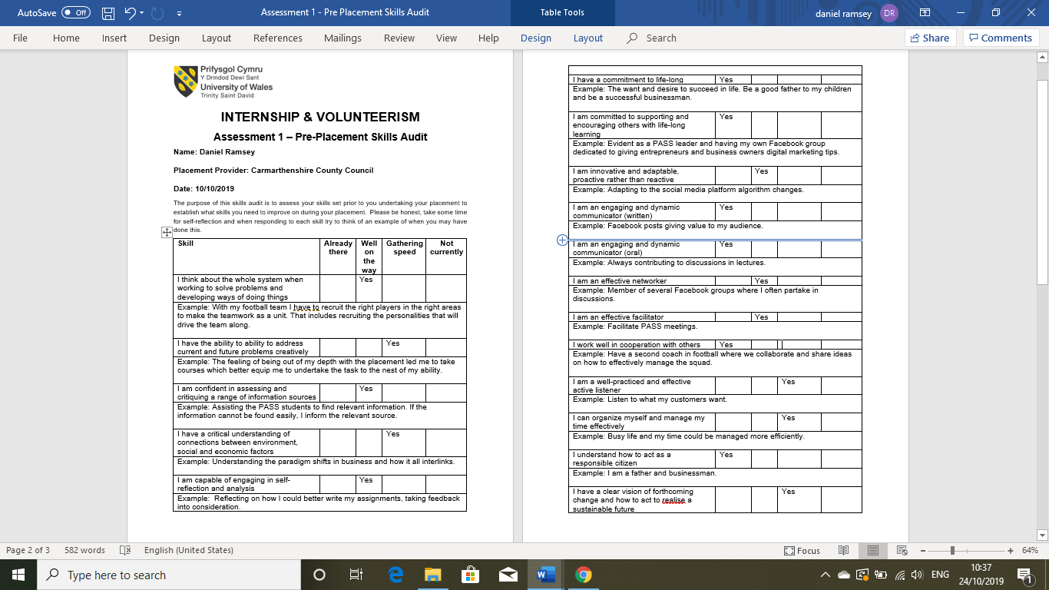

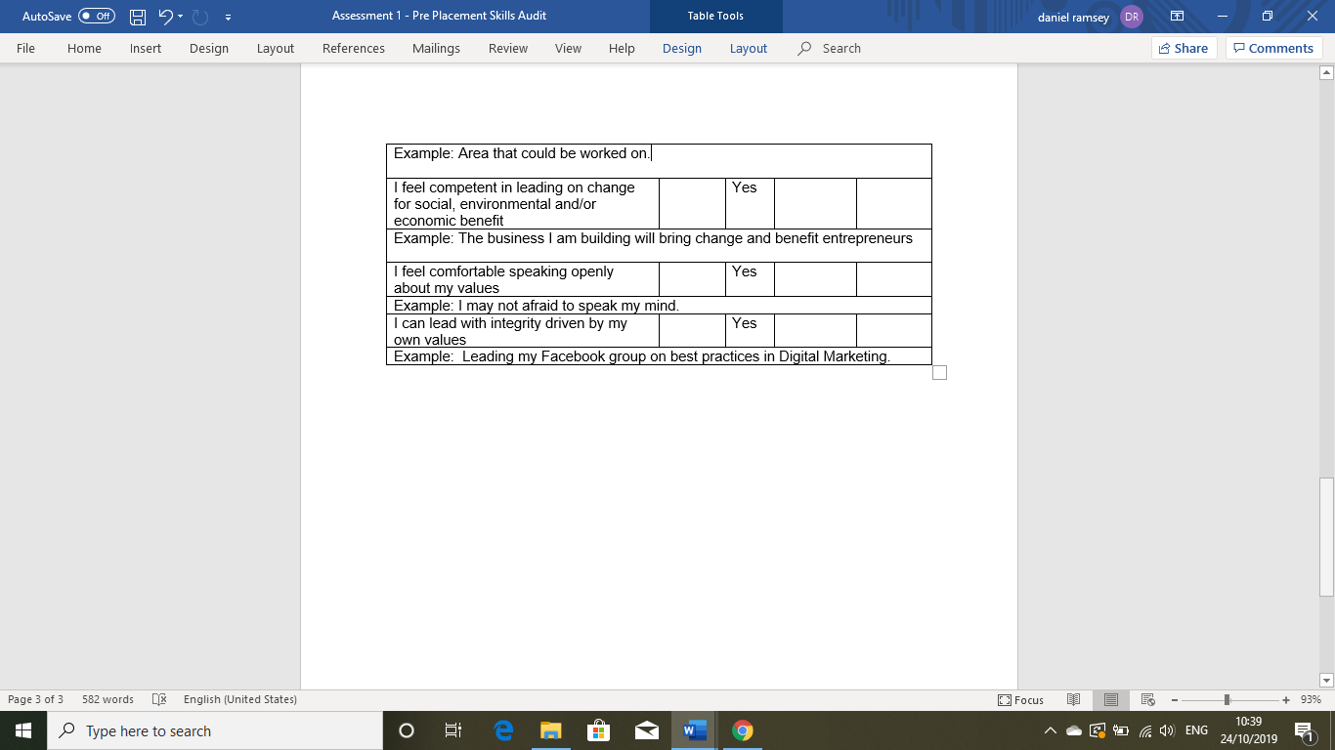

E.
 |  | Sept |  |  |  |  |  |  |  |  | Oct
 |  | 1 | 2 | 10 | 19 | 20 | 21 | 22 | 23 | 24 | 1 | 2 | 3 | 4 | 5 | 6 | 7 | 8 | 9 | 10 | 11 | 12 | 13 | 14 | 15 | 24
Task
Meeting With Paul | 13/5/19, 5/6/19, 30/7/19, 5/8/19 -4 HOURS |  | 50 MINS | 1.5 HOURS |  |  |  |  |  |  |  |  |  |  |  |  | 1 HOUR
Writing Letter of Intent and Questionaire | 5/8/19 2 HOURS
Revision of Questionaire | 11/8/19 30 MINS
Apologies To None Selected Stall-Holders |  |  |  |  | 30 MINS
First Interview With Chosen Stall Holder |  |  |  |  | 2.5 HOURS
Analysis of Interview |  |  |  |  |  |  |  | 3 HOURS
Recomendations and Findings Written |  |  |  |  |  |  |  | 1.5 HOURS
Feedback Session |  |  |  |  |  |  |  |  |  | 2 HOURS
Meeting With Stall Holder |  |  |  |  |  |  |  |  |  |  |  |  |  |  |  |  |  |  |  |  |  |  |  |  |  | 1 HOUR
Holiday For Stall Holder
Devise Colour Pallete
Design Logo
Optimise Personal Facebook Profile
Create Facebook Business Page - Link To Personal Profile
Create and Optimise Instagram Page/Shop
Add Products to Instagram Shop
Devise 30 Day Social Media Strategy Plan For Platforms
Create Content
Schedule Content
Research Wedding Fayres and Places For Stalls
Set Up Training And Resource Area

F.
Define Your SMART Marketing Goal
About the SMART Goal Framework
The SMART goal setting framework allows you to set clear and measurable goals while encouraging you to think about how you'll get there.
Overall Goal |  | Business Goal
 |  | To select a stall holder from Carmarthen Market and increase digital marketing use.
 |  | Personal Goal
 |  | To organise myself and manage my time more effectively while the project is being undertaken.
Specific |  | Business
 |  | To create digital marketing platforms such as a Facebook Business page, Instagram Busines page and shop which in turn will showcase the stall holders product to a wider audience and increase. A 30 day content plan will be devised to drive organic traffic to each site.
 |  | Personal
 |  | To utlise all the time mangement and organisation tools avaialable to prioritise and manage the project effectively.
Measurable |  | Business
 |  | The person selected will have little to no use of digital marketing platforms. Any increase of footfall or organic traffic to each platform will be positve, and measured using Google Analytics. Any increase in revenue will be measured by the decrease in stall stock and the increase in the reordering of new stock.
 |  | Personal
 |  | Google calender and a Gannt and will aid in the organising of appointments, meetings and sections of the project that need to completed.
Attainable |  | Business
 |  | I have studied several digital marketing platforms at lenght through various courses, therefore, in this instance, the SMART GOAL is very attainable.
 |  | Personal
 |  | Having used Google calender previously, I feel thsi objective is very attainable. Alarms will be set which will ensure all appointments are kept and deadslines are met.
Relevant |  | Business
 |  | The SMART GOAL set will contribute to the increase in organic traffic from the various platforms created, which turn will increase the stall holders bottom line.
 |  | Personal
 |  | It is imperitive that time is managed effectively to ensure the project is completed in the alloted time, meeting times are adhered to and the Gannt chart timelines meets its deadline.
Time-Bound |  | Business
 |  | The Placement is constricted to 20 days. A Gannt chart will have to be devised to ensure the work carried out is within the constraints given, and each segment will have a specific time and day allocation to ensure the the process is finished in the allotted time.
 |  | Personal
 |  | The time management and organisation falls in line with the alloted 20 day time period.

G. Placement Provider Agreement file:///C:/Users/Daniel%20Ramsey/Documents/Internship%20and%20Volunteerism/RE__Revision/PL1A.pdf
H. Placement Provider Health and Safety Questionaire
file:///C:/Users/Daniel%20Ramsey/Documents/Internship%20and%20Volunteerism/RE__Revision/PL1B.pdf
I. Placement Provider Contact Information
file:///C:/Users/Daniel%20Ramsey/Documents/Internship%20and%20Volunteerism/RE__Revision/PL1C.pdf
J. Placement Risk Profiling Guidance
file:///C:/Users/Daniel%20Ramsey/Documents/Internship%20and%20Volunteerism/RE__Revision/PL1D.pdf
K. Placement Risk Assessment
file:///C:/Users/Daniel%20Ramsey/Documents/Internship%20and%20Volunteerism/RE__Revision/PL1E.pdf

References
Carmarthenshire County Council. (2017). Carmarthenshire County Council. Retrieved from Carmarthenshire County Council - Digital Transformation Strategy 2017- 2020: https://www.carmarthenshire.gov.wales/media/1213933/digital-transformation-strategy-2017-2020.pdf
Davidson, J. P. (2000). Project Management (Illustrated ed.). Breathing Space Institute. Retrieved from https://books.google.co.uk/books?id=7x3LIw7TB5cC&dq=gantt+chart+project+management&source=gbs_navlinks_s
Kuhn, K., Warren, J., & Leong, T.-Y. (2007). Medinfo 2007, Parts 1-2 (Illustrated ed.). IOS Press. Retrieved from https://books.google.co.uk/books?id=dEXxG4XyvKwC&dq=why+do+we+use+a+health+and+safety+questionnaire&source=gbs_navlinks_s
Lopper, J. (2007). Personal Development 40 Best Articles. Lulu.com. Retrieved from https://books.google.co.uk/books?id=RoYleH9fmlUC&dq=the+relevance+of+personal+smart+goals&source=gbs_navlinks_s
Whiddett, S., & Hollyforde, S. (2003). A Practical Guide to Competencies: How to Enhance Individual and Organisational Performance (Illustrated ed.). CIPD Publishing. Retrieved from https://books.google.co.uk/books?id=ZP850cgpGI0C&dq=what+is+a+skills+audit+used+for%3F&source=gbs_navlinks_s

