Digital Skills 2 (DS2) – FreshBite Meals Digital Menu Project
Student ID: 2219181

Digital Menu

Freshbite Meals
Breakfast
Item | Price
Porridge Bowl | £3.80
Breakfast Wrap | £4.20
Fresh Fruit Pot | £2.50
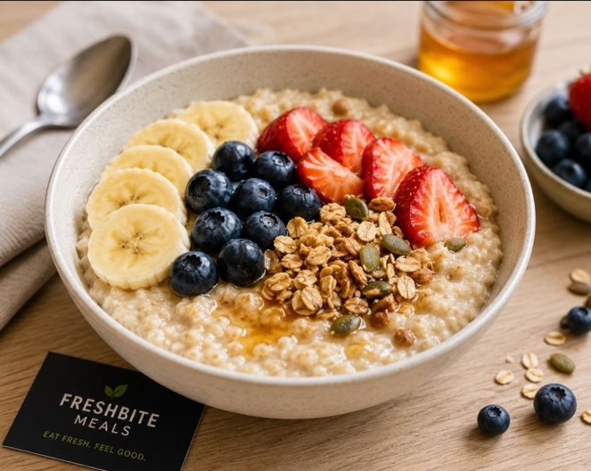
Launch
Item | Price
Chicken Salad Box | £6.00
Veggie Pasta Bowl | £5.50
Soup of the Day | £3.90

Snacks
Item | Price
Chicken Salad Box | £1.80
Veggie Pasta Bowl | £2.20
Soup of the Day | £2.50

Drinks
Item | Price
Fresh Orange Juice | £2.80
Iced Coffee | £3.20
Herbal Tea | £2.00

Why I Chose Microsoft Word
To complete this menu, I created a one-page digital menu for FreshBite Meals using Microsoft Word. I chose Microsoft Word because it is easy to use and provides useful tools for creating professional documents. Word allowed me to organize the menu very clearly using tables and formatting options.
I organized the menu into four sections: Breakfast, Lunch, and Beverages and Snacks. This makes it easier for customers to find the items they want. We also included all prices in a very clear way and used consistent formatting throughout the menu.
To create the menu, I used headings, text formatting, alignment tools, and tables. All of these features helped me a lot to present information in a clean and professional way.
I checked the menu before completing the task to make sure that all items and prices were correct. I also consider that the menu meets all the final requirements because it is attractive, clear, and easy to read for customers.
This activity helped me improve my Microsoft Word skills, especially document formatting and page layout.

