  Blog | Marketing Fundamentals  Assessment 1  Lecturer name Tushara Balendran  Student name : Mariana Zaharia  Student number:

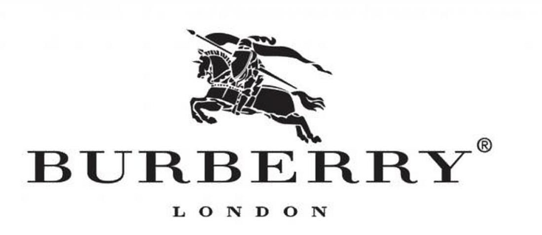

OUR HISTORY
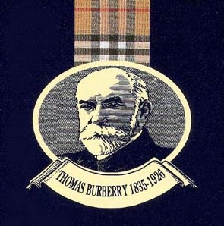

1856
The 21 years old Thomas Burberry launched Burberry in Basingstoke, United Kingdom. The globe notorious British weather made young Thomas to rethink the principals of clothing and considered that his garments should keep the British public dry and safe.

1879
Thomas invented the revolutionary fabric gabardine which was weatherproof as well as hardwearing and breathable fabric.

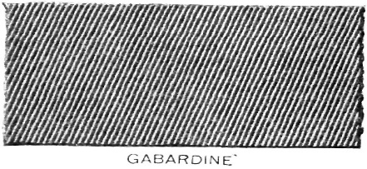
This Photo by Unknown Author is licensed under CC BY-SA

1888
The year 1888, Thomas patented the fabric gabardine and in 1891, Burberry was able to move to first store of London located at 30 Haymarket.
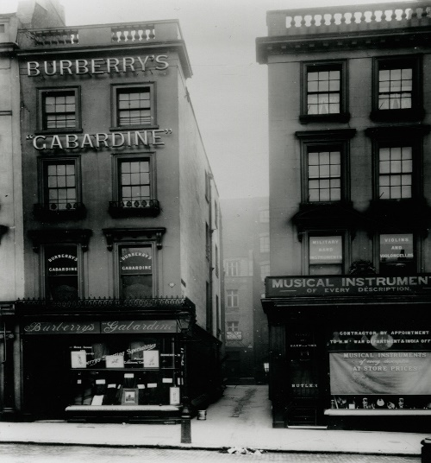

1893
DR. Fritjof Nansen was the first polar explorer that was recorded to take gabardine towards poles to the Arctic Circle. It is worth noting that in the year 1897, Major F.G. Jackson, an explorer who use to map the Arctic Circle wore the gabardine by Burberry and undertook Franz Josef Land expedition.



1901
Burberry introduced their logo in 1901 and in 1909, a store in Paris was opened 8 Boulevard Malesherbes and in 1911 Roald Amundsen, an explorer with his whole team reach the South Pole and was wearing Burberry gabardine cloth and tent.
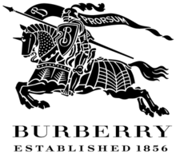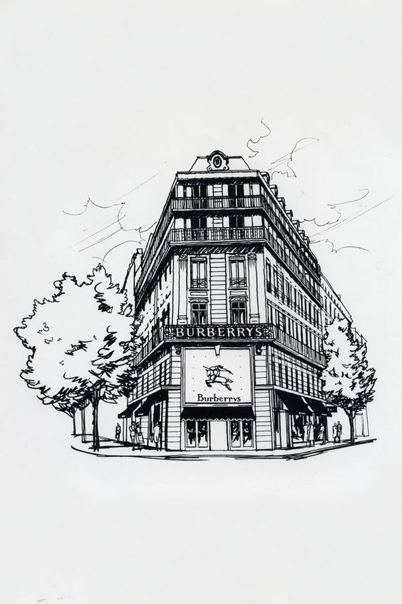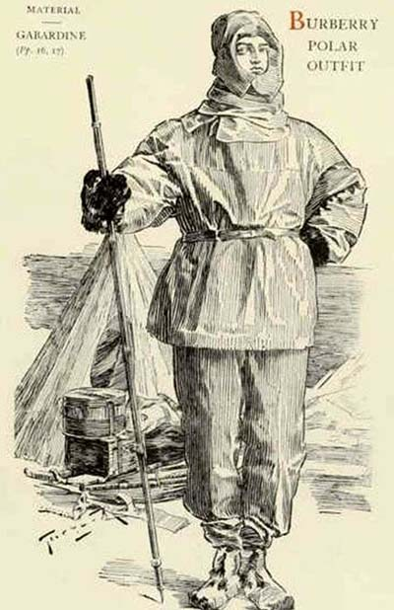

1912
In 1912 Burberry patented the Tielocken coat. It is important to note that during the First World War 1914-1918, Burberry was able to provides equipment and appeal to the Armed Forces. The business was able to introduce trench coat which had unmistaken details, serving a purpose and 1919 HM King George V appointed the business with royal warrant and appointed them as tailors.

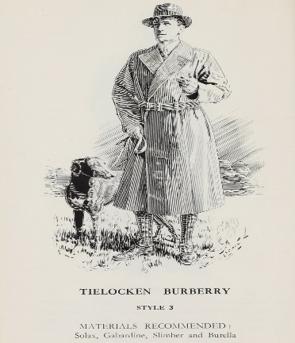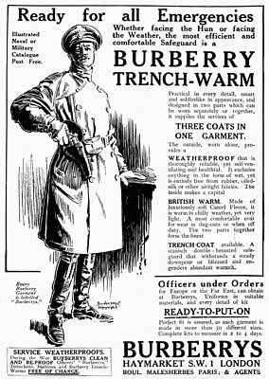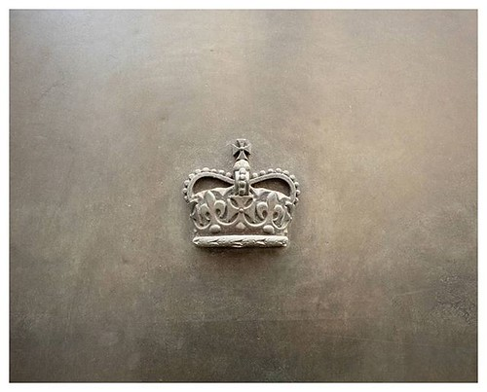

1920
Burberry in the year 1920 became publicly traded business and in the year 1937, they sponsored a flight that flew from Croydon-Cape Town and the aeroplane was names Burberry. The officers that were flying the aircraft wore the clothing of Burberry and 1955, Burberry got Royal Warrant of Weather-proofer by HM Queen Elizabeth II. Moreover, Burberry got Royal Warrant as Outfitter by the Wales Prince and they opened their first London store, displaying themselves as luxury global iconic brand and got listed on London Stock Exchange. The year 2004, the website of Burberry was made transactional in United States and the same happened in the UK in 2006 and in 2008, they had their Middle East headquarter at Dubai. Burberry joint ventured with Genesis Colours in India in the year 2010 and 2011 the same happed in Saudi Arabia.

2018
Rainbow checks was introduced in the year 2018 for supporting the community of LGBTQ+.
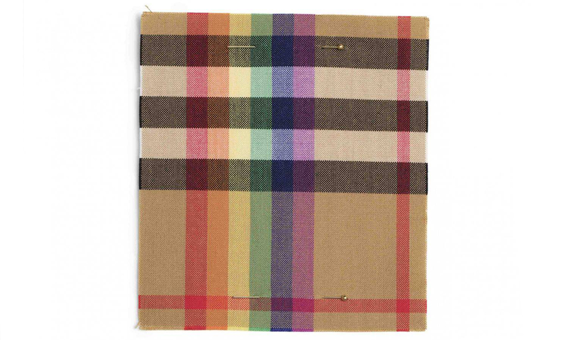

OUR MISSION

Burberry is one of the most recognized fashion brands with over 432 operating magazines on the globe. Our mission is to foster sustainability and it has been grounded in our belief which is our focus to attain growth in the future.

OUR PRODUCTS

Burberry has been able to gain expertise in fashionable clothing for men and women as well as kids and has gained the reputation of a luxury brand. Our designs are distinctive and the materials that we use are exquisite. Burberry cotton is obtained from countries like United States of America, India, Australia, or Egypt. We understand that key factor of procurement of the sustainable yarn/cotton accreditation program available to the trade nowadays is hugely environmental, and that our ability to give reassurance against work mistreatment is reduced to minimum. Gabardine is being weaved at our mill in Keighley, Yorkshire, United Kingdom and our representative trench coat in Castleford, UK. Our Tartan patterns has been considered as uniquely designed.

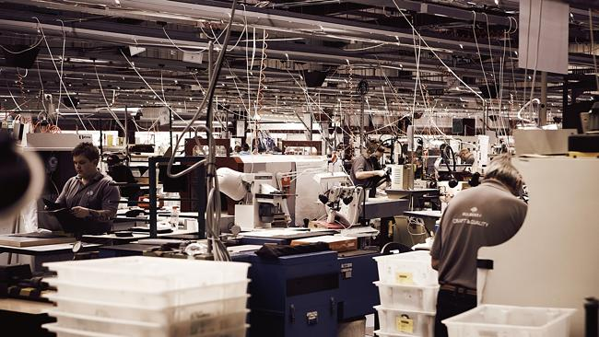

Burberry includes the following collections: Burberry London (workwear, our iconic trench and accessories) and Burberry Prorsum (ready to wear catwalk collection) as well as Burberry Weekend (casual end-of-the week wear) along with Timepieces (fashion watches).

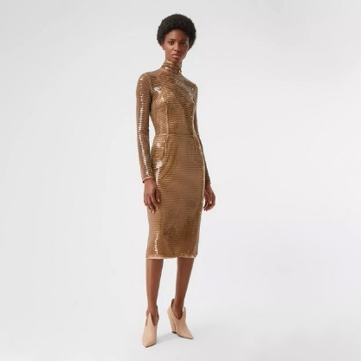
Are you ready to look fabulous this Christmas? Dim the lights in your chateau, put the music on, turn on the TV and strut, strut, strut like a catwalk model. To SHOP THE LOOK from our Prorsum Collection please click here Burberry Autumn/Winter 2020 | Official Burberry® Website

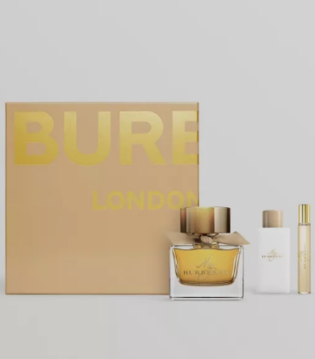
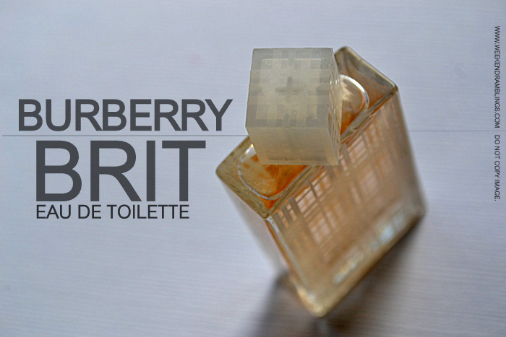
Our brand even has collections in fragrance which are Burberry Touch and Burberry Brit. Our accessories consist of leather bags, eyewear, scarves, belts, hats and gloves, jewellery, tech accessories, umbrellas, key and bag charms, wallets. It is important to understand that their main revenue is generated from their women section as well as children outwear. The customers of Burberry that are regarded as entry level have higher focus on their accessories and this section has better shelf-life as apparels fashion keeps changing.

Personalisation services – add a personal touch to your article to make it your own or maybe create something special and quirky for your loved ones.
SHOP for her SHOP for him
Personalised Gifts for Her | Burberry Personalised Gifts for Him | Burberry
Burberry has been able to occupy 60% of the market share with their signature product, trench coats.
In this pictures is presented the classic trench coat of Burberry. It has the Kensington fitting and It also has been updated with a hood that can be detachable. The outer and lining of the coat is pure polyester, and the trims have been made of calf skin. It is a timeless and versatile piece which everyone must have it in their wardrobe. You can wear it for your Sunday shopping or throw a pair of heals and you can go to Ritz for dinner. It will keep you fashionably on a wet day, however if you add a pair of Wellington boots you are ready to go grouse shooting with the Queen at Balmoral Castle. Nevertheless, do not forget to put some woollen clothes underneath as the polyester cannot compete with wool.

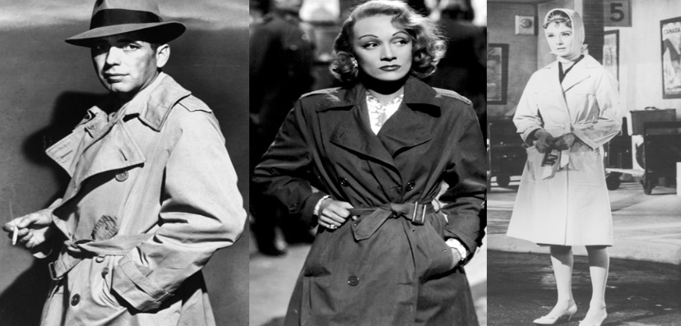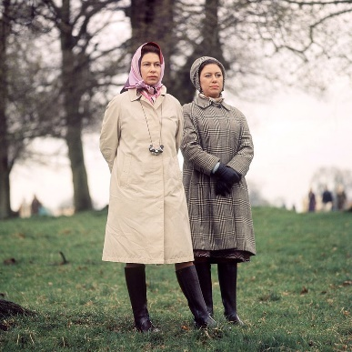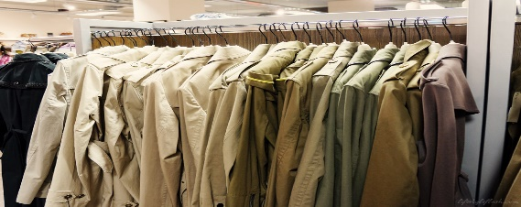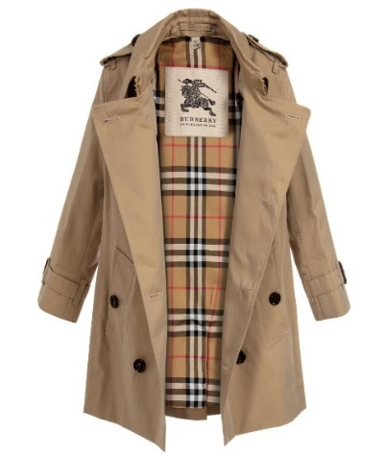
This Photo by Unknown Author is licensed under CC BY-ND

Product aftercare – expand the life of your Burberry trench coat, bag, belt, or scarf etc with our aftercare facilities and assistance. Please click on the link below for our aftercare services
Product Aftercare | Burberry

PACKIGING AND PLASTIC

NO NO NO to PLASTIC! By 2025 we guarantee to remove all the unneeded and problematical plastic. We aim to use 100% recyclable, compostable or eco-friendly plastic and reuse where possible. A great progress has been made so far in the fight to remove plastic lamination from our shops and online packaging by using wrapping material made from 58 million recycled coffee/teacups. The resulting product still feels luxurious and gorgeous and most importantly it is verified by FSC (Forest Stewardship Council).

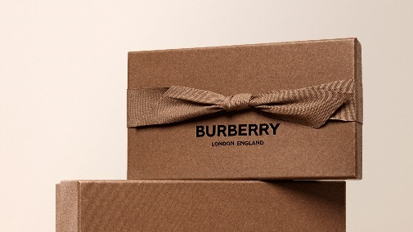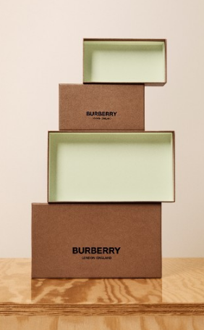

It is worth noting that the industry that Burberry is in requires differentiation and the brand has been able to gain success through our style as well as unique design along with greater quality. This has assisted the business in gain long-term success as we are considered stylish and has wider price range as well as timelessness. Moreover, the business has been able to employ the colour beige in our products that have been able to signify simple and has even differentiated us from others in the market. This has made Burberry unique and innovative and the reason why the brand has been able to grab the attention of various consumers that has helped us to grow our business worldwide.
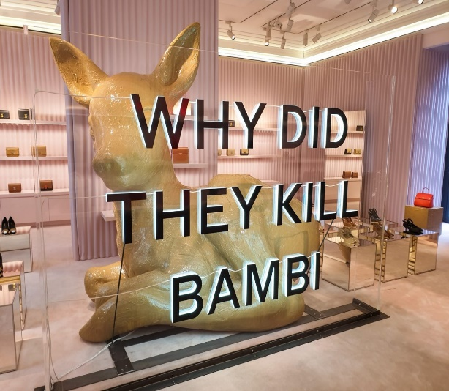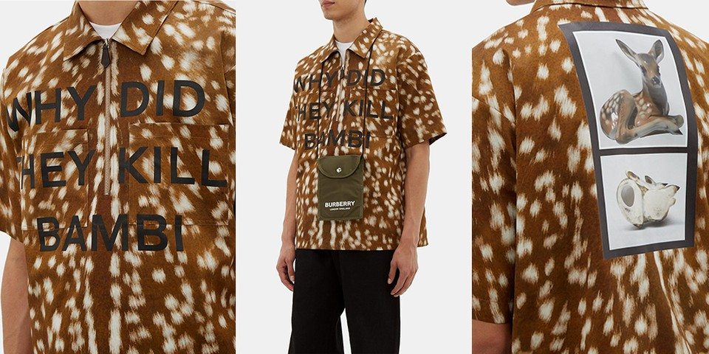

Furthermore, we are proud to announce that we stopped using real fur since 2018.We can still provide to our customers modern luxury and at the same time we can be environmentally responsible.
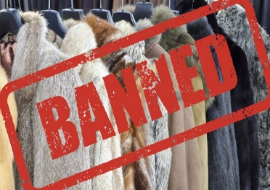

Burberry Price

Burberry being a luxury brand has been able to make use of premium pricing for selling our products. It is worth noting that we have been able rightly to mix lower costs along with high-end premium goods and this is what the brand wanted to achieve. Our brand does not compete with others in the market, considering the pricing that we have rather Burberry has greater focus on design and durability as well as perception. It is important to understand that Burberry tries to keep their pricing strategy as premium as changing our prices can make the consumers turn away from our offerings. We price our products after we have deeply evaluated the demand of the market as well as the pricing of our competitors. Therefore, Burberry first understands the demand of the consumers and their purchase willingness which then assists them in determining the price of their products. Moreover, we have excellency in craftsmanship as well as our focus is over innovative design which helps us in catering the high-class zone of elites. The target market of Burberry is focused with quality and these consumer does not focus on price that much.
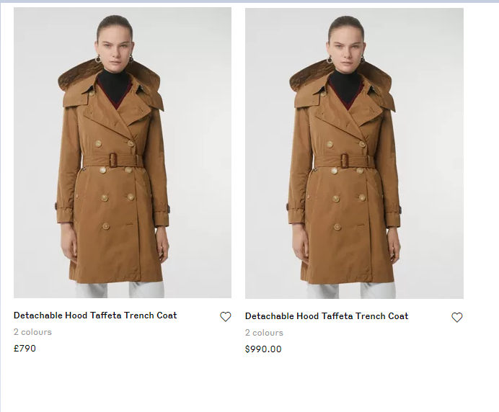
Burberry Trench coat prices across the Globe,2020
The price of the trench coat in the UK is £790 whereas in US it is $990 and this due to the differences in the currency. However, the trench coat is costlier in the UK as compared with United States or Japan.
United States | $990
United Kingdom | £790
Australia AUD | $1580
Canada CAD | $2.250
Japan Yen | ¥190.918
Burberry® | Iconic British Luxury Brand Est. 1856
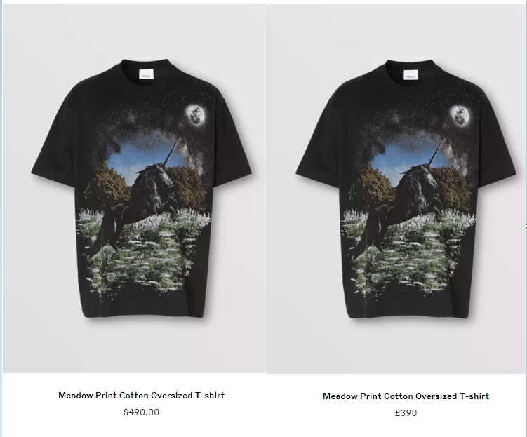
Burberry t-shirt mentioned in this pictures is sold at £390 in the UK and $490 in the US and this due to the differences in the currency. However, the t-shirt is costlier in the UK as compared with United States.

Burberry being into luxury as well as the business has been able to globally capture markets therefore, we ensure that we have price consistency everywhere. This is because any discrimination in our prices can result into brand image dilution. Thus, Burberry has a global team that looks after the pricing of the brand and takes the responsibility of making strategies for pricing after deeply evaluating demand and prices of competitors.


Burberry Promotion


Celebrity endorsement

This sort of celeb collab helps to promote the brand. Many individuals have a great admiration for celebrities, so an endorsement of a service or product immediately raises the amount of credence the client has in the brand. However, if the celeb gets bad publicity it might have a damaging impact on the brand.
Burberry was possibly the first fashion house to use the concept of celebrity endorsement and see the benefit in having celebrities like Romeo Beckham, Emma Warson, Matt Smith fronting our line.
Our campaigns have become a talking point, which reconceptualized the brand. Having the 16 years old Brooklyn Beckham photographing one of our adverts had not gone unnoticed and even got some criticism but definitely got everybody taking about us and put Burberry on the map and definitely change the mind of millions of his Instagram follower about our brand and target market. In 24 hours, his Christmas commercial attracted over 10 million views.
British born and bred top models Kate Moss, Naomi Campbell, Cara Delevingne and Sienna Miller are unquestionably Burberry girls who are closely attached with the brand and indisputably helped to promote it successfully.

This Photo by Unknown Author is licensed under CC BY-SA-NC
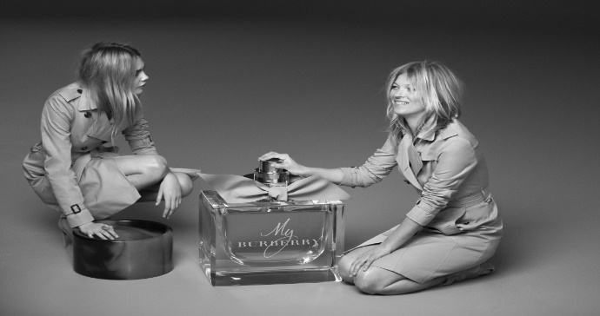
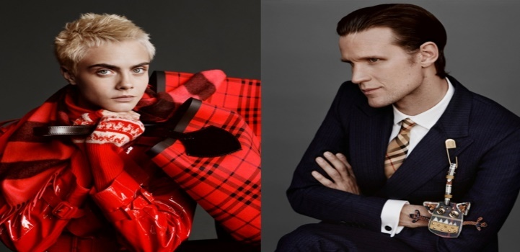



Burberry is referred to as the digital innovator of the fashion industry. Our approach to social platforms is not to just repeat the content all over our social media but to try to comprehend our buyers needs and wants, what kind of clients are on that particular platform so we can tailor it accordingly. Or most popular social media accounts are:
LIKE our Facebook page https://www.facebook.com/Burberry
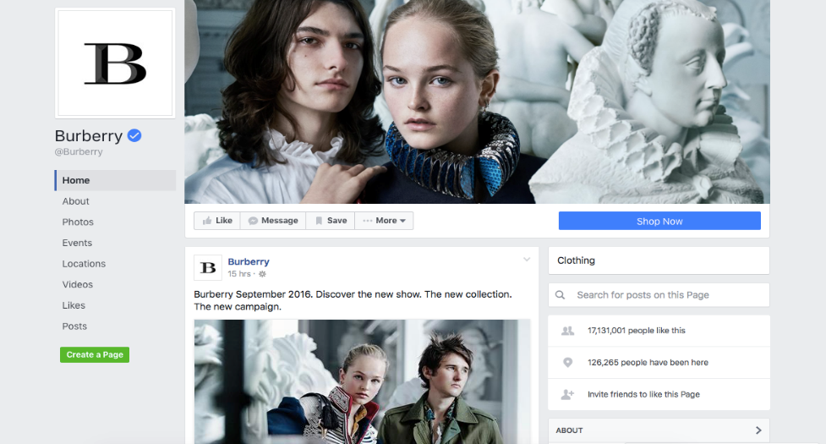
Follow us on Instagram https://www.instagram.com/burberry

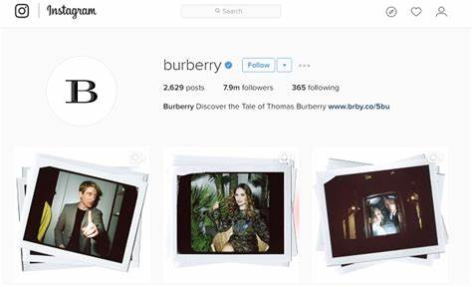
Keep in touch with us by following us on Twitter https://twitter.com/Burberry
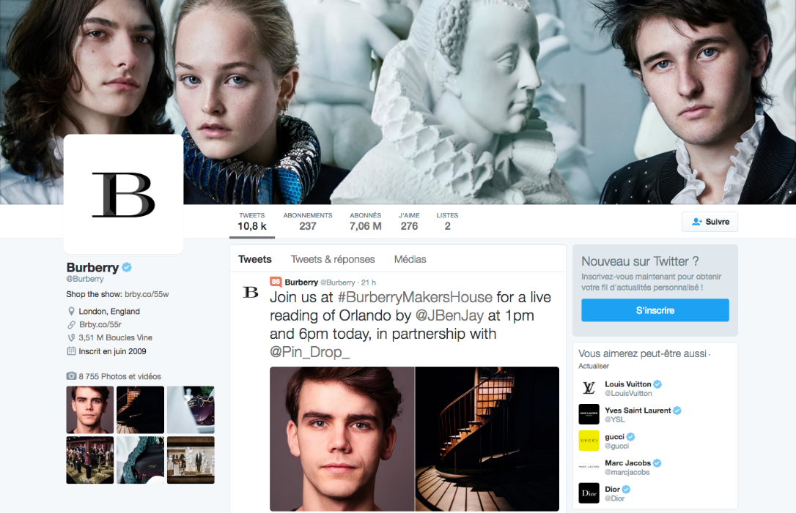
Add us on Snapchat
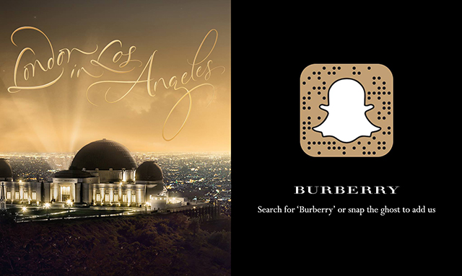
Or download our app to shop the new Burberry drop using your phone.
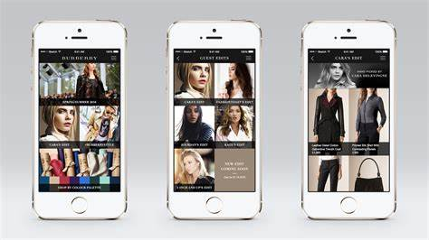
See-Now Buy-Now

In 2016 Fall/Winter collection at London Fashion Week, Burberry has revolutionized the fashion industry by introducing first ever See-Now Buy-Now show in which the customers could have gotten their hands on the latest Burberry items straight after the show without having to wait for 6 months for the collection to be released. This immense change allowed us to develop a friendlier bond between the experience that we generate with our fashion shows and the minute when our fans can tangibly discover the newest Burberry ensemble for themselves.

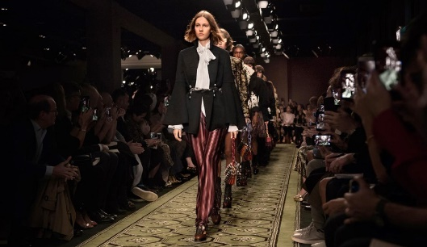
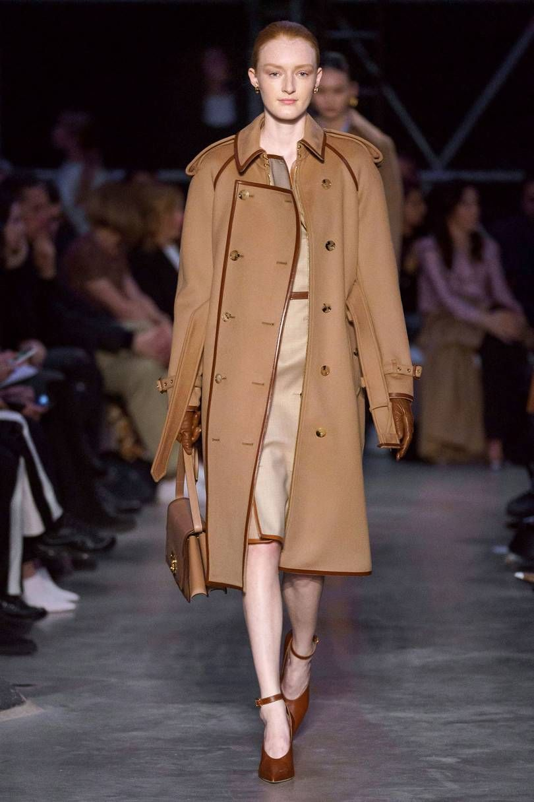

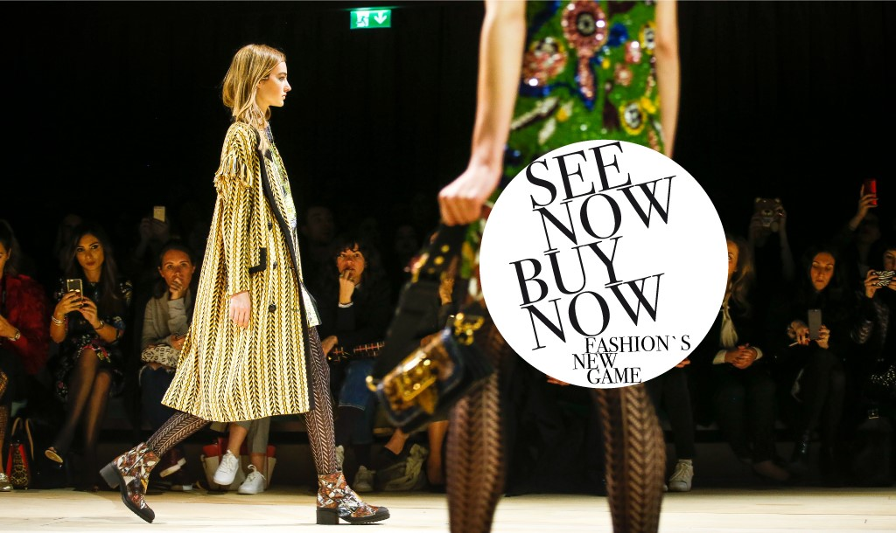



Burberry’s Distribution and locations
2020 has been a fantastic year for our brand. Distribution channels has encountered a major progress during this year. We have a sizable group of franchised and owned retailers in the most fashionable cities across the Globe and our very own electronic commerce supplying 55 states.

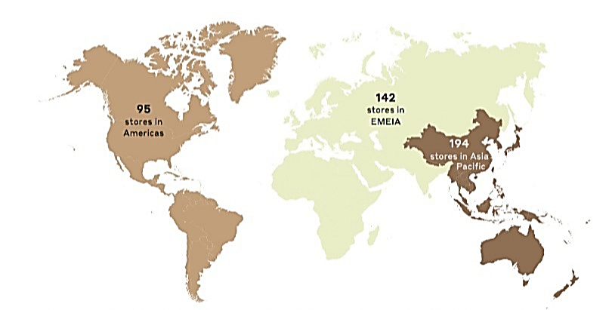

Furthermore, we have teamed up with exclusive high fashion resellers and licensing partnerships (Japan only), as well as TPPs (third-party providers), to add to our distribution. We improved our client touch point with our digital capabilities from the minute our customer gets the desire and the vision of what they want until the post-acquisition experience. Burberry releases only 2 collections per year fall/winter and spring/summer. Wholesale clients must place the order for fall/winter collection in February the latest and for the spring/summer period starts in the previous May to August.

Retail distribution
Our stores are situated in the most fashionable cities in the world, in wealthy areas like Regent Street in London, or on Passeig de Garcia in Barcelona, Madison Avenue in New York or luxury Ginza Chuo-dori Street in Tokyo to name few. All our stores have a minimum of 12.000 square feet and have full supply of Burberry London and Prorsum collections also different fashion accessories collections. Acting as a platform to the fashion journalism/media and wholesalers, our shops are an essential part in communicating the unique placing of the Burberry label. We offer a variety of products that are in general similar but adapt them to fit the local weather and local differences. For instance, our shops in London would stock a larger range of raincoats, wellies, umbrellas etc compared to the stores in Barcelona which will mainly display lighter weight items. Burberry operates successfully also as a store within a store called concession. It gives us access to a wider customer base and offers a modified version of Burberry Brit and London ranges. Lastly, we operate 25 designer outlets and 12 factory stores in United Sates, United Kingdom, Spain, Poland etc.

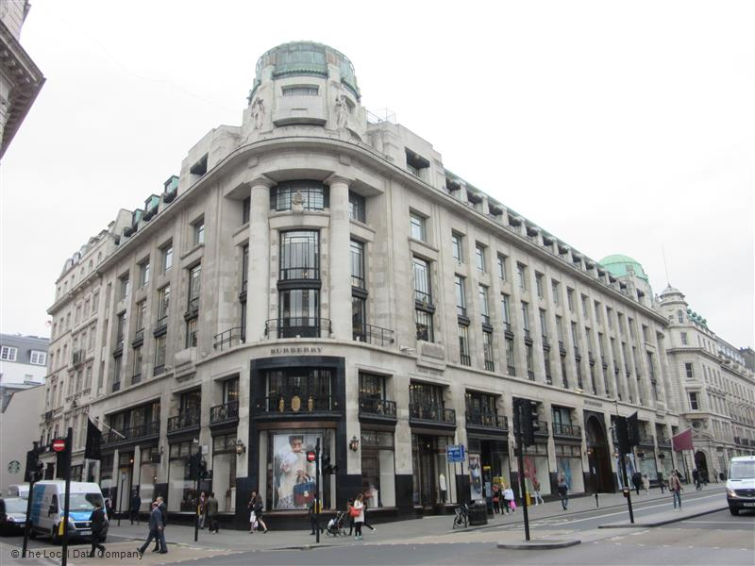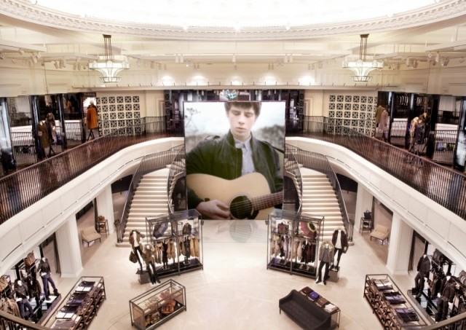
Please visit our store on 121 Regent Street, Mayfair, London W184TB
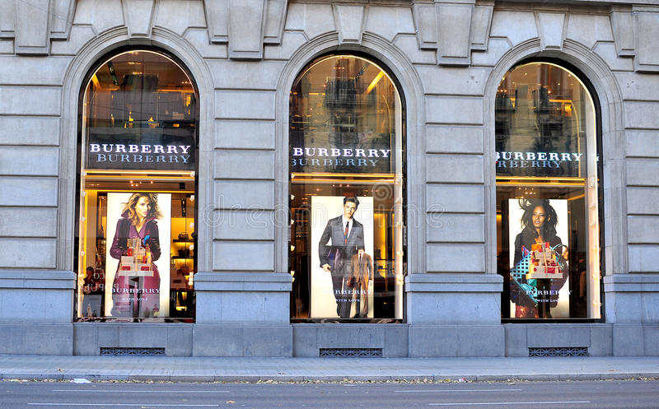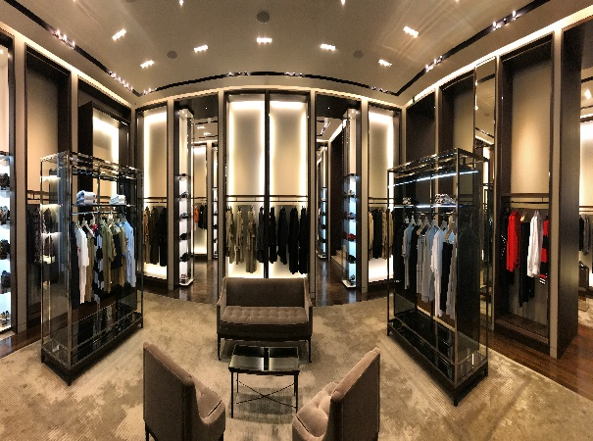
If you are in sunny Barcelona do not forget to pay us a visit. We are in Paseo de Gracia 56, Barcelona · 932 158 104

References
burberryplc.com 2020. CREATIVITY OPENS SPACES [online] https://www.burberryplc.com/content/dam/burberry/corporate/oar/2020/pdf/Burberry_Annual_Report_2019-20.pdf.downloadasset.pdf [accessed 4th December 2020]
burberry.com 2020. WOMEN’S FRAGRANCES [online] https://mo.burberry.com/womens-fragrances/ [accessed 2nd December 2020]
burberry.com 2020. WOMEN’S BAGS [online] https://us.burberry.com/womens-bags/ [accessed 6th December 2020]
burberryplc.com 2020. History [online] https://www.burberryplc.com/en/company/history.html [accessed 5th December 2020]
burberryplc.com 2020. PLASTIC AND PACKAGING [online] https://www.burberryplc.com/content/burberry/corporate/en/responsibility/focus-areas/company/plastic_and_packaging.html [accessed 24 November 2020]
BORSBOOM, L., CASE, B. and LAWSON, N., 2018. BURBERRY JOUSTING FOR REDEMPTION. LBMG Corporate Brand Management and Reputation-Masters Case Series.
Hulleman, C.S., Thoman, D.B., Dicke, A.L. and Harackiewicz, J.M., 2017. The promotion and development of interest: The importance of perceived values. In The science of interest (pp. 189-208). Springer, Cham.
jingdaily.com 2018. Is Burberry’s Simple New Logo Catnip to Copycats? [online] https://jingdaily.com/burberry-new-logo-copycats/ [accessed 12th December 2020]
Olteanu, L., 2020. Rebranding strategies and their boomerang effect—The curious case of Burberry. The Journal of World Intellectual Property.
Silvano, M.D.C.L.F., 2020. Playing against the rules: how a digital strategy can enhance a luxury business: the case of Burberry (Doctoral dissertation).
Sprovieri, A.,2017. From E-commerce to social commerce, a study about digital customer engagement: the Burberry case
Sull, D., Turconi, S., Sull, C. and Yoder, J., 2018. Turning strategy into results. MIT Sloan Management Review.
uk.burberry.com 2020. Detachable Hood Taffeta Trench Coat [online] https://uk.burberry.com/detachable-hood-taffeta-trench-coat-p80061121 [accessed 3rd December 2020]
us.burberry.com 2020. MEN’S T-SHIRTS & POLO SHIRTS [online] https://us.burberry.com/mens-polo-shirts-t-shirts/ [accessed 3rd December 2020]
Wang, W. and Zhao, S., 2018. On the power divergence in quasi gluon distribution function. Journal of High Energy Physics, 2018(5), p.142.

