Designing an Automatic Traffic Light Controller for a T- Junction Road
Table of Contents
Table of Figures 1
Introduction 2
Background Research 2
PIC16F877A 2
PIC16F877A Advantages 2
PIC16F877A Disadvantages 3
7-Segment Display 3
LED Traffic Light Display 4
Circuit Design/Relevant Diagrams 5
Flowchart 7
Software Listings 7
Proteus 7
PCW CCS Compiler 8
Simulation Screen Dumps 8
Testing, Simulated Outputs and Results 14
Conclusion, Recommendations on Future Work 14
References 15

Table of Figures
Figure 1: Working Principle of 7-Segment Display 3
Figure 2: 7-Segment Truth Table 4
Figure 3: Proteus Circuit Design 6
Figure 4: Circuit Flowchart 7
Figure 5: Proteus Simulation at 7 Seconds 8
Figure 6: Proteus Simulation at 17 Seconds 9
Figure 7: Proteus Simulation at 27 Seconds 10
Figure 8: Proteus Simulation at 37 Seconds 11
Figure 9: CCS Compiler Lines 1 - 50 12
Figure 10: CCS Compiler Lines 51 - 100 13
Figure 11: CCS Compiler Lines 101 - 116 14

Introduction
This assignment has been set with the task of developing a traffic light control system for a T-Junction that is operated with precise timing intervals, the aim of which is to regulate the flow of traffic effectively with safety for both the pedestrians and drivers as the primary focus, this can be done by implementing time-based signal changes which will be a reliable solution for a situation such as this. As the traffic lights will be situated at a T-Junction there will be three different roads that all converge to this point along with a pedestrian crossing available at each road. The standard that this traffic should operate and function to are as follows:
- Install a set of traffic lights at each side of the road for comprehensive traffic management.
- Using a 7-segment display to count up or down for a duration of 40 seconds, with the light display shown changing every 10 seconds.
- The final 10 second display should be dedicated for safe pedestrian crossing. During this phase the traffic lights should either be in an off state or all being illuminating red.
This task will require the use of programs such as Proteus, PCW and CCS Complier. These software programmes used in unison will all for the electronic circuit to be designed, produce a program that enables the circuit to function as well as the complier which will allow the whole system to be able to function as one.

Background Research
To be able to undertake this task efficiently there are a variety of components that need to work cohesively to be able to get the system in a functional state.

PIC16F877A
The PIC16F877A is an 8-bit microcontroller that is commonly found in a wide variety of embedded electronic applications. This microcontroller has is comprised of 40 pins that is then broken down into five ports starting from PORT A to PORT E, 33 of the 40 pins found on this microcontroller can be used as either an input or output. As this type of microcontroller could be deemed as basic in comparison to others within this field, the characteristics that it is comprised of makes it extremely suitable for the task of controlling traffic lights at T-Junction. [1] Below is a more in-depth breakdown of the advantages and disadvantages of this specific microcontroller:

PIC16F877A Advantages
- This microcontroller provides the user with 33 general purpose input/output pins making it a suitable option for projects that require a multitude of inputs and outputs.
- For how high the performance is of this device, the power consumption is considerably low especially when it is not processing data. As it has such a low power consumption it can also work with battery operated devices.
- Another benefit of this microcontroller is the ease that it can be programmed and reprogrammed, all that is required is the hex file embedded into the component to be updated.
- It also features 368 bytes of data memory (which is more commonly known as RAM) and 256 bytes of EEPROM that allows for non-volatile data storage, which is plenty for most applications it will be found in. [2]

PIC16F877A Disadvantages
- The PIC16F877A can only operate of a maximum frequency of 20 MHz which will become an issue when trying to run higher speed/demand applications.
- Another issue I see being present using this microcontroller would be that it has quite a high learning curve in comparison to other 8-bit microcontrollers like the Arduino for example.
The balance of pros and cons make this microcontroller a very suitable use for a variety of applications especially those which are not overly complex, as the traffic lights at a T-Junction is reasonably minimal operation in comparison to what the device can do it will be more than adequate for the task at hand. I would be less likely to suggest it to be used in a situation that required a much higher demand but for this situation it is a perfectly reasonable device that is fit for use.

7-Segment Display
The 7-segment display is a light emitting diode formation that is used to display the numbers 0 to 9. This LED is broken down into seven different LEDs that are arranged in a rectangle formation that looks like the figure eight, each of the individual 7 seven LEDs can be illuminated to change the number displayed. These types of displays are commonly seen in use throughout the world in a variety of industries, some of the most common applications of this being used would be such as a digital clock, clock radios, calculators, wristwatches and motor vehicle odometers for example. [3], [4] Below is a figure illustrating the working principle:
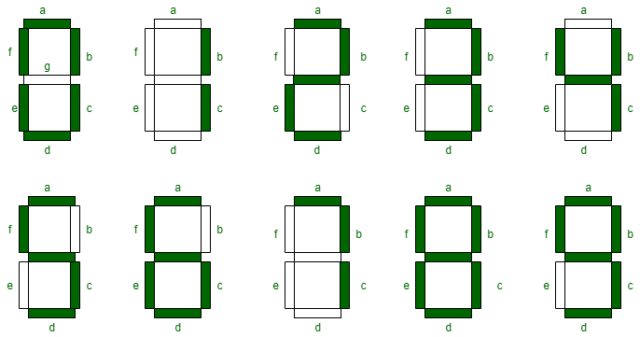

[4]
Figure 1: Working Principle of 7-Segment Display
As seen in the figure above depending on which segments are powered will dictate the value shown on the display, so if all segments were powered on the display would show the value eight in numerical form. This principle can then be applied for every other value between 0 to 9, below is truth table that breaks down the segments that needed to show every value possible:

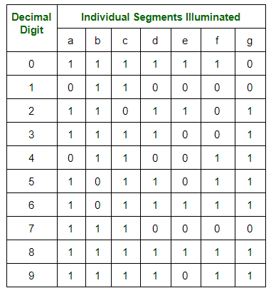
Figure 2: 7-Segment Truth Table

Additionally, there are two different types of configurations that you can get a 7-segment display these are a common anode display and a common cathode display. The main difference between an anode and cathode display is the with the common cathode display all the segments built-in to the display are connected to each other via logic 1, meaning that the individual segments are powered on by applying a logic 0 through a current limiting resistor. Alternatively, the common anode you would connect the positive terminals of the segments together and ground them individually, then to power the segments on you would have to apply a low voltage through the common anode to the respective segment to power it on. [3], [4]

LED Traffic Light Display
LED traffic light displays could be considered as one of the most common LED displays in the world, as these styles of displays are seen on the roads in almost every country in the world. It is a system that is very easy to follow as the colours used are red, amber and green which are known to be associated with stop, wait and go when in a situation for controlling road traffic.
These LED light displays can be controlled by using a high or low signal from a microcontroller which will dictate which LED is illuminated. This is done by each LED having its own connection to the microcontroller which will have a built-in programme that outlines the instructions/sequence for the lights. This method of display also uses a common cathode configuration for the connections along with the programme within the microcontroller.

Circuit Design/Relevant Diagrams
The circuit design required for the task of an automated traffic light control system at a T-Junction with a pedestrian crossing would require components such as a microcontroller, 7-segment displays, traffic light displays and LEDs. Firstly, going through the microcontroller, PORTA, B, C and D will be required to be configured as an output in the software which will be a sufficient number of pins to operate the system.
Each LED integrated within the traffic light display will need to be assigned an individual pin on the microcontroller because of the need for each traffic light to display a different colour to ensure that there is a constant flow of traffic. Since each traffic light has three terminals (representing red, amber and green), a total of nine pins on the microcontroller will be required to be connected to these. As seen in figure 3, each individual traffic light has a connection to the microcontroller labelled numerical starting from 1 to 9. The connections for the traffic lights can be seen on PORTA and PORTB on the microcontroller, as a port doesn’t have 9 pins within a port they had to be split across two.
The next key component within this circuit is the 7-segmet display. In this design two displays are required to work to cohesively as the count needs to reach as high as 40 seconds which is impossible to achieve by only using a single display. The first three display’s responsible for counting from 0 to 9 seconds are all connected to PORTC, the seven pins on microcontrollers PORTC are wired directly the all three 7-segment displays, they are all run of the same terminals as this ensures that they all count identically removing the possibility of them misalignment and causing problems for the system.
The same principle in then applied to the next three 7-segment displays which are responsible for counting from 10 to 40, these displays again are all linked to PORTD on the microcontroller and follow the same wiring configuration to maintain synchronisation. The software controls the energising of the relevant pins to align with the elapsed time. Since the count should be identical on each pair of displays, the software only must account for the power going through the required microcontroller pins, which splits of to all three of the 7-segment displays.
The final portion of the circuit is the pedestrian crossing. The connections for the LEDs at the pedestrian crossing can been seen at PORTB on the microcontroller in Figure 3, with the relevant connections are labelled as X and Y. The pedestrian crossing features a red LED and a green LED, for the first 30 seconds of the systems cycle the red LED illuminates to show that it is not safe to cross. During the final 10 seconds the red LED turns off and the green LED illuminates to signal that it is safe to cross.
The control for this feature is managed within the microcontroller’s software. The 3 pairs of LEDs are all connected to the same pins on the microcontroller to ensure proper alignment. The LEDs are also linked to ground, providing a 0v reference point necessary to establish the voltage potential difference required for the LEDs to function. Additionally, when the green LEDs at the pedestrian crossing is illuminated green, all the traffic light displays are set to red. This feature was added as an additional safety feature and to more accurately replicate how these systems operate in a real-world scenario.
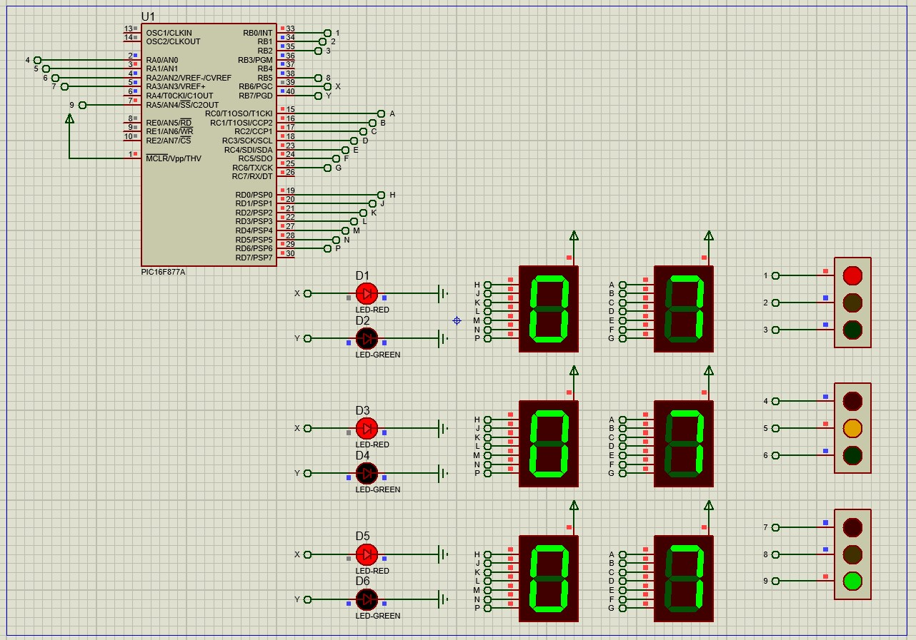
Figure 3: Proteus Circuit Design

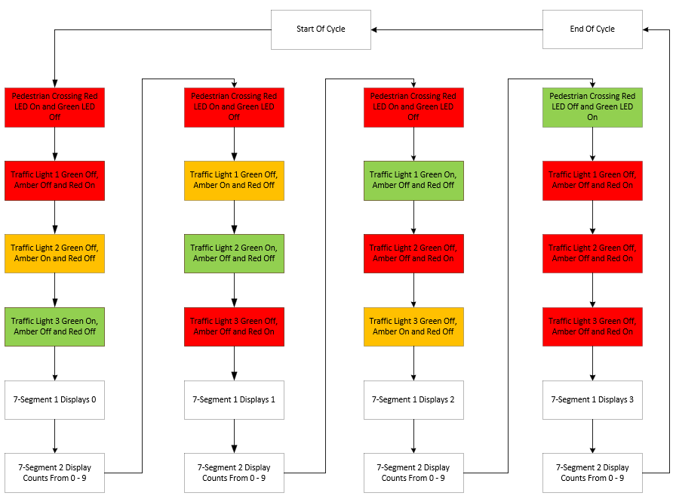
Flowchart
Figure 4: Circuit Flowchart

Software Listings

Proteus
Proteus is a software design and simulation application that allows users to build circuits using simulated components. This program is used to generate circuits with simulated components, allowing circuits to be correctly created and improved through a low-risk trial-and-error process. Using this program, numerous adjustments may be done, such as changing the layouts, wiring, and component properties to guarantee circuit optimisation. The program covers both the physical and characteristic composition of a wide range of components, including several microcontrollers and electronics components such as traffic lights, LEDs, and 7-segment displays, ensuring that this project is completed successfully. [5]
Proteus appears to be an adequate software package for the traffic light project, this program offers a wide range of microcontrollers and components. This also has the benefit of simulation, which is required to complete the project by simulating the entire system in order to troubleshoot and optimise the software and its components. [5]

PCW CCS Compiler
A Code Composer Studio (CCS) is a program composition software application that allows the user to input a program, compile it, and identify faults in the program's formatting. This allows the user to identify and correct formatting mistakes before submitting items to the simulation. This combination of compiler and simulator helps to minimise the time and expense of developing a program and complicated circuit by allowing changes to be made to the program fast, followed by additional testing and simulating. [6]
However, this software does not immediately aid with program debugging; instead, it solely addresses formatting errors. As a result, understanding of the program and the coding language is necessary to debug more advanced issues and ensure that this application functions properly. CCS PCW Compiler is an appropriate solution for this project since it is simple to use and interacts well with Proteus, resulting in a smoother experience with some troubleshooting support. [6]

Simulation Screen Dumps
Figure 5: Proteus Simulation at 7 Seconds

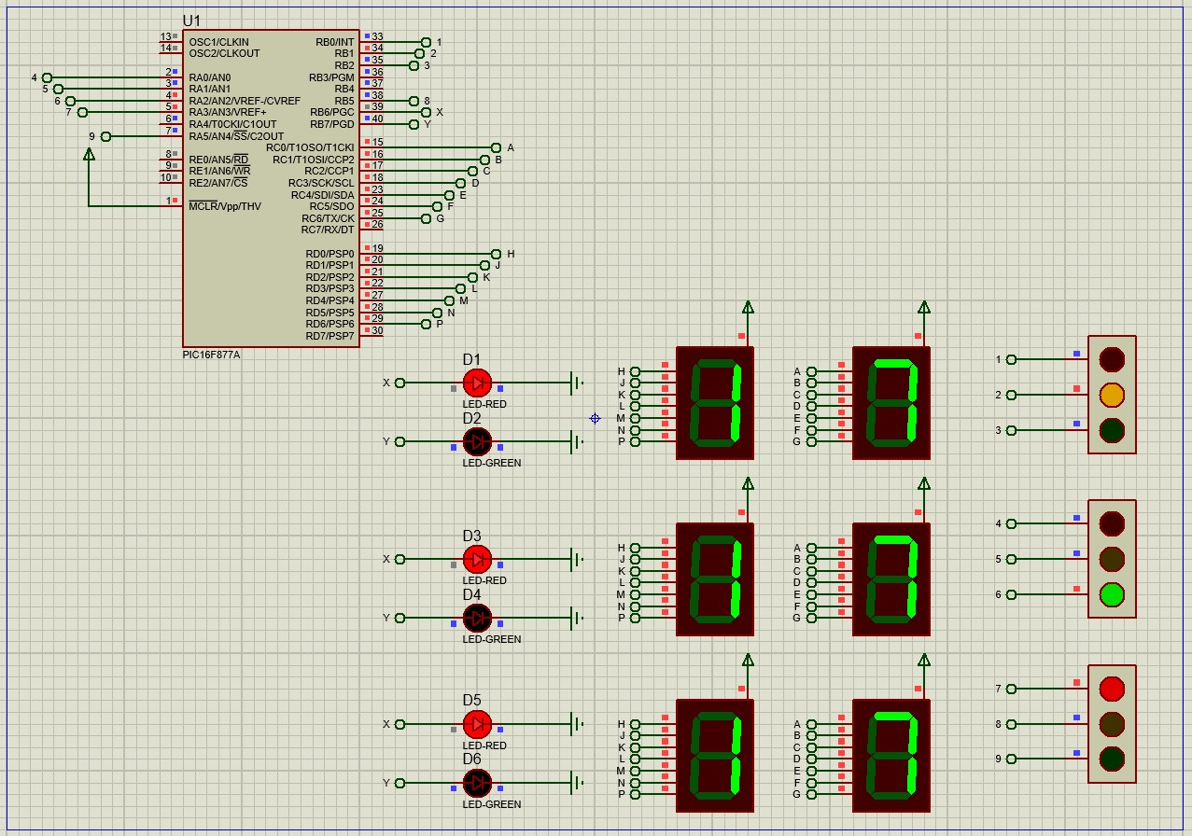
Figure 6: Proteus Simulation at 17 Seconds

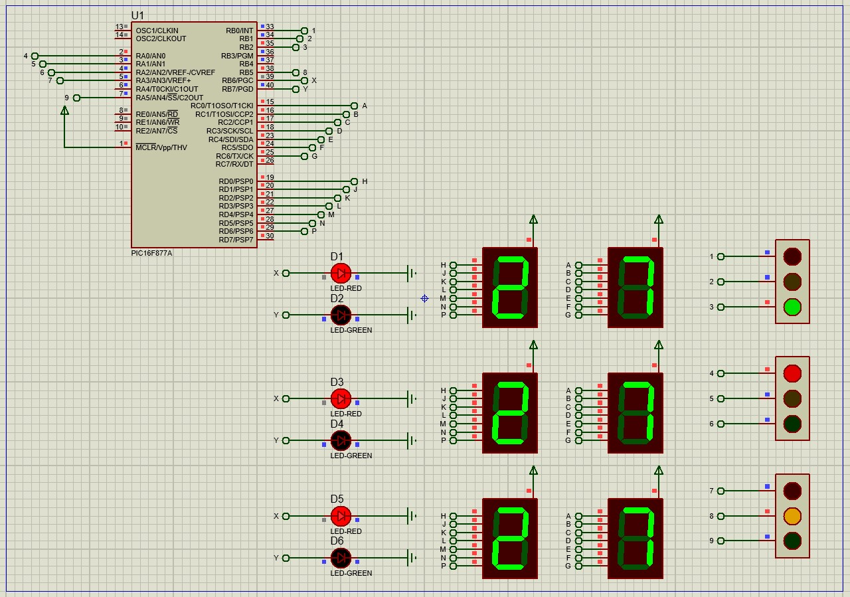
Figure 7: Proteus Simulation at 27 Seconds

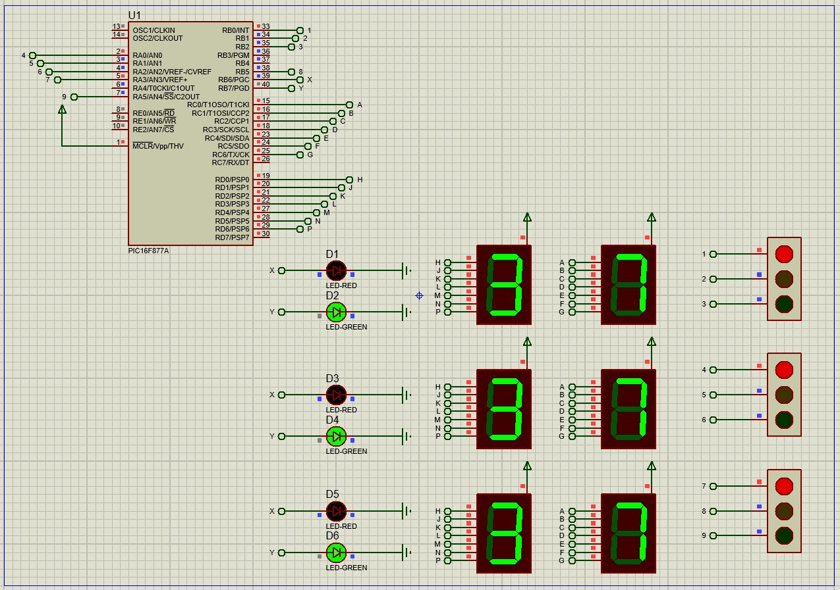
Figure 8: Proteus Simulation at 37 Seconds

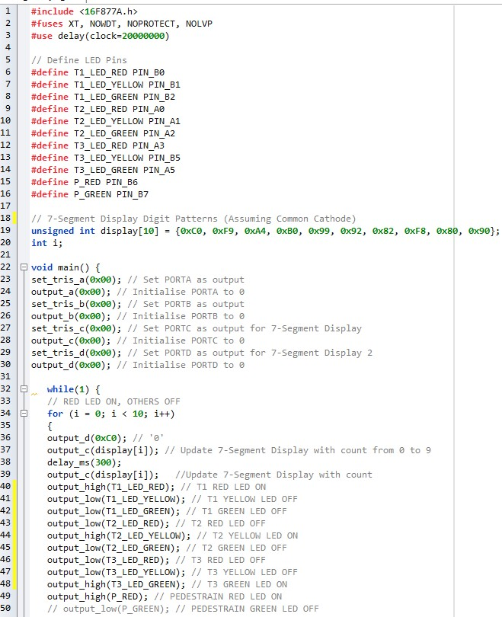
Figure 9: CCS Compiler Lines 1 - 50

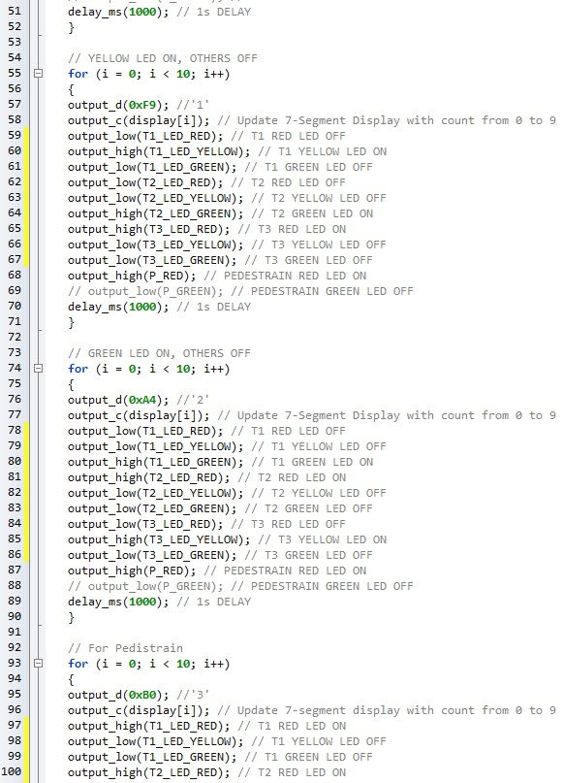
Figure 10: CCS Compiler Lines 51 - 100
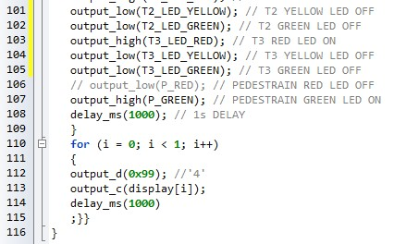
Figure 11: CCS Compiler Lines 101 - 116

Testing, Simulated Outputs and Results
By constructing the circuit using the software such as Proteus and CCS Compiler, it is possible to simulate the circuit meaning you can check the functionality of the system as you go. This capability allows the user to ensure the system functions as intended, while also providing additional benefits such as being able to test potential improvements to the overall system.
When simulating the circuit to assess how the system was functioning, a few issues presented themselves within the programs on both software packages. In the CCS Compiler, formatting errors were reported when attempting to compile the file into the microcontroller. The software highlights where the errors occur, making it much simpler to fault find. These errors were typically minor such as spelling mistakes or incorrect/missing punctuality. However, even simple errors like these can cause significant issues for the system regardless how simple they are.
Testing on the Proteus software was relatively straightforward, as the working principle in the software are the same as they would be when wiring the components in reality. However, an error was encountered during testing and simulating this circuit. The issue was related to labelling, two outputs from different pins on the microcontroller were assigned using the same value. This caused LEDs to incorrectly operate, deviating from the intended plan for the design of the circuit.

Conclusion, Recommendations on Future Work
In conclusion, this task of designing an automatic traffic light controller for a T-junction road was an excellent exercise for enhancing knowledge within the electronic industry. This task encompasses various aspects within the field of electronics including circuit design, programming and fault-finding techniques for example.
The program produces a safe and effective T-junction traffic signal system that works safely and efficiently for both pedestrians and automobiles passing through the junction. Although installing a push button at each pedestrian crossing would make the system more efficient by allowing pedestrians to indicate their presence, if the button is not pressed within the first 30 seconds of the traffic lights section of the program, the pedestrian crossing 10 second section of the program would be skipped. This upgrade would allow pedestrians to cross when they were present while keeping vehicle traffic going if there were no people attempting to cross.

References
[1] H. Smith, Introduction to PIC16F877a - The Engineering Projects (Accessed 4th December, 2024).
[2] M. Groves, PIC16F877A Microcontroller(PDIP) (Accessed 4th December, 2024)
[3] H. Undery, 7-segment Display and Driving a 7-segment Display (Accessed 5th December, 2024)
[4] O. Airey, Seven Segment Displays - GeeksforGeeks (Accessed 7th December, 2024)
[5] A. Karakus, What is Proteus. In this detailed guide about Proteus we… | by EA & HAM Club, NIT Warangal | Medium (Accessed 6th December, 2024)
[6] J. Willaims, Review Of The CCS PIC C compiler « Lancaster Hunt Systems Ltd (Accessed 7th December, 2024)

