A Practical Study of Operating System Functions and Command-Line / Scripting Operations Across Windows and Linux Platforms
Student Name: Raja kaleem
Student Number: 2523175
Course Name: Computer Architecture and Operating Systems
Module Code: ACCA4022
Submission Date: 24-july-2026

Table of Contents
Introduction 2
1. Key Functions of General-Purpose Operating Systems 2
1.1 User Interface, Protection and Security 2
1.2 File and Device Management 2
1.3 Memory Management 3
1.4 Process Management 4
2. Command line of the Linux OS 4
2.1 Task Scheduling 4
2.2 User Management 5
2.3 Network Testing and Monitoring 7
2.4 File and Directory Management 9
2.5 Process Management 10
3. Use of Windows OS CLI Commands 11
3.1 Task Scheduling 12
3.2 User Management 12
3.3 Network Testing and Monitoring 13
3.4 File and Directory Management 15
3.5 Process Management 16
4. Use of Linux OS Scripts 17
4.1 Script 1 – System Disk Usage Monitor 18
4.2 Script 2 – Simple Calculator 19
5. Use of Windows OS Scripts 19
5.1 Always make a backup of your files 19
5.2 Script 2 – Simple Calculator 20
Conclusion 21
Reference 22

Introduction
An operating system is a software that integrates and manages hardware to make it accessible to users and programs, and is used by any modern computer, ranging from a personal computer to a server in the enterprise. This report aims to discuss the mechanism through which this is achieved by general purpose operating systems, and develop practical command-line and scripting skills on two of the most popular operating systems on the market: Microsoft Windows and Linux (Kali Linux). The rest of the report is organized as follows: The core functions performed by an operating system are discussed, some examples of Linux command-line operations are given, some examples of Windows command-line operations are given, and finally, there are examples of Bash and Batch scripts that automate simple administration tasks. Each command is accompanied by a screenshot of its working, while the end section summarizes the main findings.

1. Key Functions of General-Purpose Operating Systems
A generic operating system like the Microsoft Windows or Linux system handles a variety of essential tasks that maintain a computer's continuity and enable multiple applications to operate on the same hardware without harming one another.

1.1 User Interface, Protection and Security
All operating systems have an interface that allows people to communicate with the machine, either by means of a graphical interface (a GUI) or a text-based one (a CLI) [1]. In parallel, protection and security mechanisms restrict the access of specific users and processes to specific resources: authentication verifies credentials (usernames and passwords), and access control specifies the types of operations an authenticated user or process is allowed to perform, preventing data theft, unauthorised access and malware attack. In both cases, command-line tools are available to handle accounts and permissions; these are shown later in Section 2 and 3 of this report.

1.2 File and Device Management
File management refers to the naming, storing, and retrieval of data on a storage device, including the setting of permissions, sequential access and direct access [2]. Communication between the operating system and the physical hardware (such as disk drives, printers, and network adapters) is mediated by device management, which handles jobs by means of drivers, including queuing print jobs to overcome the delay caused by a slow device (called spooling). The permissions and ownership of files and directories can be seen through the ls -la command from a terminal on Kali Linux (Figure 1), and the ipconfig /all command can be used to see the configuration of the Windows network adapters (Figure 2).
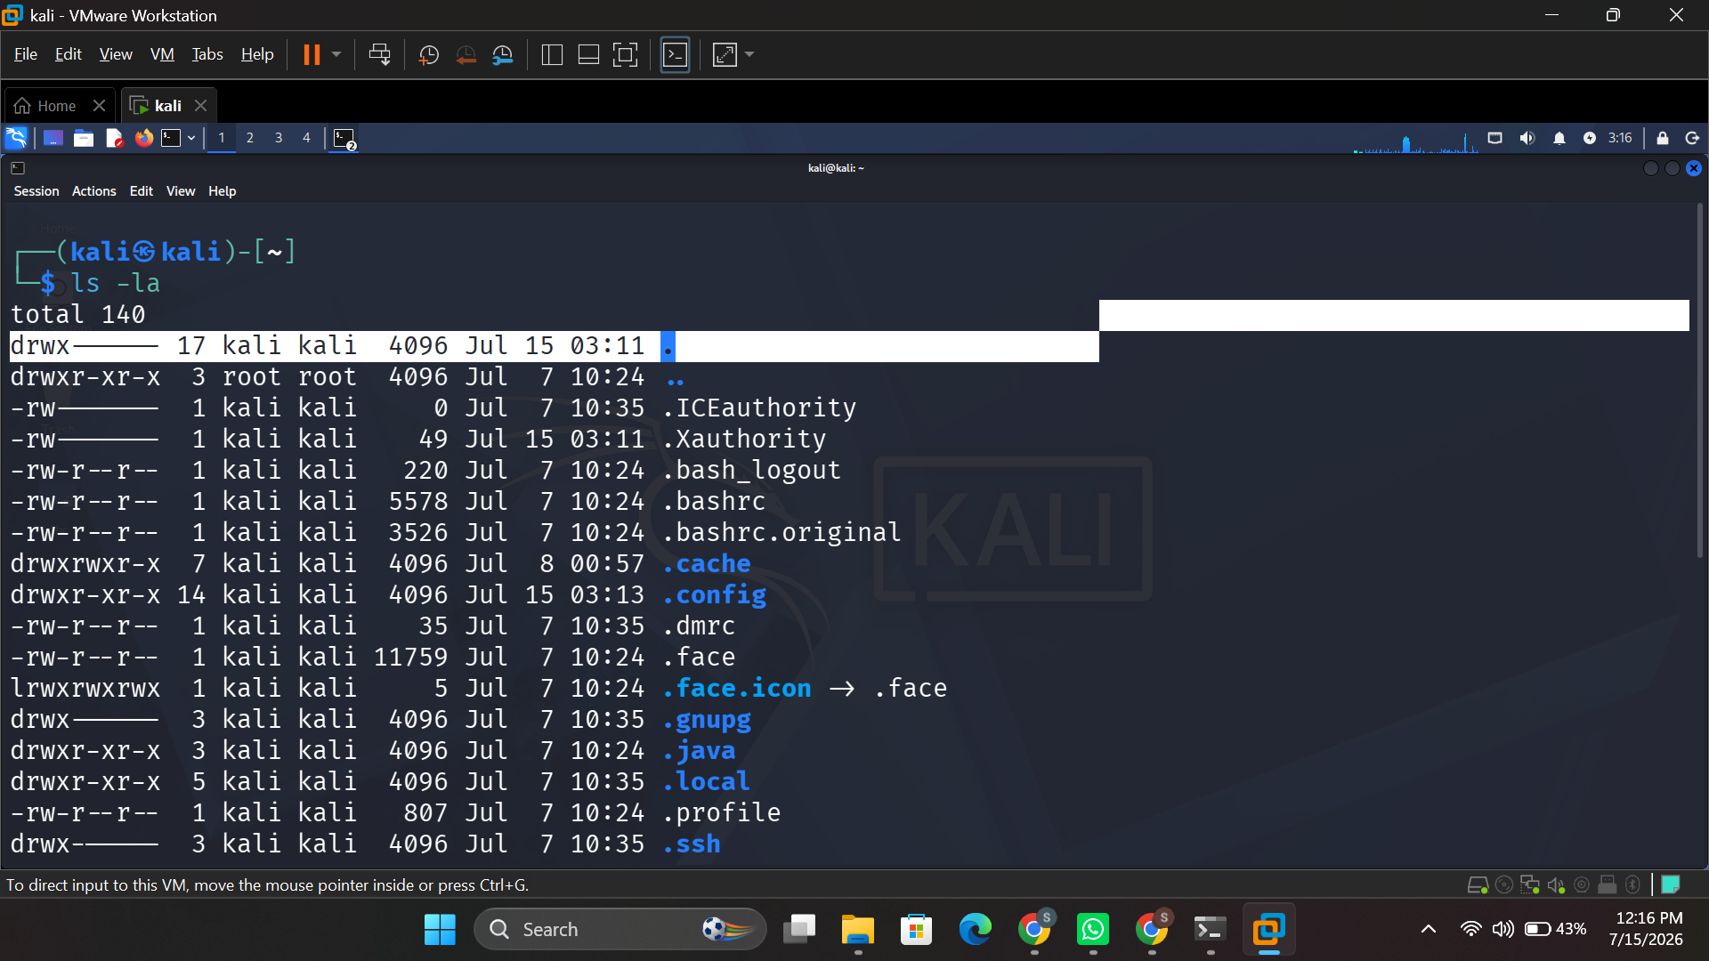
Figure 1: ls -la command showing file permissions and attributes on Kali Linux (file management).
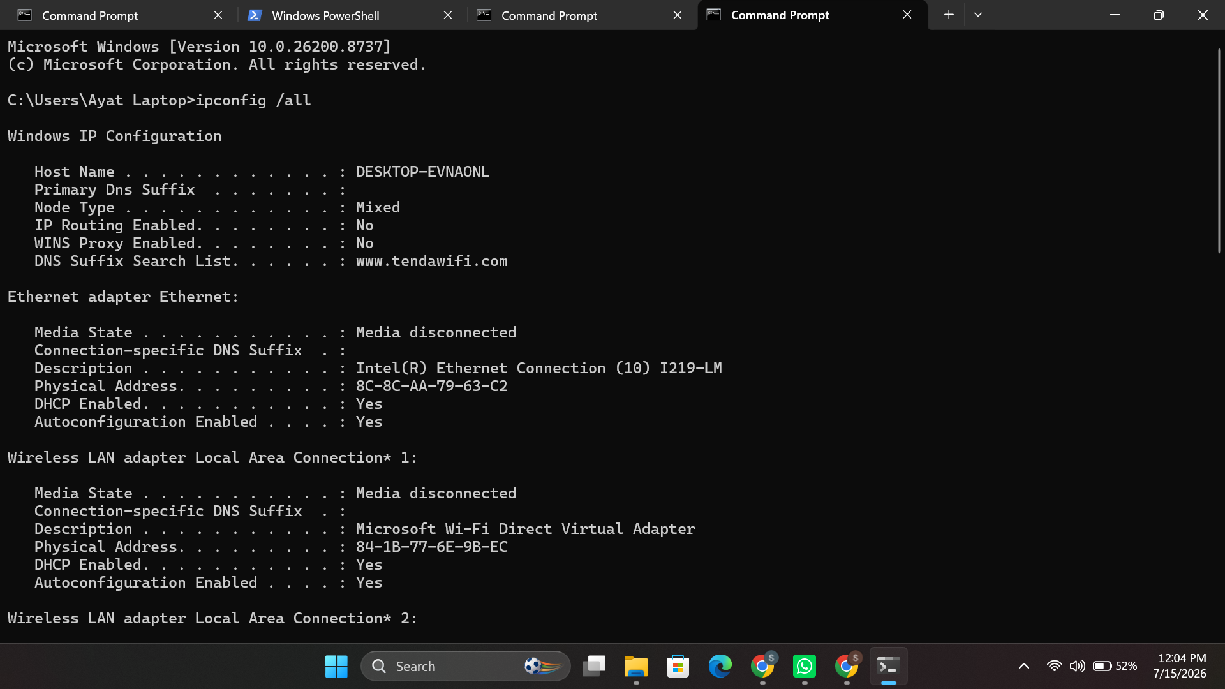
Figure 2: ipconfig /all command showing network adapter configuration (device management).

1.3 Memory Management
Memory management is responsible for allocating, protecting and freeing up primary memory (RAM) for each of the processes currently running, so that one process can never read or overwrite memory used by another process [3]. Modern operating systems use a variety of methods to utilize an available amount of RAM, including paging, segmentation, and virtual memory, which uses disk space as if it were additional RAM when there isn't enough to go around [4] [5]. For instance, Windows allocates 8 terabytes of virtual address space to each 64-bit process, and threads within a given process can access the memory space at will without being able to access another process's memory space because that would be a problem for Windows. Paging in especially has been reported to minimize external fragmentation and at the same time enable the efficient and portable use of memory space on OS, including Linux, Windows and macOS [6]. Section 3 of this report shows how PowerShell’s Get-Process cmdlet can be used to inspect the live memory footprint of individual processes.

1.4 Process Management
Process management includes process creation, process scheduling and process termination, and determining the process to be given CPU time with scheduling algorithms like Round Robin or Priority Scheduling [1]. It also is capable of synchronising concurrently executing processes and provide inter-process communication, so that programs run concurrently do not interfere with one another [1]. These can be seen on Windows by Task Manager, or by command-line (CLI) utilities like tasklist or Get-Process, and on Linux by ps or top as seen in Section 2.

2. Command line of the Linux OS
This section shows Bash commands run on the Kali Linux in five administrative areas. To vary the order from a typical process-first walkthrough, the areas below are presented starting with task scheduling and finishing with process management.

2.1 Task Scheduling
Whereas the crontab -l command outputs the cron jobs that are already set for the current user, the crontab -e - at 10:00 am will run a one-shot job at a particular time with the /bin/sh shell [7] (Figure 3).
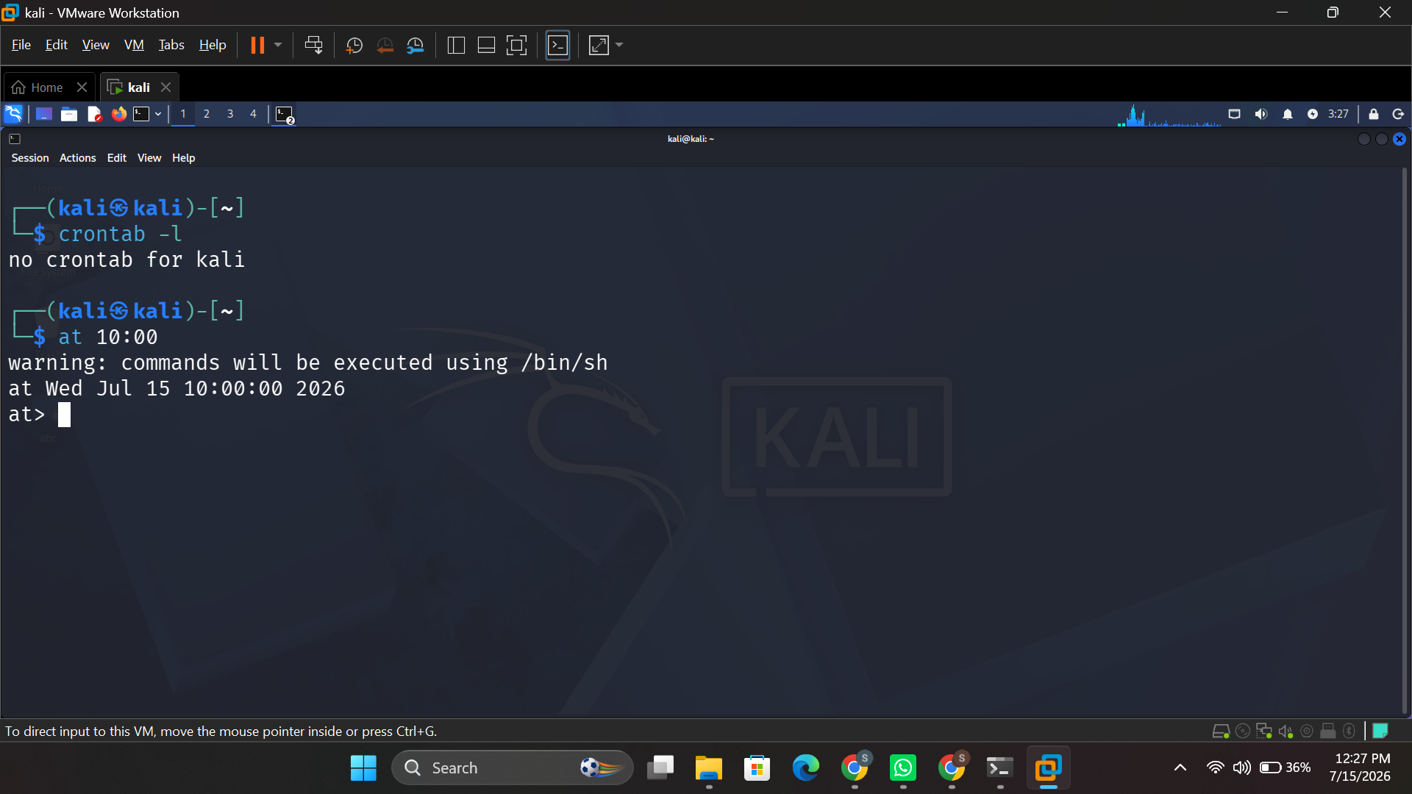
Figure 3: crontab -l and at 10:00 — viewing and scheduling one-off jobs.

2.2 User Management
The whoami command prints out the currently logged in user (Figure 4), useradd adds a new account to the system and passwd sets its password (Figure 5), and the cat /etc/passwd command displays all of the local accounts that have been configured on the system (Figure 6), while the groups <username> command returns a list of all of the groups that the user belongs to (Figure 7).
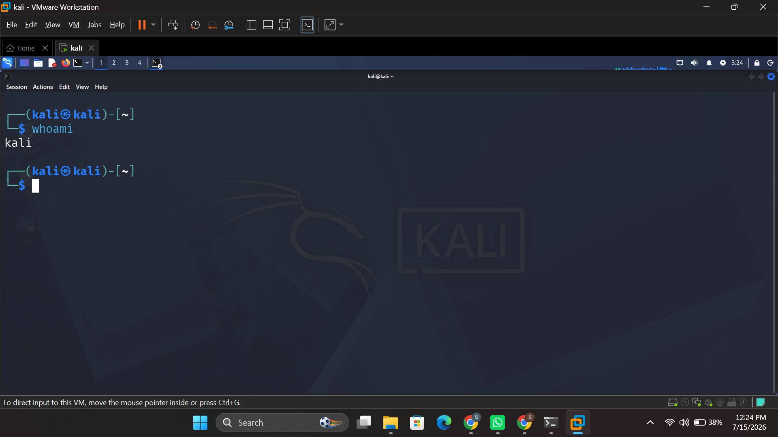
Figure 4: whoami — displaying the current logged-in user.
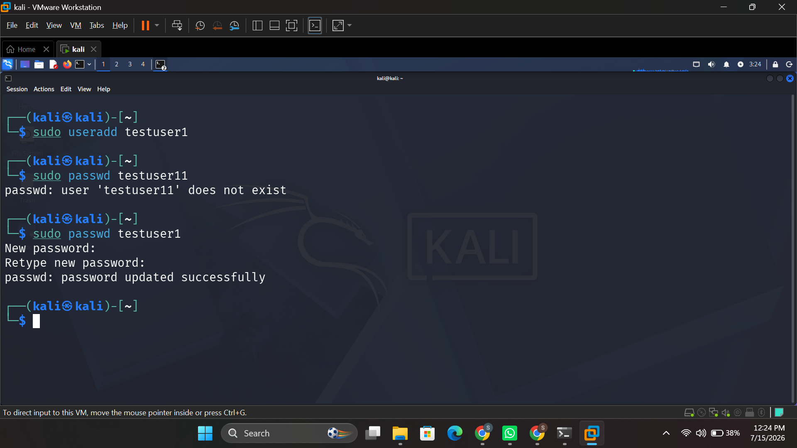
Figure 5: sudo useradd and passwd — creating a user and setting a password.
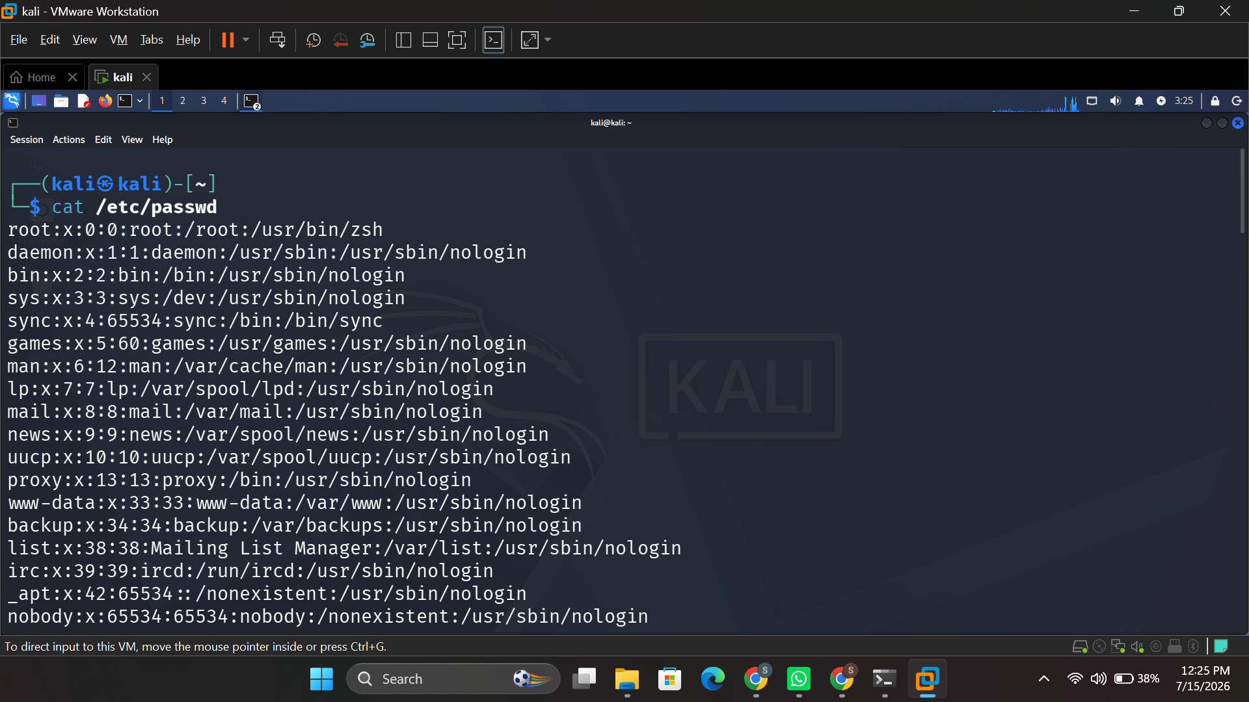
Figure 6: cat /etc/passwd — viewing all local user accounts.
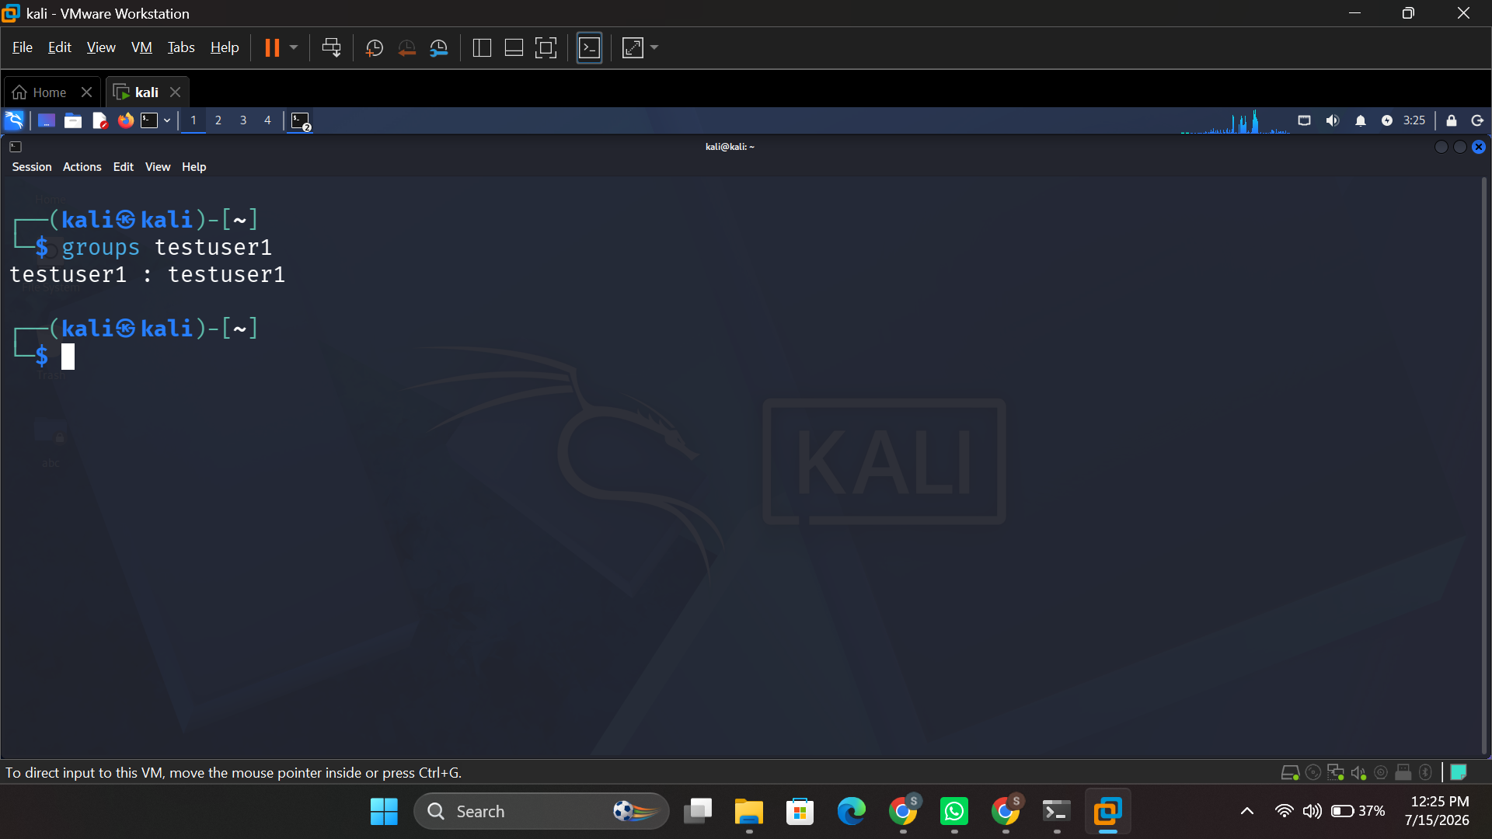
Figure 7: groups testuser1 — listing group membership for a user.

2.3 Network Testing and Monitoring
The ping -c 4 command prints out the round-trip time and packet loss for the four ICMP echo requests it sent to the target IP address (Figure 8), and ifconfig lists the IPv4/IPv6 and MAC Address of each network interface (Figure 9); the netstat -tulnp command prints a list of listening TCP and UDP ports along with the process that owns each one [7] (Figure 10), and the traceroute command prints the route taken over the network to a target host (Figure 11), and nmap -sV prints the result of a service-detection scan of a target IP address (Figure 12).
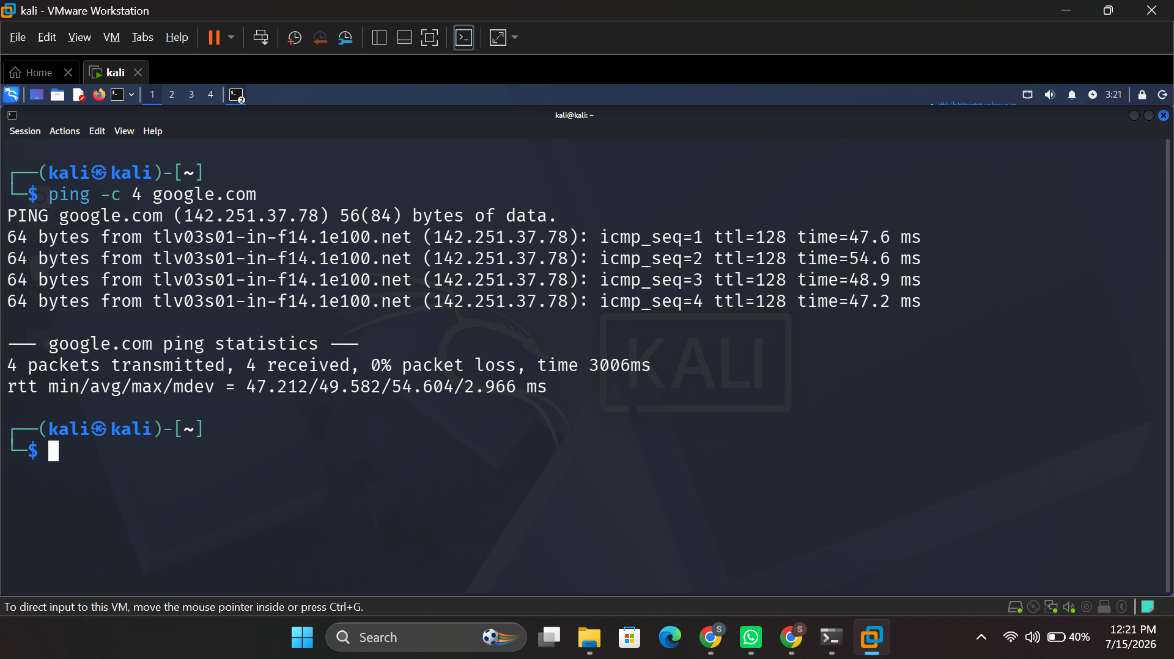
Figure 8: ping -c 4 google.com — testing connectivity and latency.
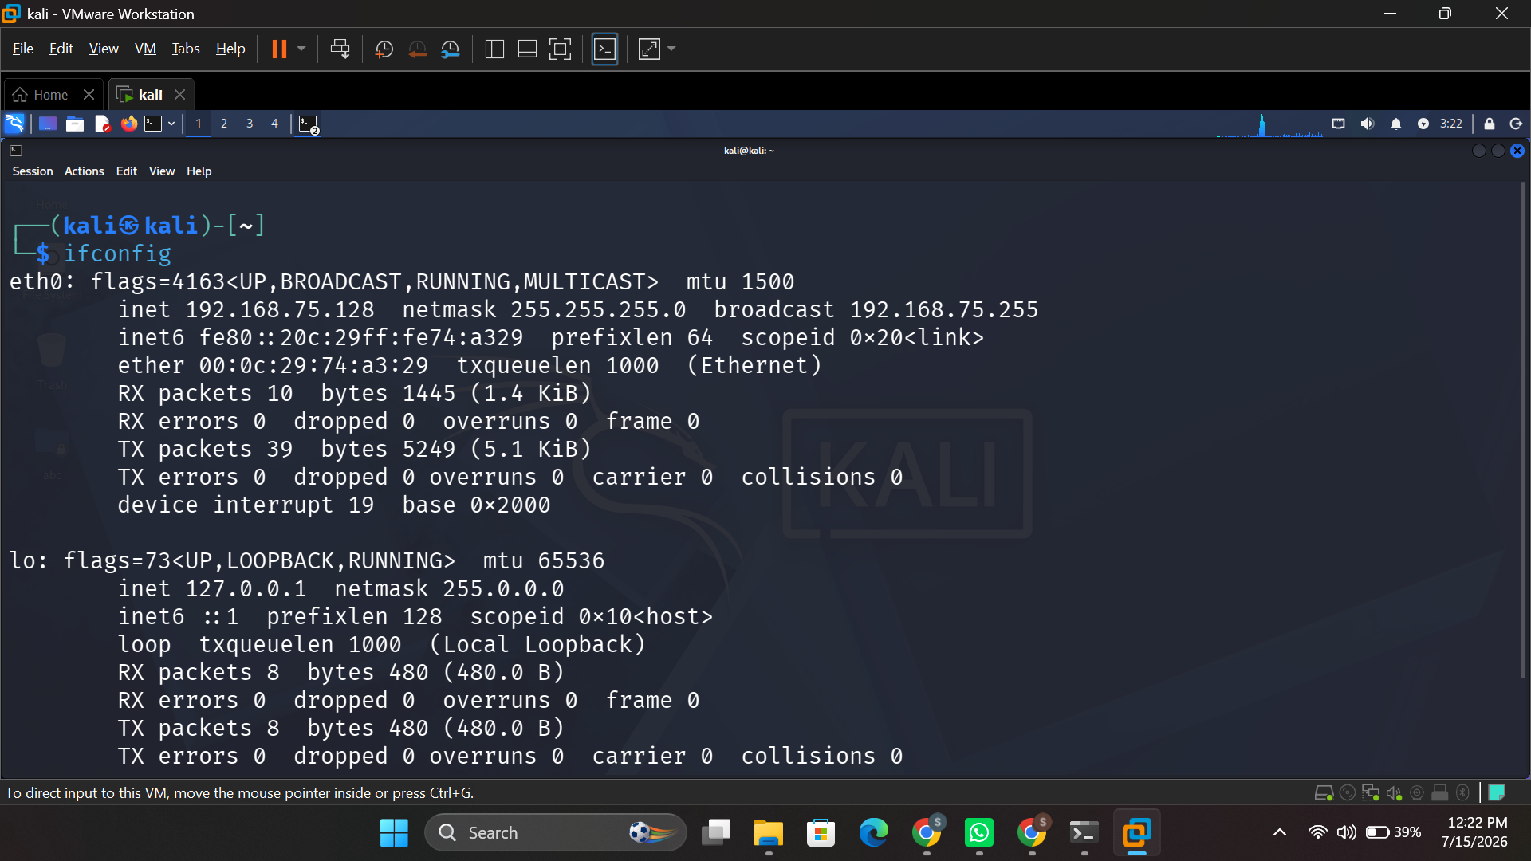
Figure 9: ifconfig — network interface configuration.
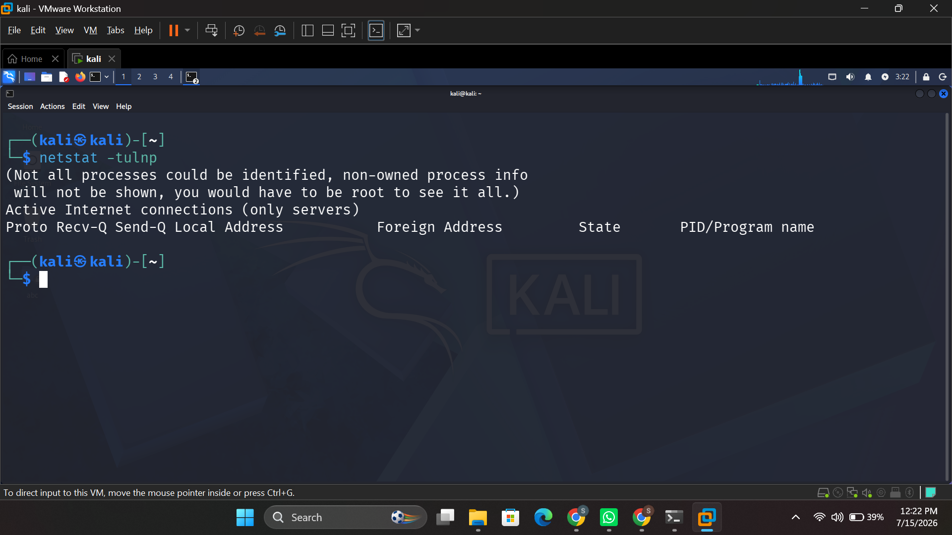
Figure 10: netstat -tulnp — listening TCP/UDP ports.
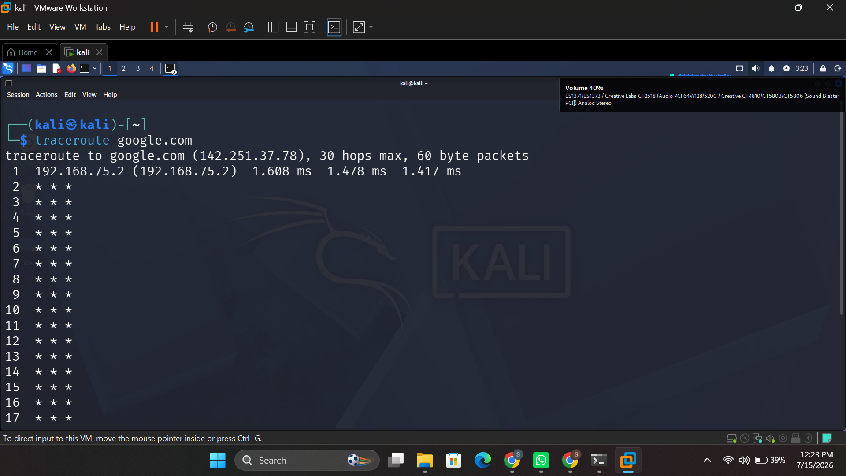
Figure 11: traceroute google.com — tracing the route to a destination host.
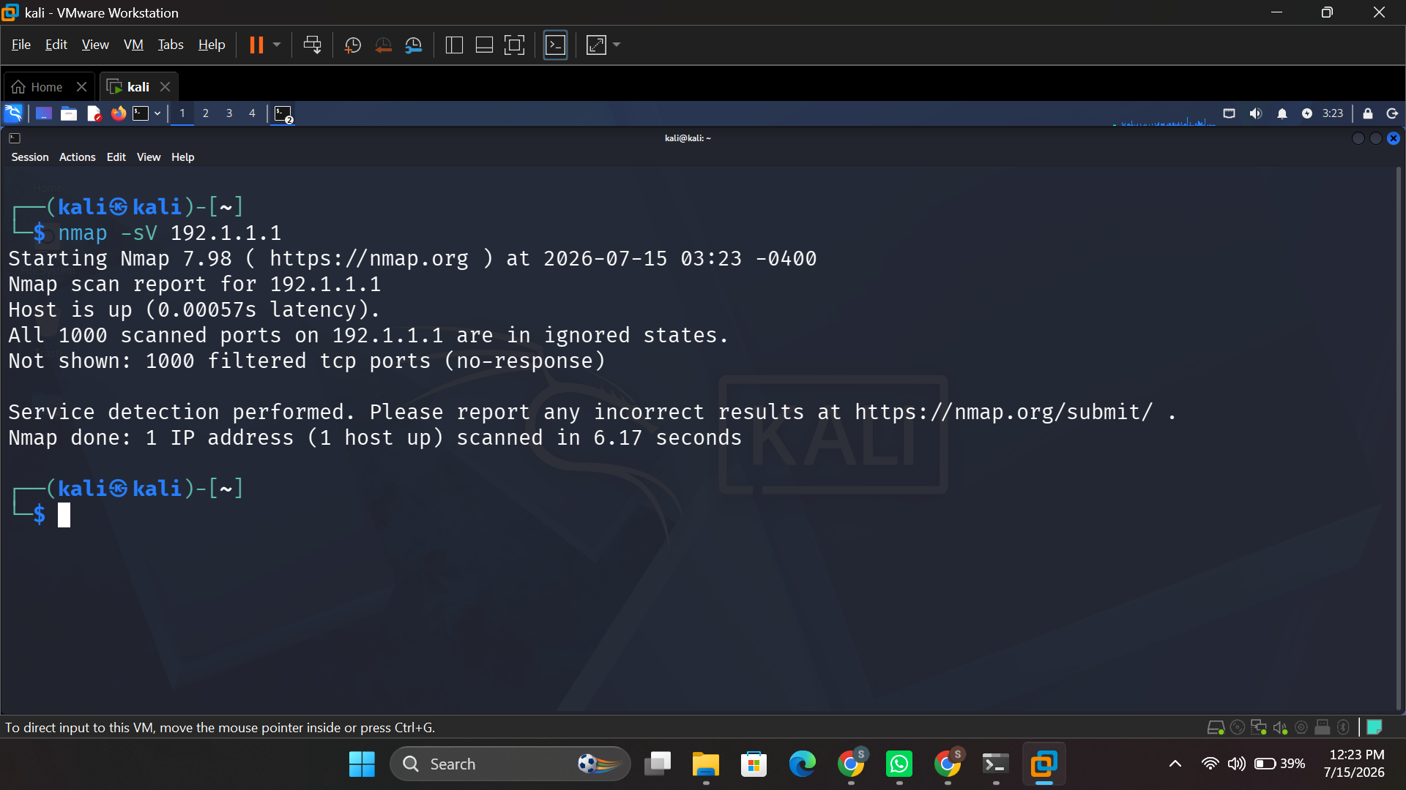
Figure 12: nmap -sV — service-detection scan of a target host.

2.4 File and Directory Management
mkdir is used to create a new directory (Figure 13), chmod sets permissions of files and directories as follows: read/write/execute for owner, read/execute for others (Figure 14), ls -la lists all the files and directories including others (hidden) with their permissions, ownership, and size [8] (Figure 15), find is used to find a file with a particular name in the file system with recursive search (Figure 16).
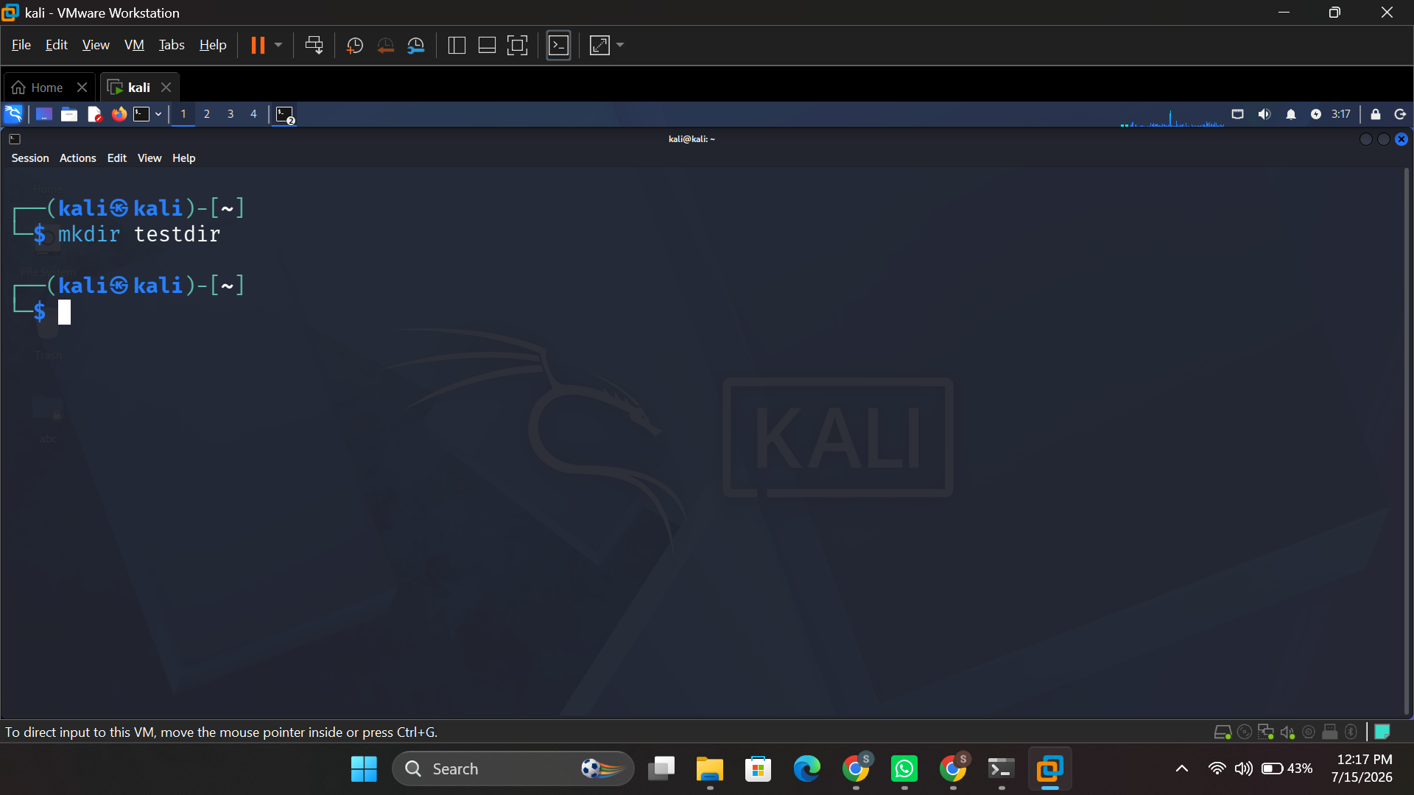
Figure 13: mkdir testdir — creating a new directory.
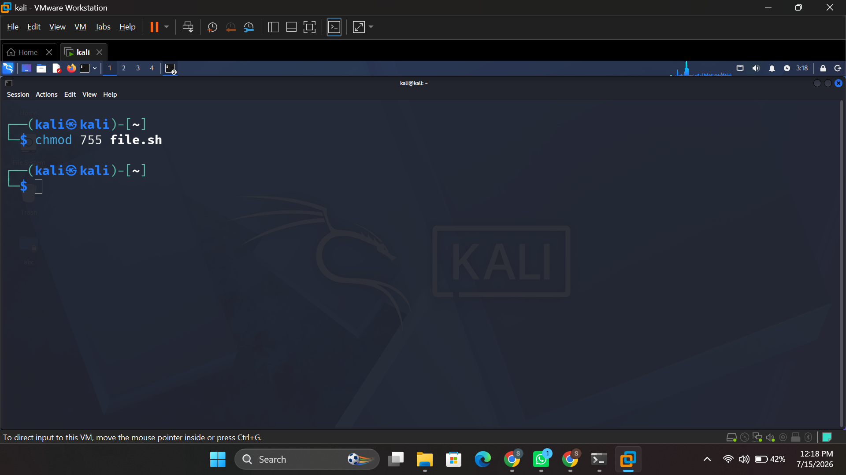
Figure 14: chmod 755 file.sh — setting read/write/execute permissions.
Figure 15: ls -la — listing files with permissions and ownership.
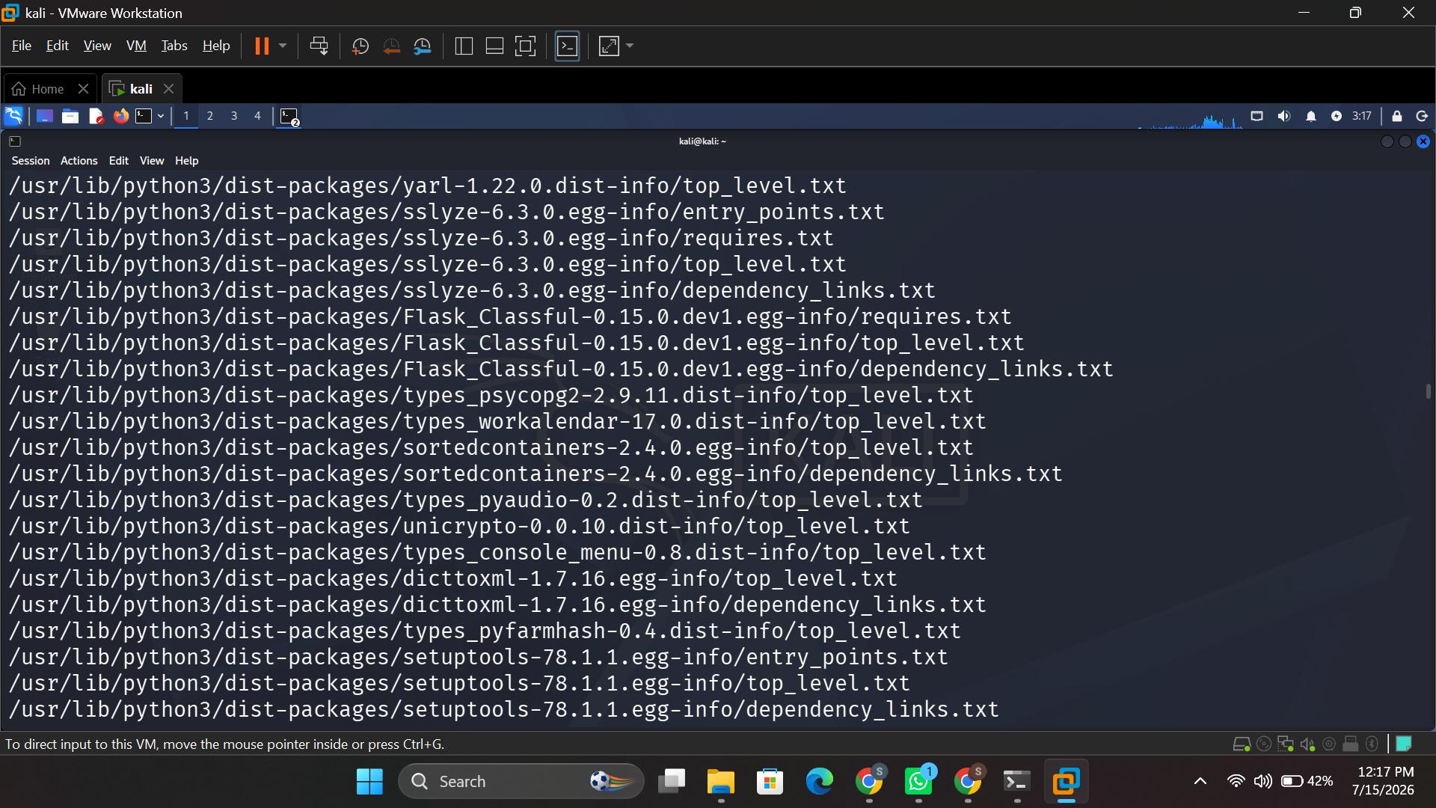
Figure 16: find / -name — searching the filesystem for files by name.

2.5 Process Management
kill -9 <PID> sends the SIGKILL signal to a process causing it to be killed as soon as possible by its process id [9] (Figure 19).kill -9 <PID> sends the SIGKILL signal to a process, causing it to be killed immediately by its process id [9] (Figure 19).
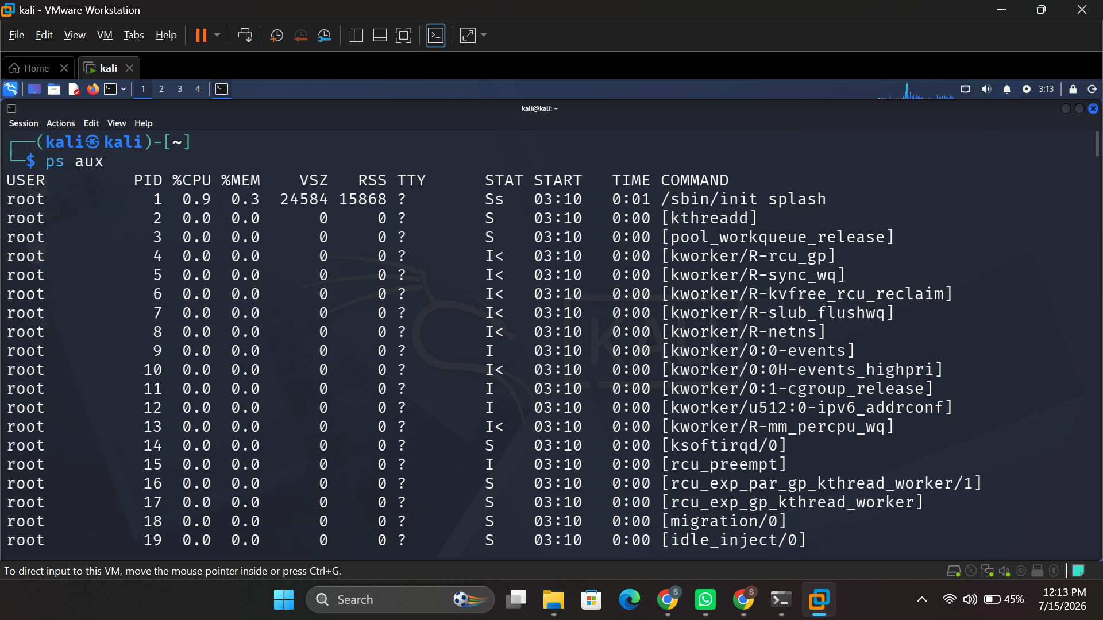
Figure 17: ps aux — listing all running processes.
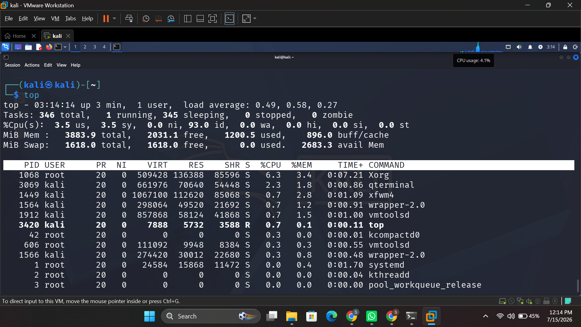
Figure 18: top — live view of system resource usage by process.
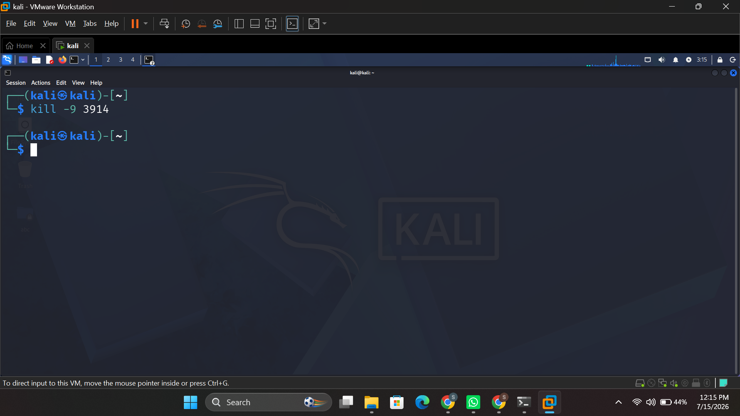
Figure 19: kill -9 3914 — forcibly terminating a process by PID.

3. Use of Windows OS CLI Commands
This section does the same five administrative areas again, but this time using Windows Batch and PowerShell commands, with the two operating systems compared on the same terms, but in reverse.

3.1 Task Scheduling
schtasks /query lists all the tasks that have been registered in Windows Task Scheduler and their next run time and current status [10] (Figure 20), whereas schtasks /create /tn /tr /sc /st registers a new scheduled task, here a task is created with a name TestTask and a command notepad.exe executed once daily at 09:00 [11] (Figure 21).
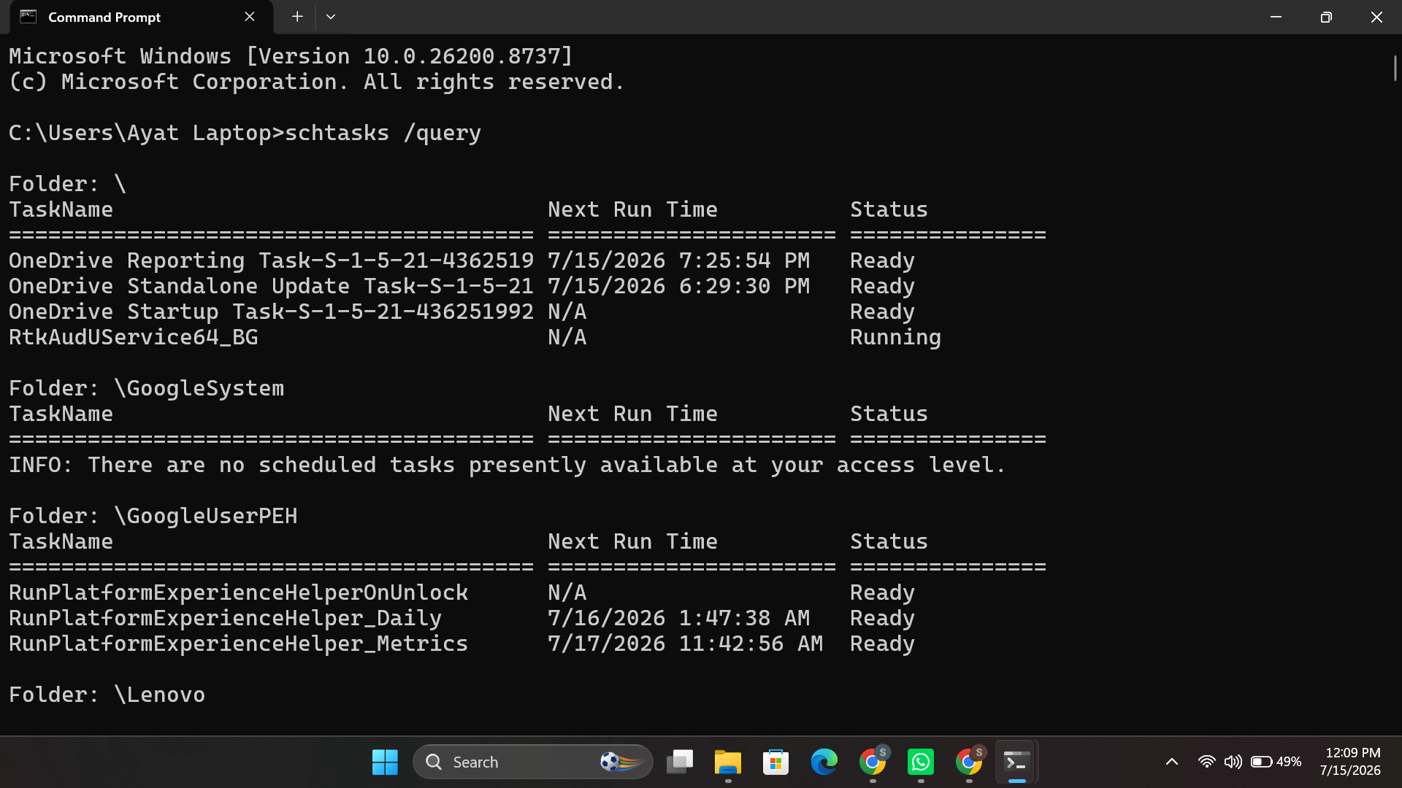
Figure 20: schtasks /query — listing scheduled tasks and their status.
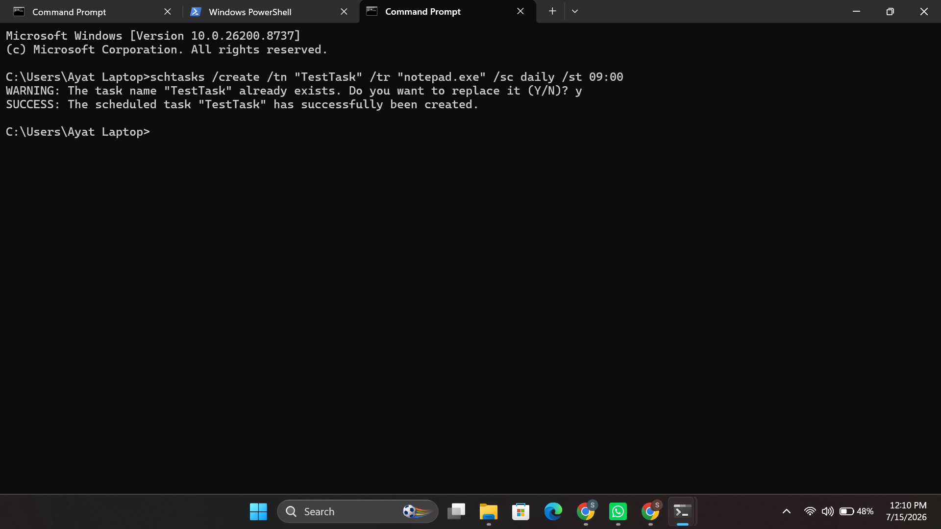
Figure 21: schtasks /create — registering a new daily scheduled task.

3.2 User Management
net user lists the local user accounts (Figure 22); net user TestUser Pass123 /add adds a new local account with a password; and net localgroup Administrators lists the user accounts that are members of the local Administrators group, verifying that certain accounts have elevated privileges (Figure 23).
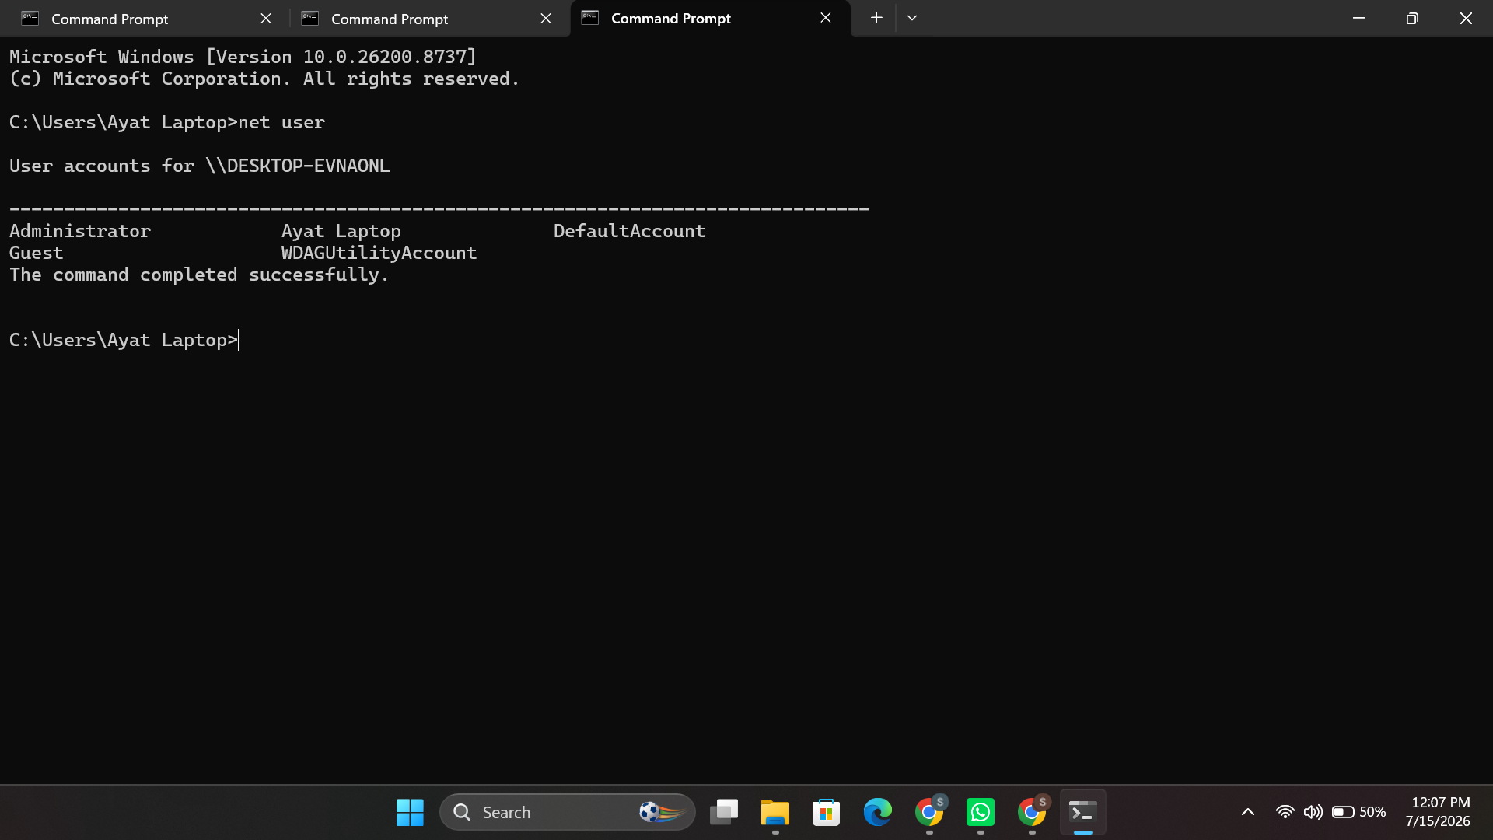
Figure 22: net user — listing local user accounts.
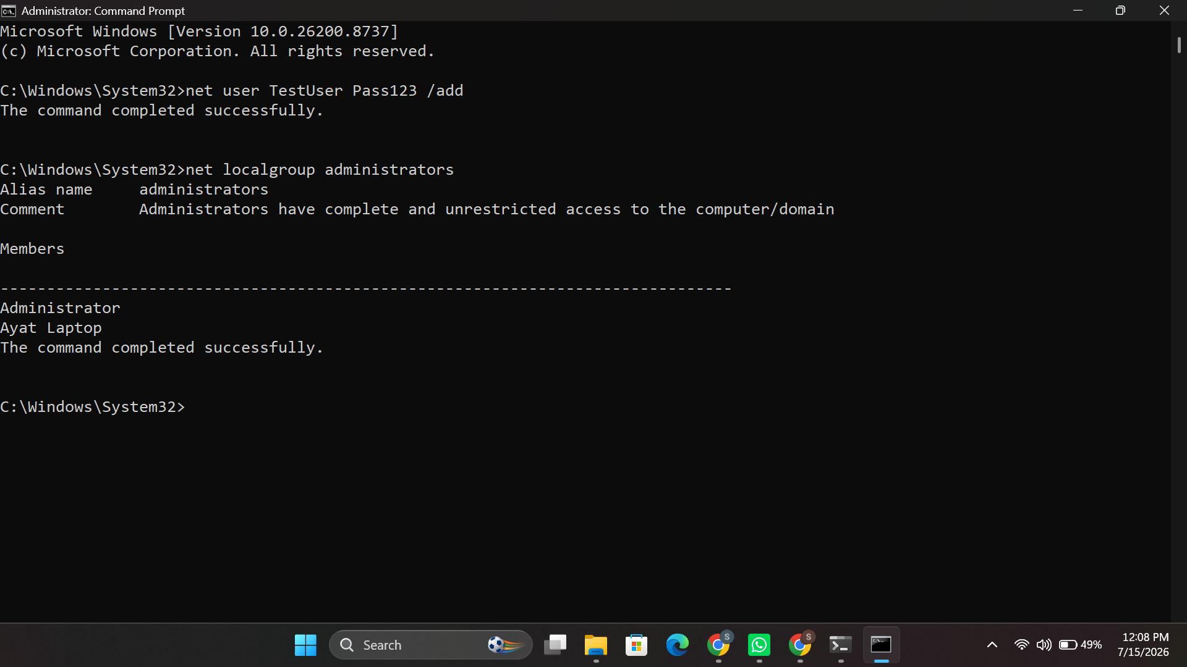
Figure 23: net user /add followed by net localgroup administrators — creating a user and viewing group membership.

3.3 Network Testing and Monitoring
ping -n 4 – sends 4 ICMP echo requests to check connectivity and measure round trip time (RTT) (Figure 24), ipconfig /all – provides detailed information about the configuration of each network adapter such as host name, DNS suffix, MAC address (Figure 25), netstat -an – displays active and listening TCP connections (Figure 26), tracert – traces the latency of each hop to a destination (Figure 27), and nslookup – resolves a domain name to an IP address using the configured DNS server (Figure 28).
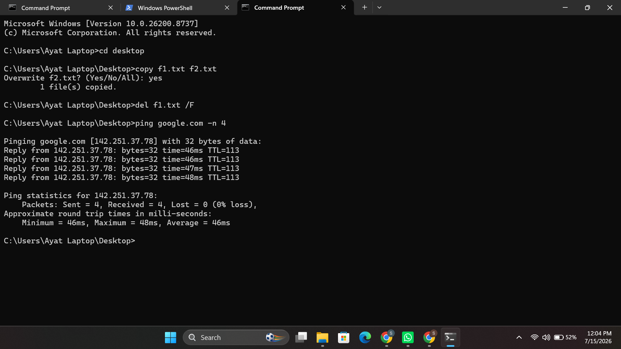
Figure 24: ping google.com -n 4 — testing network connectivity.
Figure 25: ipconfig /all — detailed network adapter configuration.
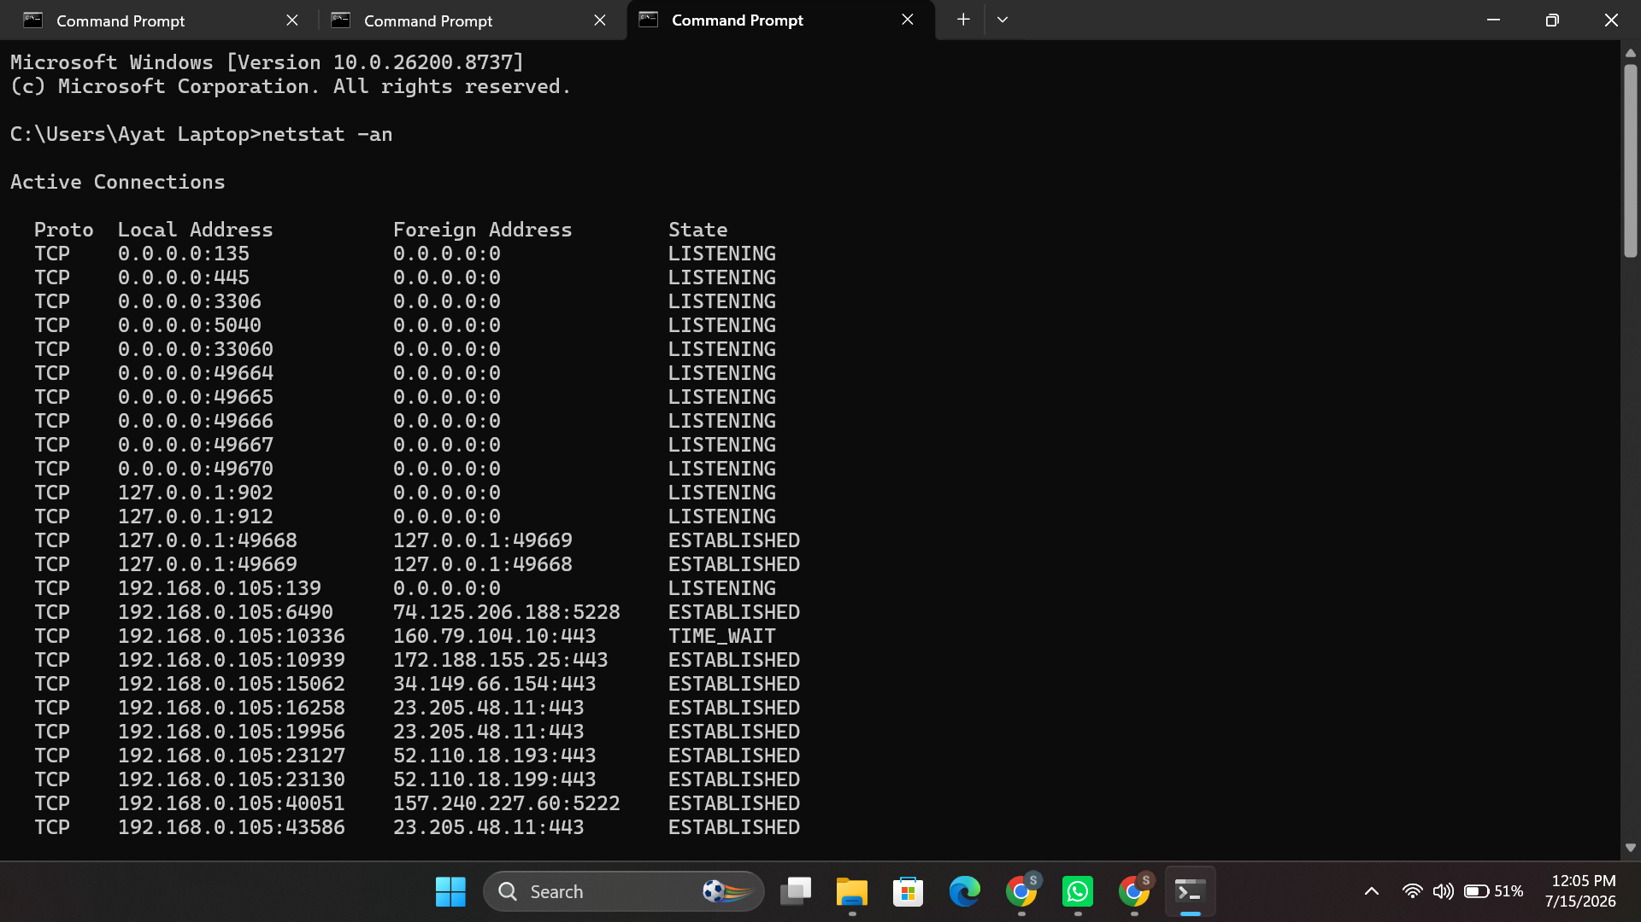
Figure 26: netstat -an — active and listening TCP connections.
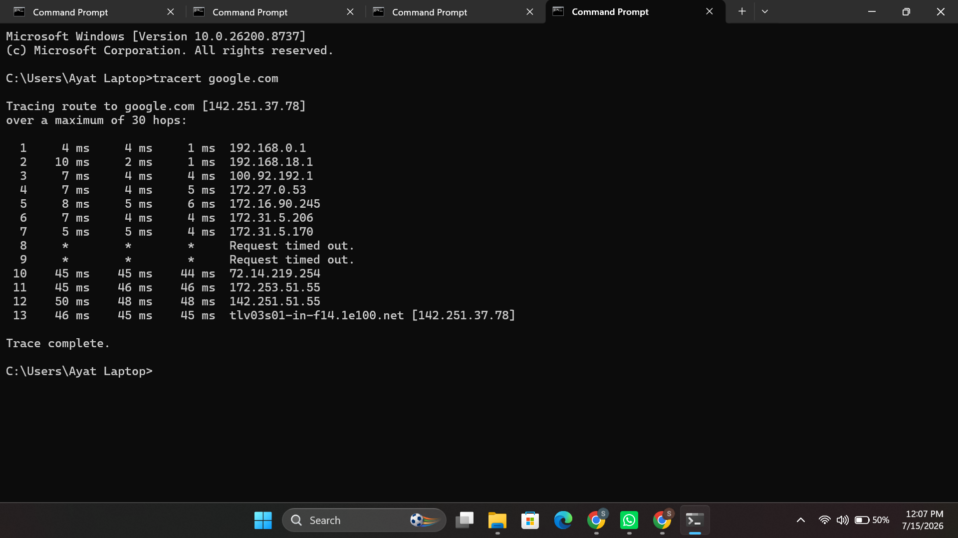
Figure 27: tracert google.com — tracing the network route to a destination.
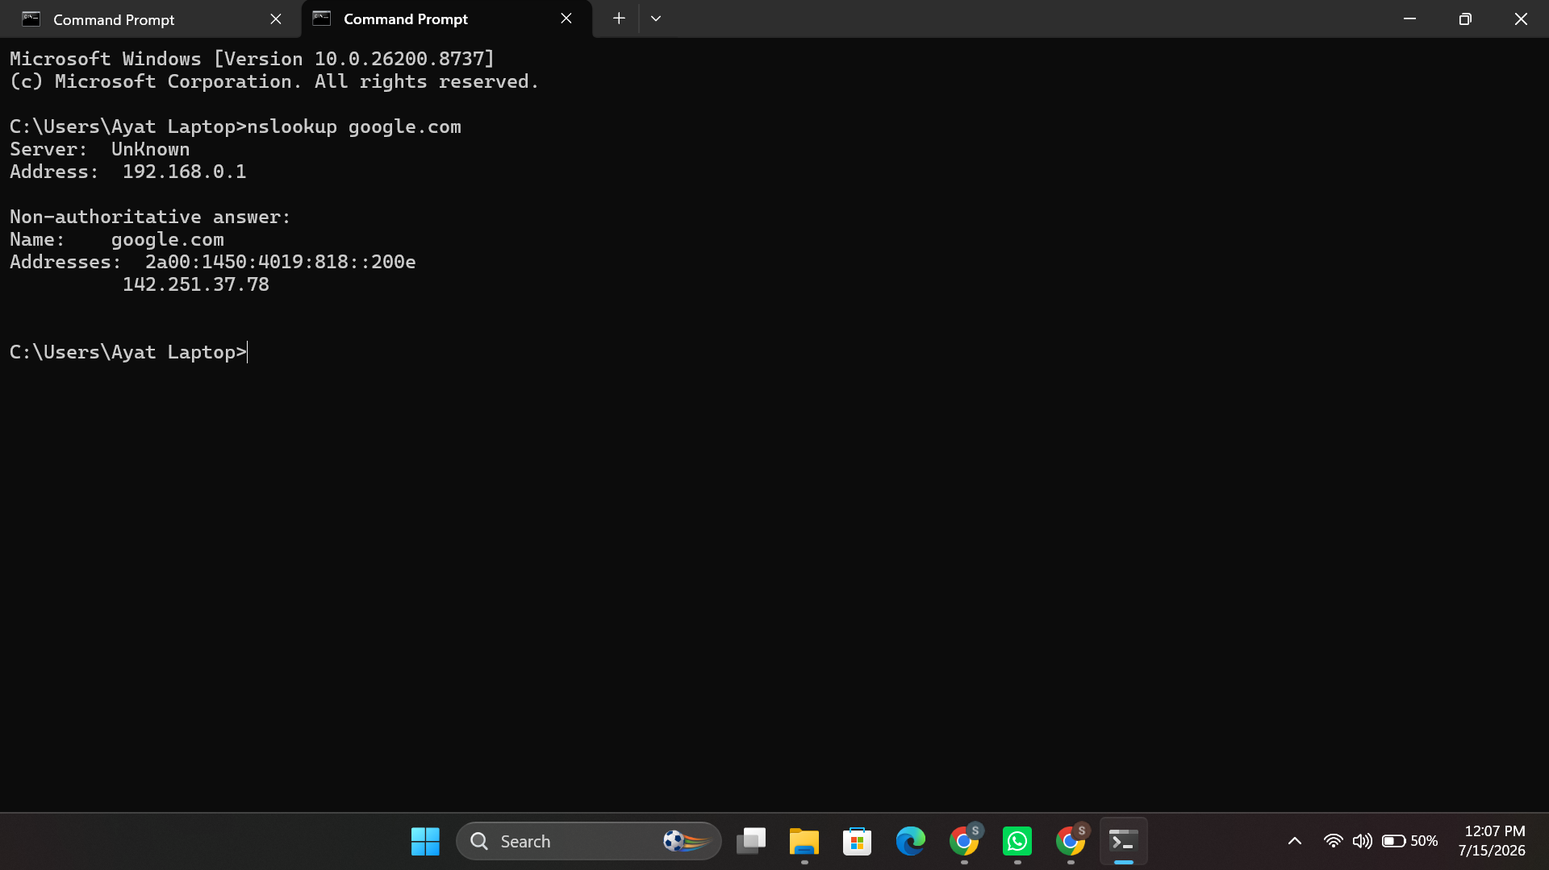
Figure 28: nslookup google.com — resolving a domain name to an IP address.

3.4 File and Directory Management
mkdir creates a new directory (Figure 29), copy duplicates a file to another location, prompting before it overwrites an existing one (Figure 30), and del /F force-deletes a file (Figure 31).
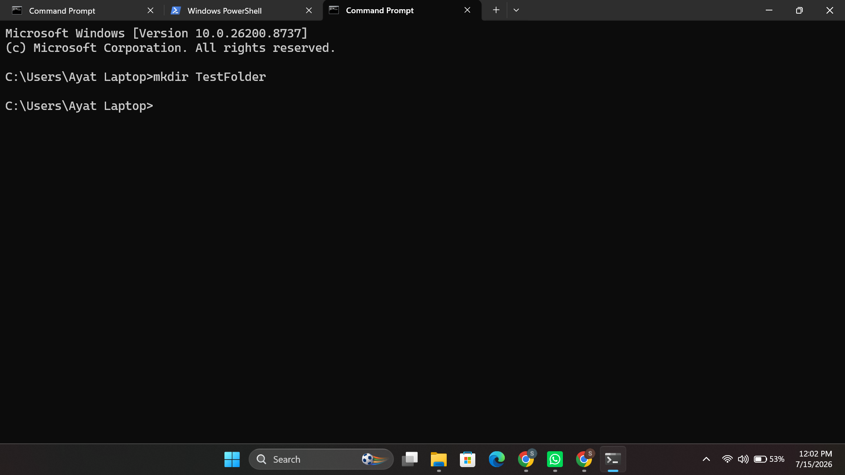
Figure 29: mkdir TestFolder — creating a new directory.
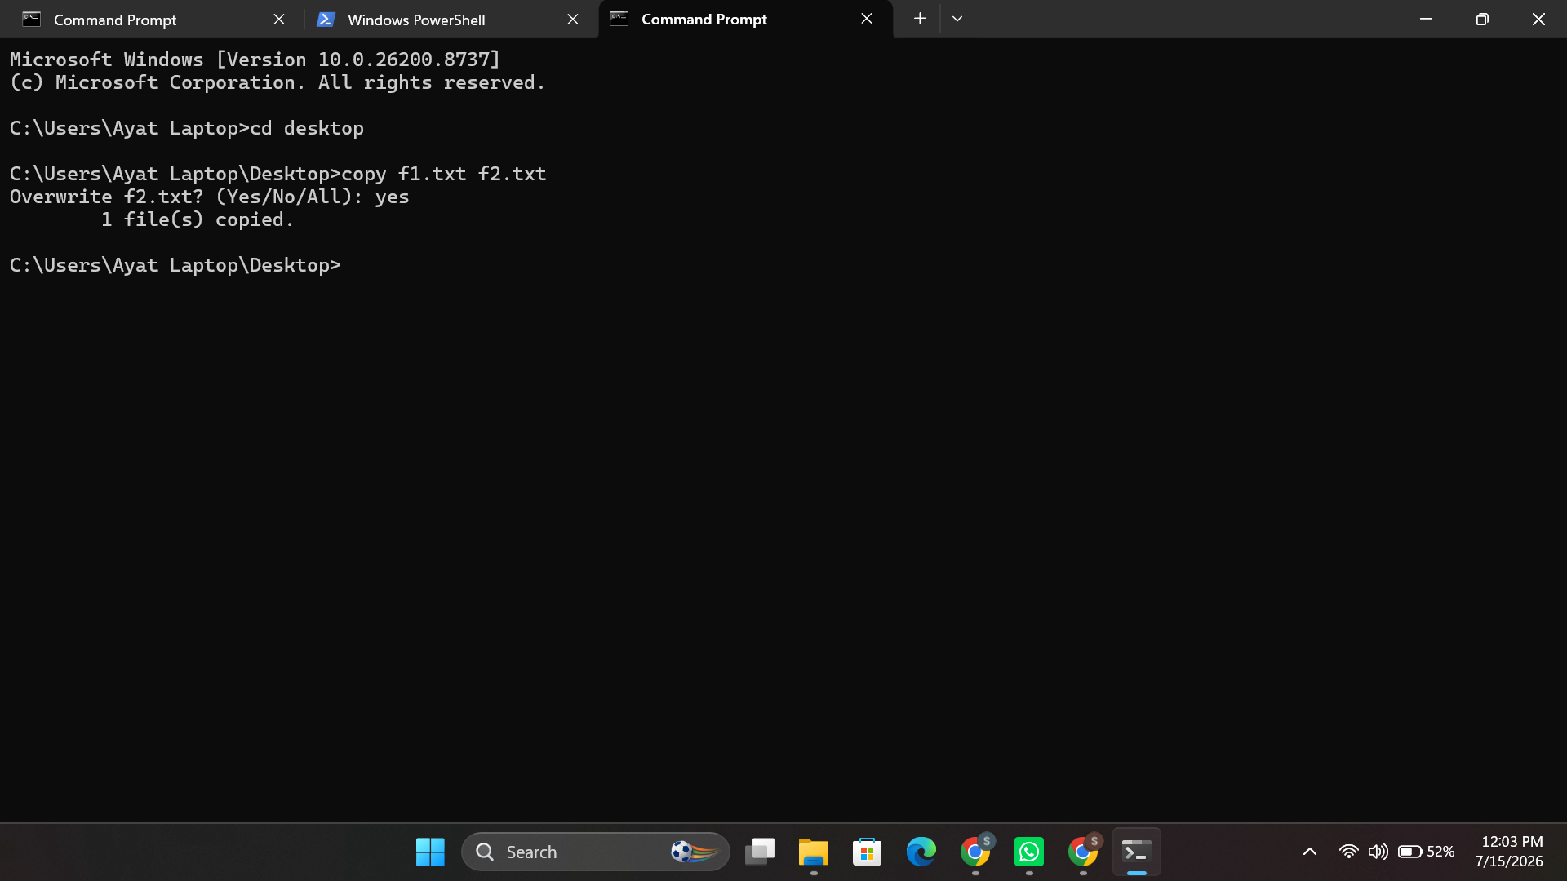
Figure 30: copy f1.txt f2.txt — copying a file with overwrite confirmation.
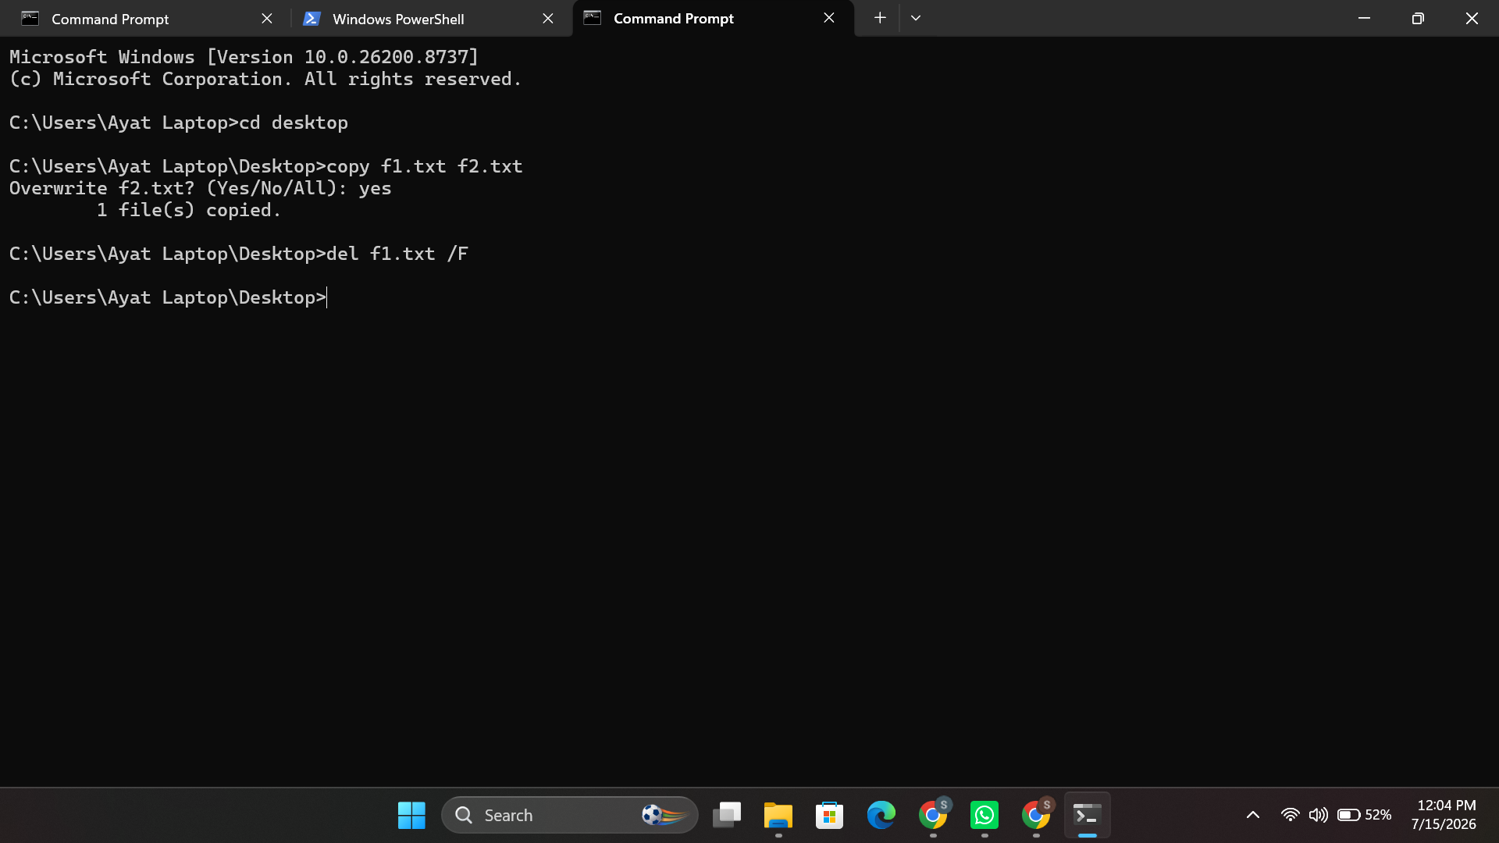
Figure 31: del f1.txt /F — force-deleting a file.

3.5 Process Management
tasklist /IM notepad.exe lists every process that contains the image name notepad [12] (Figure 32); taskkill /IM notepad.exe /F forcibly kills a process with the image name notepad [12] (Figure 33); and Get-Process | Sort-Object CPU -Descending retrieves live process objects and sorts them by CPU time [12] (Figure 34).
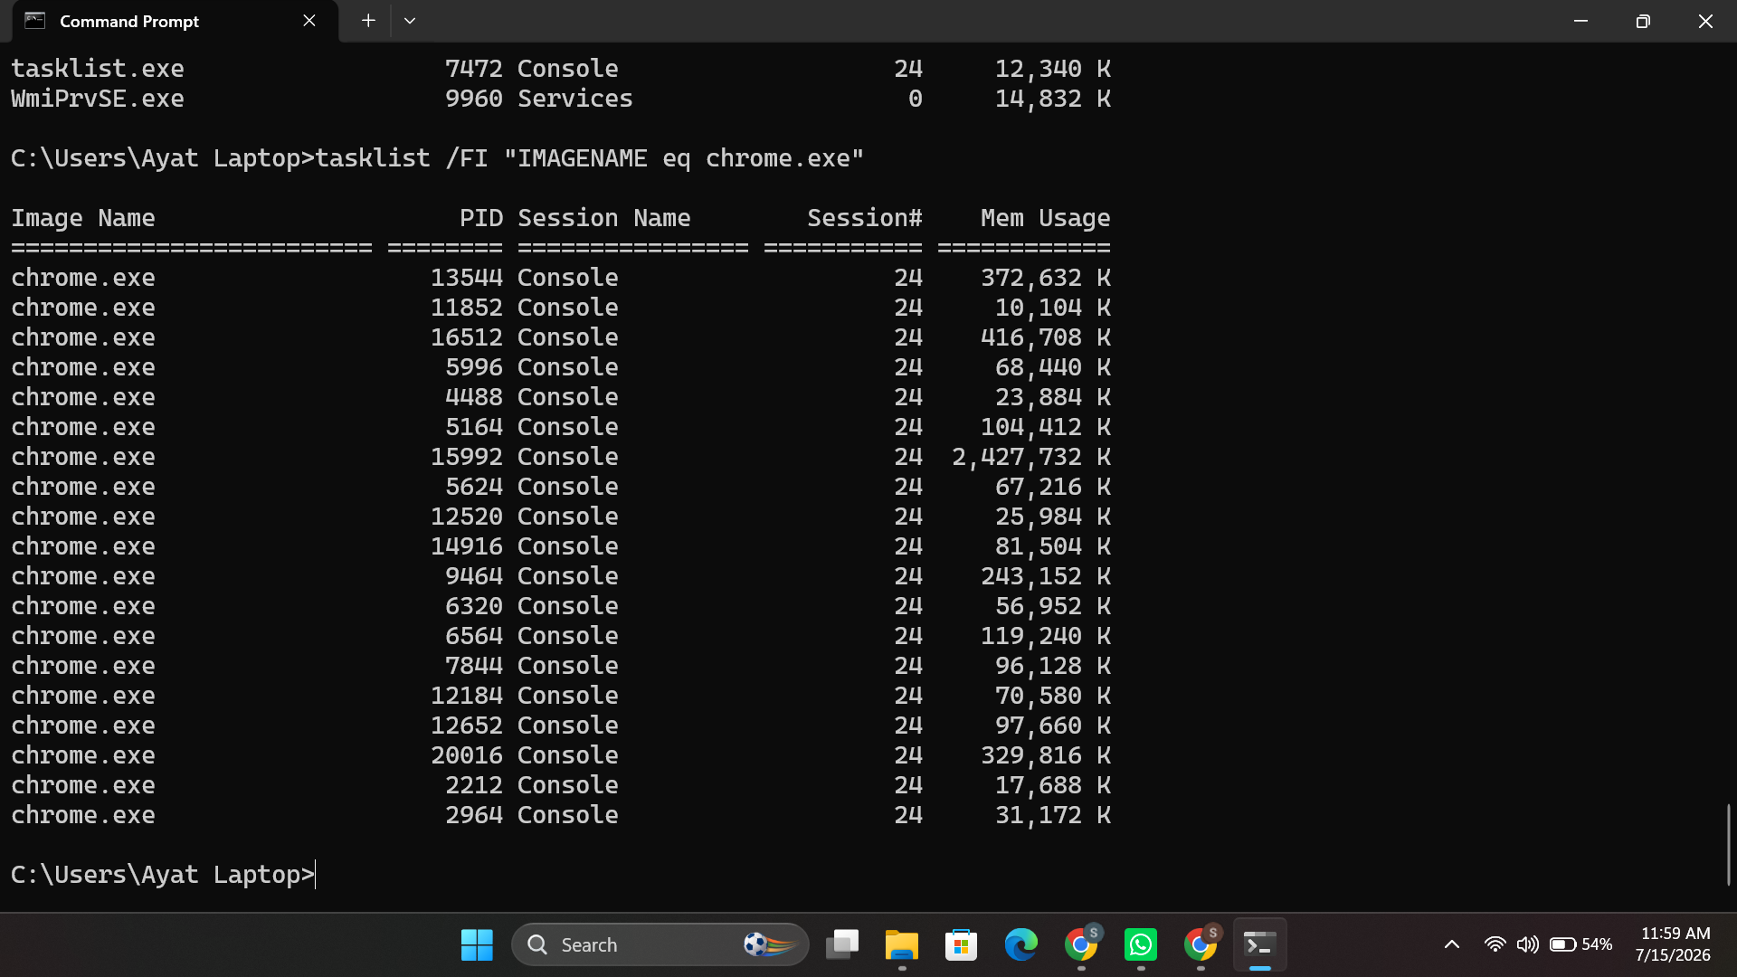
Figure 32: tasklist /FI "IMAGENAME eq chrome.exe" — filtering processes by name.
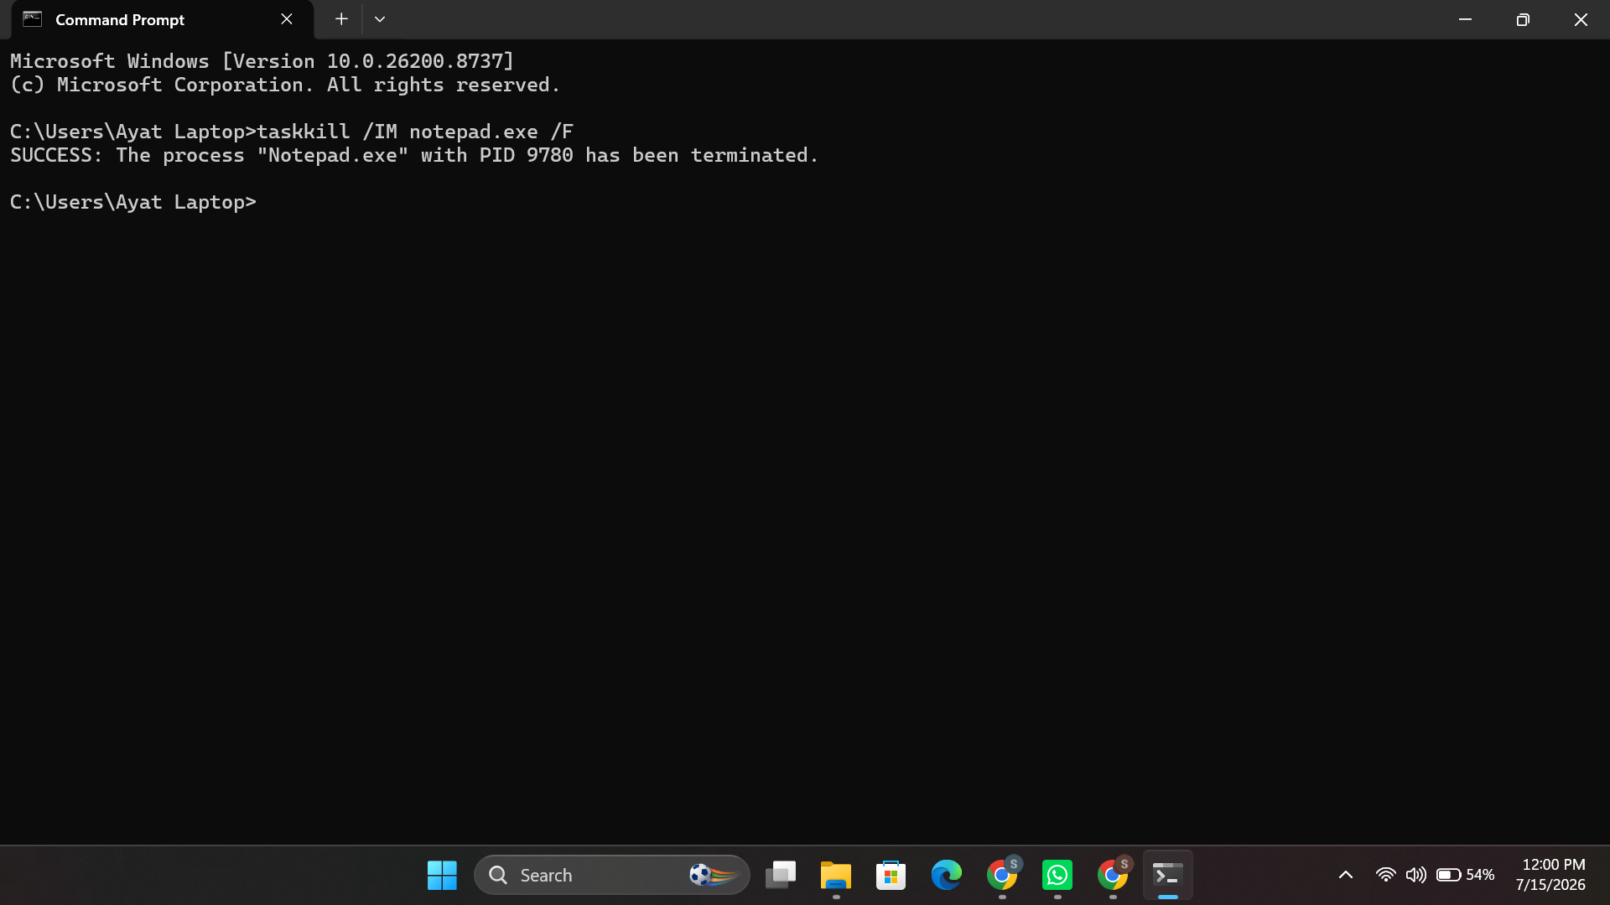
Figure 33: taskkill /IM notepad.exe /F — forcibly terminating a process.
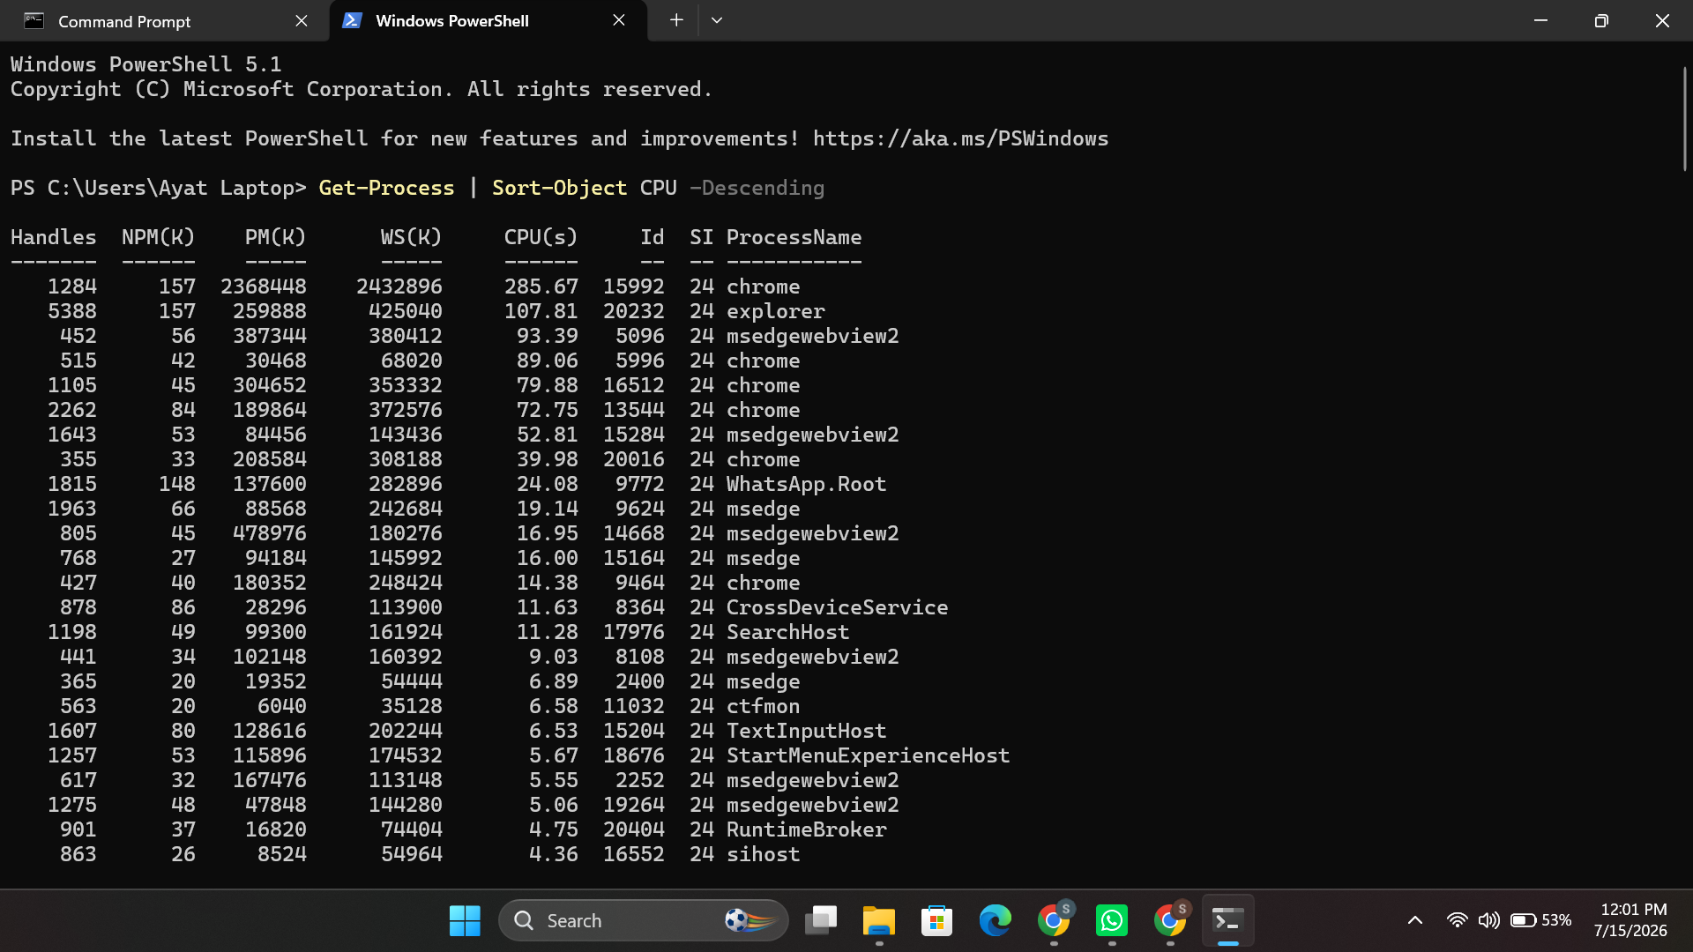
Figure 34: Get-Process | Sort-Object CPU -Descending — ranking processes by CPU usage.

4. Use of Linux OS Scripts
Two bash scripts were developed to demonstrate how common administration-related processes can be performed from the Linux terminal, both of which used a combination of variables, user input, an arithmetic operation, and a loop or conditional statement.

4.1 Script 1 – System Disk Usage Monitor
This script runs 5 passes using a for loop, each pass collects the disk usage information with df and an if/else statement alerts the user to disk usage exceeding 80% in the first pass.
#!/bin/bash
for i in {1..5}; do
echo "Check $i:"
df -h | grep "/dev/sda1"
used=$(df / | tail -1 | awk '{print $5}' | tr -d '%')
if [ "$used" -gt 80 ]; then
echo "Warning: Disk usage high!"
else
echo "Disk usage normal."
fi
sleep 2
done
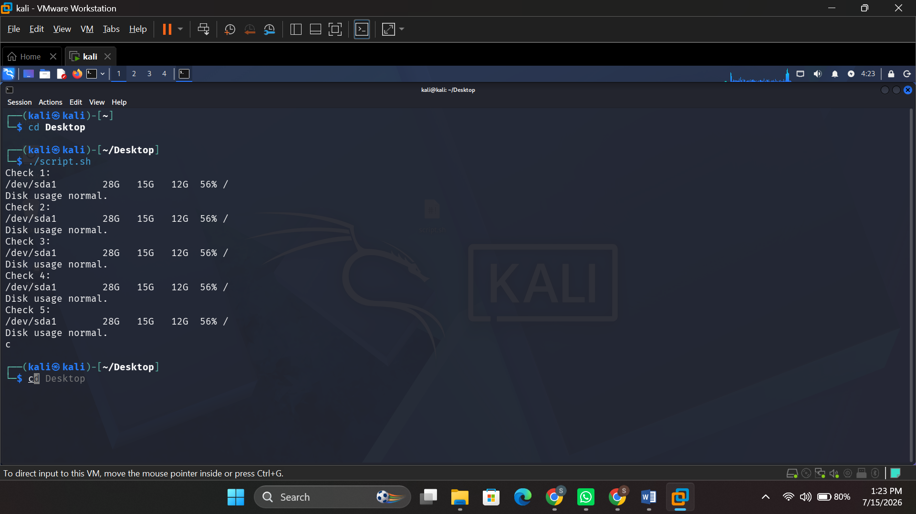
Figure 35:System Disk Usage Monitor

4.2 Script 2 – Simple Calculator
This is a second script to read two numbers from the user, use Bash arithmetic expansion $((...)) to add them, and put it in a conditional break, that is, put it in a while loop that is repeatable if the user desires..
#!/bin/bash
while true; do
read -p "Enter number 1: " n1
read -p "Enter number 2: " n2
result=$((n1 + n2))
echo "Sum = $result"
read -p "Run again? (y/n): " ans
[[ "$ans" != "y" ]] && break
done
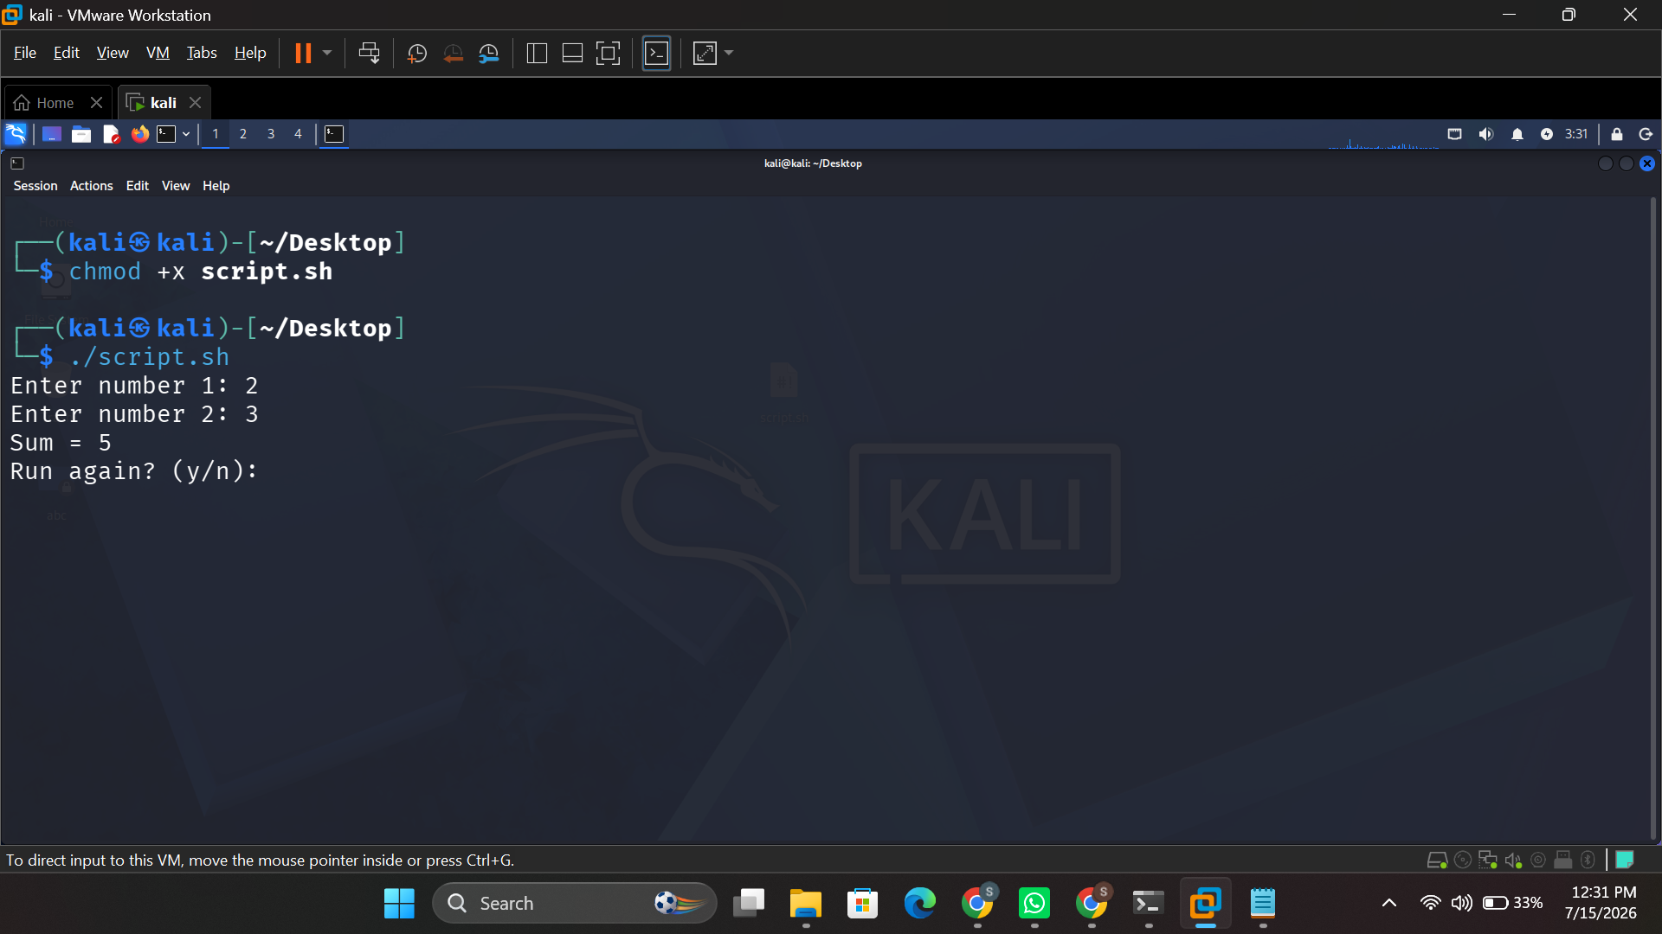
Figure 36: chmod +x script.sh followed by execution of the Bash calculator script.

5. Use of Windows OS Scripts

The Batch scripts below were created to reproduce similar automation to the Linux scripts, utilizing variables, user input, a mathematical operation, and a loop or conditional statement.

5.1 Always make a backup of your files

This script puts the source and destination paths into variables, and uses an if not exist conditional to make sure the backup folder doesn't exist before the backup is made; then it uses a for loop to copy each text file in the source folder to the backup directory.
@echo off
set src=C:\TestFolder
set dest=C:\Backup
if not exist %dest% mkdir %dest%
for %%f in (%src%\*.txt) do (
copy "%%f" "%dest%"
echo Copied %%f
)
echo Backup complete!
pause
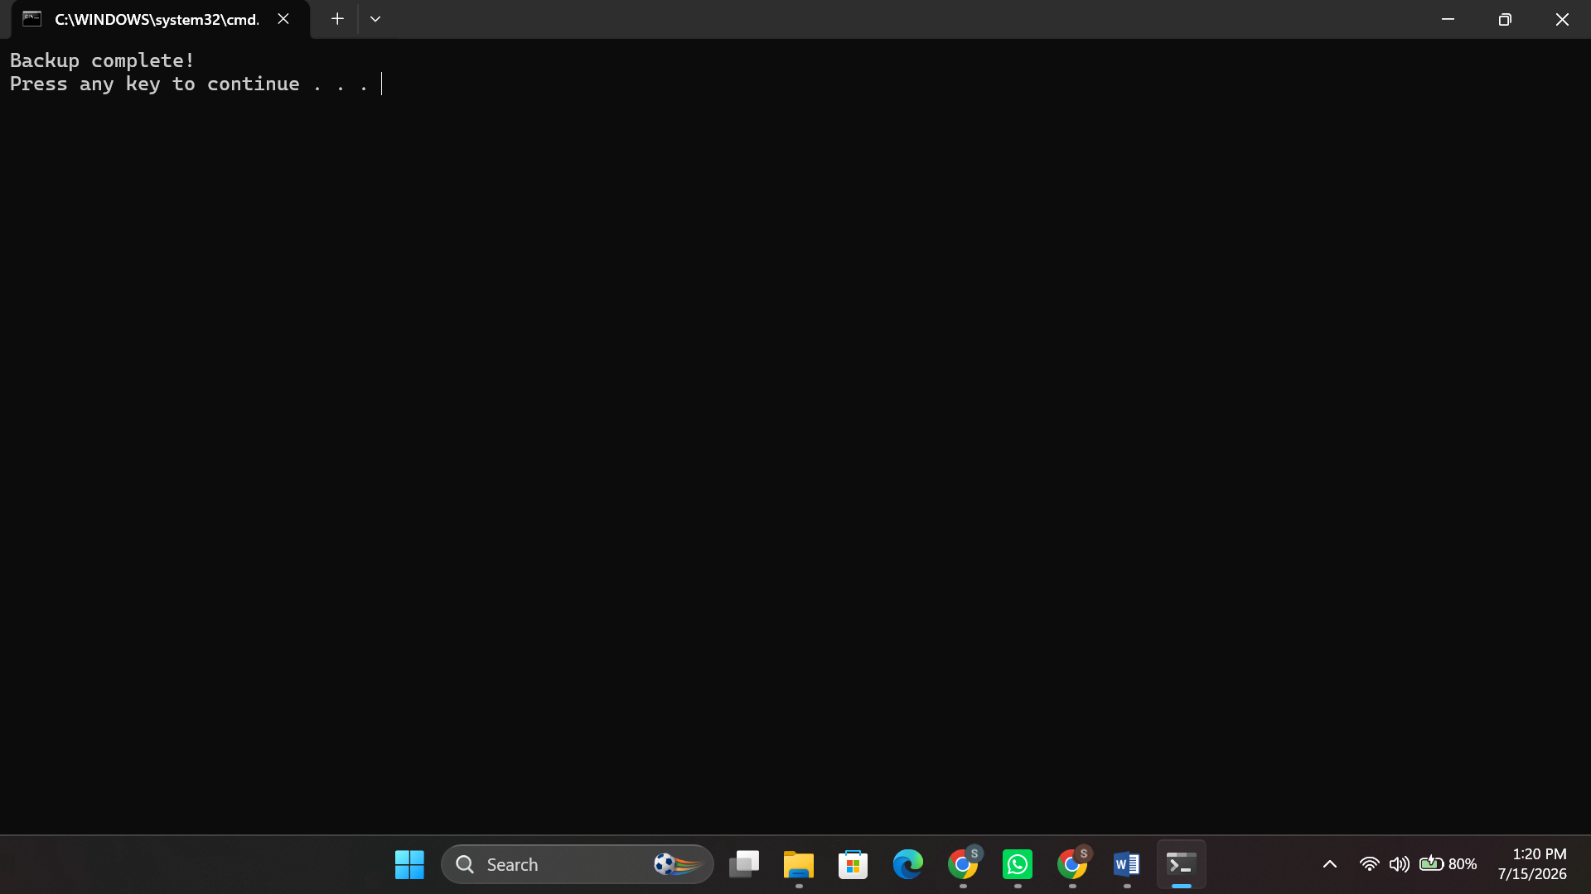
Figure 37:File Backup Automation

5.2 Script 2 – Simple Calculator

This script asks for two numbers, adds them together using the set /a arithmetic operator, and uses a conditional if with a goto label to enable the user to repeat the calculation as many times as is necessary.
@echo off
:menu
set /p num1="Enter first number: "
set /p num2="Enter second number: "
set /a sum=%num1%+%num2%
echo Sum = %sum%
set /p again="Run again? (y/n): "
if /i "%again%"=="y" goto menu
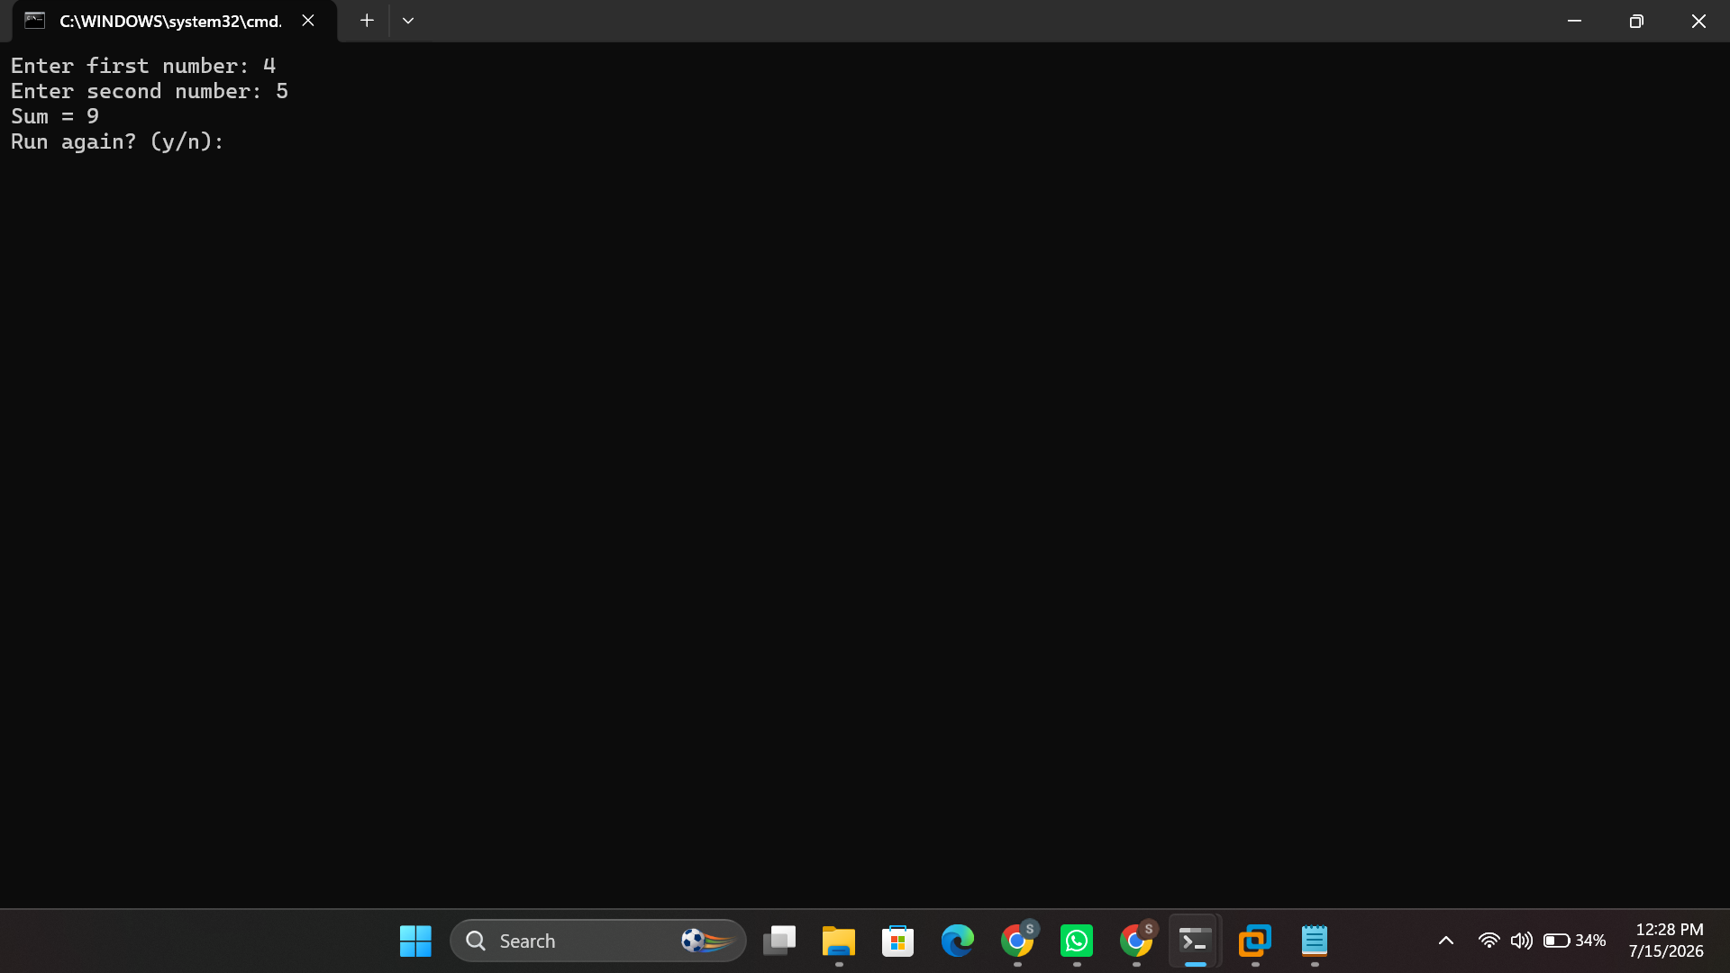
Figure 38: Execution of the Batch calculator script, showing user input, the calculated sum, and the loop prompt.

Conclusion
This report was designed to explore the management of user interaction, security, files and devices, memory and processes by a general purpose OS, and demonstrate it from command line, rather than just a graphical interface.
The Linux scheduling commands crontab and at were then compared to Windows' schtasks; useradd, passwd and groups were compared to net user and net localgroup; ping, ifconfig, netstat, traceroute and nmap were compared with ping, ipconfig, netstat, tracert and nslookup; mkdir, chmod, ls and find were compared with copy, del, mkdir and chmod; and ps, top and kill were compared to tasklist, taskkill, and Get-Process. It was easy to see that even with the syntax differences, both platforms delivered similar administrative ability, from their command lines, respectively.
This research included writing and executing scripts in Bash and Batch, since variables, user input, arithmetic operations, and control-flow constructs like loops and conditionals were all integrated to automate a disk usage check, file backup routine, and a small calculator, this provided another practical application of the investigation – to eliminate repetitive administrative tasks through the use of scripts.
This coursework has in combination reinforced an understanding of how an operating system allocates and protects the resources of the system, and the command-line and scripting skills that are transferable to the operation of two of the most widely used operating system families in industry today.

Reference
[1] Indeed Editorial Team, "Types of Operating Systems (With OS Functions and Examples)," Indeed Career Guide. [Online]. Available: https://www.indeed.com/career-advice/career-development/types-of-operating-systems [Accessed: 15-Jul-2026].
[2] GeeksforGeeks, "Functions of Operating System," GeeksforGeeks, Oct. 2025. [Online]. Available: https://www.geeksforgeeks.org/operating-systems/functions-of-operating-system/ [Accessed: 15-Jul-2026].
[3] Microsoft, "About Memory Management - Win32 apps," Microsoft Learn. [Online]. Available: https://learn.microsoft.com/en-us/windows/win32/memory/about-memory-management [Accessed: 15-Jul-2026].
[4] GeeksforGeeks, "Memory Management in Operating System," GeeksforGeeks, Jan. 2026. [Online]. Available: https://www.geeksforgeeks.org/operating-systems/memory-management-in-operating-system/ [Accessed: 15-Jul-2026].
[5] Coursera, "What Is Memory Management? How It Works, Techniques, and Uses," Coursera, Jan. 2026. [Online]. Available: https://www.coursera.org/articles/memory-management [Accessed: 15-Jul-2026].
[6] TutorialsPoint, "Operating System - Memory Management," TutorialsPoint. [Online]. Available: https://www.tutorialspoint.com/operating_system/os_memory_management.htm [Accessed: 15-Jul-2026].
[7] Red Hat, "Linux commands cheat sheet," Red Hat Developer, May 2026. [Online]. Available: https://developers.redhat.com/cheat-sheets/linux-commands-cheat-sheet [Accessed: 15-Jul-2026].
[8] T. Carrigan, "Linux for beginners: 10 commands to get you started at the terminal," Red Hat, Nov. 2025. [Online]. Available: https://www.redhat.com/en/blog/10-commands-terminal [Accessed: 15-Jul-2026].
[9] LinuxVox, "Mastering Red Hat Linux Commands: A Comprehensive Guide," linuxvox.com. [Online]. Available: https://linuxvox.com/blog/red-hat-linux-commands/ [Accessed: 15-Jul-2026].
[10] Microsoft, "schtasks query," Microsoft Learn, Feb. 2024. [Online]. Available: https://learn.microsoft.com/en-us/windows-server/administration/windows-commands/schtasks-query [Accessed: 15-Jul-2026].
[11] Microsoft, "schtasks," Microsoft Learn, Feb. 2023. [Online]. Available: https://learn.microsoft.com/en-us/windows-server/administration/windows-commands/schtasks [Accessed: 15-Jul-2026].
[12] Microsoft, "Get-Process (Microsoft.PowerShell.Management)," Microsoft Learn. [Online]. Available: https://learn.microsoft.com/en-us/powershell/module/microsoft.powershell.management/get-process [Accessed: 15-Jul-2026].
[13] T. Carrigan, "Linux for beginners: 10 more commands for manipulating files," Red Hat, Nov. 2025. [Online]. Available: https://www.redhat.com/sysadmin/10-more-commands-terminal [Accessed: 15-Jul-2026].
[14] S. Kenlon, "Managing files with the Linux terminal," Red Hat, Nov. 2025. [Online]. Available: https://www.redhat.com/sysadmin/managing-files-linux-terminal [Accessed: 15-Jul-2026].
[15] DigitalOcean, "50+ Essential Linux Commands: A Comprehensive Guide," DigitalOcean Community, Apr. 2026. [Online]. Available: https://www.digitalocean.com/community/tutorials/linux-commands [Accessed: 15-Jul-2026].
[16] Hostinger, "60 essential Linux commands with syntax & examples," Hostinger Tutorials, May 2026. [Online]. Available: https://www.hostinger.com/tutorials/linux-commands/ [Accessed: 15-Jul-2026].
[17] S. Rajack, "How to Get Scheduled Tasks in PowerShell?," SharePoint Diary, Jul. 2025. [Online]. Available: https://www.sharepointdiary.com/2022/01/get-scheduled-tasks-in-powershell.html [Accessed: 15-Jul-2026].
[18] A. Howell, "Learn to automate with PowerShell and Task Scheduler," TechTarget, Feb. 2025. [Online]. Available: https://www.techtarget.com/searchwindowsserver/tutorial/Learn-how-to-create-a-scheduled-task-with-PowerShell [Accessed: 15-Jul-2026].

