Course Title: BSc in Applied Computing

An investigation into information chatbots for students

By Kyle Pixley

Supervisor: John Williams

Project submitted as part of the requirements for the award of BSc (Hons) Applied Computing

April 2021

Declaration Form

DECLARATION
I, Kyle Trevor Pixley declare that I am the sole author of this Project; that all references cited have been consulted; that I have conducted all work of which this is a record, and that the finished work lies within the prescribed word limits. This work has not previously been accepted as part of any other degree submission.

FORM OF CONSENT
I, Kyle Trevor Pixley hereby consent that my Project, submitted in candidature for the B.Sc. (Hons) Applied Computing degree, if successful, may be made available for inter-library loan or photocopying (subject to the law of copyright) and that the title and abstract may be made available to outside organisations.

Abstract
Information in educational institutes can be difficult to gather due to the range of places it is stored. This problem has potentially caused unnecessary stress among students as they must go to several places to get assignment dates, attendance, results, and various other information. This problem is more important to those impacted directly by this issue and therefore it should be discussed. Although this problem may seem less important than others that may exist proposing a solution to this issue can make this process significantly easier. In this project, research has been conducted on some of the uses, types, and examples of chatbots in education and other locations. A chatbot has been produced for providing information quickly and easily as a proposed solution to the problem, this project could be seen as a data analysis project as research was conducted, a system was produced to get further data, and then analysis occurred to find the outcomes to the research, the process used to design and implement this system has been documented and an evaluation has been produced based on primary research results. The results from this primary research have provided insights into how the chatbot could be improved and how it improves upon the traditional methods. Some data from this primary research is that the chatbot’s interface is easier to understand and quicker to use than the traditional methods as stated by 10 of the 16 participants. Although this system may not be a major change to current systems it can provide a quicker solution to be implemented alongside current systems.
Contents
Declaration Form 2
DECLARATION 2
FORM OF CONSENT 2
Abstract 3
Chapter 1 – Introduction 5
Objectives 5
Chapter 2 – Research & Review of literature 6
Literature Review 6
Introduction 6
What is a Chatbot? 6
What types of chatbots exist? 6
How are they used in educational systems? 7
Methods used for creating chatbots 7
General Uses for Chatbots 9
Potential Uses for Chatbots 9
Conclusion 10
Chapter 3 – Methodologies 12
Research Methodology 12
Philosophy 12
Approach 12
Strategy 12
Time Horizon 12
Data Collection Method 12
Development Methodology 13
Chapter 4 – Design & Implementation 14
Requirements 14
Implementation & Testing 18
System Testing 21
User Acceptance Testing 21
Chapter 5 – Evaluation 22
Chapter 6 – Conclusions & Recommendations 23
Suggestions for further work 23
Chapter 7 – Reflection 24
Chapter 8 – References 25
Chapter 9 – Bibliography 27
Demonstration Video 29
Appendices 30

Chapter 1 – Introduction
This project aims to look at chatbots that have been produced for use within educational institutes mainly surrounding students and the current methods of gathering information that are available. This project aims to identify the issues and produce a system that could improve upon the existing issues and make quality of life changes for students in education. The reason this project has been decided upon is because of existing methods for information gathering being quite unoptimized and typically taking quite a significant amount of time due to the wide area that information is being spread across such as attendance and assignment dates being in several different locations making the process more lengthy than necessary. The objectives needed to meet these aims can be found below this paragraph.

Objectives
This section will look at the objectives of this research project.
- To conduct a literature review on the various chatbots and how they are used in educational systems.
- To gather data from primary research about the benefits or drawbacks of the information chatbot.
- To design and develop an information chatbot for students.
- To compare the existing method for gathering information and information chatbots.
- To evaluate the effectiveness of the information chatbot for providing information to students.
This report will present a system to work alongside the standard methods of providing information to students by allowing the use of a chatbot to enable faster and easier collection of information such as attendance, results, and assignment dates. Before the system is produced research into the existing data will be conducted to gain further understandings of how chatbots are currently used as well as look at some examples of chatbots currently being used in education. Designs will be created before development begins for the desired system and an evaluation of the produced system will be created using primary research, this will help gauge the effectiveness of the chatbot for students.

Chapter 2 – Research & Review of literature

Literature Review

Introduction
This project proposal contains several topics that surround the use of chatbots in educational systems and the benefits that they provide when used in the right manner. The literature review below will contain the various types of chatbots currently being used in educational systems along with their effectiveness, this will help with the progression of this project as an understanding will be gained allowing further insight into how, where, and why chatbots are used in educational systems to aid students. This literature review will compare current systems to the chatbot variants if applicable to gain a perspective on the benefits and improvements that are made using a chatbot instead of a more complicated system.

What is a Chatbot?
The definition of a chatbot varies slightly but the consensus is that a chatbot is a machine that uses natural language user interfaces to communicate with users. Originally chatbots were developed to try and “fool user’s that they were real humans” but now they are used in several ways to aid users in an effective and timely manner. Chatbots have become a method of simplifying tasks such as customer service, marketing, education, and support. Chatbots have been developed for years making them become more advanced and more implemented into the day-to-day lives of people some examples of chatbots that are more complex than just the original text-based interfaces would be Google Assistant, Siri, and Alexa, these are just chatbots which make use of the advancing digital technologies to provide useful functionality and information when needed. ^{[1-4]}

What types of chatbots exist?
Chatbots are not necessarily “associated as a single category but they fall along a wider spectrum.” Chatbots can be classified by their input or their messaging channels some examples of input-based chatbots would be chatbots that make use of buttons to follow a hierarchy of decisions, keyword input to present pre-generated responses, voice-enabled which works similarly to the keyword although it takes what the user is saying and then produces an outcome whether it is a task or answering a question or a contextual chatbot which makes use of machine learning to improve answers according to how a user asks for something. As mentioned previously chatbots can also be classified by their messaging channels, messaging channels that might be utilised by chatbots would include web services, standalone applications, and integrated. The most well know messaging channel for chatbots is likely web-based services as chatbots are commonly found on websites providing customer support or additional information through a text-based interface. ^{[3]}
Some examples of chatbots that exist and are frequently used today would be systems like Alexa, Siri, and Cortana which are not conventional text-based interfaces but are AI-based systems that use inputs made by users speaking to the system, chatbots are being consistently improved and produced to provide an easy to use and beneficial experience to its users, an example of this is the use of voice over text-based interfaces as several users would prefer this method of interaction as it is easier for them. These systems can also be referred to as voicebots or socialbots as stated by Amazon during their Alexa prize competition. ^{[14-15]}
Freudbot is a chatbot that had a study completed by fifty-three students, this study consisted of 10-minute conversations using instructional sets, once these conversations had been completed a questionnaire was filled out based on their experiences with the chatbot. The outcome from the questionnaire turned out to be a “neutral evaluation of the chat experience although participants positively endorsed the expansion of chatbot technology.” When looking at the data from the studies it was determined that the instructional sets that were used for the studies were not impactful on the outcome of this study. From this study, it was determined that chatbots could be promising when used as a “teaching and learning tool in distance and online education.” ^{[16]}

How are they used in educational systems?

Effective Learning – Individual Assistance
Chatbots are starting to be used in educational locations more and more, the types of chatbots and how they are used vary from each organisation, some educational institutes currently struggle to provide individualised support due to the ever-growing number of students on courses, this causes issues with providing effective learning to all students as ideally it would be one lecturer to one student but this is not possible due to restrictions both financially and organisationally. This is where chatbots come in as they can provide several advantages to organisations including being available 24 hours a day and cutting down costs caused by having several support personnel to handle issues that arise or provide information to people when they require it. The traditional systems that are used in educational institutes include intelligent learning systems that attempt to “provide immediate and customised instruction or feedback to the learner.” If chatbots were to be used over these traditional interfaces they would allow students to control their learning process as “chatbots interact with students in a synchronous way”, this makes the chatbot able to react to individual intents. An example of a chatbot that was implemented into an educational institute includes the University of Georgia which “created a chatbot using IBM’s Watson platform, this chatbot was used to handle posts on forums from students that were enrolled on a computer science course”, the result of this chatbot was that students felt more engaged with their course. ^{[5-7]}

Information Sharing & Gathering
Another use for chatbots in educational institutes is information sharing and gathering, an example of this is Bolton College’s chatbot named Ada which is a chatbot available to students to help with the gathering of information that may be important to the student such as information about attendance, or content within the curriculum along with personalised learning as mentioned previously, this chatbot uses IBM’s Watson platform which is an AI program. This type of chatbot cuts down the number of hours needed for administration within the college or even in their spare time. This chatbot is not limited use as it can be accessed from a mobile application which allows students to get the information they need when they need it as they can use it after college hours. Chatbots that are used in this way for education increase the support and engagement that students get while reducing the workload for administration within the organisation. ^{[8-10]}

Methods used for creating chatbots

Development Methods
When creating a chatbot there are several different methods of doing so for example you can code it from scratch using the language of your choosing depending on the platform and method of implementation such as HTML with CSS, PHP, and AJAX or you can use languages such as C#, Java and JavaScript. The alternative method that can be used for creating chatbots would be to use a system that lays out the very basic information and allows you to code and implement the functionality of the chatbot an example of this is a system named Flow.ai which allows the user to determine the logic for the chatbot by laying out the flow of the chatbot using several inputs and outputs as well as actions to be completed when specific input is made by the user. “A flow is one specific part of the dialog you want to automate”, this refers to the basic structure that the developer creates for their chatbot. This system enables the creation of an artificial intelligence-driven chatbot that follows a set of instructions that are implemented during the development through the user teaching the AI what it should be looking for, some examples of what the chatbot may look for would be keywords or phrases commonly used by users so that the correct information can be retrieved and output to the user, as stated within the documentation that Flow.ai provides “Flow.ai features a state-of-the-art NLP engine that can train or be trained to understand different types of user input within the context of a conversation.” Alongside being able to create a flow or logic system for the chatbot you can implement actions, these actions typically start as a blank action and require the input of code for the chatbot to understand what the action means and what the chatbot should do when it gets to said actions in its conversation flow as previously mentioned, an example of an action that can be created using this system would be identifying the user by taking the users input and verifying it against data in a database through the use of an API. The use of a flow system within chatbots enables the creation of dynamic chatbots that can produce a wide range of responses through several different methods such as API calls or processing of data for analytical requests. ^{[11,13]}

Methods for data retrieval
During the development of a data retrieval-based chatbot, a method must be chosen for collecting and presenting the data based on the user inputs, there are a few different methods for doing this which include the use of single databases, a data warehouse, or unstructured documents. The first method for data-retrieval is a simple database, when using a single database system it will typically consist of set questions and responses which have been setup so that if a user inputs a specific question they will get a specific response back that is linked to the question they asked. The second method is using a data warehouse which takes the single database concept and expands upon it by having a database with queries that the user could input which then links to several other databases with information that the user may be looking for, this method of data collection enables the use of several databases and is beneficial to educational organisations as they will typically have several databases for information such as attendance and contact details. The last method that was stated in this section for data retrieval is unstructured documents, this method of data retrieval uses any type of document that may contain useful information to provide information to users, this method will typically use generation instead of direct retrieval as it will take the users input or queries and turns them into “vector representations” through the use of encoding, “then feed this representation into a decoder to generate a response.” This system is also based on questions but the responses that the chatbot provides are sentences that are generated as a response instead of directly taking information from a database. ^{[12-13]}

Challenges faced during the development of chatbots
When developing a chatbot several challenges can be faced including natural language processing which is the process of understanding what the user is looking for as there can be several ways of asking similar questions. For example, “if we ask them that “what’s the weather?”. You will get an answer but what if we ask, “Could you check the weather?” you might not get the proper answer.” This could lead to an incorrect output if the chatbot is unable to understand the context in which this question is being asked or by simply not understanding some of the several variations of questions. To avoid this issue chatbots will typically make use of keywords to find the specific information or machine learning for a much more complex and flexible chatbot that can change how it responds based on what is input to begin with. An example of a chatbot that was created and used in an experiment that was keyword-based that aims to help with teaching foreign languages in China, the overall outcome to the experiment was that the chatbot was able to provide some help regarding the learning of foreign languages as “11.39% of the total users, talked about English” this was because English is prioritised within Chinese universities, other users discussed and used the German language and several other languages at a much lower rate. ^{[17-18]}
Another challenge that can arise when developing is a chatbot is the use of machine learning due to the complexity that comes with it. Chatbots that make use of machine learning aim to create a system that enables the chatbot to learn from the users and alter the outcomes based on what may be input, this can be quite difficult due to the time it may take for the chatbot to provide the correct response as this relies on the use of “efficient programming with AI concepts.” ^{[17]}

General Uses for Chatbots
Regarding the chatbot that was developed to help with the learning of foreign languages it was discovered that the chatbot was able to provide additional support to the students as it was recorded that a significant number of users talked to the chatbot about topics that could be associated with “private emotional problems and experiences.” This provides insight into potential other uses for chatbots for students as students may find it easier to discuss their problems with a chatbot rather than other people just to help relieve stress or other negative feelings. ^{[18]}
When discussing the uses of chatbots there are several that would come to mind these may include the various types of service chatbots for example customer service chatbots for handling issues or messaging requests from a buyer to a seller an example of a customer service chatbot would be Amazon’s messaging assistant which acts as a middleman for customer order issues and helps reduce the number of staff required to answer customer questions, the use of this messaging assistant also “fixes your problem or connects you to someone who can” indicating that staff can still be contacted if the chatbot does not resolve the issue. This use for chatbots is seen in a wide range of businesses. ^{[19]}
Home Automation is a new use of the more technologically advanced chatbots such as Alexa and Google Assistant, this use typically uses the chatbot along with the internet of things to manipulate objects such as lights, fans, and other devices over the internet. As mentioned in the challenges with chatbot development section, “natural language processing techniques” are used to take what the user is asking for, typically this is done through voice activation due to the availability of this function within AI chatbots such as Alexa, this will then be processed and the web application will execute the command. ^{[20]}

Potential Uses for Chatbots
Although chatbots can be found on several websites for several reasons there are still areas where chatbots could be utilised to fill gaps or provide support to existing systems. An example of where chatbots could potentially be used would be medical institutes. The reason chatbots could be beneficial in medical locations or regarding medical information is because several people would rather look up symptoms of potential diseases before contacting a medical specialist for further advice, most of the advice or information regarding these medical conditions is typically found on forums where anyone can post their thoughts, although this current method is functioning well there are still “some limitation such as there is no instant response given to the patients they have to wait for experts acknowledgement for a long time,” if a chatbot was to be implemented alongside existing systems more correct information would be given out to people and better decisions could be made in a shorter time rather than potentially leaving a condition until it gets much worse. ^{[21]}
The previous example could also be implemented into courses for students studying health-related topics or training to become medical experts so that gathering necessary information regarding various conditions and other stored information can be gathered more easily during their learning process. This could be used in a variety of ways to potentially speed up processes that may have taken much more time by cutting down the time needed to gather this information from several databases. An existing system called the unified medical language system or UMLS contains medical knowledge and “is essentially a collation of various medical ontologies and terminologies.” A proposed chatbot would make use of this existing system's data to make the gathering of information easier by taking the user query and outputting information regarding the stored concepts, this could be used by medical students to provide a significant amount of information about their desired concept within a much shorter time. ^{[21-22]}

Conclusion
From the research that has been conducted on the various topics surrounding chatbots, it is evident that chatbots have become more beneficial and used as technologies have advanced because they can be produced in many ways to provide several benefits to the users of the system as mentioned previously chatbots can be used for information gathering, providing assistance like Alexa or Siri through the use of voice or to help with the automation of a common process to cut down on administration requirements and provide services in a faster manner. This research has provided insights into how chatbots are developed while mainly focussed on data-retrieval chatbots as these are the types of chatbots found commonly within educational institutes. This research has also helped with creating an understanding of some of the existing challenges that can be faced when developing a chatbot which will be useful to this project as this information will help when creating the chatbot for this project by potentially using some of the methods mentioned to mitigate the challenges entirely. Although this project is more focussed on the educational uses for chatbots this research has also provided insights into some of the more common and more general uses of chatbots which can commonly be found in businesses or homes today. During this research, an understanding of how chatbots have evolved and are used has been created which will enable easier creation of a chatbot for this project.
After some further research into other chatbots such as Freudbot, the chatbot that was used for helping to learn foreign languages or the proposed chatbot that would make use of the unified medical language system, it has allowed further understanding of some uses for chatbots potentially beneficial to a wider range of students including students on medical related courses or students who may struggle with understanding a specific language due to moving from another location, having this knowledge is beneficial to this project as it allows for thoughts into how the chatbot can be modified and expanded upon for potential other projects and also allows further understanding of the wide variety of uses that chatbots provide in education as from this research it has been discovered that chatbots can provide a means for information gathering in education, chatbots can provide learning support to students in education by allowing students to have much more control over their own learning such as the chatbot that had been produced to provide support to students that were learning another language, and chatbots can also be used to replace or assist an existing system to create an easier to use option such as the proposed medical students system, it was discovered that students that interacted with the Freudbot chatbot found the chatbot to be a positive change as students positively endorsed the chatbot based on their experience gathered from the 10-minute conversation that they had undergone. The use of a chatbot for supporting students who are learning another language seemed extremely beneficial as this was not an aspect that had been considered before this research had been conducted, the research that came out of this study allowed an understanding to be gathered of some other aspects that may need to be thought of when producing or after implementation of the proposed system as this system aims to be used by a large group of students including those that do not speak English as their first language. From the study on the chatbot for foreign languages, it was also determined that chatbots create an environment for students to express their feelings as it was found that students used the platform to talk about topics that are typically linked with “private emotional problems and experiences.”
When starting this project, the topic that had been decided upon was quite focussed on the information-gathering side of chatbots but after the completion of research, it has become apparent that there are significantly more uses for chatbots than had been anticipated originally and has therefore provided some more beneficial knowledge as different aspects have been discussed within this literature review. The completion of this literature review has provided information regarding the numerous methods of support that chatbots can provide including but not limited to learning support for both on course learning and language learning, emotional support as chatbots can provide an environment that students feel is a safer place to discuss their issues to relieve some stress, and chatbots can also provide support for existing systems by creating an easier and faster to use interface for getting the same information as traditional methods such as through website interfaces. While chatbots can provide all of these various types of support they can also provide significant benefits to the users or businesses that decide to implement a chatbot system into their environment, the benefits that are provided by chatbots typically fall under the category of speeding up or making a process easier in some manner an example of that had been found during this research which was Bolton college’s chatbot named Ada which is a similar chatbot to the one that this project aims to produce. This chatbot aimed to help reduce the extensive amount of time needed for administration and provide support to students outside of college hours due to the availability of the chatbot.

Chapter 3 – Methodologies

Research Methodology
To ensure success during this project, appropriate research methods should be chosen so that expected outcomes can be met, and research can be conducted correctly for this project.

Philosophy
For this project, a phenomenological philosophy will be used because this project will use the experiences from users of the student systems to create a chatbot that can provide all that information in a simplified and easier-to-use manner. The benefits of using a phenomenological approach are that it enables the ability to look at change processes over time, this would come into play with seeing how the system would be implemented and used over time. However, this approach may make the analysis of data harder as it is gained from experiences, the use of primary research in this project aims to lessen the impact of this as questions can be asked to answer questions about the experience. ^{[23]}

Approach
This project will use a deductive approach as this project will aim to produce a hypothesis from an existing theory, the theory for this project is that students struggle to get the information they need promptly as the information they need is across multiple locations. The benefits of a deductive approach are that concepts can be measured quantitatively. The deductive approach is more suited to projects where the available sources are abundant and for projects with a shorter time for completion. ^{[23]}

Strategy
The strategy that this project will use is a case study because this will allow further investigation into cases that align with the theory or oppose the theory, these case studies will be based on other students as well as the current system available to those students. A downside to this strategy is the introduction of bias as case studies tend to be based on one person with a single researcher gathering the data, this produces a potential for bias inside of the data, to prevent this the participants will review the results to ensure it matches what they have experienced over experience from the researcher.

Time Horizon
This project will be cross-sectional as this project will be looking at the outcomes when using traditional methods of information gathering versus the use of the chatbot to gather the same information, this project will not extend over a major period and will look at the impacts caused by the newer system after the implementation instead of how it causes changes within a student’s method for gathering information.

Data Collection Method
This project will use literature searches, surveys, and interviews to collect data because these methods of data collection will enable the collection of enough primary and secondary data that can then be used to create links and draw a conclusion for this project. Whether it is more beneficial or whether it did not have much of an impact on the time it takes to get the information the student is looking for. The use of surveys and interviews should provide quantitative data to produce statistics while the use of literature searches enables the gathering of qualitative data. ^{[23]}

Development Methodology
This project will make use of prototyping during the development of the system because this will allow more time to test and fix issues early on as multiple prototypes will be created with additional features or bugs being fixed for each iteration of the system, this will use findings from each iteration of the prototype to make further improvements and can make use of suggestions for what could potentially be added to the program or improved for usability. This method of development is advantageous to this project as it enables faster identification of problems meaning that issues can be resolved or improved earlier instead of having to make multiple last-minute changes to ensure functionality. This approach to development also makes the project much more likely to meet the requirements of the system as prototypes can be checked against the requirements to be able to understand what needs to be implemented next and what is already completed. ^{[24]}
The downsides to this method of development are the increase in development time that can be caused by adding multiple additional features mid-way through the development process, to prevent this user requirements must be agreed upon with an understanding that further features may add to the cost of the system due to them being additional unless they were stated in the requirements to begin with. Prototyping also has issues with having too much focus on a single section causing a lack of development in other areas making the system unsatisfactory, to negate this, specific features should not be focussed on entirely as it can run the project over deadlines. Prototyping can also lead to confusion in the user as there may be far too many prototypes to track for the user causing confusion on how the system functions, to prevent confusion in this project each prototype will only add a specific number of features to reduce the complexity so that users do not become confused and these changes will be noted so that the user can understand what has been changed or improved since the previous prototype. ^{[25]}
The use of brackets with HTML, PHP, and AJAX is how the chatbot will be developed for this project as this chatbot aims to be implemented as a feature in a website, although this is subject to change. HTML will allow the creation of the layout of the chatbot and PHP enables the creation of the functionality of the chatbot using AJAX to update the page as information is input. Changes for software or languages used will be documented in the implementation section of this report.

Chapter 4 – Design & Implementation
When planning out the application for this project it became apparent that various tools and resources would be needed to ensure the successful completion and functionality of the application. The resources and tools that had been decided upon included brackets for the coding using HTML, PHP, and AJAX to create the functionality while using a local phpMyAdmin database for storing the required data.

Requirements
For the system to be fit for purpose it must allow the user to retrieve information quickly through the use of an interface that is connected to a database, due to this being a system used by students the data that would exist in a real environment is too sensitive to have access to so for this project a local phpMyAdmin database will be used, the sensitive data will be obfuscated by replacing real data with realistic fake data to ensure privacy. This data will be used to test the system and ensure functionality. The requirements document has been included in the Appendix.
To begin the process of designing the system an investigation into the current methods used for data gathering was conducted, it was found that the typical means of data gathering was done through websites, and information that was required was scattered across several locations, once this investigation had been completed some wireframe designs were created to decide on how the chatbot would work, these designs can be found below as figures 1 and 2.
Figure 1 – Wireframe Design 1
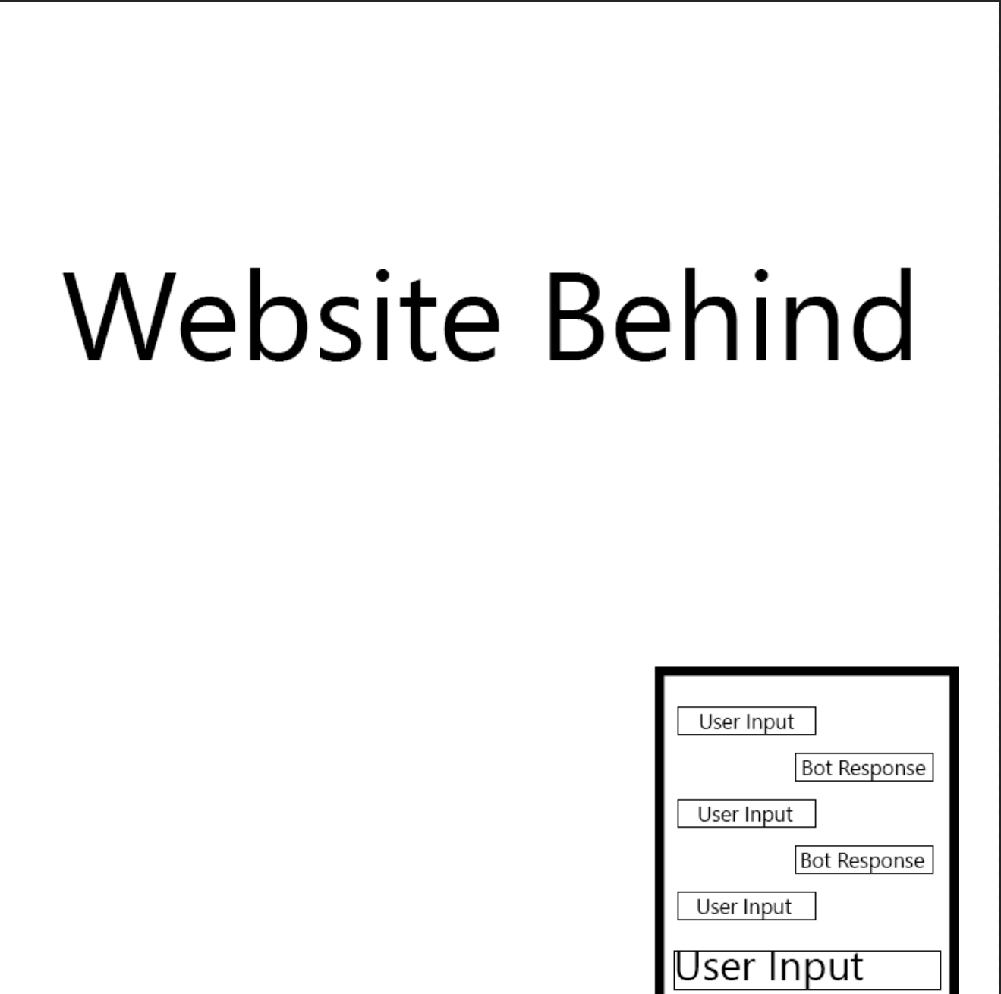
Figure 2 – Wireframe Design 2
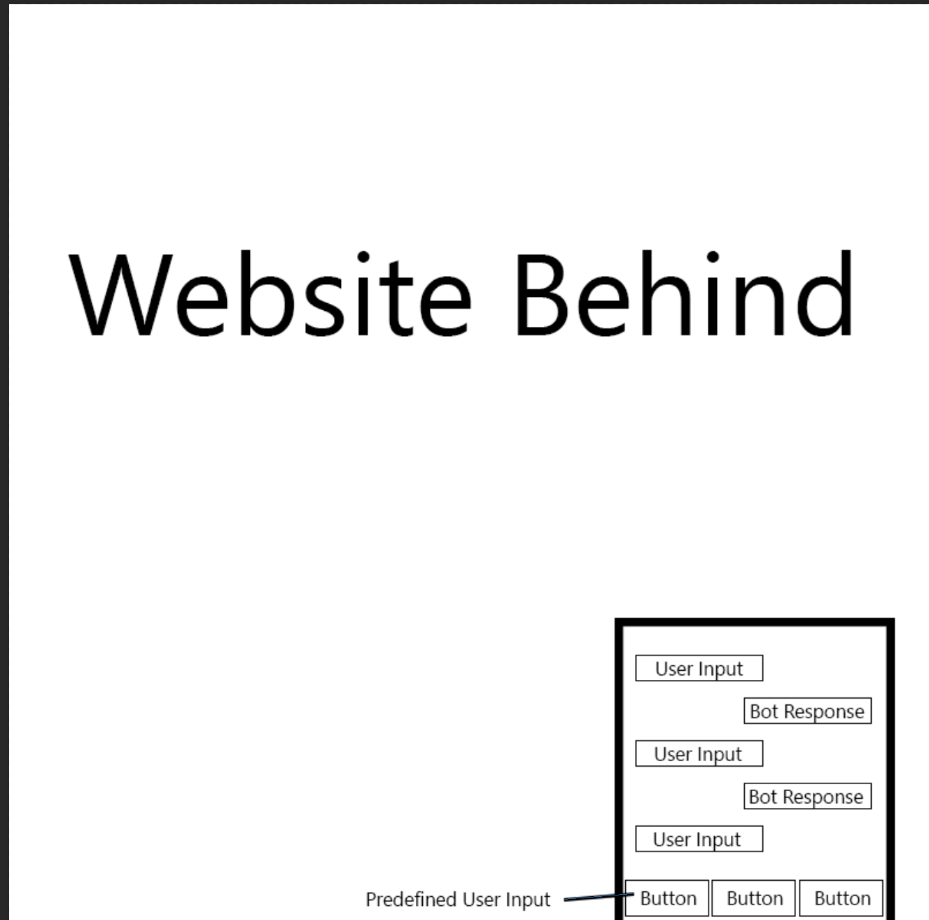
Figure 1 displays the first design that was created which utilised a textbox for user input rather than the buttons displayed in figure 2, this was decided on due to the wider range of inputs and the future expansion of the system that could be implemented even though the second system would have been easier to develop. Once the development of the system had begun it became apparent that the need for a website as depicted in the previous figures was not necessary and instead would focus on creating the chatbot on its own. After the initial design had been created which can be seen in figure 3 development continued introducing functionality stemming from the base that had been created.

Figure 3 – Base for Development
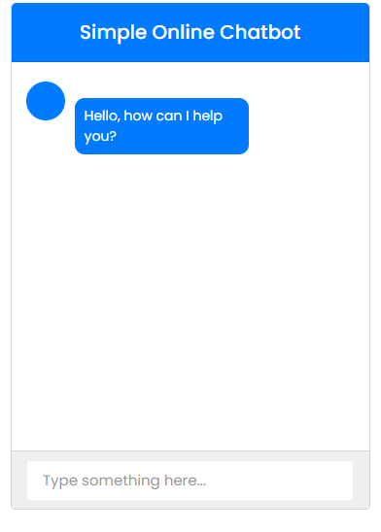
The next stage of designing the system was the data structure, originally it was planned to use a data warehouse structure with a single fact table and multiple dimension tables, however, this seemed to be a much harder approach to take when adding further details as some information was more sensitive such as attendance, results as they are linked to a single person whereas units and their assignments would be more publicly available when compared to current systems. A very basic data structure was created as seen in figure 4. This data structure can be expanded upon to allow further information to be included in the system.

Figure 4 – Data Structure
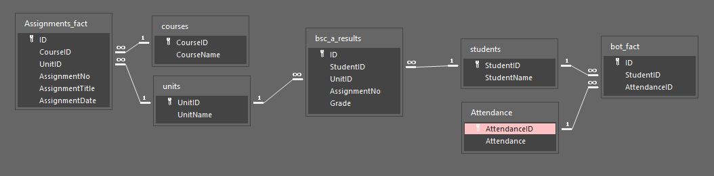
Originally it had been planned to expand upon the bot_fact and include the results for each unit in separated columns, but after more thought, this seemed like a bad idea as only one course had been considered previously, if this chatbot was to be used by several different courses then this table would have become far too large due to the number of units available.

Implementation & Testing
When development began it was apparent that the method that had been selected to develop the chatbot was not suitable due to the over-complication needed to ensure that the chatbot functioned properly within the set deadlines and therefore a change in the tools and methods used for development occurred as a transition from HTML, PHP, and AJAX to a C# Windows Form Application which would solve the issue that had arisen surrounding variables being significantly more complicated in HTML and PHP than C#. The issue that had arisen was related to storing the student's ID number for use when collecting other data such as attendance for the specific user at the time, this turned out to be a significant challenge due to the way HTML and PHP functions and would have required several PHP scripts to be created or the use of other frameworks which included Laravel, C# or JavaScript, the decided new framework for development was C# due to the existing experience with the language being far greater than the other discussed frameworks.
During the development of the chatbot using this new framework implementation of a MySQL database was harder as previous experiences with implementing databases were limited to using an access database and hard coding. To implement the MySQL database a connection had to be made as a localhost database was being used, the connection string that was used to connect to this database can be found as figure 5, this was easily resolved after some short research.
When testing queries no results were being found with the created queries, this issue took more time than anticipated to correct and the solution was extremely simple compared to what had been tested while attempting to solve the issue, the solution involved removing the variable as a value from the query and instead taking the input directly from the textbox and inserting it into the query, an example of a query used within this system can be found labelled as figure 6. An understanding as to why this error occurred when using a variable has not been gained as it seemed to be almost identical to the solution. The only reason that could potentially be behind it is the type of the variable being different from the data type.
Figure 5 – Connection String (Database Connection)
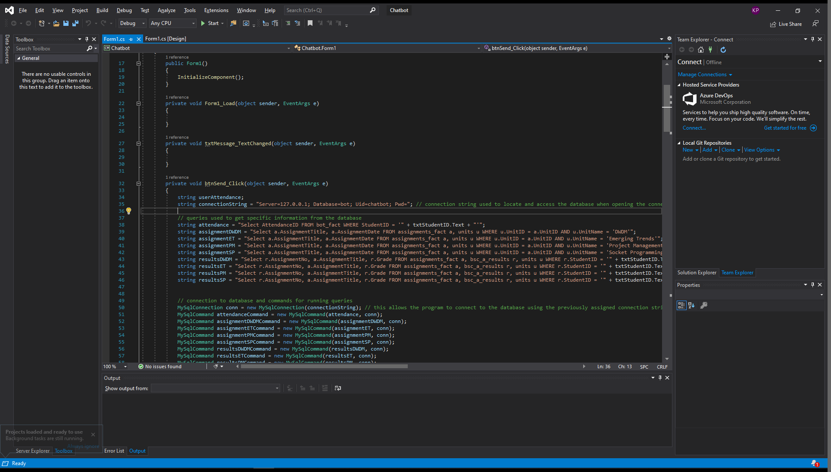
Figure 6 – Example Query Strings
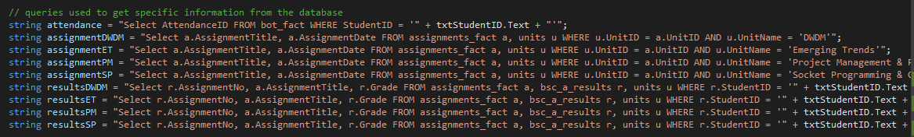
To utilise these queries within the system the user’s input was scanned for specific keywords and depending on what they had input and whether it matched specific keywords one of the listed queries were used to get results from the database. The block of code displayed in figure 7 shows the structure used for checking the user's input.

Figure 7 – Keyword Searching Code
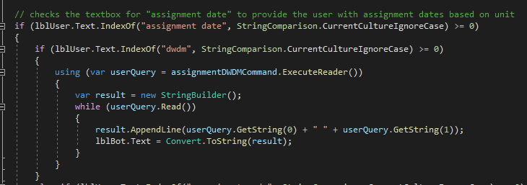
This code looks for the terms “assignment date” and “dwdm” and then uses the query to get assignment dates for the data warehousing and data mining unit, when the query is used a reader is used to collect the results and then a string builder is used to create a string including all of the information necessary, this had to be utilised as the results before adding this string builder ended up being a mess as no spaces were included. Once the string had been created it was then output to the bot’s label to show the results from the query and the information that the user requested. The outcome of this exact piece of code can be found as figure 8, this figure also shows the updated interface after switching the framework used for development. The reason for using this method of getting data is because it can easily be expanded upon by creating new queries and then adjusting the code as necessary. Due to assignment dates being public the query used for this did not utilise a student ID as anyone should be able to access this information. When sensitive data is requested the system makes use of the student’s ID to get only data linked to them such as their attendance.
When first implementing this code some issues had arisen which included the input being case sensitive so only “assignment date” would work and not “Assignment Date”, this was resolved in later iterations of the program by checking the string and using a string comparison to ignore the case of the input, so now if any capital letters are involved it will still function correctly. As mentioned previously the output string also had issues before the implementation of a string builder as it ended up putting all outputs together without any spacing or separation between data. The string builder allowed the layout to be created for the output as seen in figure 7.
Figure 8 – Query Result – DWDM Assignment Dates
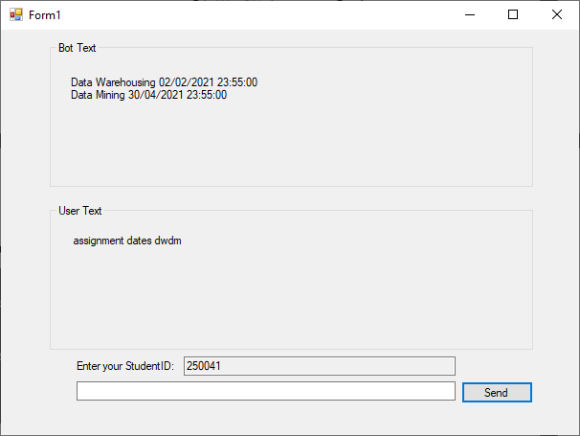
After testing this new interface, it was found to be very simple to use as the user can see where their text will be displayed as well as the bot’s text as well as required information and inputs available to them. Improvements regarding the appearance such as colour could be made in the future as usability of the interface was ensured first so that confusion was minimised. Future implementation of a command list may be needed unless the bot is altered as the number of commands can be extremely large after expansion.
An overview of the development iterations are as follows:
- Create an application that connects to the database
- Create an interface to test this on
- Implement and test the attendance query
- Implement and test the assignment date queries for a single unit
- Add additional units to the code for assignment dates and test them
- Implement and test queries for results for a single unit
- Refine the interface for the system to make it more usable
The process of developing the system was separated into iterations as prototyping had been selected for this project, each iteration of the system implemented a new section as detailed above and then testing was completed to ensure that the implementation was correctly done and the system was still functioning.

System Testing
After implementing the basic queries for assignment dates and attendance, system testing was conducted to ensure that the system functioned without any issues like overlapping of outputs or incorrect information being displayed, the outcome to this testing shows that the system functioned correctly and without any issues and from this point implementation of results was carried out using the same structure for the code as seen in figure 7. When implementing the new code for results the query that was created had an issue with getting the incorrect information, this was promptly resolved by altering the query.

User Acceptance Testing
User acceptance testing for this system was quite difficult as it makes use of a localhost database so instead of being able to directly interact with the system the users provided the information they wanted to input and it was completed virtually. This allowed the users to see how the system functioned, as well as test the functionality of the system. Once they had completed the testing they answered a questionnaire which provided some insights which will be beneficial for the evaluation but the outcome to the user acceptance testing was that the system functions with some drawbacks that need to be addressed, these issues will be discussed in the evaluation.

Chapter 5 – Evaluation
After gathering all the data provided by the testers of the chatbot some valuable information was gathered about the system developed for this project. The questionnaire consisted of 6 questions discussing the chatbot and a section for further feedback. The first question discussed the experiences the user had and whether the chatbot made it easier for them when compared to traditional systems from the 16 people that answered this questionnaire 11 people answered this question as yes, this question led into further details as details regarding the benefits and drawbacks of the chatbot were questioned, a significant amount of users stated that the chatbot enabled the gathering of information easily as it only required an input of their desired information although the inputs were quite limiting this information is something that should be considered in future development of this chatbot as it is currently limited to specific inputs and should allow a wider range of inputs for the same information. The third question that was asked stated “when comparing the chatbot to traditional systems which would you prefer to use”, 75% of the responses to this question selected the chatbot as their preferred choice, and the reasons provided in the following question included that the chatbot had an interface that was “easier to navigate” and was “quite basic” the users that preferred the traditional means of collecting information stated that the experience they had with traditional systems allowed them to get their information quickly from knowledge of the interface. When asked “how easy or difficult was it to get the information you required from the bot?” 7 users stated that it was “easy” and an additional 3 users stated it was “somewhat easy”, the remaining answered were scattered across “somewhat difficult” and “difficult”, this could have been caused by the limited range of inputs currently available. The final actual question asked the users to state whether the chatbot was quicker or slower than traditional systems, 10 users stated it was quicker than traditional systems, this question was worded poorly as it could have been viewed in various ways such as the speed of results being given or the speed of the system functioning. Some further feedback stated that inputs should accept a wider range of questions which is something that should be added in the future development of the system.
When comparing the chatbot produced for this project to a similar chatbot by Bolton College, insights have shown that the chatbot can be quicker and easier to use than traditional methods but Bolton College’s chatbot has additional functionality as it can be accessed from a mobile phone, so although this chatbot may not be accessible from all locations it can still be considered an improvement in some aspects over traditional systems. When reviewing the development of the chatbot it is now clear that implementation of machine learning is definitely a very complex thing to do as the chatbot does not utilise this technology simply due to the lack of experience and complexity of it.
The objectives for this project were met as a literature review was conducted and information was gathered surrounding chatbots and their uses, a chatbot was developed for this project and primary research was conducted for opinions on the chatbot and its benefits or drawbacks, the primary research also allowed a comparison to traditional methods for information gathering as users answered questions and justified why they preferred a chosen method, the primary research also helped provide some insights into the effectiveness of the chatbot and how it could be improved in future iterations based on feedback and statistics gathered from the questionnaire. The overall aim for this project was to investigate information chatbots for students, due to the successful completion of objectives in this project and the information gained from the project the aim has been met for this project. The answers that were gained from the primary research were quite limited on some questions but on the more open questions, some of the responses were expected such as some of the issues that had been encountered such as the limited inputs available. However, some response was not expected such as some users selecting traditional methods due to experience, although this is a logical way to think it was not expected due to the simplicity of the chatbot that had been aimed for. If this project was to be redone in the future, I would aim to create the chatbot in a more complex way and use actual data over mock data if possible. I would also avoid using a localhost database as it made some of the user acceptance testing more difficult than was necessary.

Chapter 6 – Conclusions & Recommendations
In this report, a literature review has been conducted on chatbots and various topics surrounding them, information has been gained about the various uses of chatbots both inside and outside of educational institutes and specific examples of chatbots have been looked at. Some information gained from the research conducted in this project provides avenues for further research such as chatbots for medical institutes not specifically aimed at students but as general systems in medical locations. When beginning this project several objectives were set with the main aim, these objectives have been completed successfully throughout the completion of this project, some beneficial information came from this project with regards to the development of chatbots and the methods that have been used in this project, some issues that had not been encountered previously were resolved and have provided knowledge for future projects in this topic. Some recommendations for future studies in this topic includes not focussing so much on a single point as there are a significant amount of chatbots available that are being improved upon daily, these chatbots also have a significant amount of uses so focusing on a single type or use could limit the amount of information available to a project.

Suggestions for further work
Further work that could be completed would be implementing the proposed system into a live educational environment for actual use to see how students adapt to the new system which could provide further insights after they have had more time to use the system. Potentially improving the system through the addition of features such as voice commands.

Chapter 7 – Reflection
This project provided me with knowledge and information that I had not researched or previously considered such as the various uses and types of chatbots, environments where chatbots are currently used and some examples of chatbots in education but when beginning work on this project my interest in the topic increased due to the various pieces of information and the challenges that I faced during the development of the chatbot for this project. Although I may not have understood the complexity of this topic originally, I still went with it as it piqued my interest simply because I have dealt with issues regarding information gathering during my time as a student. Although this project went well there were some negative points which included challenges faced during the designing and development of the chatbot, essentially the challenges that I faced were typically issues that I had not encountered in previous projects so solutions were not as clear and required more time than normal, this led to a point where the report was lacking as development was being focussed on. Looking back at this project I now understand significantly more and have gained knowledge on solutions to issues that I previously had not encountered when developing the proposed system, from the information found during the research I have found several uses, several types, and examples of existing chatbots in various institutes, from primary research conducted in this project it was found that the proposed chatbot was considered to be quicker than traditional systems by 10 of the 16 participants, this makes me understand that more than half of the users thought that the system developed in this project found the system useful, this information makes me feel as if the proposed system could be further developed using feedback gained but also that the proposed system is beneficial in some capacity, I feel as if the data found from this project could be beneficial for future research done in this area even if it was a smaller group that was able to test and use the system. If I was to do anything differently in this project I would have preferred to have used artificial intelligence for the proposed system as this could potentially be a better method as it would utilise phrase matching or similarity checking, although the method used in this project was sufficient I feel that is another avenue that could have been better but due to a lack of experience and knowledge on the creation and implementation of AI this was not taken. If I was to complete the same project I would probably aim to design the system and implement it quicker by gaining more experience with the framework beforehand, due to these sections taking longer than anticipated my available time for the project was impacted, although this did not have a major impact on the outcome of this project this issue could impact future projects as time management and planning are key skills needed for projects. To develop this skill more projects and work should be completed so that deadlines are met, and organisation and planning are better within future projects. Planning for future projects should discuss the strengths I possess so that areas I am more confident in are used more or my assigned area for group work is easier to complete due to strengths in that area.

Chapter 8 – References
[1] Abu-Shawar B, Atwell E. (PDF) Chatbots: Are they Really Useful? [Internet]. ResearchGate. 2007 [cited 20 December 2020]. Available from: https://www.researchgate.net/publication/220046725_Chatbots_Are_they_Really_Useful
[2] Brandtzaeg P, Følstad A. Why people use chatbots [Internet]. SpringerLink. 2017 [cited 15 December 2020]. Available from: https://link.springer.com/chapter/10.1007/978-3-319-70284-1_30
[3] Smutny P, Schreiberova P. Chatbots for learning: A review of educational chatbots for the Facebook Messenger [Internet]. Science Direct. 2019 [cited 15 December 2020]. Available from: https://www.sciencedirect.com/science/article/pii/S0360131520300622
[4] Vaidyam A, Wisniewski H, Halamka J, Kashavan M, Torous J. Chatbots and Conversational Agents in Mental Health: A Review of the Psychiatric Landscape - Aditya Nrusimha Vaidyam, Hannah Wisniewski, John David Halamka, Matcheri S. Kashavan, John Blake Torous, 2019 [Internet]. SAGE Journals. 2019 [cited 15 December 2020]. Available from: https://journals.sagepub.com/doi/full/10.1177/0706743719828977
[5] Unleashing the Potential of Chatbots in Education: A State-Of-The-Art Analysis [Internet]. Alexandria.unisg.ch. 2018 [cited 15 December 2020]. Available from: https://www.alexandria.unisg.ch/254848/1/JML_699.pdf
[6] Wollny S, Schneider J, Rittberger M, Drachsier H. Chatbots -An Opportunity for Individual Assistance in Education [Internet]. Research Gate. 2020 [cited 15 December 2020]. Available from: https://www.researchgate.net/profile/Sebastian_Wollny2/publication/340314350_Chatbots_-An_Opportunity_for_Individual_Assistance_in_Education/links/5e837eb54585150839b2b018/Chatbots-An-Opportunity-for-Individual-Assistance-in-Education.pdf
[7] Hien H, Pham-Nguyen C, Hoai Nam L, Kim Nhung H. (PDF) Intelligent Assistants in Higher-Education Environments: The FIT-EBot, a Chatbot for Administrative and Learning Support [Internet]. ResearchGate. 2018 [cited 20 December 2020]. Available from: https://www.researchgate.net/publication/329634846_Intelligent_Assistants_in_Higher-Education_Environments_The_FIT-EBot_a_Chatbot_for_Administrative_and_Learning_Support
[8] Education Secretary praises Ada, Bolton College's AI chatbot » Bolton College [Internet]. Boltoncollege.ac.uk. 2019 [cited 20 December 2020]. Available from: https://www.boltoncollege.ac.uk/latest-news/praise-for-ada-bolton-colleges-chatbot/
[9] Cunningham-Nelson S, Boles W, Trouton L, Margerison E. A Review of Chatbots in Education: Practical Steps Forward [Internet]. Queensland University of Technology. 2019 [cited 20 December 2020]. Available from: https://eprints.qut.edu.au/134323/1/AAEE2019_SCN_WB_LT_EM.pdf
[10] Mondal A, Dey M, Das D, Nagpal S, Garda K. Chatbot: An automated conversation system for the educational domain - PDF Free Download [Internet]. Docplayer.net. [cited 20 December 2020]. Available from: https://docplayer.net/122970896-Chatbot-an-automated-conversation-system-for-the-educational-domain.html
[11] Flow.ai | Chatbot design and management solution for professionals [Internet]. Flow.ai. 2021 [cited 14 January 2021]. Available from: https://flow.ai
[12] Yan Z, Duan N, Bao J, Chen P, Zhou M, Li Z et al. DocChat: An Information Retrieval Approach for Chatbot Engines Using Unstructured Documents [Internet]. Aclweb.org. [cited 14 January 2021]. Available from: https://www.aclweb.org/anthology/P16-1049.pdf
[13] Dynamic Chatbots [Internet]. Patentimages.storage.googleapis.com. 2014 [cited 14 January 2021]. Available from: https://patentimages.storage.googleapis.com/b5/e8/96/b70a898fdf8b37/US20140279050A1.pdf
[14] Batish R. Voicebot and Chatbot Design [Internet]. Google Books. 2018 [cited 14 January 2021]. Available from: https://books.google.co.uk/books?hl=en&lr=&id=XSxxDwAAQBAJ&oi=fnd&pg=PP1&dq=AI+chatbot+alexa&ots=Ra5jty6Zc2&sig=B7IYg-q-75pxqjFpOUeMlko4jrA&redir_esc=y#v=onepage&q=AI%20chatbot%20alexa&f=false
[15] Ram A, Prasad R, Khatri C, Venkatesh A, Gabriel R, Liu Q et al. Conversational AI: The Science Behind the Alexa Prize [Internet]. arXiv.org. 2018 [cited 14 January 2021]. Available from: https://arxiv.org/abs/1801.03604
[16] Heller B, Proctor M, Mah D, Jewell L, Cheung B. Freudbot: An Investigation of Chatbot Technology in Distance Education [Internet]. Learntechlib.org. 2021 [cited 19 April 2021]. Available from: https://www.learntechlib.org/p/20691/
[17] Mahmudur Rahman A, Al Mamun A. Programming challenges of chatbot: Current and future prospective [Internet]. ResearchGate. 2017 [cited 19 April 2021]. Available from: https://www.researchgate.net/publication/323211844_Programming_challenges_of_chatbot_Current_and_future_prospective
[18] Jia J. The Study of the Application of a Keywords-based Chatbot System on the Teaching of Foreign Languages [Internet]. arXiv.org. 2021 [cited 19 April 2021]. Available from: https://arxiv.org/abs/cs/0310018
[19] Amazon's Customer Support Chatbot [Internet]. Amazon. 2021 [cited 19 April 2021]. Available from: https://www.amazon.co.uk/gp/help/customer/contact-us?ie=UTF8&ref_=hp_ss_v3_cu_t4&
[20] Joe Baby C, Ayyun Khab F. Home automation using IoT and a chatbot using natural language processing [Internet]. Ieeexplore.ieee.org. 2018 [cited 19 April 2021]. Available from: https://ieeexplore.ieee.org/abstract/document/8245185
[21] Dwarwadkar R, Deshpande N. A medical chatbot [Internet]. D1wqtxts1xzle7.cloudfront.net. 2018 [cited 19 April 2021]. Available from: https://d1wqtxts1xzle7.cloudfront.net/61052907/reportmedical_chatbot20191028-44031-hq2g2a.pdf?1572327538=&response-content-disposition=inline%3B+filename%3DA_Medical_ChatBot.pdf&Expires=1618864253&Signature=FGMmkp5MmR1UCTOolh8g-qpoJ92M6xHW5xAJxTgwojDPz5RDyqd44uirZnHizlu2t4L7FQNPW2IBrCRi0kJ-pxno24kGuDObCvrtEpVbBdm5ZexgsNNJQAgJ4LVhkiQ8wD3Fg6-4d0-2~DwUY3Ijxs6200mW0zyXqzP4FUN4ZTjW-FkpjQasblTQ5jw33em~0XtBNfjx19xC8s1DKZA6I9mjfKnmfrU5BgNoUBZxd3UmRrA-fe5B7wVSpWMzHnoyg7g3fjjdOu5nV5sLgyPmiTaqHPW0WM0KrPMAQes4iP1807UcgkVie68xT1oFkgEbEw2kGjdvG5zEojr~iFkmqg__&Key-Pair-Id=APKAJLOHF5GGSLRBV4ZA
[22] Kazi H, Memon Z. MedChatBot: An UMLS based Chatbot for Medical Students [Internet]. Citeseerx.ist.psu.edu. [cited 19 April 2021]. Available from: http://citeseerx.ist.psu.edu/viewdoc/download?doi=10.1.1.248.1230&rep=rep1&type=pdf
[23] Research Methodology [Internet]. Research-Methodology. [cited 22 April 2021]. Available from: https://research-methodology.net
[24] Ell E. What are the Benefits of Prototyping? [Internet]. Nectarpd.com. [cited 22 April 2021]. Available from: https://www.nectarpd.com/blog/what-are-the-benefits-of-prototyping
[25] The Advantages & Disadvantages of Prototyping - Rapids Reproductions [Internet]. Rapids Reproductions. [cited 22 April 2021]. Available from: https://rapidsrepro.com/advantages-disadvantages-prototyping/#:~:text=Prototyping%20most%20importantly%20helps%20eliminate,and%20specifications%20provided%20to%20customers.

Chapter 9 – Bibliography
[1] Abu-Shawar B, Atwell E. (PDF) Chatbots: Are they Really Useful? [Internet]. ResearchGate. 2007 [cited 20 December 2020]. Available from: https://www.researchgate.net/publication/220046725_Chatbots_Are_they_Really_Useful
[2] Brandtzaeg P, Følstad A. Why people use chatbots [Internet]. SpringerLink. 2017 [cited 15 December 2020]. Available from: https://link.springer.com/chapter/10.1007/978-3-319-70284-1_30
[3] Smutny P, Schreiberova P. Chatbots for learning: A review of educational chatbots for the Facebook Messenger [Internet]. Science Direct. 2019 [cited 15 December 2020]. Available from: https://www.sciencedirect.com/science/article/pii/S0360131520300622
[4] Vaidyam A, Wisniewski H, Halamka J, Kashavan M, Torous J. Chatbots and Conversational Agents in Mental Health: A Review of the Psychiatric Landscape - Aditya Nrusimha Vaidyam, Hannah Wisniewski, John David Halamka, Matcheri S. Kashavan, John Blake Torous, 2019 [Internet]. SAGE Journals. 2019 [cited 15 December 2020]. Available from: https://journals.sagepub.com/doi/full/10.1177/0706743719828977
[5] Unleashing the Potential of Chatbots in Education: A State-Of-The-Art Analysis [Internet]. Alexandria.unisg.ch. 2018 [cited 15 December 2020]. Available from: https://www.alexandria.unisg.ch/254848/1/JML_699.pdf
[6] Wollny S, Schneider J, Rittberger M, Drachsier H. Chatbots -An Opportunity for Individual Assistance in Education [Internet]. Research Gate. 2020 [cited 15 December 2020]. Available from: https://www.researchgate.net/profile/Sebastian_Wollny2/publication/340314350_Chatbots_-An_Opportunity_for_Individual_Assistance_in_Education/links/5e837eb54585150839b2b018/Chatbots-An-Opportunity-for-Individual-Assistance-in-Education.pdf
[7] Hien H, Pham-Nguyen C, Hoai Nam L, Kim Nhung H. (PDF) Intelligent Assistants in Higher-Education Environments: The FIT-EBot, a Chatbot for Administrative and Learning Support [Internet]. ResearchGate. 2018 [cited 20 December 2020]. Available from: https://www.researchgate.net/publication/329634846_Intelligent_Assistants_in_Higher-Education_Environments_The_FIT-EBot_a_Chatbot_for_Administrative_and_Learning_Support
[8] Education Secretary praises Ada, Bolton College's AI chatbot » Bolton College [Internet]. Boltoncollege.ac.uk. 2019 [cited 20 December 2020]. Available from: https://www.boltoncollege.ac.uk/latest-news/praise-for-ada-bolton-colleges-chatbot/
[9] Cunningham-Nelson S, Boles W, Trouton L, Margerison E. A Review of Chatbots in Education: Practical Steps Forward [Internet]. Queensland University of Technology. 2019 [cited 20 December 2020]. Available from: https://eprints.qut.edu.au/134323/1/AAEE2019_SCN_WB_LT_EM.pdf
[10] Mondal A, Dey M, Das D, Nagpal S, Garda K. Chatbot: An automated conversation system for the educational domain - PDF Free Download [Internet]. Docplayer.net. [cited 20 December 2020]. Available from: https://docplayer.net/122970896-Chatbot-an-automated-conversation-system-for-the-educational-domain.html
[11] Flow.ai | Chatbot design and management solution for professionals [Internet]. Flow.ai. 2021 [cited 14 January 2021]. Available from: https://flow.ai
[12] Yan Z, Duan N, Bao J, Chen P, Zhou M, Li Z et al. DocChat: An Information Retrieval Approach for Chatbot Engines Using Unstructured Documents [Internet]. Aclweb.org. [cited 14 January 2021]. Available from: https://www.aclweb.org/anthology/P16-1049.pdf
[13] Dynamic Chatbots [Internet]. Patentimages.storage.googleapis.com. 2014 [cited 14 January 2021]. Available from: https://patentimages.storage.googleapis.com/b5/e8/96/b70a898fdf8b37/US20140279050A1.pdf
[14] Batish R. Voicebot and Chatbot Design [Internet]. Google Books. 2018 [cited 14 January 2021]. Available from: https://books.google.co.uk/books?hl=en&lr=&id=XSxxDwAAQBAJ&oi=fnd&pg=PP1&dq=AI+chatbot+alexa&ots=Ra5jty6Zc2&sig=B7IYg-q-75pxqjFpOUeMlko4jrA&redir_esc=y#v=onepage&q=AI%20chatbot%20alexa&f=false
[15] Ram A, Prasad R, Khatri C, Venkatesh A, Gabriel R, Liu Q et al. Conversational AI: The Science Behind the Alexa Prize [Internet]. arXiv.org. 2018 [cited 14 January 2021]. Available from: https://arxiv.org/abs/1801.03604
[16] Heller B, Proctor M, Mah D, Jewell L, Cheung B. Freudbot: An Investigation of Chatbot Technology in Distance Education [Internet]. Learntechlib.org. 2021 [cited 19 April 2021]. Available from: https://www.learntechlib.org/p/20691/
[17] Mahmudur Rahman A, Al Mamun A. Programming challenges of chatbot: Current and future prospective [Internet]. ResearchGate. 2017 [cited 19 April 2021]. Available from: https://www.researchgate.net/publication/323211844_Programming_challenges_of_chatbot_Current_and_future_prospective
[18] Jia J. The Study of the Application of a Keywords-based Chatbot System on the Teaching of Foreign Languages [Internet]. arXiv.org. 2021 [cited 19 April 2021]. Available from: https://arxiv.org/abs/cs/0310018
[19] Amazon's Customer Support Chatbot [Internet]. Amazon. 2021 [cited 19 April 2021]. Available from: https://www.amazon.co.uk/gp/help/customer/contact-us?ie=UTF8&ref_=hp_ss_v3_cu_t4&
[20] Joe Baby C, Ayyun Khab F. Home automation using IoT and a chatbot using natural language processing [Internet]. Ieeexplore.ieee.org. 2018 [cited 19 April 2021]. Available from: https://ieeexplore.ieee.org/abstract/document/8245185
[21] Dwarwadkar R, Deshpande N. A medical chatbot [Internet]. D1wqtxts1xzle7.cloudfront.net. 2018 [cited 19 April 2021]. Available from: https://d1wqtxts1xzle7.cloudfront.net/61052907/reportmedical_chatbot20191028-44031-hq2g2a.pdf?1572327538=&response-content-disposition=inline%3B+filename%3DA_Medical_ChatBot.pdf&Expires=1618864253&Signature=FGMmkp5MmR1UCTOolh8g-qpoJ92M6xHW5xAJxTgwojDPz5RDyqd44uirZnHizlu2t4L7FQNPW2IBrCRi0kJ-pxno24kGuDObCvrtEpVbBdm5ZexgsNNJQAgJ4LVhkiQ8wD3Fg6-4d0-2~DwUY3Ijxs6200mW0zyXqzP4FUN4ZTjW-FkpjQasblTQ5jw33em~0XtBNfjx19xC8s1DKZA6I9mjfKnmfrU5BgNoUBZxd3UmRrA-fe5B7wVSpWMzHnoyg7g3fjjdOu5nV5sLgyPmiTaqHPW0WM0KrPMAQes4iP1807UcgkVie68xT1oFkgEbEw2kGjdvG5zEojr~iFkmqg__&Key-Pair-Id=APKAJLOHF5GGSLRBV4ZA
[22] Kazi H, Memon Z. MedChatBot: An UMLS based Chatbot for Medical Students [Internet]. Citeseerx.ist.psu.edu. [cited 19 April 2021]. Available from: http://citeseerx.ist.psu.edu/viewdoc/download?doi=10.1.1.248.1230&rep=rep1&type=pdf
[23] Research Methodology [Internet]. Research-Methodology. [cited 22 April 2021]. Available from: https://research-methodology.net
[24] Ell E. What are the Benefits of Prototyping? [Internet]. Nectarpd.com. [cited 22 April 2021]. Available from: https://www.nectarpd.com/blog/what-are-the-benefits-of-prototyping
[25] The Advantages & Disadvantages of Prototyping - Rapids Reproductions [Internet]. Rapids Reproductions. [cited 22 April 2021]. Available from: https://rapidsrepro.com/advantages-disadvantages-prototyping/#:~:text=Prototyping%20most%20importantly%20helps%20eliminate,and%20specifications%20provided%20to%20customers.

Demonstration Video
A demonstration video file has been uploaded alongside this project.
Additional Link for the video: https://youtu.be/FxgHi2dLc8o

Appendices
Example Completed Questionnaire
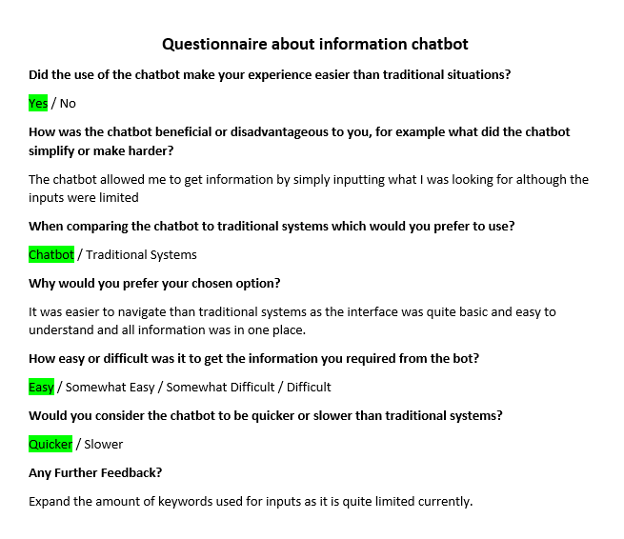
Requirements Document


