Part 1
In order to support the agenda set out in A Healthier Wales (2018), The Improvement Cymru Strategy (2021) aims to support the formation of a superlative health and care system for Wales, striving to provide safe, effective, and reliable care across the entire health system. To help achieve this, Public Health Wales launched the Safer Care together programme, assisting organizations to identify and improve quality and safety processes (Public Health Wales, 2021).
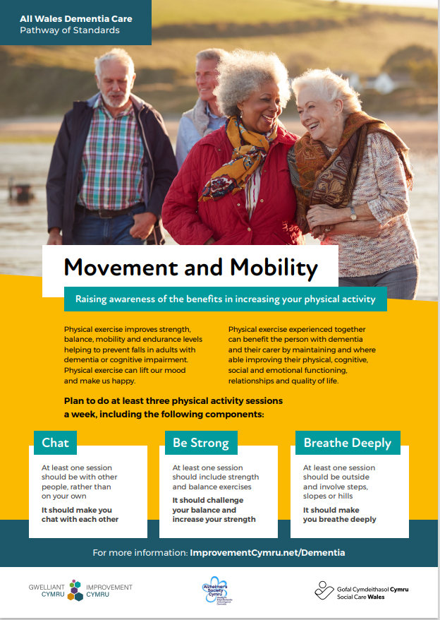
Public Health Wales have dedicated a team to making Wales Dementia friendly. The dementia care programme supports Welsh Government initiatives to make Wales dementia friendly through collaboration with health and social care providers by offering improved access, timely responses, early assessment, and diagnosis, together with promoting and developing care and interventions (Public Health Wales, 2021). As part of the dementia care programme, The All Wales Dementia Care Pathway of Standards (2021) were introduced, setting out 20 standards that aim, assisting people living with dementia to live a better life, as directed by the requirements of The Dementia Action Plan for Wales (2018).
The Movement and Mobility Initiative promotes awareness of the benefits of increasing physical activity. It encourages people with dementia to exercise at least three times per week incorporating three different components; talking with another person, strength and balance exercises, and breathing deeply. Talking with another person encourages engagement with other people, strength and balance exercise aims to challenge balance and strength, while breathing deeply consists of at least one outside activity preferably involving steps, slopes or hills.

This initiative supports dementia care and provision by accomplishing standard 9 of The All Wales Dementia Care Pathway of Standards (2021) which promotes movement and mobility. Performing physical exercise helps individuals with dementia or cognitive impairment improve strength, balance, mobility, and endurance levels, reducing their risk of falling. Furthermore, physical evidence experienced together can improve physical, cognitive, social, and emotional functioning as well as improving quality of life and relationships for both the person with dementia and their carer. The benefits of physical activity extend to mental health as well as wellbeing and happiness.
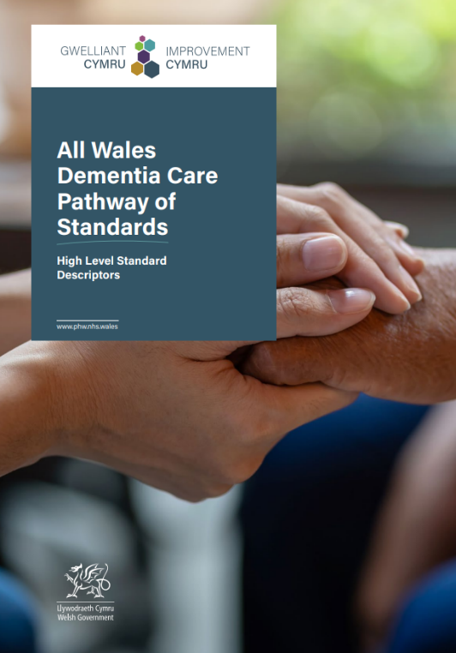
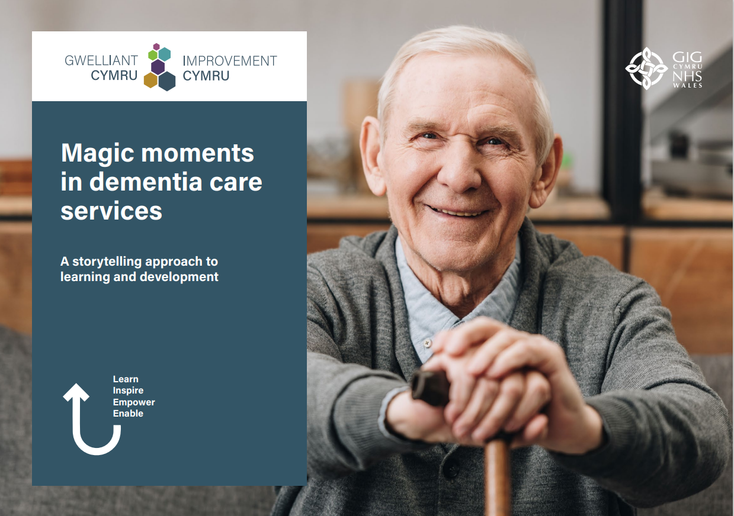
Magic Moments in dementia care services is a story telling approach to learning and development which aims to encourage people with dementia, carers, and service providers to share and talk about their experiences, or “stories”, through exploratory talk.

Magic Moments in dementia care was inspired by the Developing Evidence Enriched Practise (DEEP:2022) developed by the Wales School of Social Care Research (Andrews et al.,2015). It was developed in line with the ethos of The Social Services and Wellbeing (Wales) Act 2014, using a collective approach to explore and use diverse types of evidence in policy and practise development, using stories and caring, reflective dialogue. Many of the outcomes of this project such as compassion, kindness, accessibility and partnership are recurring themes in The All Wales Dementia Pathway of Standards.

This initiative supports dementia care and provision by recording and sharing compassionate stories of care and participation. Throughout 2018 and 2019, throughout a series of workshops, people with dementia, their carers, and service providers collaborated to share and exchange their views and experiences of dementia services in Wales. Sharing these stories and their messages makes it possible to elaborate on the ability to share experiences to help improve services and a better understanding of the impact of dementia. The stories can also help other people experiencing dementia to use this approach to shape their care. As well as the therapeutic value for the participants who shared their stories, care staff and practitioners are able to use the information contained within the book to improve and change dementia care positively.
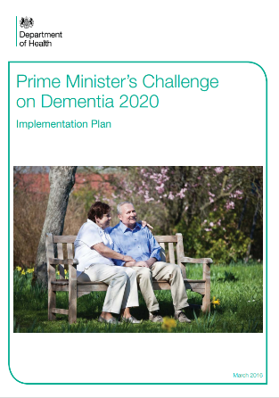

According to the Department of Health (2016), the Prime Minister's Challenge on Dementia 2020 aims to make England the best country worldwide for dementia research, care and support. Over 50 specific commitments are included in the 2020 challenge, which builds on the progress made under the 2012 challenge. Risk reduction, health and care, awareness and social action, and research are the four core themes of the challenge, with the goal of becoming the world's pioneer of dementia care, research, and awareness by 2020.

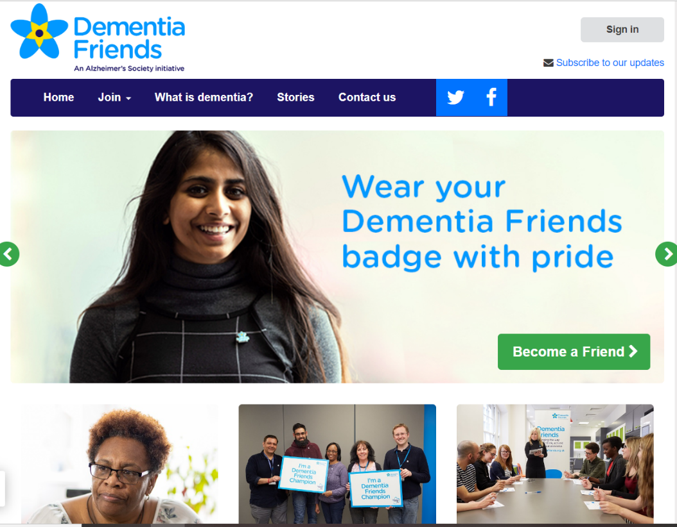

A significant amount of progress has been made since the launch of the Prime Minister's Challenge on Dementia 2020, including improved health and care for people with dementia and their care givers, creating dementia-friendly communities, and enhancing dementia research.

Launched in May 2014 with the goal of getting one million dementia friends by March 2015, Dementia Friends is the largest initiative aimed at changing attitudes about dementia, seeking to change how people think, act, and talk about dementia (Dementia Friends, n.d.). Dementia Friends learn about living with dementia and then use that understanding to do good - for instance, by volunteering for a local dementia cafe or raising dementia awareness among colleagues, friends and family.

This initiative supports dementia care and provision by addressing two of the four key themes of the Prime Minister's Challenge on Dementia. Besides helping people learn about dementia, Dementia Friends raise awareness of what living with dementia is like. Currently, there are over 10,000 Dementia Friends Ambassador volunteers encouraging people to learn more about dementia and supporting people living with dementia by facilitating information sessions in their communities. In addition to this, Dementia Friends aim to directly address the isolation and exclusion that people with dementia often experience by helping people to stay active and involved in the community, for example by volunteering to accompany a dementia sufferer to an event.



M6X02255
Mental health and the ageing population

Design an intervention to help an elderly person or their family deal with Dementia (1500 words).
The proposal form will be marked in line with the Level Six Grading Rubric. The boxes below will expand as you type.

Suggested intervention title: (between 10-15 words and must reflect the essence of your proposed intervention, study design and study population and should be more specific than a broad topic area).

Incorporating baby doll therapy into dementia care to improve the wellbeing of dementia patients in the community.

Please state the aim and rationale of your intervention: (why is your intervention important?, how will it improve the lives of those who take part in the intervention?)

This study aims to explore the benefits of incorporating baby doll therapy (DT) into Dementia care to improve the overall wellbeing of people living with Dementia. A general improvement in wellbeing is predicted to lead to improved behaviour, social interaction, and participation in daily living activities, improving the quality of life of the Dementia patient and those around them. The study proposes that improving the wellbeing of dementia patients in the community will delay or preclude the need for admission to a residential or nursing home.

The current cost of care for people with Dementia in the UK is £34.7 billion, £4.9 billion of this is costs to the NHS. These figures are predicted to rise sharply to £94.1 billion by 2040 (Wittenberg et al., 2019). 39% of people aged over 65 with Dementia in the UK are living in care (either residential or nursing), which comes at a high cost to both the NHS and the individuals and their families, as specialist Dementia care requires private funding (Alzheimer's Research UK, 2015).

It is essential to explore effective non-pharmacological interventions as pharmacological interventions can generate side effects such as an increase in drowsiness and fall risk, leading to an increase in hospital admissions (Canterella et al., 2018). Pharmacological intervention, usually in the form of antipsychotic medication, does not always work and increases the risk of further digression of cognitive faculties and death (Braden & Gaspar, 2014). It is, therefore, vital to consider non-pharmacological, psychosocial interventions to decrease mortality rate and hospital admissions to reduce costs to the NHS, improve the lives of dementia patients and their families, and allow dementia patients to remain in the community for longer.

What theory and empirical research evidence supports your intervention? (Please provide a brief review of relevant psychological literature and theory and a minimum of six references – refs not part of the word count).
Approx. 500 words

Symptoms of dementia include anxiety, agitation, sleeplessness, inability to care for oneself, wandering, defiant and sometimes violent and destructive behaviours. (Baumann, 1990). In an attempt to manage challenging behaviour, antipsychotic medications are often used. However, they are not always effective and often cause unwanted side effects (Braden & Gaspar, 2014). The review of existing literature for alternative therapies to pharmacological interventions indicates that Doll Therapy (DT) is a positive and rewarding activity that can contribute to enhancing the wellbeing of people with dementia. A reduction in agitation, improved sleep, improved relationships with others, and an overall improvement in positive affect is usually an outcome (Baumann, 1990; Higgings, 2010; James et al., 2006).

DT is a non-pharmacological, psychosocial intervention aiming to meet the psychological needs of people with Dementia. During therapy, a baby doll with human-like features such as facial expressions, sounds, and textures is presented to the person with dementia (Cantarella et al., 2018). Yonemitsu et al. (2001) suggest that DT reminds patients of their younger days when they may have cared for real babies. By reducing loneliness, calming the patient with dementia, and providing a sense of purpose, DT is hypothesised to increase wellbeing (Mitchell, 2014).

Anecdotal evidence suggests DT is beneficial for people with dementia (Verity, 2006; James et al., 2005; Moore, 2001). According to Bailey et al. (1992), dolls provided comfort, reassurance and companionship for elderly residents with advanced dementia living in care homes by providing sensory stimulation and promoting purposeful activity.

Despite increasing anecdotal evidence, there is still a paucity of empirical studies supporting DT as a treatment for dementia. A pilot project by Mackenzie et al. (2006) examined the impact of dolls on the general wellbeing of residents of a care home. The results of the study were primarily positive, with staff reporting that the dolls were beneficial to residents' wellbeing. However, some problems with residents arguing over dolls were reported.

James et al. (2006) used a methodology similar to Mackenzie et al. (2006) to evaluate the impact of dolls in a care home. Staff were asked to describe the perceived benefit of dolls to residents in comparison to those who did not use dolls. The general wellbeing of residents who chose a doll was improved, as concluded by Mackenzie et al. (2006). People without dolls did not experience any change in wellbeing. According to staff, the dolls were beneficial and each individual formed an individual bond with them; however, as with Mackenzie et al. (2006), participants argued over the dolls, with one participant becoming possessive and carrying multiple dolls.

Alander et al. (2015) used a grounded theory approach conducting interviews and focus groups investigating the experience and views of residents participating in doll therapy, concluding that dolls have a mainly positive impact on users. They found that attachment to the dolls evoked positive emotions and brought the individual happiness and pleasure. As a result of this enjoyment, wellbeing was perceived to be enhanced. Wellbeing was also improved by providing a sense of affinity, companionship, and decreased social isolation and loneliness.

The proposed research aims to address an identified gap in the existing literature by investigating the therapeutic benefit of DT for people with Dementia living in the community; existing literature samples participants who are in care homes and are already institutionalised. In addition, many previous studies focus primarily on females with Dementia. This proposed study will be carried out with a larger sample of participants consisting of an equal sample of both genders. Previous studies report problematic behaviour amongst participants arguing over ownership of the dolls. As this study will take place at the participants' homes, this should not occur.

This study aims to support the hypothesis that DT is useful for improving the wellbeing of elderly dementia patients in the community. It is a robust psychosocial intervention to improve the lives of people with Dementia and their families.

Methodological Details

Please describe the anticipated design of your intervention (e.g., exercise programme, cognitive tasks, pet-therapy)

Participant group – including anticipated numbers, target population, and any specific inclusion/exclusion criteria:

Local Dementia support groups within the Local Authority will be contacted with details of the proposed study. A stratified sample of Sixty participants, thirty male and thirty female, will be recruited. These participants will be randomly allocated so that an equal number of participants will be allocated DT (IV) while the remaining participants will receive no intervention (control group). Male and female participants will be distributed equally between both groups.

Inclusion criteria
• Aged 65+
• Living in the community at the time the study begins
• A diagnosis of mild to moderate dementia
• Having a sufficient level of manual dexterity to hold and embrace a baby doll
• Ability to distinguish the form of a baby doll with sufficient visual acuity

Exclusion criteria
• A diagnosis of severe Dementia
• Participants who reject the doll after two attempts
• Participants in whom the doll invokes adverse, irritated reactions
• Participants with a known history of pregnancy/infant bereavement
• Participants who are already given a baby doll to hold and are already accustomed to DT

Materials/measures (dog, cognitive tasks):

A lifelike baby doll (see Appendix).

Please describe the study procedure (what will your participant have to do from start to finish? It should be clear from this how you are actually planning to carry out your intervention, and what will happen to participants – how long is the intervention?):

This intervention will take place in the participants homes.
Sessions will last for around one hour a week for twelve weeks. Participants in the IV and the control group will be observed and their wellbeing will be recorded.

Ethics: Describe the main ethical issues of your intervention and explain how you will address them here (Refer to the BPS ethical guidelines and address all issues not just informed consent).

Each of the four principles of the BPS Code of Ethics & Conduct (2018) will be considered. Following The BPS Code of Ethics (2018), the researcher's intentions to store data and the participants' right to anonymity, confidentiality, and the right to withdraw from the study at any time will be outlined.

Addressing the issue of informed consent, people with advanced Dementia who might lack cognitive capacity will not be included in this study. As the participants' cognition may deteriorate throughout the study, it is also appropriate to obtain written consent for the ongoing practice of DT from the participants' relatives (Mitchell & Templeton, 2014).

Cayton (2001) argues that treating a doll as a real human infant qualifies as deception and could be considered an example of malignant social psychology violating a person's right to autonomy, dignity, and respect (Kitwood, 1997). It is also suggested that DT has the potential to infantilise the person with Dementia, contributing to a perception that this intervention is demeaning and patronising (Alander et al., 2015; Mitchell & Templeton, 2014). A family member may raise these concerns. They will be addressed by providing an information sheet to inform family members of the benefits of DT and the ethos of a person-centred approach in gerontological nursing (McCormack, 2010).

The issue of choice is another important ethical consideration for DT (Mitchell & Templeton, 2014). Taking an autonomous stance, if a person's choice is to engage with a doll, they should be allowed to do so, even if they are unable to maximise their previous level of autonomy for complex decisions. Introducing the doll to the participant will involve strategically placing it for them to access, not forcing them to do so (Mackenzie et al., 2007).

Alleviating concerns that participants may become distressed if a doll they have interacted with is taken away once the study is complete, thus causing psychological harm, participants will be allowed to keep the doll.

Please describe how you will measure the effectiveness of your intervention. the data you will obtain and how it will be analysed (e.g., tests, questionnaires, interviews; stats tests, qualitative analysis)

A mixed methods approach will be taken to provide contextualisation. Qualitative and Quantitative data will be triangulated to strengthen the credibility and validity of the research conclusions.

The study will adopt a Convergent Parallel design to establish the relationship between wellbeing and interaction with the doll.

The Bradford Wellbeing Profile (BWP:2008) will be used to measure participants' wellbeing at weekly intervals using qualitative observation. It consists of positive and negative behavioural indicators that build each participant's profile. BWP relies on participant observations; however, participants can also comment on their wellbeing to provide additional evidence if they are able. Results will be analysed quantitatively using thematic analysis (See Appendix).

An Observer rating scale will also measure participants' interaction with the baby doll. No specific scale exists for this purpose; however, the Paediatric Rehabilitation Measure of Engagement -Observer version (PRIME-O:2015) has been selected to be adapted for this purpose. Although designed for paediatrics, the PRIME-O consists of ten items for which a rating of between 0-4 is given for each item and is designed to capture observations of engagement in an intervention session. The PRIME-O is designed to provide a multifaceted view of engagement's affective, cognitive, and behavioural components (King et al., 2015). (See Appendix). Descriptive statistics will be analysed from this data.

Appendix (not included as part of the 1,500 words but must still be completed)
- Attach any questionnaires/materials to the end of this proposal as an appendix.

Reference List
Alander, H., Prescott, T., & James, I. A. (2015). Older adults’ views and experiences of doll therapy in residential care homes. Dementia, 14(5), 574-588. https://doi.org/10.1177/1471301213503643
Andrews, N., Gabbay, J., le May, A., Miller, E., O’Neill, M. & Petch, A. (2015) Developing Evidence Enriched Practice in Health and Social Care with Older People, York, Joseph Rowntree Foundation
Alzheimer’s Research UK (2015) Dementia in The Family, the Impact on Carers Dementia-in-the-Family-The-impact-on-carers1.pdf (alzheimersresearchuk.org)
Baumann, T. L. (1990). Baby dolls in dementia. Archives of Internal Medicine, 150(5), 1132-1132.
Bailey, J., Gilbert, E., & Herweyer, S. (1992). To find a soul. Nursing2021, 22(7), 63-65.
Braden, B. A., & Gaspar, P. M. (2015). Implementation of a baby doll therapy protocol for people with dementia: Innovative practice. Dementia, 14(5), 696-706. https://doi.org/10.1177/1471301214561532
Bradford Dementia Group (2002) Well-Being Profiling Pack. Bradford: University of Bradford. http://www.sirona-cic.org.uk/wp-content/uploads/2021/05/D02-Bradford-Well-Being-Profile-with-cover-3.pdf
British Psychological Society. (2018). BPS Code of Human Research Ethics https://www.bps.org.uk/sites/bps.org.uk/files/Policy%20-%20Files/BPS%20Code%20of%20Ethics%20and%20Conduct%20%28Updated%20July%202018%29.pdf
British Psychological Society. (2021). BPS Code of Human Research Ethics https://www.bps.org.uk/sites/www.bps.org.uk/files/Policy/Policy%20-%20Files/BPS%20Code%20of%20Human%20Research%20Ethics.pdf
Cantarella, A., Borella, E., Faggian, S., Navuzzi, A., & De Beni, R. (2018). Using dolls for therapeutic purposes: A study on nursing home residents with severe dementia. International journal of geriatric psychiatry, 33(7), 915-925. https://doi.org/10.1002/gps.4872
James, I. A., Reichelt, F. K., Morse, R., Mackenzie, L., & Mukaetova-Ladinska, E. (2005). The therapeutic use of dolls in dementia care. Journal of Dementia Care, 13(3), 19-21.
James, I. A., Mackenzie, L., & Mukaetova‐Ladinska, E. (2006). Doll use in care homes for people with dementia. International Journal of Geriatric Psychiatry: A journal of the psychiatry of late life and allied sciences, 21(11), 1093-1098. https://doi.org/10.1002/gps.1612
Higgins, P. (2010). Using dolls to enhance the wellbeing of people with dementia in residential care. Nursing times, 106(39), 18-20.
Improvement Cymru (2021) The All Wales Dementia Care Pathway of Standards https://phw.nhs.wales/services-and-teams/improvement-cymru/news-and-blog/publications/dementia-standards/
King, Chiarello, Thompson, McLarnon, Smart, Ziviani & Pinto (2015) The Paediatric Rehabilitation Measure of Engagement – Observer version (PRIME-O) Observational Rating Scale PRIMEO.pdf
Kitwood, T. M. (1997). Dementia reconsidered: The person comes first (Vol. 20, pp. 7-8). Buckingham: Open University Press.
Mackenzie, L., James, I. A., Morse, R., Mukaetova-Ladinska, E., & Reichelt, F. K. (2006). A pilot study on the use of dolls for people with dementia. Age and ageing, 35(4), 441-444. https://doi.org/10.1093/ageing/afl007
McCormack, B., Dewing, J., Breslin, L., Coyne‐Nevin, A., Kennedy, K., Manning, M., ... & Slater, P. (2010). Developing person‐centred practice: nursing outcomes arising from changes to the care environment in residential settings for older people. International Journal of Older People Nursing, 5(2), 93-107. https://doi.org/10.1111/j.1748-3743.2010.00216.x
Mitchell, G., & Templeton, M. (2014). Ethical considerations of doll therapy for people with dementia. Nursing ethics, 21(6), 720-730. https://doi.org/10.1177/0969733013518447
Mitchell, G. (2014). Use of doll therapy for people with dementia: an overview. Nursing older people, 26(4).
Public Health Wales. (2021) Achieving Quality and Safety Improvement, Improvement Cymru Strategy 2021-2026 https://phw.nhs.wales/services-and-teams/improvement-cymru/improvement-cymru-strategy/
Public Health Wales. (2022) Dementia Care, services and teams https://phw.nhs.wales/services-and-teams/improvement-cymru/our-work/mental-health/dementia-care/ accessed on 12th November 2022
Verity, J. (2006). Dolls in dementia care: bridging the divide. Journal of Dementia Care, 14(1), 25.
Welsh Government (2018) A healthier Wales: long term plan for health and social care https://gov.wales/healthier-wales-long-term-plan-health-and-social-care
Welsh Government (2018) Dementia Action Plan for Wales 2018-2022 https://gov.wales/sites/default/files/publications/2019-04/dementia-action-plan-for-wales.pdf
Welsh Government (2022) Developing Evidence Enriched Practice (DEEP) https://www.deepcymru.org/en/index accessed on 12 November 2022
Wittenberg, R., Hu, B., Barraza – Araiza, L., & Rehill, A. (2019) Projections of older people with dementia and costs of dementia care in the United Kingdom, 2019-2040 (CPEC Working Paper 5). Care Policy and Evaluation Centre, London School of Economics and Political Science. https://www.alzheimers.org.uk/sites/default/files/2019-11/cpec_report_november_2019.pdf
Yonemitsu, S., Nakamura, K., Itoh, A., Higashi, Y., Fujimoto, T., Tamura, T., ... & Uno, H. (2001). Virtual baby used as a virtual environment for patients with severe dementia. 2001 Conference Proceedings of the 23rd Annual International Conference of the IEEE Engineering in Medicine and Biology Society (4) 3758-3760

Appendix
- The Bradford Wellbeing Profile (BMP)
- The Paediatric Rehabilitation Measure of Engagement -Observer version (PRIME-O)
- Doll criteria

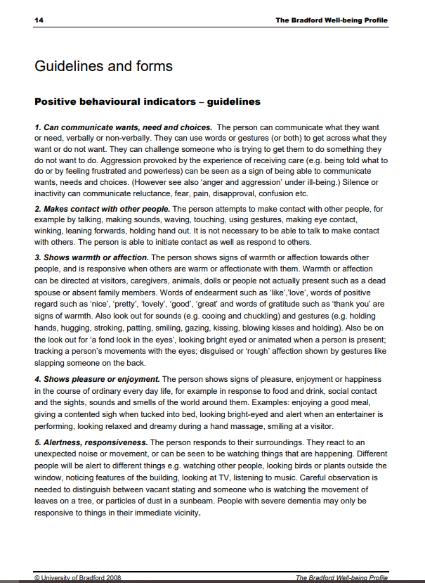
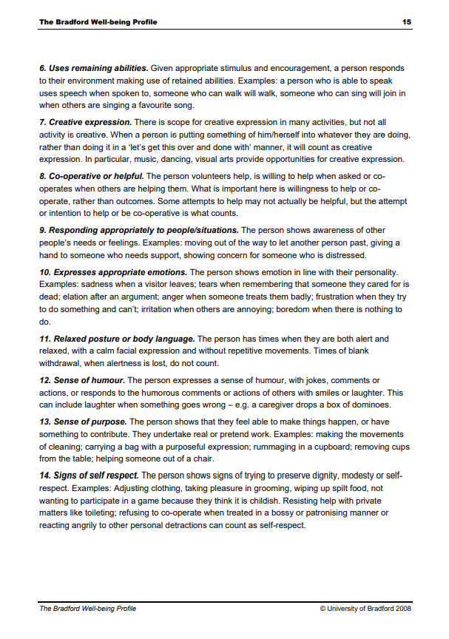

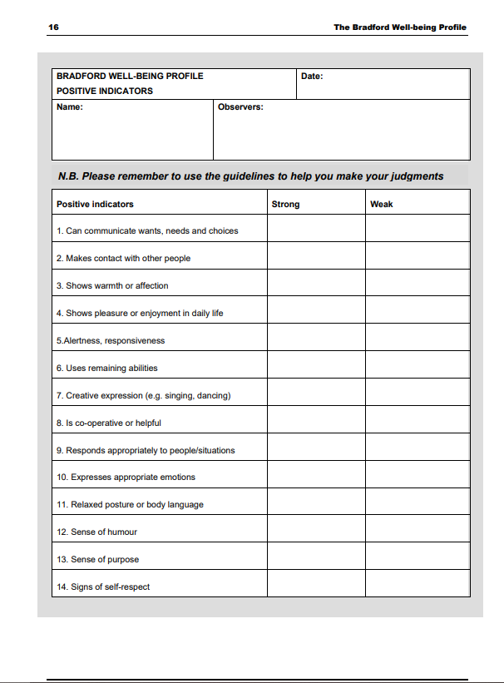

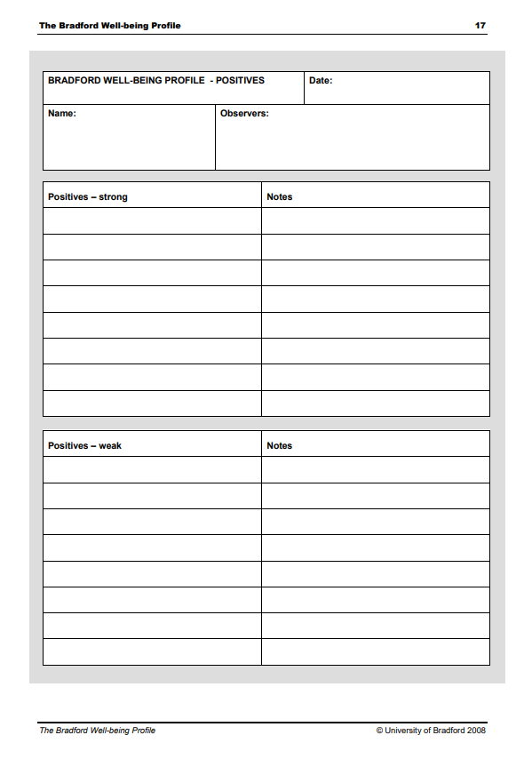

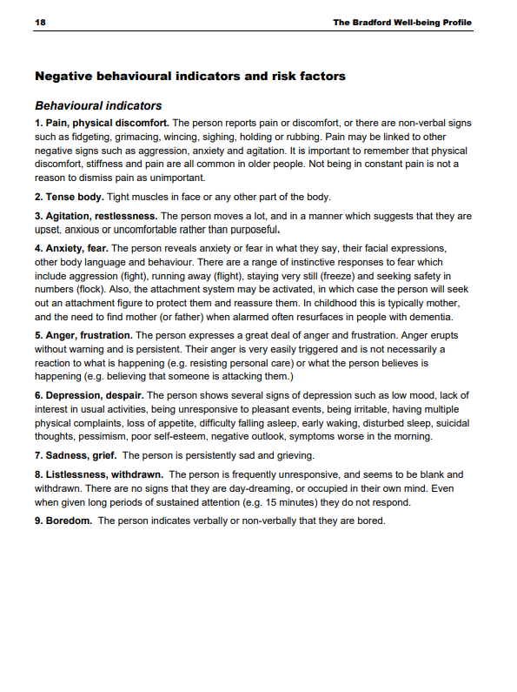

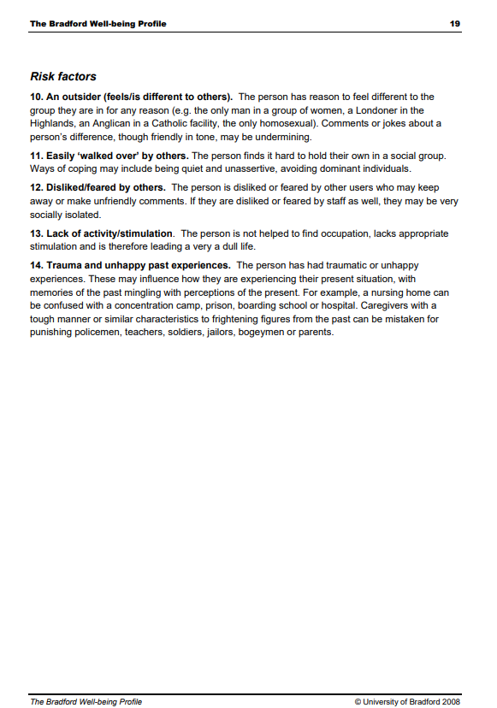

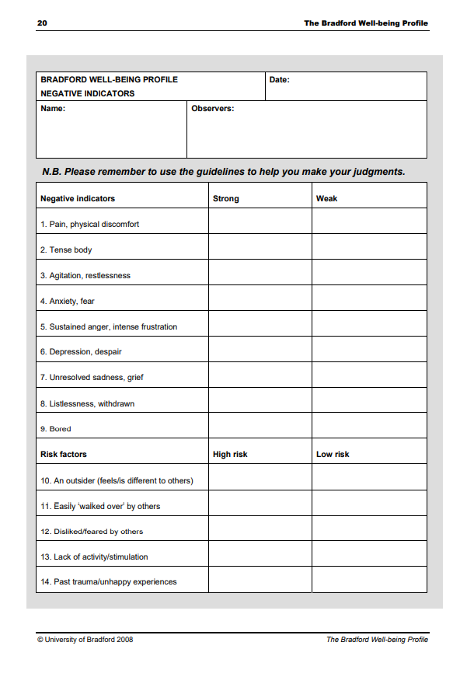

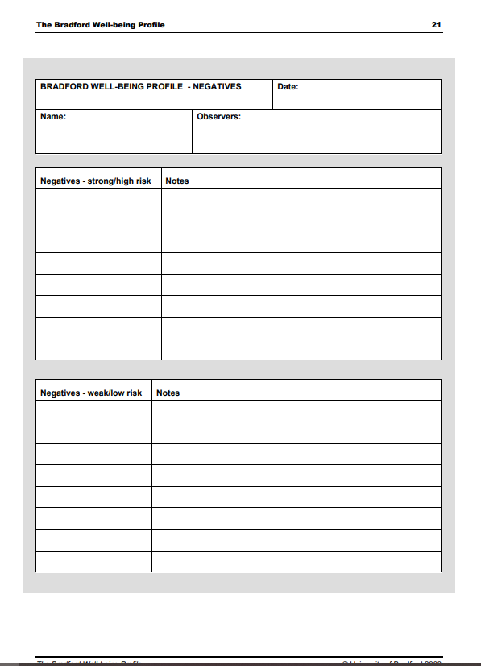

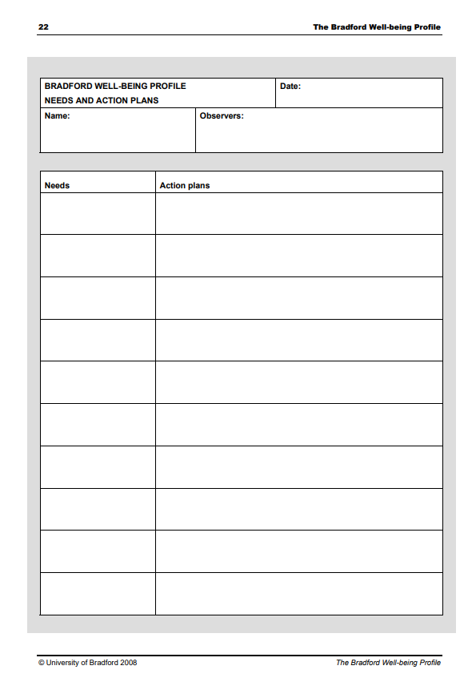

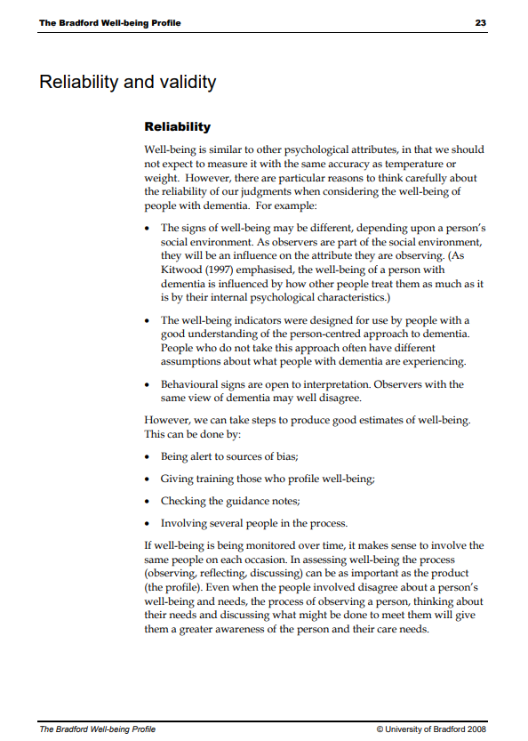

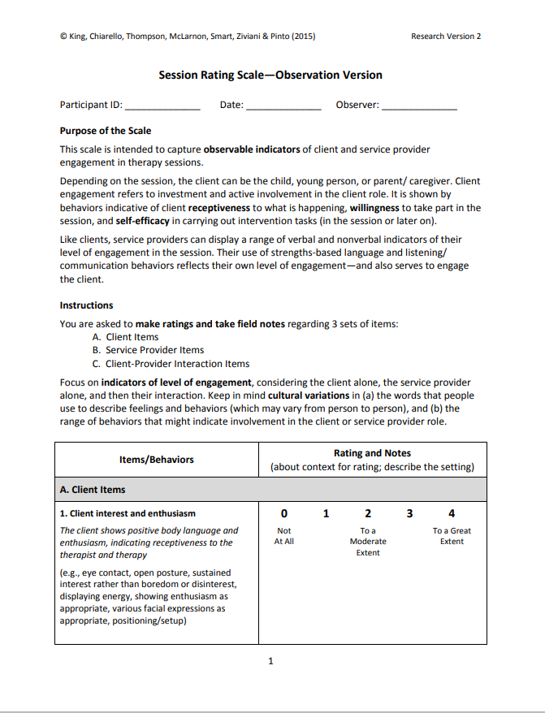

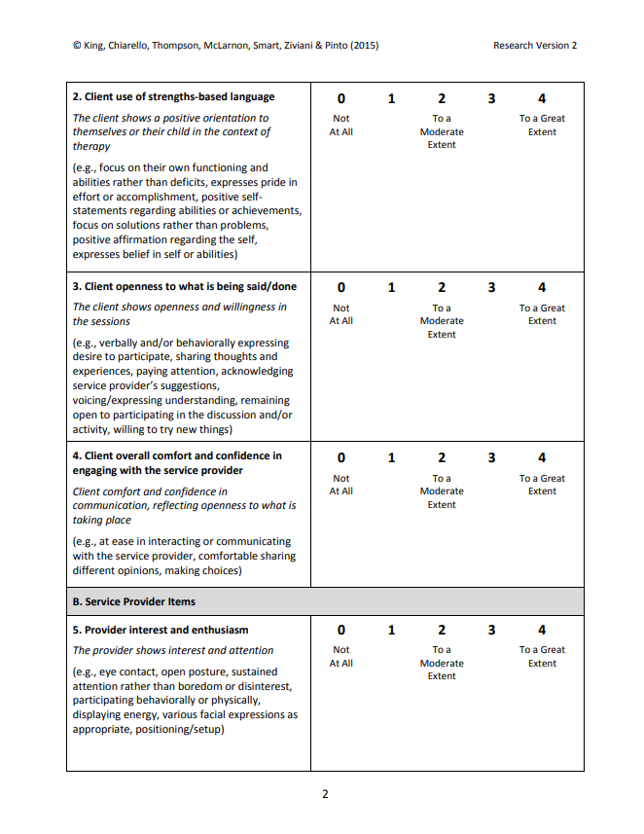

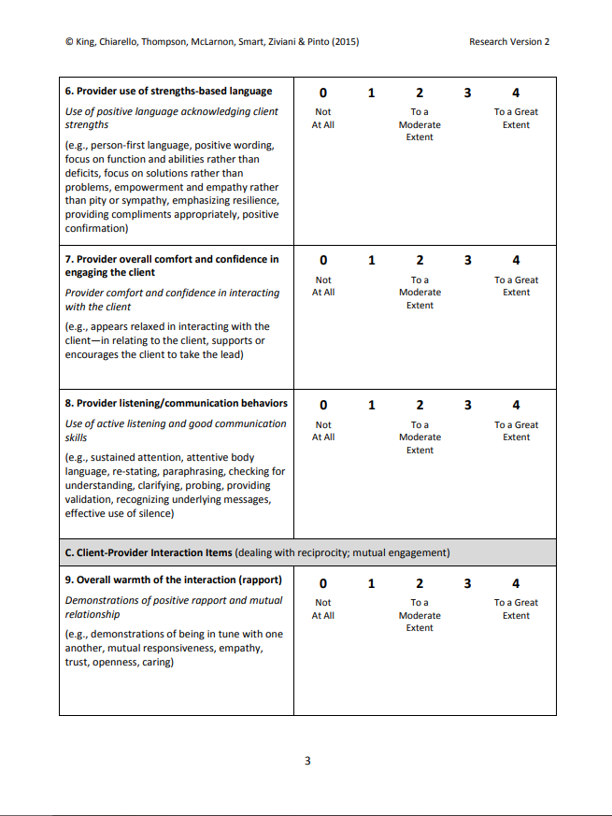

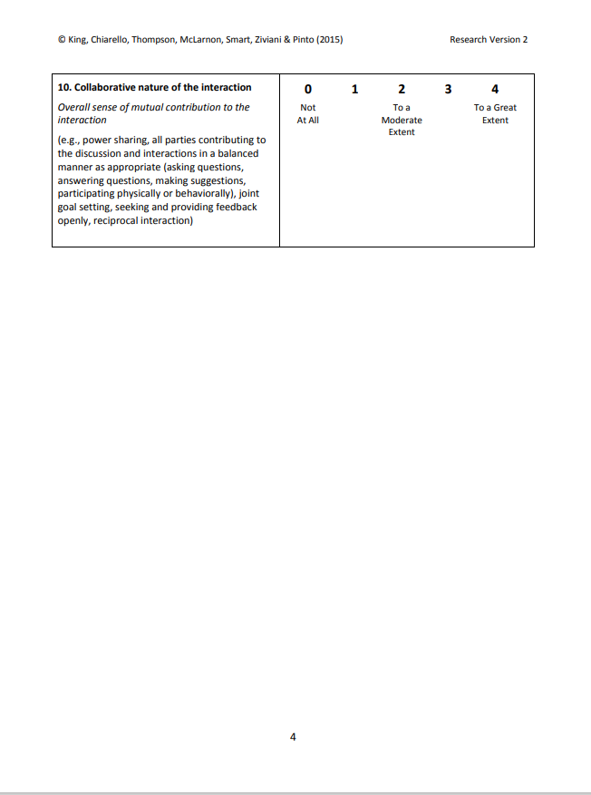

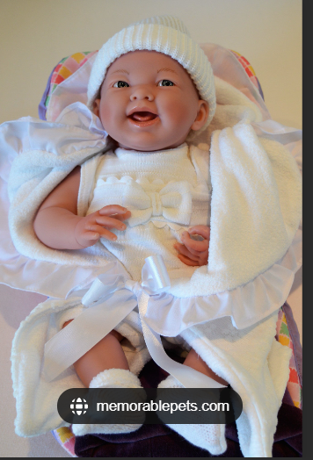

• A lifelike baby doll
• Around 20cms in length with a face made of silicone and with the texture of a real baby.
• Hair must be painted on to baby doll as dementia patients have been known to eat hair.
• Baby dolls are weighted as a 6 month old baby with floppy heads and soft cuddly bodies.
• Dolls eyes should open/close, dolls with permanently closed eyes are not to be used.
• “Crying” dolls that make a noise are not to be used as this could distress participants.
• Baby dolls are dressed in old style baby clothes in traditional colours (white/pastel) – modern baby grows/outfits to be avoided.
• A soft blanket plus a cot/bassinet to be provided put the baby in.

