
Skills for the Workplace
Module Assignment Submission
Student Name: | Stephen Smith
Student Number: | 1811431
Module No: | BMSK4005
Module Title: | Professional Career Development

Statement of Confirmation of Authenticity
By the act of making this submission, the student declares that this is the work of the student named above. The work has not, in whole or in part, been knowingly presented elsewhere for assessment, or where assessment has been built on a previous assessment, this has been identified. Where materials have been used from other sources it has been properly acknowledged. If this statement is untrue, the student acknowledges that an assessment offence has been committed.
Attention is drawn to the plagiarism and unfair practice policies of both the University and of ILM.

Table of Contents
Introduction 2
Section 1: Know how to identify development needs 2
1.1 Identify learning styles for self and another 2
1.2 Use a simple technique for identifying development needs for self & another. 5
1.3 Identify potential barriers to learning for self and another. 6
1.4 Explain how these barriers to learning can be overcome. 6
Section 2: Know how to develop self & others to achieve organisational objectives 7
2.1 Analyse learning/development options to meet needs of self & another. 7
2.2 Identify support mechanisms for development 7
2.3 Prepare a development plan for yourself & another 7
2.4 Method used to monitor development. 9
Section 3: Know how to prepare for the recruitment process 9
3.1 Job Application 10
3.2 Job Focused CV 10
3.3 The Interview Stage 11
Appendix A – Job Description 13
Appendix B – Cover Letter 14
Appendix C – Curriculum Vitae 15
Conclusion 17
References 18

Introduction
This assignment is focused around my professional development and equally as important as a line manager; identifying the development needs of others. In the first section will be focussed around identifying development needs and learning styles of myself and another. With this information, section 2 will focus on the practical side of development. I will start with a SWOT analysis to identify strengths, weaknesses, opportunities and threats and together with the identified learning styles, design suitable Personal Development Plans. Lastly, Section 3 is a reflective summary of a management role which I have recently applied for. I will discuss that specific recruitment process, evaluate my experience and look at what was good, what was poor and anything I would have done differently.

Section 1: Know how to identify development needs
Development within the workplace is an important aspect of an individual’s career it allows them to progress not only in their current business but also in the wider relevant industry. Entrepreneur Sir Richard Branson on his website, March 2014, said “Train people well enough that they can leave, treat them well enough that they don’t want to”. Richard Branson’s quote confirms my understanding that investing into developing individuals will install a higher feeling of appreciation and ultimately lead to increased loyalty and a higher productivity in the workplace

1.1 Identify learning styles for self and another
To assist in identifying what development in needed, we must first ascertain the learning style of the individual. Every person had a different way in which they prefer to receive information (Clark & Griffiths, 2008). There are a number of models which can be used which, through a series of questions, identify the learning style of a person. Once the learning style is determined, development plans can be tailored to suit the individual.
3 common models to identify learning styles are VAK, Honey and Mumford and Dantec.
I have completed the 3 learning Style questionnaires. The results are as follows:
VAK:
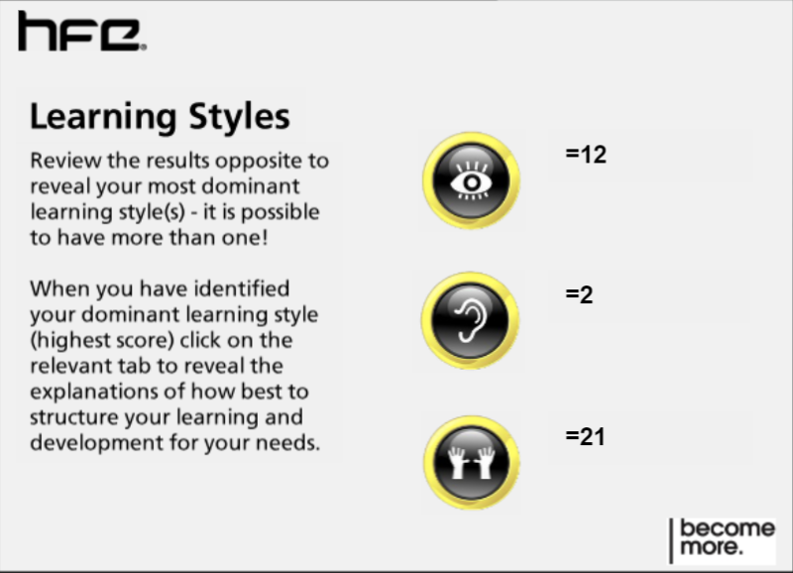
The results show that I am a Kinaesthetic Learner which means that I prefer a hands on practical approach to learning. The results suggest that I would rather have a go at a task and learn through trying as opposed to watching or listening to demonstrations or explanations.

Honey and Mumford:
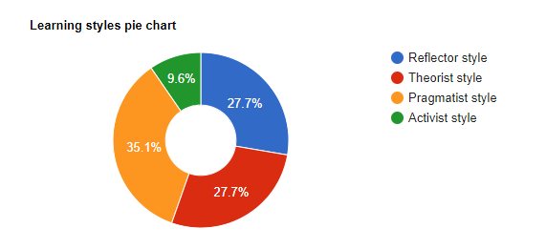
The results from Honey and Mumford show that my learning style is that of a Theorist which suggests that I will think through any problems or tasks in a very logical manner. I will analyse reasonableness of solutions and take facts and theories into consideration.

Dantec:
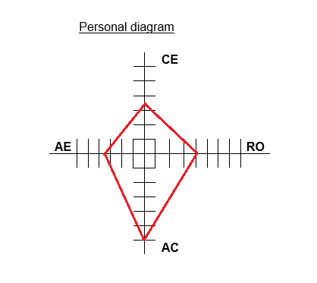
The results from Dantec highlight that I score very favourably towards Abstract Conceptualisation. This axes suggests that I am a logical thinker and like new ideas. It explains that I prefer organisation and that I think things through throurighly

I asked “A” to also complete the same VAK learning Style questionnaire and the Honey and Mumford quiz. His results are as follows:
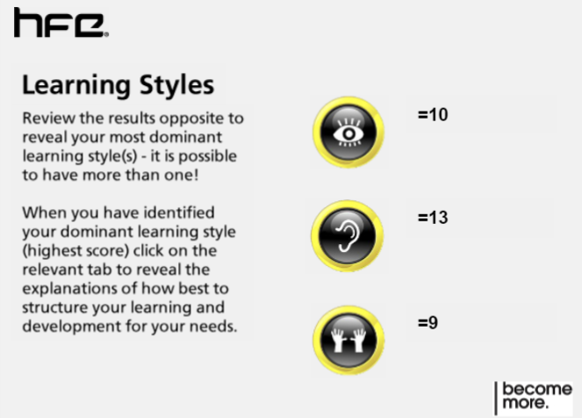
“A’s” results highlight that his learning style is Auditory. This means that “A” prefers to learn via listening and following instruction as opposed to watching, reading or getting hands-on.
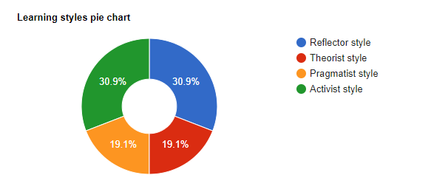
Honey and Mumford questionnaire shows that A is equally a reflector and activist. This shows that A’s learning methods include problem solving, group work, role play, group discussions and brainstorming. A also benefits from coaching and feedback from other.

As a Line Manager it is extremely important to understand the learning style of “A” so that his development and training needs can be designed to fit in with his preferred learning style. Every individual has their own preferred learning style so what would work for one employee, would not necessarily work for another.
In real terms, if myself and “A” were both to learn a new computer skill, for example setting up a spreadsheet to track financial changes. “A” would prefer to be talked through the process step by step, giving him time to understand the instructions for setting up formulas and laying out the spreadsheet whereas I would prefer to start strait away and figure it out for myself as the project progresses.

1.2 Use a simple technique for identifying development needs for self & another.
One of the best tools available to identify an individual’s development needs is to conduct a SWOT analysis. A SWOT analysis plots 4 elements into a table which can then be evaluated with a view to identifying what development is needed for the individual. The 4 aspects, with examples, are:
- Strengths – Key Strengths & Attributes. Skills, qualities or experience that make you unique (USP), achievements, what other view as your strengths, access to business networks
- Weaknesses – Poor work habits, negative personality traits, what do others view as yoru weaknesses, insufficient education or lacking qualifications
- Opportunities – Is there a gap in the market, are you able to identify a new strategy or way of working, is the industry growing. Changes in Technology
- Threats – is there a more suitable colleague in competition, changes to industry or legislation. Changes in technology
The 4 aspects are then broken down into internal and external factors
- Internal – Strengths and Weaknesses - These are aspects which can be influenced by the individual
- External – Opportunities and Threats - These are aspect that the individual has little direct control over. (i.e. legislation changes)
Once SWOT has been completed, further cutinisation can take place which allows the individual to convert Weaknesses into Strengths and Threats into Opportunities. Further it allows the use of identifies strengths to be used to create further opportunities.
My SWOT Analysis:
Strengths  Strong organisation skills  Communication skills  IT Skills | Weaknesses  Planning other people’s development  Presentation Skills  Research Skills
Opportunities  Opportunity for the next progression within the business as it may become available in the near future. | Threats  The next progression role within my current employment is that of an Operations Manager. There is only 1 Operations Manager but 2 people, myself and another Regional Manager eligible for it. The other regional manager has 10 years longer length of service and I do so he will be seen more favourably when/if the position becomes available

A’s SWOT Analysis:
Strengths  Logical approach to problems  Multi-Tasking | Weaknesses  Industry Knowledge  IT Skills  Leadership skills
Opportunities  The massive investment in technology will future-proof the business. Employees who adapt to the changes and embrace the new technology will be in line for a long career within the organisation. | Threats  Currently in probationary period. The business going through a large investment and transition with technology so A’s employment could be jeopardised if skills are not developed to allow A to keep up with business changes.

1.3 Identify potential barriers to learning for self and another.
In order to discuss any potential barriers to learning for myself or A, I must first identify what it is that constitutes as a barrier to learning. Swanson & Tokar (1991) argued that there are 2 types of barriers to learning; internal and external. Barriers are aspects which can arise which can be of detriment to the learning process and are different for each person. Some common barriers can be:
- Financial – the individual may not have the means to be able to invest in their own learning or a business may not have funding available.
- Family Life – Childcare, caring for elderly relatives and general family commitments are only a few aspects of a person’s family life which may pose barriers to the individual ability to study or learn.
- Geographic’s – Accessible location of required training courses may not be available
- Transport – Transportation may prove a significant barrier to learning if the course requires travelling.
My Barriers to Learning;
- Childcare - My partner works unsociable hours and as such, available childcare is limited.
- Work Commitments – I am currently employed as a senior manager so my responsibility level is very high. I need to be contactable and on-call at all times so this can hinder my availability for learning.
A’s barriers to learning
- Transport – A shares a car with his partner so this will need to be planned in advance to ensure he has access to the car to attend study days or courses.

1.4 Explain how these barriers to learning can be overcome.
Barriers are natural interference to learning, the key to successful learning is to plan to overcome these barriers. In order to do this we must identify, as I have above, what the barriers are and then put steps in place to ensure they are a less of a hindrance as possible.
Some examples of overcoming the common barriers I explained above are as follows:
- Financial – Funding in the form of personal grants may be available depending on the learner’s home location or alternatively if it is work-organised learning there may be provisions in place from the company or organisation. There may also be other funding available in the form of loans or help with childcare costs.
- Family Life – Planning is the key to overcoming any family related barriers. Planning childcare and other commitments. Creating a priority list and ranking each aspect accordingly will aid this process.
- Geographic’s – Research will help overcome geographical constraints. There may be a course or training more suitable location for the learner or there may be options for distant learning from home or even relocation should the nature of the course or training be important enough to warrant it.
- Transport – As with family life, planning is paramount. The learner needs to plan ahead to ensure that transport is available to allow study.

Section 2: Know how to develop self & others to achieve organisational objectives
To be able to develop myself and other to achieve organisation objectives I must first look at each person’s SWOT analysis (1.2) and additionally their learning style (1.1) to determine the best options with regards to training and development for maximum efficiency. An incorrectly paired method to learning style will become another barrier to learning as discussed in 1.3.

2.1 Analyse learning/development options to meet needs of self & another.
My Development options:
Reviewing my SWOT analysis I have identified that my weaknesses are all aspects that with proper planning, can be turned into strengths and thus create opportunities for me. As concluded in 1.1 I am a kinaesthetic theorist and follow the abstract conceptualisation learning style so I must take these learning styles into consideration when planning my development. Therefore, to improve on my best learning options to meet my needs would be classroom based tasks to look at things from a logical point of view.
A’s Development options:
Two of the weaknesses in A’s SWOT analysis were in leadership and IT skills. A is a Reflector and Activist who prefers an auditory method of learning. Developing IT skills for A will be difficult as IT based training is more suited to a kinaesthetic learner as it will inevitably be hands-on, however a form of interactive E-learning with verbal instructions would be suitable. To develop leadership skills, A would benefit from shadowing a colleague running a team then having reflective conversation afterwards to evaluate the experience as a form of learning.

2.2 Identify support mechanisms for development
As with SWOT and also barriers to learning, support mechanisms can also be divided into 2 categories; Internal and external (Ohlsson & Borg 2010). Internal support would be that of inside the organisation. For example 1-1’s with Line manager or HR Policies focussed on training and development whereas external support mechanisms would be aspects like support from family or financial support to allow study.

2.3 Prepare a development plan for yourself & another
A personal development plan is essential for mapping out learning targets for an individual. PDP’s have become an integral part of career development across most organisation. A PDP will have a list of gaps in skills and set SMART objectives in a tabular form and will be used to continually monitor the person’s progress.
SMART stands for Specific, Measurable, Achievable, Realistic and Time Bound. SMART targets are a perfect way to set an objective for any situation as long as all 5 elements are included. For Example; a poor objective could be “Buy a loaf of bread”. This leaves too many uncertainties, what type of bread? When? The person may not have money so it is not achievable. A SMART objective would be “Buy a load of white Hovis bread costing 99p, from the Tesco store on the main road, on your way home from work today”
My Personal Development Plan:
What do I want or need to learn? | What will I do to achieve this? | What resources or support will I need? | What will my success criteria be? | Start and/or Finish Dates
Improve knowledge of different learning styles and the importance of developing targeted learning for subordinates to enable me to take an active involvement in the development of my staff | Enrol on Cert HE course  Attending all study days  At home revision of material  Completing BMSK4005 Assignment | Tutor support  Family support for example childcare to attend course  Access to course material  Access to laptop | Passing BMSK4005 module of ILM Level 4 Diploma in Leadership & Management | Start : 13.10.18  End: 23.11.18
Develop presentation skills to improve on employability skills | Complete built in tutorial on PowerPoint  Research presentation skills  Record myself delivering presentation and review timing etc.  Practice delivering the presentation to a small audience  Gather feedback | Time  Access to Laptop & Internet  Use of Digital recording device  People to act as audience | Becoming confident in delivering a presentation to a live audience. Prepare and deliver presentation for next operations meeting | Start: 01.01.19  End: 10.02.19
Improve Digital skills and Research Methods | Enrol on Cert HE course  Attending all study days  At home revision of material  Completing BMSK4003 Assignment | Tutor support  Family support for example childcare to attend course  Access to course material  Access to laptop | Passing BMSK4003 module of ILM Level 4 Diploma in Leadership & Management | Start : 27.11.18  End: 25.01.19

A’s Personal Development Plan:
What do I want or need to learn? | What will I do to achieve this? | What resources or support will I need? | What will my success criteria be? | Start and/or Finish Dates
Improve leadership skills within the workplace and be able to confidently take charge of a team | Buddying with Regional Manager during set office days to get an insight as to how to lead and manage at team. | Support from Line Manager  Entrustment from members of the team | Stepping up as a “team leader” for the day and being able to successfully lead the team during an office day. | Start: 25.11.18  End: 20.12.18
Enhance computer skills, specifically the 3 commonly used Microsoft office applications. Work, Excel and Outlook. | Enrol on an interactive E-learning course in Word, Excel and Outlook | Time  Funding  New Skills Academy online account  Access to computer system and Internet | Achieving pass mark and E-learning Certificates in all 3 software packages | Word: 19.11.18  Excel: 22.11.18  Outlook: 23.11.18

2.4 Method used to monitor development.
To monitor and track my development or the development of another I would use a learning log. A learning log is a tool which compliments the individual’s personal development plan but is used as a ‘live’ document which is continuously updated to track the person’s progress ad would typically be updated during scheduled one to one reviews with the person’s line manager.
In application, the learning log is an ongoing evaluation of the persons PDP and it allows the person to document aspects of their learning, track progress against pre-decided milestones and provide feedback in a structured form. From this feedback, adjustments can be made, if necessary, to ensure that the learning and development methods chosen are working efficiently.

Section 3: Know how to prepare for the recruitment process
Applying for a new job role is not something to be rushed into. The candidate should first identify a role that they are interested in applying for and have suitable experience and/or qualifications.
The way that I would identify such positions is to review the Job Description and person specification for the relevant position and from there write a suitable and targeted cover letter and CV. I would refer to the Job description and person specification to ensure that I meet the required criteria for the role.
If shortlisted and invited for interview, I then endeavour to look into the company to prepare for interview. I will research key dates (company forming, awarded memberships, etc.), key personnel (Managing Directors name, company structure, key individuals) and generally any other information about the company and the role which will allow me to give informed answers and interact well at the interview stage.
An example of the last position I applied for was for a Regional Account Manager role for a facilities management company looking after corporate cleaning contracts. The Job Description can be found in Appendix A

3.1 Job Application
There was no formal application form required for this position, application was to be made with cover letter and CV via Email.
When preparing my cover letter I reviewed the Job Description and determined that the position required managing multiple sites across a wide geographical area. This is something which is implied on my CV but cannot be fully explained. I made a point of including this information in my cover letter as it was very relevant to the position. I also explained in a bit more detail than my CV what my duties in my current position involve.
The cover letter for this position can be found in Appendix B.

3.2 Job Focused CV
A job focussed curriculum Vitae is an important part of the recruitment process for any job position. The CV should be tailored to the position which is being applied for. The latest CV I have used was for a position I applied for with a facilities management company as a Regional Account Manager.
A CV should be kept brief as all CVs are typically read within 30 seconds so masses of text can get skipped through. Ultimately, the content and layout of the CV must be easy to read and leave a lasting impression.
Firstly it contains my name and contact information. This is imperative as I want a prospective employer to be able to contact me with ease. It is located at the top so easy to locate. I have also included my LinkedIn profile which is the equivalent of a Digital CV.
I then have my personal statement and key skills. My personal statement contains vocabulary which highlight my personality and values but outside of the generic buzz words which appear on every other CV. For example, an un-thought CV will say “good team player” it is statements like this which employers disregard as are too common. I have listed my key skills and also IT skills as any modern workplace will put a lot of emphasis on computer literacy.
Next section is current employment and employment history in reverse chronological order. It is importance that I put emphasis on key achievements in each role as opposed to listing a set of duties as if it were a job description. Employers are more interested in what you have achieved as opposed to what you do day-to-day. It is important to list specific jobs which relate to the one that is being applied for.
I then list my qualifications and relevant training. My master CV lists every course and qualification that I have but my tailored CV only lists those relevant to the position. For example, I also have qualifications as a Gym instructor and I holed a HGV and dangerous goods licence but as these are not relevant to a management positions they are omitted. I ensure I keep all management/health and safety qualifications as they are relevant.
Finally I have listed some hobbies and Charity work. This is sometimes left out depending on the audience but I try to keep the charity aspect as it shows a personality trait that thinks of others.
To aid my CV preparation I engaged in a useful exercise called a peer review. My CV was sent to 12 colleagues who each reviewed it as if they were an employer and gave feedback, both positive and negative, which I have incorporated in my CV.
A copy of my CV, as prepared for a Regional Operations Manager position, can be found in Appendix C.

3.3 The Interview Stage
The most recent interview I attended was for the Regional Account Manager position for the facilities management company.
To reflect on my experience in this interview I will use the reflective cycle (Gibbs, 1988).
The reflective cycle is a tool for reviewing what happened, analysing how the situation made the individual feel and looking at ways it could be done differently. There are 6 phases to the reflective cycle.


Using the reflective cycle, I am going to reflect on each aspect of the interview experience and discuss what was good/bad and what I would have done differently.
I was invited to attend the interview in Bristol, when I arrived at their location I attempted to park in accordance with the instructions in the invite in the designated area but area was blocked with heavy goods vehicles. I went into reception to ask where else I should park and the lady was quite passive and said “anywhere will do”. I was asked so sign in and to take a seat in the waiting room. My interview was scheduled for 10am and at 10.30 another lady called me and took me to a small meeting room and introduced me to the interviewer who remained seated when I walked in. I shook her hand and took a seat. The interviewer had an A5 notepad on the table and a copy of my CV. There was no other documentation or a laptop in the room. The interview commenced immediately into the first question which was asking what salary I was looking for. The questions continued and I found them very inconsistent, ranging from my knowledge of the cleaning industry to my motivation for applying for the position. The interviewer kept referring to my job history primarily being in the security industry and asked if I had applied for the wrong job and suggested that she passed my CV to the person in charge of their security division. The interviewer then asked again about my salary expectations before thanking me for coming and pointing the way out. The whole process lasted about 20 minutes.
My first impressions were not great of the location. The office was in the centre of an industrial estate surrounded by distribution units and with HGV’s blocking a lot of access. The passiveness of the lady who greeted me wasn’t very welcoming and it felt as though I was being an inconvenience. If I was arranging the interview I would have ensured that the reception/welcoming staff were fully prepared with a list of candidates and also ensured that the designated parking areas were available.
The timekeeping of the interview was also poor. I understand that there are sometimes unavoidable delays but there was no apology from the person who escorted me to the room nor the interviewer herself. When I hold recruitment drives and plan interviews, I always ensure that there is a 30min buffer after each interview to allow me to finalise notes, prepare for the next interview and also for any additional like a comfort break. This will help to eliminate any delays. If there was still a delay, I would always make a point of apologising to the candidate.
When I entered the room, the interviewer did not stand to great me which I felt was somewhat disrespectful, nor did she invite me to take a seat. These are just common professional courtesy and business etiquette. I always stand to greet the individual and ensure that there is fresh water and invite them to help themselves.
The first question asking about salary I felt to be unnecessary as it was explained on the Job Advert. The following questions did not flow and it was evident that the interviewer did not have any sort of standard questions to ask. The notes she made were very vague and I felt that the question set were not prepared and were being improvised. The fact that the interviewer was asking me about my interest for another decision for the business, not the one I was applying for, gave the impression that she was trying to put me off and finally revisiting the salary question at the end was excessive. To have made this interview flow better, there should have been a set list of questions to ask with opportunity for probing questions to gain further clarity if needed. The interviewer should have been taking substantial notes or had a note-taker present so that an informed decision could be made and it would also allow for factual feedback should the candidate ask for it post interview.
When the interview concluded, the interviewer thanked me for coming and pointed at the door saying “are you ok to find out own way out” this again showed unprofessionalism. If I were to conduct this interview, I would have posed the question to the interviewee as to “any questions”, I would have stood to shake their hand and thanked them for coming and I would have personally walked them out of the building, or at very least opened the door for them and ensures that there was someone else to escort them out.
To summarise, I felt this interview experience was very much improvised, unprofessional and a perfect example of how not to conduct an interview.

Appendix A – Job Description

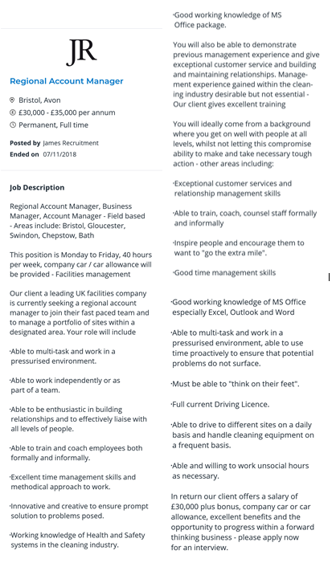

Appendix B – Cover Letter

To whom it may concern,

My name is Stephen Smith and I have been employed as a Regional Manager with Total Security Services for the past 3 years. Prior to this, I spent 2 years as an Area Manager and before that I was the site manager at a major retail park in Newport overseeing a number of facilities; security, cleaning, grounds keeping and maintenance.

In my current role I am responsible for the geographical areas of South, West and Mid Wales, Cheltenham & Gloucester, Hereford, Bristol, Swindon, Hungerford, Bath, Trowbridge, Warminster, Glastonbury and Weston Super Mare. Additionally my region also covers Northern Ireland and the Isle of Man. My level of accountability comprises of 6 Area Managers, over 250 Stores and approximately 500 Security officers. This equates to over 60,000 monthly hours across our main customers; Tesco, Boots, Waitrose, Morrisons and Smyths Toys Superstores. I am responsible for 10% of our current business which is the largest proportion for any region outside of London. I report directly to the Operations Director.

My day-to-day responsibilities involves directly managing a small number of stores and officers myself as well as effectively communicating with and motivating a team of Area Managers to ensure they meet their service level targets. I also have to collaborate with a number of other departments within the business to ensure the smooth running of the region, mainly; Control Room Managers, Recruitment, Human Resources and Company Directors. I attend regular meetings with clients at Senior Management Level to build on the existing good relationships and to ensure the correct level of service is being delivered by my team.

I have a proven track record of successfully managing my areas and region so now feel that it is time for me to tackle a new challenge and offer my expertise and experience to another organisation.

I have attached my CV for your reference and would relish the opportunity to showcase my skills and highlight what I could bring to your organisation.

I look forward to hearing from you.

Kind Regards
Steve Smith

Appendix C – Curriculum Vitae

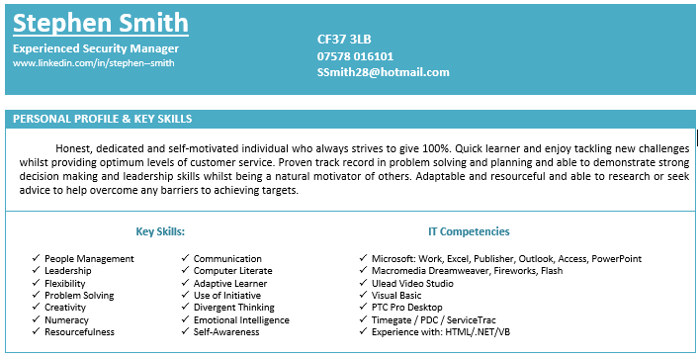
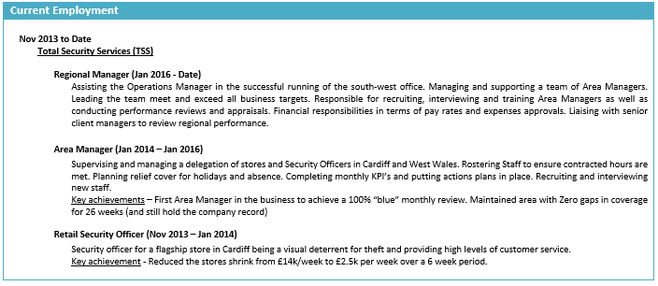
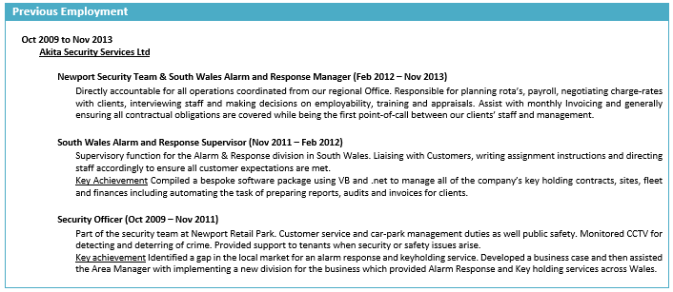
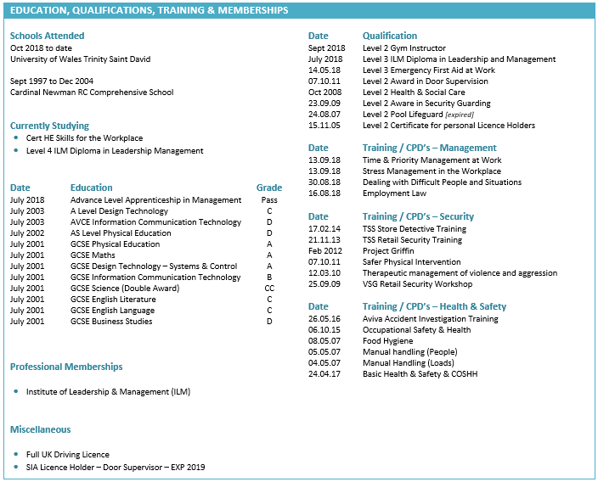
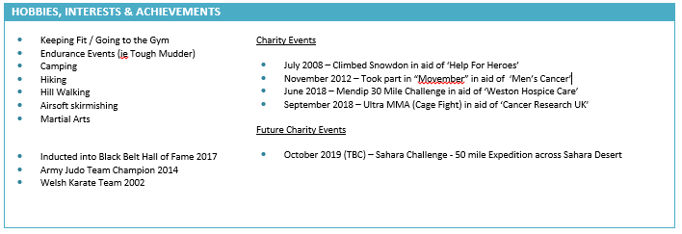

Conclusion
Every individual has their own way of learning. In order to be able to develop an individual we must first determine their preferred learning style. From there we can identify the various barriers to learning and put support measures in place to reduce or eliminate these barriers. Tools such as SWOT is paramount for identifying skill gap and deciding on what development is necessary for the individual and a personal development plan can be derived from that information. Finally for the whole process to be effective, the use of regular monitoring in the form of learning logs is essential to ensure that the individual is achieving their goals.

References

BRANSON, R. (2014) 27 March. Available at www.virgin.com/richard-branson/look-after-your-staff (Accessed 12 November 2018)
CLARK, L. & GRIFFITHS. (2008). Learning disability and other intellectual impairments. Chichester: John Wiley & Sons.
GIBBS, G. (1988). Learning by Doing: A Guide to Teaching and Learning Methods. Oxford: Further Educational Unit.
OHLSSON, H. & BORG, H. (2010). Career development. New York: Nova Science Publishers.
SWANSON, JL. & Tokar, DM. (1991). College students’ perceptions of barriers to career development. Journal of Vocational Behaviour, vol 38, Pages 92-106. [Online]. Available at www.sciencedirect.com/journal/journal-of-vocational-behavior/vol/38/issue/1 (Accessed 19 November 2018)

