

Student name: Shakil Ahmad
Student ID: 2434777
Module name: Professional Development within Health and Social Care
Module code: LCHS4009
Assignment No: Assignment 2
Assignment Title: Personal Development Portfolio
Lecturer name: Amitave Banik

Acknowledgement of AI use: I confirm that I have not used AI to complete my work.

Table of Contents
Introduction ............................................................................................................ 3
1. Curriculum Vitae (CV) ...................................................................................... 4,5
2. Personal Statement ............................................................................................. 6,7
3a. SWOT Analysis (Healthcare Assistant Role) ................................................... 7
Strengths ......................................................................................................... 8
Weaknesses ..................................................................................................... 8
Opportunities ................................................................................................... 8
Threats ............................................................………………………………. 8
3b. Personal Development Plan (PDP) .................................................................... 9
Goal 1: Clinical Skills Development .............................................................. 9,10
Goal 2: Communication and Patient Interaction ............................................ 10
Goal 3: Career Progression to Nursing .......................................................... 10,11
4. Gibbs Reflective Cycle ......................................................................................... 11
Description ........................................................................................................12
Feelings ............................................................................................................. 12
Evaluation ......................................................................................................... 12
Analysis ............................................................................................................ 13
Conclusion ........................................................................................................ 13
Action Plan ....................................................................................................... 13
5. References ............................................................................................................. 14

Position: Healthcare Assistant
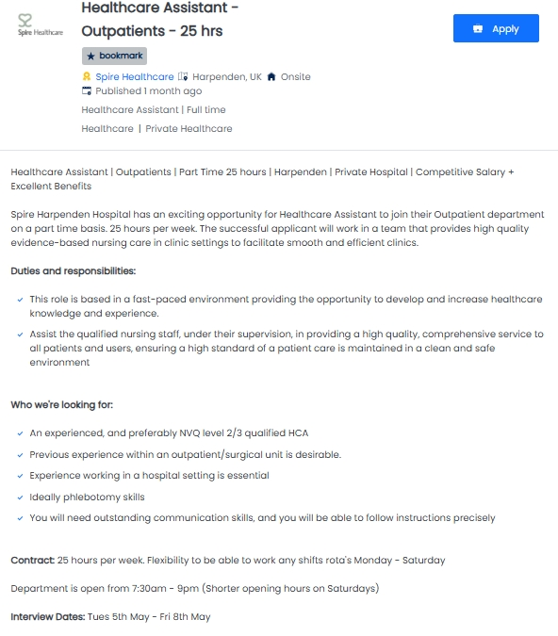
Introduction:
A portfolio is described as a collection of student work that represents learning and development over time, used to assess progress and achievement in education. (Myers, 2021)

Task 1: Curriculum Vitae
Curriculum Vitae
Shakil Ahmad 111A Holland Road W14 8AS, London
Mob: 07533531113
Email: shakil097@gmail.com
Personal Profile
A highly motivated and compassionate Health and Social Care student of safeguarding, infection control, and effective communication through both academic study and practical experience. I am eager to begin a career as a Healthcare Assistant where I can contribute to patient wellbeing while continuing to develop professionally.
Education and Qualifications
University Of Wales Trinity Saint David
Level 4 Health and Social Care
June 2025- May 2026
Units Studied Include:
- Academic and Employability Skills
- Digital Skills and Research Methods
- Introduction to Health and Social Care
- Introduction to Public Health
- Professional Career Development within Health and Social Care
- Psychology in Health and Social Care
Jalalabad Cantonment Public School & College
GCSEs:
- English Language - A
- Mathematics - A+
- Combined Science - A
- Health & Social Care - A
- Other subjects - A
Relevant Experience

Care Homework Placement
St Teresa’s Care Home, Kensington. (Feb 2021- Nov 2024)
- Supported residents with daily living activities, promoting independence.
- Assisted staff in delivering person-centred care.
- Followed infection control and hygiene procedures.
- Communicated effectively with residents, including those with additional needs.
- Observed safeguarding practices in a real care environment.

Voluntary Experience

Community Volunteer
Community Care London, Fulham. (Apr 2020- Jan 2021)
- Provided support to members of the community.
- Helped organise and run activities.
- Built positive relationships with individuals from diverse backgrounds.
- Developed confidence in communication and teamwork.
Key Skills and Competencies
- Communication: Able to communicate clearly and sensitively with patients and staff.
- Empathy: Understanding and responding to individual needs with compassion.
- Teamwork: Works effectively as part of a multidisciplinary team.
- Organisation: Manages time effectively and prioritises tasks.
- Problem-Solving: Able to respond calmly in challenging situations.
- Safeguarding Awareness: Understands the importance of protecting vulnerable individuals.
Achievements and Certifications
- First Aid Qualification
- Health and Safety Certificate
- Safeguarding Awareness Training
First Aid Qualification – Trained in basic emergency response, including CPR and minor injury management.
Health and Safety Certificate – Knowledge of maintaining a safe environment and reducing risks in care settings.
Safeguarding Awareness Training – Knowledge of protecting vulnerable individuals and recognising signs of abuse.

Interests and Hobbies
- Volunteering within the community.
- Health and wellbeing activities (e.g. gym, walking).
- Reading about healthcare and nursing.
- Team sports, demonstrating leadership and teamwork.
References
Available upon request.

Task 2: Personal Statement
I am applying for the Healthcare Assistant position as I am committed to developing a career within the health and social care sector. Currently studying Level 4 Health and Social Care at the University of Wales Trinity Saint David, I am building a strong academic and practical foundation that supports my ambition to progress into a professional healthcare role, with a long-term goal of training as a nurse.
My course has provided me with a comprehensive understanding of key areas such as safeguarding, public health, psychology, and professional development within health and social care. Through units such as Introduction to Public Health and Psychology in Health and Social Care, I have developed an awareness of how physical, emotional, and social factors influence an individual’s wellbeing. Additionally, my studies in research methods and digital skills have strengthened my ability to analyse information and apply evidence-based approaches to care.
Alongside my academic studies, I have gained significant practical experience through my placement at St Teresa’s Care Home in Kensington. During this time, I supported residents with daily living activities while promoting independence and maintaining dignity. I worked closely with care staff to deliver person-centred care and followed strict infection control procedures to ensure a safe environment. This experience allowed me to develop strong communication skills, particularly when interacting with individuals who have additional needs, and reinforced my understanding of safeguarding responsibilities in a real care setting.
I have also developed valuable interpersonal and teamwork skills through my voluntary role with Community Care London. In this position, I supported members of the community and contributed to organising activities, which helped me build confidence and adaptability. Working with individuals from diverse backgrounds has strengthened my ability to communicate effectively and maintain a respectful, non-judgemental approach at all times.
My key strengths include empathy, reliability, and the ability to remain calm under pressure. I am able to build positive relationships with individuals, offering reassurance and support to those who may feel vulnerable. I am also highly organised and able to prioritise tasks effectively, ensuring that care is delivered efficiently and safely. These qualities, combined with my training in first aid, health and safety, and safeguarding, enable me to contribute positively within a healthcare environment.
I am particularly interested in this role as it offers the opportunity to work directly with patients and be part of a multidisciplinary team delivering essential care. I am eager to continue learning from experienced professionals and to further develop my clinical and communication skills.
In conclusion, I am a motivated and compassionate individual with both the academic knowledge and practical experience required for the Healthcare Assistant role. I am enthusiastic about contributing to high-quality patient care and committed to developing my career within the health and social care sector.

Task 3a: SWOT Analysis (Healthcare Assistant Role)
SWOT analysis is a strategic planning tool used to systematically evaluate an individual or organisation’s internal strengths and weaknesses, along with external opportunities and threats, to support effective decision-making and long-term planning. (Farag, 2025)

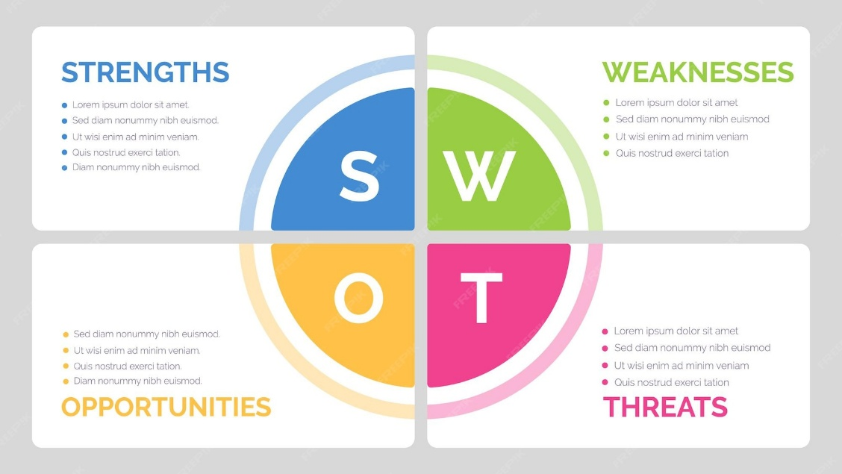

This section presents a personal SWOT analysis that critically evaluates my strengths, weaknesses, opportunities, and threats in relation to the role that I am applying.

Strength | Weakness
- Strong communication from care home placement and volunteering with patients.  - Compassionate and empathetic approach, supporting person-centred care.  - Good understanding of safeguarding, infection control, and public health from Level 4 studies.  - Ability to work effectively within a team, demonstrated through placement and voluntary roles.  - Reliable, organised, and able to prioritise tasks in busy environments. | - Primarily experienced in care homes, with limited exposure to hospital settings.  - Developing confidence in high-pressure or unfamiliar clinical situations.  - Limited practical experience with clinical tasks such as taking observations.  - May take longer to complete tasks due to being overly cautious.  - Continuing to build confidence in professional decision-making skills.
Opportunities | Threats
- Access to training and professional development within the Healthcare Assistant role.  - Opportunity to develop practical skills through hands-on clinical experience.  - Working within a multidisciplinary team to develop communication and teamwork skills  - Clear career progression pathway towards nursing or other healthcare roles.  - Continuous professional development to improve knowledge and skills. | - High-pressure and fast-paced hospital environment may be challenging initially.  - Emotional demands when working with vulnerable or critically ill patients.  - Competition from candidates with more clinical experience.  - Risk of stress or burnout if workload is not managed effectively.  - High expectations for performance and responsibility in healthcare settings.
Using SWOT analysis helped me reflect on my strengths and areas for improvement in relation to becoming a Healthcare Assistant. It supported my self-awareness by identifying key skills, development needs, opportunities, and potential challenges. It also helped me link my current abilities to job requirements and recognise the need to build confidence and gain more practical experience in clinical settings. Overall, it improved my understanding of my employability and supported my future development planning. (Helms and Nixon, 2010)

Task 3b: Personal Development Plan (PDP)

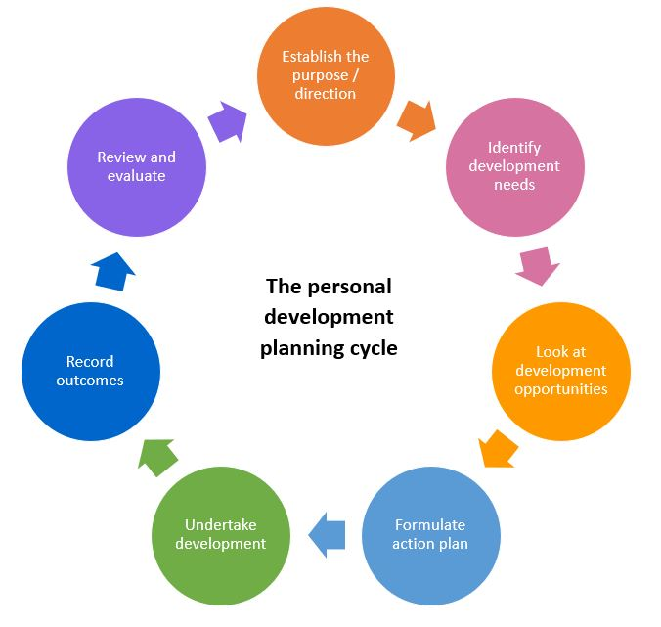

Personal Development Plan (2026–2028)

Goal 1: Improve Clinical Skills
Target: Develop confidence in basic clinical tasks such as measuring temperature, pulse, and respiration within 12 months.
How I will achieve this:
- Attend all training provided by employer
- Observe experienced staff and ask questions
- Practice skills during placement or work experience
Monitoring Progress:
- Feedback from supervisors
- Self-reflection after each shift
- Skills checklist completion
Evaluation:
I will review my confidence and competence every 4 months and identify areas for further improvement.
Goal 2: Build Confidence in Communication and Patient Interaction
Target: Communicate confidently with patients, including those with complex needs, within 6–12 months.
How I will achieve this:
- Engage regularly with patients during placements
- Observe how experienced staff communicate
- Practice active listening and empathy
Monitoring Progress:
- Feedback from staff and peers
- Personal reflection on interactions
- Noting improvements in confidence
Evaluation:
I will assess my progress by reviewing feedback and reflecting on how comfortable I feel in different situations.
Goal 3: Progress Towards a Nursing Career
Target: Apply for a nursing degree or apprenticeship within 2 years
How I will achieve this:
- Gain experience as a Healthcare Assistant
- Research university or apprenticeship requirements
- Improve academic grades if needed
- Develop a strong personal statement
Monitoring Progress:
- Track application deadlines
- Review entry requirements
- Seek advice from tutors or mentors
Evaluation:
Success will be measured by submitting strong applications and receiving offers or interview opportunities.

Task 4: Gibbs Reflective Cycle

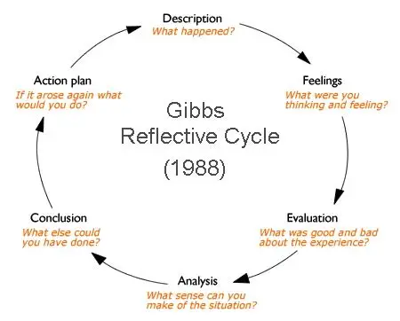

Description:
The LCHS4009 Component 1 presentation required me to deliver a structured presentation on a health and social care topic using a PowerPoint alongside verbal communication. The aim was to demonstrate both subject knowledge and effective presentation skills, including organisation, clarity, and audience engagement. Reflective practice is widely recognised as an important process in learning, allowing individuals to evaluate experiences and improve future performance (Gibbs, 1988). Therefore, this reflection will critically analyse my performance using Gibbs’ reflective cycle.
Feelings:
Before the presentation, I felt anxious and lacked confidence in my ability to speak in front of an audience. Although I had prepared thoroughly, I was concerned about forgetting key information and making mistakes. During the presentation, I initially experienced nervousness, which affected my pace of speaking and made me more reliant on my notes. However, as I progressed, I began to feel more comfortable and slightly more confident in delivering the content. After completing the presentation, I felt relieved and satisfied that I had successfully delivered it, although I was aware that there were areas that required improvement.
Evaluation:
A key strength of my presentation was the structure and organisation of my content. The slides were clear, logically arranged, and supported my verbal explanation effectively. I demonstrated a good understanding of the topic and used appropriate terminology throughout. My teacher commented that “the presentation was well structured but did not demonstrate a clear understanding of the subject,” which highlights that, although my organisation and preparation were effective, my depth of subject knowledge and ability to apply it accurately require further development. However, there were also weaknesses in my performance. I spoke too quickly at times, which may have reduced clarity and made it more difficult for the audience to fully understand my points. Additionally, I relied heavily on my notes, which limited my eye contact and reduced audience engagement. My teacher noted that “delivery skills, particularly pacing and eye contact, need improvement to reach a higher level.”
Analysis:
The strengths identified suggest that I have developed strong research and organisational skills, which are essential in both academic and healthcare settings. Being able to present information clearly and logically is particularly important in health and social care, where effective communication contributes to patient safety and quality of care (Skills for Care, 2022). However, the weaknesses highlight a gap in my communication and presentation skills, particularly in relation to confidence and delivery. Speaking too quickly and relying on notes are common indicators of nervousness, but they can significantly reduce the effectiveness of communication. In a healthcare environment, ineffective communication may lead to misunderstandings or errors, which could negatively impact patient outcomes (NHS, 2023). This demonstrates the importance of developing strong verbal communication skills. The lecturer’s feedback was valuable in identifying specific areas for improvement. While my knowledge was at the required level, my delivery limited my overall performance. This highlights that both subject knowledge and communication skills are equally important in achieving high standards in both academic and professional contexts.
Conclusion:
Overall, the presentation was successful in demonstrating strong subject knowledge and preparation. However, it also highlighted the need to improve my confidence and communication skills, particularly in relation to pacing and audience engagement. This experience has been valuable in identifying areas for development that are directly relevant to my future career as a Healthcare Assistant.
Action Plan:
To enhance my presentation skills, I will engage in regular practice by speaking in front of others to build confidence and reduce anxiety. I will focus on improving my delivery by controlling my pace, speaking more clearly, and using appropriate pauses to enhance clarity and audience understanding. Furthermore, I will minimise reliance on notes by rehearsing thoroughly and using brief prompts rather than full scripts. I also plan to record my practice sessions to critically evaluate aspects such as tone, pace, and body language. Feedback from tutors and peers will be actively sought and used to monitor progress. Engaging in continuous reflective practice will support my ongoing professional development and enable me to become a more confident and effective communicator (Gibbs, 1988).

5. References:
- Farag, M.I.H. (2025) The Role of SWOT Analysis in Enhancing Business Growth and Long-Term Management Sustainability. Available at: https://msa-journal.org/journal/article/view/28. (Accessed: 18 April 2026)
- Gibbs, G. (1988) Learning by Doing: A Guide to Teaching and Learning Methods. Oxford: Oxford Polytechnic.
- Helms, M.M. and Nixon, J. (2010) Journal of Strategy and Management. Available at: https://www.emerald.com/jsma/article-abstract/3/3/215/252714/Exploring-SWOT-analysis-where-are-we-now-A-review?redirectedFrom=fulltext. (Accessed: 16 April 2026)
- Myers, S. (2021) Portfolios. EBSCO Research Starters: Education. Available at: https://www.ebsco.com/research-starters/education/portfolios .(Accessed: 17 April 2026).
- NHS (2023) Healthcare Assistant Role Overview. Available at: https://www.healthcareers.nhs.uk (Accessed: 18 April 2026).
- Skills for Care (2022) Code of Conduct for Healthcare Support Workers. Leeds: Skills for Care.

