Digital Class – Collage
October 7th 2020

Tutorial 2
THEME – Abstract Layer - Robert Rauschenburg or Cecil Touchon.
Use 3 colours
USE ADOBE PHOTOSHOP – BREAK FONT
COLLAGE OVERLAYS / ABSTRACT SHAPES / MIXED MEDIA / VARIED TEXTURES / PAPER CUT-OUT SHAPES / LAYERED PHOTOCOPIES / SIMPLE COLLAGE

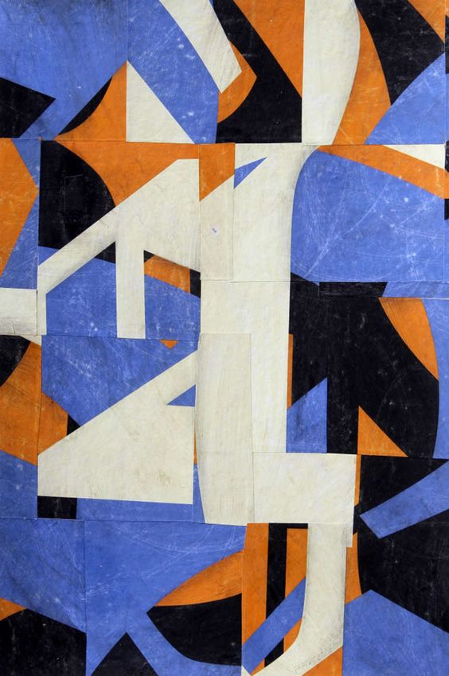

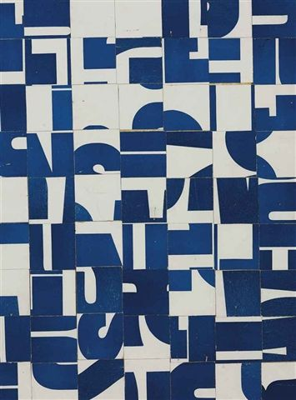

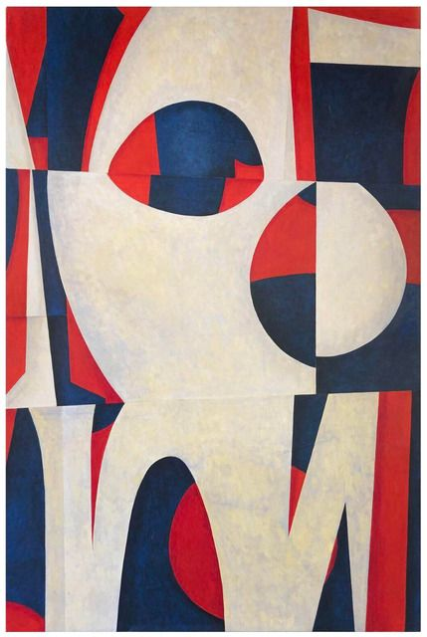
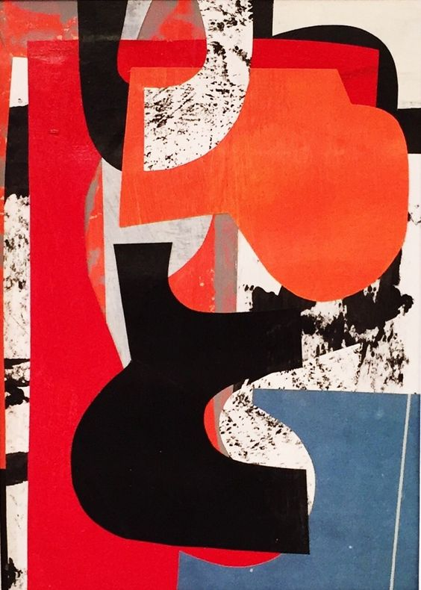

BREAK UP FONT

DISRUPT WORDS & SYMBOLS

USE THE WORDS TO CREATE PATTERN

ABSTRACT
LAYER

ABSTRACT
LAYER

