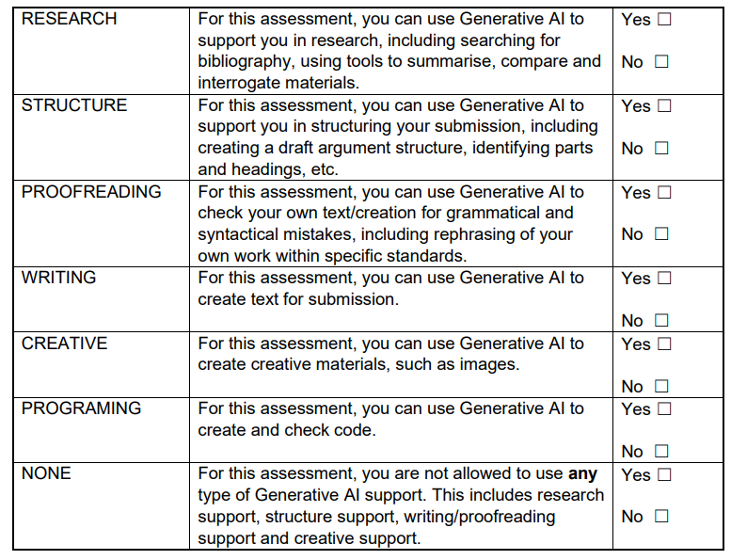

Reading the plays that we were given made me feel more prepared going into the module. I found that the The Last Of The Pelican Daughters, was a very easy read for me. The play had so many deep values and did an excellent job at showing the raw ugly side of a big family and how it can be torn apart. The play was also very relatable, and I identified myself with some of the characters. I also liked how there is no clear, right and wrong, in the play; it’s up to the audience to decide who they believe is right, just like a real family. Playing characters in this play would definitely be a challenge as it’s very real; real situations, real family dynamics and very hard-hitting themes.
And just as you’ll have a powerful immediate response the moment you clap eyes on your blind date, so the importance of your first impression of a script shouldn’t be underestimated (Merlin, 2007, p.57).
I agree with the following statement, as the first impression sets up the creative path that I will take during the rehearsal process. In this case, I had a great first impression with both plays, and this has made me feel engaged and excited to start this module.
Mythfits, is also an interesting play. I admire the approach to the myths and how they modernise them, as I said in my presentation, it gives these characters more of a personality to work with as the people in these stories seem to me described in the same way.
We started working on The Last Of the Pelican Daughters, creating the setting or the home of the characters, the childhood home. Using a limited number of props was challenging but also engaging; this really helped get into the mindset of the characters. Understanding where the characters ate, slept and grew up really helped visualise them. As a team I think we worked quickly and decisively as we only had a limited amount of time. For me visualisation is a massive help in my process, so I found that this was very helpful in understanding the family’s dynamic and values.
Building a complete picture of the place or places in which the action of the play occurs helps the actor enter and believe in the world in which their character exists (Mitchell, 2008, p.20)
Visualisation, is a big part for my process as it helps me forget that I am Betsy, and makes me believe that I am in fact Joy.
Going through the script and finding the questions and the current facts and events before the play, we found more depth to the characters as well as the story, causing us to ask more questions. As a company, discussing the characters in more detail gave us a better understanding of, not only our casted characters, but all the characters in the play. Because of this I found that we felt more like a company, as we helped each other with seeing a different side to each character.
Starting to work on the Mythfits play, we did a few physical exercises. Working through these exercises at first felt hard as they’re something that I am not familiar with. However, moving through the space and becoming more and more immersed in my own movements I felt more fluid with the context and themes; this exercise was very useful in visualising the scenes in a practical and physical way. I would like to increase my knowledge in this method as I found it hard to understand initially but going through it and sticking through it made me see the improvement and understanding of the point of the exercise.
Lisa Scott-Murphy, talks about how movement is important in becoming a better actor, Movement is Acting (Using Movement to Become a Better Actor)(Scott-Murphy, 2017). I think it’s important to think about the way you move. In this situation, the exaggerated movements need to be there as we are doing a movement piece, but you have to try and get out of a previous comfortable mind set when acting. Like I have previously stated, this way of working is not familiar to me as an actor, but it’s still so important because it opens you up to so many other creative possibilities as an actor; it can show you a knew trait that your character possesses, or it can show you the exaggerated version of said character.
However, I would like to work on my physical health. I still believe that certain aspects can be lost in this movement type of theatre because of the amount of creativity that we has as actors, directors and writers but we can forget that it’s our job to show and translate the story to the audience.
Going further into the play, Mythfits, we looked at the prologue and how to incorporate this into the first movement piece that we perform. I found this hard as it proved to be confusing, but also I worried about the echoing and repartition, and that the motives and language might get lost to the audience. As a company we all know why and what the text says. but the audience doesn’t. I would like to work backwards in a sense, I want to start with the audience, how I want them to feel and then work back from there.
Using the tools provided by Katie Mitchel, eventing proved effective when going through the text. However, I did find that the process in creating this was difficult and I found it hard to understand at certain points. But, the end of that process showed massive improvement in my attitude in my character and the text. I would love to have more time on this technique in future productions as this will be valuable in any practises soon. Eventing, is something that can work well for any actor as it gives the actor something stable to work on, titling the scenes helps me remind myself what that scene needs to feel like, and how I should play it. As much, as I think that this process works in the bigger picture, I do believe that certain things need to be sacrificed in this situation; because we have such a shorter time limit than usual, I think more things could have taken priority. Since we started this module, I have found that the tasks we complete are useful but I find myself feel too deep in the logical side of creating a character because I feel I don’t have time to invest my full emotional side into my characters.
When reading The Directors Craft, Eventing was made simple to me with the quote “It may help to study events in real life and begin to notice how a change occurs and how it affects what people are doing.” (Mitchell, 2008, p.56). This really helped me to understand that these methods are just borrowed from real life and observation. The answers and inspiration are Infront of me, I just have to have my actor eyes on. Since reading this, it’s helped me find the inspiration in real life and use what I found and put it into a scene or a character.
I have been finding the short time limit on this hard, however this is allowing me to force myself to learn a large amount of lines quicker and find more efficient ways to learn them. I have started to use recordings of myself and start to speak at the same time as this recording. This also helps with finding the parts of speech that I find hard to pronounce. Now that we are coming up to assessment day, I find myself seeing the tools I have learned being put into practice without even knowing until I see it myself.
Conclusion:
The assessment was a perfect show of how hard we worked. I think that we made a good show as well as a good assessment. My monologue could have used some improvement, I would like to practice my acting with more “doing”, as I think that I let the movement control the speech and the pace of the monologue. However, even with all of this in mind I think I did my best in that moment, and I should take that as a learning experience. The company scenes that we did, I felt, were much better than the previous attempts. The Mythfit scenes had more sharpness to them and more attack, as well as the Pelican scenes. This was one note that I really wanted to hold onto, the energy drop needed to be tackled and I think as a company we all did a great job at maintaining that energy all the way from the Mythfits prologue.

Reference List:
Merlin, B. (2007) The Complete Stanislavsky Toolkit Revised Edition. London: Nick Hern Books. P.57
Mitchell, K. (2009) The Director’s Craft A Handbook For The Theatre. Oxfordshire: Routledge. P.20
Scott-Murphy, L. (2017). Movement is Acting (Using Movement to Become a Better Actor) Available at: Movement is Acting (Using Movement to Become a Better Actor) (Accessed: 11 December 2024).
Mitchell, K. (2009) The Director’s Craft A Handbook For The Theatre. Oxfordshire: Routledge. P.56

