Student Name: Diyana Shapshalova
Student ID: 1907713
Marketing Fundamentals Analysis and Evaluation - Assessment 2
Lecturer name: Tushara Balendran Module Title: 4004

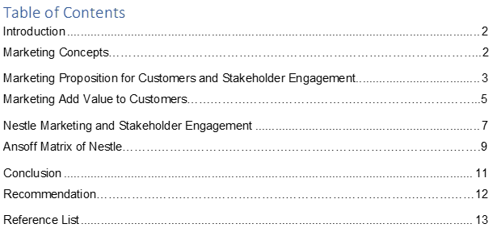

Introduction

This report similarly presents Nestle in the evaluation and necessary evaluation process. The performance of central research is critical to customer evaluation, the method of selling things and associations, as well as building strong relationships between the Association and its customers. Near the start, the trailer takes a look at the centre of the stand and the technology involved. The central part of the study is to consider the rules for necessary declaration and valuation. The last part appreciates the critique of the exploration and evaluation of the most outstanding results for the Association.

Editing teaches recipients how to organize something in their minds and what they can remember from competitors' results (Pride et al., 2018). Associations typically do this by requesting a sensible guide based on how equals buyers in the comparative industry view their costs and quality. The Association changes its actions from the moment something is posted on the card to the point of view of the object between the customer and its position among the competitors.

Marketing Concepts
Showcase trading involves accepting an item or administration and giving something different as a result. In order for an organization to be effective in advertising, key activities include establishing, maintaining, and expanding the bond between customers and clients. Markets typically develop due to real goods and trade between buyers and merchants (Candy & Kahn 2016, p180). In this day and age, we have customers with innovation, so advertisers need to take care of their customer connections by allowing them to reach their organization. The window layout area includes a layout plan for the organization's advertising work. The advertising plan can also be applied to a particular item and to the general display process of the association. The union's window management cycle is derived from general business technology. In this direction, when the top management forms its main title / campaign, the promotional activities organized for this management are remembered.

Another major advance in advertising is the promotion process and the coordinated showcase plan (Armstrong, Adams, Sea & Kotler, 2014) when the organization understands the needs of customers. Market offer and a promotion system can be created. The leading and integrated organization promoting the plan should consider the target market, how to do that target market, and the forecast of the proposal. The organization must choose which customers to serve. At this point, the organization can segment the market and select the target segments. When it works well for the customers and their interests are properly controlled then an organization maximizes its benefits.

Marketing Proposition for Customers and Stakeholder Engagement
Remember to make decisions about how to choose a proposal and divorce (Payne, Frow & Eggert 2017, p. 13). Acceleration brings an ideal situation to target business areas with focal points pointing out what the Association offers to its customers after completing and separating notifications (Kangal 2017, p.54). Associations can observe some of these ideas and implement their promotion strategies. The first is the possibility of creation. Many buyers prefer that it is open and successfully accessible to them. Therefore, the Union needs to improve the construction cycle and then give them items to spin profitably.
Second, this is something to consider. In order for an association to be a well-developed promotional plan, it is important to understand that more customers in the current market prefer top-notch items. To achieve extraordinary things, an association must focus on what has been improved. This leads to more and equal sales to the Union and epic profits. The third idea is the suggestion. As far as, if an association tries to sell and improve its own goods, customers will not buy it. For example, assurance, share associations must be strong in regulation to make concrete arrangements other than quality customer associations. Otherwise, they probably won't sell a ton.
The fourth thought is to move forward. From the outside, in order to achieve its goals by identifying the needs and requirements of its customers for its organization, they need to meet with them in a comparative way, by offering comparable things and organizations to competitors or starting in the latter industry. Associations need to use buyer-organized promotional ideas to understand what customers need. Everywhere, they (customers) are not even aware of the potential consequences they need. The fifth idea of ​​progressive method development is the open demonstration. In order to increase the number of customers, an association should consider the structure of incentives that increase its success. Social advertising includes legitimacy. Significance depends on the size of the problem and the problem. For example, the built system should be natural and social.
Building tremendous customer relationships is an additional standard to improve the uninterrupted quality of the customer, or to some extent, fundamental in progress (Christopher & Peck 2012, p. 45). In order for a partnership to be profitable in terms of progress, it is necessary to establish, maintain and build relationships with customers together. Customers see this relationship as one of the most mind-blowing points of interest for them as they return for help or something that is undivided or over-created. Building a positive relationship with customers complements the equities and areas.
This is true when dealing with customer problems and needs, and the customer is fulfilled. More satisfied customers are usually devoted to the relationship in which they will buy their goods and relationships. Relationships are so intense that they have to express more than acceptance to ensure customer satisfaction. The satisfied customer will probably receive a message about the issues and meanings of this relationship. This encourages strong membership. In any case, the purpose of the Association is not to respect the customer more, but to maintain the loyalty of the customer.

Marketing Add Value to Customers
The way Nestle works together creates shared values. They recognized that the organization must be effective in the long run, encouraging investors and society. As long as they contribute to Nestle's progress, its practices and elements must have a positive impact on society.
Creating shared value is linked to ensuring long-term, manageable value creation for investors while addressing cultural issues together. Organizations create shared values that can be a force for good in business.
Nestlе focuses on three international areas of influence: individuals and families who believe in our products and brands, the networks they operate in, and the planets. It is guided by the goal of eliminating food density for all, increasing personal satisfaction for individuals today and in the future.
The customer responds to the cost and the value of the focal point that is being valued and that encourages the individual provision of this particular relationship (Mills, Carter and Belanger 2010, p.346). Second, if the relationship respects the customer more, it increases the favourable terms as the customer continues to seek more associations.
They can use many tools to create fruitful relationships with their customers. For example, they may use information, local settings, and Internet-based life stages (Lusch, Vargo, & Tanniru 2010, p. 21). When such plants are used, as a rule, progress will be significant. Progress can take a lot of time through the electronic arrangement of media scenes. The need for useful attributes for attribution, it can attract customers from which the Association ends. Similarly, employees need to understand all the essential customers to destroy and kill the problem's signs. Associations need to interface in a more critical and sharp way. Such keynote organizations can provide clients with improvements by using their blogs, sharing and evaluating records, influencing them in their social relationships.
At the internal level, associations must ensure that all their representatives or individuals are targeted for customer space - the regulated commitments of subsidiaries inside and outside the association guarantee more respect for the customer. The cosy relationship between them in membership is a more open process to guarantee success while respecting customers.
The most important recent promotion step is to persuade customers to abuse (Teece, 2010. p184). Celebrate customer relationships that encourage employers to be happy. Attribution can capture customer value by increasing customer value, combining customer total, and supporting the customer. Customer support allows them to dedicate themselves to the Association and show customers more clear respect as needed. Not all customers depend on loyalty. They can rely on favourable terms to add to the membership, and they are open. For example, an association should not destroy an accessible customer and purchase products and experience for a long time that should not remove a trusted customer.

You have to be more discriminating with the help you render toward other people. To be successful, the link must undoubtedly be based on the Vivid Plan's critical model, and an exciting, necessary framework or inspirational Plan can start with membership engagement.

Special exhibition meetings help associates relate to various social events. The critical perceptions of contributors and the data's lifestyle are unimaginably critical in the hidden times of game planning and improved structures. Unusual social relationships are associated with business status, shopping centres, models, customer/customer needs and progress opening, the equal appreciation of a dream for the connection's fate.
The most important recent promotion step is to persuade customers to abuse (Teece, 2010. p184). Celebrate customer relationships that encourage employers to be happy. Attribution can capture customer value by increasing customer value, combining customer total, and supporting the customer. Customer support allows them to dedicate themselves to the Association and show customers more clear respect as needed. Not all customers depend on loyalty. They can rely on favourable terms to add to the membership, and they are open. For example, an association should not destroy a trusted customer, an approachable and abandoned customer who has purchased products and experience for a very long time.
You just have to be more discriminating with the help you render toward other people. In order to be successful, the link must undoubtedly be based on the critical model of the Vivid Plan, and an exciting critical framework or inspirational Plan can start with membership engagement.
Special exhibition meetings help associates relate to various social events. Partners' critical perceptions and data lifestyles are unimaginably important in the hidden times of game planning and improvement structures. Unusual social relationships are associated with business status, shopping centres, models, customer/customer needs and progress opening, the equal appreciation of a dream for the connection's fate.
As referenced over, the top administration of an organization portrays the general business technique for an organization. In any case, this total business gear will be decoded and executed in different settings all through the organization.

At the institutional level, propaganda protests are often widely organized in nature and relate to the general philosophy of the Union in the short, medium or long term. For example, if an individual can accumulate a link (or amount) arrangement, the top tier organization may declare that various trades should grow at a fixed rate almost every year.

A key position office (SBU) is a sub-association in a union excited about a particular market/industry. SBU will understand corporate thinking and transform it into its sector. For example, SBU may be associated with the sports industry. Therefore, you will understand how to complement the whole business approach by reaching out to additional sports-related game plans.

The practical level is defined by the work environment within the SBU, for example, description, calculation, HR, creation, etc. Advertising office to gain SBU's unconventional core interest in reusing the sports business scenario.

Nestle Marketinh and Stakeholder Engagement

Of the vast number of clearly defined definitions, Chef's Verified Assistant is perhaps the most definitive test that the largest associations should expect to make their tremendous amount of reputation terribly and fundamentally astonishing. The relationship between the company and its products can be controversial because everyone needs to fight for their quality (Bonnafous-Boucher & Porcher, 2010). Employees of affiliated companies are responsible for society, government, buyers, owners and land. This suggests that they all need to think about their cash-related strategies and progress. The relationship between the social meetings of the Association and its affiliates predicts responsibilities. This is the core theme of this event about corporate social engagement (yet corporate, small voice). The CSR method is cut as a genetic, optimized structure in which unions ensure their dynamic stability with ethical principles and general criteria, including documented details behind the law. This is an option for working with affiliates to suggest membership requirements and find a better position, making it difficult to submit for membership. Next, links must remember all the accessories for a vast selection.

Recorded as open access to corporate social responsibility as a guide for presentations and in the present case as a printed copy by collaborators and basically in more trained professionals (practice). In any case, board accessories are the main subject of the pioneering lesson needed for business and society (Bonafos-Boucher and Porcher, 2010).

There is a proposal for the assistant's accent on the board and the concept of the assistant: the assistant's idea is instructive. The Association presents a model that illustrates what it looks like. She presents as a social phenomenon of collaborators with real worth and stars of genuine interest. This model's bits can be followed for the accuracy of knowledge: is this model more accurate than combat models? Also, do speakers and individuals remember that relationship? The model can be similarly used as a structure for testing each experiment, including instrumental cravings related to auxiliaries' idea (Bonnafos-Boucher & Porcher, 2010).

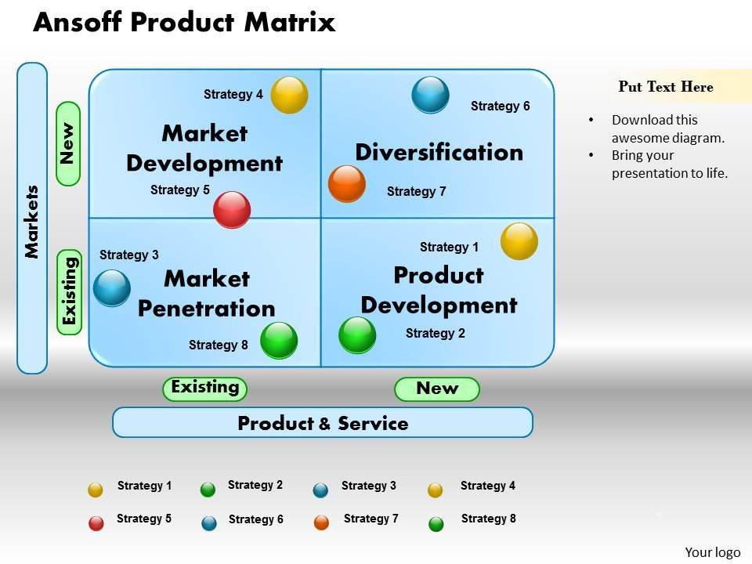
Ansof'f’s development network is an incentive tool that is regularly used to understand the basic specific options available to the firm (Ansoff, 1980, p131). When we look at the open door in both new and existing business areas, the emphasis within the framework is determined based on the advantages and challenges of each key alternative and the internal assets and capabilities of the association to choose from.
Market Penetration
Market entry is a technology that supports development by introducing existing products into the existing market. By resetting market entry, the firm will have the option of maintaining existing product offerings and expanding its business through special products and promotions. It uses a variety of channels to promote its products, flavors, and pack sizes. Various items of different sizes are posted to provide access to the person who can buy oversize packages. This organization is also known to have more humble competitors in various fields to reduce the competition in the existing business sector.
Market Development
When Nestle shifts existing goods to a new business area, it is called market development. The organization is constantly growing geographically in the field of business. It did not enter into the system of building business areas. No matter where it enters the next market, the organization ensures that its cost is reasonable and its products can be accessed quickly through efficient use of distribution channels. Placement firmly captures its essence and the various products it sells through various advertising sources. Likewise, there are items that will fit in a nearby market. These changes can be similar to product grouping or product variations. For example, Nestle Maggi Instant Noodles cannot be accessed in Pakistan and India, USA or Europe (Nestle, 2015). The United States has more breakfast than South Asia.
Product Development
Product development is done by Nestle when it posts new products to existing business areas. Nestle did these different events. Snickers and Mars are chocolates sold by Nestle. Anyway as part of its product development method, Sneakers and I Marshal distributed frozen yogurt which hit their asons. The company produces new products such as new baby food lines, breakfast cereal lines, various beverages, and more.

Diversification
The least secure of the processes is to transport another product to another market. Level expansion regular experiment method by Nestle. It sells existing products and sends new defined products to them. For example, despite the Gillette shaving foam, the organization has posted items related to other beard shaving. There are plenty of places for an organization to enter electronic savers. The organization sells infant formula and formula milk for infants. Also, it can go into diapers and other baby preparation materials. There is an excellent room and Nestle continues to test it regularly with new products. However, this technology requires a more specific understanding of the market and what will be successful.

Conclusion

All things considered for Nestle, providing a little information about the most efficient technology to inspire customers and build a stable and stable relationship with customers to maintain customer respect. The program has five significant successes. The basic entry-stage involves understanding the Mall strictly as the customer needs it. Ensuring considerable progress in the promotion can get rid of a progress strategy and an indicator plan. The third major step in progress is to create a tailored project for the benefit of customers. Recent central progress in implementation has been to encourage customers to take advantage. As reviewed, each key is isolated in the article. For an association to be practical in declaring its reports, it must adhere to the above criteria or the show's basics.

To summarize location-directed research partners, of the organization. Personal status is to get the best disadvantages. Simultaneous benefits; They are investors and speculators. The word is established in many articles, and the killer appears as teenagers. This clearly shows that the organization does not like the younger age, which is essential. The settlement is dangerous because most of the food items available come from the payment and cannot be sure that it does not contain unsafe substances. Based on the report's research, it is safe to say that the organization did not specify how to address delegates' behaviour. The organization should emphasize improving employees' behaviour at all levels to give people the image of a higher association in general. To improve the behaviour of delegates, the Union can screen workers' relationships within the work environment. Additionally, the organization can organize unique workshops to expand union representatives' behaviour to shape the high corporate character of the Association.



