VARIATION 1 – CHANGE IN SCREED THICKNESS
Omit 205m² of 25mm thick sand and cement (1:3) screed; steel trowel finish.
Add 205m² of 50mm thick sand and cement (1:3) screed, same finish and method.

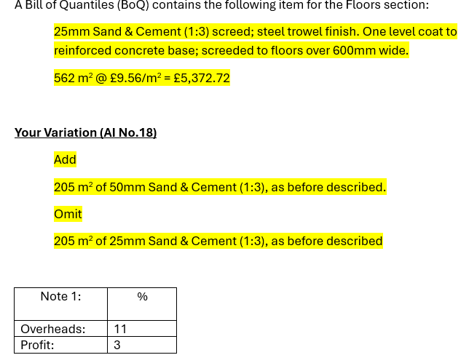

Pro rata pricing
The pro-rata pricing method effective because additional works are very similar to the originally planned works. The materials and methods used are exactly the same, with both using sand and cement at (1:3) with a steel trowel finish, With the only change is the screed thickness increasing from 25mm to 50mm.
In clause 5.6 of the JCT Building Contract, it states that if there is a difference between the drawings provided and the “Boq”, and the works that are carried out follow the original design and method, but it is measured differently in the “Boq” then the ammount can be adjusted. This clause allows the current rates to be used with small tweaks when the work is of similar type.
The use of the pro-rata valuation keeps prices consistent with the “BoQ”. However, it will adjust and change the rate due to the extra thickness of screed rather than creating a new rate. This keeps pricing straightforward and simple.
For this assignment I used SPONS 2020 to check labour, plant and material breakdown as it is an industry cost breakdown guide.

Calculate the Net Base Rate (Excluding Overheads and Profit)
The original rate for the 25mm screed is £9.56/m². Contractor overheads and profit total 14%, therefor dividing the gross rate by 1.14 to get the net rate.
Overheads (OH) = 11%
Profit (P) = 3%
OH & P = 14%
Original value = £9.56/m²
Net Rate without OH & P = £9.56 ÷ 1.14 = £8.38/m²

£8.38/m²
To work out the base price without overheads and profit, I changed the 14% to its decimal form (0.14) Since the total cost of £9.56/m² includes this 14% addition, I divided it by 1.14 in order to remove the markuup and calculate the amount. This gave me a result of £8.38/m² as the value before the 14% was applied.
Using SPONS 2020 p.528 the typical breakdown for a 25mm thick sand and cement screed is as follows
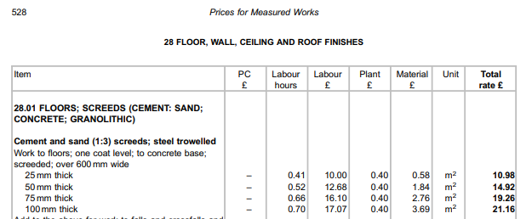

Labour = £10.00

Plant = £0.40

Material = £0.58

Total = £10.98

Labour = £10.00 (91.07%)
(£10.00 / £10.98) 100 = 0.9107 = 91.07%

Plant = £0.40 (3.64%)
(£0.40 / £10.98) 100 = 0.0364 = 3.64%

Material = £0.58 (5.28%)
(£0.58 / £10.98) 100 = 0.0528 = 5.28%

This shows how the total net rate of £10.98/m² is divided among Labour, Plant, and Materials Labour takes the biggest amount at £10.00, which accounts for 91.07% of the total amount.

Plant contributes £0.40 (3.64%), while Material adds £0.58 (5.28%).

This breakdown provides us with a clear view of how each element fits into the overall cost. Divide each individual cost by the total rate, then multiply by 100. For example £10.00 ÷ £10.98 × 100 gives the Labour's share of 91.07%. The same calculation was applied to Plant (£0.40) and Material (£0.58), resulting in 3.64% and 5.28%. This approach breaks the total down into precise proportions and highlights how costs are distributed.

Labour cost = 0.9107 × 8.38 = £7.63
Plant cost = 0.0364 × 8.38 = £0.31
Material cost = 0.0528 × 8.38 = £0.44

This breakdown shows us how the total net rate of £8.38m2 is split between Labour, Plant, and Material. Labour makes up for £7.63, which makes up 91.05% of the total. Plant equates to £0.31, making up 3.70%, and Material adds £0.44, coming to 5.25%. This gives us a clear view of how each element of this job fits into costs.

ADJUST COST TO ALLOW FOR THE INCREASED THICKNESS

To adjust the cost for increasing the screed thickness from 25mm to 50mm. With the thickness being doubled, this can give a good estimate that cost will follow suit and also double. Using this, we take the original values provided to us and change them.

Labour chamges from £7.63 to £15.26, Plant goes from £0.31 to £0.62, and Material rises from £0.44 to £0.88 The new rate is given to us when they are added up and gives us a sum of £16.76.

Increase in screed from 25mm to 50mm.

The adjustment factor is 50 ÷ 25 = 2.00

Apply to each cost:

Labour: £15.26

Plant: £0.62

Material: £0.88

Total adjusted net rate = £16.76

STEP 4 – ADD OVERHEADS AND PROFIT BACK TO THE ADJUSTED RATE

Once I made the adjustment for the increase in screed thickness, the new rate is at £16.76 per square meter. This new rate gives the cost of the 3 elements (Plant, materials, labour)

In construction, contractors must make profit, in this case we add 14% to our new rate as shown below

£16.76 × 1.14 = £19.11/m2

The 1.14 is our 14% that we add onto our rate as this is our overheads and profitThis gives us the final pro-rata rate for the new adjustment of 50mm screed is £19.11 metre square.

This number is including our overhead and profit.

Add 14% for OH/P
£16.76 × 1.14 = £19.11/m²

This is our pro-rata rate for 50mm sand and cement screed.

After I reviewed the original BOQ and planned works, the costs needed to be adjusted. The planned works originally included 562 m² of 25mm screed at a rate of £9.56/m2, this gave us a total of £5,372.72. However, when 205 m² of this was removed, it reduced the overall cost by £1,961.80.
The 205m2 of 25mm screed was then replaced with 205 m² of 50mm screed, which comes at a higher cost. I worked this rate out to be of £19.11/m². This added a total of £3,917.55 to the overall cost.
After making these adjustments and calculating the figure. Our new contract value comes to £7,328.47 The cost has increased by £1,955.75 overall due to the thicker material used.
The below calculations show how I got my figures.
Original 25mm Screed: 562 m² at £9.56 = £5,372.72
Omit 25mm Screed: 205 m² at £9.56 = – £1,961.80
Add 50mm Screed: 205 m² at £19.11 = + £3,917.55
Total value after the variation = £7,328.47
Net increase = £1,955.76

Switching from a 25mm screed to a 50mm screed has several issues associated with it. For example, it may delay other works planned in the area such as carpenters installing new doors, longer curing times may not allow others to be in the area, therefor extending programme. The additional time it takes to lay double the amount of screed may also influence timeframes. Issues with materials may also be an issue due to the requirement for more than originally planned.
When it comes to pricing, applying a pro-rata rate provides a simple and clear method of adjusting costs to suit. This ensures the change is valued fairly and consistently, and follows industry guides such as spons.

VARIATION MANAGEMENT
Managing changes under the JCT SBC/Q 2016 contract means finding the right balance between being commercially smart and following the rules. This paper looks at how contractors in South Wales, especially in places like Swansea, can handle changes (called “variations”) in a way that protects their time and money.
INTRODUCTION
In construction changes happen frequently, this can be caused by simple issues such as supplier issues, regulations, and even conditions that are uncontrollable such as the weather. Contractors need to follow the JCT contract rules, changes within a project can be a great thing, yet they can also have massive financial impacts
CLAUSE 3.10
Clause 3.10 of the JCT Standard Building Contract 2016 is essential to follow because it requires all contractors to follow valid instructions given by the contract administrator, and ensuring that the works are carried out in line with the agreed contract. This is important as construction projects always have changes,this clause given clear instruction as to how to follow and manage instructions.
When contractors comply and go ahead with instructions it lowers the chances of dispute and poor client/contractor relationship. A senior QS I have worked with has said that “going ahead and actioning an instruction massively reduces the risk of delay, the client request and we action. If an instruction is given and questioned over a long period, delays occur”. This leads me onto risk management, the clause gives direct and clear instruction as to the decision making and changes on a project.
A case study I found that is relevant to instructions is below,
Thomas Barnes & Sons Plc v Blackburn with Darwen
During the construction of Blackburn bus station, the project was affected by large increases in cost and overrun of time. This contract was terminated at the time by BDBC before work ended. BDBC then had another contractor join and complete the works.
A claim was made for the work completed and the extra costs due to delays in the project. It was decided that the standard delay guidance was not properly followed by the company. When in court, the judge stated that the both delays occurred at the same time and affected the projects programme. An extension was granted for 119 days but only 27 days extra cost. h (Glover, 2022)ttps://www.fenwickelliott.com/sites/default/files/dispatch_issue_269.pdf
This highlights the importance of following industry guidance in order for your party to be protected.

CLAUSE 5.1, 5.2, 5.3
Clause 5.1 If the variation work is similar to what's already in the contract and is carried out the same. Use the same rate, We used this in the last section of this assignment to work out our variation
Clause 5.2 When proposed work is not similar, use reasonable rates that are fair to the contractor.
Clause 5.3 This clause states that if you are unclear on which rule to follow, then the contract administrator is the one to decide
CLAUSE 4.2 - ADJUSTMENTS TO THE CONTRACT SUM
Clause 4.2 defines the contract sum and makes it the basis of future potential adjustments/variations within the project

THE ROLE OF THE CONTRACT ADMINISTRATOR (CA)
In a JCT construction project, Contract Administrators play an important role in ensuring that the contract is managed effectively and fairly. The CA is responsible for issuing clear and authorised instructions to the contractor, including variations and changes to the work. They value these variations and apply contract rates or fair pricing. They ensure that the contract amount is adjusted accurately. The CA monitors the programme, granting extensions of time where appropriate and ensuring the works meet the specifications required. By ensuring the contract is followed and everything is handled correctly, the CA is the primary point of communication between the contractor and employer. The CA tries to keep risks low in order to carry out a successful project.
As the contractor we first must show that we understand and have received the instruction. Once everything is confirmed, the contractor must look at if the instruction will have an impact to the project, whether positive or negative. We must then respond with quotations (if applicable) and discuss other options if required.
Once both parties are in agreement, we must then carry out the instruction and complete the new works. All losses/gains caused by the adjustment must be documented and saved. This will then be used for receiving/giving payments and will mitigate the chances for financial disputes. Following these steps will ensure a smooth and well executed instruction, no matter the scale.
CONCLUSION
The JCT SBC/Q 2016 allows for construction contractors to have a good and clear understanding for how to manage variations within a JCT contract. Understanding the clauses talked about in the above section, it allows for a smooth and well delivered project that all parties can complete on good terms. It helps to keep strong client relationships which lead to more work awarded to the contractor. It ensures everyone follows the same guidelines as this is a legal matter..
Lastly, smart variation management means fewer headaches, better financial control, and smoother delivery. It helps contractors stay on top of their game and ready for whatever the project throws at them.

References

Glover, 2022. fenwickelliot.com. [Online]
Available at: https://www.fenwickelliott.com/sites/default/files/dispatch_issue_269.pdf
[Accessed 31 3 2026].

