PARVEEN AKHTAR

1817693

BSc Health and Social Care

Module: Introduction to Physiology

BMHP5003_BIRM

Mumtaz Goolam

Project Individual Academic Poster – Part 1

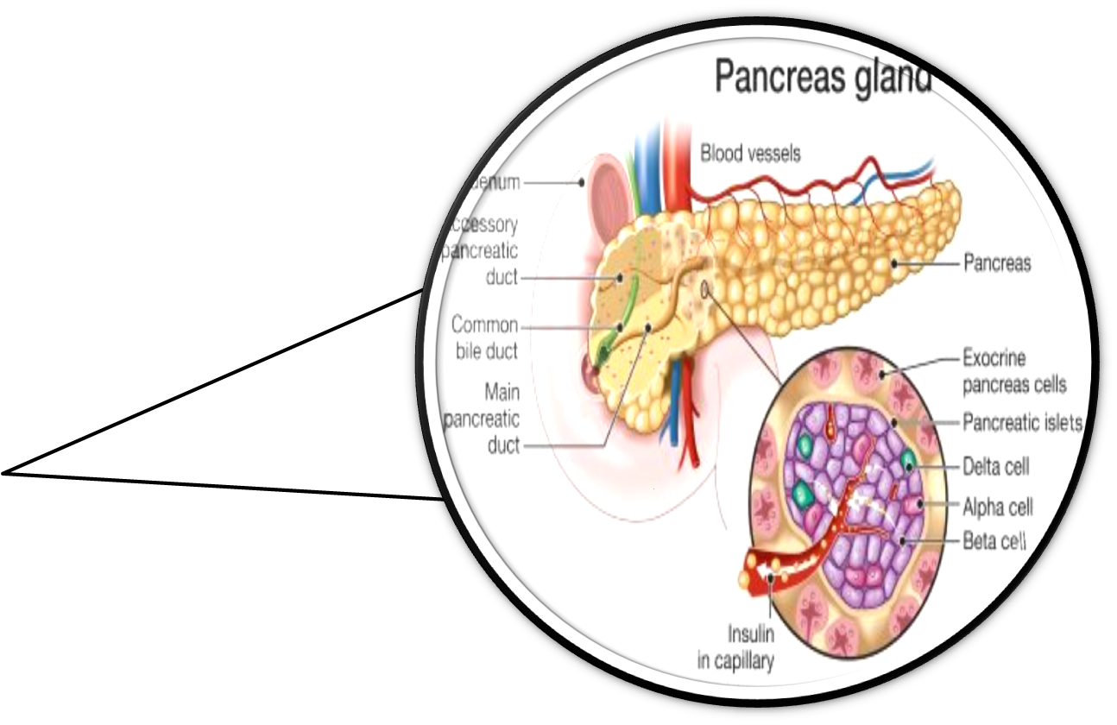
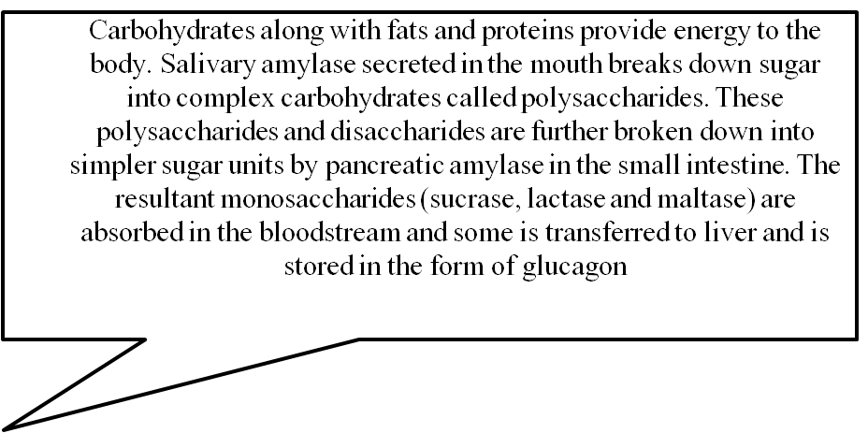
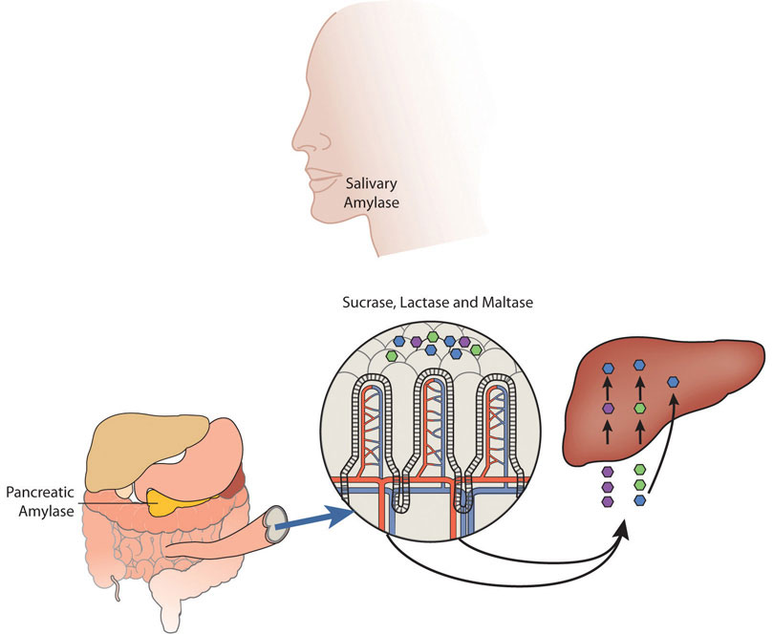
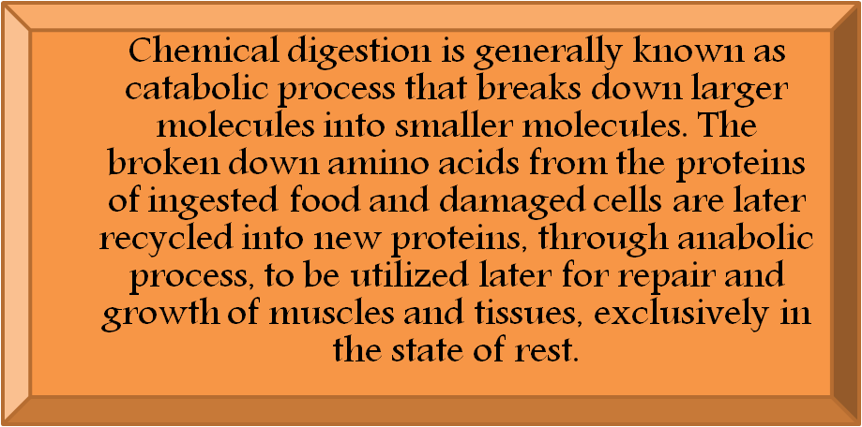
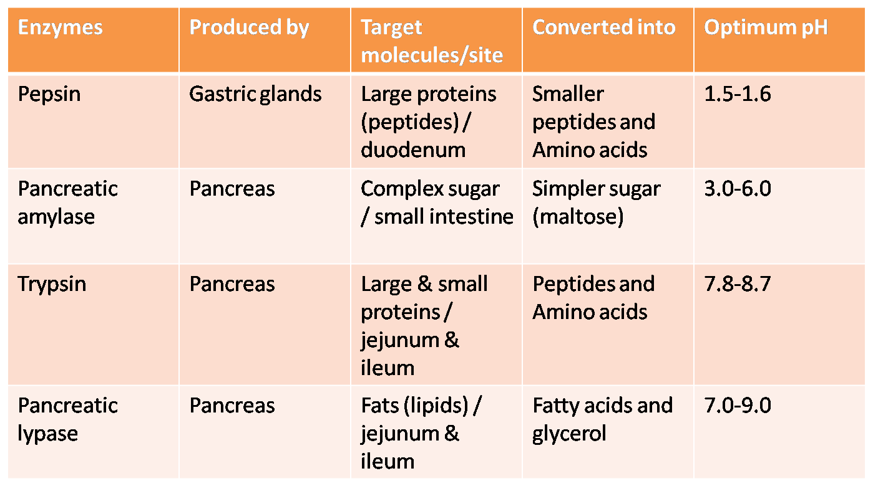
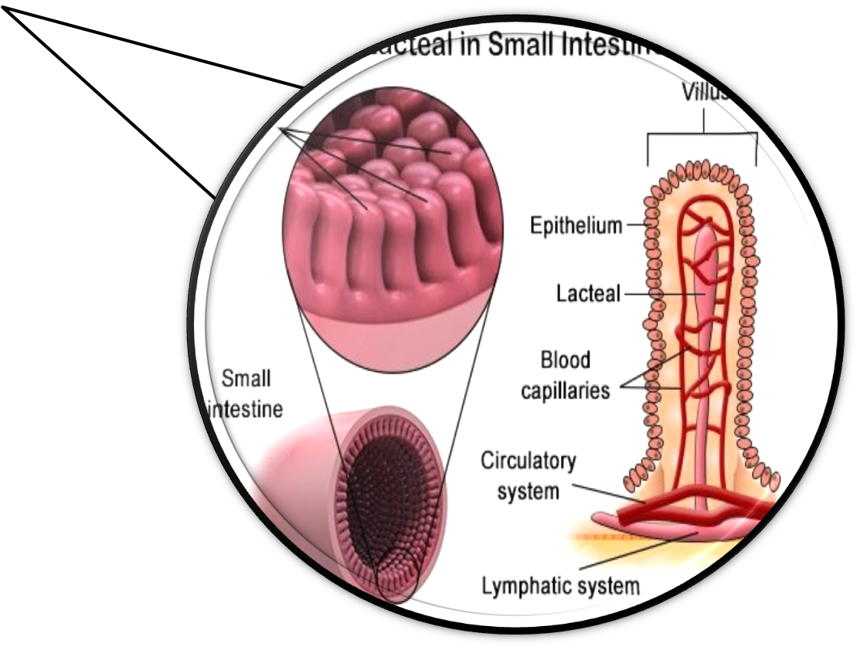
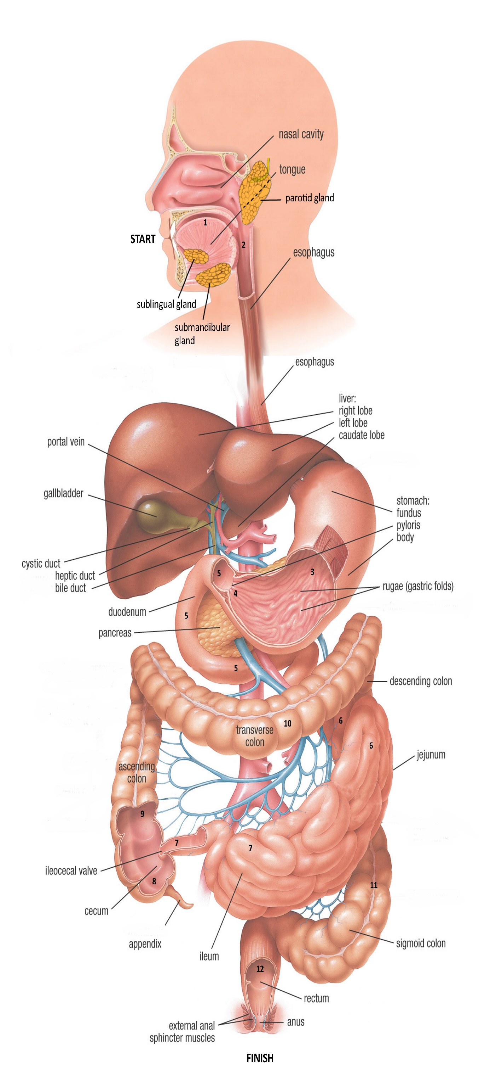
Homeostasis process & physiology of enzymes:
The gastrointestinal system plays a vital role in transferring the nutrients from external to internal environment in order to maintain homeostatic processes in the body. Pancreas organizes the glucose homeostasis by releasing hormones like glucagon and insulin to stabilize the concentration of glucose in the blood, during fasting and fed-state. Similarly, homeostasis is also organized by gastrointestinal system by the absorption of appropriate amount of iron, carbohydrates and proteins in small intestine, as per needed. Likewise, required quantity of iron is absorbed from 15-20 mg/day of ingested food, in jejunum and ileum, by epithelial cells, to produce hemoglobin (i.e. 0.5-1.0mg in men and 1.-1.5mg in female) (RSC.org, 2021). Therefore, composition of body fluids is also maintained through the system despite the losses taking place through urination and perspiration, in addition to the absorption of essential amino acids that cannot be synthesized by body cells.

Anatomical Representation of Digestive System
BodyTomy.com, 2021
Ellen Mchenry, 2021
Study.com, 2021
BiologyOnline.com, 2021
Human Nutrition, 2021
Carbohydrate
Digestion
Mesentery is a large stretched tissue that keeps the digestive system to stay intact.
Digestive System Disorders
Lactose intolerance:
It is a very common disorder affecting majority of population. It happens due to less secretion of lactase enzymes in the intestines, which is responsible for digesting lactose present in mammal’s milk and dairy items. Limiting dairy product consumption has proven to improve the symptoms like diarrhea, gas and bloating.

Gastroesophageal Reflux Disease (GERD):
Acid reflux also called heart burn occurs when the gastric acids spills onto esophageal tube twice or more in week, causing burning sensation and pain in the chest. Symptoms include, sour taste at the back of the mouth, sour throat and sometimes dry cough. If not treated on time, it could lead to onset of serious health complications such as esophagitis. Lifestyle changes like controlling caffeine, alcohol, fast food and saturated fatty acids consumption and sleeping 2 hours after having meal, have proven to improve the conditions of the patients, if diagnosed at an early stage.
(Iamaware.health, 2021)

Structure & Functions:
Mouth: An oral cavity comprising of teeth and tongue, through which food goes into the GI tract. Mechanical breakdown occurs with the help of teeth, via grinding and tearing action at the same time mixing with saliva secreted from the pairs of slavery glands (parotid, sublingual and submandibular glands). The process is known as mastication.
Esophagus: The muscular wall located behind the mouth and nasal cavity, called pharynx, constricts and pushes the bolus into esophagus, which is a 25cm long tube extending through diaphragm into the stomach. The nerves in elastic fibrous tissues sense the presence of food and initiate peristalsis (wave-like contraction of smooth muscles) that propels the food into the stomach.
Liver, Gall bladder and Pancreas: The liver, lying inferior to the diaphragm occupies upper right quadrant of abdominal cavity. It produces bile, a yellowish green liquid responsible for breakdown of fats into fatty acids and glycerol in the duodenum, that has been initially stored in gall bladder to be further transported. Gall bladder is a sac shaped like a pear attached to the liver. Pancreas is the elongated structure forming a grape-like cell clusters, located across the back of the abdomen, responsible for exocrine and endocrine functions. Along with the inactivated protein digesting enzymes, other activated enzymes are regulated by the hormones and parasympathetic nervous system, to digest starch, fats and nucleic acids in the duodenum (Rosenfeld, 2021).
Stomach: After the bolus reaches the stomach, a hollow muscular organ situated below the diaphragm on the left side of the upper abdomen, it is squeezed and crumbled into smaller pieces by the churning action of the smooth muscles, where the cells triggers the secretion of acids and enzymes-rich gastric juices. These dissolve and convert the food into chyme.
Small intestine: Maximum possible absorption of nutrients from the fragments of food in the bloodstream takes place in duodenum, jejunum and ileum, the three parts of small intestine. Inner wall of intestine is covered with small projections called villi that increase the surface area for absorption. In jejunum and ileum deconstruction of molecules of protein and carbohydrate occurs, which are converted into amino acids and glucose.
Large intestine: it is smaller and wider than small intestine. The leftover fiber, water and dead cells enter the large intestine at cecum where they are mixed with bacteria and move through ascending colon site where remaining nutrients & water, are removed. The residue runs through transverse colon and then into the descending colon where the converted faeces are stored temporarily until they are emptied by the rectum through the contraction of muscular walls of sigmoid colon (LumenLearning.com, 2021).
National healthy eating guidelines:
It is due to Routine Health information systems (RIHS), data related to health statuses of individuals and communities, provision of public and private health services, and distribution of resources are gathered. This is significant to improve the quality of healthcare services; analyze the reasoning behind common health issues and reinforcement of long-term planning and policies to eliminate such issues. To prevent people from these diseases arising from vitamins and minerals deficiency, NHS has published standard procedures for general public, to consume appropriate amount of micro and macronutrients specified in the EATWELL chart with respect to their gender and age. In addition to the balanced diet chart, NHS directs the healthcare professionals in public and private sectors to give inside information on weight loss and healthy food recipes that would enable more people to adopt good dietary practices. The information collected RIHS, helps the government, multiple sectors and stakeholder to increase the availability of nutritional food items at affordable price in order to promote healthy food environment and t o protect public health (WHO, 2021).
THE HUMAN DIGESTIVE SYSTEM
Introduction:
The gastrointestinal (GI) tract helps to breakdown the food into simpler forms, such as carbohydrates, fats, proteins, and vitamins by means of chemical and mechanical digestion, where some converts into absorbable nutrients while part of it into waste that is expelled through anal opening (Britannica, 2021).

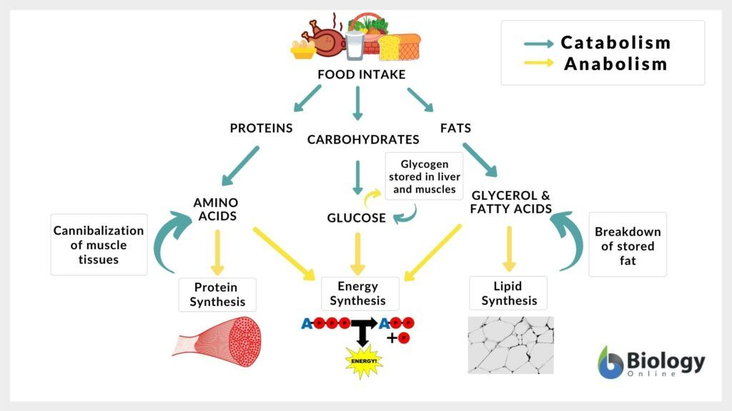
Chemical
Digestion

References list:
BBC Bitesize. 2021. Factors affecting enzyme action - What happens in cells and what do cells need? - OCR Gateway - GCSE Combined Science Revision - OCR Gateway - BBC Bitesize. [online] Available at: <https://www.bbc.co.uk/bitesize/guides/z9jrng8/revision/3> [Accessed 22 October 2021].
Biology Dictionary. 2021. How Does the Digestive System Maintain Homeostasis | Biology Dictionary. [online] Available at: <https://biologydictionary.net/how-does-the-digestive-system-maintain-homeostasis/> [Accessed 22 October 2021].
biology online. 2021. Catabolism. [online] Available at: <https://www.biologyonline.com/dictionary/catabolism> [Accessed 24 October 2021].
BodyTomy. 2021. Large Intestine Anatomy. [online] Available at: <https://bodytomy.com/large-intestine-anatomy> [Accessed 22 October 2021].
Cleveland Clinic. 2021. Gallstones: Treatment, Definition, Risk Factors & Symptoms. [online] Available at: <https://my.clevelandclinic.org/health/diseases/7313-gallstones> [Accessed 23 October 2021].
Courses.lumenlearning.com. 2021. Accessory Organs in Digestion: The Liver, Pancreas, and Gallbladder | Anatomy and Physiology II. [online] Available at: <https://courses.lumenlearning.com/suny-ap2/chapter/accessory-organs-in-digestion-the-liver-pancreas-and-gallbladder/> [Accessed 21 October 2021].
Data.gov.uk. 2021. Statistics on Obesity, Physical Activity and Diet, England - data.gov.uk. [online] Available at: <https://data.gov.uk/dataset/a7fb45df-7566-488b-80d8-a5dd5e52ff32/statistics-on-obesity-physical-activity-and-diet-england> [Accessed 23 October 2021].
DrVipinJain. 2021. Laparoscopic Gall Bladder Surgery in Jaipur | Dr Vipin Jain. [online] Available at: <http://www.drvipinsurgeon.com/gall-bladder-stone-surgery/> [Accessed 21 October 2021].
Ellenjmchenry.com. 2021. “Food to Feces” an interactive tour of the digestive system – Ellen McHenry's Basement Workshop. [online] Available at: <https://ellenjmchenry.com/food-to-feces-an-interactive-tour-of-the-digestive-system/> [Accessed 21 October 2021].
Encyclopedia Britannica. 2021. human digestive system | Description, Parts, & Functions. [online] Available at: <https://www.britannica.com/science/human-digestive-system> [Accessed 21 October 2021].
Imaware.health. 2021. Gastrointestinal Disorders: Types, Symptoms & Treatment | imaware™. [online] Available at: <https://www.imaware.health/blog/most-common-gastrointestinal-conditions> [Accessed 24 October 2021].
National Cancer Institute. 2021. Pancreatic Cancer Treatment (Adult) (PDQ®)–Patient Version. [online] Available at: <https://www.cancer.gov/types/pancreatic/patient/pancreatic-treatment-pdq> [Accessed 23 October 2021].
Natural Health News. 2021. Pancreatic Cancer Causes, Symptoms, Diagnosis and Treatment. [online] Available at: <https://www.natural-health-news.com/pancreatic-cancer-causes-symptoms-diagnoses-and-treatment/> [Accessed 21 October 2021].
nhs.uk. 2021. The Eatwell Guide. [online] Available at: <https://www.nhs.uk/live-well/eat-well/the-eatwell-guide/> [Accessed 23 October 2021].
Pressbooks-dev.oer.hawaii.edu. 2021. Digestion and Absorption of Carbohydrates. [online] Available at: <http://pressbooks-dev.oer.hawaii.edu/humannutrition/chapter/digestion-and-absorption-of-carbohydrates/> [Accessed 24 October 2021].
Rosenfeld, C., 2021. The Pancreas: Structure, Role & Pathology. [online] Study.com. Available at: <https://study.com/academy/lesson/the-pancreas-structure-role-pathology.html> [Accessed 22 October 2021].
Who.int. 2021. Healthy diet. [online] Available at: <https://www.who.int/news-room/fact-sheets/detail/healthy-diet> [Accessed 23 October 2021].

