Assignment 1

Student Name: Richard Murray
Student ID Number: 0851739
Programme: BSc/HND/HNC Built Environment Portfolio
Module: Geology and Soil Mechanics
Module Code: ACBA5004
Assignment Title: Soil Mechanics Practical
Word Limit: 3000 word +/- 10% with data collection
Word Count: 3241 (with Index)
Submission Date:
Submission Deadline: 3/4/2020

Index
Title | Page Number
Assignment Front Sheet | 1
Index | 2
Atterberg Limit
Introduction | 3
Methodology | 4-9
Liquid Limit Methodology | 4-7
Plastic Limit Methodology | 8-9
Results | 10-12
Table of Results | 10
Graph | 11
Plasticity Chart | 12
Evaluation | 13
Constant Head Permeameter
Introduction | 14
Methodology | 15
Procedure | 16
Results and Analysis | 17-18
Evaluation | 19
References | 20-21
Appendix | A

Atterberg Limits – Practical Assessment/Report

Introduction
How a soil behaves is heavily influenced by its moisture content, as this has the potential to change the physical characteristics or state of the soil itself. The Atterberg limit test is used to determine at which point a soil sample will began to alter its physical characteristics due to the pore moisture content. According to the Atterberg limits there are 4 states, Solid, Semi Soild, Plastic and Liquid and are called as such to describe the nature of the material.
During the solid state the soil will be dry, and will not clump together (i.e. low moisture content) Semi-solid there will be a clumping affect, however the material will shear and break apart. Plastic state the material will start to clump together and gain plastic properties (malleable), at this point the material has enough moisture content to it to be moulded without suffering shearing for cracking (i.e. medium moisture content). Should the moisture content increase the material begins to act with liquid properties, this is due to the pore moisture connect now pushing the particles apart, at this point the material will move under its own weight..
The Atterberg limit refers to the moisture content at which point the material will change from its semi-solid state to a plastic state (Plastic Limit), and Plastic state to a Liquid state (Liquid Limit). Using these points it is possible to classify the soil from its Plasticity Index in order to determine what the soil is, it is also used as an indication to future subsidence (the higher moisture content the higher risk of increased subsidence or potentially land or mud slips).

Methodology – Liquid Limit
In order to ascertain the liquid limit, BS1377-2 (British Standards Institute 1990) outlines 2 very different experiments, and for each of these experiments there are 2 variations. These are shown below;
- Drop Cone Test
  - Cone Penetrometer method (definitive method) (British Standards Institute 1990)
  - One Point Cone Penetrometer method (British Standards Institute 1990)
- Casagrande Method
  - Casagrande Apparatus Method (British Standards Institute 1990)
  - One-point Casagrande Method (British Standards Institute 1990)
For the subject of this report and the practical experimentation completed in the lab the Casagrande Apparatus Method was chosen. (Please note the below experiment is the method undertaken in the laboratory, in the event that there is any deviation from BS1377-2 the British standard method will also be shown in brackets.
Equipment Required
- Calibrated Scales – Displaying weight in Grams
- Casagrande Bowel with Hand Crank (matching specifications shown in figure 1)
- Gauging/Grooving Tool (matching specifications shown in figure 2)
- Water dispensing bottle
- Spatula
- 4 Metal Bowels labelled with LL
- Mixing Bowel
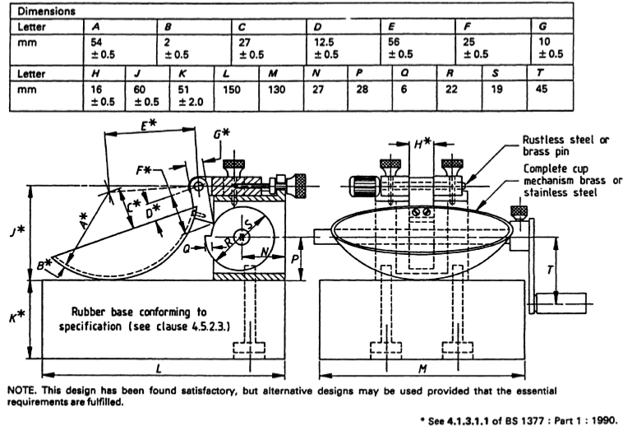
(Above - Figure 1 – Casagrande Liquid Limit Apparatus) (British Standards Institute 1990)
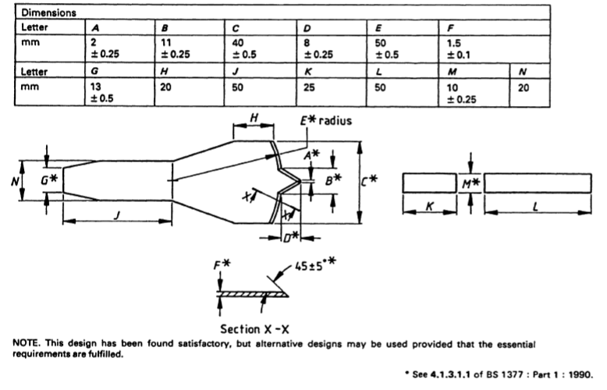
(Above - Figure 2 – Grooving Tool) (British Standards Institute 1990)

Casagrande Method – Procedure

- Obtained the weight of each of the 4 metal containers
- Obtained a clay sample that has been pre -cooked at 180C for 16 hours to remove all moisture. (BS1377-2 (British Standards Institute 1990) recommends 300g) and placed in mixing bowel
- Mixed small amount of water into the dried sample using the water sample and the spatula.
  - (Note – Sample should begin to stick together and take on the appearance of modelling clay. When undertaking the test aiming for between 30-35 drops of the casagrande bowel.)
  - (BS1377-2 (British Standards Institute 1990) recommends preparing the paste for 10minutes so that the first blow count is near 50 blows)
- Placed a small amount of the sample in the Casagrande bowel using the spatula.
- Using the spatula, levelled off the clay sample so that it covered the bowel, I aimed for a thickness of 10mm/1cm (as recommended in BS1377-2 (British Standard 1990))
- Using the gauging tool, I cut a groove in 3 swipes avoiding catching the side (this is why it is important to get the right thickness at stage 5) through the sample to the base of the cup.
  - (Note – this is best done using the wrist in 1 clean swipe each time, if more is required,, the process is to be repeated carefully until the required depth and reached.)
- Reset the counter
- Turned the hand crank so that it causes the bowel to lift and drop at a rate of 2per second (BS1377-2 indicates that the crank should turn at 2rpm (British Standards Institute 1990)) until the sides of the groove closed the gap of 12mm. (BS1377-2 indicates a contact length of 13mm (British Standards Institute 1990))
  - (Note- it is important to get the first sample to the point where it will take approximately 30-35 drops to close the gap)
- Recorded the amount of drops required
- Removed a slice the width of the spatula from edge to edge and place in bowel.
- Placed the sample and bowel in the oven to dry for 24hrs at 180C
- Cleaned the Casagrande bowel, returning the excess to the mixing bowl.
- Increased the moisture content and repeated steps 3-12 until a total of 4 samples had been obtained.
  - Note the amount of blows required to close the gap should steadily decrease, however we are looking for a range of between (35-15) from the first to the last sample obtained.
- Once the samples were dry (all moisture has been removed) I weighed the samples with the container and recorded the results for each of the bowels.
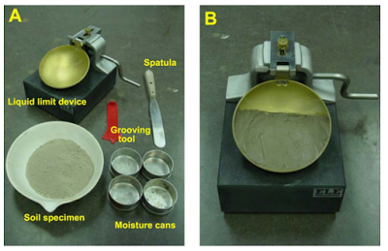
  - (Above- Photo of steps A & B – Points 1-5 in Procedure. Below Steps C & D – Points 5-8 in Procedure (Admin. 2015))
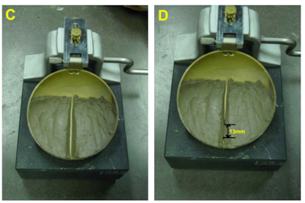

Plastic Limit –Equipment Required

- 3 Metal Containers/Jars
- Thin Wood rod at 3mm thickness (BS1377-2 recommends 100mm long (British Standards Institute 1990))
- Calibrated weigh scales – set to indicate weight in grams
- Rolling board – Wood (BS1377-2 recommends a glass plate, smooth and gives the dimensions of 10mm thick and 300mm square (British Standards Institute 1990))
- Spatulas

Plastic Limit Procedure

- Obtained a pre dried clay soil sample – (same sample as was used previously in order to determine the liquid limit test).
- Weighed the containers and recorded the results
- Took a small sample of the clay, roughly size of golf ball and kneaded between fingers so that the sample warmed and dried between fingers (drying process was slow).
- When cracks began to appear on the surface, divided the sample into 3 equal parts, kept these parts separate.
- Rolled each into a thread roughly 6mm thick (BS1377-2 recommends to cut the sample into 3 pieces (British Standards Institute 1990) we instead cut it into 3 then returned the second sample back to the mixing bowel)
- Reduced thickness further aiming for 3mm, used wood pole to measure thickness.
- Repeated the rolling motion until it started to break apart. This breaking involved both shearing horizontally and longitudinally across the sample.
  - (Note it is important to maintain a steady pressure, but the crumbling must be due to the reduction of moisture due to the board, and contact from your hangs and not due to the pressure from rolling (British Standards Institute 1990)).
- Repeated the above steps for each of the equal parts until 3 samples are obtained.
  - (BS1377-2 states that the initial sample taken on step 3 should be spilt into 2, then rolled till 6mm in width, then split once again into 3 to provide the 3 samples (British Standards Institute 1990). This was not done during our experiment, 3 samples were taken directly from the mixing bowl and steps 3-7 were repeated until 3 samples were obtained.)
- Weighed the containers and recorded the results
- Placed the samples into the oven and cooked for 24hrs at 180C to remove all moisture.
- Reweighted the bowels and the now dried out sample, recorded the results.

Atterberg Limits Results

Please see below for the table of results from the practical Atterberg Limits test for both the Liquid Limit (LL) and Plastic Limit (PL)
 | 1 | 2 | 3 | 4 | 5 | 6 | 7
Type of Test | LL | LL | LL | LL | PL | PL | PL
Container Number | G2/LL1 | G2/LL2 | G2/LL3 | G2/LL4 | G2/PL1 | G2/PL2 | G2/PL3
Wt of Wet Soil + Cont | 9.43 | 13.35 | 13.39 | 12.89 | 8.01 | 9.4 | 8.18
Wt of Dry Soil + Cont | 8.02 | 10.66 | 10.68 | 10.24 | 7.24 | 8.31 | 7.39
Wtof Container | 4.72 | 4.69 | 4.69 | 4.72 | 4.73 | 4.73 | 4.81
Wt of Moisture | 1.41 | 2.69 | 2.71 | 2.65 | 0.77 | 1.09 | 0.79
Wt of Dry Soil | 3.3 | 5.97 | 5.99 | 5.52 | 2.51 | 3.58 | 2.58
Moisture Content | 42.72% | 45.06% | 45.24% | 48.01% | 30.67% | 30.45% | 30.62%
Number of Blow | 32 | 22 | 19 | 15
(Table 1)
In order to calculate the Moisture Content the below calculation is used; $Moisture Content=\left(\frac{WEIGHT OF MOSITUIRE}{WEIGHT OF DRY SOIL}\right)*100$
Plastic Limit is the average of the 3 tests $Plastic Limit=\left(\frac{PL1+PL2+PL3}{3}\right)=\left(\frac{30.67*30.45*30.62}{3}\right)=30.58\%$

Liquid Limit Graph

By taking the number of blows and plotting it into a graph against the moisture content it produces a scatter graph, when inserting a line of best fit (Flow Curve) and ‘According to casagrande, who developed Atterbergs view stated from his experiments the most exact moisture content is obtained when the number of blows is 25’ (Admin, 2015) using above, it gives us the Liquid limit of 44.4. (For hand drawn graph please see Appendix)
LL = 44.5%
The next step is working out the Plasticity Index. This is done by the following equation;
$$Plasticity Index=Liquid Limit-Plastic Limit=44.5\%-30.58\%=13.82\%$$

(Graph 1)

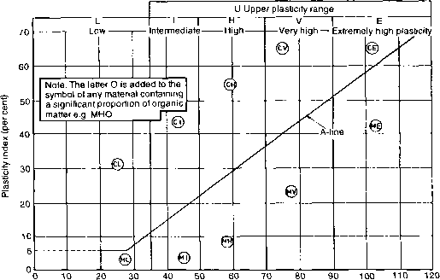
Plasticity Chart

  - Graph 2-https://www.eurocode.us/soil-mechanics/p.html

Evaluation

The results gained during the laboratory tests allows the classification of the sample, by comparing the sample to the above Plasticity Chart and the derived information from the earlier results (Plasticity Index 13.82% and Liquid Limit of 44.4%), it can be seen that if a dot is placed at this location it sits below the A Line. Due to this when classifying the soil it is classified as Silt, and not a Clay as was originally believed. due to its placement within the Intermediate column, it would be classified as Silt, with an Intermediate Plasticity Range.
The Atterberg Limits have great significance in relation to construction, in particular geotechnical engineering. The Plastic Limit represents the minimum amount of moisture present that would allow the soil to be moulded, without suffering structural failure. While the Liquid limit represents that maximum moisture content before the sample begins to flow under its own weight.
These values allow geotechnical engineers to calculate the stability of slopes in relation to the current moisture content. However sometimes ground conditions can change either from climate, or from manmade impacts. Traditionally Plastic and Liquid Limits are a good indication of subsidence, and will allow engineers to gauge how much a building will subside or settle over a period of time. However it can be used to indicate the likelihood of natural disasters such as land slips. One such slip was caused in Oso, Washington state by an increase in rain fall and potentially due to increased logging in the region (Cornwall. W. (2014).
During the Atterberg limits test it became apparent that there are several advantages and disadvantages to the test. Firstly the advantages with the Casagrande Method is that it is fairly easy to set up and complete, and can give very good indications of liquid limits, however a large disadvantage is that it is ‘difficult to maintain the apparatus in accordance with the standard… results are subject to the judgement of the operator’ (British Standards Institute 1990) and as such are difficult to repeat, due to this it is ‘the cone penetrator method is…preferred.’ (British Standards Institute 1990). However even taking this into account the Casagrande method has been used for centuries and is still an accepted method for calculating the Liquid Limits, especially when the subjective nature can also be tied to the determination of the plastic limit as well.

Constant Head Permeability –Practical Assessment/Report

Introduction

The permeability of soils differs greatly between soil types such as sand, silt, clay and stone. This is due to the space between the particles within the material. When dealing with clay samples these spaces are very small, often too small to allow water to seep through, as such these material would not be very permeable. However large samples such as sand, silt and stone would have increasing spaces between their particles, as such permeability would be expected to increase. Henry Darcy calculated that the rate of water flow through a tube was proportional to the difference in height of the water between the ends of the tube, and inversely proportional to the length of the tube (i.e. hydraulic gradient) as such he also discovered that the flow was proportional to a coefficient, as such it is referred to as the Coefficient of Permeability.
In order to calculate this Coefficient of Permeability the laboratory test Constant Head Permameter is used (BS1377-6) (British Standards Institute 1990).

Methodology

Equipment Needed
- Mixing Bowel
- Scales – Calibrated and set to display weight in Grams
- Small Hamer/(Levelling and Compaction of the soil)
- Measuring Beaker
- Stop Watch
- Measuring Ruler
- Measuring Callipers
- Constant Head Permeameter Apparatus (See figure 3)
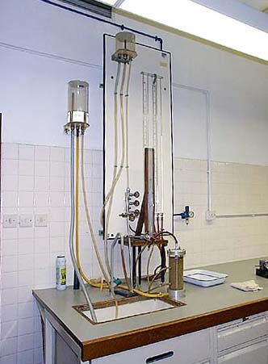
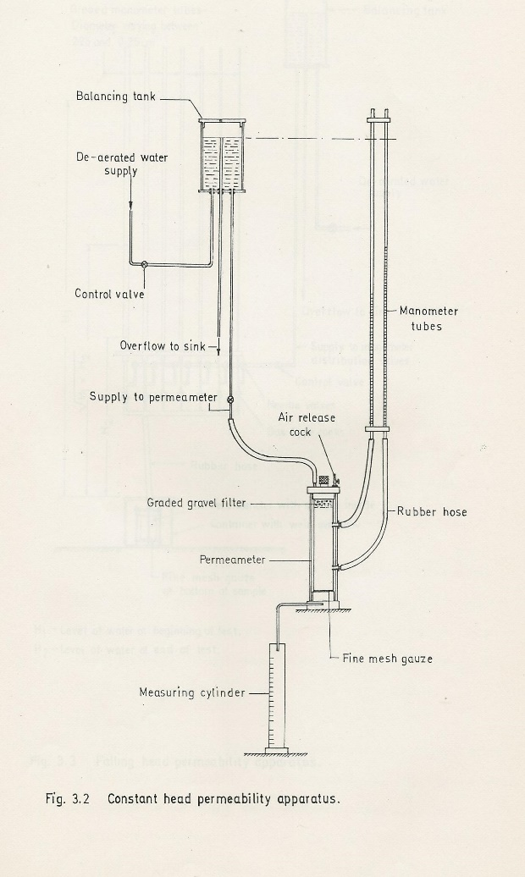
(Left Image – Photo of Constant Head Permaemeter Apparatus / Right Figure 3 – Constant Head Permeameter Diagram)

Constant Head Procedure

(As outlined by (Carleton University, 2011)
- Obtained 1kg of course soil and placed in bowel
- Recorded the mass of container plus soil
- Placed a screen at bottom of cylinder to prevent soil from escaping
- Filled cylinder with soil sample (split soil into 3 layers and compact with small hammer)
- Once filled to the top of cylinder, left enough room for screen and end cap.
- Placed screen on top of soil and placed end cap. Secured with screws.
- Recorded the mass of the bowel and the remaining soil.
- Connected intake line from reservoir to the top of test cylinder.
- Connected tubes for the 2 manometers to the correct tubes on the side of the cylinder
- Filled reservoir (Note -Closed value on the intake of the test cylinder). When filled to a certain level the water began to discharge into the sink.
- Opened value to allow water into the sample. (Allowed water to run freely for a few minutes to fully saturate the sample).
- Took Measuring Beaker – measured and recorded it’s mass when empty
- Simultaneously started watch when started filling beaker from the discharge pipe from the cylinder. (Aimed for 300ml of water)
- Once 300ml had been achieved simultaneously stopped watch and removed beaker
- Recorded the mass of the water plus beakers as well as the time it took for fill in seconds.
- Emptied beaker and zeroed watch to reset
- Repeated test twice more (total of 3 times), each time aiming for a different amount of water.
- Before completion calculated the head applied at each manometer from the base of the cylinder
- Recorded the height difference between the two outlet pipes to the manometers
- Cleaned apparatus
- Using the callipers measured the diameter of the cylinder.

Results and Analysis

During the test the following results were obtained;
- Water collected was 920 x 10⁻⁷ m³ in 2 minutes and 45 seconds.
- Water collected was 185 x 10⁻⁶ m³ in 5 minutes and 30 seconds.
- Water collected was 36.8 x 10⁻⁵ m³ in 11 minutes.
The sample was 0.1m in diameter. The head difference of 0.068m was measured between points 0.2m apart.

The above will now be used to determine the Coefficient of Permeability in m/s (to 3 decimal places using Darcy’s Coefficient of Permeability equation.

$$K (Coefficent of Permability)=\left(\frac{Q(Flow of time)*L(Length of Flow)}{A(Area of Flow)*h(Hydaluic Head Difference)*t(Time in Secs)}\right)$$

Test 1 Equations
$$K =\left(\frac{Q*L}{A*h*t}\right)=\frac{(920*{10}^{-7})*0.2}{(π{0.05}^{2})*0.068*(\left(2*60\right)+45)}=\frac{(0.000092)*0.2}{(0.007853981)*0.068*165}=\frac{0.0000184}{0.088121673}=2.088*{10}^{-4}m/s$$

Test 2 Equations
$$K =\left(\frac{Q*L}{A*h*t}\right)=\frac{(185*{10}^{-6})*0.2}{(π{0.05}^{2})*0.068*(\left(5*60\right)+30)}=\frac{(0.000185)*0.2}{\left(0.007853981\right)*0.068*(330)}=\frac{(0.000185)*0.2}{\left(0.007853981\right)*0.068*(330)}=\frac{0.000037}{0.176243333}=2.099*{10}^{-4}m/s$$

Test 3 Equations
$$K =\left(\frac{Q*L}{A*h*t}\right)=\frac{\left(36.8*{10}^{-5}\right)*0.2}{\left(π{0.05}^{2}\right)*0.068*\left(11*60\right)}=\frac{\left(0.000368\right)*0.2}{\left(0.007853981\right)*0.068*\left(660\right)}=\frac{0.0000736}{0.392878667}=\frac{2.088{*10}^{-4}m}{s}$$
$$Coefficent of Permability \left(Average\right)=\left(\frac{2.088{*10}^{-4}+2.099{*10}^{-4}+2.088{*10}^{-4}}{3}\right)=2.092{*10}^{-4}m/s$$
Using this Coefficient of Permeability value and utilising Darcy’s table (see figure 4) it is possible to classify this sample.
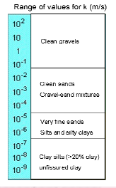
Figure 3 (Darcy’s Law Table – Classification of Soil Sample)
The values of the Coefficient of Permeability can be greatly affected by many things, such as pore size, soil structure and the viscosity of the pore fluid. However when comparing the sample used to the table above it can be determined that the soil sample provided as part of the practical assignment was Gravel-Sand Mixtures. This means that while the sample does not have great porosity, it will allow moisture to seep through at a steady rate, unlike a clay sample.

Evaluation
The Constant Head Permeameter allows for the porosity of a soil sample to be taken, this is particularly important as the permeability of a soil in the construction industry is important. As this can give good indications to the local ground water table. This is particularly important as if the tests show there is a ground water flow to a specific location, which then hits a non-permeable layer, this build-up of pressure can cause a natural spring to occur as the water is forced to the surface. Or in the event that the ground water flows to a natural pond, haloed in nonporous material, this ground water will collect, potentially causing a small reservoir. It can also provide evidence of under washing which is a problem as if too much water flows through the ground, it can loosen or lubricate the ground conditions, this loosing and increase in pore water pressure can in turn force the particles apart, which will in turn affect their shear strength and may even alter their behaviour (plastic to a liquid state), this change can in turn give rise to mud slides or slips.
The permeability of soil samples can also be especially helpful in today’s construction industry, especially as we as humans are becoming more and more aware of our impact on the environment. An example of this is our attempt to ensure that ground water tables are maintained wherever possible, an example of this is Sustainable Urban Drainage, either in the form of porous pavements or the use of soakaways, which in turn are greatly affected by the coefficient of permeability,
However while the Constant Head test can provide good reliable date due to the fact that it is a test that can be carried out under strict laboratory testing conditions and to recognised standards (British Standards 1990), the test it’s self does have several disadvantages, ‘soils that are suitable for this tests are sand and gravels, soils with silt content cannot be tested with this method’ (https://theconstructor.org/geotechnical/soil-permeability-test-constant-head/2993/, no date).The test it’s self is not a simple test and requires a great deal of equipment (Chamber, Manometers and Piping), it is not a test that can be carried out on the field, which in turn provides another disadvantage, the sample tested can only provide a very small sample area, and it is impossible to test the sample without disturbing it, as such it is possible to introduce air in between the soil particles, which in turn would provide a different result than what can be found on site.
However even with these disadvantages, the Constant Head Permameter test is still carried out in accordance with BS1377-6 (British Standard, 1990), and can still be used to provide accrete results that can assist geotechnical engineers in the design and development of construction sites.

References
Mustaq. M (no date). Atterberg Limits – Liquid, Plastic and Shrinkage Limit (Online), Available at https://civiltoday.com/geotechnical-engineering/site-investigation/296-atterberg-limits-soil (Accessed: 23/3/2020)

British Standards Institute (1990) BS 1377-2:1990 Methods of test for Soils for Civil Engineering purposes – Part 2 Classification Tests. (Online) Available at: https://www.angelofilomeno.com/upload/BS1377-2-SoilPropertiesTests.pdf(Accessed 23/3/2020)

Cornwall, W (24/7/2014) Causes of Deadly Washington Mudslide Revealed in Scientific Report (Online). Available at https://www.nationalgeographic.com/news/2014/7/140722-oso-washington-mudslide-science-logging/ (Accessed 29/3/2020)

Carleton University (2011) CIVE 3208 Lab 4: Hydraulic Conductivity. Available at http://www.youtube.com/watch?v=BqJqcTdf4FY (Accessed 29/3/2020)

Geol.T (No Date) What is Geotechnical Engineering (Online). Available at: https://www.brighthubengineering.com/geotechnical-engineering/42482-fundamentals-of-geotechnical-engineering/ Accessed 26/3/2020

Mishra. G (No Date) Permeability of Soil by Constant Head Permeameter – Objectives and Proceedure (Online). Available at: https://theconstructor.org/geotechnical/soil-permeability-test-constant-head/2993/ Accessed 30/3/2020

Admin. (4/07/2015) Atterberg Limit Test Soil Mechanics (Online). Available at https://www.basiccivilengineering.com/2015/07/atterberg-limit-test-soil-mechanics.html (Accessed 31/3/2020)

Plasticity Chart for Soil Mechanics https://www.eurocode.us/soil-mechanics/p.html (no date) (Accessed 2/4/2020)

