

Task 1 – Reading Task assignment

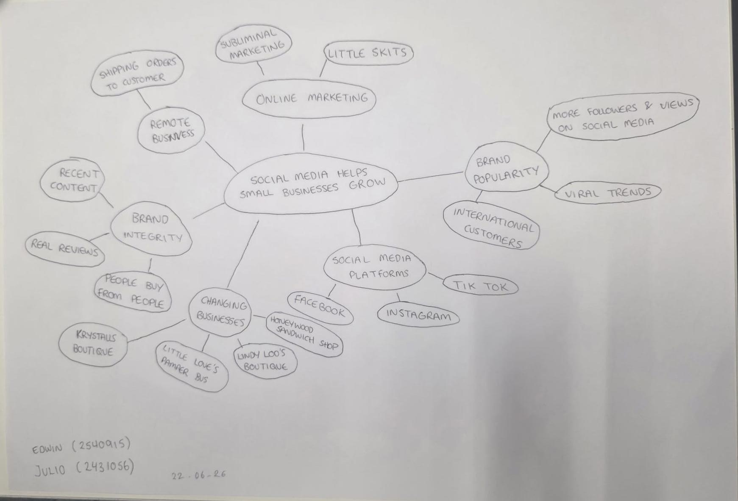

- Answer these questions using the sentence starters below

a. What is the main idea of the text?
The main idea of the text is the importance of social media in small businesses; these apps (Instagram, TikTok, Facebook....etc.) help to have more visibility , grow their business and get more customers.
b. What are two key points?
- For a small business to grow, we need to use social media.
- It is very important to post interesting videos and photos on social media, like memes or showing how do that job.

c. What part of the text did you find most important? Why?
The most important part is: Most people use social media, and this gives small businesses an opportunity to become more visible and sell their products.
d. Was anything unclear or difficult to understand?
I've been a hairdresser for 15 years, and reading this article made me feel something familiar about my work. I use social media to promote it, but at the same time, I also feel that I have to keep learning, This world has become more competitive and we have to use all the tools to grow in a business area.
e. How did your group help you understand the text better?
Working in a group helps me understand the activities in class better; we all contribute different ideas and that helps us learn more.
3. One sentence reflection
Question: What did you find challenging about this task?
What I have found most difficult is expressing my ideas. I haven't studied for many years and the language barrier is a bit of a challenge, but I have taken on the challenge and I must continue in the process.

