Sameena Hassan
Marketing Fundamentals
LCBB4004
Umar Saddat

This report will be based on a Global Organisation of my choice which I will be critically analysing and evaluating the global challenges that were overcome alongside the mega trends which had impacted the marketing functions post covid-19 pandemic. The global organisation I have chosen is the mobile phone company of Samsung. The reason why I have chosen Samsung to base my assignment on and to evaluate Samsung is because it is a major electronic brand and holds a lot of value within the industry.
Samsung is one of the world’s successful and hugest electronic company, which their success is based on their well structured and thoughtful supply chain strategy. If we are able to understand their core component of their supply chain, you are able to gain an in depth look into their well structured approach and how they have become so successful overtime and still are surviving successfully post pandemic.
Their supply chain strategy does entail by using advanced technology which includes artificial intelligence, huge data, and internet of things to optimize production line, logistics and their customer service. By using these techniques, this gives Samsung the power to be able to meet the demand in the market efficiently and maintain any supply chain disputes. Samsung’s globalisation strategy is to gain access to resources, markets and labor from all around the world. By allowing to globalise its supply chain, Samsung can reduce costs and increase the net worth efficiently and effectively.
To begin with discussing some of the challenges that Samsung had to face which affected the marketing functions post covid-19, we will look at digitalisation. Digitalisation is by adaption of a system which is set to be operated with the usage of computers and the internet. This can be completed in the leisure of your own home and comfort. This allows companies to buy and sell goods without physically being present. As Samsung uses online platforms to market their products and services, they have not been impacted as much in the digitalisation sector due to the pandemic. This is because as now there are a few stores which you can visit which was introduced before the pandemic, a lot of customers do prefer to shop and look into products online as sometimes there are great deals which are only available online. For example, contracts, pay monthly or even certain discount codes which offer a certain amount of money off or more the value of your money as such as they offer deals on a handset and headphones for a better price.
As research have advised, post pandemic fear is hurting most UK businesses and many businesses had to make big decisions for the future they hold. This has been discovered from a new study which was released in November 2022 by Samsung. However Samsung announced the expansion of its ‘Work Wonders’ B2B platform to support other British businesses as they gear up for the growth post pandemic. Following onto the rising energy costs and how Samsung have been affected by this post pandemic. As Samsung uses their energy efficiency and uses smart meters and energy, there is not change in their costing post pandemic as all businesses energy costs have increased however Samsung have introduced smart energy to reduce costs.
“Running a business is hard enough without extra complications like rising inflation, soaring energy prices, geopolitical challenges or other shocks to the bottom line,” Samsung UK head of new business development Mark Seaman said. (Statement from Samsung)
Post pandemic, Samsung have introduced flexible working hours and conditions as more and more staff are now working from home as this was introduced during the pandemic. This can be via chatline, at Samsung customer service or more. This gives the staff the freedom to work a particular working pattern as and when it also suits the company’s demands.
As Samsung offers a wide variety of products such as tv’s, handsets and more, their demand in the market has increased. This is seen as a necessity as more and more people do now work from home for which they need such electronics which will give them the opportunity to complete their jobs more efficiently. Samsung do hold many shares within larger stores for example currys and pc world which implies they are well marketed within the community and is easily available. Their marketing since post covid has had a huge increase such as mobile ads, youtube, tv ads, working with social media influencers and brand agency partnerships.
In the year 2021, Samsung launched several of the latest technology products ranging from mobile phones to household technology. In terms of technology products, mobile phones are Samsung’s most famous products. Samsung divides the mobile phone product segment into two based on the price and target market of the product. Samsung are embracing the demand in response to rapid price increases worldwide which has been followed by the pandemic in the technical sector over the past 2 years. Samsung has always been careful in approaching advertisement through marketing tools to the target market, especially for products that have middle to high targets. As a brand that has premium looks, Samsung is required to be able to present more premium marketing content for its middle and upper target audience. One of them is the project that Samsung created in 2021 for their famous S series that recently came out, namely, the Samsung Galaxy S21 5G. Galaxy S21 5G series is a short action movie, entitled “The Epic Escape”. The big idea of this project as illustrated in figure 2 that will be communicated to consumers is “Make Your Story Epic” which has the intention of inviting people to tell their daily lives using the Galaxy S21 series 5G, which has very complete features. This is the new marketing technique which now Samsung use, is by giving the consumers an insight of what that product’s quality will look like by actually using the product in all formats and settings, this is a marketing strategy which now has been implemented.
Samsung evolves in driving marketing strategies to take all advantages of any new developments by innovative ideas, high quality visuals and celebrity endorsements. This is a major marketing strategy brand awareness to showcase its products and be able to inspire its audience. Samsung’s marketing campaign have been very consistence in their messaging and visuals which has been a great help to create a strong brand image. As marketers, it is vital to develop a consistent identity for the brand across all marketing channels to be able to build a recognised brand and a good trust relationship. The main marketing strategy used by Samsung is product innovation, celebrity endorsement, sponsorships and partnerships alongside customer service and social media marketing.
Engagement with our stakeholders is essential for us to fulfil our responsibilities as a responsible global company. Samsung strive to build a cooperative relationship and enhance mutual understanding in sustainability topics with our stakeholders through various activities such as multi-stakeholder forums, surveys, and on-site visits. Identifying key stakeholders of Samsung and the impact on the marketing functions of the organisation,
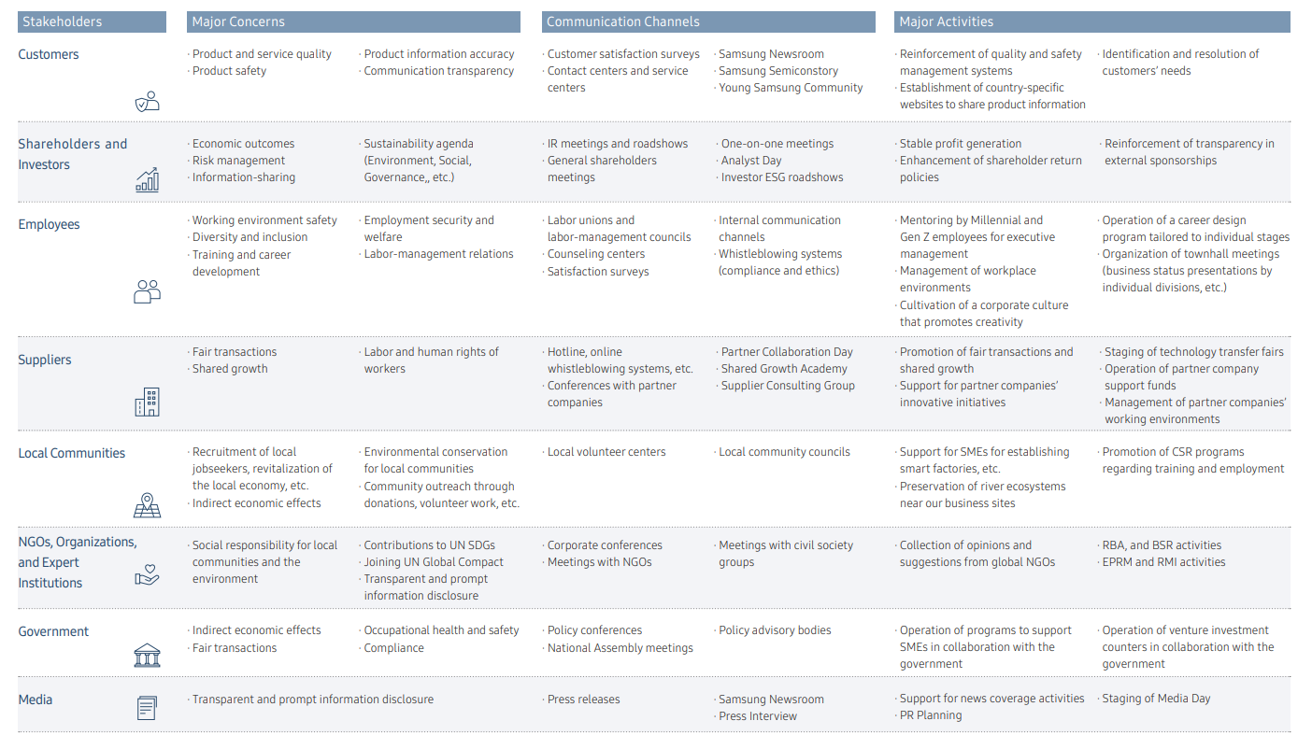
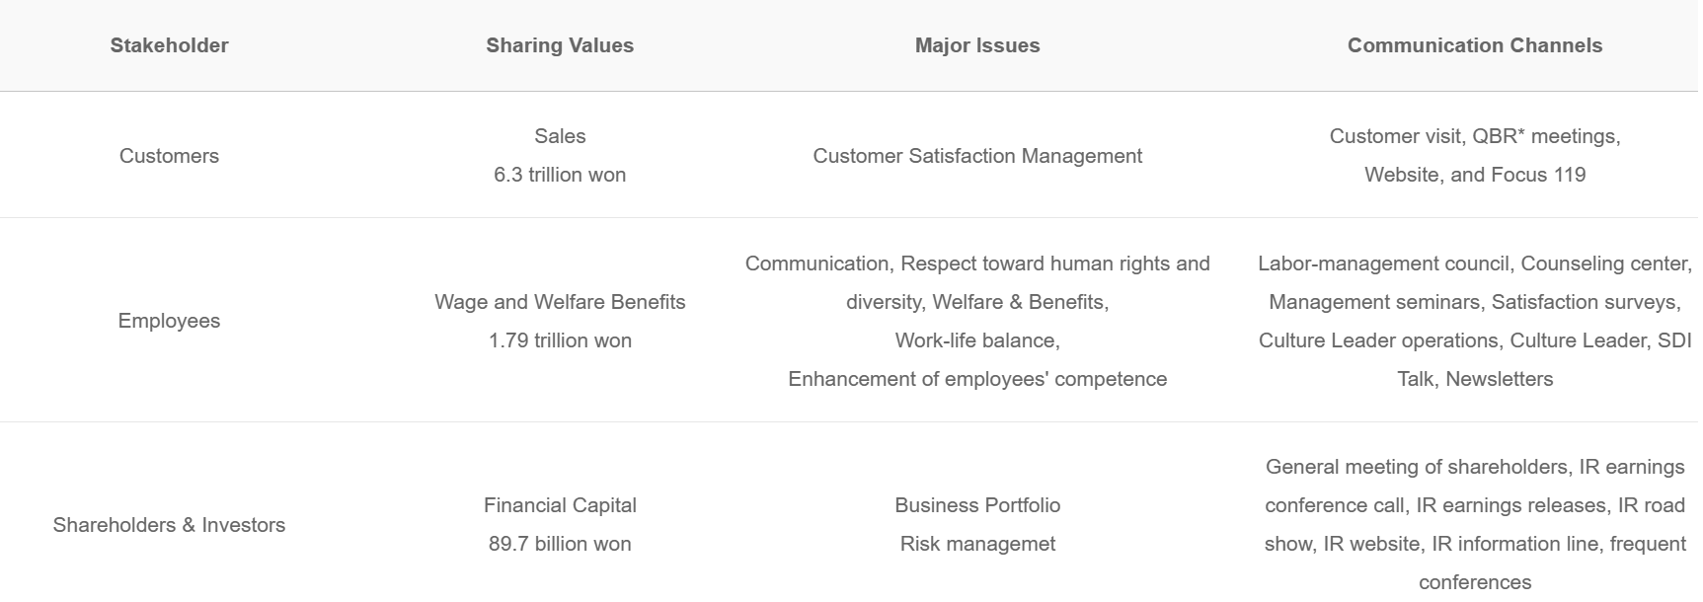
Recommendations of marketing strategy for some of the challenges faces comparing with their competitors to create better strategies which would be more profit beneficial. The first strategy is “Skimming Price Strategy”, Smartphones of Samsung are leading the market with Apple’s iPhone. Like Apple, Samsung also uses skimming price to gain the upper hand over their competitors. For instance, Galaxy S6 and S6 Edge are the brand new products of Samsung carrying the slogan “Next is Now” and claiming that they are the most beautiful smartphones ever invented. However was Samsung handsets are more android driven which have more facilities for working consumers for example it has the facilities of word document and PowerPoint where working from home consumers are able to work on the go.
The second stragery used is competitive pricing, Unlike smartphones, Samsung has difficulties in gaining an edge over its competitors with other products. In terms of home appliance, it can’t possibly surpass LG. Furthermore, in Cameras Cannon and Nikon are leading the market. So, for Samsung to withstand this fierce competition, it introduces a change. Samsung uses major electronic goods retailers such as reliance digital and Samsung Smart Cafes Institutional sales such as the airport, Shopping malls and more.
According to Winer and Dhar (2011), the 4 P’s of marketing for samsung does entail the product’s price, channels of distribution ( which comes under the promotion), actual product, communications and customer relationship management (place). Samsung have launched an example as a closer look at value proposition using 4P’s of Marketing for Galaxy S9. The product is a premium-class smartphone of the global manufacturer Samsung, called Galaxy S9. It has a great camera, face and iris recognition functionality, stereo speakers made by AKG company, many beautiful looks and another dozen of high-quality elements inside and out, which tells an average person that Galaxy S9 is a beautiful and undoubtedly powerful smartphone. Price: the price of the Samsung Galaxy S9 is the cheapest among its close competitors, like Apple’s iPhone XS with 25% higher price or Google’s Pixel 3 with 10% higher price (Dolcourt, 2018).
The promotion sector which Samsung Galaxy s9 has used is exceeded. They have used all avenues such as social media, brand agency partnerships and billboards, commercials and a lot of paid advertisements. Looking at the place P, the communication with the customers is via 2 main revenues such as the website and sale agents which is inside some retail stores such as pc world.

Evaluation of Samsung current marketing strategy and implementation
Samsung use of segmentation strategy by targeting different market segments is working very successfully. Samsung have come to the realisation that every need in the market and offers products for different customer segments. They have positioned their products well, and they have let their customers know they are offering something for everyone. They have a great market whom they target and they know which products are more suitable for which age sector and job wise and which will be most useful and reliable with the most facilities on the product. They have mastered the idea of creating products that are suitable for their chosen market segments, and positioning itself clearly so that customers are aware they recognize their needs and which will suit them on the go to be able to work for people who work from home. Everyone can see this by how they advertise their products effectively in the market, by clearly communicating how ordinary people can take advantage of the technology they are offering. Most smartphone companies do not communicate the benefits clearly and in a way an ordinary person can understand. Samsung communication strategy in its promotion component of marketing mix shows exactly who they are targeting and what they are offering to the targeted market. Surviving post pandemic which implements new strategies as they wish to create a better experience for all, by beginnings with the display technology. Which will be an important enabler in creating an immersive, inclusive and rewarding experience. Whether used in lessons, meetings or other collaborative projects, it will bring people together in new meaningful ways.

At the Samsung Display Tech Summit 2022 in Bangkok in September, Samsung shared how display technology is going to make a big difference in the future, by enabling new experiences and empowering deeper interactions post pandemic.

Samsung’s first in-person summit since the pandemic attracted some new 230 customers and partners from the region, who found the opportunity to learn and share how the future of work could develop in the years ahead and opportunities they would have to avail to make this successful as possible.

The future of work is clear for the future for the strategies which will be used, By now as we are all aware, hybrid work is no longer unusual or new since many workplaces, classrooms and work sites are looking to have workers, students and other participants connect remotely and seamlessly, no matter where they are situated.

For this to be successful, there must be parity of experiences. For example, participants need to be able to interact on an equally effective platform for meaningful collaboration and greater productivity. Today’s tools and services, including high-resolution visual displays, are now enabling this future of work and play. The future of work will be Forward-looking organisations are leaping ahead. A large immersive display like Samsung’s The Wall, for example, can draw emotive experiences customers at a premium hotel lobby or luxury retail brand as well as make for an inclusive, engaging virtual meeting. Interactive displays such as the Samsung Flip Pro are also setting new standards. By enabling multiple users to touch and interact with the screen at the same time, while allowing simple wireless sharing, it opens up so many interactive and meaningful ways to communicate and learn which will increase their revenues if they use all the tactics as planned as continue to consider all avenues when committing. Lastly the urgency for transformation post pandemic is now more important than ever. During the pandemic, organisations accelerated their digitalisation efforts to connect people remotely and enable life to carry on. Post-pandemic, the challenge is to make those investments even more relevant and forward-looking to make a positive difference. For example, it has become increasingly difficult to find talent in particular roles, with many employees citing burnout as a reason for taking a breather during The Great Resignation. Greater flexibility and more effective outcomes are what people expect as they return to more face-to-face interactions in a hybrid future. Organisations have to quickly pivot to new approaches to meet these expectations. They do now have the dear of losing talents if they do not transform their workforce strategy to meet a new world of work. Even worse, organisations may lose customers as they are now expecting immersive engagement experiences online or in the real world. Schools also risk undermining the learning experiences of students if they do not embrace hybrid learning to consider.
Post pandemic donations by Samsung generously
Last year in January, Samsung had donated USD 29 Million worth of funds and products to the local community members and the government that would have been the most affected by the pandemic which would provide most support and relief efforts which includes the purchasing of medical supplies and hygiene kits such as hand sanitizer and face masks. In some cases, they also had donated smartphones to some of the patients who were at most risk and were in quarantine centres. As education had also been affected by the closure of schools and learning centres or were reduced to size minimalizing. Samsung had very kindly donated tablets to some educational institutions so that children’s education was less impacted, and they had resources to learn from and could learn from, outside of the classroom. They could also take the tablets home, which allowed a more personalised and unique learning system in the luxury of their own homes being as safe as possible in this difficult time of covid.
Concluding this report, we have identified some of the important strategies which Samsung have prepared for post pandemic. We have looked at the the 4 P’s matrix which Samsung have used and tried to locate as many trusted resources to ensure we are backing up our views. We can see Samsung have implanted a many years plan for the future as they are always in demand and now more than ever due to the facilities that they provide on their technology devices. This is very beneficial for the work at home community and allows their journey to be as smooth as possible and on the go. They have considered workers, the public and everyone in different age groups to ensure they are meeting all demands as seamlessly as possible. They also made some very generous donations to sectors struggling during the pandemic.

References :
Definition of Digitalization - IT Glossary | Gartner – what is digitalisation – accessed 1st July 2023
Insight: Samsung reveals 75% of UK business leaders say stalled decisions have hurt bottom line (chargedretail.co.uk) – how rising energy costs affected Samsung post pandemic – accessed 5th July 2023
Samsung’s subdued profits reflect fading pandemic electronics surge | Financial Times (ft.com) – accessed 6th July 2023 – Samsung profit post pandemic
Proceedings | Free Full-Text | Advertising Strategy for Samsung Galaxy Series Mobile Phones on Through the Line Media during The COVID-19 Pandemic in Indonesia (mdpi.com) – target market for Samsung – accessed 20th July 2023
Samsung: Significance Of The Stakeholders And Communication Plan (abcassignmenthelp.com) – accessed 24th July 2023 – target innovation for Samsung
How Samsung's Marketing Strategy Transformed Them Into A Global Brand - Proecho Solutions – accessed 24th July 2023
Winer and Dhar (2011), 4 P’s of Samsung
Samsung Electronics – Wikipedia(2019). Retrieved from https://en.wikipedia.org/wiki/Samsung_Electronics
Samsung Defies the Elements in New Ad Campaign ‘Samsung Within (2019). Retrieved from https://news.samsung.com/us/making-of-make-it-yours-jesse-coulter-samsung-galaxy-s9/
Samsung Marketing Strategy: The Master Brand · Inevitable Steps(2019).Retrieved from http://inevitablesteps.com/marketing/samsung-marketing-strategy/
Samsung Marketing Strategy – research-methodology.net https://research-methodology.net/samsung-marketing-strategy-4/
All above references (4) used 1st August 2023

