Title EFFECTIVE TEAM WORKING AND COMMUNICATION

Name:Elena Loredana Grozavu
Group 4 Lecture’s name:Timothy Hopkins
Contents
INTRODUCTION 3
DISCUSSION 3
CONCLUSION 7
REFERENCES 8

Table of figures
Figure 1: Shannon and Weaver's model of communication 4
Figure 2: Tuckman's team development model 5
Figure 3: GRIP model 7

INTRODUCTION
Effective communication and team working are very important to build and maintain a positive working environment. This is because a positive work environment results in happier and positive behavior of employees while interacting with consumers and the public at large. Effective communication among the team members starts with clear standards or methods. It is the characteristics of an effective team that will effectively listen to other members and takes decisions with the consent of all members (Franz et al. 2018). This report mainly focuses on the communication practice adopted in a coffee shop that begins from top leaders and then imbibes at the lower management level. This further supports certain models of a team working, communication and group dynamics.

DISCUSSION
The coffee shop in the current scenario has changed a lot which demands quick information to give quality services to its customers. The main approach used in the coffee shop is verbal means of communication and sometimes they also use email to communicate employees formally. The reason for choosing these means of communication is that it is a fast method of sharing information and the chances of misunderstanding are very less (Hassell and Cotton, 2017). However, to make coordination with the colleagues at the coffee shop it is essential to implement some of the tools of a team working, group dynamics and communication and some of these are explained below:
Shannon and weaver model of communication
This model is mainly designed to establish effective communication between both the receiver and the sender. In between to this communication channel of sender and receiver they also face certain factors that hinder the process which is known as noise and in the coffee shop, the noise is sound of utensils, surrounding atmosphere, crowd noise, etc. The process of communication adopted in the coffee shop is as follows:
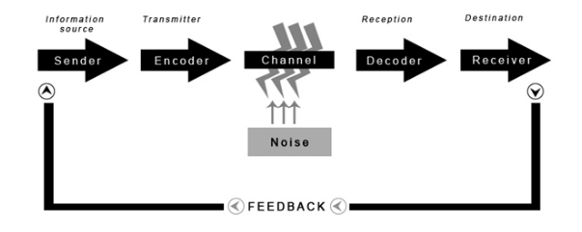
Figure 1: Shannon and Weaver's model of communication
[Source: Communication theory, 2019]
Sender: He is the originator of the message who has some idea, opinion or thoughts and selects the best channel for the receiver. If the message needs to send formally then he will write his opinions in the mail and if the message needs to be communicated orally then they will choose verbal communication (Kubota, 2019).
Encoder: This is a process of translating a message into signals that helps in transferring the message. For instance, the encoder of sending a message through email is the internet and in case of verbal communication, it will be the voice of the sender.
Channel: Channel is a medium used to transfer the message, the selected channel for the coffee shop is formal communicating by using email and oral communication by talking verbally. The effectiveness of the channel decides the effectiveness of sending a message as a slow internet connection or lots of noise makes the process ineffective.
Decoder: This is the tool used to again transform the signals into binary language so that it can be understood in the same way that is sent by the sender. This is just the opposite process of encoding (McQuail and Windahl, 2015).
Receiver: a Receiver is a person for whom the message was framed and the receiver encodes and gives feedback to the sender as per their opinions. The receiver can be either top or low management or he can be at the same level.
Noise: Noise hinders the process of communication and it can be physical or intangible disturbances such as environment surroundings, weak internet connection, crowd, the noise of utensils and similar things.
The same process is also implemented in the coffee shop i.e. sender encodes his opinion into a message with the help of a technological channel like email and then converts his opinion into an understandable message which is further converted into codes, these codes were sent through a medium to the receiver. A receiver decodes a message and tries to interpret it and may experience noise in the entire communication process.
In addition to this, an effective team is a reason behind the success of a company. An effective team will continuously grow despite the changes in the marketing conditions. And in order to make an effective team in the coffee shop, it is recommended that a team of a coffee shop must go through the stages of forming by Tuckman's team development model. This model is divided into four different stages which are as follows:
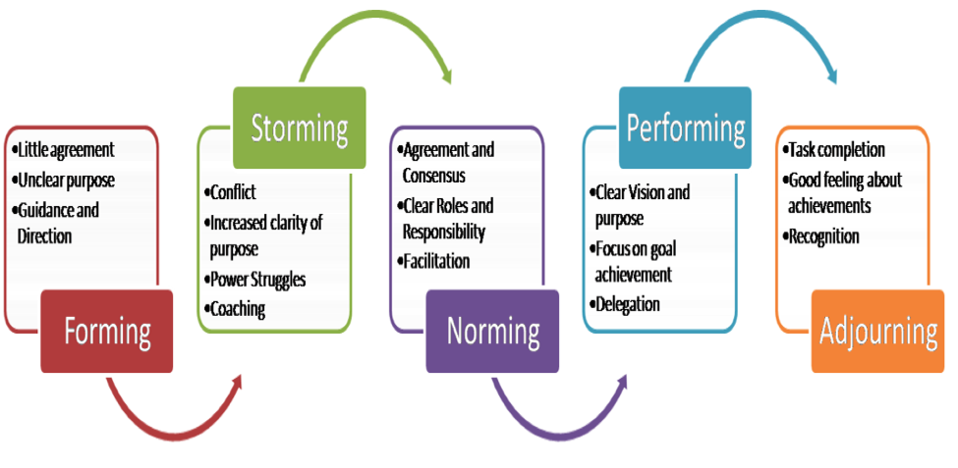
Figure 2: Tuckman's team development model
[Source: MSP guide, 2019]
Stage 1: Forming
People from different backgrounds collected together to allocate them tasks accordingly and they were expected to perform individually but in coordinated efforts so that they all will be able to achieve common goals. For instance, the people hired from different backgrounds come to give excellent services to their potential and existing customers (Zhen, 2017).
Stage 2: Storming
For this, the team members give suggestive and innovative ideas to achieve the common goal of making the customers of the coffee shop satisfied. This is the stage where group members try to make or break the relationship and all employees of the coffee shop come up with their ideas but they all agree on a single idea.
Stage 3: Norming
They start entering the norming stage where they focus on attaining group goal and agrees to work harmoniously. The employees of the coffee shop show trust and confidence in each other and support them in achieving their tasks. For instance, if employee X is absent due to ill health then employee Y will complete the task assigned to employee X. This shows a positive relationship among them and this is only possible with their friendly behavior.
Stage 4: Performing
After developing trust among team members, they started performing their assigned tasks, they all have clear objectives and responsibilities. The manager of a coffee shop does not interfere in their tasks but continuously monitor their efforts towards achieving common goal i.e. to increase the satisfaction level of customers visiting the coffee shop (Kiweewa et al. 2018).
Stage 5: Adjourning
This is the final stage which is also known as mourning or deforming. This stage is appropriate to people working in a team but this is not related to managing or evolving a team. This is the dispersion of a team where each member or employee goes back to their main purpose or tasks. This is a rarely used method in the coffee shop because the objective of satisfying the customers goes continuously and the employee’s efforts are aimed to achieve the organization's goal.
Following the above stages will help the management of coffee shop to effectively plan for a team and achieve the targets or objectives with the group efforts (Shirey and White-Williams, 2018). The model that helps in ensuring the quality of work and forming, building or changing new or existing teams and contributes in identifying the problems or finding its solution is GRIP model and this is categorized into four elements:
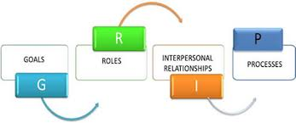
Figure 3: GRIP model
[Source: Sports conflict, 2019]
Goals: The goal of the forming team must be completely understood by each employee of a coffee shop, for instance, the goal of the coffee shop is to secure a top position in their particular locality. The manager of a coffee shop must also ensure that this goal must be aligned with individual goals so that they also contribute to achieving organization goals (Yang et al. 2019).
Roles: All employees must know their roles and responsibilities in making the coffee shop in the leading position. For instance, some employees are given the role of managing the kitchen, some reception, some providing delivery services, etc. The roles were assigned to each individual and they were responsible, accountable and liable to fill the gaps between establishing objective to fulfilling them.
Interpersonal relationship: This shows the trust, communication quality, sensitivity, flexibility, and collaboration with each other. In case one employee delivering food is not present in the coffee shop then it must be handled by the staff member of the kitchen so that absenteeism will not result in a negative experience on customers (Strandgard et al. 2016).
Processes: This includes the decision of what strategies will help in giving positive experience to customers such as offering them hot coffee, attractive presentation, less waiting time, etc. will give more effective results of giving positive experience to customers. This step includes the identification of necessary steps towards attaining the objectives effectively and efficiently.

CONCLUSION
This report on effective communication and team working mainly focuses on implementing certain models that make the team efforts and communication strategies more effective. Every employee of a coffee shop needs to understand the opinion of each employee and then plan accordingly to achieve the common goal of the organization which varies from increasing the sales, becoming a top player in a particular locality or improving the satisfaction level of customers by delivering quality services. The delegation of each task must be as per the interests or skills of team members so that they willingly contribute to the success of the coffee shop.

REFERENCES
- Communication theory, 2019. Communication Theory is online available at https://www.communicationtheory.org/shannon-and-weaver-model-of-communication/ (last accessed on 21st December 2019).
- Franz, S., Muser, J., Thielhorn, U., Wallisch, C.W. and Behrens, J., 2018. Inter-professional communication and interaction in the neurological rehabilitation team: a literature review. Disability and rehabilitation, pp.1-9.
- Hassell, M.D. and Cotton, J.L., 2017. Some things are better left unseen: Toward more effective communication and team performance in video-mediated interactions. Computers in Human Behavior, 73, pp.200-208.
- Kiweewa, J.M., Gilbride, D., Luke, M. and Clingerman, T., 2018. Tracking growth factors in experiential training groups through Tuckman’s conceptual model. The Journal for Specialists in Group Work, 43(3), pp.274-296.
- Kubota, M., 2019. What is “Communication”?―Beyond the Shannon & Weaver’s Model―. International Journal, 13(1), pp.54-65.
- McQuail, D. and Windahl, S., 2015. Communication models for the study of mass communications. Routledge.
- MSP guide, 2019. Tuckman (forming, norming, storming, performing) online available at http://www.mspguide.org/tool/tuckman-forming-norming-storming-performing (last accessed on 21st December 2019).
- Shirey, M.R. and White-Williams, C., 2018. Building High Performing Interprofessional Collaborative Practice Teams for Enhancing Population Health and Care Transitions.
- Sports conflict, 2019. GRIP model online available at https://sportsconflict.org/resource/grip-model-to-team-building/ (last accessed on 21st December 2019).
- Strandgard, M., Mitchell, R. and Acuna, M., 2016. General productivity model for single grip harvesters in Australian eucalypt plantations. Australian Forestry, 79(2), pp.108-113.
- Yang, Q., Zheng, M., Ye, Y., Li, L., Yan, T. and Song, R., 2019. The Step Response in Isometric Grip Force Tracking: A Model to Characterize Aging-and Stroke-Induced Changes. IEEE Transactions on Neural Systems and Rehabilitation Engineering, 27(4), pp.673-681.
- Zhen, J., 2017, September. Application of Tuckman's Model in the Community Folk Team Management in Community Education. In the 3rd Annual International Conference on Social Science and Contemporary Humanity Development (SSCHD 2017). Atlantis Press.

