Arybbas 343 BCE

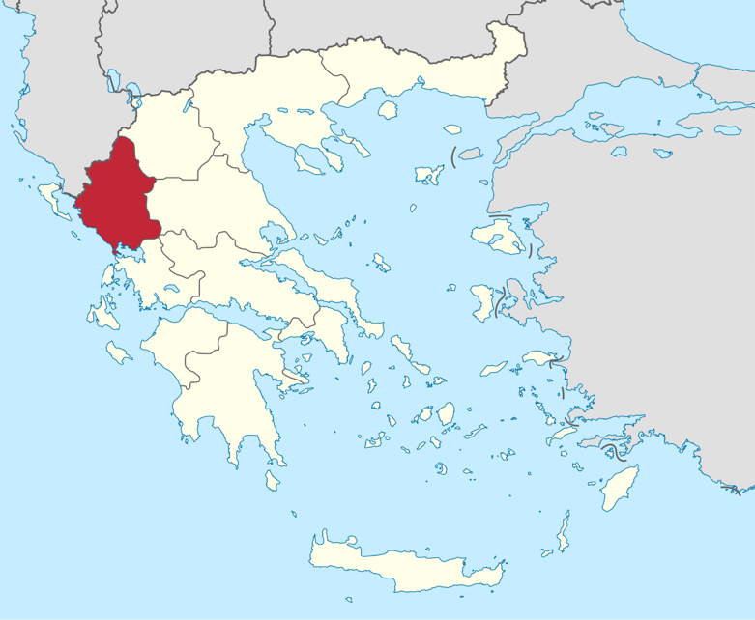
Arybbas, also knows as King of the Molossians, was the son of Alcetas I and went on to be King of Epirus as a whole when his brother Neoptolymus died in what is seemed to be around 360 BCE. This meant that Arybbas had full control of Epirus rather than the half which he and his brother dissected at the death of their late father. The Molossians can be noted as an ancient Greek tribe that inhabited the region of Epirus from what is first dated to be the era of the Mycenae (Lewis, 1994, pp.430).

Figure 1: Epirus (region)
(Image from: https://en.wikipedia.org/wiki/Epirus_(region)#/media/File:Ipiros_in_Greece.svg)

It can be inferred by the marriage of his niece, Olympias, to Philip II of Macedon that this created alliances between the Macedonians and the Molossians which would have given Arybbas lots of security (Rhodes, 2010, pp. 212). This is because at the time, Macedonia were exhausting their chances of expansion throughout Greece and as a result gaining more and more power (Kagan, 1969, pp 120-124).

Arybbas had another encounter with Philip when there were lots of conflicts. Between 343 BCE and 342BCE, Philip intervened with Molossis. He gave the throne to Alexander and disregarded Arybbas who was the rightful heir and king of Epirus. Alexander was brother to Olympias’ brother as well as Arybbas’ nephew meaning it would have been hard for him to go against the commands of Philip because of how much power he had obtained. Arybbas went on to flee Epirus and went to Athens where he was granted asylum. He was also promised his throne, however, this was unfulfilled, and he lost his title of King (Rhodes, 2010, pp. 223).

Bibliography:
Lewis, D. M. & Boardman, J (1994). The Cambridge Ancient History: The Fourth Century B.C. Cambridge: Cambridge University Press

Rickard, J. (2016) Philip II of Macedon (r.359-336 BC) Available at: http://www.historyofwar.org/articles/people_philip_II_macedon.html (Accessed: 27th January 2020)

Rhodes, P. J. (2010). A History of the Classical Greek World: 478 – 323 BC. Oxford: Blackwell Publishing Ltd

Kagan, D. (1969) The Outbreak of the Peloponnesian War. Cornell University Press

