University of Wales Trinity Saint David

Academic and Employability Skills
Reflections
Construction Manager

Student: Cosmin Constantin Mihai
Student ID: 2115663
Lecturer: Lizeta Demetriou
Content
Introduction……………………………..3
Time Management……………………...4
Academic Writing………………………6
CV Writing……………………………...7
Reflections on Task 1…………………..8
Conclusions……………………………..9
References……………………………...10
Appendix……………………………….11

Introduction
The following paper is a full reflection on the skills and knowledge that I have gathered from this course, knowledge that will help me improve and sustain the position of construction manager. I want to highlight in a few words the importance of a construction manager and also the importance of management all together.
The primary responsibility of a construction manager is the overall success of the project, including achieving the set targets safely and correctly. The construction manager is also responsible for organizing the site and staff and ensuring the construction project complies with all building codes and other legal and regulatory requirements. If delays or problems occur as they always do, the construction manager is the first responder, able to make the necessary changes to move the project forward.
Scientific management, or Taylorism, is a theory of management developed by Frederick Taylor which aims to improve the efficiency of the work flow. According to this theory, management is a science that is applied to the engineering of management. [1]In principle, construction management is the process of planning, organizing, and controlling a construction project in relation to its time and resources. Basically, constructing the required project with the least amount of time and money.
I have realized that three topics from this course were extremely important to me, academic and experience wise, these topics being: Time Management, Academic Writing and CV writing.
Time Management
Briefly, time management refers to the act of efficiently managing one's time so that a systematic business can accomplish its daily tasks. his timetable correctly, can complete nearly any task successfully. The importance of time management has been emphasized repeatedly.In today’s busy society, time management skills for students are increasingly important. The realities of participation in western society today require young people to be proficient in efficiency and productivity, even if you yearn for a simpler era when time seemed to move more slowly.
In my own experience regarding the course of time management I have realized how it had helped me on a professional basis for the past weeks.I have applied the Gibbs Reflective Cycle on the Time Management course and it showed me a new and intriguing perspective on a factor that I am dealing with it everyday. Below I will present shortly the 6 stages of the cycle from my professional perspective:
- Description
On a daily basis I have encountered different situations where time management was crucial for the current projects. My team and I developed a system where we could divide and manage time on a minute level.
- Feelings
Learning and applying everything that was thought in class regarding time management made me have a wonderful feeling specially towards my professional life.
- Evaluation
Even if entering the science of time is not an easy job, dealing everytime with variables, at the end I can see how the cost of the project goes down considerable just applying a structured management.
- Analysis
Analyzing day by day the improvements, a person can see all the benefits of applying a correct form of management either in the personal of professional life.
- Conclusion
Before learning about time management as a student, my knowledge and experience at the job was limited. Afterwards my skill in this particular domain improved signifcaly.
- Action plan
As the weeks past by, I am and was determinated to apply every time the new knowledge regarding time management in the proffesional life but also in the personal one as well. I found only positive aspects in applying the things I have learned.
Every successful task or work begins with good time management. Those who are talented and competent practice time management to ensure their dedicated tasks succeed and progress. Time management plays a key role in achieving goals.
Increasing productivity is the goal of modern time management, but the best method remains elusive. Time management has been the subject of many research studies and different theories have been developed on the subject. Personally I have found the theory of Carla Crutsinger very interesting and also effective. The process involves setting goals, allocating time to specific tasks, adjusting plans as they change, and observing the results.
Time is a valuable resource. Once spent, it cannot be recovered. A blissful, successful, and happy life requires good time management.

Academic Writing
When one has mastered the basics of writing, anyone can produce academic writing. There is no mistake that an academic paper/report should provide an argumentative thesis supported by relevant evidence, regardless of whether it is from other sources or from the author's own research. Most research follows a standard set of guidelines. In spite of a time crunch, you can still produce valuable, persuasive papers by remembering some basic rules for academic writing.Following the module of academic writing I can describe the experience as pleasant and a very useful one. I saw that different subject areas have their own conventions; the only constant is that always I should have the main argument in mind.My thoughts learning about the correct way a paper or report should be done in the professional life, especially in the domain of construction were not surprising but a little intrigued. A main rule that I have applied from a short time ago is that every paper/report from my job was done in a formal and unbiased way. At first the feeling was a little awkward but at the end the project was clearer and more structured.
For example a few weeks ago I had to deliver a report regarding the total quantity of disposable tools needed for a particular stage of a project. I took as a correct evaluation all the past similar projects and added a scientific margin of error. My report was well received, brought efficiency and cost reduction to that project.
Writing in an academic manner has its positive and negative values, mainly the positive ones are more visible. My evaluation is based purely on experience and I saw efficiency, cost reduction and top management appraisal. The only downside was that I required more time to have all the details in place.
Analyzing Through learning the module and then putting it into practice on a daily basis, I have come to the conclusion that it is very important to convince others that you are an expert who can make an intelligent argument, to have a conclusion that ties all the research together to prove a thesis, and to make use of the specific language of your field.
There is a purpose to academic writing. It may contain background information, the results of other people's research, criticism of other people's research, my own research findings, or my own ideas based on academic research conducted by others. Every aspect of life, professional and social, requires it.

CV Writing
It is undeniable that one of the benefits of globalization is the merging and expanding global market. While there have never been more job opportunities, competition has also never been fiercer.As a student I have learned the importance of having a proper and precise Curriculum Vitae and also how an employer appreciates and evaluates the honesty found in that resume. CVs are comprehensive documents that should be taken very seriously. A CV should not only include one's education and work history, but also awards, acknowledgements, achievements, publications, hobbies, and interest. Personally, I think that a CV should include the following topics: My basic information
- A brief introduction in the form of a bio
- Educational and professional history
- Personal areas of interest
A good and professional CV I think it is the stepping stone of any business relationship either as an employee or as a collaborator.

Reflections on Task 1
My personal thoughts regarding the presentation for Academic and Employability skills (task 1) are ones of exploration, new knowledge and finally confidence in myself. I have exposed from what I've learned and experienced the role of construction manager, the employability skills, SWOT analysis and also future perspectives. Even if in the presentation you can find only the highlights or major ideas, personally I had to research and study everything.
Public speaking and presenting were the experiences that posed difficulty and concern. As a result of this experience, I can now effectively communicate work problems to my peers as well as to my supervisors. Communicating is not just about talking or sending messages. The purpose of effective communication is not merely to listen and read, but also to speak and write appropriately to convey the message. I need effective communication skills in order to effectively communicate about a problem.
Researching details for the presentation that I have made, I acquired the knowledge that all goals listed there cannot be achieved with being/having a good team.
In any organization, teamwork is essential. Every member of a team must have effective personal and interpersonal skills so as to enable effective teamwork. The team members must be willing to work in the team dynamics in order for the group to run smoothly. Over time, I improved my skills on that topic.

Conclusions
The period spent on the current study I have acquired a full set of knowledge, skills and experience. I've learned that exercising good time management you aim to increase productivity, effectiveness as well as efficiency. It's true that we all receive the same amount of time each day, but it's a limited resource, which makes it extremely important to utilize and make the most of that time if you are to perform above average at work. Learning academic writing has proven to be a useful tool on a daily basis. A good academic writer needs to be able to express their ideas clearly, communicate clearly, and most importantly, convey the topic and thesis to their readers. Finally I think it is increasingly important that professionals (ex. construction manager) should have an ongoing reflection on their prior incidents and experiences including key aspects of their own personal insights and feeling to enhance depth in their reflection leading to development of different skills such as research, innovation and creativity.

References
- Crutsinger Carla,1997, Thinking Smarter: Skills for Academic Success, Skylight Professional Development, Woodstock, Vermont, U.S.A pp.10-39
- Fredrick Winslow Taylor, 2005, The Principles of Scientific Management, 1st World Library, Fairfield, Iowa, U.S.A, pp.20-45
- https://www.wsj.com, 2021, How to Improve Your Time Management Skills and Succeed in the Workplace, 02.04.2021, Available at: https://www.wsj.com/articles/how-to-create-a-work-schedule-that-helps-you-succeed-11609265688 (Accessed: 28.12.2021)
- https://www.lifehack.org, 2021, 10 Practical Ways to Improve Time Management Skills, 16.04.2021, Available at: https://www.lifehack.org/articles/productivity/10-ways-improve-your-time-management-skills.html (Accessed: 29.12.2021)
- https://www.theatlantic.com, 2015, The Needless Complexity of Academic Writing, 26.10.2015, Available at: https://www.theatlantic.com/education/archive/2015/10/complex-academic-writing/412255/ (Accessed: 29.12.2021)

Appendix
Slide 1
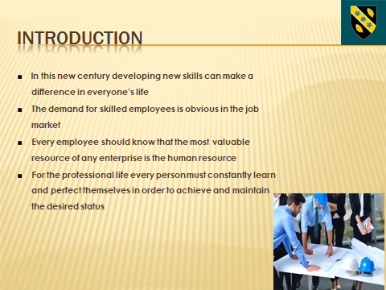
Slide 2
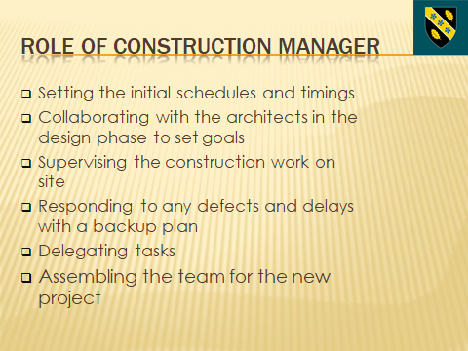

Slide 3
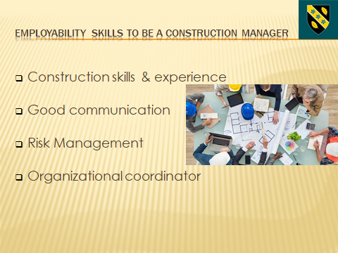
Construction skills & experience: Previous experience in the construction sector is a must-have. Going through all the steps from simple worker to site supervisor will strengthen the position of construction manager. Good communication: A construction manager should know how to communicate precise ideas and orders to their under-links and also to inform and convince the superiors in the most swift and easy way possible. Risk Management: Any profession, especially the construction business carries a lot of risk. As a construction manager you should anticipate and prepare for different scenarios. Past experience and an open mind can reduce the risk significantly. Organizational coordinator: Without a consolidated team the job of a construction manager can be very hard. Every person in that team must know very well his/hers position and the specific work for a certain job. You are responsible for managing the organization of that team.

Slide 4
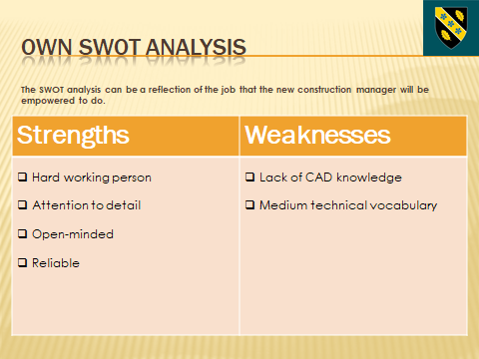
Slide 5
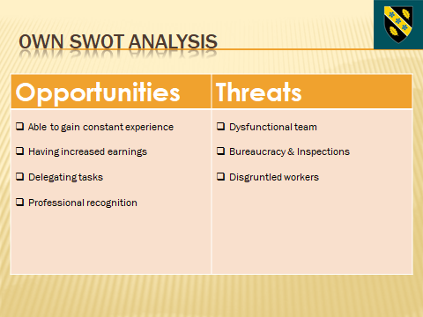
Slide 6
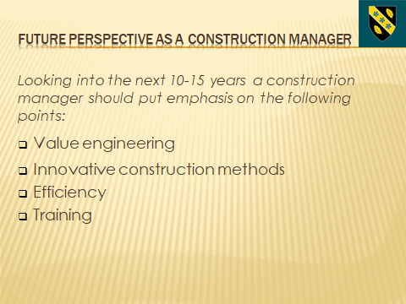
Value engineering: As a manager, constantly there must be a systematic method to improve the "value" of the current project. Innovative construction methods: Searching and learning techniques that stray away from the traditional means of construction. Efficiency: The goal of any construction manager is to be efficient. The project must be done in a short time, with quality, little waste and under the initial budget. Training: The construction sector is developing and changing constantly. Construction managers should have the best training available, should learn new skills, new abilities and improve attitudes for their own benefit and for the organization.

Slide 7
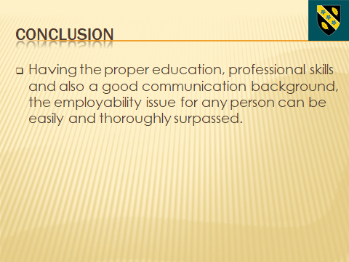
Slide 8
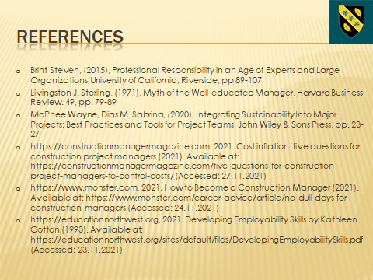

- Brint Steven, (2015), Professional Responsibility in an Age of Experts and Large Organizations,University of California, Riverside, pp.89-107
- Livingston J. Sterling, (1971), Myth of the Well-educated Manager, Harvard Business Review. 49, pp. 79-89
- McPhee Wayne, Dias M. Sabrina, (2020), Integrating Sustainability Into Major Projects: Best Practices and Tools for Project Teams, John Wiley & Sons Press, pp. 23-27
- https://constructionmanagermagazine.com, 2021. Cost inflation: five questions for construction project managers (2021). Available at: https://constructionmanagermagazine.com/five-questions-for-construction-project-managers-to-control-costs/ (Accessed: 27.11.2021)
- https://www.monster.com, 2021. How to Become a Construction Manager (2021). Available at: https://www.monster.com/career-advice/article/no-dull-days-for-construction-managers (Accessed: 24.11.2021)
- https://educationnorthwest.org, 2021. Developing Employability Skills by Kathleen Cotton (1993). Available at: https://educationnorthwest.org/sites/default/files/DevelopingEmployabilitySkills.pdf (Accessed: 23.11.2021)

