Student name: Manjit Kaur Gharu
Student ID: 1814769
University of Wales Trinty St Davids
Module: MBA Dissertation
Module code: LCMB7020
Supervisor: Zahra Mohammadnazari
Topic: How large organisations support employee wellbeing in the retail sector in the UK

Declaration

I, Manjit Kaur Gharu declare that this dissertation has been composed by myself, that the work contained herein is entirely my own where explicitly stated otherwise in the text, and that this work has not been submitted for any other degree or qualification, in whole or in part, except as specified.

Signature………. Miss Manjit Kaur Gharu
Date: 02/06/2024

Acknowledgement

I would like to take this opportunity to thank everyone who has supported me during my studies. As difficult as it as it has been I’ve managed get to the final stages of the MBA programme.

Thank you to my dearest family, I feel blessed to have you all support me. Special thanks to my Husband, Mr Sukhwinder Sahota who had confidence in me to study even when I did not. Special thanks to my beloved son Mr Anthony Sahota who guided me on the right path when things got tough. Special thanks to my precious younger children Miss Angeli Sahota, Miss Annika Sahota and Mr Prince Sahota who supported me and gave me time to study. My younger three children have tolerated my weakness and gave me strength when I have lacked sleep due to studying all night. Special thanks to my best friend, my Mum, Mrs Kulwant Kaur who supported me by reminding me how proud she is and how proud my belated Dad Mr Nirmal Gharu would be to see me progress in education. Dad always had confidence in me and would encourage me to study as he knew I had the ability to progress even when I lacked confidence. Sincere apologies to my beloved Dad for not studying when you told me. At the time, I thought I would succeed with the apprenticeship option and help our family income instead.

I extend my deepest appreciation to all the staff who supported me at the University of Wales Trinity St Davids, Birmingham campus. I could not have done this without you. Extreme thanks to Zahra Mohammednazari for your guidance and motivation with my dissertation.

Table of contents
Chapter 1: Introduction
  - Background and problem statement………. p. 5
  - Research aim………. p. 6
  - Research objectives………. p. 6
  - Research questions………. p. 7
  - Significance/ relevance of study………. p. 7
  - Brief research methodology………. p. 7 - 8
  - Structure of rest of project (Gantt chart) ………. p. 9

Reference list………. p. 10

Chapter 1: Introduction
  - Background and problem statement.
The existing wellbeing support system for employees in the retail sector has its qualities to address issues and raising awareness. Post pandemic following the Covid 19 outbreak which impacted everyone in different ways. Organisations took relevant actions and applied measures in the workplace to offer support with the wellbeing of their employees. Organisations were able to take a sit back and understand the employees needs with transitions back to work and many other factors which impacted the employee’s wellbeing. This was rare as prior to the pandemic organisations were more focused on employee reaching targets and meeting business needs. (Vaziri, 2020)

The retail sector has funded and set up wellbeing programmes which help to support employees when needed. Seven large retail organisations such as John Lewis Partnership, Tesco, Sainsbury’s, ASOS, the Co-op, ASOS, Marks and Spencer and Next have searched support from the Samaritans to help understand employee’s wellbeing and are able to offer support. The wellbeing support is available online to employees when required. (Samaritans, 2024)

Tesco which is known as one of the largest retail organisations has employee wellbeing support which all employees can access. The support offers many options which include employee assistance programme, 24/7 virtual GP, occupational health, financial wellbeing and wellbeing resources. (Tesco, 2024)

Prior to the pandemic, employees were able to manage their own wellbeing as this was not emphasised as support given in the workplace. Wellbeing was supported but was not spoken about as much as now. Post pandemic, organisations understood that employee mental health is vital. Organisations understood how the employee impacted the day-to-day operations of the business. Organisations improved to understand and took measures to support employees to minimise the increase of negative wellbeing stress.

  - Research aim.

The main aim of this research is to highlight the current support provided to employee’s wellbeing in the retail sector. The research will refer to large retail organisations in the UK. This will allow me to focus on any gaps in the support provided and consider any improvements which allow to fulfil an employee’s needs when required. Organisations currently offer wellbeing support. This research would allow to understand if the support provided by the organisation meets the employee needs or does more need to be done to support the employee at the time of need. The systematic literature review will contribute to support what is being discussed and how any conclusions ae determined.
I will focus on the key elements of wellbeing which can be related to impacts on how the employee behaves and performs in the workplace. The elements will be dissected which will allow to investigate possible support options which can manage the issue in a different manner which can possibly reduce the impact on the organisation.

  - Research objectives.

The intentions of this research activity are to explore what literature is available to provide evidence to support if adequate wellbeing support is available to employees in the retail sector in the UK.

Having focused on the categories stated in the proposed methods allows to explore how these circumstances can impact the employee and the organisation when dealt with or not. The outcome of the literature will allow to understand and gain further knowledge on how minimise any negatives outputs to the employee and the organisation.

  - Research questions.

1, Is the support for employee wellbeing sufficient in the retail sector in the UK?
2, The impact on employee wellbeing post pandemic in the retail sector in the UK?
3, Can the support of employee wellbeing increase productivity in the retail sector?

  - Significance/ relevance of study.

The purpose of the study is to research what support is available to employees to manage their wellbeing. If possible, how the support can be improved to fill any gaps which can decrease stress to the employee and the organisation. The research is to find if the organisation is supporting the employees themselves or is the support outsourced by the wellbeing programmes through external organisations and understand the outcome of this.

  - Brief research methodology.
Employee wellbeing can expand into many categories. As this MBA dissertation is time bound it will be difficult to explore all categories of employee wellbeing. I have decided to select four categories which I will focus on. This will allow me to research further into the employee support provided by retail organisations in the UK.

The categories selected are:
- Employee who needs support with health issues.
- Employee who needs support with financial issues.
- Employee who needs support with domestic abuse.
- Employee who needs support with alcohol addiction.

I will be conducting a systematic literature review to research what is previously found in the retail sector for employee wellbeing. The literature review includes reviewing academic articles and journals which will help answer the questions in the study. I will also research large retail organisations data to explore what they have in place to support employee wellbeing. The relevant systematic review will allow me to critically discuss the impact of the support provided to the employee. The findings will allow me to discuss the advantages and disadvantages of the employee wellbeing support provided.
Additional to the research findings discussion, the conclusion will provide an understanding of what is advisable for the retail sector to proceed in with employee wellbeing support.

  - Structure of rest of project.
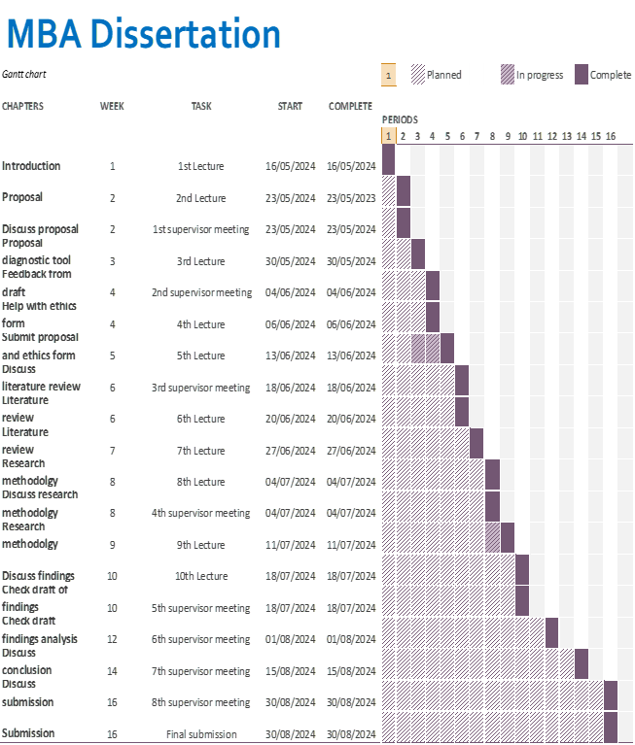
Reference list

Samaritans (2024) Wellbeing in Retail Available at: https://www.samaritans.org/wales/how-we-can-help/workplace/wellbeing-retail/ (Accessed on 1st June 2024)

Tesco (2024) Tesco Careers Colleague Wellbeing Available at: https://www.tesco-careers.com/explore-our-world/colleague-wellbeing/ (Accessed on 1st June 2024)

Vaziri, H Casper, W, J, Wayne, J, H, Matthews, R, A (2020) Changes to the work-family interface during the Covid-19 pandemic: Examining predictors and implications using latent transition analysis Journal of applied psychology, 105(10) 1073- 1087 Available at: https://psycnet.apa.org/record/2020-64602-001
(Accessed on 1st June 2024)

