

An analysis of your team role composition (using Belbin to illustrate this); including strengths, weaknesses, challenges (how to overcome them)
Student name: Cristina Serbanica

The composition of a team, including the roles and responsibilities of its members, significantly influences its effectiveness and productivity (D’Innocenzo, Mathieu, and Kukenberger, 2016). By examining the strengths and weaknesses of each team role, organisations can strategically allocate resources, enhance collaboration, and improve overall team performance. This presentation will use Belbin Model to analyse team role composition (Jasieński, and Rzeźnik, 2018).

Belbin Team Roles Model
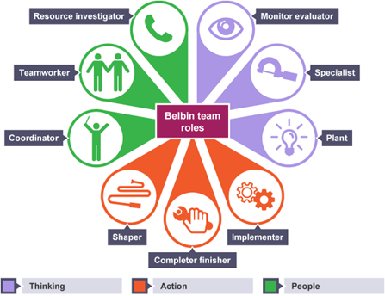
Nine roles of Belbin Model (Barenscheer, 2022)

- Plant (team member 1):
- Strengths: Creative, generates innovative ideas.
- Weaknesses: Struggles with practical implementation.
- Challenges: Translating ideas into actionable plans.
- Overcoming the challenge: Assigning a team member to collaborate and help with implementation.
- Resource Investigator (team member 2):
- Strengths: Outgoing, excels at networking.
- Weaknesses: Easily distracted.
- Challenges: Maintaining focus and task prioritization.
- Overcoming the challenge: Establishing clear goals and deadlines, regular communication.
- Co-ordinator (team member 3):
- Strengths: Strong organizational and leadership skills.
- Weaknesses: Relies on others, lacks personal involvement.
- Challenges: Balancing delegation with personal engagement.
- Overcoming the challenge: Encouraging active participation and ownership while delegating.
- Monitor Evaluator (team member 4):
- Strengths: Analytical, provides critical evaluation.
- Weaknesses: Takes time to make decisions.
- Challenges: Balancing analysis with timely actions, leverage team expertise.
- Overcoming the challenge: Establishing clear decision-making processes, incorporating input from others.

Let's integrate the Tuckman's Stages of Group Development theory into the analysis of the team composition (Acton, Braun, and Foti 2020).
The team undergoes a progression of stages in its development. In the forming stage, members come together, establish relationships, and experience excitement. The storming stage involves conflicts and differences of opinion that require constructive resolution. The norming stage sees the establishment of norms, values, and cohesion within the team. In the performing stage, the team operates at its peak productivity, with seamless collaboration and utilization of strengths to achieve outstanding outcomes. This stage represents the highest level of team performance and effectiveness.

Workplace Example

Marketing team tasked with developing a new advertising campaign.
The team consists of four members, each with specific roles and responsibilities. The Plant generates creative ideas, the Resource Investigator conducts market research, the Co-ordinator manages the team and facilitates communication, and the Monitor Evaluator provides critical analysis. Together, they bring fresh perspectives, gather external opportunities, maintain organization and leadership, and offer objective evaluations. The team benefits from the diverse strengths and expertise of its members, contributing to the overall success of the campaign.
Tuckman's Stages of Group Development:
The team progresses through four stages of development. In the forming stage, team members introduce themselves, discuss their roles, and establish initial rapport and trust. During the storming stage, conflicts may arise as diverse ideas clash, but it is important for the team to manage these conflicts constructively. In the norming stage, the team establishes norms, shared goals, and clarifies roles and responsibilities, enabling effective collaboration. Finally, in the performing stage, with clear objectives and collaboration, the team utilizes each member's strengths to develop a successful advertising campaign.

Conclusion
The analysis examined team role composition using the Belbin Team Roles model and Tuckman's Stages of Group Development. Applying these theories can improve team performance, communication, collaboration, and conflict resolution, fostering positive outcomes and a conducive work environment.

References
Acton, B.P., Braun, M.T. and Foti, R.J., 2020. Built for unity: Assessing the impact of team composition on team cohesion trajectories. Journal of Business and Psychology, 35, pp.751-766.
Barenscheer, T. 2022. Team Effectiveness Models: Why teams fail & how to fix them, Official Teamly Blog - Official Teamly Blog - Your Project Management Resource. Available at: https://www.teamly.com/blog/team-effectiveness-models/#2_the_belbin_model (Accessed: 02 July 2023).
D’Innocenzo, L., Mathieu, J.E. and Kukenberger, M.R., 2016. A meta-analysis of different forms of shared leadership–team performance relations. Journal of management, 42(7), pp.1964-1991.
Jasieński, M. and Rzeźnik, M., 2018. Team building: Its dynamics and the importance of managing diversity. Molinero, M. Ünür Yılmaz, E.(eds) Experiences of innovative women entrepreneurs of the future. Bursa Technical University, Bursa, pp.92-102.

