Student Name: Delwar Hussain
Student ID: 1813780
Module: Developing Workplace critical Thinking.
Module Code: BMSW5102
Lecturers Name: Sujeewa Herath
Assignment Title: Developing relationships and workplace achievement

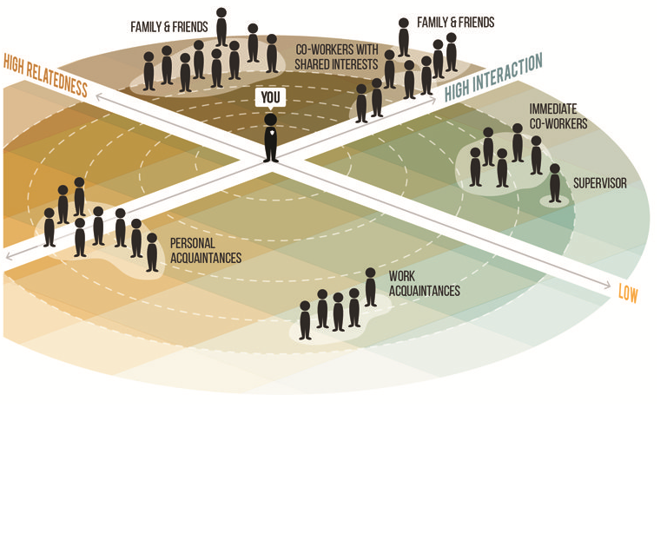

Table of Contents
Introduction 3
Development vehicles 3
Motivation 4
Types of Motivation 4
Motivational Theories 5
Maslow’s hierarchy of needs 5
Herzberg’s Hygiene factors 6
Vrooms Expectancy Theory 7
Application of the theories 8
Recommendation 9
Feedback 10
Application of Feedback to the Business 11
Recommendation 11
Training 12
References 13

Introduction
The organisation that I will be writing this report on is Asda, in this report I will explain the 3 topics that I have chosen from the list of 7. I will explain and demonstrate how Asda as an organisation use the following methods to motivate, staff Training and feedback keeps a healthy workplace within the organisation.
About the organisation
Asda was founded in the 1960s in Yorkshire; Asda is one of Britain’s leading retailers. Dedicated colleagues serve customers from our network of stores and online services, including supercentres, superstores, supermarkets, Living stores, petrol filling stations and depots across the UK. More than 18 million people shop with Asda every week and 98 per cent of UK homes.

Development vehicles

The quick changes in technology and vulnerability and the demand for the best performance in the working environment means managers and team leaders know they have to get the keep on developing their staff to get the best from them. There are many different development vehicles that help the organisation stay on top and compete with the rest of the world. I will be discussing the relevance of 3 of the vehicles such as Motivation, Feedback and Training helps an organisation to improve and get the best out of their employees.

Motivation
What is motivation?
The definition of 'motivation' can refer to the objectives that people have the ways in which
People choose their objectives, and the ways in which others try to change their behaviour.
Motivating people means getting the people to go or move the direction that you need them to go to reach a certain target or objective. Motivating yourself means that you will set yourself targets and then taking the necessary action to drive yourself towards achieving the goals.
To motivate people at work the employer needs to provide a good working environment, wages/ salary and bonuses. The good working environment includes things like flexible hours training and development opportunities, sick pay and maternity leave, and holiday entitlement. There many other benefits that could be provided with will help to motivate staff.

Types of Motivation

Extrinsic motivation
The definition for extrinsic motivation refers to behaviour that is driven by external rewards such as financial rewards, things like an increase in pay, promotion. This type of motivation arises from outside the individual.

Intrinsic motivation
The definition for Intrinsic motivation is when you do it because it's enjoyable and interesting, rather than because of an outside incentive or pressure to do it, such as a reward or deadline.

Motivational Theories

There many motivational theories but I will base this on 3 theories the Maslow’s hierarchy of needs theory, Herzberg’s Hygiene factors and Vrooms expectancy theory.

Maslow’s hierarchy of needs

What does Maslow’s hierarch of needs mean?
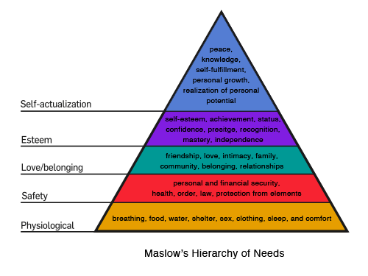
Figure1 Maslow’s Hierarchy of needs
Source: (McLeod 2018)

Maslow’s theory is all about the needs and wants of the individual in the work place. The theory is comprised of five- tiers the model of human needs. The need in the lower tiers needs to be met before the individual can move up. (McLeod 2018)

Biological and physiological needs
These are the basic needs that everyone needs to survive as shown on the diagram above
Safety needs
These are the need that gives you a sense of security, protection from elements, security, order, law, stability, freedom from fear.

Belongingness and Love needs
Love and belongingness needs the third level of human needs is social and involves feelings of belongingness to a workplace or to a group or society. The need for interpersonal relationships motivates behaviour
Esteem needs
Esteem can come in the form of achievement, status, prestige, recognition, mastery, independence and responsibility.
Self-actualisation needs
They can come from peace, wisdom, self-fulfilment realisation of personal potential, personal development and peak experiences, and contribute to being more than what we are.

Herzberg’s Hygiene factors

What does Herzberg’s Hygiene Factor Mean?
Herzberg hygiene theory of motivation is split into two factors. He worked closely with Maslow’s theory and argued there were certain directives that a business can implement which would directly motivate employees to work harder and more efficiently (Motivational factor). However there were factors that would de-motivate employees if they do not have access to. Employers would need to motivate the workers to work harder themselves. (Hygiene factors)(Tutor2u 2020).
Figure 2: Herzberg’s motivation Theory
Motivational factors
Motivational factors are things like how interesting the job is and how much opportunity it gives for extra responsibility, recognition and promotion. These are factors that are linked to the job itself.
Hygiene factors
Hygiene factors are things that 'surround the job' instead of the job itself. For example a reasonable level of pay and safe working conditions however these factors will not make him work hard they will be just doing it for the say of pay.

Vrooms Expectancy Theory

What is Vrooms expectancy theory?
Vrooms expectancy theory is all about the understanding that employer and employee have in regards to the motivation.

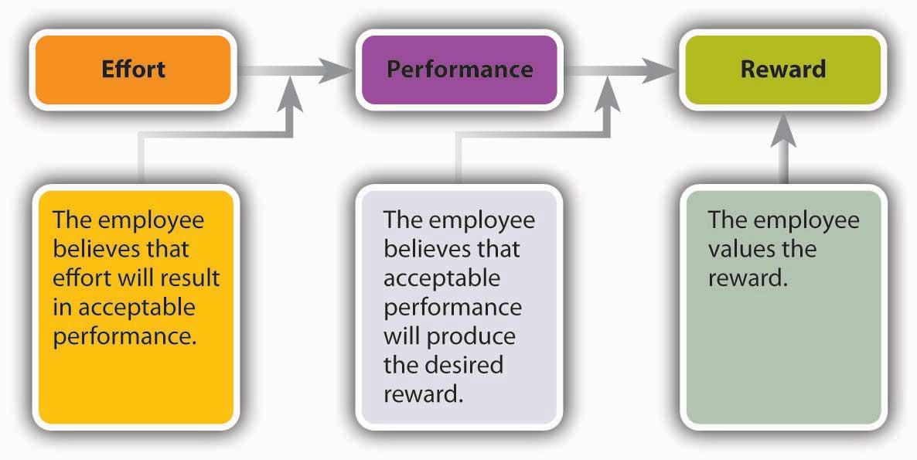
Figure 3: Vrooms Expectancy Theory
Vroom theory show that an employee's performance is based on individual factors such as personality, skills, knowledge, experience and abilities. Vroom states that effort, performance and motivation are all linked in a person’s motivation. He uses the variables Expectancy, Instrumentality and Valence to describe this.
Expectancy

He came up with the idea that the more effort one puts in the better the performance. This will only work if they are provided with the right tools for example: the right resources, do they have the correct skill set and do they have the correct support to do the job.

Instrumentality

Vroom State that if performance is better, then the outcome will the achieved. This will work if there is a clear understanding of the relationship between outcome (Rewords) and performance. The trust in the people that make the decision on the outcome, that they fairly decide who will receive the rewards. There should also be a clear understanding on the process of who gets what outcome.

Valence

The outcome should relevant and something that interests the employee for this to work it’s no use setting the outcome to time off work if the employees are interested in financial gain.

Application of the theories

When applying the motivational theories to any business there will be benefits for both individuals and the organisation. Asda sets goals and targets for the employees as an organisation, when they are met Asda will give their staff recognition and reward them for great customer service. The scheme, Asda Stars, operates in 660 locations and is available to 177,000 employees. So far, 68,856 employees have received awards, with 41,828 recognised as ‘unique’ employees for making exceptional efforts. An employee builds up Star points by meeting particular goals, and can then redeem them on a variety of rewards. (Asda 2020).
Jane Earnshaw, head of reward and recognition at Asda, says: “We are trying to reward people and recognise people who uphold the organisation’s core beliefs. The most popular reward is the Asda gift card, which makes the recognition personal.”
Each store, distribution centre and head office also nominate a ‘colleague of the month’, who is awarded Star points.
“A thank-you should have some kudos behind it,” says Earnshaw. “Rather than adding an extra £10 to someone’s pay, with no event or communication and no real meaning as to why or how they got that, we think it is important to create an event out of thanking our employees.

Recommendation
Asda as an organisation should have use the Maslow’s theory and give the staff a sense of belonging as the comments by Earnshaw in the above paragraph. Retail-chain Asda currently has a one-size-fits-all motivation strategy for its 175,000 employees, but it is hoping to offer more diverse options in the future. They give rewards that actually get put back into the business just a gift vouchers to spend within the store.
Asda uses their company survey Your Voice, to gather information on the needs and wants of its employees in terms of benefits and motivation. In 2015, 143,648 of its employees took part in the survey, from the data collected Asda learnt that most of its staff that wanted incentives to be based on factors such as employee grade, age and location.
In 2013, Asda conducted focus groups to find out what really mattered to its staff. It used this feedback to develop its colleague pledges of respect, fairness at work, opportunities and having pride in the organisation.
Carl Tabisz, senior manager, leadership and engagement at Asda, says: “We have so many different people working at Asda, different age groups, levels of experience and jobs, so we need to use what we know about them to have a better-informed motivation strategy.”

Asda need to work with their staff by get them involved in local store decision make in regard to motivation let them speak out, let them tell you what will motivate them to work harder and the kind of outcomes that keep them motivated. Instead of having a one-size-fits-all motivation strategy for its 175,000 employees they should try to listen to the needs and wants of their employees. They should prioritize the employee development needs and give individuals the benefits they earn through the levels of commitment to the business. They should also give appraisals and recognition to the staff that show the determination.

Feedback

What is feedback?
Feedback is the process of provide information to someone about how they are doing in regards to achieving certain goals or targets. Feedback is very important to measure how one if performing. In the an organisation the feedback is given to employees as an appraisal by letting them know that they are right on track or to advise them in ways them that they are not doing as well they should be and help them where they need it.
Feedback from management isn’t always appreciated by employees specially negative feedback coming from the management that don’t spend time with employees to see if they need any help or require any sort of training to do their jobs better.
360 feedback also known as multi-source feedback is a collective assessment of an individual or a team done by different people. It could be managers, supervisors, colleague’s and customers so it’s not one sided Ward (1997)

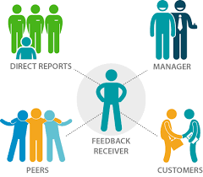
Just getting a feedback of a manager means you are getting a feedback from top to bottom where as if you get feedback from everyone from different levels then you get a better understanding of the feedback.

Application of Feedback to the Business

Asda is an international organisation and has 175,000 employees just in the UK they communicate with their staff via the annual survey and also the monthly magazine. But in regards to feedback the management of each local store take it upon themselves to give feedback to staff on status and progress of the employment with Asda. Which is a good thing but Asda stores can have up to 200 employees in a store so giving feedback to individuals is a job in its own. Feedback is a from management is top to bottom so it’s a one way system in cases of negative feedback it may not be taken well by the employee. Asda take it very seriously and take all feedback given from employees and try action where possible.

Recommendation

It would be recommended that Asda should approach the feedback strategy and work with HR to make it less intimidating for the employee. This gives the employee the ability to ask questions it they feel that they were treated wrongly. It would also advisable for the management to think about introducing the 360 feedback were the feedback comes from everyone that the individual works with in a daily basis, making it a more fair and more accurate collect of data about the individuals progress within the organisation. It also cannot be argued that it was an unfair (negative feedback) if it comes from multiple sources.

Training
What is training?
Training is used to teach or learn something that is new to you. Learning new skill to help you with the job that you are doing or training is also given to update older skills with new machinery. There are many way that training can be given Face to face individual training, group training In class the most popular now a days is the e-learning online.
As the technology is advancing the learn process is also advancing. To save time and money where possible the businesses nowadays will refer to online learning and it could be done around the job where as other types of learning may involve taking staff of the jobs or paying overtime to keep them in after hours.
e-learning give the flexibility for the employer to work round the employees job meaning that it will not affect the work. E-learning is also good for the employees as it also gives the flexibility to learn at their own process not take in a lot of information given to them in the class room environment.
Virtual Learning Environment (VLE)
What is VLE? (Virtual Learning Environment)
VLE is an online learning space and it is accessible from anywhere so long as you have an internet connection. It is a website where you add your work and share between your learning groups. It also can be used for many things like organisation lesson planning, resources, deadlines and communicating. VLE is also used for collaboration of workloads.
Example if a VLE is Moodle
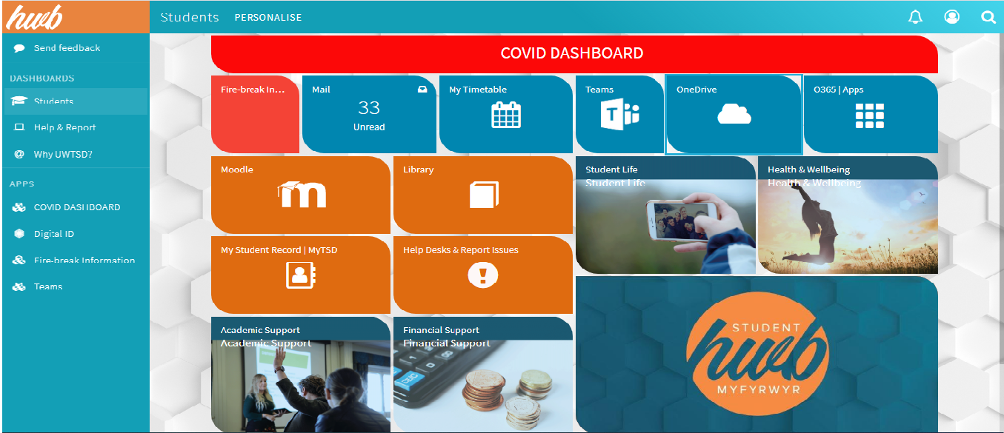
Source: Author
Moodle is used by most Educational establishments it’s a way for interaction between University, lecturers and students. Universities will keep the students updated with what’s happening on and around the campus events and opportunities up and coming. Lecturers will upload assignments get feedback and course materials so students can have access anytime and anywhere. Students have access to a range of services like help and advice, the online library, access to office software, one drive and many more facilities. Students can access source materials and upload assignments check drafts for plagiarism.
(Online Learning College 2020)

Application of training with the organisation
Organisations can setup VLE for their employees giving them access to training programmes that they can use to develop their skills to do the job at their best, doing this team leaders and managers can keep an eye on the learning process of individuals. This also saves the organisation money as they will not have to get people to come in and teach the employees as they can do it if and when they needed to. This facility will also give them access as many time as they need again saving money.

SWOT analysis on ASDA
Strengths  - ASDA id the 3rd largest retailer in the UK it holds 14.8% of the market  - 630 stores  - Strong management team  - 98% of the UK homes are served the online platform  - One stop shopping including filling stations  - Known for its loyalty schemes  - Crowned chilled retailer of the year | Weaknesses  - Critics argue that ASDA products are not as good as Waitrose  - Not cheap as other supermarkets like ADLI or Lidl  - Involved in a scandal Price fixing in 2002 and 2003 costing consumers around £270 millions  - Criticised for misleading advertising campaigns
Opportunity  - More and more people shopping online with ASDA  - Secure their shares  - Can take over smaller companies  - Invest beyond the UK | Threats  - Competitors in the UK  - Tesco is the market leaders
(Kantar 2020) (ASDA 2020)

Conclusion

References

- www.asda.com. (2020) https://corporate.asda.com/our-story
- Maslows theory (2018) https://canadacollege.edu/dreamers/docs/Maslows-Hierarchy-of-Needs.pdf
- McLeod, S. A. (2018, May 21). Maslow's hierarchy of needs. Retrieved from https://www.simplypsychology.org/maslow.html
- McLeod, S., 2007. Maslow's hierarchy of needs. Simply psychology, 1, pp.1-8.
- Huitt, W., 2007. Maslow's hierarchy of needs. Educational psychology interactive, 23.
- Dr S Sodry (2020) https://corporate.asda.com/our-story/company-facts
- Kantar (2020) grocery market shares https://www.kantarworldpanel.com/en/grocery-market-share/great-britain
- People and organisational effectiveness Cambridge university https://www.jbs.cam.ac.uk/executive-education/open-programmes
- Tannenbaum, S.I. and Yukl, G., 1992. Training and development in work organizations. Annual review of psychology, 43(1), pp.399-441.
- Noe, R.A. and Kodwani, A.D., 2018. Employee training and development, 7e. McGraw-Hill Education.
- Alshmemri, M., Shahwan-Akl, L. and Maude, P., 2017. Herzberg’s two-factor theory. Life Science Journal, 14(5), pp.12-16.
- Adair, John. (2006). Part 2. Maslow and Herzberg, Chapter 6. Herzberg’s motivationhygiene theory. Leadership and motivation. London and Philadelphia: Kogan Page
- Sarkany, D. and Deitte, L., 2017. Providing feedback: practical skills and strategies. Academic Radiology, 24(6), pp.740-746.
- Heller, M., 2017. Real-time, ongoing employee feedback: the perk that actually retains. Strategic HR Review.

