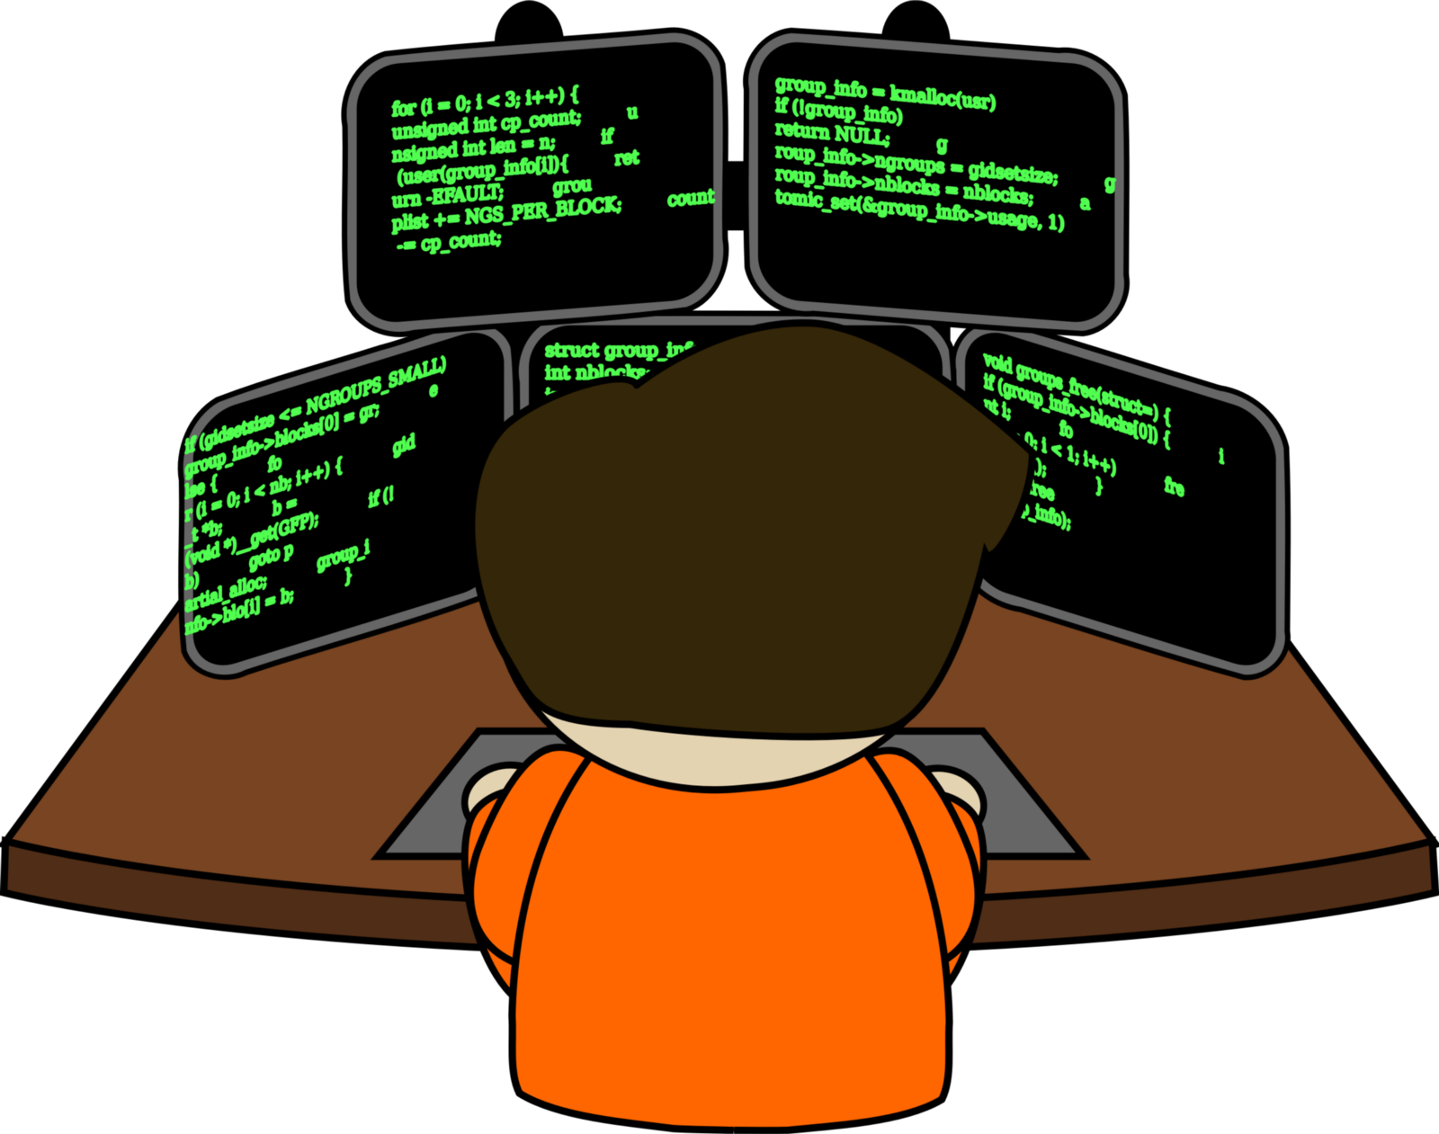  Figure 1 https://goo.gl/TwrWtr  Programming in C  Edward Patch (1801492) | Abstract  This report will discuss the planning and technique used to create the author’s projects. This report will contain the three following projects:  - Highest and Lowest  - Treasure Hunts  - Connect 4  Tim Bashford  Software Engineering (ACCA4017)

Table of Contents
Introduction 3
1. Problems Solved 3
1.1 Predicted 3
1.1.1 Highest and Lowest 3
1.1.2 Treasure Hunt 4
1.1.3 Connect 4 5
2. Stages of Development 6
2.1 Highest and Lowest 6
2.1.1 Planning Stage 6
2.1.2 Creation Stage 6
2.1.3 Evaluation Stage 6
2.2 Treasure Hunt 7
2.1.1 Planning Stage 7
2.1.2 Creation Stage 7
2.1.3 Evaluation Stage 7
2.3 Connect 4 8
2.1.1 Planning Stage 8
2.1.2 Creation Stage 8
2.1.3 Evaluation Stage 8
4. Appendices 9
4.1 Connect 4 9
4.1.1 FlowChart Troubleshooting 9
4.1.2 Check Planning 10
4.1.3 Time Bomb Plan 10
4.1 Test Plan 11

Introduction
This report will demonstrate the making of three projects, the Highest and Lowest, Treasure Hunt and Connect 4 games. The report will contain screenshots and scanned documents in order to explain the process of creating these three products.

1. Problems Solved

1.1 Predicted
For further reading about other problems that were addressed when creating these programs, refer to 4.1 Test Plan (Page 8). Extra information may also be found in the 4. Appendices (Page 6).

Highest and Lowest
The scanned documents below are my planning documents to create the Highest and Lowest program.
The screenshots below are planning documents to work out the user interface and checks for the highest and lowest game. The first scanned document on the left helped me set up a structure of the game making the functions easier to set up.
Based on the middle scanned a document I learnt that if 5 > 2 is true then low is the next number, vice versa.
The right scanned document gave me an idea of how to code the error check. Even though these documents are simple, they had a huge impact making my code easy to understand, tidy and quicker to produce.
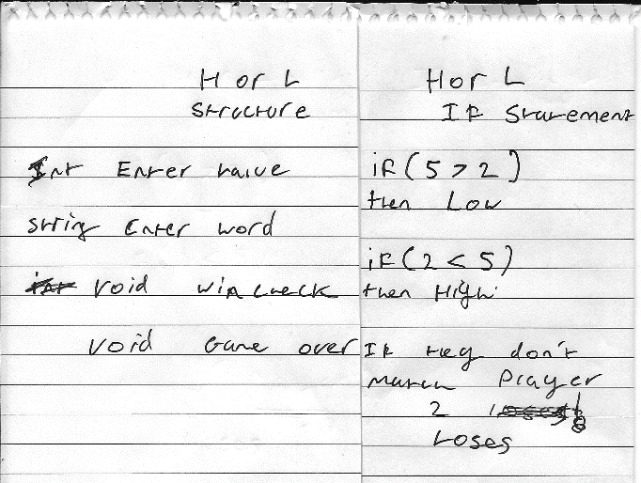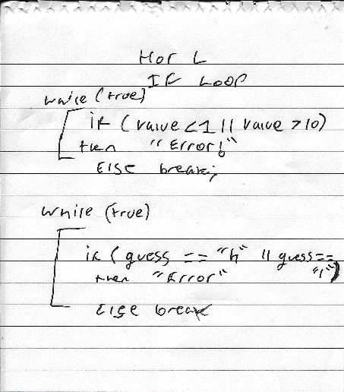

Treasure Hunt
The working out below helped me plan my treasure hunt game.
The first scanned document on the left helped me plan the types of checks and variables that will be required in order to make the treasure hunt game.
The middle-scanned document was my structure plan to make the game. Although, making the functions were hard at this point due to lack of knowledge.
The third scanned document enabled me to create a check to know if either player 1 or 2 won. The code underneath the check helps to clear the screen. This helped to prevent player 2 from cheating.
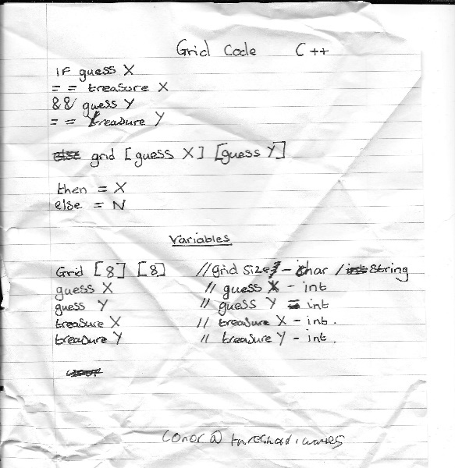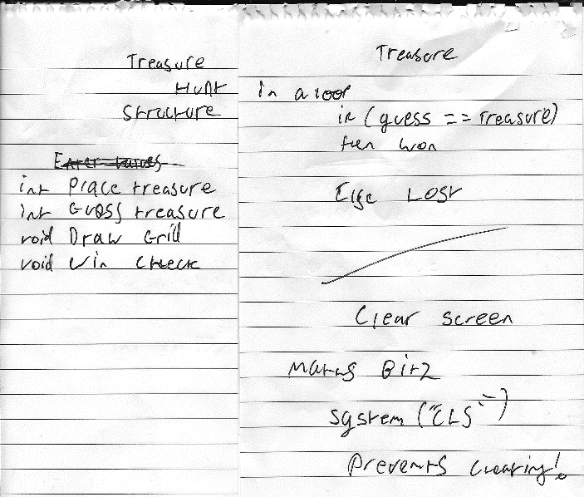
The scanned document below indicates a visual reputation of how the game may look like. By doing this technique, helped me design the game based on the plan shown below. This also helped me with debugging in the creation process.
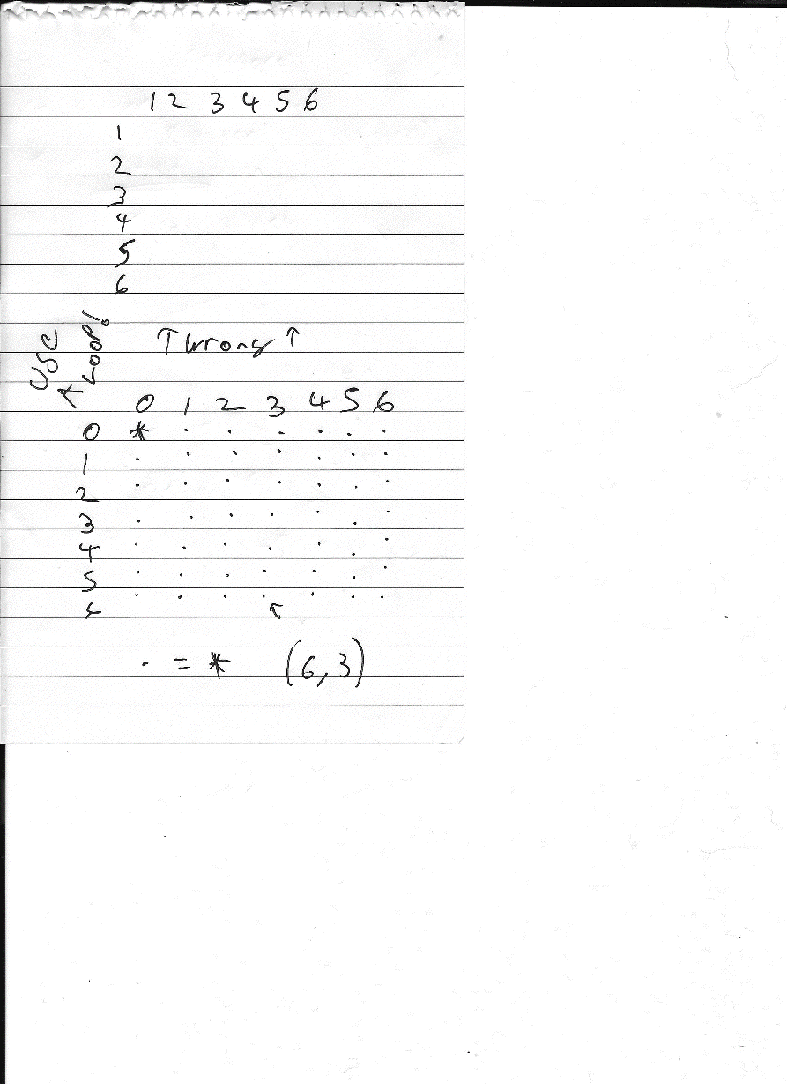

1.1.3 Connect 4
The workings out below helped me complete the connect four game. An excel spreadsheet explains the check and the time bomb workings out in further detail. Check the 4.1 Connect 4 (Page 6) found in the Appendices.
The scanned document on the left is the structure plan for the game and shows some techniques of how I could place X, O, the time bomb or the blitz bomb.
The scanned document on the right is the check to determine which player wins. By writing the loop out as 00 11 22 33 || 03, 12, 21, 30 helped me see how the loop and if statements should be set up.
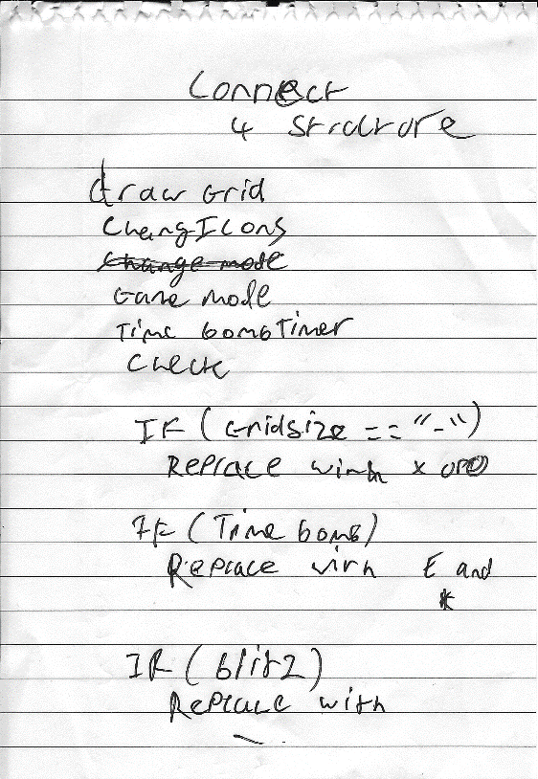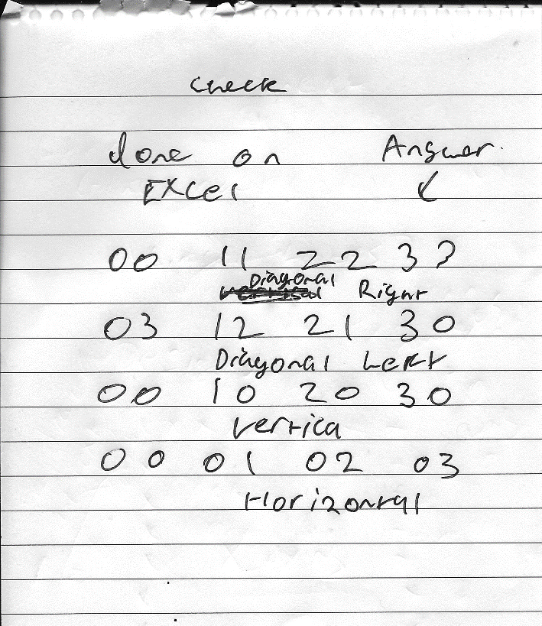
The scanned document on the left was made in the middle of the creation process. This happened because when creating the game, columns would overfill. This was hard to work out, therefore writing it out on paper helped the process. The code would simply check if there are no dashes left. It would set the column full boolean as true so it prevented it from overfilling.
The scanned document on the right were final ideas for the game, to customise the ending of the game. This is not yet implemented. However, to improve the game this could be added.
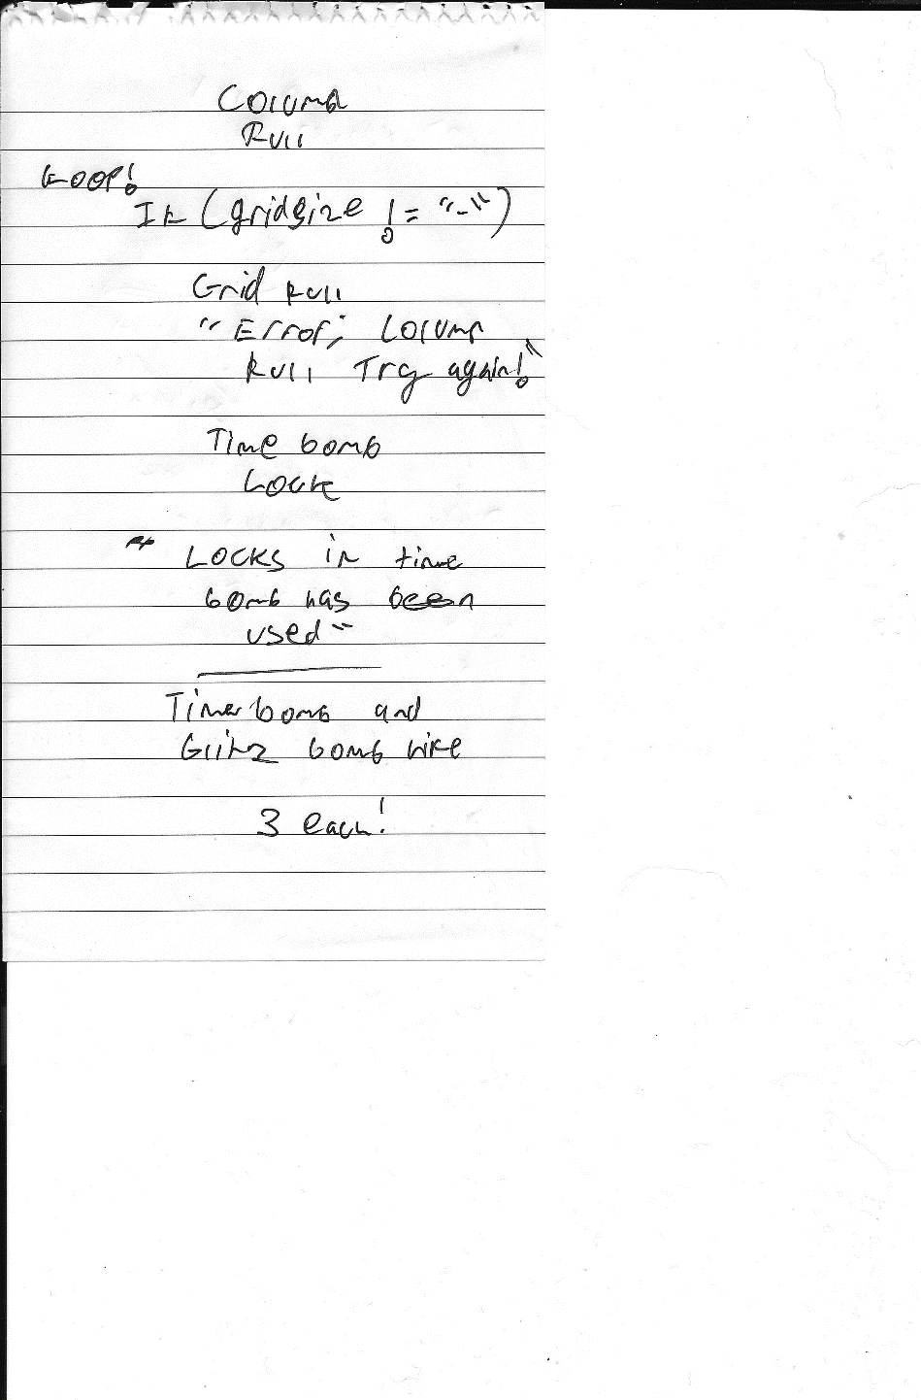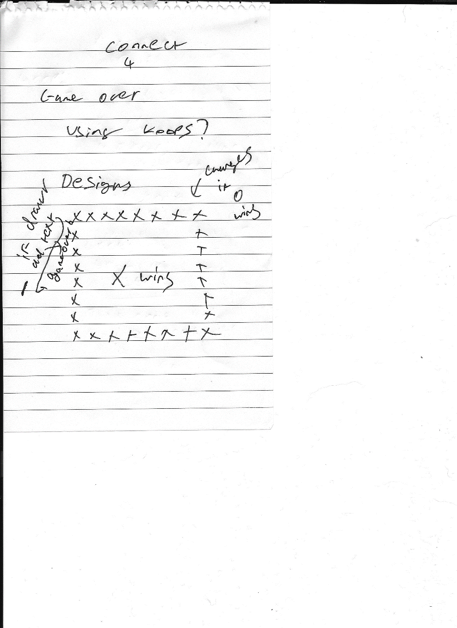

2. Stages of Development

2.1 Highest and Lowest

2.1.1 Planning Stage
During this stage, a pen and paper came in handy. First of all, the structure of the game was printed on the paper to give an idea of what the code would look like. Designing the UI on Excel helped me aim for game design. The design is shown below. The design helped me understand that the enter values should be assigned to player 1 and should be repeated 7 times and the player 2 guesses should be repeated 6 times. The other planning documents such as the structure, checks and error checks are found at 1.1.1 Highest and Lowest (Page 3)
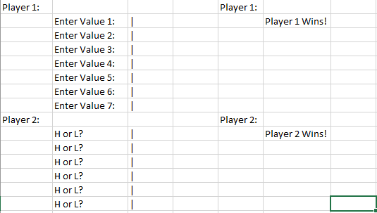

2.1.2 Creation Stage
During this stage, the game was created with the Visual Studio 2017 software package. The project was written in C++. The program was initially set up with empty functions and then the easiest steps were filled in. The problems that cropped up for this project was solved in the planning documentation’s making the task quick and easy.

2.1.3 Evaluation Stage
The product was tested multiple times to make sure that the program works. The test plan for the highest and lowest game is found on 4.1 Test Plan (Page 10) under the Highest and Lowest table heading.

2.2 Treasure Hunt

2.1.1 Planning Stage
Throughout the planning stage, I drew a grid to figure out what type of logic I would require to make the game possible. I figured that the layout I was going for was to draw the grid and ask for user input under the grid. I wanted the grid to update on the screen after the user entered the coordinates. This required further research to find the system(“CLS”) feature, which solved a few other problems in the future. This allowed me to wipe the treasure coordinates off the screen when it was player 2’s turn. This made the user interface easier to use as well.
The checks plans helped solve any issues that cropped up in the creation stage. This helped me anticipate the win check problems, time bombs and blitz bombs problems. The other planning documents such as the structure, checks and error checks are found at 1.1.2 Treasure Hunt (Page 4). The user interface design is shown below:
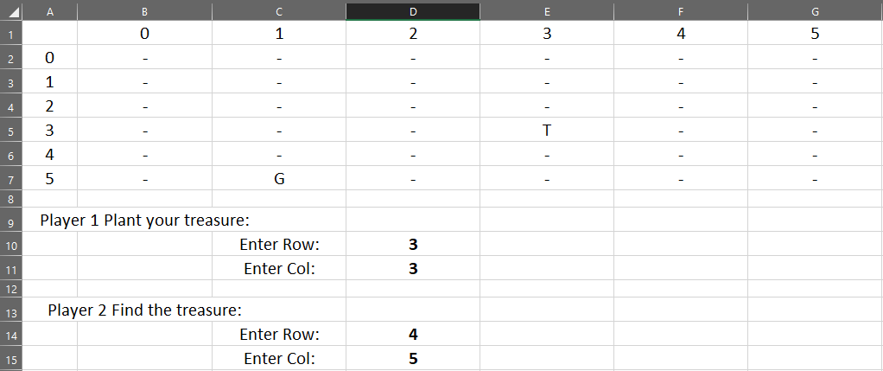

2.1.2 Creation Stage
The creation of this game was hard at first as it was coded with 1D (dimensional) arrays. This made it hard to place the treasure and draw the grid. During this stage, recreating the game had to be done, but the second time I decided to use 2D arrays. This allowed making a 6 by 6 grid, referencing the fields easier to write or read from them.
The planning stage wasn’t fully complete which impacted the time when creating the software as I never anticipated the overfill and horizontal check problem.
Whilst creating the project, I was storing the game logic in the main function and ended up putting all the functionality in that function. This can be improved to make it easier to understand.

2.1.3 Evaluation Stage
After testing it a few times, I felt the need to add some functionality such as a naming system to allow players to name themselves. This made the game less confusing.
These are found in the test plan found at 4.1 Test Plan (Page 11) on the table heading Treasure Hunt.

2.3 Connect 4

2.1.1 Planning Stage
The connect 4 planning stage involved a bit more planning than the other games. This involved solving problems for the game design, checks, power-ups and other future problem that might have occurred.
The plan below shows the user interface plan for the game. For the other plans check under 4. Appendices for 4.1 Connect 4 (Page 9).
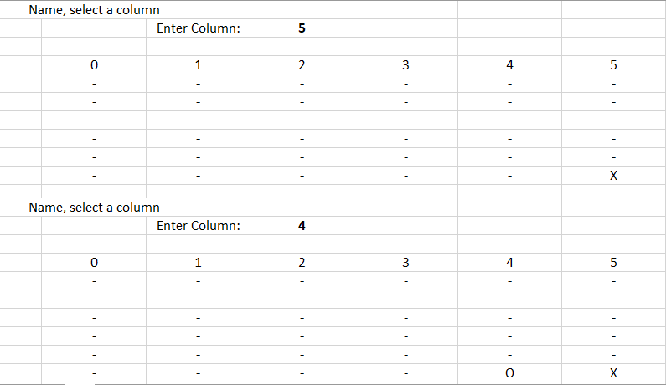

2.1.2 Creation Stage
The creation stage involved piecing the plans together and turning them into code. The plans made this step fairly easy, though some problems cropped up that were not thought of at the time. These are things like the game over sequence and whether or not add additional features.
During this process, many variables were renamed making the program easier to understand. The layout was changed based from the plan making it more user friendly.

2.1.3 Evaluation Stage
Extra functionality of the game was added such as vanilla and explosive which allows the user to play normal connect 4 or with power-ups. After testing the game a few times, I noticed that there is no game overcheck, which means that all the columns can fill up, and it doesn’t end the game on its own.
The game may improve if use of colour, bolt and different font was used. The game code is hard to understand due to the lack of functions included in the software.
These are found in the test plan found at 4.1 Test Plan (Page 11) on the table heading Connect 4. For debugging the code, I used a flowchart technique. For more information look at 4.1.1 Flowchart Troubleshooting (Page 9).

4. Appendices

4.1 Connect 4

4.1.1 Flowchart Troubleshooting
By converting my flowchart using Flowgorithm found on their website: http://www.flowgorithm.org/
This helped me find the problem in the IF statement. I need to add
|| blitzBombSelect to allow the bomb to enter the IF statement without it ignoring it, as it checks if the column is full or not but the bomb empties a column so no need.
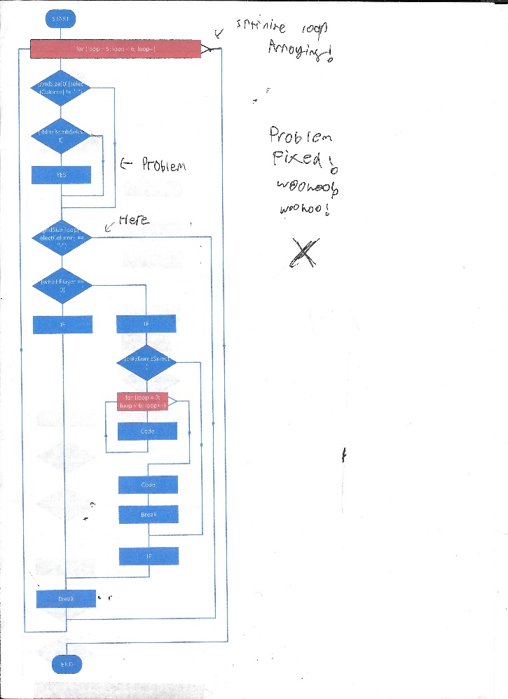

4.1.2 Check Planning
The screenshot below shows the checks I’d have to commence.
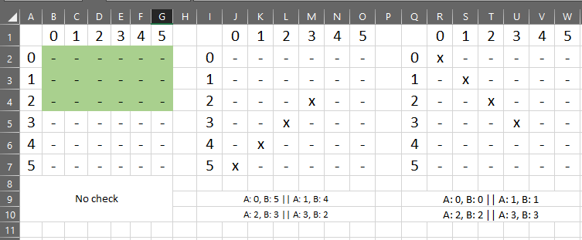
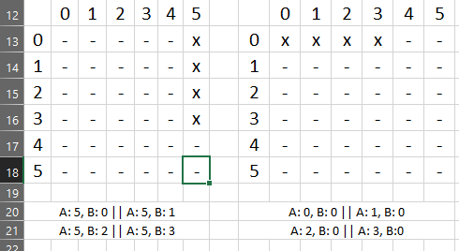

4.1.3 Time Bomb Plan
The excel shows all the possible locations the time bomb can enter giving an idea of what calculation I’d have to make.
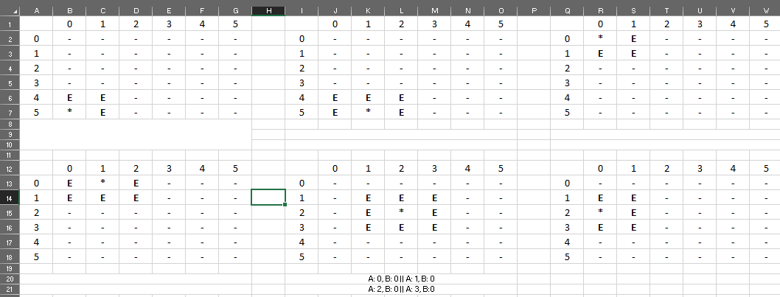

4.1 Test Plan
Project
Project | Description | Expected Result | Actual Result | Solution | Solved
Highest  and  Lowest | Values between 1-10 | Player 1 should only enter values between 1 and 10 | Player 1 could only enter 1 and 10. | Not Required | Solved
Highest  and  Lowest | Values the same next to each other | Player 1 should only enter unique numbers next to each other. For example:  505 not 550 | Player 1 could enter the same numbers next to each other. | H and L guesses both worked for player 2. This was to work around the error. | Partially
Highest  and  Lowest | Win Check and Player 2 Guess Loop | If player 2 lost the game, the game shouldn’t ask the user to enter more numbers. | When player 2 lost the game, the loop carried on. | Exit(0); was used to break exit the program once player 2 had lost. | Solved
Highest  and  Lowest | Player 2 Guess Values | Player 2 should only be able to enter 6 values. | Player 2 could enter 7 values making the program crash. | loop < 6; was set instead of loop < 7; | Solved
Highest  and  Lowest | Player 1 and Player 2 Text | Player 2 shouldn’t be able to see Player 1 entered values. | Player 2 could see Player 1’s values. | System(“CLS”); is used to prevent this from happening. | Solved

Treasure  Hunt | Enter Coordinates | Player 1 should be able to choose coordinates to hide treasure. | Player 1 could hide treasure but couldn’t be found by player 2. | The use of 1D arrays made this concept harder. Using 2D arrays fixed the problem easier. | Solved
Treasure  Hunt | Functions | The game should have plenty of functions to make it easier to understand. | Returning 2D arrays from functions was hard to grasp hold of. | Knowledge of how 2D arrays are referenced to and from functions will help improve the project. | Not Solved
Treasure  Hunt | Draw Grid | The grid should draw into the console as player 1 plants treasure updating the locations for player 1 to see. This should disappear from the screen when player 2 tries to guess where player 1 hid the treasure. | The grid does draw into the console for both player 1 and player 2 showing the planted treasure and guesses.  The grid clears after a player makes a move and redraws making the console look tidy. | System(“CLS”); and 2 loops (ROW and COL) did the trick. | Solved
Treasure  Hunt | Lives | Player 2 should be given so many lives to prevent an unfair and long game. | Player 2 was given 3 lives in the end, ending the game with Player 1 wins if ran out. | Not Required | Solved
Treasure  Hunt | Player 2 Guesses | Player 2 guesses should be stored in an int variable and would require two, X and Y. | Player 2 guesses were hard to use as they were stored in single variables. | Making the player 2 guesses in an array made it easier to use against the gridsize array. | Solved
Connect  4 | Functions | The game should have plenty of functions to make it easier to understand. | The game requires separates functions as the function main is packed making it hard to understand or even problem solve. | Knowledge of how 2D arrays are referenced to and from functions will help improve the project. | Not Solved
Connect  4 | Game Mode | The game didn’t need a game mode option. Although, personally the idea of the vanilla and explosive game modes allowed the players to choose their gameplay. | The game mode switched from standard mode to the time bombs and blitz bombs actions. | Not required. | Solved.
Connect  4 | Blitz Bomb and Time Bombs Activation | The game should allow the players to activate the power-ups by T or B values. | The game allows the players to activate power-ups by T or B values. | 10 (Time) or 11 (Blitz) activates power-ups. | Partially
Connect  4 | Time Bombs Timer | The time bomb should lock rows up until the time bomb starts to free up. | The time bomb doesn’t gradually disappear, it disappears after the next players turn. | Sorting out a timer would help the problem. Implementing the feature would make the main function longer and messier. | Partially
Connect  4 | Checks | The checks should make sure a player wins if either X or O is 4 in a row, column or diagonally. | The horizontal check never worked properly. | row < 6 & col < 6  if (col + 3 < 6)  Instead of making the loop < 3; and if(col + 3) | Solved

References
There are no sources in the current document.

