DS2 Final assessment
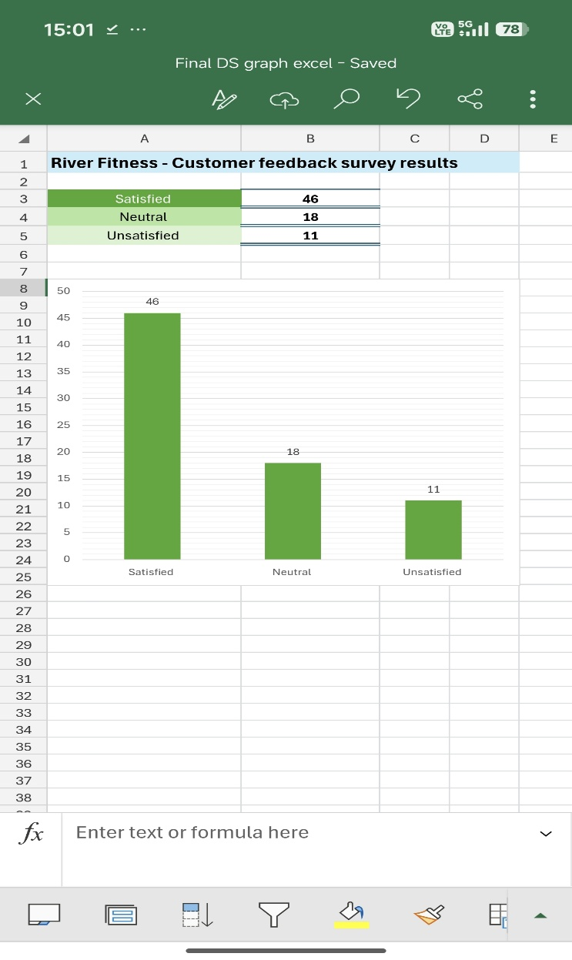
This graph shows the majority of customers are satisfied with the gym services at River Fitness.

Explanation:
This chart shows that the vast majority of customers at River Fitness are satisfied with the gym services based on the information given.

Why I chose my tool:
I decided to choose Excel as a tool for providing feedback because I understood, from the UWTSD Digital skills module, the platform supports data collection and can help create graphs for the viewer to easily read.
The use of Microsoft Excel for a business, in my opinion, is considered the most useful as it helps create charts and graphs efficiently from the data input. By collecting the data from the table, Excel automatically sorts the amount in order and creates a readable graph. This method can save time and money, helping to support the growth of a business from data analysis.
I understand the importance of presenting business information clearly and how inadequate information can become detrimental to businesses if the information is wrongly stated. Therefore, because of this reason, my artefact is clearly labelled to be able to communicate the feedback to the manager, members of staff and customers using the River Fitness facilities.

What information I used:
I used the data received from the manager of River Fitness to create the graph. I identified the number of answers for each option, Satisfied, Neutral and Unsatisfied.
From learning about how to use TEEL and skim reading in my UWTSD academic skills module, I could then transfer these new skills to help read the scenario and identify the main topic and task.
This method helped me to create an Excel table which then led onto the construction of the graph from my chosen scenario.

How I created my artefact:
Step 1-
I transferred the identified data into the Excel spreadsheet.
Step 2-
I created a table using colour-coordinated rows for readable analysis. I also chose bold formatting.
Step 3-
I used the ‘ select all’ option to highlight the table contents.
Step 4- Producing the graph
I clicked on INSERT>CHART>COLUMN to choose my graph design layout. I then searched for the tool ELEMENTS>DATA LABELS to help identify each category.
Afterwards, I decided to choose COLOUR>GREEN to match the table above the graph, to improve the appearance and make the graph easier to understand.
Lastly, I chose to use GRİDLİNES(PRİMARY MİNOR HORİZONTAL) for the graph to be able to be read more specifically.
Step 5-
Finally, I labelled the artefact in bold and highlighted in blue to stand out from the rest of the information and minimised my graph to fit underneath the table.

What changes I made:
- I used bold to highlight key information
- I changed the graph colour to stand out
- I added data labels to show specific numbers, not just approximate.
- I inserted grid lines for the viewer to easily read the outcome of the survey.

Feedback I used:
I used the input from student opinions and made a comparison to better enhance my artefact.
I also used the feedback from my tutor to improve my artefact to a greater standard.

Final explanation:
This artefact enhances the businesses operations as it shows whether improvements are required to meet the needs of the customer. By using Excel, it also reinforces the idea of using this tool in a business setting. The artefact can be compared to future survey feedback to understand whether the improvements made from the previous review have altered the satisfactory rate, increasing the number of customers positive views.

Source materials:

University of Wales Trinity Saint David (n.d) Digital skills ( week 3) Moodle. Available at: http://Moodle.uwtsd.ac.uk ( Accessed: 19 July 2026 ).
University of Wales Trinity Saint David ( n.d) Academic skills ( week 3) Moodle. Available at: http://Moodle.uwtsd.ac.uk ( Accessed : 19 July 2026 ).

