MOCK EXAM

Q1
- Circuit Design
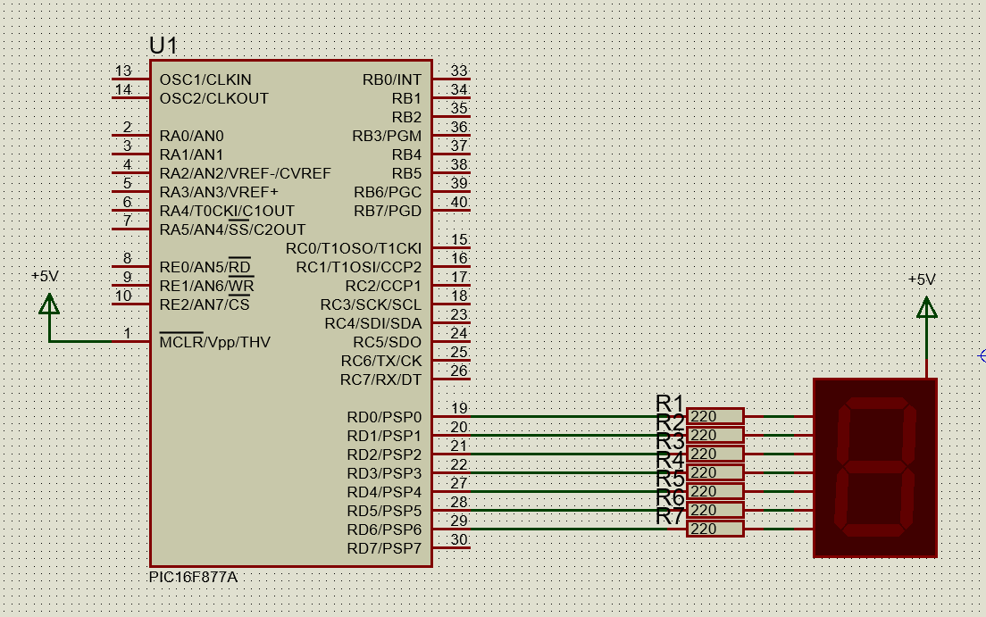
- C Program
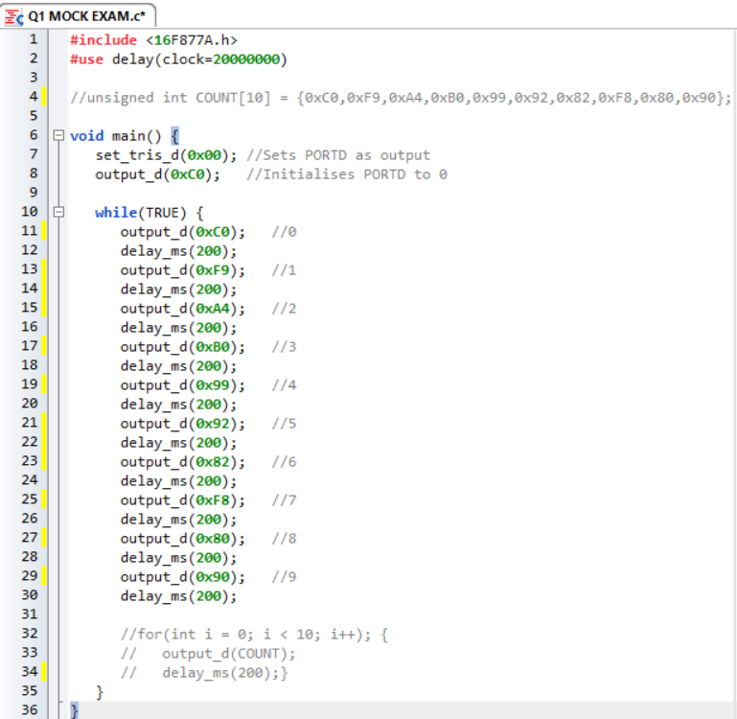
- Execution of Program

Q2
- Circuit Design
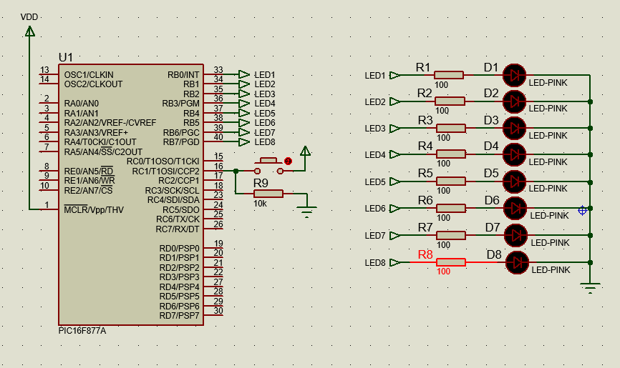
- C Program
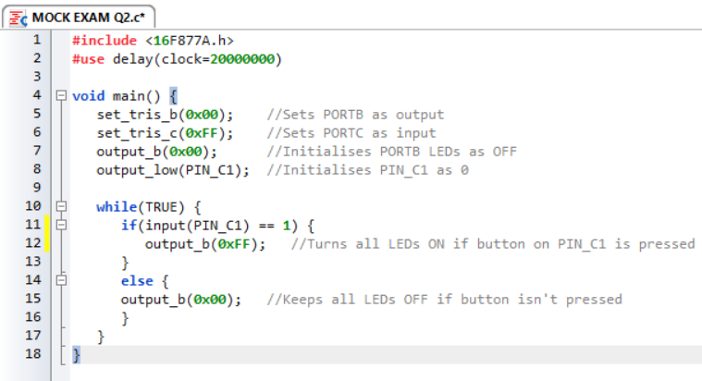
- Execution of Program

Q3
- i)
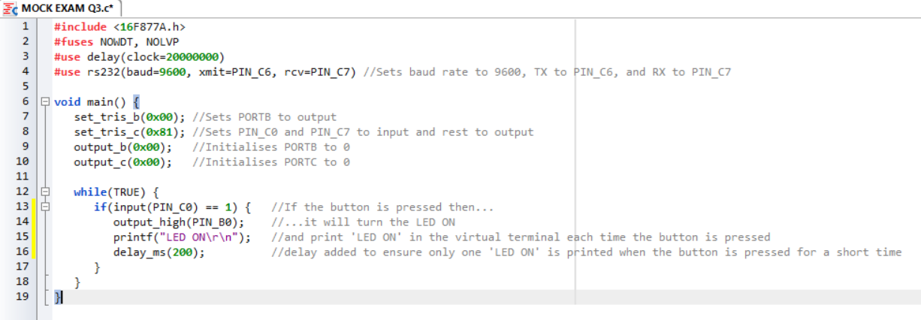

- When the start button is pressed, then the LED turns ON, and “LED ON” is printed to the virtual terminal. After the first press, the LED is constantly ON and each time the button is pressed after this another “LED ON” is printed to the virtual terminal on the line below the previous.
- The LED is controlled using PORTB as an output, so when the microcontroller gets an input on RC0, RB0 outputs 1 to turn on the LED. The virtual terminal communication is controlled by TX (transmit) and RX (receive) on PORTC of the microcontroller and this uses UART communication to communicate with the virtual terminal.
- The role of RB0 in this simulation is to be an output, to turn on the LED (when the button is pressed on RC0). The role of RC0 is to be an input to the microcontroller, that when pressed it signals the microcontroller to output a 1 on RB0 to turn on the LED.

Q4

The operation performed by this program when executed is that if the button is pressed (it will input 0 to the microcontroller as it is an active LOW button, meaning when pressed the button connects to GND) the LED will turn ON, and “LED ON” message is sent to the virtual terminal. Another message to the virtual terminal is only added after the button is released and pressed again – it doesn’t matter how long you hold the button.

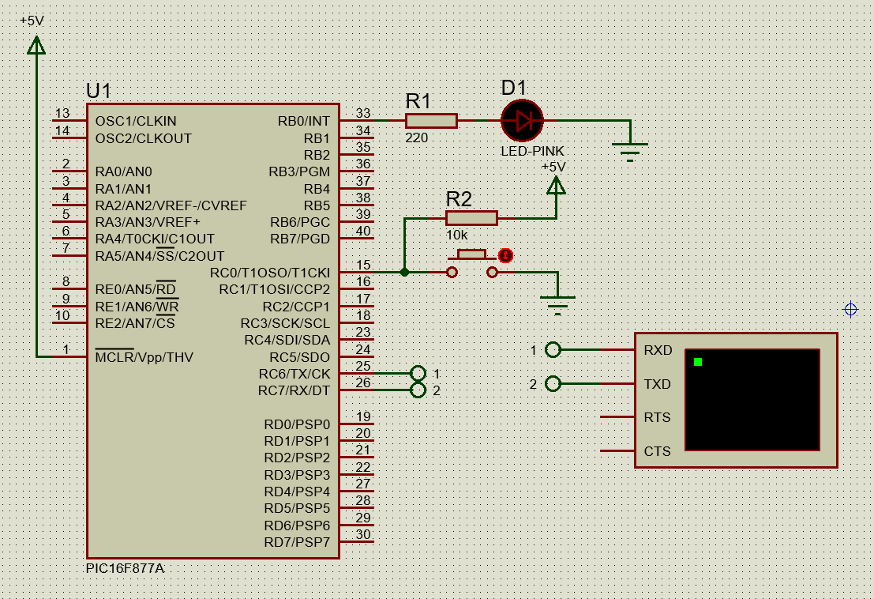

- set_tris_b(0b11111110) sets PORTB PIN_C0 to an output and all other pins to an input.
- The while statement in the program allows input polling instead of using delays.
- The microcontroller may short if there is no resistor, but if there is no GND or resistor, then the microcontroller doesn’t have a reference.

