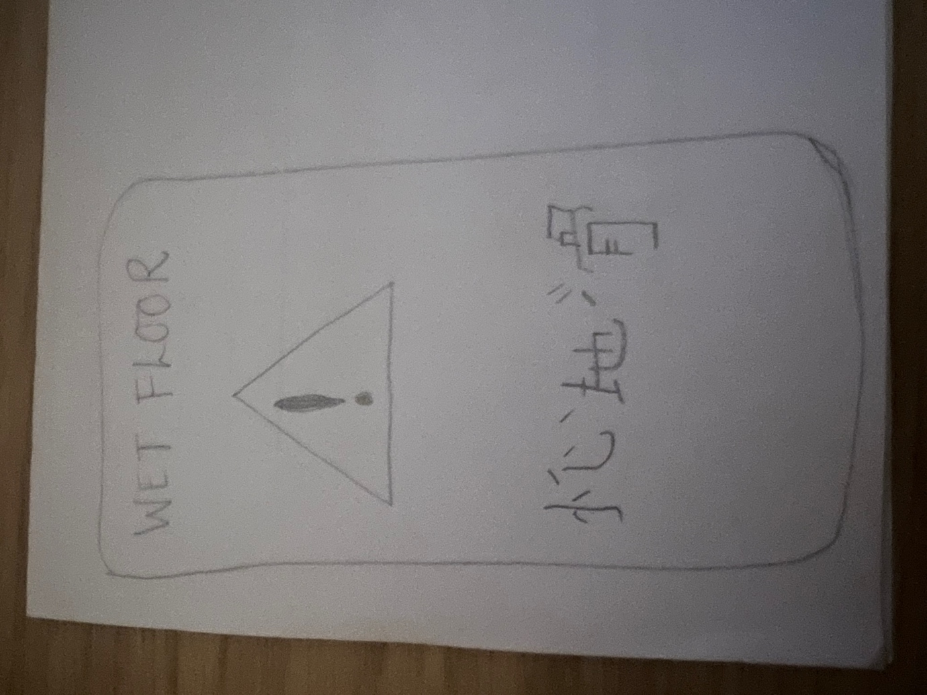

This is shabeena Khalil. Hello teacher li My caution sign wet floor for mandarin class. I hope you approve it.

