

Programme: Master of Business Administration
Module: International Business Concepts
Module code: LCMB7034

Student Name: Raj Kanubhai Hirpara
Student ID: 2413602
Group: 3

Lecturer: Gladius Kulothungan

AI acknowledgement


Table of Contents
1. Introduction 4
2. Organisational Classification and Global Strategy 5
2.1 Netflix’s International Business Model 5
2.2 Bartlett and Ghoshal’s International Strategy Framework 5
2.3 Netflix’s Transnational Strategy: Global Integration and Local Responsiveness 5
2.4 Global Geographic Configuration and International Footprint 6
2.5 Global Value Creation and Competitive Advantage 7
3. Macro-Environmental Appraisal and Market Attractiveness 8
3.1 China’s Digital Entertainment Market: Strategic Context 8
3.2 Political Factors 8
3.2.1 Government Control of Online Media and Entertainment 8
3.2.2 Censorship, Content Approval and Political Sensitivity 9
3.2.3 Geopolitical Risk and State Influence in the Digital Economy 9
3.3 Economic Factors 10
3.3.1 Market Size, Digital Infrastructure and Internet Use 10
3.3.2 Consumer Income, Price Sensitivity and Subscription Demand 11
3.3.3 Competition, Costs and Commercial Profitability 11
3.4 Legal Factors 12
3.4.1 Foreign-Investment Restrictions in Media and Audiovisual Services 12
3.4.2 Content Licensing, Platform Registration and Broadcasting Rules 12
3.4.3 Cybersecurity, Data Protection and Cross-Border Data Rules 13
3.4.4 Algorithm Regulation, Intellectual Property and Consumer Protection 14
3.5 Cultural Factors 14
3.5.1 Domestic Content Preferences and Local Storytelling 14
3.5.2 Language, Cultural Sensitivity and Content Localisation 15
3.5.3 Mobile Viewing, Payments and Loyalty to Local Platforms 15
3.6 Critical PELC Synthesis: China’s Overall Attractiveness for Netflix 16
4. Dunning’s Eclectic Paradigm: OLI Analysis 18
4.1 Netflix’s Ownership-Specific Advantages 18
4.2 China’s Location-Specific Advantages and Disadvantages 18
4.3 Internalisation Advantages and Constraints 19
5. Entry-Mode Strategy and Strategic Synthesis 21
5.1 Netflix’s Historical International Expansion Pattern 21
5.2 Suitability of Direct Platform Entry and Wholly Owned Investment 21
5.3 Evaluation of Partnership, Joint-Venture and Licensing Options 21
5.4 Recommended Phased Strategic Partnership and Content-Licensing Model 22
6. Conclusion and Recommendations 23
7. Reflective Account Using Gibbs’ Reflective Cycle 24
7.1 Description: Research and Preparation Process 24
7.2 Feelings: Initial Expectations and Challenges 24
7.3 Evaluation: Effective and Difficult Aspects 25
7.4 Analysis: Learning from Theory, Research and Evidence 25
7.5 Conclusion: Key Learning Outcomes 26
7.6 Action Plan: Future Research and Analytical Improvement 27
Reference list 28

List of Figures

Figure 1 Netflix’s geographic reporting segments and China as a proposed, non-direct-entry market 7
Figure 2 Porter’s Five Forces Analysis of Netflix’s Potential Entry into the Chinese Market 17
Figure 3 Dunning’s OLI Framework for Netflix’s Potential Entry into China 19

1. Introduction
Netflix is a global entertainment company providing subscription-based streaming services in a large international network. Its competitive strength is underpinned by a scalable digital platform, a recognised global brand, data-driven content recommendations and investment in both licensed and original programming. China is selected as a potential target market due to its large digital audience, sophisticated mobile connectivity, and a mature online-video industry. However, Netflix does not directly offer a consumer streaming service in mainland China. Its prior relationship with the market has been mostly limited to content licensing thru iQIYI, rather than owning or operating a Netflix-branded platform. This is important because licensing does not give Netflix any direct control over subscriptions, customer data, platform design, content delivery or market strategy. This report critically assesses China’s attractiveness for Netflix using Bartlett and Ghoshal’s framework, PELC analysis and Dunning’s OLI paradigm and then evaluates most appropriate entry mode.

2. Organisational Classification and Global Strategy

2.1 Netflix’s International Business Model
Netflix, Inc. is an American multinational entertainment company that provides streaming entertainment thru direct-to-consumer digital channels. Its core model marries a globally scalable platform with investment in licensed and original films, series, documentaries, games and live programming. Most of Netflix’s revenue comes from subscription plans, including ad-supported plans in some markets. The service is offered thru internet-connected devices, with data and product capabilities that enable content discovery, recommendations, customer retention and platform development (Netflix, 2025).

2.2 Bartlett and Ghoshal’s International Strategy Framework
Bartlett and Ghoshal’s model classifies international strategy on the basis of pressures for global integration and local responsiveness. An international strategy largely transfers knowledge created in the home country; a multidomestic strategy focuses on national adaptation; and a global strategy centralises activities to achieve standardisation and scale. A transnational strategy aims for global efficiency, cross-border learning and responsiveness to local markets simultaneously (Bartlett and Ghoshal, 1989). The model is relevant because streaming platforms have to manage the global scale of technology and content with local regulation, culture and consumer demand.

2.3 Netflix’s Transnational Strategy: Global Integration and Local Responsiveness
Netflix is, in the first place, a transnational corporation, as it combines global integration with selective local responsiveness. Its integrated components are a common digital platform, a globally recognised brand, shared product-development capabilities, content-delivery technology and centrally coordinated investment in data, content and marketing. That arrangement enables Netflix to spread the high fixed costs of technology and content across many countries. A show made for a market can also be sold internationally, allowing Netflix to get more mileage out of one piece of content investment.
And at the same time, Netflix localises for the market. Its catalogues differ from territory to territory due to differences in content rights, regulations and consumer preferences. The company uses subtitles, dubbing and country-specific marketing and commissions and acquires local-language content. This mix of local programming and global distribution is referred to as a “glocal” strategy in research on Netflix, where non-English-language programs are available to viewers worldwide (Lobato, 2019; Jenner, 2021).
But this strategy has limits. Localisation involves spending on production, compliance and market knowledge. Regulatory requirements can constrain availability of content and operations of platforms. Netflix’s editorial independence, data practices, and direct relationship with subscribers could be severely curtailed by official controls over audiovisual content and digital-platform activity in China. Therefore, Netflix’s typical transnational model may not be transferable without significant adaptation.

2.4 Global Geographic Configuration and International Footprint
Netflix reports its business in four main geographic regions: United States and Canada (UCAN), Europe, Middle East and Africa (EMEA), Latin America (LATAM) and Asia-Pacific (APAC), with a broad direct-to-consumer footprint internationally. The regional organization allows the company to coordinate global platform capabilities and at the same time respond to regional differences in terms of content demand, language, pricing and competition. International operations provide Netflix with diversified sources of revenue and audience demand outside of North America. However, Netflix does not have a direct consumer streaming service in mainland China, thereby making China a strategically relevant but institutionally limited potential market (Netflix, 2025).
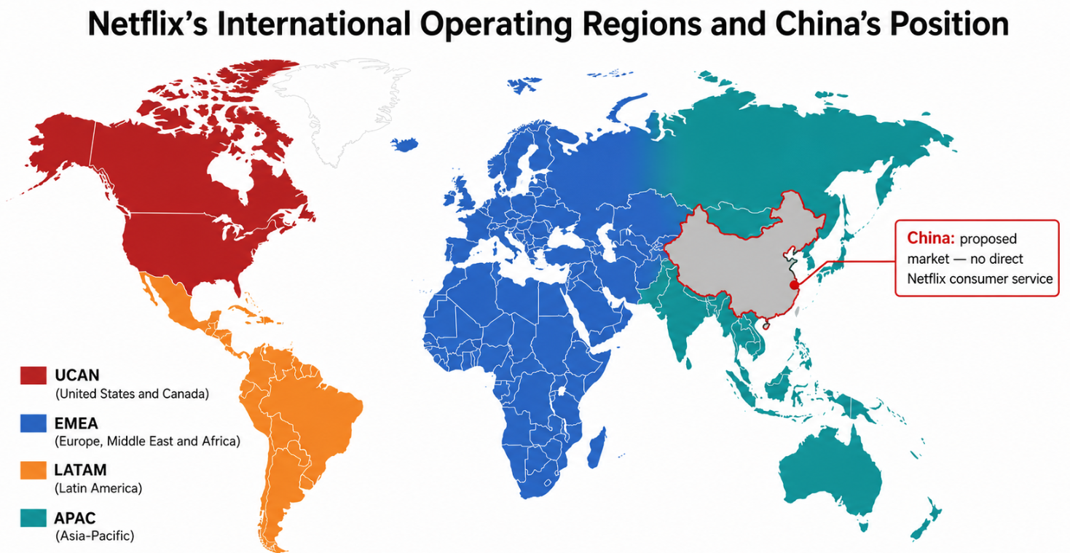
Figure 1 Netflix’s geographic reporting segments and China as a proposed, non-direct-entry market

2.5 Global Value Creation and Competitive Advantage
Netflix’s competitive advantage comes from global scale, digital technology, brand strength, content capability and cross-border learning. Its wide international reach reduces average distribution costs and increases the potential return on investment in content. The company’s recommendation and personalisation systems help users find relevant programs, boosting engagement and retention. International distribution also helps locally produced content reach larger audiences, supporting both revenue and brand differentiation. But these advantages come with access to customer data, flexibility on content and control over user experience, all of which might be constrained in China.

3. Macro-Environmental Appraisal and Market Attractiveness

3.1 China’s Digital Entertainment Market: Strategic Context
China is a big potential market for Netflix, but it’s a highly contested one. The large base of internet users, high penetration of smartphone devices and sophisticated ecosystem of digital-payments underpin strong demand for online entertainment. Video consumption is part and parcel of everyday digital life, from subscription streaming to advertising-supported services, short-video platforms and livestreaming. But the market is dominated by established domestic platforms like iQIYI, Tencent Video, Youku and Mango TV, which have local content libraries, regulatory experience and integrated domestic tech ecosystems. China's online-video sector provides scale and a sophisticated digital infrastructure, but Netflix would encounter high competitive intensity and a market structure that is fundamentally different from its current direct-to-consumer operations (Huang, 2025).

3.2 Political Factors

3.2.1 Government Control of Online Media and Entertainment
China’s online-media sector is regulated under a state-led system that treats audiovisual services as culturally and politically sensitive industries. Licensing and administrative supervision and content management obligations allow authorities to exercise broad oversight over broadcasting, online publishing, film, television and internet-platform operations. That’s important for Netflix, as its business is not solely about the technology-driven distribution, but about selecting, promoting and recommending entertainment content directly to consumers. So government control could affect the company’s catalogue, release schedules, messaging, data practices and its ability to manage the platform independently (Cai, 2008).
The environment creates a structural disadvantage for Netflix relative to domestic platforms like iQIYI, Tencent Video and Youku. Local competitors have emerged within the regulatory system and have relationships, local compliance capabilities and familiarity with regulatory expectations. Netflix would need to invest heavily in local legal expertise, ongoing compliance monitoring and regulatory engagement. Thus, political governance is not an external background condition but directly impacts the operational autonomy of Netflix, the speed of entry, and the capacity to maintain a globally consistent streaming experience (Cai, 2008).

3.2.2 Censorship, Content Approval and Political Sensitivity
Content censorship is the most pressing political challenge to any potential Chinese entry of Netflix. A part of Netflix’s international brand is its wide choice of content, its experimentation with creativity and its fast-paced global circulation of entertainment programs. But in China, politically, socially or culturally sensitive material can be restricted, removed or require approval. Themes relating to national history, state institutions, territorial issues, religion, sexuality, crime, violence or political protest could pose compliance risks. The company may also be exposed to the risk of uncertainty as acceptable standards of content may change because of political events or policy priorities. (Dimitrov, 2017)
This issue impacts Netflix’s value proposition in three ways. Firstly its international content may be less attractive than its service in other countries due to catalogue restrictions. Second, the launch may be delayed and administrative costs may be higher due to content review and approval processes. Third, Netflix’s global brand image as a provider of diverse and relatively unrestricted entertainment could be damaged by large-scale editing or removal of programming. Academic research suggests that censorship in China is not only exercised by theme, but also by people or organisations perceived as a threat to the official discourse (Dimitrov, 2017). This means that Netflix would have to develop a very cautious content-acquisition, commissioning and promotion strategy. It may also have to rely on locally produced programs made from the get-go to meet domestic regulatory expectations, reducing the flexibility and creative control that is normally associated with Netflix originals.

3.2.3 Geopolitical Risk and State Influence in the Digital Economy
Broader geopolitical tensions between China and the United States would also play a role in Netflix’s potential entry. As an American digital-media company, Netflix may also face greater scrutiny on cultural influence, national security, data governance and cross-border information flows. Such risks may increase regulatory uncertainty, delay approvals or result in restrictions that are not applied evenhandedly to domestic firms. Policy changes can be rapid and a commercially attractive opportunity can become operationally unfeasible without warning.
The state’s role in the digital economy also changes the power balance between Netflix and possible local collaborators. A Chinese platform partnership can provide market knowledge, content production capability, distribution access and established regulatory relationships. But it could also reduce the control that Netflix has over intellectual property, platform design, customer data and strategic decisions. The selection of the entry mode is therefore closely linked to political risk. A wholly owned subsidiary would provide greater control, but may be difficult to establish or manage. A partnership or licensing agreement would lower exposure but may lessen Netflix’s ownership advantages. Evidence from Chinese information control suggests incentives for online platforms to produce content and user-management practices that align with government priorities.

3.3 Economic Factors

3.3.1 Market Size, Digital Infrastructure and Internet Use
The scale, high internet penetration and mature mobile-first digital ecosystem in China present a potentially large digital entertainment opportunity for Netflix. By mid-2024, China had nearly 1.1 billion internet users and internet penetration nearing 78 percent, which presents a large addressable audience for online services. A lot of users access services thru smartphones, and the widespread use of integrated payment systems, such as Alipay and WeChat Pay, reduces friction in purchasing online services and digital subscriptions. (Zhang and Phoong, 2024)
These conditions are favourable for the technical feasibility of distribution by streaming. Netflix could leverage high connectivity and smart-device usage, along with established digital-payment habits to offer subscription, advertising-supported and perhaps even mobile-oriented plans. China also has a strong domestic content-production sector, which could provide access to local creative talent, production partners and co-production opportunities (Huang, 2025).

3.3.2 Consumer Income, Price Sensitivity and Subscription Demand
China’s large pool of urban consumers provides a potential market for paid online entertainment, particularly among digitally connected consumers looking for premium drama, films, documentaries and international programming. But Netflix should not confuse a large number of internet users with a widespread willingness to pay for a standalone foreign subscription. Chinese online video consumption has evolved with a mixture of free, ad-supported consumption, tiered memberships, bundled platform benefits and pay-per-view content. (Zhang and Phoong, 2024)
This indicates the need for modifications to Netflix’s classic subscription-based business model. A competitively priced mobile plan, an ad-supported option or bundling with a domestic telecom, device or platform partner, could reduce the barrier to trial. But lower prices could cut into margins, especially as Netflix will have to pay for local compliance, marketing and content adaptation. Price sensitivity also means the perceived value is more important: Subscribers may compare Netflix not just to other long-form streaming services, but also to free short-video, social-video and livestreaming services. (Zhang and Phoong, 2024)

3.3.3 Competition, Costs and Commercial Profitability
The biggest economic challenge is competition from established domestic platforms including iQIYI, Tencent Video, Youku and Mango TV. And these companies already have large Chinese-language catalogues, relationships with local celebrities and producers, recognised brands, advertising networks, payment integration and knowledge of domestic regulation. Netflix would pay a lot to get new customers to join or switch to a separate overseas service.
Large fixed and recurring costs would also constrain profitability. These include content licensing or co-production, localisation via subtitling and dubbing, regulatory compliance, legal advice, data-management requirements, marketing and potential revenue sharing with a local partner. A low-cost entry model might reduce financial exposure, but also reduce Netflix’s control over pricing, customer data and brand experience. Otherwise, a fully controlled launch would require a bigger investment and a longer path to scale.
So Netflix should evaluate China on the basis of risk-adjusted profitability, not market size. The scale of China’s digital market is attractive, but the need to compete with mature local platforms and absorb significant compliance costs makes a rapid, high-return direct entry unlikely. A phased licensing or partnership model would be a more financially prudent approach during initial market testing.

3.4 Legal Factors

3.4.1 Foreign-Investment Restrictions in Media and Audiovisual Services
A major obstacle for Netflix is China’s legal system, as online audio-visual services are a highly regulated industry. There are restrictions on foreign investment in several media-related activities such as broadcasting, online publishing and some internet cultural services. Since Netflix’s main activity is the distribution and promotion of film and television content thru an online platform, it could be classified within the audiovisual restricted or sensitive categories. That makes a traditional wholly owned subsidiary or standalone Netflix platform less likely.
The legal risk is a strategic one, not merely administrative. Netflix usually sets the design of its platform, catalogue, brand, content investment and customer relationship. Restrictions on foreign ownership may require local participation, regulatory approvals or a structure in which operational authority is shared with a Chinese entity. Those sorts of deals could water down Netflix’s control over intellectual property, user experience and strategic decision-making. Thus, legal constraints make high-control foreign direct investment less suitable than limited licensing or partnership model.

3.4.2 Content Licensing, Platform Registration and Broadcasting Rules
Netflix would also be bound by rules on online audiovisual distribution, content licensing and platform operation. A streaming service needs to be legally entitled to distribute audiovisual content and might be subject to content review, platform registration and administrative supervision requirements. Individual programs may also be restricted on political themes, national history, religion, violence, sexuality and portrayals that are deemed inconsistent with public policy.
These rules would involve direct costs in terms of compliance staff, legal advisers, local content review and possible delays in program release. More importantly they could limit Netflix's ability to provide the catalogue that sets its global service apart. This doesn’t automatically extend to distribution in China, where Netflix would need to obtain local rights and make sure each title complies with domestic regulations. That could undermine the value of Netflix’s global library and limit simultaneous worldwide releases.

3.4.3 Cybersecurity, Data Protection and Cross-Border Data Rules
The business model of Netflix relies on the collection and analysis of viewer data, including account information, payment information, device data, viewing histories, and user preferences. This data feeds personalisation, recommendations, fraud prevention and retention. China's Cybersecurity Law, Data Security Law and Personal Information Protection Law create a data-governance regime centred on privacy, national security and data sovereignty. The framework may require firms to secure personal information, manage risks to data security and comply with conditions for cross-border transfers of certain data.
For Netflix, the implications are significant. Existing global systems may not be able to process Chinese user data due to local data storage requirements, security assessments or transfer mechanisms. The company may require local infrastructure, separate data governance processes and additional cybersecurity investment. These requirements would increase fixed costs and could impair the efficiency of Netflix’s globally integrated recommendation and analytics model (Niu, 2025).

3.4.4 Algorithm Regulation, Intellectual Property and Consumer Protection
Netflix’s recommendation algorithm is one of the main features of its customer experience. It identifies and promotes content based on user behaviour and preferences. China’s algorithm-governance rules further impose duties on platforms using recommendation technologies, particularly when the systems shape the circulation of information or consumer choices. Netflix would have to make sure its algorithmic recommendations, content ranking and advertising practices follow local rules. This could reduce the transparency, operational freedom and global consistency of its platform design.
Protection of intellectual property is also key as Netflix’s library of content, original productions, software and brand are key ownership advantages. Piracy, unauthorised distribution and poor contractual control can undermine the value of licensing agreements. Consumer protection rules may also require clear subscription terms, transparent pricing, cancellation rights and proper handling of complaints. These obligations are manageable but, collectively, they make compliance more complicated.

3.5 Cultural Factors

3.5.1 Domestic Content Preferences and Local Storytelling
Chinese audiences may judge Netflix not just on its global reputation but on the local relevance of its content. Homegrown platforms like iQIYI, Tencent Video, Youku and Mango TV have carved strong positions thanks to Chinese-language dramas, reality programs, variety shows, animation, historical series and celebrity-led entertainment. These formats are grounded in familiar social values, humour, language, historical references and audience expectations. Netflix's international catalogue may be new, but its appeal could be limited if it does not contain stories that resonate locally and familiar domestic talent. (Yaqoub, Jingwu and Ambekar, 2023)
Netflix would thus have to invest in acquiring Chinese-language content, co-productions locally compliant and partnerships with local producers. But local storytelling creates a strategic tension. Netflix’s international strategy generally benefits from original programs being able to travel across many markets, but China-specific productions may have limited international distribution due to content rights, policy requirements or cultural specificity. On the flip side, a generic global content might not be sufficient to differentiate Netflix from domestic players with large libraries of local content.

3.5.2 Language, Cultural Sensitivity and Content Localisation
Any Netflix entry would have to be localised in terms of language. It would need Mandarin Chinese subtitles, dubbing, user-interface translation, local customer support and culturally relevant marketing to be widely accepted by consumers. Netflix has experience with international localisation of its service but China would require deeper adaptation as language is so closely linked to content preferences, social norms and regulatory expectations. The regional linguistic diversity might also need to look at dialects and audience differences across provinces and cities. (Yaqoub, Jingwu and Ambekar, 2023)
Another challenge is cultural sensitivity. Netflix would need to ensure that its programming, marketing materials and recommendation practices do not offend local values or politically sensitive expectations. Themes that are commercially successful elsewhere may not translate, or may be restricted or require substantial editing in China. This can restrict Netflix’s creative freedom and increase the cost of reviewing, adapting and approving content. (Yaqoub, Jingwu and Ambekar, 2023)

3.5.3 Mobile Viewing, Payments and Loyalty to Local Platforms
The key features of Chinese digital entertainment are mobile-first consumption and platform ecosystems. Consumers are consuming content on smartphones and engaging via short-video, social-video and livestreaming formats in addition to long-form streaming. The research on short-video platforms in China demonstrates that users are both consumers and producers of content, mirroring the interactive and socially embedded nature of digital entertainment. That’s a shift from the traditional Netflix model, which has always focused on long-form, professionally-produced, on-demand content.
Netflix would need to tailor product design, pricing and promotion to mobile behaviour. A cheaper mobile plan, an advertising-supported option, integration with mobile payments and local telecommunications bundles could make the service more accessible. But linking up with local payment and digital ecosystems may entail dependence on local partners and adherence to technical or data-governance requirements.

3.6 Critical PELC Synthesis: China’s Overall Attractiveness for Netflix
China’s a compelling market, with its large digitally-connected audience, mature online entertainment market and local production capacity. However, political control, barriers to foreign investment, content restrictions, data governance obligations, fierce domestic competition, and strong cultural localisation needs all greatly reduce the feasibility of Netflix’s typical direct-to-consumer model. The country thus is a high potential and high risk market. Market size should not be a sufficient reason for Netflix to go in fully, but rather to pursue a cautious, phased content licensing or a regulated strategic partnership where there is acceptable control, compliance certainty and commercial return.
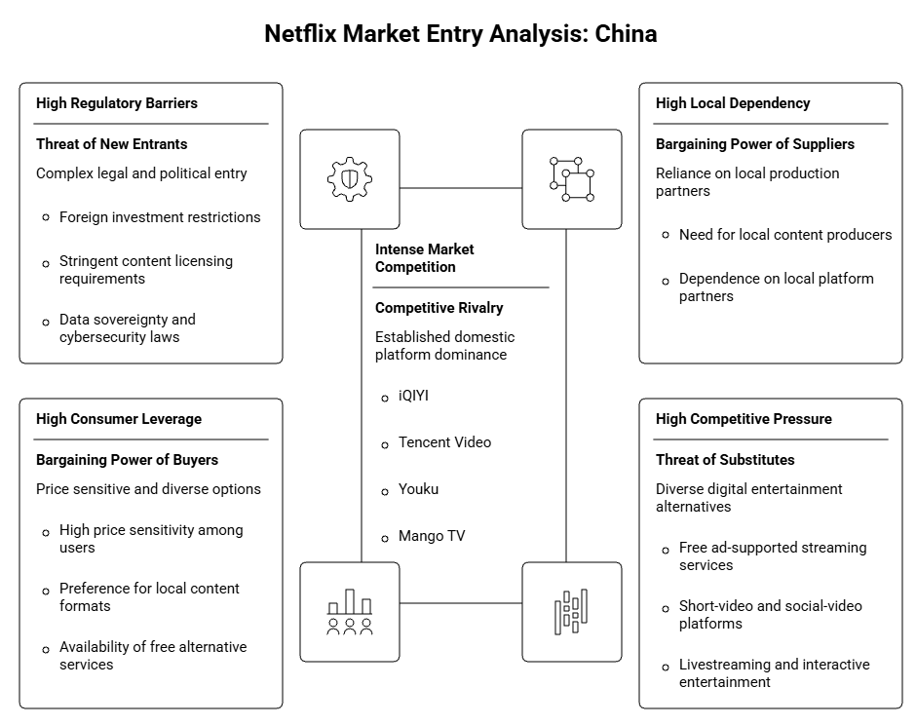
Figure 2 Porter’s Five Forces Analysis of Netflix’s Potential Entry into the Chinese Market

4. Dunning’s Eclectic Paradigm: OLI Analysis

4.1 Netflix’s Ownership-Specific Advantages
Dunning’s eclectic paradigm accounts for foreign market entry by means of ownership, location and internalisation advantages. Netflix enjoys significant ownership-specific advantages including a globally recognised brand, streaming technology, content-acquisition expertise, original-production capabilities and data-driven recommendation systems. Its platform is scalable globally, enabling the company to distribute content in many countries at a relatively low marginal cost. Netflix also benefits from experience in localising content via subtitles, dubbing, local marketing and investment in non-English language productions. (Zhang, 2024)
However, these benefits are somewhat reduced in China, as domestic competitors already have large Chinese-language libraries, local production relationships, platform ecosystems and regulatory knowledge. Hence, the global brand of Netflix alone might not be enough to overcome local competitive advantages.

4.2 China’s Location-Specific Advantages and Disadvantages
China possesses potentially significant location advantages: a large digitally connected population, widespread smartphone use, advanced digital payments, a mature online-video market, and extensive creative production capacity. These conditions could give Netflix a large potential audience, local production partners and opportunities to develop Chinese language content.
But the drawbacks of location are significant. In China, some very competitive domestic streaming platforms include iQIYI, Tencent Video, Youku and Mango TV. The country also applies political oversight, limits on foreign investment, requirements for content control, and obligations for data governance. These factors add to costs, slow down the company’s time to market, and limit Netflix’s ability to provide its normal global catalogue. So China is attractive in market size but difficult in access and risk-adjusted profitability.

4.3 Internalisation Advantages and Constraints
Netflix generally benefits from internalising its activities as direct ownership provides control over customer experience, pricing, platform technology, subscriber data, recommendation algorithms and brand standards. The internalisation also prevents any leakage of proprietary content, technology and operational knowledge to external partners. (Zhang, 2024)
In China the benefits are limited as a wholly owned model may be difficult to put in place legally and politically. Netflix could be forced to work with a local partner due to data-localisation expectations, restrictions on foreign participation in audiovisual services and content controls. Licensing or a partnership would reduce investment and compliance risk but would also reduce Netflix’s access to customer data and limit strategic control over content distribution and platform operations.
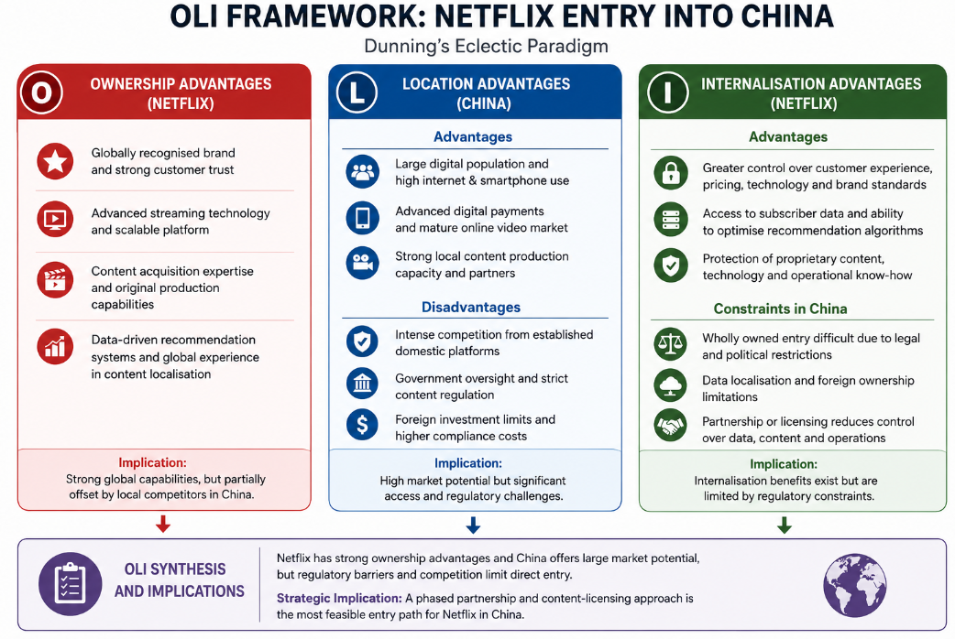
Figure 3 Dunning’s OLI Framework for Netflix’s Potential Entry into China

5. Entry-Mode Strategy and Strategic Synthesis

5.1 Netflix’s Historical International Expansion Pattern
Netflix’s international growth has been largely a direct-to-consumer digital-platform model. The company typically provides its service on a branded and direct basis, retaining ownership of the interface and relationship with the subscriber, and tailoring content, language, prices and payment methods to each market. It has added local content production, telecoms partnerships and device distribution deals to the model. This approach gives Netflix control over its brand, customer data, recommendations system and viewing experience. Historically, however, it has only expanded in markets where it is legally able to operate a foreign platform directly.

5.2 Suitability of Direct Platform Entry and Wholly Owned Investment
Full-owned Netflix platform would provide maximum strategic control. Netflix could control pricing, content selection, platform design, marketing, algorithms and subscriber data without relying on a local intermediary. It would also keep all the economic upside of successful subscriptions and ad revenue. (Sun, 2022)
But it is not suitable for China in the short term. Political oversight, restrictions on the media sector, content approval requirements, and data governance obligations could impede Netflix’s ability to operate independently or make compliance prohibitively expensive. Direct entry would also expose Netflix to high fixed costs for local infrastructure, compliance, marketing and locally acceptable content. China already has powerful domestic platforms and Netflix would have to plough in a lot to get to scale that matters. The benefits of high control are thus balanced by regulatory, financial and operational risk.

5.3 Evaluation of Partnership, Joint-Venture and Licensing Options
Entry option | Advantages | Limitations | Suitability
Wholly owned platform | High control over brand, data and user experience | Very high regulatory and investment risk | Low
Joint venture | Local knowledge, regulatory access and shared cost | Potential conflict, reduced control and IP risk | Moderate
Content licensing | Low commitment, faster access and flexibility | Limited revenue, data access and brand control | High initially
A joint venture could give Netflix access to local regulatory expertise, distribution capabilities, payment systems and Chinese-language production partners. But it could also create governance disputes for Netflix and lower the level of protection for its intellectual property. Licensing some content to an established local platform can test lower risk and demand, however Netflix will have little control over customer relationships (Sun, 2022).

5.4 Recommended Phased Strategic Partnership and Content-Licensing Model
Netflix should think about a phased strategic-partnership approach, beginning with licensing a limited amount of regulatorily compliant content to a local Chinese streaming service. The arrangement should include co-production opportunities for Chinese language programs and well-defined rights for international distribution. That limits financial risk, avoids an immediate effort to build a wholly owned platform and lets Netflix learn about local audience preferences.
Subject to regulatory clearance and performance validation, Netflix may later consider a minority equity alliance or joint venture. Progression should be based on audience demand, acceptable revenue sharing, reliable intellectual-property protections and a clear ability to protect its brand. That is more plausible than trying to copy Netflix’s usual pattern of going straight to platforms.

6. Conclusion and Recommendations
Despite the huge digital market potential that China represents for Netflix, the political control of media, the restrictive legal framework, data governance obligations, fierce domestic competition and the need for highly localised content make a direct platform launch commercially and institutionally inappropriate. So, Netflix should not enter fully owned but rather thru a phased approach with licensing of selected content and co-production with an established Chinese platform. Any move toward a joint venture should be conditioned on formal regulatory approval, strong intellectual property protections, limited exposure of proprietary algorithms and customer data, clear revenue sharing arrangements and indications of sustainable demand. This provides market learning and flexibility while protecting Netflix’s brand, technology and long-term strategic value.

7. Reflective Account Using Gibbs’ Reflective Cycle
This reflective essay evaluates the process of research, analysis and report preparation for the possible entry of Netflix into China. The research process was considered using Gibbs’ Reflective Cycle which includes the description, feelings, evaluation, analysis, conclusion and action plan (Tawanwongsri and Phenwan, 2019).

7.1 Description: Research and Preparation Process
The assignment called for a critical evaluation of a multinational corporation entering a country where it had not had a significant operational presence. I selected Netflix and China because Netflix is a well-known global digital entertainment company and China is a large but highly regulated streaming market. This gave me the opportunity to look at international strategy, environmental factors, entry barriers and market-entry options.
"My first job was to set up the relationship that Netflix would have with mainland China." In the case of Netflix, I knew it would be wrong to say there were no links to China, given some limited indirect activity around licensing content. So I removed indirect activities from meaningful direct market presence with a consumer streaming platform, local operations or a wholly owned investment.
I divided the research into four sections. Netflix international strategy, China PELC environment, Dunning OLI framework and possible entry modes. We also referred to company reports, academic literature, regulatory sources, market research and reputable news sources. I also made a word count structure before writing to keep a balance across the report.

7.2 Feelings: Initial Expectations and Challenges
At the beginning, I was confident because Netflix has a clear global business model and is widely discussed in the international business literature. Also, with its population, digital infrastructure and developed entertainment industry, I had high hopes for research opportunities in China.
But the research turned out to be more complicated than expected. China’s political and legal environment includes content regulation, restrictions on foreign investment, cybersecurity requirements, and data governance. I saw that to list these items would be to write a descriptive report. So I focused on explaining how these could impact Netflix’s content, platform operations, customer data, costs and strategic control.
Another challenge was defining properly Netflix’s relationship with China. Research indicated that you needed to maintain credibility by the difference between indirect involvement and major direct market presence.

7.3 Evaluation: Effective and Difficult Aspects
An important strength of my approach was to identify the core strategic question early on: could Netflix’s global advantages overcome the regulatory and competitive barriers in China? This meant the report could not be a general country profile.
Finally the structured word-count plan worked well as it helped to ensure that adequate attention was given to the PELC analysis without allowing too much discussion of company background. The analysis was strengthened by the use of theories of international business. Bartlett and Ghoshal’s framework explained Netflix’s global integration and local responsiveness strategy and Dunning’s OLI framework was used to evaluate Netflix’s ownership advantages, China’s location advantages and internalisation constraints.
The greatest challenge was to find up-to-date and credible evidence on Chinese media regulation. Some sources were old but detailed, and some recent sources didn't have enough explanations. I dealt with this by giving priority to official sources, company reports, academic research and credible industry evidence.

7.4 Analysis: Learning from Theory, Research and Evidence
The research changed my understanding of entering the international market. Initially, China seemed an attractive market for its population, digital infrastructure and demand for online entertainment. But the PELC analysis showed market size does not automatically create a viable opportunity. Transfer of an existing business model of a multinational company can be held back by political, legal and cultural conditions.
Bartlett and Ghoshal’s framework was helpful in my understanding of the challenges that Netflix faces in its transnational strategy. Globally integrated technology, algorithms, content investment, brand standards but also local adaptation (subtitles, dubbing, local content, partnerships) Netflix benefits. In China, the adaptation would be more difficult due to regulatory requirements, political sensitivities, domestic content preferences and strong local competitors.
But the OLI framework provided the most critical strategic insight. Netflix has ownership advantages because of its brand, streaming technology, original production capabilities and recommendation systems. China is well positioned with a large digital population, a mature online-video market and creative-production capacity. But the internalisation advantage for Netflix is limited as its preference for control of customer data, content, algorithms and platform operations could be in conflict with Chinese regulatory conditions.
The analysis of the entry modes showed the trade-off between control and risk. Direct entry provides more control but entails a big investment and regulatory uncertainty. Licensing would reduce risk, but also reduce control and access to customer information. Thus, a phased partnership and content-licensing strategy appeared to be the most balanced option.

7.5 Conclusion: Key Learning Outcomes
What I have learned thru this assignment is that good international-business analysis requires a clear connection between firm capabilities, host-country conditions and strategic recommendations. I was trained to go beyond describing environmental factors and to assess their tangible effects on operations, costs, content, data and strategic control. I also gained a better understanding of the link between theoretical frameworks and practical market entry choices.

7.6 Action Plan: Future Research and Analytical Improvement
In the future, I will create a source-evaluation matrix at the start of the research process, where I would note down the publication date, credibility, evidence and relevance of each source. I will focus on official reports, legislation, company publications and researches.
I will also spell out decision criteria before writing. These will include market potential, regulatory access, strategic control, investment, risk and expected return. I will organise evidence in writing to reduce repetition and improve the link between evidence and recommendations. Finally, I will ask for feedback earlier to see whether each paragraph contains enough critical analysis. This will allow me to produce reports that are more targeted, credible, and analytically stronger.

Reference list
Bartlett, C.A. and Ghoshal, S. (1989). Managing across borders: The transnational solution. Boston, MA: Harvard Business School Press.
Cai, Y. (2008). Local governments and the suppression of popular resistance in China. The China Quarterly, 193. doi:10.1017/s0305741008000027.
Dimitrov, M.K. (2017). The political logic of media control in China. Problems of Post-Communism, 64(3–4), pp.121–127. doi:10.1080/10758216.2017.1318346.
Huang, D. (2025). Virtual identity construction and community culture: A study on the identification mechanism of the online game ‘sword heroes fate III’ from the perspective of art anthropology. Scientific Journal Of Humanities and Social Sciences, 7(6), pp.12–15. doi:10.54691/c9k5vb24.
Jenner, M. (2021). Netflix and the re-invention of television. Cham: Palgrave Macmillan.
Lobato, R. (2019). Netflix nations: The geography of digital distribution. New York: New York University Press.
Netflix, Inc. (2025). Annual report / form 10-K. Los Gatos, CA: Netflix Investor Relations.
Niu, J. (2025). The sovereignty exception: China’s state-centric approach to national security in cross-border data flows. Lecture Notes in Education Psychology and Public Media, [online] 107(1), pp.60–66. doi:10.54254/2753-7048/2025.ld27192.
Sun, X. (2022). Two decades and more: Evolution of Netflix’s business models and outlook of future. SHS Web of Conferences, 148(2). doi:10.1051/shsconf/202214803032.
Tawanwongsri, W. and Phenwan, T. (2019). Reflective and feedback performances on Thai medical students’ patient history-taking skills. BMC Medical Education, [online] 19(1). doi:10.1186/s12909-019-1585-z.
Yaqoub, M., Jingwu, Z. and Ambekar, S.S. (2023). Pandemic impacts on cinema industry and over-the-top platforms in China. Media International Australia, 191(1), p.1329878X2211459. doi:10.1177/1329878x221145975.
Zhang, C. and Phoong, S.W. (2024). Will pay-per-view in the advanced charging model recover the business losses for online video companies in China? PLOS ONE, [online] 19(1), p.e0297977. doi:10.1371/journal.pone.0297977.
Zhang, J. (2024). Netflix evolution and strategy for future development. Lecture notes in education psychology and public media, 51(1), pp.36–40. doi:10.54254/2753-7048/51/20240649.

