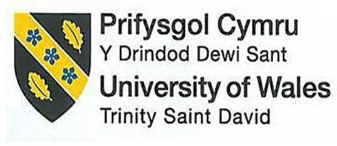

Student ID number: 2022840
Programme: BA International Hotel Management
Module: Management & Organisational Behavior
Module code: BMIH5004

Declaration
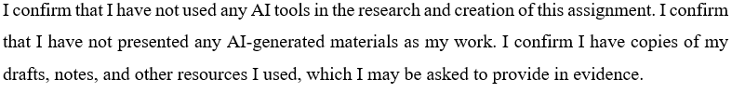

Executive summary
Hilton is one of the global leading hotels that emphasises providing the best services and excellent experience. Hilton has made significant changes such as expanding their business globally and also improving their sustainability. Hilton uses a structured approach to manage their changes and make sure they succeed. Hilton loyalty program and diverse brands help to attract the customers for the growth. Hilton face the challenges from their competitors by innovation and engaging with the employees and communities. The Hilton aims to maintain their position among the hospitality industry as a top leader and fulfill the customer needs and demands.

Table of Contents
Executive summary 2
1 Introduction 4
2 Hilton Structure, Culture and Goals 4
2.1 Hilton Structure 4
2.2 Hilton Culture 5
2.3 Goals of the Hilton at both corporate and individual unit levels 6
3 Recent Change initiatives 7
3.1 Hilton Change Initiatives Lewins Change Model 7
3.2 Impact of the initiatives on Hilton 8
3.3 Changes managed 9
4 Strategic Direction 10
4.1 Strategic direction of Hilton 10
4.2 Strategies implemented to achieve long-term objectives 11
5 Conclusion 12
5.1 Recommendations 12

Introduction
Hilton built a customer-centric brand that stands the test of time, and it evolves according to the travellers' demand. Hilton is the award-winning brand that shows a unique personality, and it has remained a signature hospitality that was established by Conrad Hilton a century ago. In 1925, the Conrad Hilton opened the first hotel, whose aim was to operate the world's best hotel in Texas. He made the commitment, innovation, and leadership that become the respected brand globally. Hilton Hotels & Resorts is the worldwide hotel brand that has full-service resorts and hotels. It is the flagship brand of the American multinational hospitality industry (Hilton Report, 2025). The report discusses the culture, goals and structure of Hilton, the current changes and how these changes impact Hilton and how these changes are managed. Moreover, discuss the strategic direction of Hilton, and the implementation to achieve the long-term objectives of Hilton. In the end, conclude the overall report and give a recommendation.

Hilton Structure, Culture and Goals

Hilton Structure
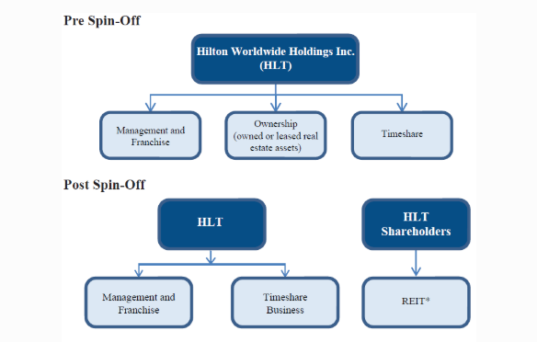
Figure 1: Hilton Structure
(Source: Cornell, 2025).

The hierarchical and divisional organizational structure of Hilton demonstrates its large-scale operations with diverse business activities. Hilton operates through ownership divisions while it also manages franchises and timeshare operations. The company's executive leader who functions as CEO is currently holding the position of Christopher J. Nassetta who oversees the strategic direction. Workers in the next organizational level after the CEO serve as Vice Presidents and Directors who oversee their respective teams within sub-sections such as Marketing Operations and Human Resources ((Nassetta, 2024). Through an organized corporate setup, the company can draw specific choices and properly distribute resources that enables smooth guest experiences and operational triumphs.
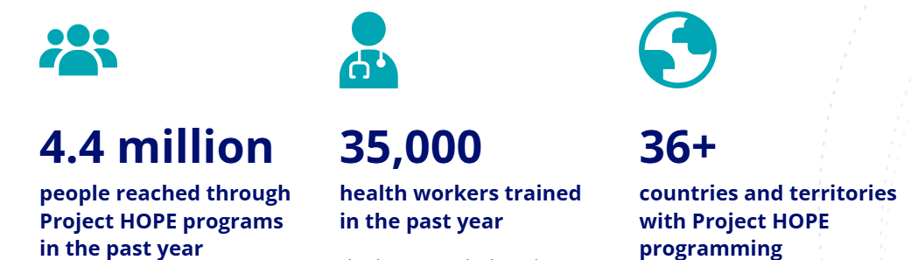
Figure 4: Hilton Project Hope
(Source: Project Hope, 2025).

Hilton Culture
The mission at Hilton leads employees to develop this company's culture of hospitality where they serve "people to people." The corporate culture at Hilton functions through four essential pillars which includes purpose and growth alongside wellness along with inclusion. Hilton follows these cultural procedures. The organization seeks to produce meaningful encounters with guests alongside rewarding opportunities for team associates along with valuable returns for its owners while creating social benefits in all communities (de Carvalho, 2024). The company sets its mission to distribute exemplary hospitality encounters for filling the world with hospitality's light and warmth. Hilton maintains its wide workforce through various wellness programs complemented by professional development and lifestyle initiatives which build community spirit throughout the company. Company surveys directed toward all team members enable the company to detect employee requirements while listening to their needs through these assessments (Hilton Story, 2022). Hilton maintains diversity is essential because it improves organizational strength and company innovation while creating brand representation that matches its worldwide clientele. The company represents natural diversity along with purposeful inclusivity by allowing various perspectives and voices to become part of its operational structure.

Goals of the Hilton at both corporate and individual unit levels
Hilton supports the Travel with Purpose strategy by targeting environmental, social and governance (ESG) initiatives (Hilton, 2023). The corporate level of Hilton focuses on:
- Hilton seeks to decrease emissions by 75% in managed facilities together with 56% in franchised establishments by the year 2030.
- Cut water usage and waste generation in half.
- The organisation plans to develop 5 million educational possibilities for their staff members alongside community members (Hilton, 2023).
- The company plans to benefit 20 million local people through dual support of job creation and economic growth opportunities (Hilton, 2025).
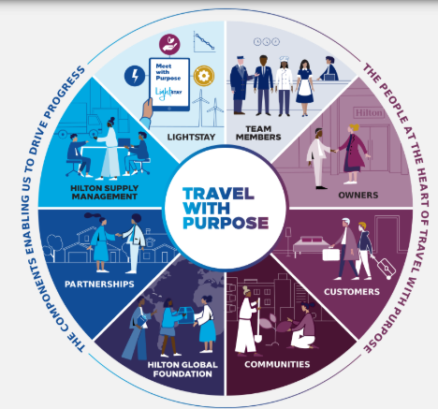
Figure 2: Hilton Travel with Purpose
(Source: Hilton, 2025).
Hotels get encouragement to adopt sustainable practices through individual unit-level programs which involve reduced waste generation and efficient energy usage (Ertuna et al., 2022). The hotels function as independent local businesses because they use funds to support their neighbours and nearby suppliers while undertaking community initiatives. Each Hilton property uses this strategy to fulfil broader sustainability and community engagement initiatives that the company sets forth.

Recent Change initiatives

Hilton Change Initiatives Lewins Change Model
Implementation of change initiatives at Hilton becomes more effective by using Kurt Lewin's Change Model's three-stage approach of Unfreeze followed by Change and Refreeze. The model shows organisations a way to handle complicated transitions through analysis of emotional and collective workforce factors.
The Unfreeze Stage enables Hilton to set its organisation on a change path through widespread awareness-building about necessary transformation. Leaders determine which aspects of the organisation require development through two processes: sustainability advancement and customer service standard upgrading. Leaderships effectively shares information about changes to employees by emphasising advantages such as superior customer satisfaction and environmental improvements. Hilton resolves employee reluctance by support systems that promote change implementation (Imaoui and van Veen, 2021).
Hilton executes new practices and systems through the Change Stage of their initiatives. Organisational training focuses on delivering complete education about new sustainability methods as well as service standards to all staff members. The company provides regular feedback discussions along with coaching services to help workers accept new procedures. Hilton follows up with new practice implementation to identify necessary modifications needed for successful implementation (Abardeh, 2022).
The Refreeze Stage enables Hilton to embed generated changes within its organisational culture (Zientara et al., 2020). The organisation updates its operational policies to establish the new practices as established procedures. The organisation rewards employees who lead change initiatives because their behavior demonstrates support for newly implemented systems (Ali and Anwar, 2021). Hilton allows ongoing feedback streams to help identify ongoing areas that need improvement as part of their ongoing dedication to sustaining their changes (Fachada, 2023).
Hilton has launched a sustainability initiative to cut energy usage alongside waste generation in all their properties (Matteucci, 2020). The implementation of Lewin's model allows Hilton to convey urgent sustainability requirements that will lower environmental harm and strengthen its brand recognition. The organisation implements new sustainable systems with waste management solutions while conducting employee training about these updates.

Impact of the initiatives on Hilton
Hilton successfully improved its company performance through its sustainability programs. Energy conservation and waste reduction together with water preservation initiatives have enabled Hilton to reduce carbon emissions by 45.1% in managed hotels and 25.1% in franchised hotels starting from 2008. The waste reduction performance of the company went beyond its initial targets since the managed hotel waste landed in landfills decreased by 63.7%. Hilton's brand reputation grew better through these efforts while supporting its target of reaching net-zero emissions by 2030. Since 2017, Hilton has directed its social impact initiative, which generated more than 2.5 million hours of volunteer work in communities (Hilton Shine, 2024). These initiatives have elevated Hilton to sustainability leadership status by following global environmental objectives while creating social benefits.
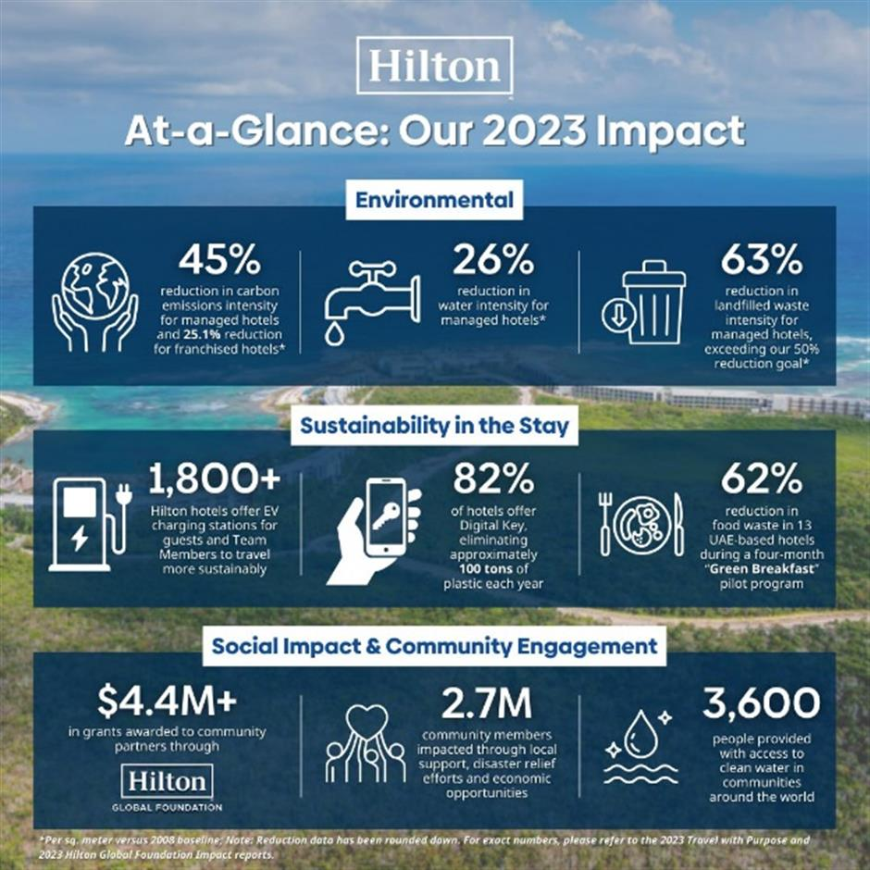
Figure 3: Hilton Sustainability
(Source: Hilton Shine, 2024).

Changes managed
The change initiatives at Hilton have achieved success across multiple essential aspects. The successful communication about sustainability and social impact changes led Hilton to engage both employees and stakeholders effectively throughout the process. The initiative allowed the organisation to create a robust supportive environment where employees actively took part. Hilton achieved system-wide implementation of new practices at its global properties through their structured approach and Lewin's Change Model. New operational standards received guaranteed implementation through essential training and resource provision from the company. The system faced possible difficulties when sustaining uniformity in multiple locations while ensuring ongoing compliance with new operational requirements. Hilton addresses operational issues rapidly through their ongoing procedure for monitoring and feedback processes (Hilton Shine, 2024). Through its strategic management of change Hilton has developed leadership in sustainable hospitality which leads to enhanced organisational reputation and operational efficiency.

Strategic Direction

Strategic direction of Hilton
1 Strengths
- Hilton maintains a broad brand selection of 13 companies which serve markets across multiple segments for different customer needs. The wide array of brands at Hilton enables the company to address shifting customer needs while entering new market locations.
- The extensive network of more than 6800 properties across the world gives Hilton opportunities to optimise operational costs and sustain market domination in the hospitality business (Zeng, 2021).
- The Hilton Honors loyalty program has become a prominent and big-scale program giving travelers steady revenue and brand devotion.
2 Weaknesses
- The usage of franchises by Hilton results in brand standard variations between locations following different guidelines, which might degrade customer satisfaction.
- The costs related to operating numerous hotel branches impact Hilton's profitability because they put pressure on the company's financial stability when economic performance deteriorates (Santos and Lima, 2024).
3 Opportunities
- The hospitality service market expansion across Asia focuses primarily on China and India as Hilton adopts an aggressive growth plan targeting rising demand. The company expands through partnership-based growth while delivering market-specific products.
- Hilton can draw environmentally concerned travellers and boost their reputation through sustainability focus thus gaining both loyal and retained customers (Oskam and Zandberg, 2019).
- The company plans to increase its lifestyle hotel footprint twice while developing its luxury brand portfolio, hence creating a new profitable avenue for growth.
4 Threats
- Many brands contest each other for leadership position within the competitive hospitality market. Hilton requires constant advancements of their products and services to preserve their business leadership position.
- A reduction in travel demand during economic downturns produces negative consequences for Hilton's revenue streams (Hilton, 2024). The organisation needs to prepare itself for alterations in economic environments.
- Modified environmental regulations with evolving tax policies force the company to face elevated operation expenses while implementing necessary costly compliance initiatives.

Strategies implemented to achieve long-term objectives
Strategy | Objective | Implementation
Brand Diversification | Expand market share | Offer diverse brands to cater to different customer segments.
Market Development | Increase global presence | Expand into new markets, especially in Asia-Pacific.
Product Differentiation | Enhance customer experience | Implement innovative technologies and services.
Strategic Alliances | Enhance global reach | Form partnerships to penetrate local markets effectively.
Sustainability Initiatives | Achieve ESG goals | Implement sustainable practices across operations to meet 2030 targets.
Digitalisation | Improve operational efficiency | Leverage technology to enhance customer experience and reduce costs.

Conclusion
Through its strategic direction and change initiatives Hilton has secured its position as the top company in the hospitality sector. Through its extensive brand diversity and international growth together with sustainability commitment Hilton maintains solid business success in today's dynamic market. Lewin's Change Model provides optimal organisational change management through its operational methods to enable steady implementation and persistence of new business practices throughout the entire organisation. Hilton achieves improved brand reputation through its dedication to sustainability and creates lasting value while accomplishing long-term goals. Recently observed market competition and economic fluctuations have not prevented Hilton from sustaining its powerful market position because of its well-designed strategic direction. The hotel chain Hilton has built a resilient base through strategic planning combined with cultural advancement, which will facilitate continuous advancement and achievement in the hospitality industry.

Recommendations
- Invest money in digital technology to develop better customer interactions as well as runs operations more smoothly and enable data-driven choices (The hospitality industry, 2019). The hotels can maximise their operations and personalise their services through AI applications.
- Expanding existing sustainability projects requires organisations to establish advanced sustainability targets together with their stakeholders who participate in environmental conservation activities. The brand should expand renewable energy activities throughout all properties while implementing waste reduction measures (Chygryn et al., 2020).
- The company should form stronger alliances between its hotels and nearby entities and businesses to create improved cultural tours for visitors, together with strengthening the regional economy. Initiating entry into new markets becomes more efficient through this approach (The hospitality industry, 2019).

References
Abardeh, H. C. (2022). Finding a Path to Success for the Hilton Atlanta Downtown Hotel. SAGE Publications: SAGE Business Cases Originals. DOI: https://doi.org/10.4135/9781529794878
Ali, B. J., and Anwar, G. (2021). An empirical study of employees’ motivation and its influence job satisfaction. Ali, BJ, and Anwar, G.(2021). An Empirical Study of Employees’ Motivation and its Influence Job Satisfaction. International Journal of Engineering, Business and Management, 5(2), 21-30.
Chygryn, O. Y., Bilan, Y. V., and Kwilinski, A. (2020). Stakeholders of green competitiveness: Innovative approaches for creating communicative system. https://doi.org/10.1002/bse.3160.
Cornell, Joe. “Hilton (HLT) to Spin-off Real Estate Assets.” Forbes, 29 Dec. 2015, www.forbes.com/sites/joecornell/2015/12/29/hilton-hlt-to-spin-off-real-estate-assets/.
de Carvalho, J. M. (2024). Leadership as a Business Adaptive Strategy During the COVID-19 Pandemic: A Case of Grupo UIP (Master's thesis, Universidade Catolica Portuguesa (Portugal)).
Ertuna, B., Gu, H., and Yu, L. (2022). “A thread connects all beads”: Aligning global CSR strategy by hotel MNCs. Tourism Management, 91, 104520. https://doi.org/10.1016/j.tourman.2022.104520
Fachada, B. C. (2023). Business Adaptive Strategies in Crisis: The case of Hilton Hotels Worldwide (Master's thesis, Universidade Catolica Portuguesa (Portugal)).
Garden, Hilton. HILTON PORTFOLIO | 1 BRAND PORTFOLIO. 2025.
Hilton Project Hope, (2025). Online Available at: https://www.projecthope.org/. Accessed date: [07/03/2025]
Hilton Report, (2025). Online Available at: https://www.hilton.com/en/corporate/. Accessed Date: [07/03/2025]
Hilton Shine, (2024). Online Available at: https://www.shine.cn/biz/company/2406289196/. Accessed Date: [07/03/2025]
Hilton Story. “Hilton Expands Wellness Platform and Benefits to Launch New Offerings Supporting Team Member Caregiving Responsibilities.” Stories from Hilton, 21 July 2022, stories.hilton.com/releases/hilton-expands-wellness-platform-benefits-new-offerings-supporting-team-member-caregiving-responsibilities.
Hilton, (2025). Online Available at: https://esg.hilton.com/our-approach/. Accessed Date: [07/03/2025]
Hilton. “TRAVEL with PURPOSE.” Hilton, 2024, esg.hilton.com/.
Imaoui, S., and van Veen, J. (2021). " Out of sight.... Out of mind" How employees made sense of organisational changes resulting from crisis management.
Matteucci, V. (2020). How can the hospitality industry increase corporate value aligned with sustainable development goals? Case examples from Hilton, Meliá and Sun. Worldwide Hospitality and Tourism Themes, 12(5), 509-523. . https://doi.org/10.1108/WHATT-06-2020-0043.
Oskam, J., and Zandberg, T. (2019).
Santos, F., and Lima, S. (2024). Hilton´ s Path to Post-Pandemic Prosperity (Master's thesis, Universidade NOVA de Lisboa (Portugal)).
Scott, S. R. (2024). Stimulating Faculty Participation in Supporting and Developing Change Initiatives.
The hospitality industry. In HospitaliJackson, P., and Carruthers, C. (2019). Data driven business transformation: How to disrupt, innovate and stay ahead of the competition. John Wiley and Sons.ty Experience (pp. 66-96). Routledge.
Zeng, L. (2021). Analysis of Hilton Worldwide Hotel Group’s Transnational Operation Strategy. Academic Journal of Business and Management, 3(11), 20-27. DOI: 10.25236/AJBM.2021.031104
Zientara, P., Bohdanowicz-Godfrey, P., Whitely, C., and Maciejewski, G. (2020). A case study of LightStay (2010–2017)—Hilton’s corporate responsibility management system. Energies, 13(9), 2303.

