Luminita Capmoale
2030541

Assessment 2
Community Engagement

LCBB4002
Community Engagement

Dr Molly Jack

September 2021

Contents

1 Introduction 2

2 Community project and charity organisation 3

3 Conclusion 8

List of references 9

Introduction

"In every community, there is work to be done. In every nation, there are wounds to heal. In every heart, there is the power to do it”. (Marianne Williamson)
I agree with this quote, because in any community where people work, live, interact with family or other people, there are various situations that require attention and when as many people are involved together so the problem seems small. In additional, community engagements appear when a need is identified and understanding for a particular group of people.

Community engagement can be defined by social or economic aspects, interests, issue, values and tradition and their connection to the problems.
Furthermore, the pillars of community engagement can offer sustainability with a much greater involvement of people such as build capacity, reduce barriers, communication and action oriented to dialogue.

The involvement of members in the community depends on their own visions and aspirations, also the collaboration through communication and interaction with all members, offers the possibility to achieve all objectives.
The role of communication and collaboration are a complex one, because when people working collaboratively and communicatively for example when analyze a problem in a group, everyone expresses their opinion, other people can comment and arguing their point of views and in this way is creating a bigger result. (Dumlao, 2018)

Similarly, in the project considered below, evidence is given that a group of people is aimed at a problem to solve it by communicating and rallying together, then the result is much greater.

Climate change has become a huge problem in the 21st century, also natural disasters increase and become more devastating. In the community that I analysed, the council Croydon seems to be concerned about that problem which requires the attention and involvement of the community, also urgent action can still reduce the pollution and increase quality of life.
Friends of the Earth was founded in 1971 and the first action was to use more efficiently of resources that planets’ have and re-use for possible savings.
Over 50 years many projects were draw and realized, accompanied by an increasing in the number of people involved in these activities.

One of the biggest events that demonstrated people power that can change the world. In addition, were involved people and members which support Friends of the Earth company and events of hundreds of thousands of people the last three years. For example, the event like the Big Ask live benefit concert with Radiohead the UK government brought in the historic Climate Change act in 2008, tying government to achieving at least 80% reducing in greenhouse gases by 2050. (Friends of the Earth, 2015)

The difference between both projects, I can say the project that I elaborated to help the community in reduction environmental pollution and improving life in community it is limited in space and focuses only on the local community. Regarding the projects created by Friends of the Earth it is one of national level, but with local action plans. Moreover, due to the number of active local groups in the communities can create a considerable change. There are approximatively 250 Climate Action groups in England, and they have online page https://takeclimateaction.uk/ for easily application. It is simple, only write postcode on interactive map, click on the group nearest and work together with community for change climate and environmental. (Friends of the Earth, 2021)

More people equal to more power, in other words Friends of the Earth make effort to engage and increase many people as possible and online facilities is a good instrument.
Also, they are building groups and collaborate with partners, following some principles:
Information and participation – the prosperous execution and achieve all proposed goals of any projects is possible with a good communication and participation. In addition, support people to take part in decision making and encourage everyone to get involved in the activity, inclusion, and equality in race, religion, ethnic, age, gender, and mobility. To build community support the friends of the Earth will ensure that the community have enough information about issues.
Furthermore, the public can express their opinions on-line and concerns about the project or if have interesting ideas which may involve changes.

Collaboration and empowerment - that increasing the ability of individuals and groups to influence issues. For example, Friends of the Earth the defines community empowerment as a collective process that implement key population to address the structural constrains to start our change environment and put climate action at the top of issues that need immediate intervention.
In my practices these principles are more based on activities that contribute to change and establish relationships with neighborhoods and creat a partnership with them. In additional only in collaboration we will be able to plant the necessary number of trees, only with collaboration we will be able to place the necessary solar panels to improve energy efficiency in homes and commercial area, also reduce the CO2 emissions in community.
In both projects, focused on more collaboration, because it is obvious that any community can achieve more objectives if they work together towards the same target.

I identified three best practices of Friends of the Earth and their community engagement approaches:

First is climate change and local solution to a global crisis – their aim in this project is build a more sustainable world for all in a clean climate.
All action that they do at this project were worked with hundreds of local groups to increase in government at local and national levels attention and adopt a climate action plan.
In addition, the Covid -19 pandemic, stopped all groups activities in community, also due to the pandemic time, in which all factories and the commercial sector were closed, the climate has begun to recover and now is the time to make a better decision. In this way bring people together and increase more pressure on governments trying to act on climate control and carbon emission.
Demonstration by communities is crucial act in the city to mobilize the governments to take more severe action on issues that need action.
Social inclusion reducing barriers and creating connection between the community and people, also this event is a great change to connect with people across the country and understanding of climate justice and international climate issues. There are several ways to get involved in this project first is social media for example in Facebook create a hashtag #COP26 and use the term “UN climate talks” in posts, create audience and show how climate and social justice are linked, highlight it as an opportunity for change climate. Finally, can take part in events in the run up to COP, where a flash mob will be made in support of environmental protection.
Global Day of Action – it is day when all climate activists and groups are together around a common goal, to demand governments and corporations to deliver real and just solution to the climate and environmental crisis.
Community engagement at this stage is considered a central strategy in the development of a healthy climate and environment also their results measure how the government supports fossil fuels and reduce carbon emissions.
The organization developed many projects of arts and give more opportunities to involved people in creative arts, for example create the stunts with messages about climate crisis.
In additional, key that they use for successful approach to community engagement are effective communication, inclusivity, and accessibility for all people. Also, they engage social and local media to make the event public.
As a result, when public meeting is done well this meeting allows for correct decision making based on public opinion also solve community issues. (Friends of the Earth, 2021).

Second is friends of the earth: the next generation – the aim is that by 2030, the next generation to live in cleaner environment without carbon emissions.
The objectives are to transfer our environmental intro one green and sustainably. In this project are strong defined their values, challenges, and opportunities, that involve all people in collaboration with the network.
The environmental problem is quite serious and complex, which requires more time, resources, and active participation in education people.
Communities need to understand that pollution and daily destruction of natural environmental already having dramatic conscience. People have been divided into two categories who are already urbanized and expect only economic success without looking at nature and protecting what is wild also people why understand and protect the nature. Positive engage people in communities demonstrates the power which coming together and acting for change, also their priorities were 3 issues such as climate, nature and health intersect with people lives directly where environmental injustice is strong. This project gives people confidence that change is possible and on the strength of engagement, community recorded a series of results for example people consume more renewable energy, contributed to reduce gas emissions and support people for practical action.
In additional, they meet the needs of the people who get involved and focusing on communication, inclusion and increase the long-term sustainability. (Friends of the Earth, 2016).

In addition, as I said before the organization Friends of the Earth have a 300+ groups in country, which activates and have a great communication with local neighborhoods, also have a support member in Europa – see Figure 2.1.

Fig. 2.1
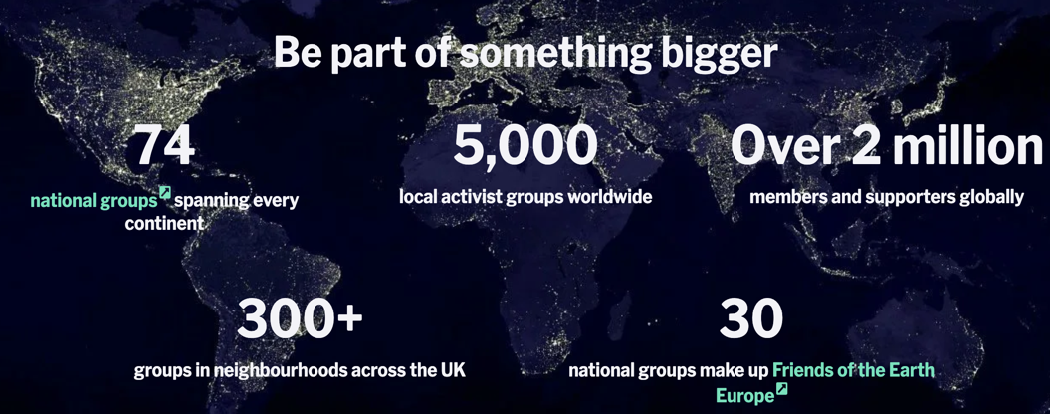

Social connection and effective communication, encourage collaboration between people and community members to achieve a significant goal: protecting the environment and improving the climate action change.
As a result, people are engaging and have a significant participation that make more result. From figure 2.2, can see social connection throughout the territory which sustain their moral standards and achievement goals.

Fig 2.2
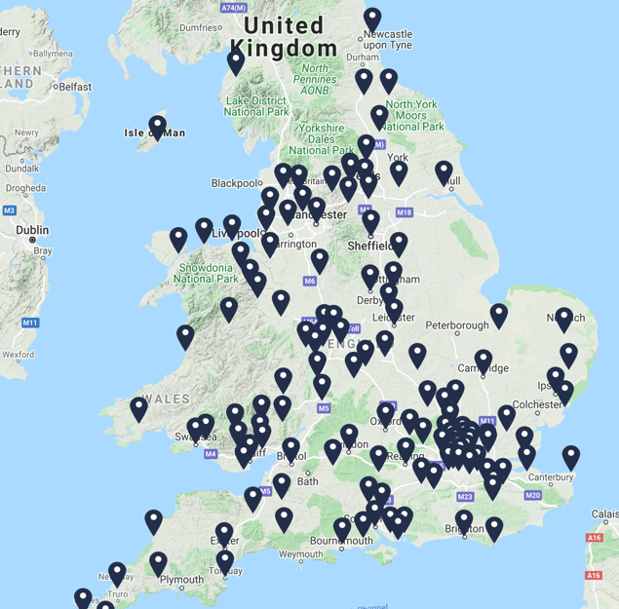

Community engagement in this organization is about: connection people together and building capacity, also through collaboration and communication the community can make sustainable approaches.
Therefore, they have an exceptional online platform that makes the Friends of the Earth more accessible to all people, and for people who want to be engaged in community.

Finally, I will present an analysis of the strengths, weaknesses, opportunities, and threats of both projects, also analyzing current position and future potential.

Table 2.3 SWOT analysis of both projects
Local project | in Croydon | Organization project | Friends of the Earth
Strengths:  - focused on local community.  - engage volunteers.  - implicated different age category.  - accessible location  -established relationship | Weaknesses:  - many volunteers.  -partnership development.  - few sources of funding.  - lack of online platform. | Strengths:  - engage members in all country.  - passion and volunteers.  -different experience.  -more people more action | Weaknesses:  - the goal set  (It is a complex one and requires time)  - strong leadership  - government  (Do not make the promises)
Opportunities:  - promoting green activities.  - engage stakeholders.  - creating a positive atmosphere in the community.  -develop communication with residents.  - promote awareness about environment.  - creating sustainable approaches.  - elaborate and promoting local online forum about issues in community. | Threats:  - stakeholders are confused about their hopes and fears for the future.  - not enough support to develop community.  - the absence of creative solutions to involve more people. | Opportunities:  - collaboration with other organization.  - involving the community.  - increase volunteering of young people.  -locality meetings  (To be aware of the environmental situation in the world) | Threats:  - disproportionate monitoring.  - many sources of funding.  - risk of receiving low receptivity from the target community.

Conclusion

Organization that guarantees compassion, love to environment, trust in their power, empathy and friendship is Friends of the Earth.
The community is very responsible for the actions that they make. Their vision is of a peaceful and sustainable world based on societies living in harmony with environment.
In addition, empowerment people, local communities’ groups, and individuals and to ensure public participation to starting the car and forcing the government to reduce emissions, to halt and reserve environmental degradation and depletion of natural resources and the secure sustainable livelihoods. In a few years the organization together with local communities achieved more successfully projects for example they won a lawsuit in which a judge has held a corporation liable for causing dangerous climate change, was reduce considerable the carbon emission.
Always all participants are engaging in the communication process and have meet working together to achieve more goals.
Participation techniques such as online site social media public meetings creative arts and events open opportunities four diverse voices and perspectives to be shared and saw. Furthermore, offers a wider chance to involve the community in interactions, dialogues, and relationships.

Friends of the Earth continue to create connection between the community, people, and collaboration with other institution to improve the environment in which we live.

Reference

Dumlao, R. (2018) A guide to collaborative communication for service learning and community engagement partners. Stylus Publishing.

Friends of the Earth (2015) Our History. Available at: https://friendsoftheearth.uk/who-we-are/our-history/ (Accessed: 30 August 2021).

Friends of the Earth (2016) Friends of the Earth: the next generation Available at:https://cdn.friendsoftheearth.uk/sites/default/files/downloads/Friends%20of%20the%20Earth%20strategy.pdf?_ga=2.89132571.1404286588.1630482360-530884601.1630482360/ (Accessed: 30 August 2021).

Friends of the Earth (2021) Climate action groups. Available at: https://friendsoftheearth.uk/about/climate-action-groups/ (Accessed: 30 August 2021).

Friends of the Earth (2021) Global Day of Action. Available at: https://takeclimateaction.uk/get-involved/global-day-action-6-november-2021/ (Accessed: 30 August 2021).

Williamos, M. [good reads] 31 August. Available at:
https://www.goodreads.com/quotes/27273-in-every-community-there-is-work-to-be-done-inq/ (Accessed: 01 September 2021).

