CHANGEMAKERS: CREATIVITY AND VALUE CREATION
BMHP5014_BIRM



Mind-map and Blog

Student: Ramona Robu (1913214) Lecturer: Dr Azora Hurd

TASK 1: MIND-MAP
Create a mind map that demonstrates how the ideas and concepts covered in Unit One of the modules are interconnected and how they contributed to the development of your project idea. Your mind map should be no more than 300 words, with supporting imagery, and can be hand drawn or produced using MS Word, PowerPoint using Office 365 or an appropriate technology such as Mind Meister available at: www.mindmeister.com/ . The mind map should be referenced appropriately. The resources covered in Unit One of the module material’s which will help you to complete this task. Ensure that you the University’s Office 365 PowerPoint. The project idea can be anything of your choice which you are passionate about. Ensure it is a topic area which you can create links with supporting imagery. (18 marks)
My idea in the illustrated mind-map (fig.1) relates to spreading awareness of how Pulse Oximeter helps detect early deterioration of patients with Covid -19, and it can save lives. Because Pulse Oximeter's new purpose was discovered recently, it is important to spread the information worldwide through every traditional channel.
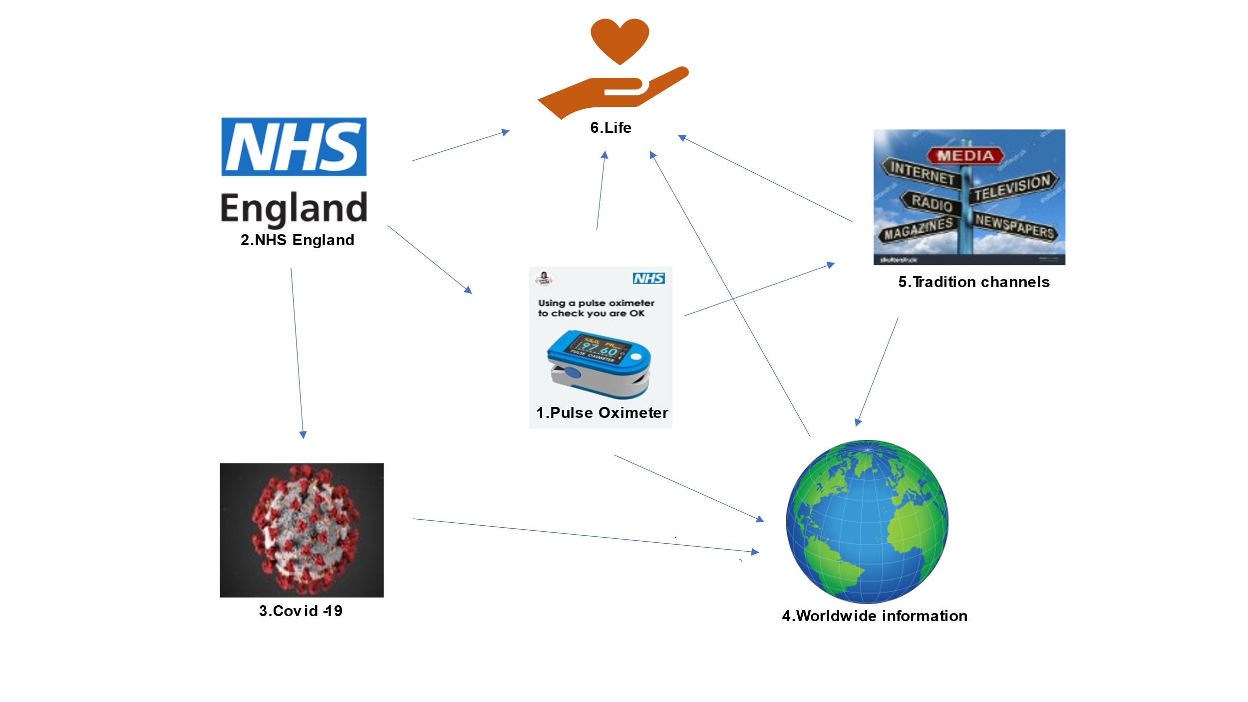
Figure 1: Mind-map
1.Pulse Oximeter it is a small device that measures the oxygen level of the blood. If the blood oxygen level is under 94 or 93 or lower than usual is, the GP or NHS 111 should be contacted to receive help.
2.NHS England gives guidance and advice to use Pulse Oximeter to detect early deterioration of patients with confirmed or possible Covid-19 in primary and community settings. In the case of deterioration, by using the Pulse Oximeter, lives will be saved.
3.Covid-19 is an illness caused by a virus named Coronavirus, which led to a worldwide pandemic.
4.Worldwide information. With the World Health Organization's help, the information about this innovation will get to the health structures in each country of the world.
5.Traditional channel transmits the information through newspapers, magazines, radio stations or television stations. In this way, people worldwide will find out the new purpose of using Pulse Oximeter and can ask for it from the health services or buy it themselves, provided if it is a certified one.
6.Life. By spreading awareness through traditional channels, global exposure, and the NHS guidance on how and for what this little device (Pulse Oximeter) can be used, will save lives.
Innovation is defined as "the process of making changes to something established by introducing something new that adds value to customers and contributes to the organisation's knowledge store" (O'Sullivan and Dooley, 2009).
TASK 2:BLOG
Using a medium of your choice, create a summary that outlines how you came up with your idea and how it adds value, based on the concepts introduced in Unit Two of the module. You should use a medium appropriate to your subject discipline, this can be a written document, a blog, or a visualisation and should be equivalent to 500 words. A list of sources used to inform your summary should be included in a reference list, using the appropriate referencing standard. The resources covered in Unit Two of this module will help you to complete this task. (18 marks)

Figure 2. Blog (https://www.simplesite.com/)
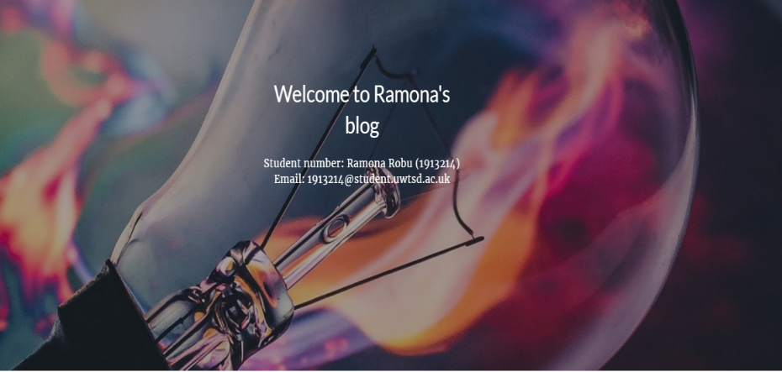
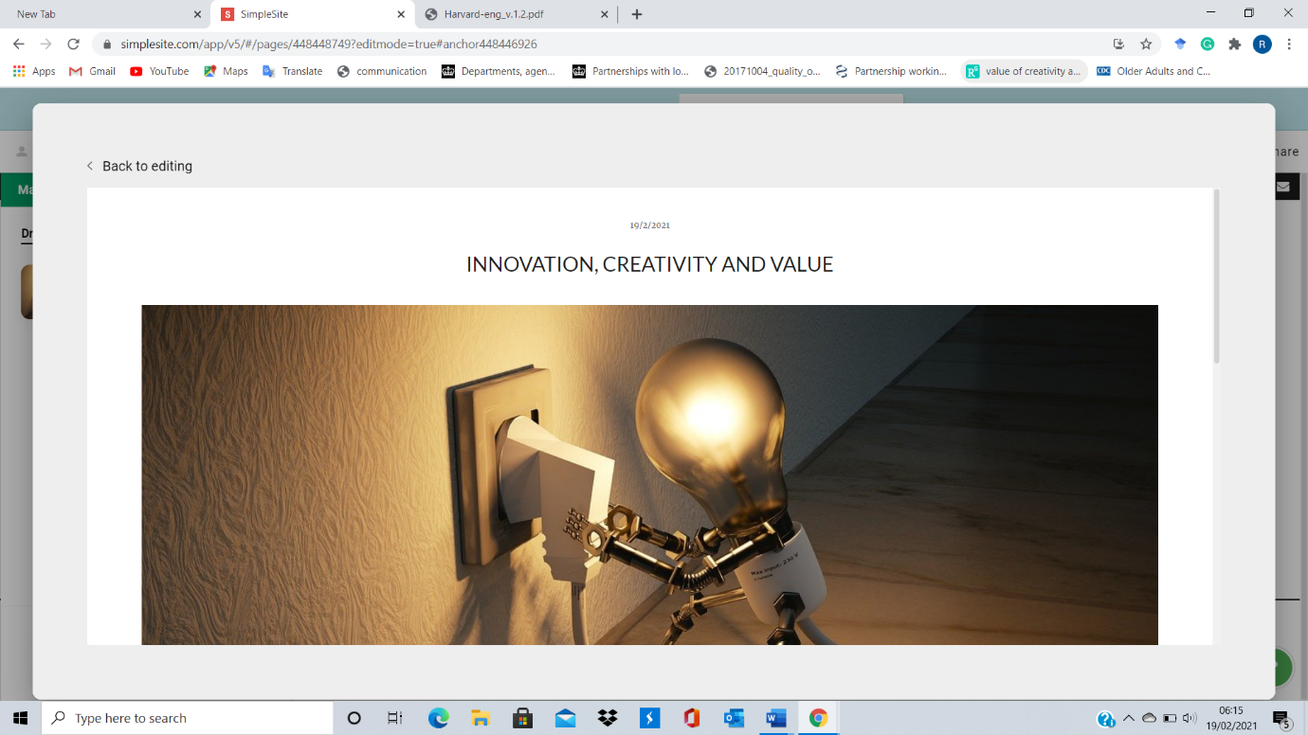
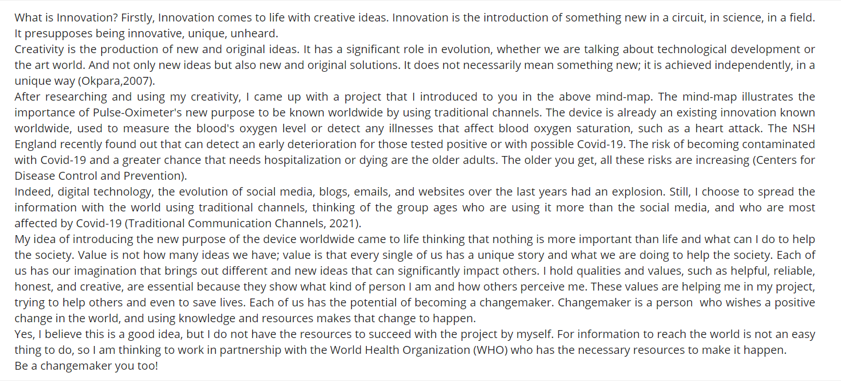

Tasks 1 and 2 should be submitted together by 19th February 2021 as one document and uploaded in to Turnitin. You should ensure that you have added your student’s name, student number, the module title and reference number and the tutor’s name. You can add all your material in a word document, or a PowerPoint document provided, that it uses the University standard of Office 365. It is your responsibility to ensure that the material you submit can be opened in Turnitin and can be viewed by your tutor.

References:
Blog Available at: https://www.simplesite.com/ (Accessed 14 February 2021).
Centers for Disease Control and Prevention Available at: https://www.cdc.gov/coronavirus/2019-ncov/need-extra-precautions/older-adults.html (Accessed: 18 February 2021).
Coronavirus disease Available at: https://www.bing.com/images/search?view=detailV2&ccid=5rFmys4O&id=B0EBB61D5827111D3FE89A0FF98E62FCFF5CF1C9&thid=OIP.5rFmys4O6Q6NWbfm-8r5dAHaFA&mediaurl=https%3a%2f%2fwww.cdc.gov%2fdotw%2fcovid-19%2fimages%2fmain_928px.jpg&exph=628&expw=928&q=coronavirus&simid=608008666497550277&ck=954AA5EBF55F6221029DE95DB8CAD4FD&selectedIndex=1&FORM=IRPRST&ajaxhist=0 (Accessed: 10 February 2021).
NHS England Available at: https://upload.wikimedia.org/wikipedia/en/thumb/e/ed/NHS_England_logo.svg/1200px-NHS_England_logo.svg.png (Accessed: 10 February 2021).
Okpara, F. O. (2007) ‘Journal of Asia entrepreneurship and sustainability’, The Value of Creativity and Innovation in Entrepreneurship, 3(2).
O'Sullivan, D. and Dooley, L., (2009). Applying innovation. Thousand Oaks [Calif.]: Sage, pp.3-5.
Pulse-Oximeter Available at: https://www.england.nhs.uk/coronavirus/wp-content/uploads/sites/52/2020/06/Pulse-Oximeter-Easy-Read-final-online-v4.pdf (Accessed: 10 February 2021).
Tradition channels Available at: https://www.bing.com/images/search?view=detailV2&ccid=8FXfeFOh&id=4956A7E515DE215C1465873E8D53E297D7C6D1EF&thid=OIP.8FXfeFOhFFvSs31nWqATJwHaGD&mediaurl=https%3A%2F%2Fimage.shutterstock.com%2Fz%2Fstock-photo-media-signpost-shows-internet-television-newspapers-magazines-and-radio-102143884.jpg&exph=1225&expw=1500&q=Media+Internet+Television+Radio+Newspaper+Magazines&simid=607999836038301552&ck=11CA088BBA68428096A62DFE629D27DA&selectedindex=0&form=EX0023&adlt=demote&shtp=GetUrl&shid=aed8174a-e855-46eb-836e-ae95a2c3572f&shtk=TWVkaWEgU2lnbnBvc3QgU2hvd3MgSW50ZXJuZXQgVGVsZXZpc2lvbiBOZXdzcGFwZXJzIFN0b2NrIC4uLg%3D%3D&shdk=Rm91bmQgb24gQmluZyBmcm9tIHd3dy5zaHV0dGVyc3RvY2suY29t&shhk=P6Y%2FM6V4o%2FGGfucI9uf%2Br%2BZn8%2FMC5m008%2FeS%2BT0ME3I%3D&shth=OSH.yHc%252BItZe%252BAsL93clQos%252BIQ (Accessed: 10 February 2021).
Traditional Communication Channels Available at: https://smallbusiness.chron.com/traditional-communication-channels-65162.html (Accessed 18 February 2021).
Worldwide information Available at: https://upload.wikimedia.org/wikipedia/commons/thumb/b/b1/Globe_Atlantic.svg/764px-Globe_Atlantic.svg.png (Accessed: 10 February 2021).

