Six Senses

Author name: Jayson Anthony Luba
Student number: 2245377
Module Tutor: Scott James
Submission date: 09.06.2023.
Word count: 1351 words

Introduction
The purpose of this marketing plan is to outline a comprehensive communications strategy for Six Senses hotel, with a particular emphasis on identifying problems or opportunities for marketing and offering innovative solutions given the current environment. In order to enhance the hotel’s brand image, attract more guests, and increase the revenue, this strategy is being created for the management team and other stakeholders of the property. In developing this plan, we will utilize frameworks such as SOSTAC, the 4Ps, Ansoff’s Matrix, and other relevant theories and concepts to provide a structured approach and strategic direction for the hotel’s marketing efforts.

SOSTAC (Situation, Objective, Strategy, Tactics, Actions, Control) and 4Ps (Product, Price, Place, Promotion) guide our marketing plan for Six Senses. Ansoff’s Matrix informs growth prospects. Integrating these frameworks, we aim for an effective plan.

Company (SWOT Analysis):
Six Senses is a luxury hotel brand known for its strong brand image, exceptional service, sustainable practices, innovative amenities, and global presence. These strengths position the company well in the competitive luxury hotel industry. However, there are weaknesses to address, including limited reach, a competitive market, seasonal demand, limited marketing channels, and dependence on tourism for revenue. (Landman, 2009). Appendix 1.

Customers (Segmentation and Targeting / Customer Profile):
Six Senses targets customers aged 25-55 seeking luxury and wellness experiences, with higher disposable incomes and valuing luxury and relaxation. They prioritize wellness, sustainability, and balances lifestyles and appreciate immersive experiences, tranquility, and nature. By analyzing browsing behavior and visitor demographics through tools like SimilarWeb, the company can gain insights into the interests, preferences, and characteristics of its online audience. (Amplify, 2022)
https://sixthsenses513094188/wordpress.com/2019/11/10/customer-portfolio-of-the-six-senses/
Competitors (Perceptual Positioning Map, Bowman’s Strategy Clock):
Using a perceptual positioning map, Six Senses can position itself in the top-right quadrant, emphasizing luxury experiences and sustainable practices. This helps differentiate the brand and target the desired customer segment. Adopting a Differentiation strategy on Bowman’s Strategy Clock allows Six Senses to justify its premium pricing and provide a unique and desirable experience that sets it apart from competitors. (Sridharan, 2021) Appendix 2., Appendix 3.
https://sixthsenses513094188.wordpress.com/2019/11/03/competitive-analysis-of-six-senses/
https://sixthsenses513094188.wordpress.com/2019/12/01/differentiation-positioning-of-six-senses/

Collaborators:
Six Senses can enhance growth through B2B relationship, partnership and franchises. Collaborating with travel businesses, tourism boards, and wellness brands leads to marketing campaigns and joint initiatives. (Ramadani, 2020) Franchise enable rapid expansion while maintaining standards and sustainability. (Sustainable Hospitality Alliance, 2020)

Climate (PESTLE Analysis):
Analyzing the macro environment using a PESTLE analysis helps identify external factors impacting the business. Economic uncertainty can affect luxury travel spending, political and social instability can deter guests, changing consumer preferences require continuous adaptation, disruptive technologies can disrupt traditional hotel models, and environmental risks like natural disasters and climate change can impact operations and reputation. Having knowledge factors enables Six Senses to minimize risks and seize opportunities. (Bertozzi, 2020) Appendix 4.

Marketing Mix
Six Senses’ Marketing Mix:
- Luxurious, sustainable experiences
- Premium pricing
- Strategic placement
- Effective promotion
Summary: Leverage strengths, target segments, differentiate, collaborate, adapt for growth. Appendix 5., Appendix 6.
https://www.reachmarketingandsocial.com/blog/the-hospitality-marketing-mix-your-guide-to-5-star-results

Product:
- Offer luxurious, sustainable experiences
- Provide personalized, innovative amenities
- Focus differentiation and value
Price:
- Reflect premium positioning and value
- Consider market demand and competition
- Offer pricing options for different customer segments
Place:
- Strategically locate properties in desirable destinations
- Utilize effective distribution channels and partnerships
- Ensure convenience and accessibility
Promotion:
- Employ traditional and digital marketing strategies
- Utilize social media, search engines, and referral sites
- Create engaging campaigns to reach the target audience
People:
- Train and empower staff for exceptional service
- Foster a customer-centric culture and focus satisfaction
- Create memorable experiences for customer loyalty.
Process:
- Streamline and optimize operational processes
- Ensure smooth customer journey from booking to check out
- Continuously improve based on feedback
Physical Evidence:
- Create visually appealing, well-designed spaces
- Pay attention to details and ambiance
- Provide tangible evidence of luxury and quality

SMART Objective for the Marketing Plan:
The SMART objective of this marketing plan is to increase the overall occupancy rate of Six Senses hotel by 10% within the next year. This will be achieved by targeting and attracting affluent travelers who are seeking unique, sustainable, and wellness-focused luxury experiences. The strategy will involve implementing targeted marketing campaigns, forging strategic partnerships with local businesses and wellness brands, and enhancing guest offerings. By effectively reaching and engaging the target audience, the hotel aims to drive an increase in bookings and revenue, solidify its position in the luxury hospitality market, and maintain its commitment to sustainability and wellness practices. (Mirelle, 2023)

Strategy:
Six Senses hotel will adopt a market development strategy by Ansoff’s matrix, to address its reputation and enhance customer experiences. The new value proposition will focus on reputation management, service excellence, and guest experience enhancements.
- Reputation Management: Implement a comprehensive plan to address poor reviews, actively respond to feedback, and communicate improvements transparently.
- Service Excellence: Enhance staff training programs, empower employees to proactively address concerns, and foster a culture of continuous improvement
- Guest Experience Enhancements: Implement improvements based on customer feedback, including room upgrades, dining experiences, wellness programs, and innovative technologies.
- Changes to the marketing mix: Emphasis enhanced services and amenities (products), consider promotional pricing (price), strengthen online presence (place), implement targeted campaigns (promotion), train and empower staff (people), and showcase physical improvements (phiysical evidence).
https://sixthsense513094188.wordpress.com/2019/10/06/six-senses-marketing-strategy/
Through this strategy and marketing mix changes, Six Senses aims to rebuild its reputation, regain customer trust, and position itself as a leading luxury hotel known for exceptional service, sustainability, and memorable guest experiences.

Tactics:
- Reach: Implement targeted digital advertising campaigns on search engines, social media, and travel websites to increase brand awareness and drive website traffic.
- Act: Enhance the website’s user experience through clear messaging, high-quality visuals, easy navigation, and a seamless booking process. Develop valuable content through blogs, articles, and videos, positioning Six Senses as an industry authority.
- Convert: Utilize email marketing nurture leads, promote special offers, and engage with guest. Implement remarketing campaigns to encourage individuals who have shown interest to convert.
- Engage: Enhance social media engagement by actively interacting with comments, messages, and reviews. Introduce live chat functionality and chatbots for instant assistance. Implement a loyalty program to reward and enhance customer loyalty.
To improve communications efforts, conduct a thorough analysis of social media presence, email marketing performance, and SimilarWeb results. Address areas of improvement, such as low social media engagement and suboptimal email open rates. (Chaffey, 2022) Appendix 7.

Introduce the following steps:
- Social Media Strategy Revamp: Develop engaging content aligned brand values.
- Email Marketing Optimization: Conduct A/B testing, and deliver personalized content.
- SEO and Website Traffic Enhancement: Optimize the website an implement an SEO-focused content strategy.
- Social Listening and Online Reputation Management: Monitor brand mentions and respond promptly.
Result: Enhance communications, increase engagement, bookings, and improved guest experience. (Hollander, 2023)

Control:
To measure the success of the marketing plan and ensure its effectiveness, Six Senses will utilize key performance indicators (KPIs). (Marr, B., 2012)
Customer Satisfaction: Conducting guest satisfaction surveys, monitoring online reviews will provide insights into customer attitudes towards the brand and the effectiveness of reputation management efforts.
Website Analysis: Evaluating website traffic, bounce rate, conversion rates, and click-through rates offers valuable insights into the performance of digital marketing campaigns and website optimization initiatives.
Social Media Engagement: Measuring the growth in social media followers, engagement rates, reach, and sentiment analysis will indicate the success of social media strategies and the hotel’s online presence.

Conclusion:
The marketing plan for Six Senses hotel focuses on addressing challenges and leveraging opportunities in the current climate. Through comprehensive analysis (SWOT, customer segmentation, competitor analysis, B2B relationships, and PESTLE), key areas for improvement and growth have been identified. The marketing mix will be adjusted to enhance the hotel’s value, adapt to customer needs, and boost brand reputation. Tactics like targeted advertising, reputation management, content marketing, and social media engagement will be used. Success will be measured through web analytics, customer satisfaction, revenue and social media engagement. Recommendations include a focusing on online reputation, personalized campaigns, and continuous monitoring to stay competitive.

References
- Amplify XL (2022). The Target Market for Luxury Hotels: Who enjoys luxury?
https://amplifyxl.com/target-market-for-luxury-hotels/?utm_content=cmp-true
- Bertozzi, F., Ali, C. M., & Gul, F. A. (2020). Resource based view of an organization and Pestel analytical tool – An analysis of Hotel Corallo, Rimini, EPH-International Journal of Science and Engineering, 6(1), 30-39.
- Dave Chaffey (2022). Introducing The RACE Growth System and RACE Planning Framework: practical tools to improve your digital marketing
artinsights.com/digital-marketing-strategy/race-a-practical-framework-to-improve-your-digital-marketing/
- Fisnik Ramadani (2020). The impact of airline companies in the development of hotel industry.
https://www.researchgate.net/publication/347472198_The_impact_of_airline_companies_in_the_development_of_hotel_industry
- Jordan Hollander (2023). The Ultimate Guide to Hotel Marketing
https://hoteltechreport.com/news/hotel-marketing-guide
- Marr, B. (2012). Key Performance Indicators (KPI): The 75 measures every manager needs to know. Pearson UK.
- Mithun Sridharan (2021). Bowman’s Strategic Clock – How To Position Your Product?
https://thinkinsights.net/strategy/bowmans-strategic-clock/
- Mirelle (2023). Develop Marketing Objectives for Your Hotel: Driving Growth.
https://furoore.com/develop-marketing-objectives-for-your-hotel/#:~:text=By%20setting%20SMART%20marketing%20objectives%2C%20you%20provide%20a,your%20resources%2C%20track%20progress%2C%20and%20achieve%20meaningful%20results
- Patrick Landman (2009). Hotel Swot Analysis.
https://www.xotels.com/en/revenue-management/revenue-management-book/competitor-analysis
- Sustainable Hospitality Alliance (2020). Business case for sustainable hotels.
https://sustainablehospitalityalliance.org/wp-content/uploads/2020/05/Business-Case-for-Sustainable-Hotels-Recommendations-for-franchisees.pdf
- https://www.reachmarketingandsocial.com/blog/the-hospitality-marketing-mix-your-guide-to-5-star-results
- https://sixthsense513094188.wordpress.com/2019/10/06/six-senses-marketing-strategy/
- https://sixthsense513094188.wordpress.com/2019/11/03/competitive-analysis-of-six-senses/
- https://sixthsense513094188.wordpress.com/2019/11/10/customer-portfolio-of-the-six-senses/
- https://sixthsense513094188.wordpress.com/2019/12/01/differentiation-positioning-of-six-senses/

Appendix

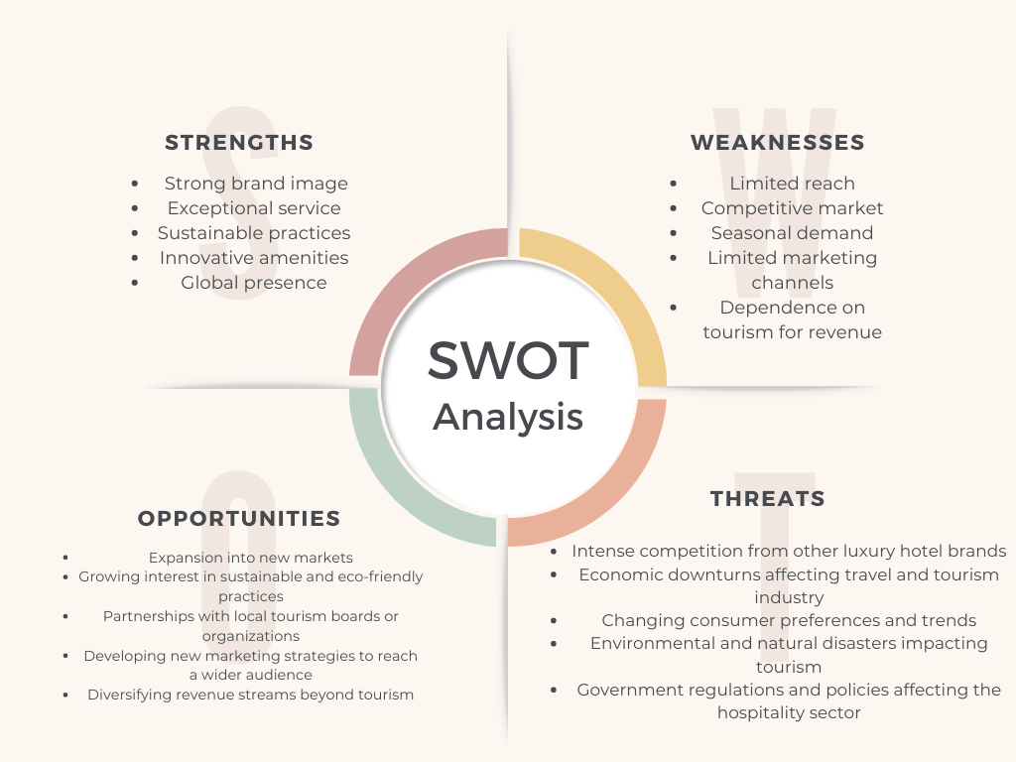
- SWOT Analysis

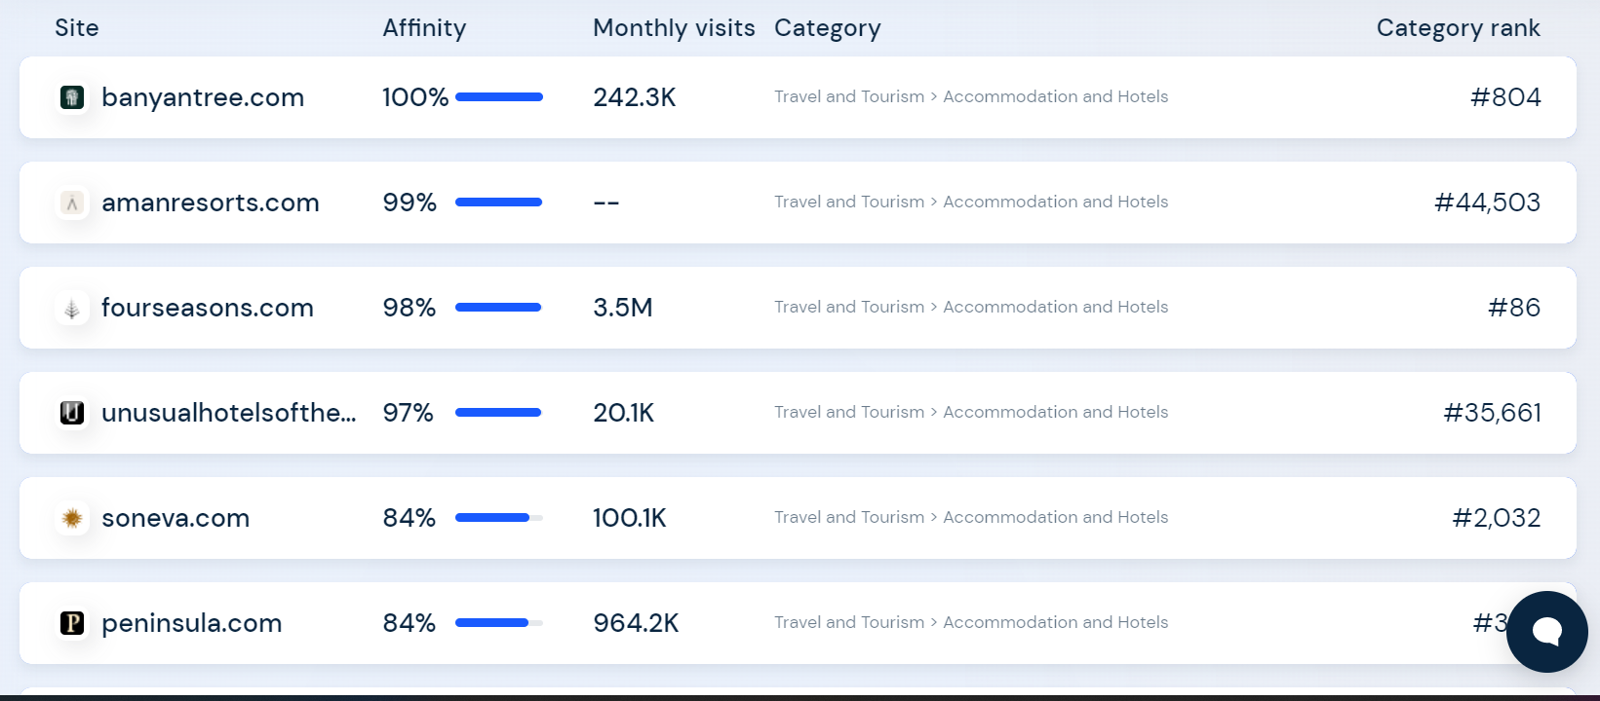
- https://www.similarweb.com/website/sixsenses.com/#competitors

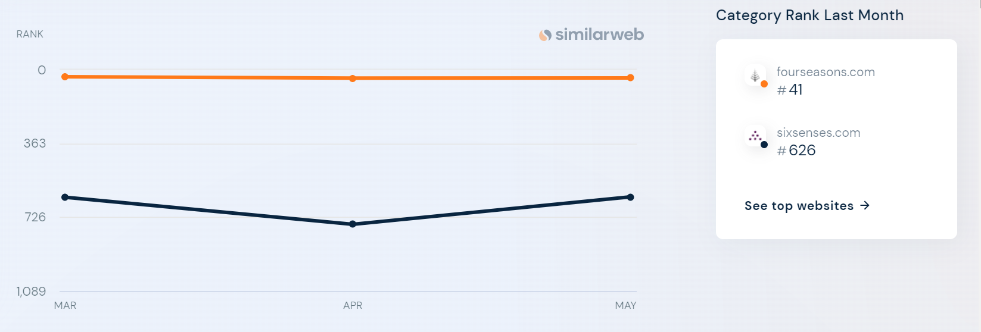
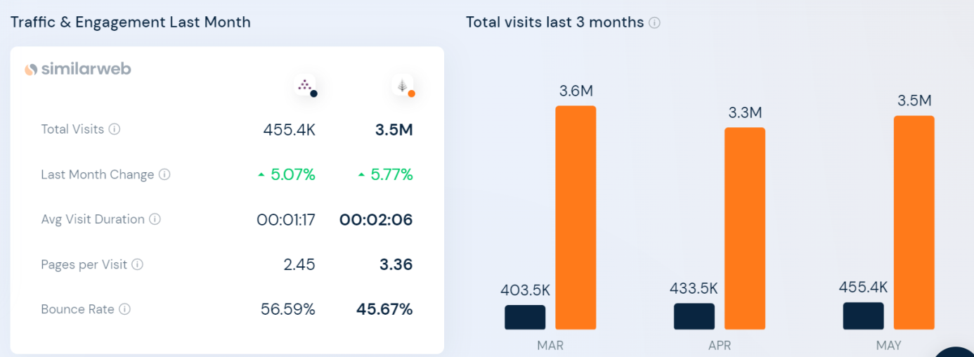
- https://www.similarweb.com/website/sixsenses.com/vs/fourseasons.com/#traffic

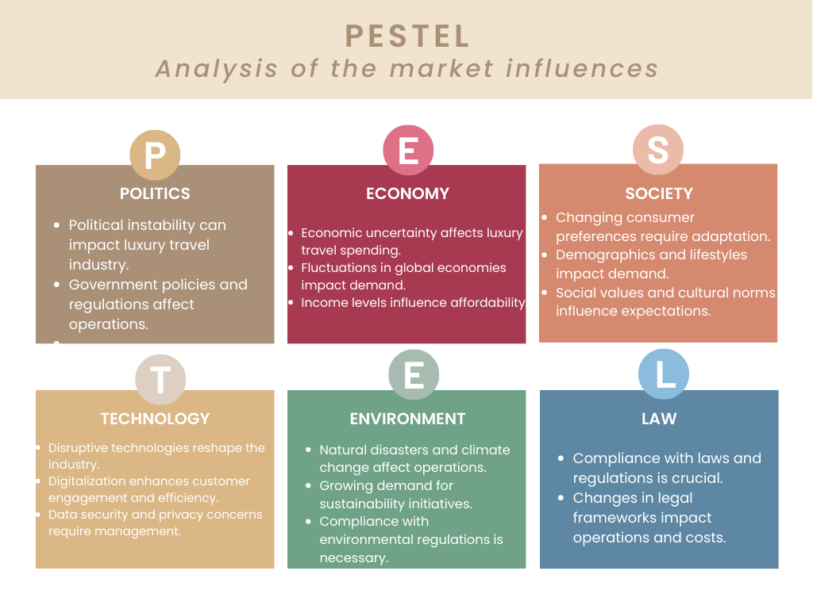
- PESTLE Analysis

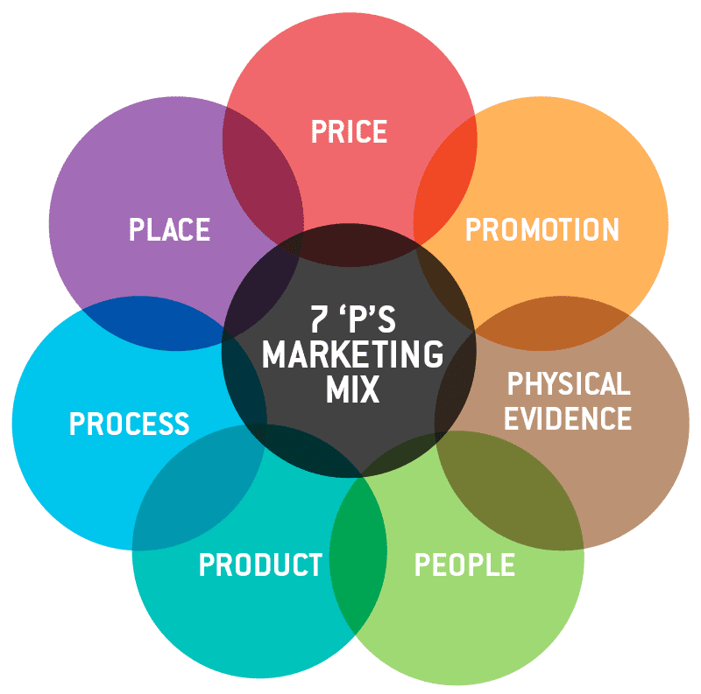
- 7 P’S Marketing Mix

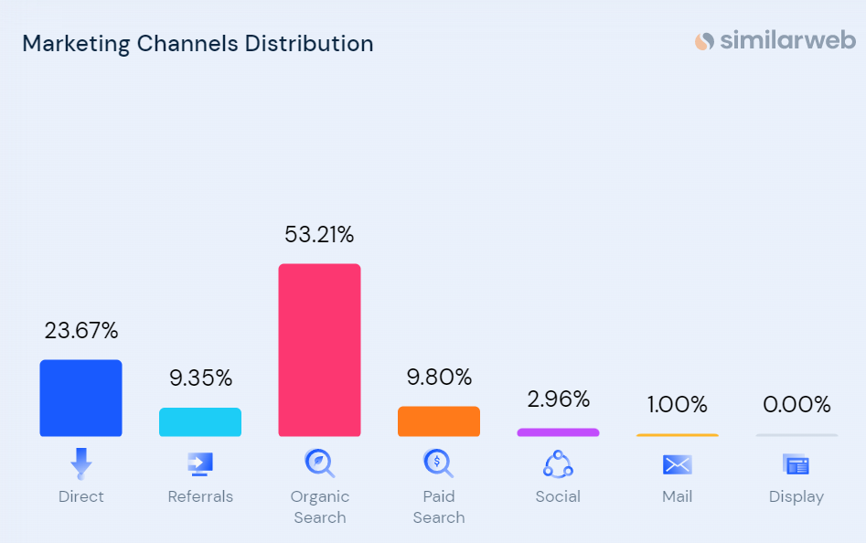
6. Marketing Channels Distribution

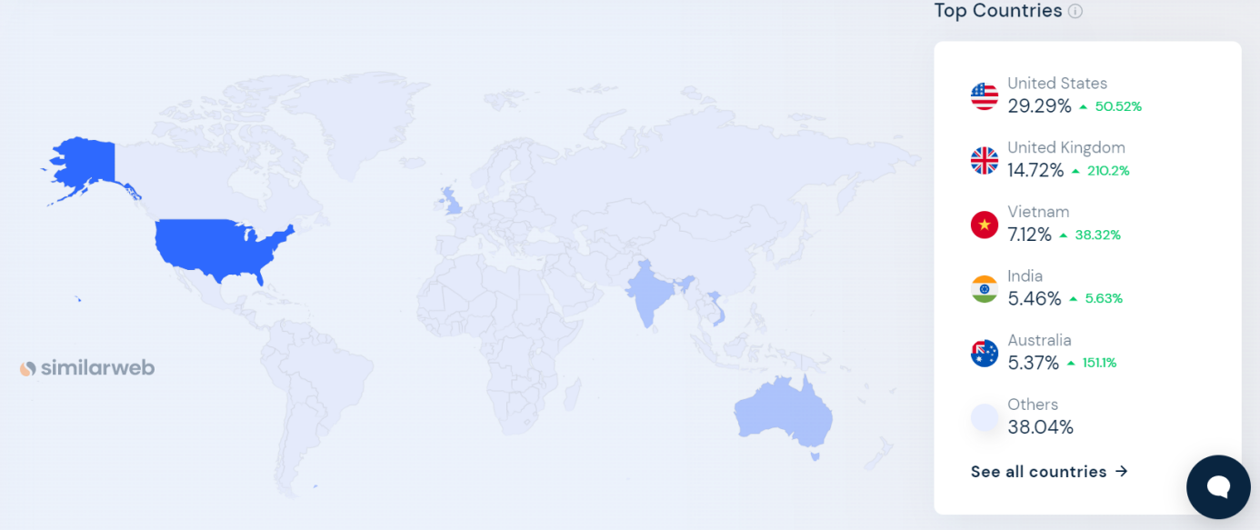
- https://www.similarweb.com/website/sixsenses.com/#/geography

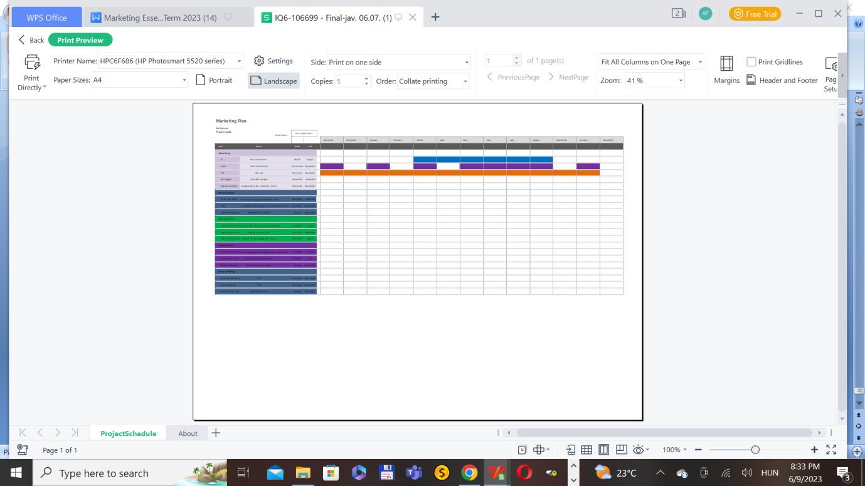
- Six Senses communication plans on Gannt Chart (Moodle, 2023)

Presentation


