

L4 – Principles of OME
(OME Degree) ACDA4019
Understanding the importance of critical diameter and critical density in the detonation process
Charlotte McCombe
Student Number: 2411524

Contents
Contents 2
Introduction 3
Explosives and Explosions 3
Classification of Explosives 4
The Explosive Train 5
Literature review 6
Lead Azide 6
Trinitrotoluene 7
Performance Figures 9
Critical diameter, density and detonation 10
Critical Density and Theoretical Maximum Density 10
Critical Diameter 11
Detonation 12
Detonation path of lead azide to TNT 12
How confinement would alter critical diameters 13
How confinement benefits OME professionals 14
Explosive Train – Lead Azide and TNT 15
Conclusion 16
Bibliography 17
Appendices 20

Introduction

Explosives and Explosions
An explosive is a substance which is effective in producing an explosion through self-sustaining chemical reactions. An explosion is the rapid expansion of heat and gas, producing effects including blast and fragmentation. An explosion can be physical, chemical or nuclear [1]. Pyrotechnics are a type of explosive that are non-detonative chemical reactions to produce heat, light, sound or gas [2]. Explosive substances are used in many environments including defence, mining and fireworks.

Classification of Explosives
Explosive substances are separated into different categories based on their qualities and behaviour.
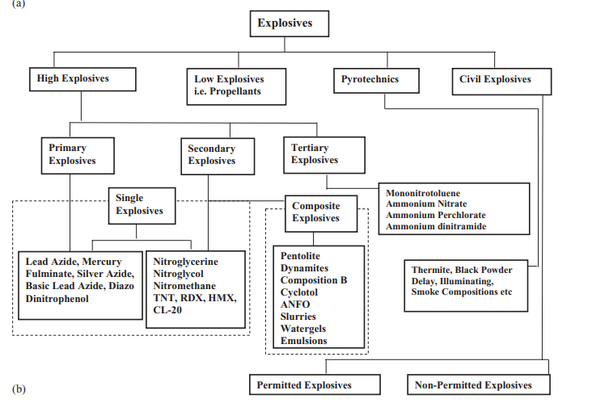
Figure 1- Classification of explosives with examples [3]
The diagram above shows the main types of explosives as high, low, pyrotechnics and civil explosives. Pyrotechnics are often treated as a low explosive due to their nature of deflagrating [1]. High Explosives undergo detonation and high gas pressures with a velocity of detonation greater than 1800m/s [4]. Low Explosives undergo deflagration at a fast pace releasing gas and have reaction velocities between 600-1000m/s [4]. Primary explosives are a high explosive and are very sensitive and can be easily initiated through various factors including heat, friction and shock [5]. Secondary explosives are also a high explosive and are less sensitive therefore require a greater amount of energy to initiate. This energy is provided through the explosive train.

The Explosive Train
The explosive train is a path of explosive components from initiation to detonation. The train normally contains three components – initiator, booster and main charge. However, it is possible to have an explosive train with only two components which uses a primary explosive to initiate a secondary explosive. This two-step train is used for small applications where the detonation wave from the initiator provides enough energy for the secondary explosive to detonate [6].
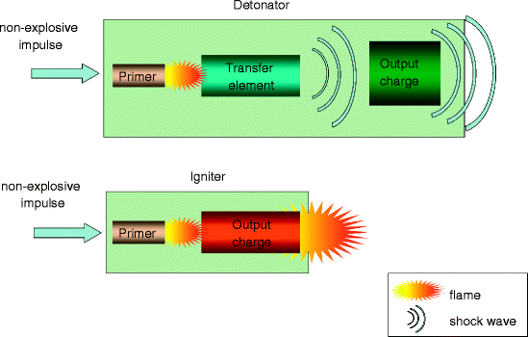
Figure 2- 2 and 3 step explosive trains [8]

The three-step chain has a decreasing sensitivity and increasing quantity of the explosive. The initiator is the most sensitive part of the train made of primary explosive and is found in primers or fuzes. The initiator reacts to a stimulus such as heat, electricity or friction and detonates. The energy is then transferred from the primary explosive to the booster which detonates and transfers a larger amount of energy to the less sensitive main charge which then detonates [1]. The large amounts of energy produced in this train ensure detonation of the main charge given other requirements such as critical diameter and density are met.

Literature review

Lead Azide
Lead Azide is a primary explosive produced by mixing sodium azide and lead acetate or nitrate. It is a very sensitive material with a figure of insensitiveness value of 20 and is very sensitive to multiple stimulus such as heat and electrostatic charge. However, is less sensitive to stabbing and flash without the use of topping material. The main uses for Lead azide are military ammunition and commercial blasting caps which act as initiator in the explosive train [3]. Lead Azide has been used by British services since 1925 with various compositions created for fill in detonators [7]. The LZY detonators use service lead azide which has a sensitive hard crystalline structure and uses a sensitiser composition of RD1651 as a top increment so it can be used for stab sensitive applications [1]. Lead Azide’s ability to be used at a high density without being dead pressed makes it suitable for the use in detonators [8].
In comparison to mercury fulminate, another commonly used primary explosive, lead azide has a greater detonative effect and shelf life [1]. The critical threshold stress for initiation to shock lead azide for full detonation is 0.5GPa [9]. Lead azide has been tested to determine the length of the detonation zone and shown there is a an unsteady detonation formed up to 3mm of the charge length was reached and the detonation becomes steady as the reaction wave catches up to the shock wave [10].
Lead azide is mainly produced in two forms, alpha(α)- orthorhombic and beta(β) - monoclinic with the alpha form used for technical applications as it is the most stable formation [8]. Pure lead azide has a high ignition temperature of 330°C and a high thermal stability [8]. However, in the production of the alpha formation it is possible for other forms to be present, causing the substance to be more sensitive and unstable and therefore must be destroyed [8].
Figure 3-α form and β form of Lead Azide [8]
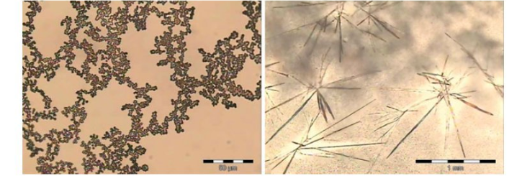

Trinitrotoluene
TNT (Trinitrotoluene) is a secondary explosive and contains nitrogen, carbon, oxygen and hydrogen. TNT is easily manufactured through the nitration of toluene with nitric acid and sulfuric followed by purifications [11]. It is used as the main charge in the explosive train, often in mixtures, to produce effects such as blast and fragmentation.
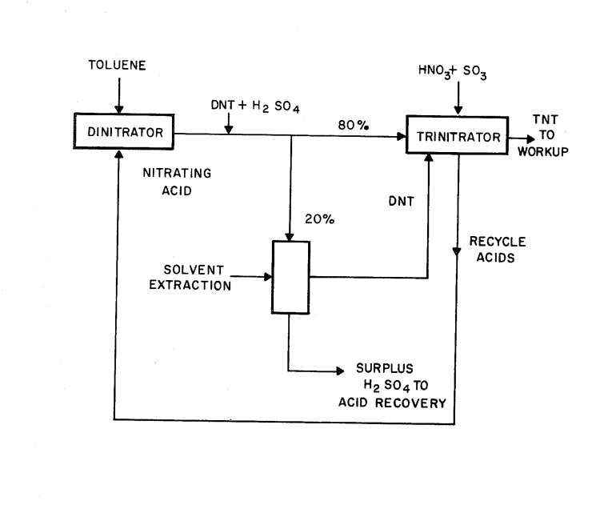
Figure 4- Process of nitration of Toluene to produce TNT [11]
TNT is a widely used energetic compound due to the ease of manufacture and ability to be used in mixtures for ammunition fill. It has a melting temperature between 80-82 degrees Celsius allowing it be cast filled in munitions such as mortars, grenades and warheads [12] The density and critical diameter of TNT varies with the method of manufacture such as compaction ,cast and pressed charges shown below [13].
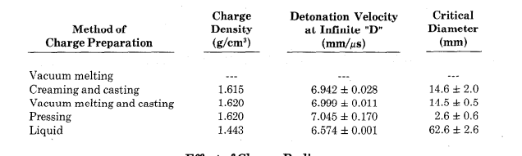
Figure 5 -Charge density's, detonation velocities and critical diameter of unconfined TNT cylindrical charges [13]
The table shows TNT has the smallest critical diameter of 2.6mm in the pressed form and the highest detonation velocity in this form at 7.045mm/μs. As TNT is a secondary explosive it requires a much more powerful stimulus to initiate than lead azide, often from a detonator or a fuze in an artillery shell. With large quantities of TNT a booster is also used to provide energy for complete detonation.

TNT has a negative oxygen balance of -73.96% therefore produces carbon, water and carbon monoxide as products of reaction [1]. The products of the decomposition of an explosive can be found using Kistiakowsky-Wilson Rules.
The production process of TNT involves the addition of hexanitrostilbene (HNS) to ensure crystals are random and interlocking. Adding HMX increases the resistance to cracking of the TNT, reducing the possibility of ignition through adiabatic compression [1].
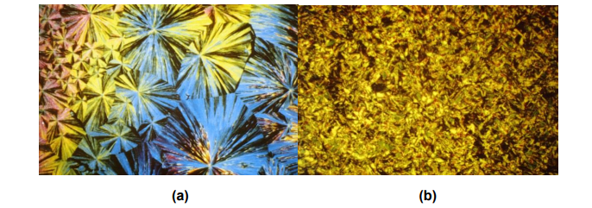
Figure 6- Unmodified TNT (a) and TNT with HNS added (b) [1]

Performance Figures
Table 1 - Lead Azide and TNT performance characteristics [1].
 | Lead Azide | TNT
Formula | PbN6 | C7H5N3O6
Detonation Velocity (m/s) | 4550 (Pure) | 6900
Ignition Temperature (°C) | 330 | 240 degrees Celsius
Gas Volume $V /dm^{3}kg^{-1})$ | 218 | At STP 739.65
Detonation Products | Pb+3N2+110.8kcal [7] | 3.5Co+3.5Cs+2.5H2O+1.5N2
Critical Diameter | <50μm [14] (confined and unconfined) | 2.6-62.6mm [13]
Critical Density $(gcm^{-3})$ | 3.8(pure) | 1.443-1.620 [13]
Oxygen Balance (%) | 0.00 | -73.96
Heat of explosion ($∆H_{d}/kJ mol^{-1}$) | -469 | -929.34
Heat of Detonation ($Q_{v}/kJ kg^{-1})$ | 1610.36 | 4091.63
Detonation Pressure (GPa) | 17.12 [10] | 24
Factor of insensitiveness | 20 [3] | 150
Theoretical Maximum density | 4.71g/cc [5] | 1.64 $gcm^{-3}$
Power Index (%) | 12.8 | 110.32
Explosive power | 35.11 | 302.64
Standard density $(gcm^{-3})$ | SLA 4.78 | 1.60

In comparison lead azide and TNT have many differences, lead azide is a much denser compound than TNT at both standard value and at critical diameter. TNT has a much greater detonation velocity and explosive power. Both share a negative heat of explosion releasing huge amounts of heat and gas to the surroundings.

Critical diameter, density and detonation

Critical Density and Theoretical Maximum Density
The critical density is the value at which a steady detonation and decomposition of an energetic material occur [15]. Explosives have a theoretical maximum density (TMD) which is the “mass per unit volume of a single crystal of the explosive” [16]. It is not possible to reach TMD and at values above 98% TMD dead pressing can occur [16].
Pure TNT in the form of needle shaped crystals has a loose texture and therefore is not at maximum density, additions to the casted TNT can improve the structure and density [17]. Higher detonation velocity can be produced using a non-explosive to replace the air in the explosive material. This can be applied to explosives with a density lower that the theoretical max density [18].
TNT has a theoretical maximum density of 1.64$(gcm^{-3})$ with a factor of insensitiveness of 150 from the Rotter Test [1]. Appendix A and B show the comparison of charge diameters of poured and creamed TNT in both confined and unconfined environments. In unconfined creamed TNT there is no detonation at density’s below 1.605$(gcm^{-3})$ with a charge diameter of 1.66cm, however when confined in a steel tube, densities of 1.600$(gcm^{-3})$ and 1.605$(gcm^{-3})$ detonated with velocity 6630m/s and 6770m/s. It can also be seen that increasing the density in the confined creamed TNT increased the mean velocity. Increasing the density of the unconfined creamed TNT also increased the mean velocity. These tests shown that increasing up to TMD leads to an increase in the detonation velocity [19]. Appendix C also shows the boundaries and limits for the maximum velocity of detonation and diameters of a cast TNT. The limiting value of velocity of detonation is 6950m/s obtained with pure TNT at density 1.625($g/cm^{3})$ [20].

Critical Diameter
Critical diameter is “diameter of a cylindrical charge below which stable detonation cannot propagate, no matter how high the velocity of the initiating shock wave” [21]. The critical diameter can vary for the same type of explosive depending on particle size, confinement and temperature [22]. Primary explosives have a small critical diameter compared to secondary explosives as they are much more sensitive.
TNT requires a high critical diameter when unconfined and has shown failure to detonate from deflagration when in the moulded unconfined state [23]. There has been successes of detonation high amounts of unconfined TNT such as one-million-pound TNT detonation completed in Canada in 1964 [24]. The UK uses TNT/RDX mixtures with 39.5% TNT and 59.5% RDX for the filling of ammunition to cause effects such as blast and fragmentation [1]. The filling is confined within a casing therefore the critical diameter is reduced and is much easier to detonate using a primary explosive in the fuze of the shell.
Increasing the diameter of an explosive beyond critical diameter and below failure diameter will increase the velocity of detonation and produce greater effects. Failing to reach critical diameter of an explosive can cause unsuccessful detonation or remaining unexploded materials.

Detonation
Detonation is a type of combustion and occurs when the flame front through an explosive reaches the speed of sound through that material [1]. High explosives detonate producing shockwaves to produce detonations in other explosive materials or blast effects [1]. Whereas low explosives such as pyrotechnics burn to produce explosions.
Detonation occurs through many methods including hot spots, areas where the temperature in the material exceeded the initiation temperature of the material. In lead azide this was determined to be caused by methods such as adiabatic compression and friction with hotspots between 0.1-10 µm in diameter [5]. These hot spots occur when pockets of air are compressed then grow within the material often through compression and heating [1].

Detonation path of lead azide to TNT
When detonation occurs in a primary explosive the shock waves produced are transferred to the secondary explosive providing the energy for detonation to occur as discussed in the explosive train (Appendix D). Given standard unconfined lead azide has a very small critical diameter this can be detonated in amounts as small as milligrams [1]. Lead azide has an activation energy of 105kJ/mol whereas TNT has a much higher activation energy of 222kJ/mol [1]. The detonation of Lead azide does not require a high energy stimulation therefore sufficient heat or electrostatic discharge to produce a stable supersonic shock wave through the material [1]. The high energy shock wave then proceeds to detonate the booster, producing a greater shock wave to detonate the secondary explosive such as TNT. Successful detonation occurs given the critical diameter and density are over the threshold value and under the failure values noted in table 1. The shock wave of high energy is transferred to the secondary explosive. Given the transfer of energy from unconfined lead azide to unconfined TNT the Chapman-Jouget pressures must be met to sustain a steady detonation [1]. Failure to detonate can be caused by dead pressing where the density of the material is too high and if the diameter or density of the energetic material being lower than the critical values.

How confinement would alter critical diameters
Confinement of an explosive, including pyrotechnics, is the encasement of the energetic material within another material. This is used in artillery shells, warheads and fireworks to increase the pressure within a casing. Materials for confinement are carefully selected to ensure reactions between the explosive compound and casings do not cause additional hazards.
The confinement of lead azide in materials including aluminium and brass has shown that the weight of the lead azide required for initiation efficiency is not hugely decreased compared to alternate primary explosives including Mercury Fulminate [8]. Appendix A and B show the confinement of TNT can lead to successful detonations at lower densities and smaller charge diameters compared to unconfined TNT. Confining TNT within an artillery shell ensures full detonation of the material to produce blast/fragmentation.
The critical diameter of the explosives is reduced when confined as there are less energy losses to surroundings and energy is maintained within the material and detonation reaction.

How confinement benefits OME professionals
The effects of a confined explosion can differ to those of an unconfined explosion due to the pressures produced detonation shock forces within the containment material [25]. A smaller critical diameter allows the same effect to be produced by a smaller quantity of the same material at a higher density.
Reducing the charge diameter therefore means a lower amount of explosive is required to produce the desired effect of the explosive. Lower quantities of explosive can also lead to the overall size of munitions decreasing, therefore easier to handle and store. A higher detonation velocity can also be produced by using a non-explosive to replace the air in the explosive material. This can be applied to explosives with a density lower that the theoretical max density [18]. Using a non-explosive material reduces the costs of manufacture as the non-explosive compound is more accessible and lower manufacture costs.
The confinement of explosives within a material also allows the path of the explosive train to be more efficient and precise due to the alignment of the materials. For example, within an artillery shell the primary explosive can be aligned to transfer the maximum energy to the main charge. This can also improve the safety of explosives as they become less sensitive and less accidental detonations.

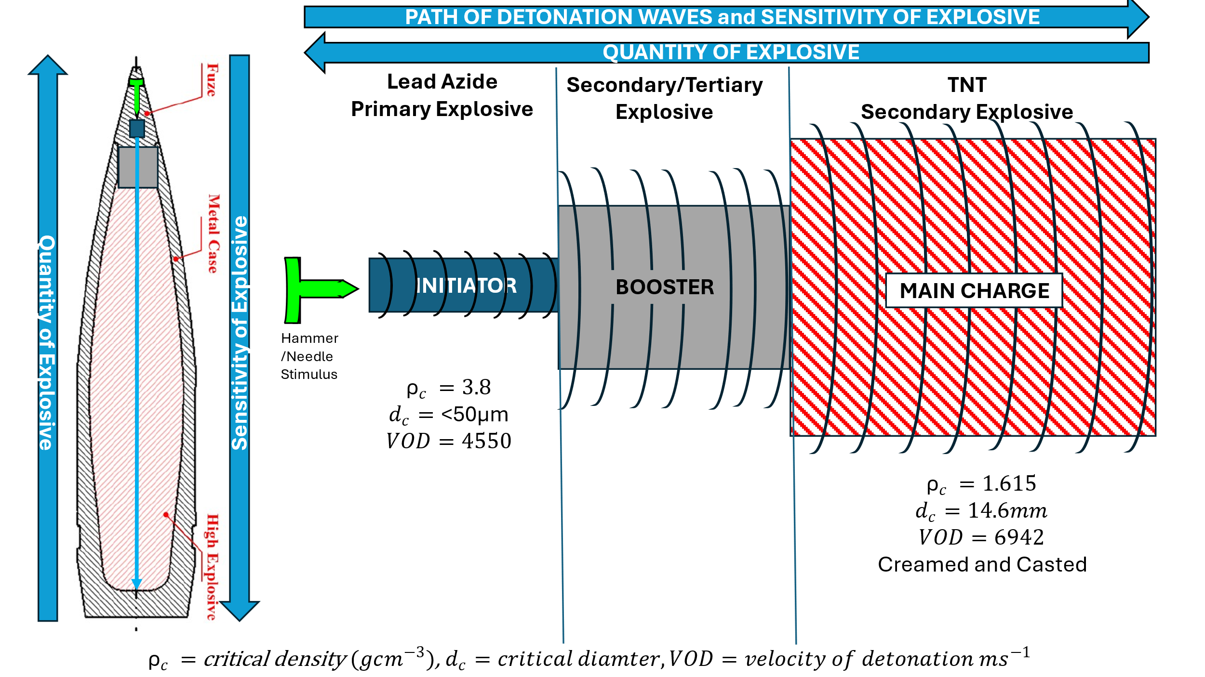
Explosive Train – Lead Azide and TNT

Sketch of artillery round [26]
Figure 7 - Explosive train of confined Lead Azide and TNT using values from Table 1 and Figure 5

Conclusion
In conclusion the confinement of primary and secondary explosives can produce more efficient detonations producing greater pressures and effects. The critical diameter and density are two key factors in the function of an explosive and if these are not abided to an explosive compound will not function to maximum ability.

Bibliography

[1] | MOD UK National Authority for Qualification of Explosives, Services Textbook of Explosives, London: Ministry of Defence, 2020.
[2] | UN (United Nations), “https://unece.org/sites/default/files/2023-07/GHS%20Rev10e.pdf,” 2023. [Online]. Available: https://unece.org/sites/default/files/2023-07/GHS%20Rev10e.pdf. [Accessed 1 December 2025].
[3] | J. P. Agrawal, High Energy Materials, Great Britain: Wiley-VCH, 2010.
[4] | E. G. Mahadevan, Ammonium Nitrate Explosives for Civil Applications, Weinheim: Wiley-VCH, 2014.
[5] | P. C. Jung, “Initiation and Detonation in Lead Azide,” Texas Tech University, Texas, 2006.
[6] | A. R. Mahmud, “Risk Assessment,” Universiti Putra Malaysia, Malaysia, 2018.
[7] | Ministry os Defence, Services Textbook Of Explosives Procurement Executive, Ministry of Defence: London, 1972.
[8] | R. Matyas, Primary Explosives, Springer, 2013.
[9] | N. K. Bourne, “On the critical threshold for detonation,” Combustion and Flame, vol. 244, 2022.
[10] | Y. Mu, W. Zhang, R. Shen and Y. Ye, “Observations on Detonation Grwoth of Lead Azide at Microscale,” Micromachines, vol. 13, no. 451, 2022.
[11] | M. Hill, P. Alto, W. E. Tolberg, G. J. McDonald and M. Park, “United States Patent , PROCESS FOR THE MANUFACTURE OF TNT,” United States Department of the Army, 25 August 1972. [Online]. Available: https://patentimages.storage.googleapis.com/27/a9/79/ef49d0665bd7f1/US3799993.pdf. [Accessed 6 December 2025].
[12] | A. Talaat, A. Elbeith, H. Tantawy and A. K. Hussein, “Thermal behavior and explosive properties of TNT/RGO,” Journal of Physics:, vol. 2305, no. 1, 2022.
[13] | T. R. Gibbs and A. Popolato, LASL Explosive Property Data, Berkeley & Los Angeles: University of California Press, 2023.
[14] | A. S. Tappan, P. C. Jung, R. Knepper, R. R. Wixom, B. R. Melvin, M. Marquez, J. Ball, J. C. Miller and E. J. Welle, “Lead Azide and PETN Reactions at,” Sandia National Laboratories, April 2011. [Online]. Available: http://www.cecdarchive.umd.edu/documents/presentations/synthesis-workshop-tappan.pdf. [Accessed 5 December 2025].
[15] | A. V. Utkin, S. A. Kolesnikov and A. V. Pershin, “Effect of the Initial Density in the structure of Detonation Waves in Heterogeneous Explosives,” Combustion, Explosion and Shock Waves, vol. 38, pp. 590-597, 2002.
[16] | R. Weinheimer, “Properties of Selected High Explosives,” PACSCI EMC, July 2000. [Online]. Available: https://psemc.com/resources/pyrotechnic-white-papers/properties-of-selected-high-explosives-rev/. [Accessed 7 December 2025].
[17] | R. Meyer, J. Kohler and A. Homburg, “Casting of Explosives,” in Explosives, Wiley-VCH Verlag GmbH & Company KGaA, 2015, p. 55.
[18] | T. M. Klapotke and M. Suceska, “A computational Study on the Detonation Velocity of Mixtures of Solid Explosives with Non-Explosive Liquids,” Propellants, EXplosives, Pyrotechnics, vol. 46, no. 3, pp. 352-355, 2021.
[19] | W. B. Cybulski, W. Payman and D. W. Woodhead, “Explosion waves and shock waves. VII.The velocity of detonation in cast T.N.T,” Mathematical And Physical Sciences, vol. 197, no. 1048, pp. 51-72, 1949.
[20] | W. B. Cybulski, W. Payman and D. W. Woodhead, “Explosion Waves and Shock Waves.VII, The detonation velocity of detonation in Cast TNT,” Proceedings of the Royal Society of London. Series A, Mathematical and Physical Sciences, vol. 197, no. 1048, pp. 51-72, 1949.
[21] | I. Jaffe and D. Orice, “Determination of the Critical Diameter of Explosive Materials,” ARS Journal, vol. 32, no. 7, pp. 1060-1065, 1962.
[22] | Z.-X. Zhang, “Chapter 8 - Explosives and Detonators,” in Rock Fracture and Blasting, Oxford, Butterworth-Heinemann, 2016, pp. 179-195.
[23] | N. Galustanian, M. Elshazli, H. Kaur, A. Elsisi and S. Orton, “Experimental Characterization of Cast Explosive Charges Used in Studies of Blast Effects on Structures,” CivilEng, vol. 6, no. 2, 2025.
[24] | The New York Times, “Million Pounds of TNT set off in Canada Blast,” in The New York Times, New York, July 18 1964, p. 4.
[25] | M. Short, C. Chiquete and J. J. Quirk, “The influence of multi-layer confinement on detonation propagation in condensed-phase explosives,” Proceedings of the Combustion Institute, vol. 38, no. 3, pp. 3595-3603, 2021.
[26] Khalil, M., Abdalla, H., & Mahmoud, O. M. "Dispersion Analysis for Spinning Artillery Projectile " May 2009[Online]. Available:"https://www.researchgate.net/publication/283055036_Dispersion_Analysis_for_Spinning_Artillery_Projectile" [Accessed 15 December 2025]

Appendices
Appendix A – Detonation density and velocity of unconfined TNT [19]
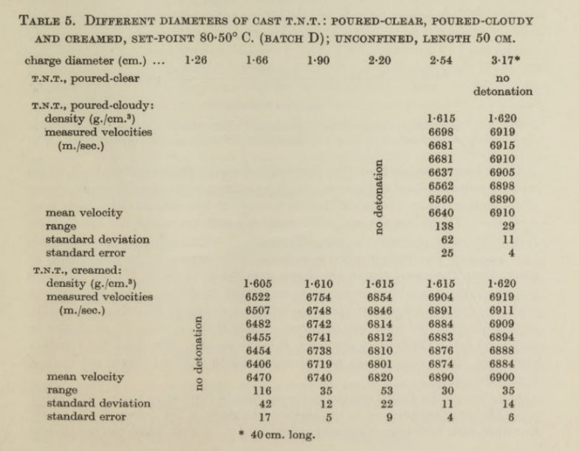

Appendix B – Detonation density and velocity of confined TNT [19] 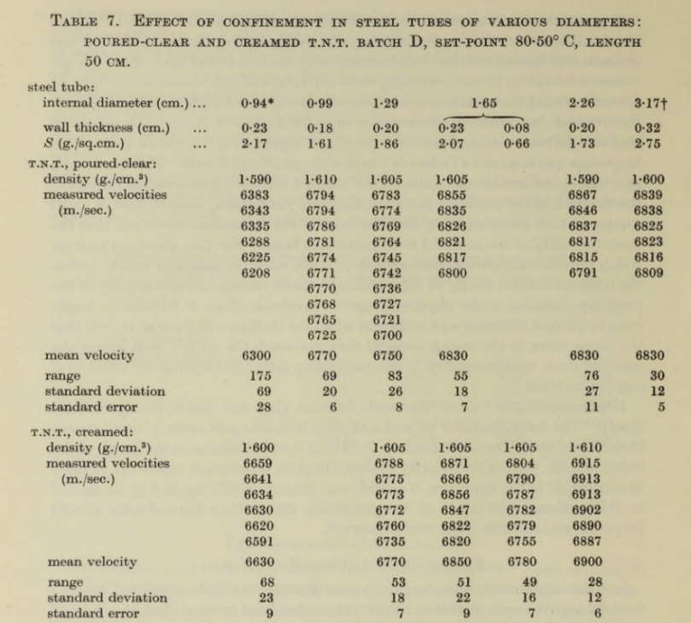

Appendix C – Boundary and Limit Diameters and Velocity of TNT [19]
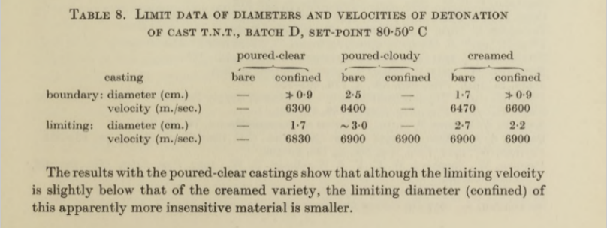
Appendix D – Detonation wave from explosive with lower velocity of detonation to explosive with higher velocity of detonation. [1]


