Nerys Craig
P148404
RESEARCH PROPOSAL

Table of Contents
- 1.1 Title
- 1.2 Rationale and Background

- 2. 2. Aims and Objectives
- 2.1 Aims
- 2.2 Objectives

- 2.1 Aims
- 2.2 Objectives

- 3 Research Design:
- 3.1 Methodology.
- 3.2 Philosophy
- 3.3 Research Approach
- 3.4 Research Strategy and Method.
- 3.5 Sample

- 4. Limitations and Ethical Considerations
- 4.1 Research Limitations
- 4.2 Ethics and risks.

- 5. Reliability and Validity.

- 6. Resources.

- 7. Bibliography

  - Title:
A Critical Analysis of Unpaid Volunteers at Events: A Case Study of Iron Man Wales.
1.2 Background and Rationale:
The definition of an event is articulated by Getz (2005) ‘an opportunity for leisure, social or cultural experience outside the normal range of choices or beyond everyday experiences. The phenomenon of events has increased considerably over recent decades as explained by Long (2004) that due to globalisation, events that previously attracted a parochial local audience now have increased considerably attracting a global market. This has vastly increased the volume of attendees at events, creating the capacity for private organisations to create profitable businesses. In the case of Iron Man Wales it is defined as a ‘Hallmark Event’ (Hall, 1992) it can be said to be able to attract large scale numbers of spectators, however not on the scale as its counterparts of ‘Mega Events’ such as the Olympics and FIFA. The long-distance triathlon event is owned by World Triathlon Corporation, which was bought in 2015 by China’s biggest commercial property company, The Dalian Wanda Group for $650 million. China’s richest man Wang Jiankin controls the group, he is estimated by Forbes (2019) to have a fortune estimated at $26 billion. Himself and other big investors are realising the profits of such events as they require no stadium cost and predominately have a nature of being run by volunteers. The testament to the profits of these events is the 20% increase year on year since 2015. In 2015 Iron Man made $180 Million proving this event model is multi million profitable business model. (The Guardian, 2015)
Iron Man Wales is perceived as one of the most arduous one-day sporting events in the world today. The ultimate Iron Man is the ‘World Championship’ is hosted in its founding location Hawaii dating back to 1978. Iron man Wales is a qualifying race for this ultimate championship. The Iron Man Wales event is being hosted in the Welsh seaside town of Tenby, Pembrokeshire. The event began in 2011 with 1400 athletes competing, it has gained much popularity amongst the triathlon community increasing in 2018 to 2400 athletes. (Iron Man, 2018) The event now being claimed by Iron Man (2019) to bring revenue to local area of a sum amounting to £5 million (Iron Man, 2019) As identified by Fredline & Faulkner (2002) host communities can be become significantly reliant on the revenue however it can be identified as having associated negative effects.
The literature related to Cooperate Social Responsibility (CSR) is well developed according to McWilliams (2001) where there is reference to the intangible value of Human Capital. Freeman (2017) also states that there has been a renewed interest in CSR emphasizing the idea of Conscious Capitalism arguing that companies that endorse such policies will outperform others that do not, he continues to discuss Friedman’s claim that the only social responsibility of a company’s executive was to produce as much profit to the shareholders as possible. The counter argument is his New Business story according to Freeman ‘A sense of values and ethics has to go alongside purpose’ he supports the claim by stating scientific facts that human beings are not rational economic beings, which are not always driven by extrinsic rewards. Identifying that the new generation of Millennials a driven by sense of purpose, an experience not just money-making motive.
The purpose of this dissertation is to determine Iron Mans organisational business ethics regarding payment of Iron Man volunteer roles, if their social policies are synced with that of the community that host the event. The research will take a qualitative survey of targeted groups that have connections with Iron Man volunteer roles, its to ascertain their equanimity regarding their involvement in these roles. The research will proceed with interviews with the Iron Man team alongside analysis of their organisational volunteer management policies and the delivery of the volunteer experience. The dissertation will be enhanced with a secondary research literature review. The overall critical analysis will demonstrate the findings to present the topic, if Iron Man have a moral obligation to pay their volunteer roles. Watson (2008) explains the complexity of morality in stating a ‘given theory of morality applies a theoretical mechanism for linking its moral imperatives to essential facts’. McWilliams (2001) highlights that ‘CSR investments have seldom been considered in the context of cost-benefit analysis or market-based decision making’. The perception of volunteers being used as a work force is highlighted in The Guardian (2015 where a quote argues ‘Nobody can live for free – its unfair to expect them to do so. Even if it is for a good cause’.

2. Aims and Objectives:
2.1 Aim:
The aim of the research is to gain an insight into Iron Man volunteer motives, is the experience accessible for all across society? To then critically analyse Iron Man’s ethical management of volunteers and their CSR approach to host their communities?
2.2. Objectives:
a) Survey Iron Man volunteers to ascertain their motives and any barriers to them volunteering.
b) Review data collected from surveys across cluster groups.
c) To conduct a content analysis of Iron Man’s organisational policies for volunteer management and their sustainability in regard to social impacts of their events through semi-structured interviews with the Iron Man team.
d) To summarise the literature review, emphasising current business ethics.
e) Collate the evidence to present an ethical evaluation of the financial numeration for volunteers.

3. Research design.
3.1 Methodology:
Saunders et.al. (2009) defines research as 'something that people undertake in order to find out things in a systematic way, thereby increasing their knowledge’. The nature of the research needs to be conducted in a strategic process, to ensure the researcher has thoroughly planned and identified their approach. The Research Onion depicts the complexity and importance of the researchers approach and strategy, the issues of data collection and data analysis can be followed by the researcher using the onions layers. In order for this research case to achieve its aims and objectives the researcher will apply the systematic process elaborated by Saunders per the Research Onion to develop the most suitable research strategy.

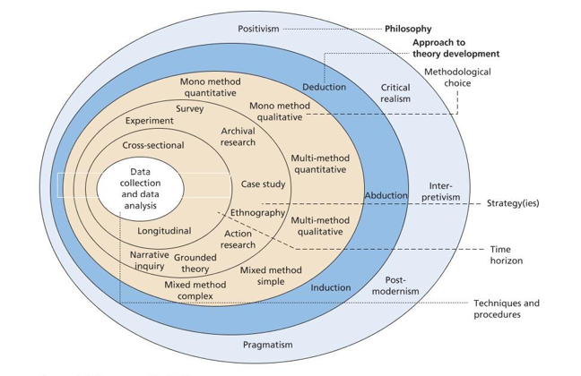
Figure 3.1. Saunders. (2016)
3.2 Philosophy:
The dissertation will be conducted in a manner described by Saunders ( 2015) as ‘Subjectivist Researcher’ he goes on to explain it is the researchers responsibility to seek and understand the differentiating realities of all the volunteers and Iron Man management, its imperative to make sense of their motives, actions and intentions in a way that is coherent and purposeful.
The research paradigms are explained by Collis and Hussey (2203) as being ‘universally recognised scientific achievements that for a time provide model problems and solutions…offer a frame work comprising an accepted set of theories, methods and ways of defining data’. They continue to explain that there are two main research paradigms. One being Positivistic Paradigm and secondly Phenomenological (Interpretivism) Paradigm for the purpose of this research the latter will be utilised as this approach focuses on the opinions , experiences and evaluation of individuals involved in the situation. Saunders (2015) explains that working within this paradigm would be ‘to understand the fundamental meanings’ that are held within an organisation.

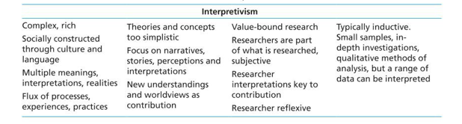
Figure 3.2 Saunders (2016)
3.3 Research Approach:
Developing the theory approach to deliver the aims and objectives of the dissertation is the ‘Abductive Approach’, which is said by (Suddaby, 2006) to combine both deductive and inductive approaches. It is described by Saunders (2015) as the approach incorporated into many businesses management researchers process. For this study the theory will move back and forth testing to data to theory being induction, theory to data being deduction. Data will be collected from targeted Iron Man volunteer groups, to content analysis of Iron Man Volunteer management to their personal reviews of the volunteer experience. Back to literature review investigating business ethics and Iron Man social responsibility policies.

3.4 Research Strategy and Method:
As identified in the Methodology and illustrated in Figure 3.1 the research follows systematic process. The research strategy is by which means the researcher is going to gather their data both primary and secondary of the purpose of this dissertation will be The Case Study strategy which is defined by an in-depth investigation into a single topic, in this case an organisation being Iron Man. Bouma and Atkinson (1995) explain that a case study can answer the question ‘What is going on?...Is there a relationship between X and Y?’. For this dissertation we limit the use of the term to an Exploratory Study’ this where the limit of content analysis is involved to explore rather than testing a hypothesis.
The case study strategy allows for varying methods to be deployed, for this study it will involve quantitative surveys, semi-structured qualitative interviews, analysis of documents and a multifaced literature investigation with accompanying evaluation.
The figure by Denscombe (2014) below shows the suitability of the Case Study strategy for this dissertation.
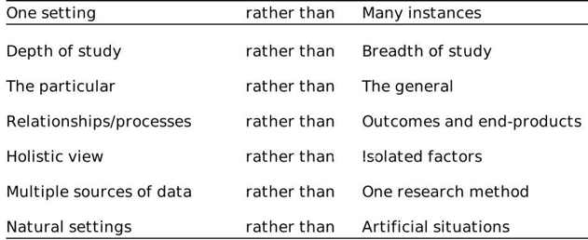
Figure 3.4 Denscombe 2014

3.5 Sample:
Researchers are required to select a sample of the larger population, Fink (1995) stated that the ‘population is the universe to be sampled’. For a sample to be most effective it needs to represent a miniature version of the larger population. The sample needs to give a clear reflection of the larger population its representing. Quantitative surveys are being used for this research to derive the information set out in the aims and objectives, it will provide an evaluation of volunteer opinions and experiences. For this survey Cluster Sampling method will be adopted, as it has naturally occurring units. The cluster units will include previous Iron Man volunteers, UWTSD Event, Tourism, Leisure management students and target volunteer groups identified by Iron Man recruitment being Pembrokeshire based clubs and associations. This will be conducted predominately via email using survey forms on Goole Documents, in the instance where more surveys are needed the researcher will distribute hard copies to students in the identified cluster These are convenient group clusters and will attempt to mitigate the restriction in time and resources available to the researcher. The statistical analysis will be presented using software to produce graphs and pie charts.
Under the case study strategy, the researcher will conduct interviews with Iron Man employees who deliver the volunteer management programme and logistics of the event delivery. The Social Science Research Council (1954) stated many decades ago that ‘Interviewing as a method of inquiry is universal to the social sciences’. The researcher will conduct a semi-structured interview process, with a set of questions referred to as the ‘Interview guide’ (Bryman (2008). This allows the interviewer to follow a set of questions but be spontaneous in elaborating questions around the responses.
This is study intends to achieve the best outcomes using mixed methods triangulation approach the quantitative data and qualitative data, will combine with content analysis of Iron Man policies and business ethics literature to give an evaluation of critical analysis of the Iron Man case study to present findings for the title topic successfully meeting and accomplishing the aims and objectives.

4. Limitations and Ethical Considerations:
4.1 Research Limitations:
The limitations that resides within this study is the time and resources available to the researcher. To support the researchers time management a Gantt Chart (Figure 6.1) has been produced to mitigate any limitations. This will aid the researcher’s coordination of the research study.
4.2 Ethics and risks:
According to Said (1979) ‘the study of human experience usually has an ethical, to say nothing of a political, consequence in either the best or the worst sense, we will not be indifferent to what we do as scholars’. The ethical content analysis, research study is limited regarding ethical risk. The Researcher needs to conduct themselves at all times in a manner that is respectful and adheres to the Ethical Form supplied with proposal. All the surveys and interviews will be conducted on a voluntary basis. No vulnerable groups or under eighteens are not approached. All data captured will be anonymous and held securely on device and server that has protected login details. There will be no breaches of GDPR or other legislation.

5. Reliability and Validity:
The researcher developed the research study following the methodology approach, strategy, systematic process referred to in Figure 3.1 which will promote the superior design possible. This managed by the researcher with consistent supervisor interaction will ensure the aims and objectives are derived in a reliable and valid manner. The researcher’s credibility is largely down to the eventuality of the opinions at that time (Agee, 2008)

6. Resources:
The resources applied for this study will be in the form of online survey through Google Documents, email questions and Skype interviews. The accessed documentation to analyse the volunteer management policies supplied directly ny Iron Man team. Secondary data will be accessed through the university’s resources by the

Gantt Chart Figure 6.1
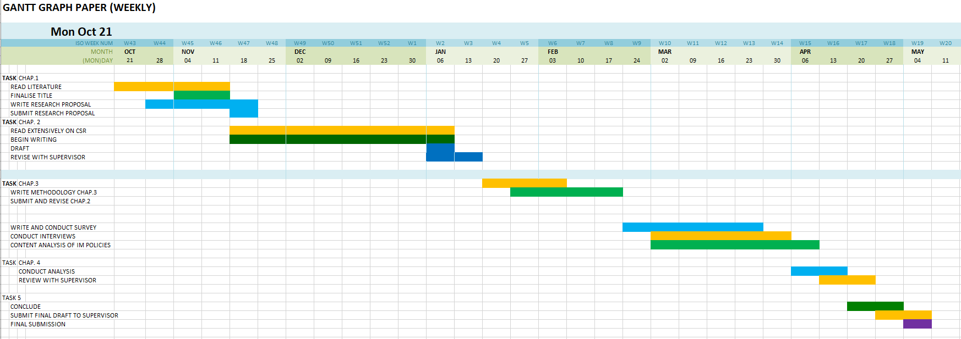

7. Bibliography:

Agge, J. (2008) Developing qualitative research questions: a reflective process. . Volume 22, 2009 - Issue 4

- Bouma, G. and Atkinson, G. (1995) Social Science Research. Oxford University Press.

- Bryman, A. (2008) Social Research Methods. Oxford University Press.

- Collis, j. and Hussey, R. (2003) Business Research. Palgrave Mcmillan.

- Denscombe, M. (2014) The Good Research Guide: For Small-Scale Social Research Projects. Open University Press.

- Fink, A (1995). How to Sample in Surveys. Sage Publications.

- Freeman, R. Edward (2017)The New Story of Business: Towards a More Responsible Capitalism. Business & Society Review (00453609). Vol. 122 Issue 3, p449-465.

- Fredline, E., & Faulkner, B. (2002). Variations in residents' reactions to major motorsport events: Why residents perceive the impacts of events differently. Event Management, 7(2), 115–125. http://dx.doi.org/10.3727/152599501108751524.

- Forbes. (2019) Accessed 11.11.19 https://www.forbes.com

- Getz, D. (2012) Event Studies. Routledge.

- Guardian, The (2015) Accessed on 11.11.19 https://www.theguardian.com/lifeandstyle/2015/sep/11/rise-of-ironman-the-global-triathlon-brand-worth-650m

- Hall, C. M. (1992). Hallmark Tourist Events: Impacts, Management and Planning. London: Belhaven.

- Hyman, H. (1954) Interviewing in Social Research. The University Of Chicago Press.

- Ironman (2018). 09/9/2018 Results: Wales. Available at: <http://eu.ironman.com/triathlon/events/emea/ironman/wales/results.aspx

- Iron Man (20190 Jackson, R. Presentation. 12.11.19.

- Long, P. Et. Al., (2004) Festivals and Tourism Marketing. Business Education Editors Ltd.

- McWilliams, A. and Siegel,, D. ‘Corporate Social Responsibility: A Theory of the Firm Perspective’, Academy of Management Review, 26, No.1, 2001, pp. 117–127

- Saunders, M. et. Al., (2016) Research Methods for Business Students. Pearson education Limited.

- Suddaby, R. (2006) What Grounded Theory is Not. Academy of Management Journal. Vol, 49.

- Said, E. (1979). Orientalism, New York: Vintage Books

- Watson, G.W Et., Al. (2008) Connected Moral Agency in Organizational Ethics. Journal of Business Ethics (2008) 81:323–341

- https://www.theguardian.com/commentisfree/2011/jun/28/charities-unpaid-interns-graduates
- https://www.chron.com/neighborhood/woodlands/news/article/Volunteers-key-to-success-of-Ironman-event-in-6234310.php
- http://crushingiron.com/should-volunteers-have-to-pay-ironman/
- https://www.reddit.com/r/triathlon/comments/6r930j/ironman_must_stop_using_free_labor/

- https://www.google.com/search?client=firefox-b-d&ei=83_NXduhJMK58gKWy6egDQ&q=should+iron+man+pay+volunteers+because+it+can+afford+it&oq=should+iron+man+pay+volunteers+because+it+can+afford+it&gs_l=psy-ab.3..33i160.36846.37211..38011...0.2..0.101.165.1j1......0....1..gws-wiz.......0i71j33i21.YabGv3oWZxU&ved=0ahUKEwib54rtjurlAhXCnFwKHZblCdQQ4dUDCAo&uact=5

- https://www.researchgate.net/profile/Allan_Jepson/publication/277278177_Planning_and_managing_communities_festivals_and_events/links/5a4f6737458515e71b09298e/Planning-and-managing-communities-festivals-and-events.pdf#page=69

