7/20/2026
University of Wales Trinity Saint David
london campus
LDE Assignment 1
E-Portfolio

Module Name: Learning In the Digital Era
Module Code: ACCA 4025

Student Name: Svitlana Matviiuk
Student ID: 2541758
Group: 1

Lecturer’s Name: Koushik Modak

E-Portfolio Link: https://2541758.wixsite.com/my-site-16

Table of Contents
Main Body 2
Task 1: Essential Academic and Employment Skills for the future career Path 2
Task 1 (a): Report on Essential Academic and Employment Skills 2
Task 1 (b): Evaluation of Task 1 (a) based on Similarity report 3
Task 2: Collaborative Mind Map and Individual Poster 4
Mind Map (Collaborative) [3] 4
Poster (Individual) 4
Task 3: Virtual Collaboration and RefWorks[1] 4
Report on Virtual Collaboration 4
Step-by-step process of using RefWorks with visuals 4
Task 4: E-Portfolio Creation and Evaluation 4
Task 4 (a): E-Portfolio Creation 4
Task 4 (b): Illustrative Review of E-Portfolio tool Selection 4
Conclusion 4
References 4
Task 1 References: 4
Task 3 References: 5

Introduction
As a Computing student at the University of Wales Trinity Saint David, I realize that the development of academic as well as work-based skills is necessary for achieving success within the digital industry. The fast-changing pace of technology has led to a greater need for people who are knowledgeable not only in terms of their technical expertise but also in terms of being effective communicators, team players, problem solvers, and critical thinkers. As my future career objective, I aim to be a UX/UI Designer.

Main Body

Task 1: Essential Academic and Employment Skills for the future career Path

Task 1 (a): Report on Essential Academic and Employment Skills
As a Computing student in my future career as a UX/Ul designer, developing both academic and employment skills will be essential for professional success. Technology is changing rapidly, and employers are looking for graduates who have strong technical knowledge as well as good personal and professional skills. In my future career, I would like to become a UI UX Designer.

Essential Employment Skills
Communication is important in the work environment. The process of designing involves collaboration between UX/UI designers and developers, project managers, researchers, marketers, and the clients. Communication makes it possible for designers to explain their research, design choices, and to make sure that everyone involved has the same goals [1].
Collaboration is yet another key employability skill because UX/UI designing is very collaborative in nature. The designers engage in brainstorming sessions, design workshops, usability testing, and Agile development teams. Collaborating effectively with peers from other professions helps in the effective delivery of digital products Solving problems is the primary function of a UX/UI designer. In solving each design problem, the designer identifies the need of the user, generates solutions to the problem, tests prototypes, and improves the designs according to the user feedback [2].

Another crucial ability required by employees is time management. Time management involves the ability of designers to undertake several jobs at once under tight schedules. It includes planning, scheduling, and proper management of the workload.
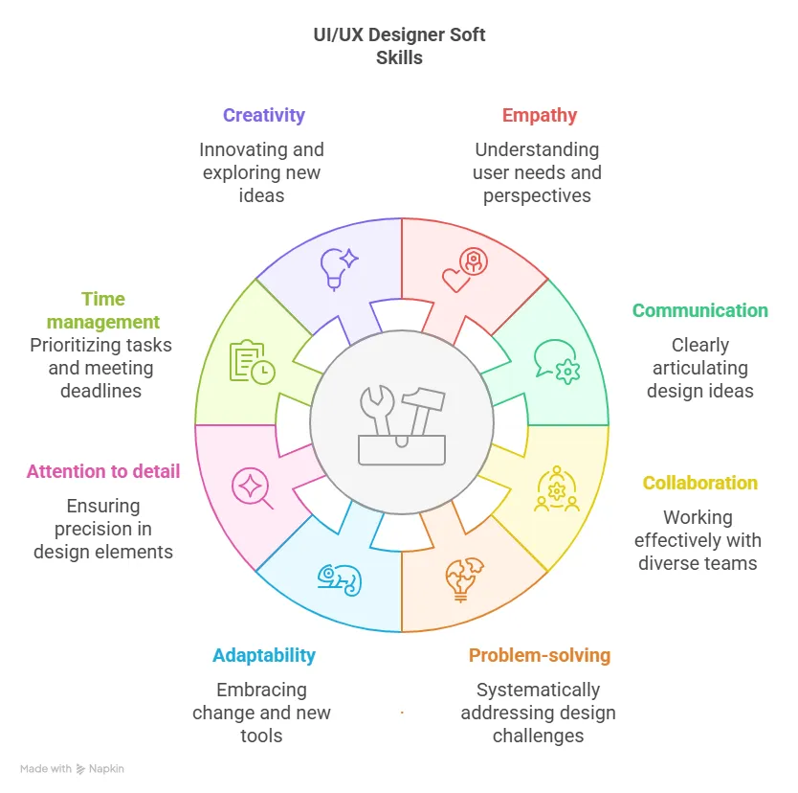Figure 1. Essential employment skills for UX/ Ul designers [3].

Essential Academic Skills
A key skill that one must develop in an academic environment is research. To design digital products, UX/Ul designers must know what the user behaviour, needs, and expectations are. Research tools include, but are not limited to, interviewing people, using questionnaires, performing usability tests, and conducting competitor analysis.

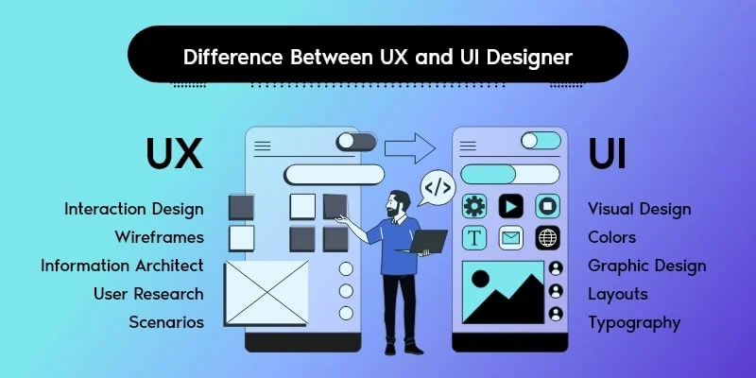

Figure 2. Differences between UX and Ul Design [4].
The next vital academic skill is critical thinking. The designer needs to evaluate various design options, spot usability problems and support his or her choices with scientific results. Critical thinking helps to analyse data objectively and create innovative solutions that can make user experience better. Digital literacy is another crucial skill for the present day. The UX/UI designers should be proficient in the use of professional software like Figma, Adobe XD, Sketch and prototyping software. Furthermore, knowledge of responsive design, accessibility standards and basics of front-end development like HTML and CSS can facilitate communication with software developers and increase teamwork efficiency. Writing and presenting skills are also very important for the modern designer. UX/UI designers often must write documentation for projects, user personas, design reports, usability research and case studies. Written and oral communication can help the designers to present their ideas to the clients and other people [5].

Technical skills will also be necessary for a career in Computing in the future. Programming languages such as Python and Java, knowledge of databases, and knowledge of cybersecurity and cloud computing are all skills that are useful in today's world of employment. But knowledge of technical skills is not sufficient. Employers also expect the graduates to have the ability to communicate well and work in teams.
UX/UI Designers usually utilize professional tools such as Figma, Adobe XD and Sketch for wireframes, prototyping and creating the user interface. Knowledge of these tools enhances teamwork and increases employability in the digital world [6].

Task 1 (b): Evaluation of Task 1 (a) based on Similarity report
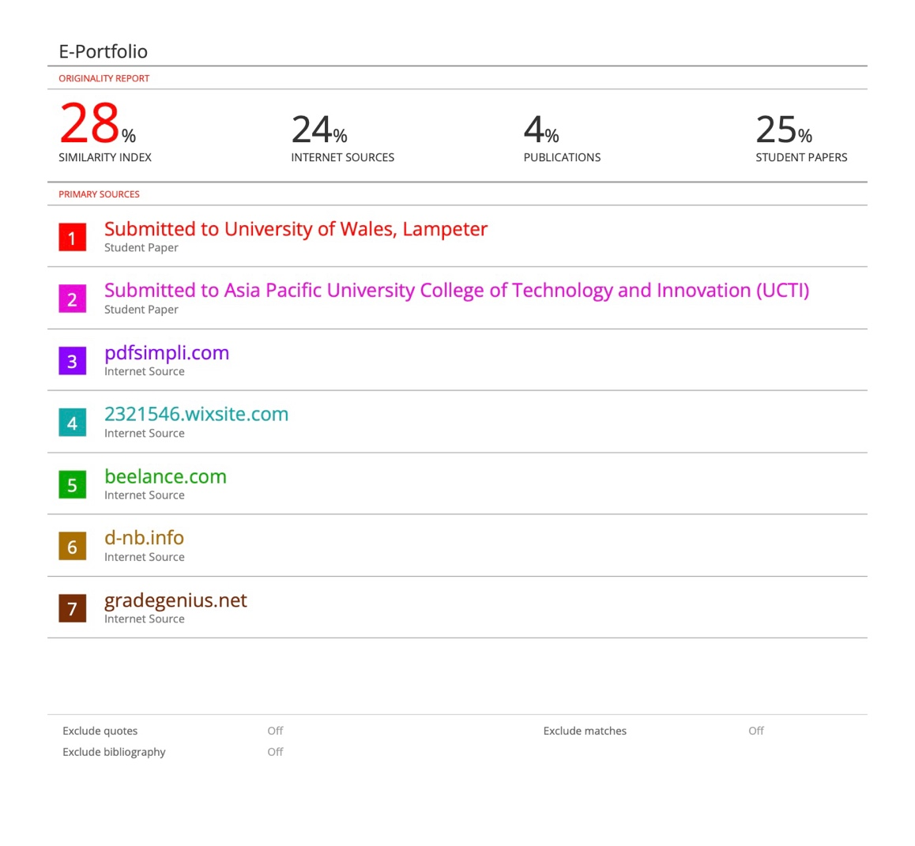
Figure 3. Similarity report
Following submission on Turnitin, my work was assigned a similarity score of 28%. The score indicates that there is some degree of similarity between some aspects of my work and other sources due to correctly referenced facts, technical language, and commonly used academic expressions. In future, I will make my work better through the use of effective paraphrasing techniques and including more of my own words.
Based on the Generic Assessment Criteria (GAC), I would rate my work at 70%. I feel that my work is properly organized, relevant to the task, and has the correct IEEE referencing. I showed a good grasp of academic and employment skills, but I need to do better critical analysis and refer to a variety of academic sources.

Task 2: Collaborative Mind Map and Individual Poster

Mind Map (Collaborative)
Mind Map Link: https://www.mindmeister.com/app/map/4053137546
Mind Map Image:
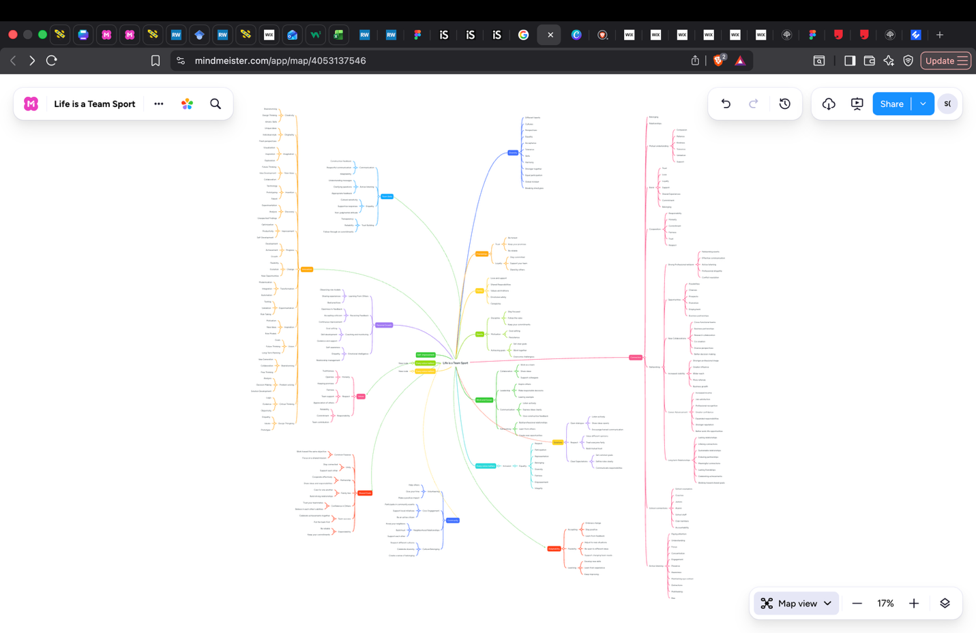

Individual Academic Poster
Poster Link: https://canva.link/lvpxuujfc69amd5
Poster Image:
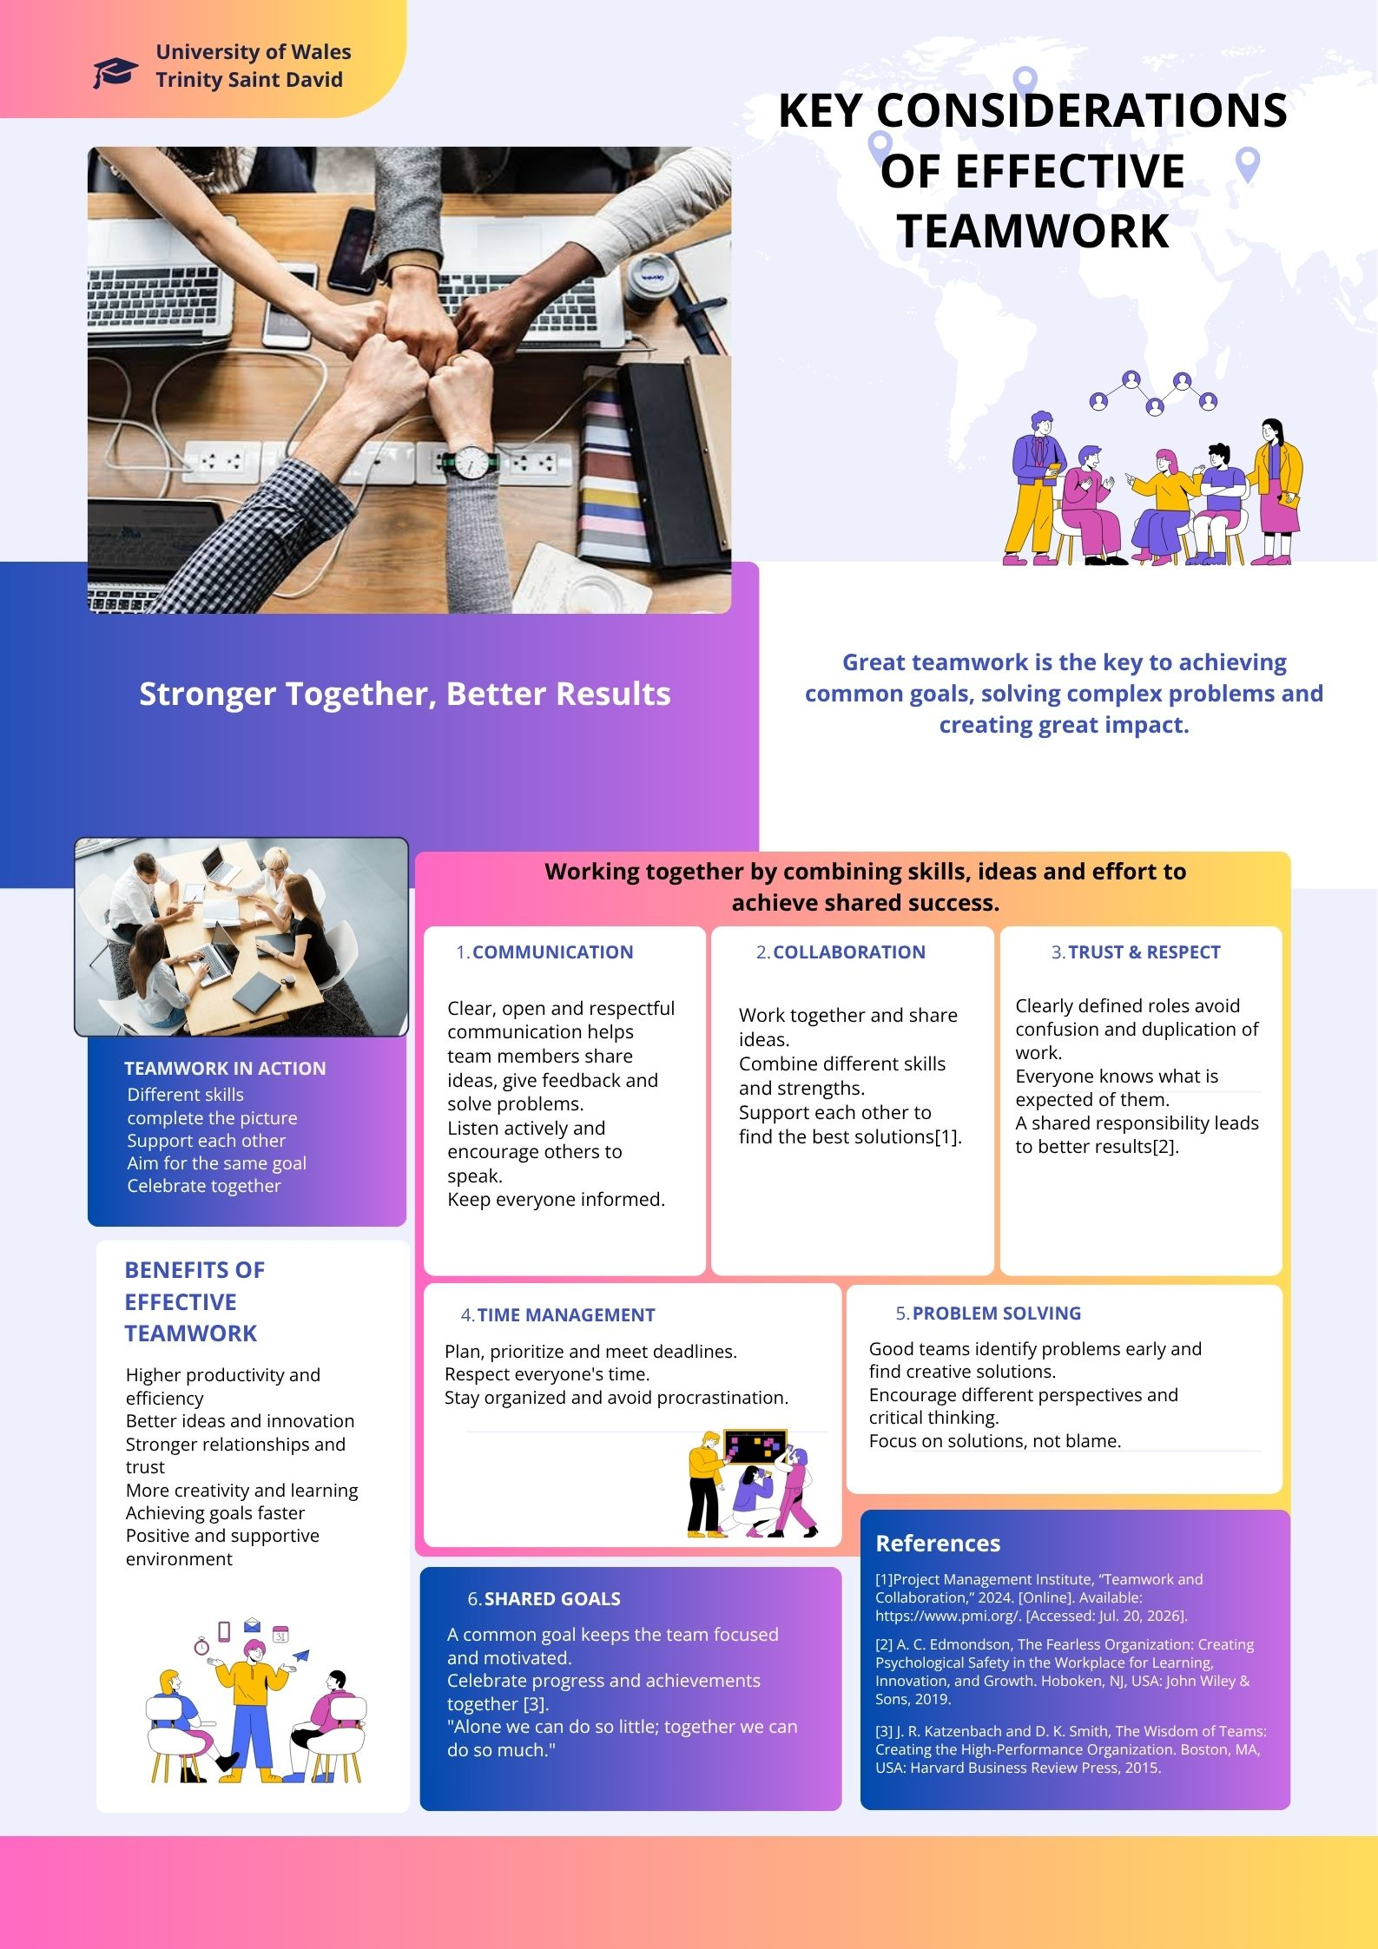

Task 3: Virtual Collaboration and RefWorks

Topic 3: The new norming

Norming is the third stage in Tuckman’s team development process. At this stage, the members start working in a much more effective way after having overcome the problems they faced during the previous two stages. Strong relationships are established, better communication takes place, and the team members gain mutual trust and respect for one another. This makes the team more organized and efficient since every member knows his/her role and objective[1].
Constructive feedback is one of the key aspects of the process of norming. Constructive feedback enables the team members to understand their strengths as well as the areas which require development in a respectful manner. To be effective, feedback needs to be specific, balanced, and behaviour based rather than being personality based [2].
Another concept worth mentioning here is Radical Candor, developed by Kim Scott. The principle of Radical Candor is an approach to leading and communicating with two key aspects: caring personally and challenging directly. It includes providing feedback to others, being respectful and caring about other people who work alongside you. Using the approach of Radical Candor, workers can create an atmosphere when it is easy to express thoughts and discuss issues [3].
Virtual collaboration is highly dependent on efficient communication since team members collaborate remotely, hence, they may never see each other personally. Communication channels such as Microsoft Teams, Zoom, Slack, and Google Workspace facilitate collaboration, however, they do not substitute for trust and communication. It is important for team members to exchange information, listen to one another, and give feedback for effective collaboration. Communication eliminates conflicts and helps keep everyone aligned with common goals [4].

Step-by-step process of using RefWorks with visuals
I go to the University Library website and sign in via your university account. I select the RefWorks option from the list of library options. The RefWorks interface is opened after signing I look up a journal article through Google Scholar. Then I click Cite and choose RefWorks or download the RIS file. I then import the file into RefWorks to add the reference to my library.
Step 1: Login to RefWorks
To start with, I logged into the RefWorks website through my university account. I used my university email and password to log into RefWorks.
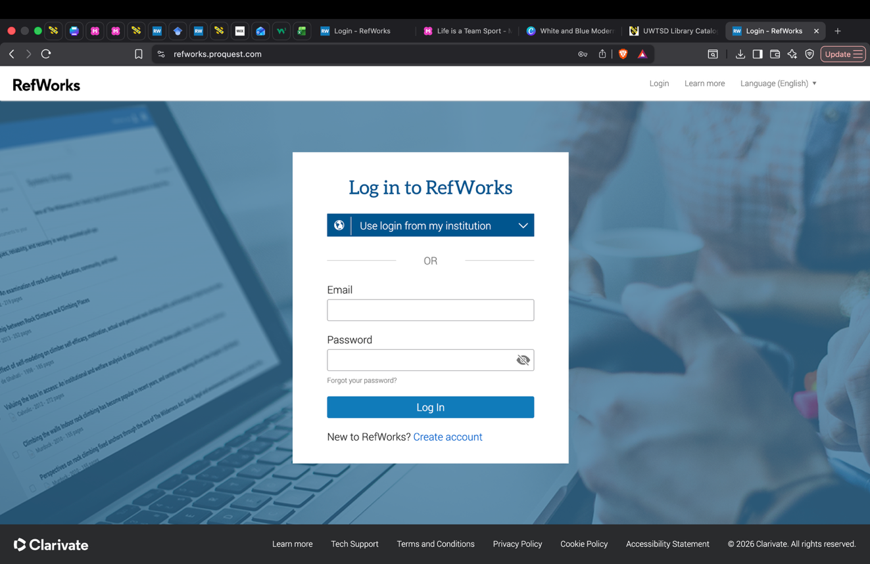
Figure 1. RefWorks login page or dashboard

Step 2: Exporting a Reference to RefWorks
To cite this reference in Google Scholar, I clicked on the Cite button beneath the reference. Then I clicked on the “RefWorks” option within the citation box that popped up. The reference was then exported to my RefWorks library.

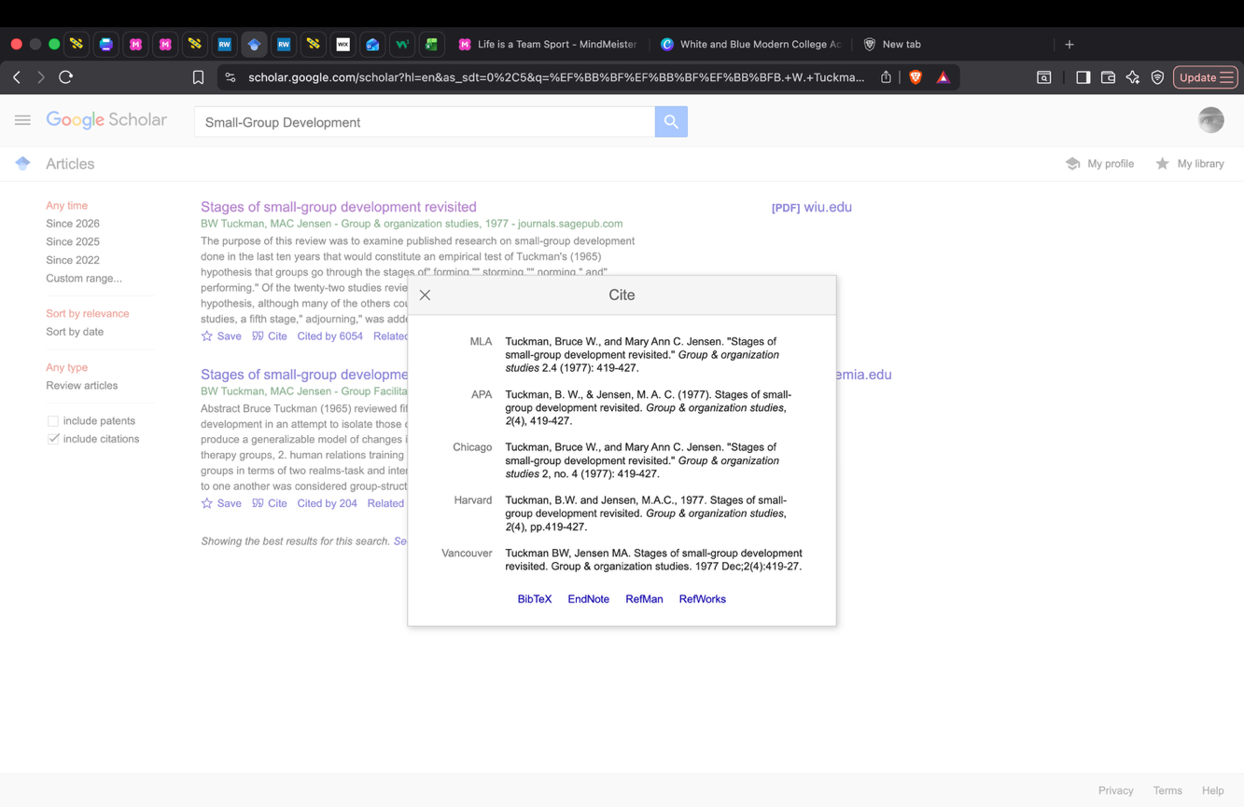
Figure 2. Exporting a Reference to RefWorks
Step 3. Importing Reference
References were also imported from an online database. The citation was chosen, imported into RefWorks, and checked to ensure that it was included in my library.
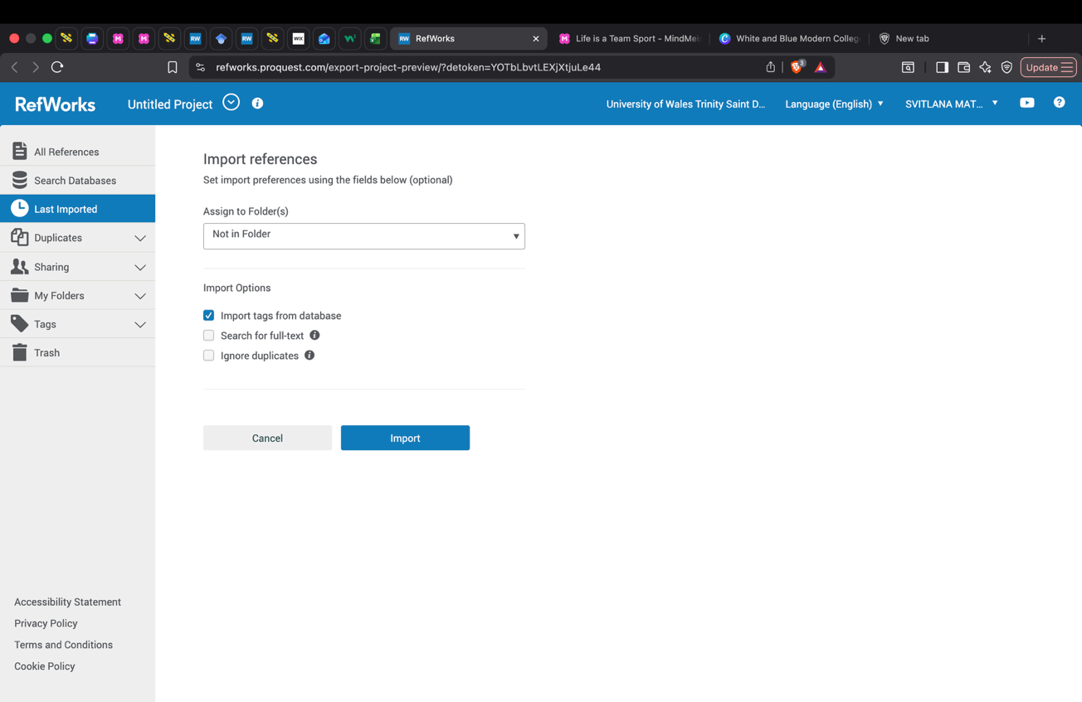
Figure 3. Importing references
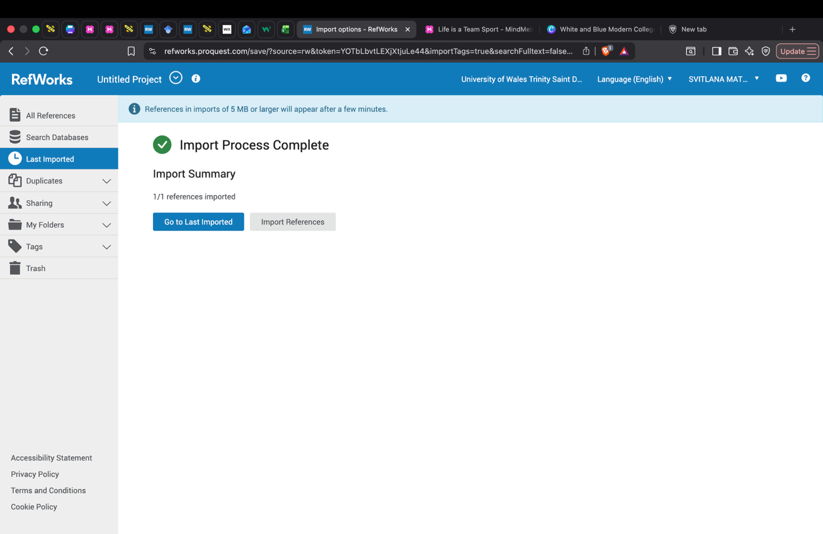
Figure 4. Import process

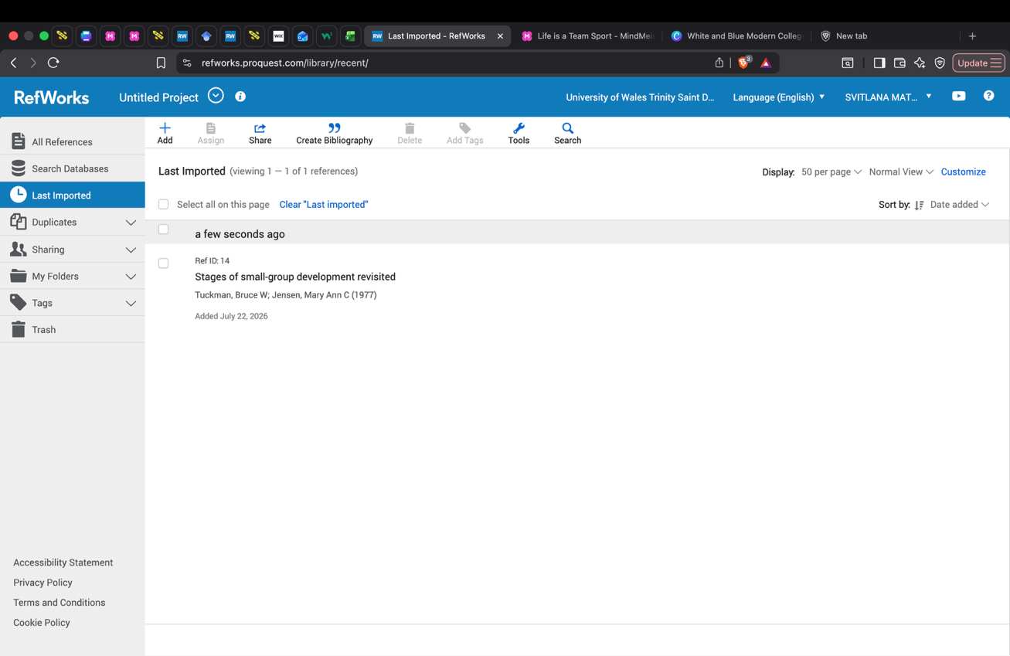
Figure 5. Import process
Step 4. Installation of RefWorks Citation Manager
For using RefWorks in MS Word, I installed the RefWorks Citation Manager plugin. After installation, I logged in to my RefWorks account.
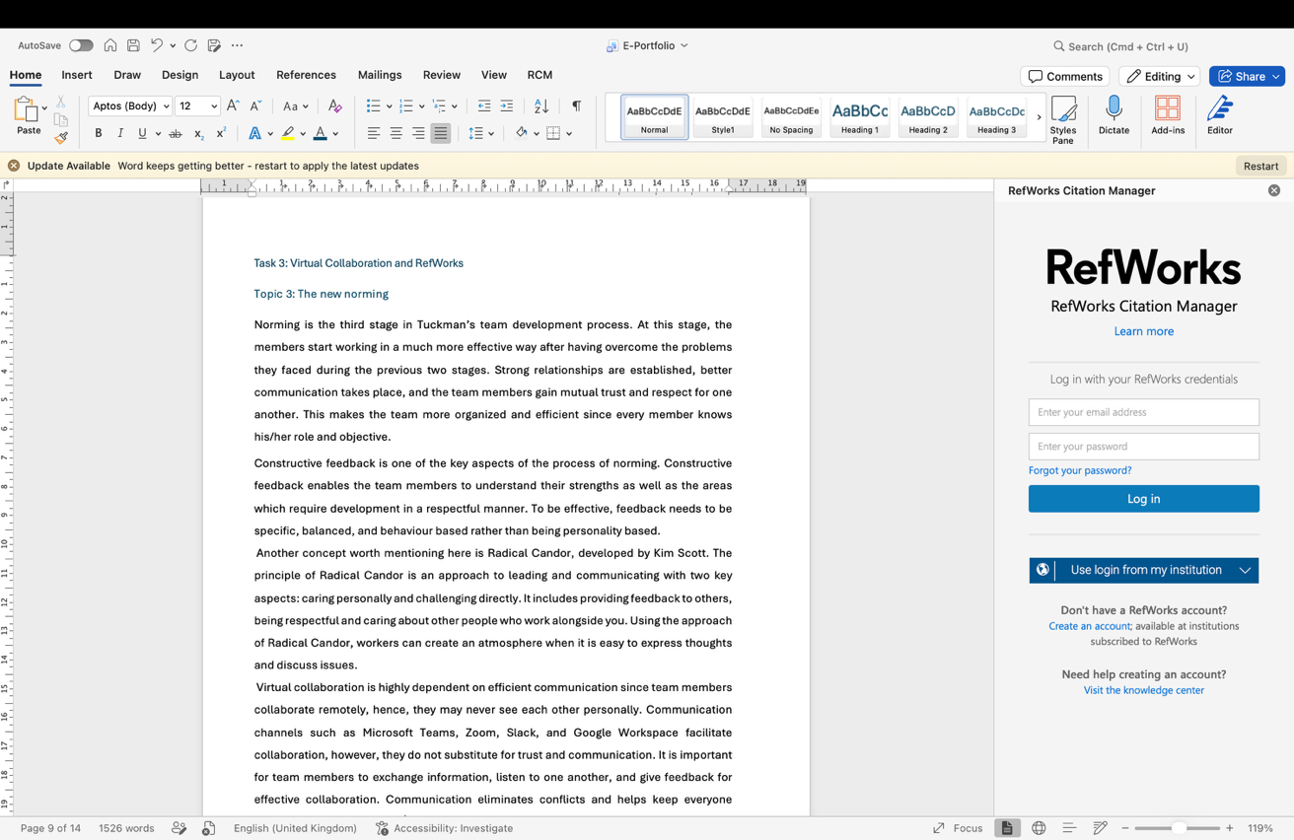
Figure 6. Citation Manager in Word
Step 5. Placing an In-text Citation
When working on my document, I opened RefWorks Citation Manager in Word. I found my reference in RefWorks, selected it, and placed it as an in-text citation.
I place the cursor where you want to insert a citation in my document and I open the RefWorks Citation Manager, search for the required reference, and click Insert Citation. The citation will automatically appear in the selected referencing style.

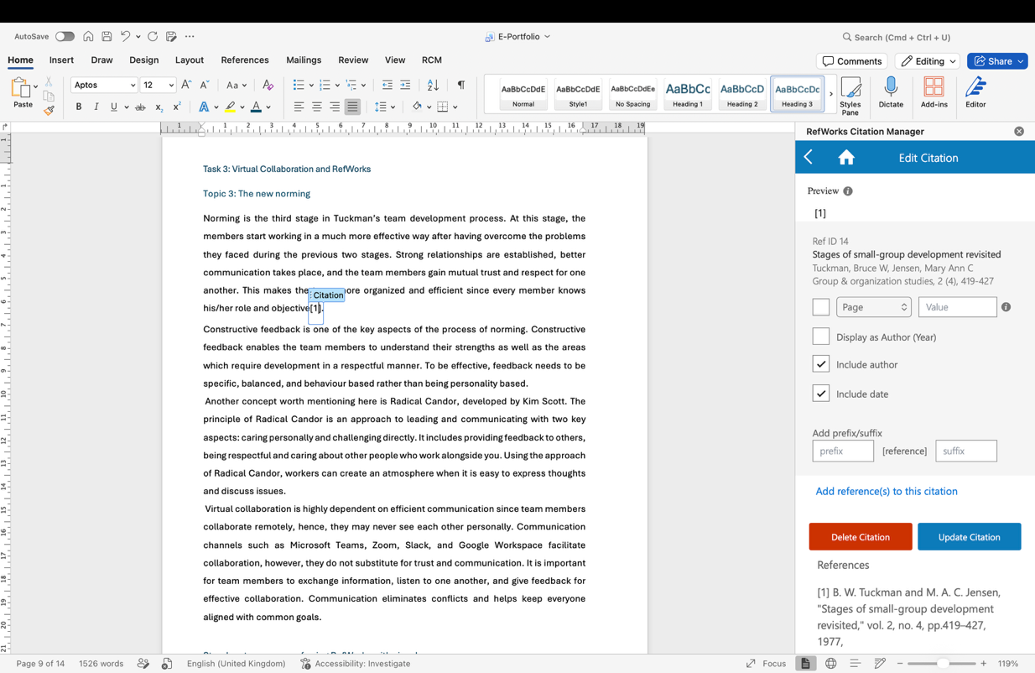
Figure 7. Placing an In-text Citation
Step 6. Preparing the Reference List
Once I had written my paper, I chose “Insert Bibliography” and RefWorks produced the list of references in the required style for me automatically.
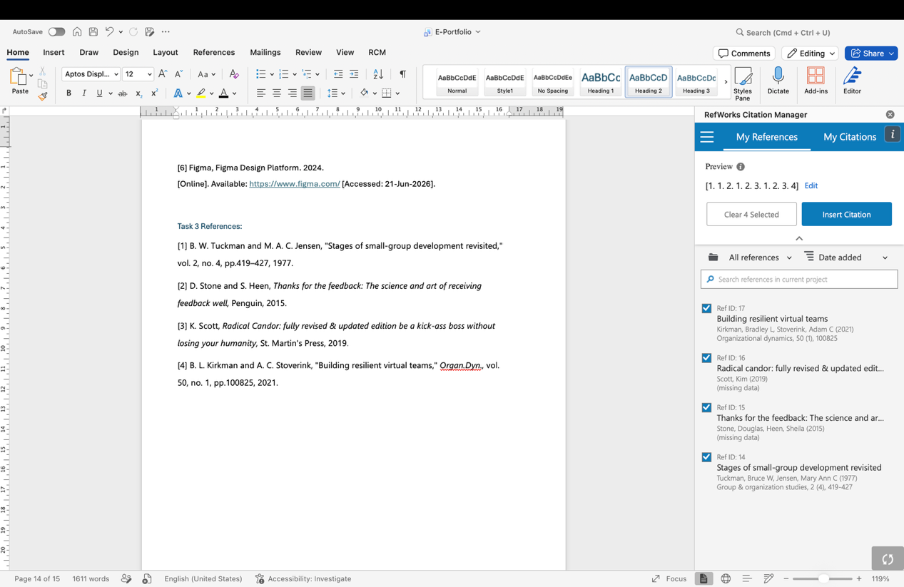
Figure 8. Inserted bibliography

Task 4: E-Portfolio Creation and Evaluation

Task 4 (a): E-Portfolio Creation
E-Portfolio Link: https://2541758.wixsite.com/my-site-16
E-Portfolio Image:
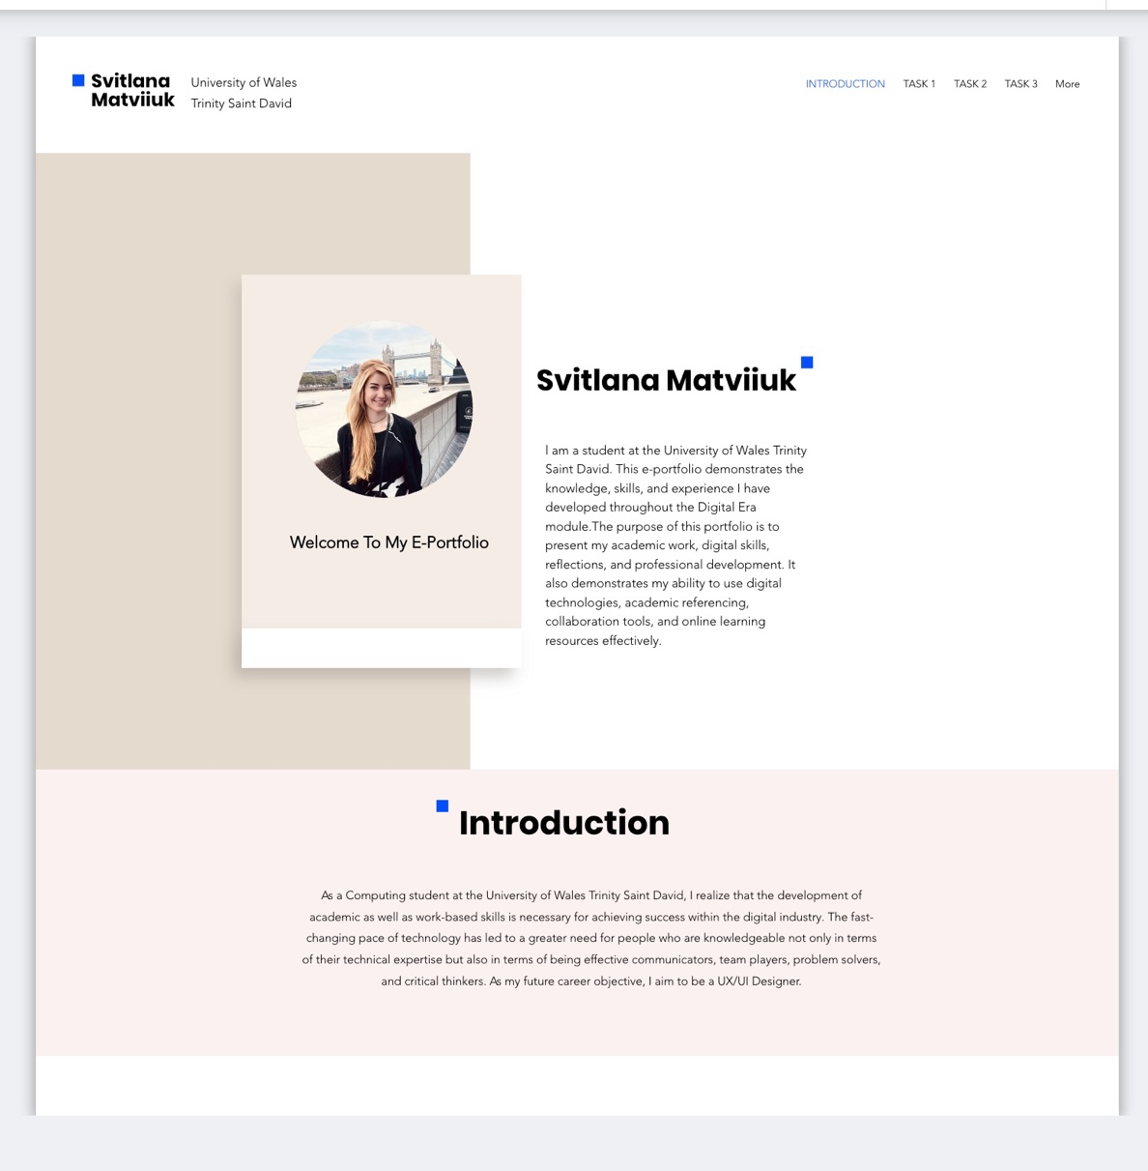

Task 4 (b): Illustrative Review of E-Portfolio tool Selection
I used Wix to create my e-portfolio. I selected this tool as it enables me to build a website where I can have all my assignments organized with professionally designed templates without any special technical knowledge.
The website built by Wix enables you to add text and images to your site and create different pages for each assignment. Wix makes it easy for me to publish the portfolio and share it through links so that my tutor can have access to view my e-portfolio. Moreover, Wix adjusts the website according to the device being used. In all, Wix was a good selection for the development of my e-portfolio.

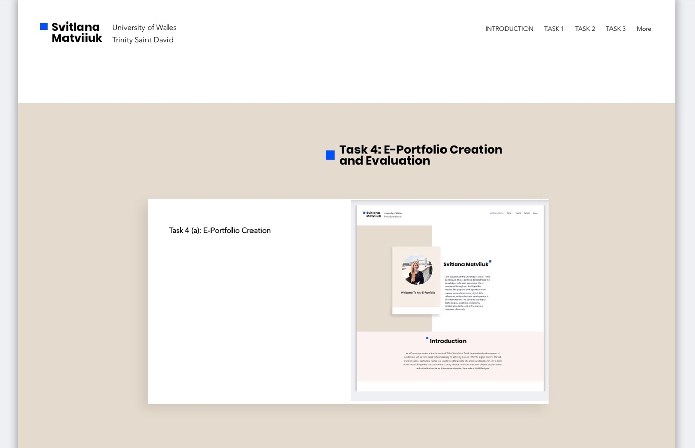

Moreover, using Wix to make my e-portfolio has allowed me to develop both my digital and organizational abilities. I have been able to organize information efficiently, create good-looking websites, and demonstrate my academic accomplishments in a professional manner. Furthermore, using Wix will allow me to maintain my portfolio by adding new assignments and accomplishments in the future. Thus, Wix can be used not only in the context of this assignment, but also in my further studies and career.

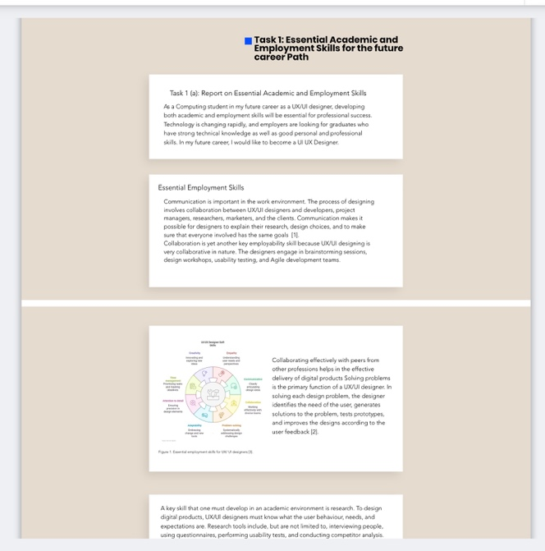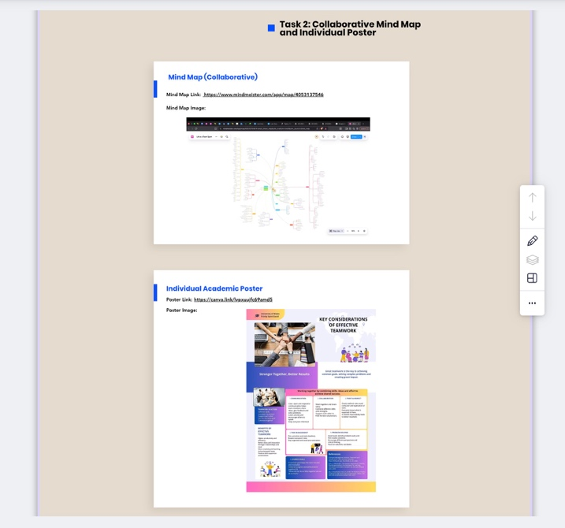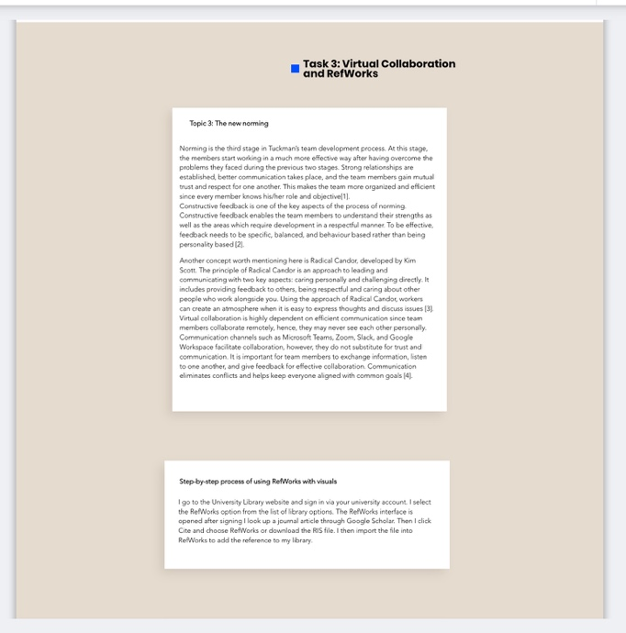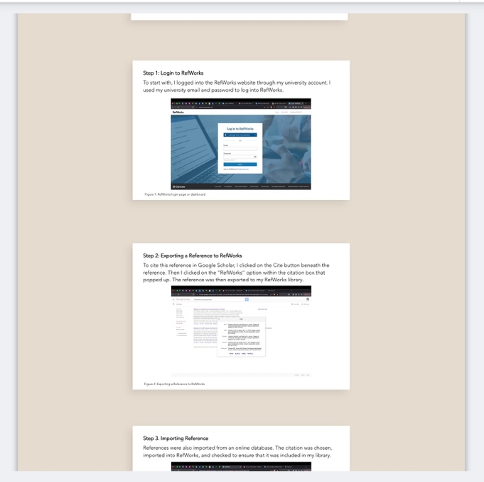

Conclusion
Through this assessment, it has been made clear the significance of digital technologies in enabling efficient communication, collaboration and professional development in the digital age. By engaging in various tasks, it has become possible for me to explore digital technologies and think about their real-life application in academia and beyond.
Through building my e-portfolio, I have had the chance to organise and structure my work properly while developing my digital literacy. By making use of the Wix software, I was able to create a proper portfolio.
In summary, this task has allowed me to gain better knowledge on the use of digital technologies, increased my confidence in working with online technologies and skills which would come in handy in my academic and professional life.

References

Task 1 References:
[1] S. Krug, Don't Make Me Think Revisited: A Common-Sense Approach to Web Usability, 3rd ed. Berkeley, CA: New Riders, 2014.
[2] D. Norman, The Design of Everyday Things, Revised and Expanded Edition. New York: Basic Books, 2013.
[3] upGrad, “UI UX Designer Job Description in 2025: Skills, Qualifications, and Salary Insights,” Apr. 23, 2025. [Online]. Available: https://www.upgrad.com/blog/ui-ux-designer-job-description [Accessed: 21-Jun-2026].
[4] Excellent WebWorld, Product Design vs UX Design: Differences, Similarities, Types.
[Online]. Available: https:// www.excellentwebworld.com/product-design-vs-ux-design
[Accessed: 21-Jun-2026]
[5] Interaction Design Foundation, what is User Experience (UX) Design? 2024. [Online].
Available: https://www.interaction-design.org/ literature/topics/ux -design. [Accessed:21-Jun-2026]
[6] Figma, Figma Design Platform. 2024.
[Online]. Available: https://www.figma.com/ [Accessed: 21-Jun-2026].

Task 3 References:
[1] B. W. Tuckman and M. A. C. Jensen, "Stages of small-group development revisited," vol. 2, no. 4, pp.419–427, 1977.
[2] D. Stone and S. Heen, Thanks for the feedback: The science and art of receiving feedback well, Penguin, 2015.
[3] K. Scott, Radical Candor: fully revised & updated edition be a kick-ass boss without losing your humanity, St. Martin's Press, 2019.
[4] B. L. Kirkman and A. C. Stoverink, "Building resilient virtual teams," Organ.Dyn., vol. 50, no. 1, pp.100825, 2021.

