MASTERS DEGREE ASSIGNMENT SPECIFICATION

Student name: | Anu N Kashyap | Student number: | 1708450
Programme: | eMBA
Module: | Entrepreneurship | Module Level: | 7
Module code: | SBMA7111D | Contribution to Overall  Module Assessment (%):
Lecturer: | Roisin Mullins | Internal Verifier:
Assignment Title: | Entrepreneurship | Assignment No (2 of 2): | 2 of 2
Hand Out Date: |  | Submission deadline:  Feedback deadline: | Task one: 13th January 2020

Referencing: | In the main body of your submission you must give credit to authors on whose research your work is based. Append to your submission a reference list that indicates the books, articles, etc. that you have read or quoted in order to complete this assignment (e.g. for books: surname of author and initials, year of publication, title of book, edition, publisher: place of publication).
Disclosure: | I declare that this assignment is all my own work and that I have acknowledged all materials used from the published or unpublished works of other people. All references have been duly cited.
Student’s Signature: | (Only where hard copies required) | Date: | 13-January-2020
Contents

1.0: Executive Summary 3

2.0: Introduction 3

3.0: Sustainable Development through Opportunity Enterprise 4

4.0: Conclusion 7

5.0: Bibliography 7

- Executive Summary:

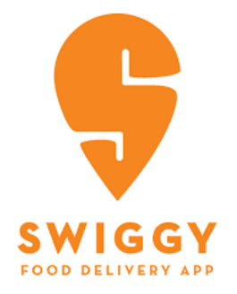
The below review illustrates as to how the entrepreneur has identified enterprise opportunities that has led to the social and economic changes for the Indian Society. Swiggy has been chosen as part of the entrepreneurial venture selection. Swiggy is India’s esteemed and largest online food ordering and delivery platform which started its operations in 2014 and headquartered in Bengaluru, India. Sriharsha Majety and Nandan Reddy, both alumni of BITS Pilani decided to start a hyper local food delivery service with the idea of changing the way Bengaluru eats by just click of a button. Swiggy has now extended their business beyond food delivery to deliver products from local stores which includes groceries and health care. Swiggy Go has been introduced in order to deliver any item ranging from forgotten files, keys, lunch box documents and so on which could be of great help to the citizens in many ways. The below review explains how Swiggy services has helped the Indian communities in bringing the social and economical change through job creation, delivering food to the needy and improving local economy.

way Bengaluru eats by just click of a button. The below review explains how Swiggy services has helped the Indian communities in bringing the social and economical change through job creation, delivering food to the needy and improving local economy.

Most of the information about the entrepreneur has been taken from the interview from YouTube and various websites/blogs of entrepreneurs which have been referenced in the bibliography.

- Introduction:

In the contemporary world, the conventional business models have become outdated and not so preferred by the millennial due to the massive change in information technology and drastic growth in the internet usage by the consumers. Hence entrepreneurs are adopting new business models in the form of e-commerce in order to sustain their business. The rapid growth in e-commerce has fascinated several entrepreneurs towards online business, especially online food industry. These online platforms make food readily available anytime, anywhere to its customers. As per Worldometer, 2020, India is the second most populated country in the world with the median age of 28 years. This age group would form a huge consumer market for food industry as this is where the maximum craving for fast food arrives. This consumer behaviour creates a huge potential for the online food delivery in Indian cities and Swiggy has been triumphant in seizing the opportunity
“Online food delivery and discovery platforms are changing the way Indians eat. The secret sauce: Logistics, data and technology, all deeply embedded in the granular knowledge of Indian food preferences.”
- Sriharsha Majety, 2019

According to Harsha Majesty, 2019, ‘Less than a decade ago, the way the nation consumed food was completely different. Back then, the market was highly segmented and 'ordering in' was not yet a part of our culinary vocabulary. Eating out was predominantly occasion-driven while ordering food was limited to dialling a few restaurants who offered home delivery or calling a trusty pizza chain. There was a window of opportunity, giving birth to marketplaces and aggregators who listed down restaurants across city areas, giving customers some measure of convenience.’

Swiggy, following its outstanding performance, has now extended their business on demand beyond food delivery to deliver products from local stores which includes groceries and health care. Swiggy Go has been introduced in order to deliver any item ranging from forgotten files, keys, lunch box, documents and so on which could be of great help to the society in many ways.

In most ways, Swiggy invented a food delivery platform that was original and incomparable with the existing ones. Establishing itself very soon as the largest online food ordering platform in the country, some of the unique merits of Swiggy include lightning fast deliveries, live order, no restrictions on order amount, and providing the comfort of giving them their most favourite food to the customers wherever they are.

- Sustainable Development through Opportunity Enterprise:

According to Kirzner, 1973, “Entrepreneur is someone who facilitates adjustment to change by spotting opportunities for profitable arbitrage.” Knowledge is the prime source of innovation, wealth and sustainable value in today’s world with all its economical and social challenges. Hence, the productive use and development of knowledge becomes a major process in creating the value both for the organisation as well as the society.
“When entrepreneurs start successful businesses, they create jobs that contribute to widespread prosperity. Unlike large companies, which often divert profits to centralized corporate headquarters in distant cities, small businesses keep local dollars close to home. Their successful businesses create jobs, and those jobs pay neighbourhood workers, who in turn, reinvest their pay checks in local economies.”

- Devra Gartenstein , 2019

The main objective of economic development is to increase the standard of living. Entrepreneurs play a role in contributing to the society by finding contemporary and innovative solutions to financial and social issues. As suggested by Naudé, “Entrepreneurship is concerned not only with business success, as measured by profits, but also with subjective welfare and non-economic well-being”.

According to a report from Boston Consulting Group “With rising affluence in India, households are climbing up the income ladder to drive nearly 3.5 times growth in consumption. This growth, fundamentally, is driven by two main factors—average spend per household and the total number of households," Many of the young generation in India are being employed in lucrative MNCs and this has become the reason for the raise in their personal disposable income resulting in the betterment in their living style. BCG reports, “Consumers are increasing discretionary spends on categories other than essentials such as food and consumer durables, along with the rise in income levels.” Swiggy has identified a potential in establishing themselves with the change in consumer spending pattern and offering them with the service the way they want it.
“With bigger spending power, though, Millennial have higher requirements: effortless ordering, instant delivery, one-step checkout, gamification, and more. I think the millennial generation is much more demanding than prior generations”

- Nigel Travis, CEO of Dunkin’ Brands

Commuting on road has been a major problem in the urban cities in India, especially in Bangalore where Swiggy started its business, due to heavy traffic and people find it hard to reach out to the restaurants they prefer to visit. Swiggy has helped the consumers in getting the food delivered with convenience. It has offered an opportunity to its consumers to feast at home with the equal food quality they would wish to relish at a fine restaurant.

There is a remarkable section of people in India with no or minimal education mainly due to poverty. Swiggy has helped these communities by creating jobs to thousands of people with minimal qualification, especially people from smaller towns and villages. According to Harsha, “If some of our growth estimates continue, it will not be too many years before we can be the third-largest source of employment in the country, behind the Army and Indian Railways,’ he adds ‘Swiggy currently has 2.1 lakh monthly active delivery staff and about 8,000 corporate employees on its payroll.” This has improved the quality of life of the delivery staff resulting in overcoming poverty and achieving social integration.

Dual Income families in urban India have changed the lifestyle, routine and food habits of the consumers and this mindset demands quick access to the food. According to Jiachen Mo, 2018, “In today's fast-paced society, people are constantly on-the-go. As a result, more people are choosing the alternative form of dining, food delivered straight to their doorsteps. It dramatically lessens meal-prepping time without sacrificing food quality. Imagine having the option of anything within your city delivered to you within thirty minutes, who would turn that down? More apps are surfacing in order to meet the demand for better and faster food delivery services.” Adding to it, there has been a change in Indian demographic profile due to which there is an outstanding increase in the number of working women in India. These working women find it hard to cook at home on all days due to high work pressure and all they need is someone to arrange healthy food for themselves and their family. Swiggy has indirectly become a helping hand by serving them home cooked food through their specialised restaurant partners.
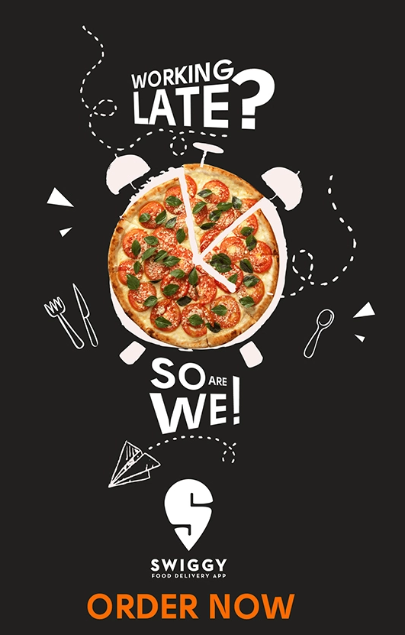

According to Tish Sanghera, 2018, “An estimated 17 million Indians were living abroad in 2017, making India the largest source country for international migrants globally, up from 7 million in 1990 and a 143% increase, according to an IndiaSpend analysis of data from the United Nations Department of Economic Affairs.” With the increase in the number of young professionals moving abroad for lucrative jobs, their old aged parents are forced to stay back in the home country with nobody to take care of their basic needs. They would be financially fit through their children’s earning however needs physical support for their daily routine. Swiggy has come a long way in supporting them through food and grocery delivery service. Swiggy go has been a best solution for them in getting anything needed to be delivered at their doorstep.

Further to increased disposable income and changing demographic profile, heavy traffic is a major problem for commuting in the metropolitan cities in India. Also, there has been a change in the lifestyle of consumers, especially in the urban areas. People would prefer spending time with their families peacefully rather than being in the crowded restaurants. This gives a huge opportunity for online food delivery servicers to take charge of the situation and Swiggy has been successful in creating an in-house restaurant for its customers.
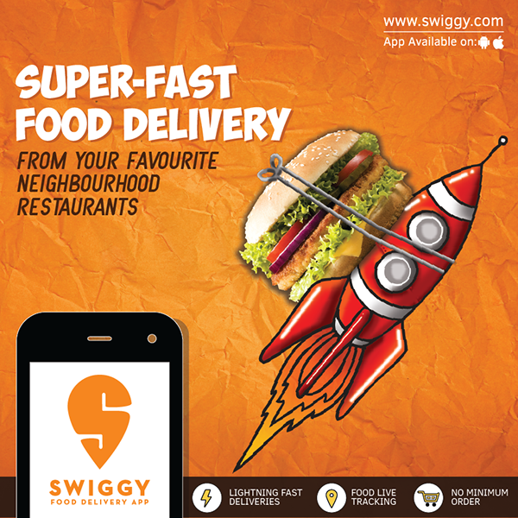

Swiggy is also working on delivering food with affordability considering the other economic category in the society. According to Harsha Majety, 2019, “As food ordering becomes mainstream, consumers are looking for economically sustainable solutions. Consequently, we have launched Swiggy SUPER, a subscription programme that does away with delivery fees, and Swiggy POP, the curetted and single-serve meals, which are reasonably priced.”

Furthermore, Swiggy has been encouraging the delivery only kitchens considering the demand for online food delivery which in turn supporting small scale food businesses resulting in significant operating cost savings. Harsha adds, “Plugging the gaps in hyper-local supply: Over the past few years, there has been an increase in the food choices demanded by consumers. Simultaneously, the restaurant industry is slowly but surely adapting to delivery-only kitchens, thanks to its ease of set-up and efficiency. Swiggy has been galvanising supply of restaurants through our delivery-only kitchen access. By using data and insights, we are working with restaurants to bridge gaps in supply, especially in under-served locations. I firmly believe that delivery-only kitchens will be the next wave in the food industry and there is a need to build and scale these highly efficient restaurants of the future.”

Swiggy has not only created jobs, increased profits, but also helped the restaurants to increase their revenue irrespective of their dine-in space. “Slowly, not just us but also the restaurants realised that the much-neglected delivery segment is contributing to their top and bottom lines alike. It has changed the way they look at business operations and the wheels are finally set in motion. In fact, our early differentiators in terms of end-to-end logistics and technology, were slowly being acknowledged as the way forward, and with those in place, the Indian food delivery sector reached its first milestone of one million orders a month in March 2015.”, Harsha, 2019.

- Conclusion:

Although, Swiggy is not considered to be a social entrepreneurship and very much into making profits, its business has led to significant societal changes for the well being of its customers and stakeholders by delivering food to the people in need anytime, anywhere and providing jobs for thousands of people with minimal educational qualification and improving local economy. Today, Swiggy as an opportunity entrepreneurship, proved to be a choice of every house hold in India.

- Bibliography:

- India Bureau, 2019, Unknown Facts About Swiggy Founders Sriharsha Majety and Nandan Reddy [Online]. Available at: https://www.businessinsider.in/business/corporates/article/unknown-facts-about-swiggy-founders-sriharsha-majety-and-nandan-reddy/articleshow/72289555.cms?utm_source=contentofinterest&utm_medium=text&utm_campaign=cppst . [Accessed Jan 3, 2020].

- Sriharsha Majety, 2019, Delivering Economic Growth: One bite at a time, [Online]. Available at: https://www.businesstoday.in/magazine/the-buzz/the-data-dining/story/304080.html [Accessed Jan 5, 2020].

- Pragnesh Dixit, 2019, How Swiggy Works: Business Model of India’s Largest Food Delivery Company, [Online]. Available at: https://www.tristatetechnology.com/blog/how-swiggy-business-model-works-and-make-money/ [Accessed Jan 5, 2020].

- Devra Gartenstein , What Do Entrepreneurs Contribute to Society?. [Online]. Available at: https://smallbusiness.chron.com/entrepreneurs-contribute-society-78923.html [Accessed Jan 5, 2020].

- Nigel.H., & JIM, A, (2006). The evolution and future of national customer satisfaction index models. Journal of Economic Psychology, 22 (2),217-245. 5. [Accessed Jan 6, 2020].

- Rashed Al Karim (2013). Customer Satisfaction in Online Shopping: A study into the reasons and motivations and inhibitions. IOSR Journal of Business and Management, 11(6),PP 13-20. 6. [Accessed Jan 6, 2020].

- SathiyaRaj, S.Kumar,A.S& Subramani. A (2015). Consumer perception towards online grocery stores, Chennai, Zenith International Journal of Multidisciplinary Research, 5 (6),24-34 [Accessed Jan 6, 2020].

- H.S.Sethu, Bhavya Saini (2016).Customer perception and satisfaction on ordering food via Internet, a Case of Foodzoned.com, in Manipal. Seventh Asia-Pacific Conference on Global Business Economics, pp.15-17 [Accessed Jan 6, 2020].

- Dr.G.SyamalaRao , 2018, A Conceptual Study On Opportunities And Challenges Of Online Food Services Market In India, PP 48-50 [Accessed Jan 6, 2020].

- Worldometer, 2020, Countries in the world by population (2020), [Online]. Available at: https://www.worldometers.info/world-population/population-by-country/ [Accessed Jan 7, 2020].

- Sunera Tandon, 2019, Aspiring, affluent households driving India consumption growth, [Online]. Available at: https://www.livemint.com/news/india/aspiring-affluent-households-driving-india-consumption-gr0owth-bcg-report-1551222553295.html [Accessed Jan 7, 2020].

- Jiachen Mo, 2018, How Food Delivery Apps and Services are Transforming Society, [Online]. Available at: https://globaledge.msu.edu/blog/post/55666/how-food-delivery-apps-and-services-are [Accessed Jan 9, 2020].

- Daryna P, 2019, 7 Hot Trends That Will Change the Future of the Food Delivery Industry, [Online]. Available at: https://rubygarage.org/blog/food-delivery-trends-2019 [Accessed Jan 9, 2020].

- Tish Sanghera, 2018, As India becomes wealthier, 17 mn leave the country to settle abroad, [Online]. Available at: https://www.business-standard.com/article/current-affairs/as-india-becomes-wealthier-17-mn-leave-the-country-to-settle-abroad-118112100113_1.html [Accessed Jan 9, 2020].

- Jon Russell, 2019, India’s Swiggy goes beyond food to offer product delivery from local stores, [Online]. Available at: https://techcrunch.com/2019/02/11/swiggy-store/ [Accessed Jan 10, 2020].

- Digbijay Mishra, 2019, Swiggy to hire 3L in 18 months, [Online]. Available at: https://timesofindia.indiatimes.com/business/india-business/swiggy-to-hire-3l-in-18-months/articleshow/71657065.cms [Accessed Jan 10, 2020].

- Wim Naudé, Chapter 18 of Naudé, W. A. (Ed.). (2010). Entrepreneurship and economic development. Palgrave Macmillan [Accessed Jan 3, 2020].

