

Name: Eduarda Pimentel
Student ID: 2436860
Module Code: LCHS4003_BIRM
Module: introduction to Health and Social Care
Lecturer: Dr Aishat Bakre

Submitted on: 18 October 2025

2: Mini Report

2.1 Introduction
The National Health Service (NHS) stands as one of the most significant social achievements in British history, embodying the principles of universal healthcare and equity. This report examines the establishment of the National Health Service (NHS) in the United Kingdom. Its core design was inspired by the Beveridge Report, which advocated for a comprehensive welfare state encompassing healthcare, education, and employment. It also explores the current structure and function, as well as the challenges the system is facing at present.

2.2 The Origins of the NHS: Historical Context and Key Principles

The National Health Service (NHS) was established in the United Kingdom in 1948, against the backdrop of World War II and subsequent social reforms aimed at rebuilding the nation. The origins of the NHS can be traced back to a time when health services were characterised by inequality, with access often determined by one's ability to pay. Before the NHS, healthcare in the UK was private, with the poor reliant on charity and hospitals funded by local governments (Shapiro, 2010).

The idea of a universal healthcare system appeared in the 1940s, inspired by the Beveridge Report, which proposed a welfare state enveloping health, education, and employment as integral parts of societal reform (Beveridge, 1942). The report highlighted the need for a health system accessible to all citizens, free at the point of use, thereby ending the barriers posed by the cost of healthcare. The Labour government, led by Prime Minister Clement Attlee, supported the creation of the NHS under the supervision of Health Minister Aneurin Bevan (RCN,2023).
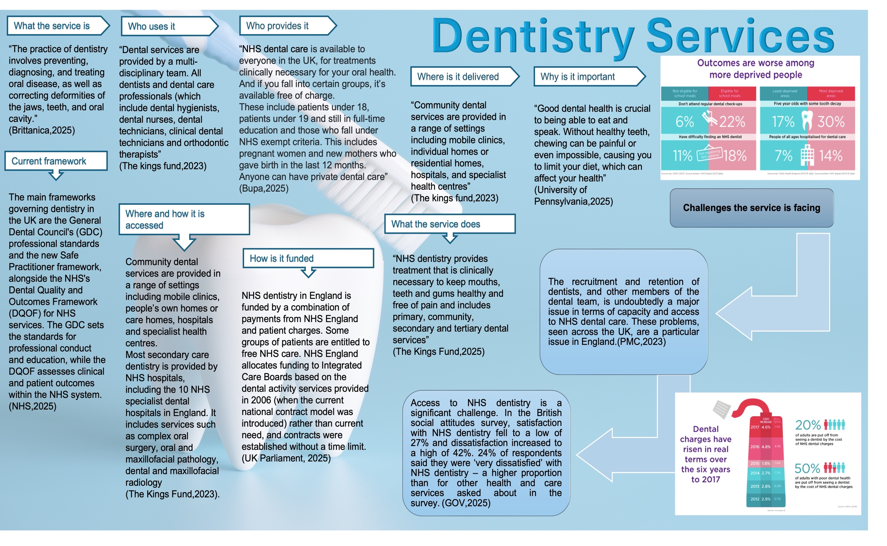
The principles of the NHS were firmly rooted in the ideals of universality, equity, and comprehensiveness. The NHS aimed to provide comprehensive healthcare services to everyone, funded through taxes, ensuring that healthcare was a right rather than a privilege (NHS,2023). This marked a significant improvement over earlier systems.

2.3 Current Structure and Functioning of the NHS

Today, the NHS runs as a complex organisation composed of various entities responsible for providing healthcare services across England, Scotland, Wales, and Northern Ireland. At its core, the NHS aims to deliver quality care accessible to all citizens. However, critical examination of its current structure reveals both strengths and weaknesses (Grosios, 2010).

The NHS is funded through general taxation, which supports a wide range of services, including primary care, hospital treatment, and public health initiatives. The structure is decentralised, with NHS England overseeing services in England while devolved administrations manage healthcare in Scotland, Wales, and Northern Ireland independently (NHS England, 2023).

However, the NHS faces significant challenges today, including funding pressures and workforce shortages. The increasing demand for services due to an ageing population and the rising prevalence of chronic diseases has strained resources, leading to longer waiting times and reduced access to care in some areas (The King's Fund, 2022).

The introduction of sustainability and transformation partnerships (STPs) aims to improve collaboration between different NHS entities and address environmental and health inequalities (NHS England, 2023). There are still concerns about the implementation of market-based reforms, which some critics argue could undermine the founding principles of the NHS by prioritising efficiency over equity (Davis, 2021).

In terms of service delivery, the NHS continues to embrace technological advancements, including telemedicine and electronic health records, which improve patient management and access to services. However, the digital divide poses challenges for some patient populations who may lack access to online resources (Graham, 2022).

2.4 Conclusion

In summary, the NHS has significantly changed the landscape of healthcare since its start in 1948, yet it currently faces substantial challenges. The foundation values of universality, equity, and comprehensiveness remain essential, but modern pressures demand flexibility and ongoing commitment to health equity. As reforms and innovations evolve, the core principles of the NHS must endure to support its mission of delivering accessible healthcare for everyone.

Reference List

Beveridge, W. (2024). Social insurance and allied services. 1942. Bulletin of the World Health Organisation, 78(6), p.847. Available at: https://pmc.ncbi.nlm.nih.gov/articles/PMC2560775/
Britannica (2019). dentistry | Definition, History, & Fields | Britannica. In: Encyclopædia Britannica. Available at: https://www.britannica.com/science/dentistry
BUPA (2025). The differences between NHS and private dentistry | Bupa Dental Care. www.bupa.co.uk. Available at: https://www.bupa.co.uk/dental/dental-care/news/nhs-vs-private
Evans, D., Mills, I., Burns, L., Bryce, M. and Hanks, S. (2023). The Dental Workforce Recruitment and Retention Crisis in the UK. British Dental Journal, 234(8), pp.573–577. doi:https://doi.org/10.1038/s41415-023-5737-5.
Google Books. (2019). Public Health And Health Services Research In Traditional, Complementary And Integrative Health Care: International Perspectives. Available at: https://books.google.co.uk/books?id=otacDwAAQBAJ&lpg=PR5&ots=TUgdtynys_&dq=Adams%2C%20R.%20(2019).%20The%20National%20Health%20Service%3A%20A%20very%20short%20introduction.%20Oxford%3A%20Oxford%20University%20Press&lr&pg=PR5#v=onepage&q&f=false [Accessed 16 Oct. 2025].
Grosios, K., Gahan, P.B. and Burbidge, J. (2010). Overview of healthcare in the UK. EPMA Journal, 1(4), pp.529–534. doi:https://doi.org/10.1007/s13167-010-0050-1.
HFMA. (2025). Funding NHS dentistry. Available at: https://www.hfma.org.uk/publications/funding-nhs-dentistry
Nuffield Trust. (2025). Dental health infographic. Available at: https://www.nuffieldtrust.org.uk/dental-health-infographic [Accessed 16 Oct. 2025].
Public Health England (2021). Inequalities in oral health in England: summary. GOV.UK. Available at: https://www.gov.uk/government/publications/inequalities-in-oral-health-in-england/inequalities-in-oral-health-in-england-summary
Royal College of Nursing (2023). NHS 75: the history of our National Health Service | RCN Magazine | Royal College of Nursing. The Royal College of Nursing. Available at: https://www.rcn.org.uk/magazines/History/2023/July/NHS-75-anniversary-history-of-the-National-Health-Service
Shapiro, J. (2010). The NHS: the story so far (1948–2010). Clinical Medicine, 10(4), pp.336–338. doi:https://doi.org/10.7861/clinmedicine.10-4-336.
The King’s Fund. (2023). NHS Dentistry In England Explained | The King’s Fund. Available at: https://www.kingsfund.org.uk/insight-and-analysis/long-reads/dentistry-england-explained#how-is-nhs-dentistry-commissioned-and-contracted? [Accessed 16 Oct. 2025].
www.england.nhs.uk. (n.d.). NHS England» Dental contracting framework. Available at: https://www.england.nhs.uk/primary-care/dentistry/dental-commissioning/dental-contract/ [Accessed 16 Oct. 2025].

